**THE IT WORLD**

# **Team Profile:**

## **Team name: DDQN**

This name represents the team's spirit, which shows all the expectations and the interest in the IT World. These letters take from the first letter of an individual member's name that shows each person is a piece of the puzzle indispensable in the team.

## **Personal information:**

### **Pham Vo Dong - s3891968:**

My name is Pham Vo Dong, and my student number is s3891968. You can contact me on the primary email phamvodong0811@gmail.com or the optional email s3891968@rmit.edu.vn. I am a motivated Vietnamese student who can learn and receive new information using logical thinking. I graduated from high school in Vietnam with a 4.0 GPA, and mathematics and physics are my best subjects. I began learning English in sixth grade and am now fluent in both Vietnamese and English. Since grade 11, I've studied information technology and competed in robotics competitions.

For the time being, I am pursuing a Bachelor of Information Technology at RMIT, and in my spare time, I enjoy playing basketball and taking photographs. And the main reason why I choose to spend my time in IT is that in the current era, information technology plays an essential role in our lives, directly affecting personal daily activities that no one can ignore. In my opinion, the advancement of information technology makes a person's life better and more convenient. IT, for example, makes it easier for people to weather the storm of COVID-19 without difficulty because they can do everything online, which does not require face-to-face contact, such as shopping online, studying online, and working from home. Since I was a child, I've had a strong interest in technology. When my family got their first computer, I was introduced to a new world where I expanded my knowledge of technology. As a result, it piqued my interest. Through my high school robotics club, I participated in some competitions and made some small projects, such as automatic watering systems, light bulbs, and balance cars. In addition, I have worked as a graphic designer since I was in high school, and I know Python, HTML. Therefore, I expect to learn the skills necessary to manage an IT project and bring my fantastic idea to fruition after finishing my studies.

### **Bui Quang Thanh Dat - s39127551:**

I was initially from VietNam, which my hometown is Hue city. A bit of trivia is that although my father came from the Central – region, I still have a Southern accent. I think this is because he went to the South quite a while to settle, and my mother is originally Southern. I am addressing this since a few of my friends or new acquaintances usually could not recognize my accent as a Southern but somewhere else like a mixed accent. Aside from Vietnamese, I also know English.

I am interested in technology in general; that is why I chose the major in the beginning. My interest in IT most I have to state is games. Ever since I have interacted with it at a young age, I remember I was in elementary school. My brother introduced the game. I remember watching him play and felt it was an opening mind. At that time, I found it fascinating, and everything about the game was so exciting and addictive, the game is called StarCraft, so after playing, I was dreaming about becoming a game developer. However, on my journey of studying it, I did not find making games to be as enjoyable as playing them. I only like playing them rather than creating the game, so I changed my path to RMIT. I expect that I will gain a lot of knowledge and a general idea about IT.

### **Mai Chi Nghi - s3864219:**

I live in Binh Duong, Vietnam, and I graduated from my 12 years of school two years ago to communicate with everyone in two languages: Vietnamese and English. I started to study at RMIT University in 2019. I am studying an English course to get a Bachelor of Information Technology. Besides that, I have already joined the Flag Football Club (FFC) as a member at university, and when I have free time, I play games and go to coffee shops with my friends. Nowadays, the world is growing faster and faster. Technology has entered and influenced our daily lives in many ways, so it is fair to say that IT has made our lives less difficult. Currently, we can do online shopping, study online, and work online. People can do those things through smartphones or computers and laptops. Since 2020, my friends and I have studied IT online because of COVID-19, but in fewer weeks we have to come back to school face-to-face, which helps us more and more and more develop teamwork skills. So, I decided to add more knowledge for myself which will help me in the future.

### **Le Anh Quan - s3877457:**

I was born in Ninh Hoa, a small district near Nha Trang city. My parents were very open-minded and allowed me to find my path on my own. They had the first aim for me to be a doctor, but after discovering my programming hobby, they let me study for programming jobs instead. I chose software engineering as my RMIT major because I think it would help me develop my programming skill and help me make use of my English. I am quite an introvert, but I am trying to improve myself to work better with my teammates.

My dream is to get a well-paying job so I can help provide for my parents when they get older. I like to play video games in my free time, and one of my favourite things to do with games is to mess with the code or the value of the game to break the game balance; that is what got me into software programming. When I got older and was able to do more research, I chose IT as my major because it just started to bloom in Vietnam. IT has the potential to explode when I graduate, and I think I have qualities that are fit for IT, such as focus, commitment and a willingness to change and adapt. I chose RMIT to study because of its international presence, internal environment, and excellent facilities and specialization in IT. It also helps that my sister was an RMIT graduate at that time, and she was able to get a good job thanks to RMIT job finding support service. Even though she studied business, it helped convince my parents of the opportunities RMIT will give me in the future.

## **Team Profile:**

### **Pham Vo Dong**

#### **Myers-Briggs test:**

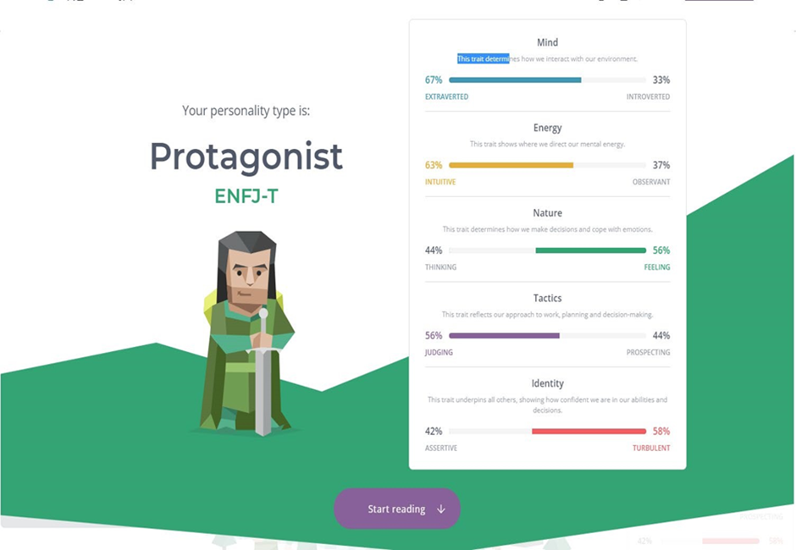

[**https://www.16personalities.com/enfj-personality**](https://www.16personalities.com/enfj-personality) **(16personalities, 2021)**

#### **Learning style test:**



[http://www.educationplanner.org/students/self-assessments/learning-stylesquiz.shtml?event=results&A=5&V=9&T=6](http://www.educationplanner.org/students/self-assessments/learning-styles-quiz.shtml?event=results&A=5&V=9&T=6) (Education Planner.org, 2021)

#### **Creative style:**

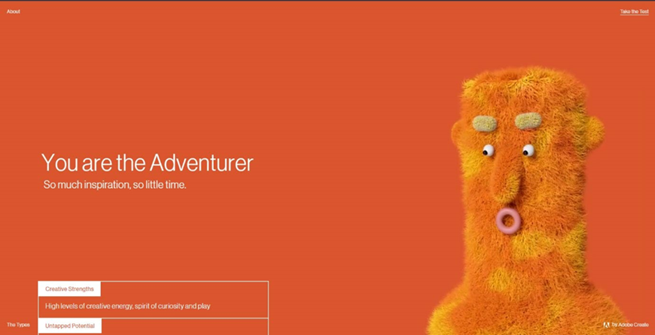

<https://mycreativetype.com/share/adventurer/> [(](https://mycreativetype.com/)Creative Types by Adobe Create[,](https://mycreativetype.com/) 2021)

* These tests show that I am an extrovert, and I could become a potential leader. I will take on my position as a team leader with valuable skills such as idealistic, charismatic, creative, and social, which leads my teammate and me to success. Moreover, I create a better environment that is the most comfortable, making them feel motivated and inspired. Every person in my team will have an excellent chance to perform their most vital skill to join and complete the project successful

### **Bui Quang Thanh Dat**

#### **The results of an online Myers-Briggs test:**

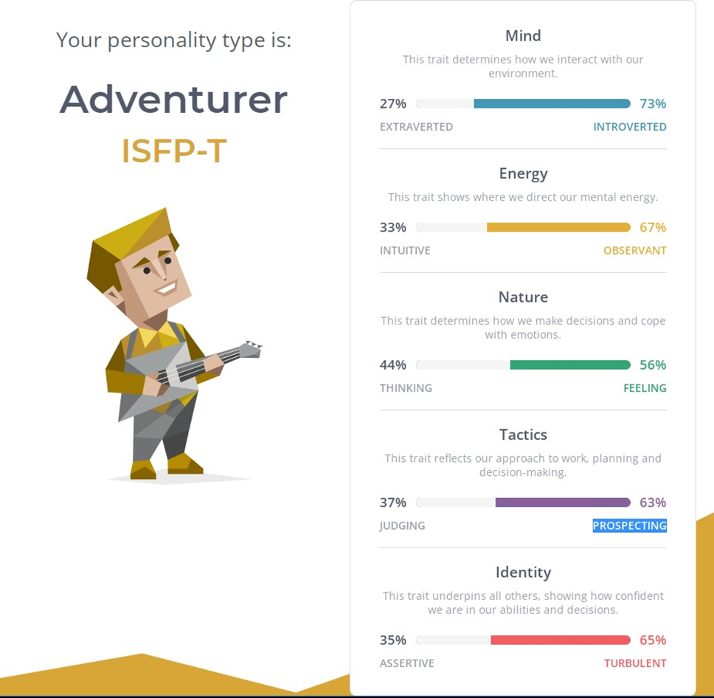

[**https://www.16personalities.com/articles/tactics-judging-vs-prospecting**](https://www.16personalities.com/articles/tactics-judging-vs-prospecting)

The results of an online learning style test:

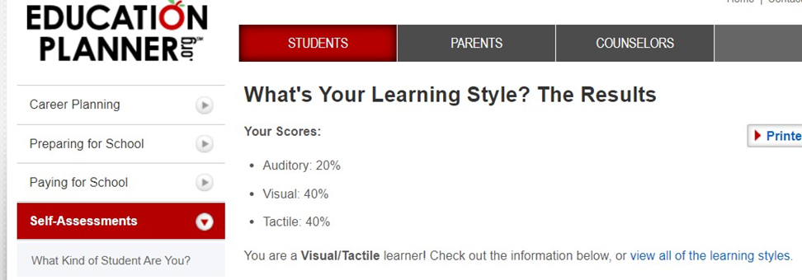

[**http://www.educationplanner.org/students/self-assessments/learning-styles-quiz.shtml**](http://www.educationplanner.org/students/self-assessments/learning-styles-quiz.shtml)

#### **The results of one further online test of your choosing:**

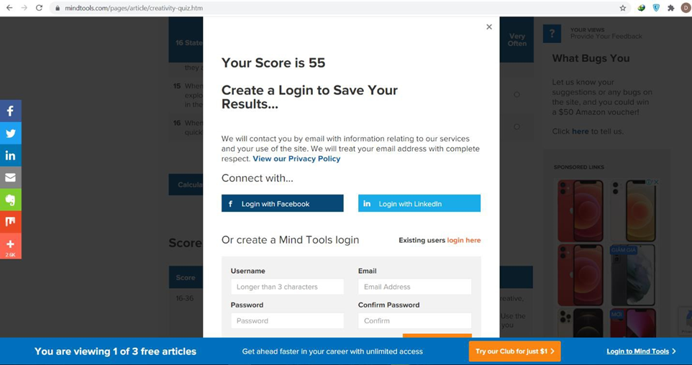

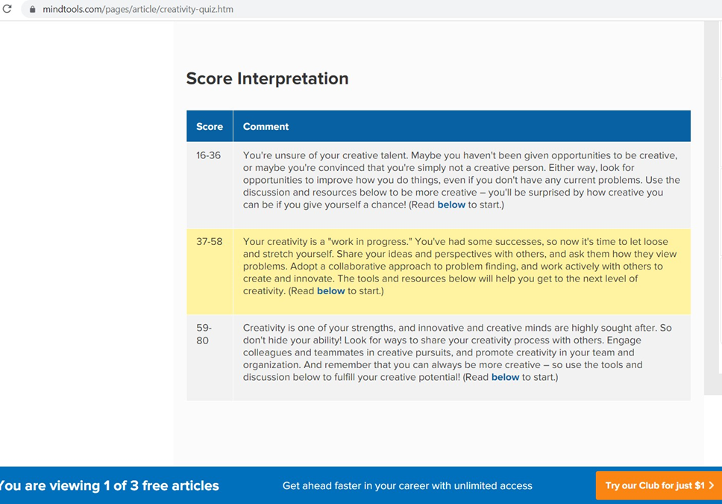

[**https://www.mindtools.com/pages/article/creativity-quiz.htm**](https://www.mindtools.com/pages/article/creativity-quiz.htm)

* I think the result delivered the purpose of the test. The 16personalities test states I am an adventurer, which gave me insight into my characteristics like open minds, a welcome new adventure, and a grounded, warm personality. Regarding the influence of the result on my behaviour, in a way, I think the test result suggests what I should do with my character, like how I should react and interact with other members of a team. Everyone has their opinions when being in a group, so it isn't a big issue since the team is heading towards a common problem. and the personalities may make it be challenging to share the idea and solution

### **Mai Chi Nghi**

#### **Humanmetrics Jung Typology Test:**

<http://www.humanmetrics.com/personality> (Humanmetrics Jung Typology Test, 2021)

#### **Learning style test:**

<http://www.educationplanner.org/students/self-assessments/learning-styles-quiz.shtml> (Education Planner.org, 2021)

#### **Personality Test:**

<https://www.truity.com/test/type-finder-personality-test-new> (Personality Test, 2021)

* According to those results, I will introduce myself and support others who want to work on a team with me, which helps everyone can connect and know about each other and push me to work together well in the future.

### **Le Anh Quan**

#### **Myers-Briggs test:**

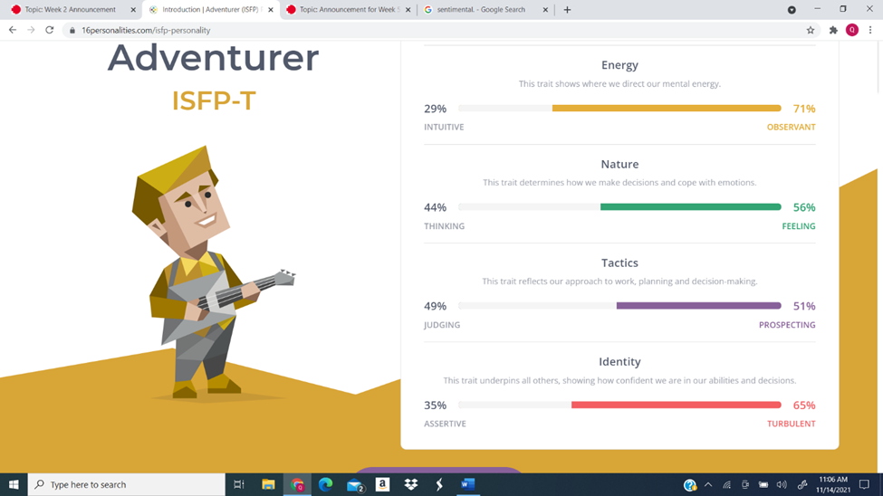

#### **Learning style test:**

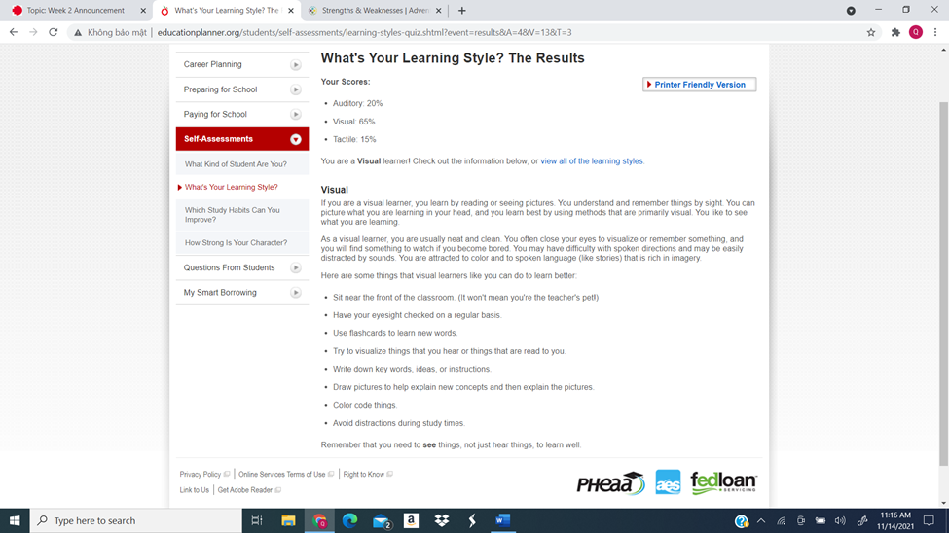

#### **5 big personalities test:**

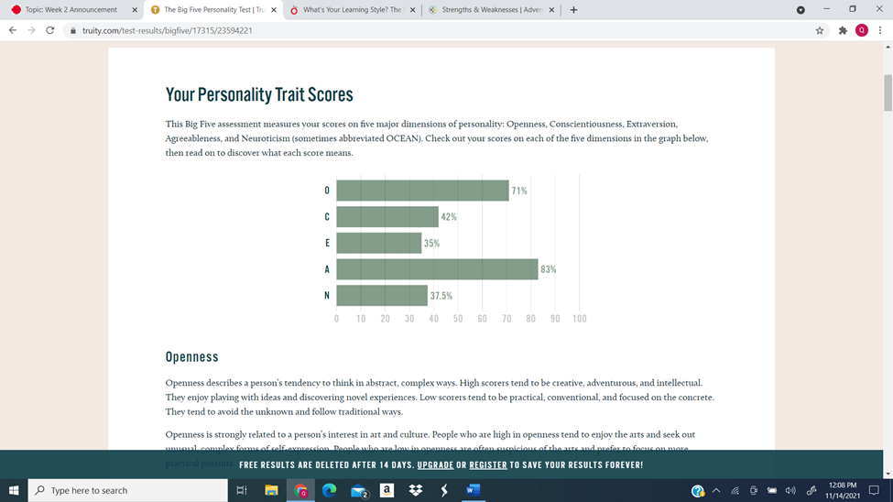

These tests give me information about my personality, strengths and weaknesses, and preferred learning style. After answering the questions, I can see some of my traits being correct with the characteristics shown. While these tests may not be entirely accurate, and the result may change over time as I develop, they give me an excellent baseline to start working on myself. These tests show that I am creative and observant, which means I am fit to brainstorm ideas for the team. The test also showed that I am a highly introverted person, which means I shouldn't be the first choice if we need a spokesperson for the group, and I need to work on my presentation skills and communication skills. When forming a team, I should find people who cover my weaknesses to cover more areas, but I also can't let my shortcomings stop me from trying a new position or taking a missing role in the team.

## **Ideal Jobs:**

* The ideal jobs of our team member are very different from each other and have no similarity aside from all of them involve programming. In specific Nghi wish to be a security engineer, Dong wants to be an AI engineer, Dat want to be a front-end developer and Quan’s ideal job is a back-end developer in the form of a java programmer. There are both pros and cons with our team difference in goals. The cons are that we will have a harder time discussing more specialize topic because our specialty is so different from one another and it will be harder to give feedback or support on a member’s job because of this difference. The pros however outweigh the cons, the difference in experience means that we can give feedback from different perspective to further our project, and we can also can cover different elements of our project because different sides of a project may require different specialty. Furthermore, working with other from different experience means you can learn more about their jobs and how to work with people with similar jobs in the future. We see this as a good opportunity to learn about the different branches of programming and how people of different specialty can work together to create a joined project.

# **Tools:**

* **Group website:** <https://phamvodong.github.io/Assigment2-DDQN/web/homepage.html>
* **Git repository (GitHub):** <https://github.com/phamvodong/Assigment2-DDQN>
* **Interview video:** <https://youtu.be/QCpgvUhjpPY>
* The Git repository helps us organize the team progress, which shows all the tasks people are doing in their branches. And the leader easily controls the work of teammates; therefore, the final result is posted into the main branch, which is more precise and convenient. Moreover, we can work on a mobile that is very suitable for people working online in the pandemic era that people do not allow face-to-face meetings to graduate from the rule of avoiding sickness.

# **IT Work:**

* **Interview an IT professional (15mins):**  <https://youtu.be/QCpgvUhjpPY>

## **Report an interview:**

* Bui Quang Thanh Vinh
* vinhbui@itrvn.com
* IT professional interview
* Microsoft teams 01/12/2021
* Bui Quang Thanh Dat
* This interview is about IT professionals, making people understand what IT professionals work in and which fields. Therefore, people know more about the pros and cons of IT jobs.

### **What kind of work is done by the IT professional?**

* The kind of work done by an IT professional is a business analyst that he has taken the requirement his clients and a greeting with his team, including the developers. Along with the quality control steps, the product owner and the project manager, so that his team have to implement in the new release. Then, his team moves to generate some proposals, transmitting them to the client. According to a professor, after his team accepts everything, they want to start building from their writing user story to implementing a customer, best testing and then releasing it to the customer.

### **What kinds of people does the IT professional interact with? Are they other IT professionals? Clients? Investors? The general public?**

* Kind of person that an IT professional wants to interact with his supervisor because the product owner and technically that he is leading the project most of the time in his team. He said that everything is overseas by the project manager. However, the project owner would be in charge of a particular project. He has to report to his manager. After that, a professor has a greeting with his client when they have some requests, and his customer has to join a discussion, which makes him feel happy.

### **Where do the IT professionals spend most of their time?**

* IT professional has to spend his time checking every project or product with his team when their project has some troubles in their process and get some feedback from their clients to fix and update their skills and project to serve his customer better.

### **What aspect of their position is most challenging?**

* An aspect of his position that is most challenging is a disadvantage. It means that the IT professor said that they are not a sourcing company, which is causing it too hard for them to make a decision. Besides that, his team has to release project after project after project, which has to bring a little bit of difficulty.

## **Overview:**

* This is a brief interview with IT professionals - business analysis - which people have innovated in thinking about IT. It is not a problematic field easily accessed by every person of many ages and genders. This interview was hosted on Microsoft Teams by Bui Quang Thanh Dat, and Bui Quang Thanh Vinh was a guest. The challenge we got in this work was the viewer's experience because of an online interview in which the quality was not as good. However, it transfers every necessary information for people to understand and clarify.

# **IT Technologies**

## **Cloud computing (services, platforms, servers etc.)**

## **Cybersecurity and privacy**

Many fascinating developments have appeared in the IT World in this day and age, but they cannot achieve some success in recent years. However, some of them have to change and develop in the 4.0 era, especially in the fascinating developments that I want to focus on cybersecurity and privacy. That means I will show what cybersecurity and privacy do and the likely impact, how to affect me in life.

First of all, there is the operation of network security and privacy, which helps many companies of business and national networks to confront attacks from hackers who want to take important information. Cybersecurity has a cyber analyst function, which helps people protect computer networks from cyber-attacks and unauthorized access. That means the cyber analyst has to try to predict and defend against cyber threats and cope with security breaches when those things happen. In this job, people

have to play a vital role in protecting their organization's valuable data in their company and nation. They show that this new technology's state of the art is complex if people do not avoid unauthorized access or access to dark websites with risky viruses, which destroys intelligence on computers of companies or nations. However, each government has a group or a professional IT person specializing in cybersecurity, which helps their country prevent many threats from attacking the network. For example, in Vietnam, they have Hieu PC, one of the professional IT about cybersecurity that protects the network stay safe. In the next three years, many students will be trained or studied at the university in cybersecurity in technology. They also need to learn the basics of cybersecurity, which they know from industry colleagues experience, which helps them improve their network skills, such as cybersecurity technical skills. That has to use tools like virtual private networks (VPNs), firewalls, antivirus software, and network access control from endpoint management, which helps professors know how to use their phones and computers to protect the network. Besides that, the professor has to use some programming apps to support them in understanding languages such as Javascript, Python and C/C++, which gives them a competitive edge. Along with cybersecurity, workplace skills that bring people to join a communication help them support each other when they work on a team and document the investigation and recovery process. They can see consultation and ideas that help them improve their listening skills. This network security has to link with privacy, which assists people in having to keep private information when they work for companies or national security. Solitude will help people establish boundaries to limit who access the internet in any place, which protects people's information and communication. That means privacy has a rule is when some have deliberately accessed the websites of specific companies or countries, their privacy is violated. The state of the art of aloneness is quite complicated because companies and nations do not know how to keep the confidentiality of their information safe. People have to use essential protection to keep their information private. In the next three years, the thing likely to be done soon is hiring more qualified civilians for privacy positions because companies want to engage people who have experience or have a clear goal or purpose, which means those things help them carry their information. Hence, cybersecurity and privacy are similar in that they both have to protect and secure critical information on the computer.

When people hear about cybersecurity and privacy, people have to think about things that are likely to have impacts. When hackers access dark websites, people are apprehensive about their information being taken by hackers, but company personnel lack a thing. I mean that different parts of a company lack some people specializing in cybersecurity and privacy, which is a challenge that people have to confront. In the future, many companies are hiring people who have to finish their university or students who practice as students from RMIT University, which is likely to change when the company accepts and adjusts it. Business enterprises are people who will be affected by network security and privacy. For example, when a company runs a business that they have to sell and advertise their product online, competitors could likely steal or alter the sales figures of the better seller, along with giving some malicious viruses for the viral websites. Cybersecurity and privacy will create places for potential people who can show off their skills and knowledge. That means people have a job to do to deal with unemployment, although not many people can try hard for this job in the long-term, study and work in Vietnam. Because there are many codes and complex numbers to remember, along with concentrating when they have to analyse and fix many issues for their computer. Therefore, those things show that cybersecurity and privacy have a positive and negative impact on many jobs in the world who have to use the internet to run businesses online, such as advertising on social media like Facebook, Instagram and the Youtuber, together with online shopping that those new technologies are essential, that will protect their information exclusively before illegal access to websites. Hopefully, cybersecurity and privacy have to make a positive change for many companies in the future.

In my experience, network security and privacy have affected my life in two ways: positive and negative. Things in the world have many aspects that influence people to discuss them. Positively, cybersecurity and privacy are helping my family and my friends control our information to protect profiles on safety. Besides that, we have to know more technical knowledge, especially when looking after the internet, which must be a complicated and completed process of training and studying for experiences. Negatively, we do not know who visits and impacts our information, making us feel uncomfortable. However, this new technology will be making my life change because that motivated me to study information technology at RMIT University, which makes me think that those things have more of a positive influence than the worse ones. In addition, this new technology is essential to companies and organizations and a significant thing to streamers and YouTubers or people who work related to the network. That means this new technology can support them to protect them or use some applications such as antivirus software or firewalls for their computers or phones. Hence, cybersecurity and privacy have changed my life going in a great direction, and I will find a little more knowledge about this industry that can help me in the future.

In general, cybersecurity and privacy are a critical technology for people's daily lives; that is the best backup for people's information when they network for work, entertainment, or study for their deadline. However, network security and privacy will be developed if many potential people want to be professors for this job in the future.

## **Blockchain and cryptocurrencies**

A blockchain is a decentralized ledger of all transactions across a peer-to-peer network. Using this technology, participants can confirm transactions without needing a central clearing authority. Blockchain is the technology that enables the existence of cryptocurrency. Bitcoin is the name of the best-known cryptocurrency for which blockchain technology was invented. A cryptocurrency is a medium of exchange but is digital and uses encryption techniques to control the creation of monetary units and verify the transfer of funds. Thanks to its benefits and potential, Blockchain and cryptocurrency are starting to play a more critical role in society. The most well-known use of Blockchain is with cryptocurrencies such as Bitcoin, Bitcoin has earned its fame as the most famous cryptocurrency because it has cemented itself as a legitimate trading currency, and the value of Bitcoin is very high at around 55000 USD per Bitcoin. Other than Bitcoin, other cryptocurrencies such as Ethereum and Litecoin are getting more and more importance and recognition. One cryptocurrency called Dogecoin has even gotten mass media coverage due to its value rising in the hundreds despite being created as a joke. Developers have also started to develop a new way to apply cryptocurrency, combining it with a game, creating blockchain games. One example of this is the most successful blockchain game Axie Infinity. Axie Infinity is a perfect combination of a game and blockchain technology in the form of an Axie coin. This model works so well that it has over 4 billion dollars turned into an Axie coin, and it has become a side job for extra income in countries with low GDP. Aside from cryptocurrency, Blockchain does not apply in many areas. However, due to its benefit of increased transparency, trackability, and reduced cost due to no ledger, many big companies across many sites are currently researching Blockchain as they see this technology's potential. Both cryptocurrency and Blockchain have bright futures ahead of them. Cryptocurrency like Bitcoin is already accepted as a trading currency, but at this moment, it is still a niche one and is usually traded back into the country currency because of its unstable nature. But with more mainstream exposure every year, more services are offering payment in cryptocurrency, and in the future, it will be a mainstream trading currency that has equal importance as USD or EUR, and loses its unstable nature and becomes more than just a riskier form of stocks. On the other hand, although it has many real-world applications, its potential to be applied in many areas is enormous. Transactions between individuals or companies can be less expensive and faster-using Blockchain. Both sides will know the term of the contract. Since the contract is hosted online using blockchain technology, which is checked, and security will be guaranteed, and if something happens, Blockchain ensures it will be easily tracked and recovered, not only that the lack of a third-party middle man will further reduce the cost while ensuring no bias occurred. Blockchain will also keep data such as your Social Security number, date of birth, and other identifying information about a more secure public than current systems more susceptible to hacks. Blockchain technology can also be used to secure access to identifying information while improving access for those who need it in industries such as travel, healthcare, finance, and education. Further uses of Blockchain include using its traceable nature to ensure that voting is done correctly since every vote can be traced back to the voter, making that no one vote more than once, or it can be used to make sure no illegal copies of music and films exist.

Both cryptocurrency and Blockchain will cause change to the world we live in today. Even though we already have online transactions through online wallets like Momo, cryptocurrency will allow global transactions to be done since there will be no need for exchange between country currencies. Cryptocurrency will also be more secure than normal online since it uses Blockchain with all of its security benefits. Companies will start to pay with cryptocurrency or transfer their funds into cryptocurrency once it becomes stable because of its increased security and traceability. Governments will have to update their laws to adapt to cryptocurrency since it is still a new concept in developing countries like Vietnam. Blockchain causes change through cryptocurrency, as mentioned above and through its applications in other areas. More actions will be done online, such as entering personal information for healthcare and education, voting and transactions to make use of the simplicity, security and efficiency of blockchain technology while also reducing the pricing needed. As new jobs and services will be created to adapt to the rise of these new concepts, existing jobs will be replaced unless they adapt to this technology. Banks and Online wallets will have to transfer to using well-known cryptocurrencies such as Bitcoin or integrate cryptocurrency into their system. Third-party companies' contracts will also be made obsolete since Blockchain makes sure the warranty is as transparent, secure, fast and traceable as possible, so the two sides won't need to spend extra money on a third party that lacks the benefits of Blockchain. These are just the tip of the iceberg for the change that cryptocurrency and Blockchain will cause and gain more attention over time.

These technologies also affect me in a variety of ways. Cryptocurrency won't affect my life or my family because it values stability, so they don't find much interest in cryptocurrency because of its unstable trait. I am in the line of thought with my family, and since my major won't interact much with it, I would only research it because of its potential in the future. On the other hand, I would spend time exploring Blockchain because of its potential to change and possibly revolutionize many areas in the world. I would study Blockchain and prioritize courses that touch it when picking courses. I would also follow news about progress on Blockchain to know of the newest advancement in the technology. If Vietnam is to use Blockchain in any area, I would find information on it and notify my family to adapt to the change. My family is not too interested in technology, nor do they understand much about Blockchain, but they are interested in its benefits and will be willing to learn more about it should it come to Vietnam. As a result, cryptocurrency and Blockchain are unique technologies with enormous potential to cause massive change across many areas. However, while cryptocurrency has been quite successful with even mainstream attention, Blockchain is still in the testing phase in many places but have been successful in the areas it is applied in, such as cryptocurrency or Ethereum. In the future, as these technologies gain more attention and funding, they may revolutionize the world either by cryptocurrency becoming a mainstream stable trading currency or Blockchain transferring many processes online to take advantage of all its benefits.

## **Artificial intelligence and machine learning**

In the digital era, people seem to be lazier and lazier, so almost all work is done by the computer, which can resolve the problem faster thanks to the computer's brain that can calculate the algorithms in a few seconds. That is the consequence of the progressing advancement of machine learning (ML) and artificial intelligence (AI). The father of machine learning is Alan Turing in full Alan Mathison Turing, (born June 23, 1912) in London (Britannica, 2021), a British mathematician and computer scientist major establishing the first machine learning system called bombe. And the term "artificial intelligence" was coined in the 1950s after his research was published at the time; he must be incognito because this was the government secret. From that, AI has grown deeply embedded in many aspects of society, and it frequently runs in the background of our electronic gadgets. AI machine learning is represented as experiential "learning" combined with human intelligence (ResearchGate, 2021), which can study and develop analysis progress through computational algorithms. This process is as same as raising the baby, which people should take care of in little things of the "toddler AI" to make it become good children in the future (see appendix 1 for the working of AI). However, the knowledge of AI is proportional to the development of data which constantly improves multiple times in a second. Therefore, AI can easily access many fields of people's lives, such as E-commerce, advertising, entertainment, and digital personal assistants. In the E-commerce and advertising industries, AI plays an essential role in the tool hooking the customers to keep using their product or services because of the recognition algorithms in the AI, which allow learning the previous research and purchase and provide a personal recommendation for each person. And it is crucial in optimizing products, planning inventory, and logistic industries. Moreover, AI helps improve the experiential of the user into the entertainment platform like Netflix, YouTube, Facebook, and web search engine. Like E-commerce, AI studies the customer's habits and brings the best advice for the new content. In addition, the application people always use AI, the digital personal assistants. Smartphones employ artificial intelligence to deliver services as relevant and personalized as feasible and virtual assistants have grown commonplace, answering inquiries, making recommendations, and assisting with daily tasks. Moreover, some smart homes, cities, and infrastructure are established using AI to operate. In 2016, the incredible project in the scientific movie was the AI robot called Sophia of Hanson Robotics. Sophia, the first robot citizen, is a Saudi Arabian, and her birthday is February 14, 2016 (Wikipedia, 2021). She is a human-like robot that can show all the feelings like a human. When she interacted with people to communicate, it looked like the speech of humans. Hence, Sophia is opening the hybrid era in which people will live with robots like the science fiction movie in the future. Looking at the rapid development of AI brings the vision of all transportation in the world using self-driving cars, reducing the rate of vehicle accidents. The electric vehicle is the best option for the green vehicle because the world has been transformed into a green world that uses green energy. In addition, the electronic vehicle easily allows applying AI self-driving technology more than the traditional vehicle. Consequently, AI is becoming more innovative than before thanks to the big data-industrial because more data means more speed and intelligence; therefore, AI plays an essential role in human living conditions.

The benefits of AI have changed how the world is working, which is becoming a technological revolution affecting all people, including the bourgeoisie (business) and the proletariat (individual). In recent years, AI has had a substantial potential impact on global economic activity, increasing many countries and cooperation finance. According to McKinsey Global Institute research, an estimated 70% of organizations may have implemented at least one type of AI technology due to the positive results of AI in industrialized countries - 20 to 25% in net economic gains (McKinsey and Company, 2021) - because many businesses are shifting to using AI technology to run their businesses, which is faster and more efficient than doing so manually. In addition, AI brings good efficiency into the Company and has impacted society in the advantages. For example, our workplace has significantly increased productivity by AI while also augmenting the jobs humans can accomplish, which can do all the dangerous jobs. Therefore, people have free up time to increase happiness and job satisfaction. Moreover, AI improves health care service and security. Big data will solve the problem of medicine and pharma, and people could save up to 100 billion dollars annually under the prediction of McKinsey (Bernard Marr and Co, 2021). And the rate of crime decreased because of the increase in AI security. According to the Awake the NDR Security Division of ARISTA, AI security was a technology trend in 2020. It will continue moving forward because it augments the shrinking cyber workforce besides helping save time hunting for threats. The statistics showed that 54 per cent of critical alerts are completely investigated (Awake the NDR Security Division of ARISTA, 2021), which is done automatically by AI. Consequently, the world completely changes; from 2017 to 2037, 7 million existing jobs will be replaced by AI, but it could create 7.2 million jobs. However, AI will become the fundamental technology for improving other things such as AR, VR, robotics, and computers.

As mentioned above, Ai impacts all people globally, becoming an indispensable role in human life day by day. It quickly captures the image of people who use AI in their daily lives. The most typical application of this technology is the virtual assistant in their smartphones, such as Siri on iPhone, Google Assistant on Android, and Alexa on Amazon. These assistants help me and people around me manage the multitasking convenience. I use my voice to request the command, and AI takes care of the rest. For instance, when I say "set the meeting on Microsoft Teams at 10 am", AI opens the Teams Microsoft and sets the meeting at 10 am, which is done automatically, and I can review the command and commit it without any problems. In addition, some AI bots are used for recognizing the melody, speech, finding out the song, or adding the subtitle, which lets people live carefreely. However, it has many challenges using these technologies. I need to be good at languages because AI learns the specified action to give the clear command for AI knowing what to do. In the future, AI will be more and more important in human life, which will be brighter and brighter that can be compared with the most intelligent system that is the human brain. And that future is not far because nowadays the technologies are developing unstoppable and perhaps in the future people will live in the cyberpunk environment with the AI like Blade runner 2049, or we will use them as entertainment such as "Westworld", or the wrong ways AI will dominate us, but in the fact that AI has a significant impact on the evolution of human.

# **Project ideas**

## **About the project:**

This project will create a new version of an ergonomic chair that incorporates artificial intelligence to address various bone problems. It is not only for those who have always been in their chairs for extended periods, but it is also for youngsters to minimize the risk of scoliosis.

People in the Covid-19 period must work from home. Some firms are moving from the typical working office to working online, and utilizing seats that appear to be dependable coworkers, they are enhancing the efficiency of online workers. Scoliosis affects around six to nine million persons in the United States, accounting for about 2-3 percent of the population, according to the American Academy of Neurological Surgeons (AANS). Furthermore, according to the same source, the primary age of onset for scoliosis is 10-15 years old, and it affects both genders equally. The number of persons with scoliosis is growing every day, and the average age of scoliosis patients is getting younger. It is a dangerous statistic for people's health, especially for youngsters, who need the most protection for their growth and development. As a result, the AI Ergonomic Chair project was designed to solve this problem and safeguard people's spines.

Because of the advantages of ergonomic seats, they are becoming increasingly popular among office employees and those with a home computer setup. Ergonomics are helpful because of the unique construction. First and foremost, the ergonomic chair provides total back support, which, thanks to the chair's flexing form, helps preserve your spine. Second, sitting with a weird spine is tough since individuals always slump forward when they sit due to gravity. Finally, the seat cushion may be adjusted to maintain a bit backward inclination that supports the spine close to the chair's back. Third, customers may customize their chairs to fit their unique personalities and body shapes by adding or removing additional items. Finally, the chair's fabric is net, which allows it to absorb sweat better than traditional canvas chair fabrics. Because individuals sit on the chair for long periods, much lather is produced. Furthermore, the canvas material absorbs sweat, allowing bacteria associated with venereal illnesses to proliferate. Consequently, the ergonomic chair provides better comfort to those who sit in it, lowers the risk of becoming sick from the spine or skin, and boosts productivity.

And the AI will make this chair more comfortable by employing the AI's intelligence, which will automatically modify the chair to the customer's tastes and needs. AI technology will be used in two ways: to scan the body and perform operations in the chair. First, the AI will utilize the sensor to check the user's body form and calculate each individual's best-suited chair design. Artificial intelligence, for example, will adapt a chair to have a long back and a large seat if a person has a long back and a wide waist. Furthermore, artificial intelligence will automatically learn the user's sitting form and adjust the chair's look. Consider someone seated with their legs crossed on the seat cushion; artificial intelligence will extend or build a little flat in the middle of the leg chair so that people may rest their feet on it. The chair's AI will then adjust to their body shape to guarantee that their back is constantly covered by the chair back, as individuals who work for extended periods tend to vary their physical look and their seating performance at different times. Furthermore, because of flexible coupling with the chair, the chair automatically alters its shape to meet the activity being done, such as typing, which demands a weird chair, reading, which necessitates a soft chair akin to a couch, and gaming, among other things. Similar to Google Assistant, Siri, and Alexa, this AI will also give visual aid. Individuals may open and command it by using simple instructions like sliding up and down the seat cushion or playing music. This chair will include small speakers on both sides for people who want to rest while listening to music. Furthermore, users may encode their orders into the chair's software, which they can then access from their phones, allowing them to do more complicated operations. Consequently, when artificial intelligence (AI) and an ergonomic chair are integrated, the chair becomes smarter. Furthermore, it is better equipped to adjust to each customer's position, ensuring better protection against sickness.

If this initiative succeeds, the number of people who suffer from spine-related ailments, including scoliosis, poor blood circulation, and venereal infections, would decrease. Parents and children are unconcerned about their children's sitting positions, supporting everyone's optimum physical health. This chair has the potential to promote productivity by assisting people in relaxing and decreasing their body weight as they get older, allowing them to better and advance more swiftly in their jobs.

## **Tools and Technologies:**

We will collaborate with D’ERGO company to make a chair and use a 3D scanning machine from Scantech 3D Vietnam named GOM SCAN 1 for identifying the customer’s shape. Moreover, our team will create an AI bot with the Microsoft Azure AI Platform, which uses python language and machine learning.

# **Feedback**

## **Pham Vo Dong**

This is the first time I have undertaken the leader role in a team that does not avoid mistakes during the operating team. My tasks are web development and project management, in which I finish all my tasks on time. However, I do not have any experience in web designing, so this web is not as expected as I want. I do not do well. That is not the management team's time best. Because members do not assign their tasks on time, my leadership skill is not good enough. In the next assignment, I will cultivate my leadership skills and knowledge to achieve the goal in the next project and future.

About Quan, he is responsible for doing his task and reaching all requirements finishing on time. His knowledge in IT technology is good; however, he needs to do some research and reflect on making his work more complex and attractive to people. Coming up with Nghi, his section stratified the goal, but it was not as fast as the speed I expected. Finally, Dat is the slowest person because his computer was attacked by a virus that is not good. However, his work meets all the requirements, and his interview video is good, which gives all the information for people to know about the IT world.

Overall, all members' work meets the requirements and is well done; therefore, in the next assignment, they must improve their speed to finish all the needs on time, making the project go on the path.

# **Reference**

## **D: IT techonologies**

Britannica, 2021, *artificial intelligence*, viewed 5 Dec 2021 <<https://www.britannica.com/technology/artificial-intelligence/Is-strong-AI-possible>>

ResearchGate, 2021, *Machine Learning and Artificial Intelligence: Definitions, Applications, and Future Directions*, viewed 5 Dec 2021 <<https://www.researchgate.net/publication/338827846_Machine_Learning_and_Artificial_Intelligence_Definitions_Applications_and_Future_Directions>>

Wikipedia, 2021, *Sophia (robot)*, viewed 5 Dec 2021 <<https://en.wikipedia.org/wiki/Sophia_(robot)>>

McKinsey and Company, 2021, *Modelling the global economic impact of AI*, viewed 5 Dec 2021, <<https://www.mckinsey.com/featured-insights/artificial-intelligence/notes-from-the-ai-frontier-modeling-the-impact-of-ai-on-the-world-economy>>

Bernard Marr and Co, 2021, *What Is The Impact Of Artificial Intelligence (AI) On Society?,* viewed 5 Dec 2021<<https://bernardmarr.com/what-is-the-impact-of-artificial-intelligence-ai-on-society/#:~:text=Artificial%20intelligence%20can%20dramatically%20improve,creativity%20and%20empathy%20among%20others>>

Awake the NDR Security Division of ARISTA, 2021, *AI Security,* viewed 5 Dec 2021 <<https://awakesecurity.com/glossary/ai-security/#:~:text=AI%20security%20refers%20to%20tools,on%20similar%20or%20previous%20activity>.>

SAS, 2021, *Artificial Intelligence What it is and why it matters,* viewed 5 Dec 2021 <<https://www.sas.com/en_in/insights/analytics/what-is-artificial-intelligence.html#:~:text=AI%20works%20by%20combining%20large,or%20features%20in%20the%20data>>

## **E: Project ideas**

American Academy of Neurological Surgeons, Scoliosis - Symptoms, Diagnosis, and

Treatment, viewed 10 Dec 2021 <[https://www.aans.org/en/Patients/Neurosurgical-](https://www.aans.org/en/Patients/Neurosurgical-Conditions-and-Treatments/Scoliosis#:%7E:text=Scoliosis%20affects%202%2D3%20percent,occurring%20equally%20among%20both%20genders.)

Conditions-and-[Treatments/Scoliosis#:~:text=Scoliosis%20affects%202%2D3%20percent,occurring](https://www.aans.org/en/Patients/Neurosurgical-Conditions-and-Treatments/Scoliosis#:%7E:text=Scoliosis%20affects%202%2D3%20percent,occurring%20equally%20among%20both%20genders.)

[%20equally%20among%20both%20genders.>](https://www.aans.org/en/Patients/Neurosurgical-Conditions-and-Treatments/Scoliosis#:%7E:text=Scoliosis%20affects%202%2D3%20percent,occurring%20equally%20among%20both%20genders.)

# **Diagram Description automatically generatedAppendix** 1