# Personal information

Name: BÙI QUANG THANH ĐẠT

Student number: S3927551

Background: I was original from Viet Nam in which my hometown is Hue city. A bit of trivia is that although my father came from the Central – region, I still have a Southern accent. I think this is because he went in the South quite a while to settle and on my mother side is originally Southern. I’m addressing this since a few of my friends or new acquaintances usually couldn’t recognize my accent as a Southern but somewhere else like a mix accent. Aside from Vietnamese, I also know English. I have an interest about technology in general that’s why I chose the major in the beginning.

# Interest in IT

My interest in IT most I have to state that is game. Ever since I’ve interacted with it at a young age, I remember I was in elementary school. The game was introduced by my brother, I remember watching him play and felt it so open-mined. At that time, I found it’s very fascinating and every about the game is so exciting and addictive, the game calls StarCraft so after playing I was dreaming about becoming a game developer. However, on my journey of studying it, I didn’t find making games to be as much interesting as playing them. I release I only like plying them rather than creating the game, so I changed my path to RMIT. My expectation is that I will gain a lot of knowledge and a general idea about IT.

# Idea Job

The job recruitment I chose is front-end developer from the website Vietnamworks:

[https://www.vietnamworks.com/front-end-developer-reactjs-vuejs-2-1-1-1-1-1-1438643-](https://www.vietnamworks.com/front-end-developer-reactjs-vuejs-2-1-1-1-1-1-1438643-jv/?source=searchResults&searchType=2&placement=1438644&sortBy=date) [jv/?source=searchResults&searchType=2&placement=1438644&sortBy=date](https://www.vietnamworks.com/front-end-developer-reactjs-vuejs-2-1-1-1-1-1-1438643-jv/?source=searchResults&searchType=2&placement=1438644&sortBy=date)

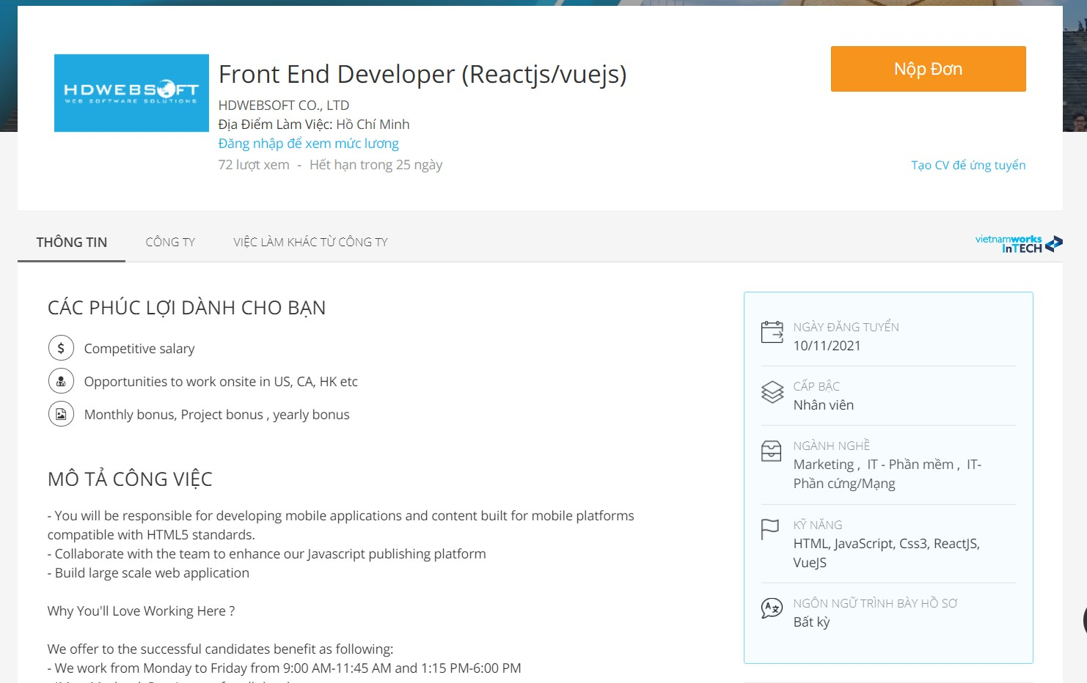

# Job description:

* The knowledge of basic web programming like HTML5, CSS3 and JavaScript to build mobile applications
* Capable of worming in group to improve JavaScript publishing platform
* Involving in big project web application

# Job requirement:

* Proficient in basic web programming as mentioned in the description
* Had done project using one or more JavaScript framework like Reactjs, Angularjs,Vuejs, jQuery,
* Working in IT fields for at least a year to be applicable.

# Plan:

The requirement for this position is knowledge in web programming in general which I’ve already known. Another skill that I do know a few about is Reactjs but I was taking like a gap year, so I have to review that one. Like I mentioned since I’ve already acquired the knowledge of basic web coding like HTML5, CSS3 and jQuery but still I know there will be a difficult journey for me to go. Further by attending RMIT which will benefit me in web programming and acquire the knowledge for this job. The next step is to study a JavaScript framework, and I will choose Reactjs since I have quite an interest for it after coding it. Another thing is I have to make a project out of it, yes, I’m talking about building a fully function website using React framework. I think I have to first ger an internship and then working for almost a year finally I think I would

be able to get an interview for this. Indeed, not all of this will get me this position without an interview so I think that’s all the step I could think of. I think the description for this is quite suitable for me since I do have.

# Personal Profile

**The results of an online Myers-Briggs test.**

<https://www.16personalities.com/articles/tactics-judging-vs-prospecting>

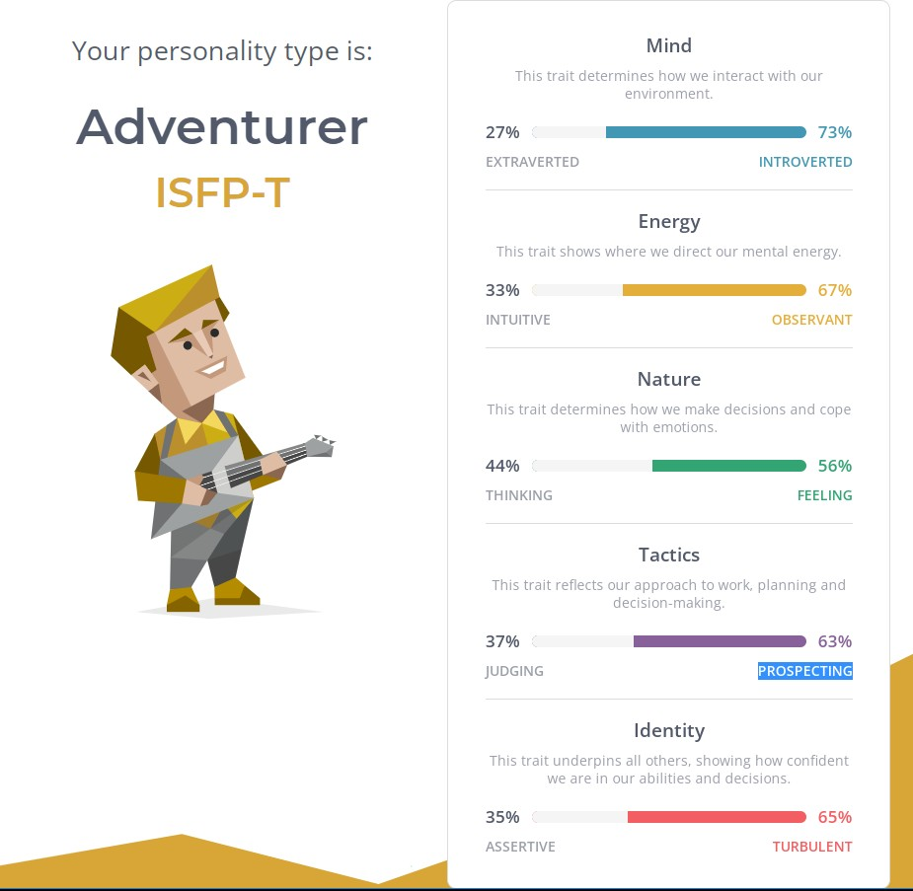

# The results of an online learning style test.

<http://www.educationplanner.org/students/self-assessments/learning-styles-quiz.shtml>



# The results of one further online test of your choosing.

<https://www.mindtools.com/pages/article/creativity-quiz.htm>

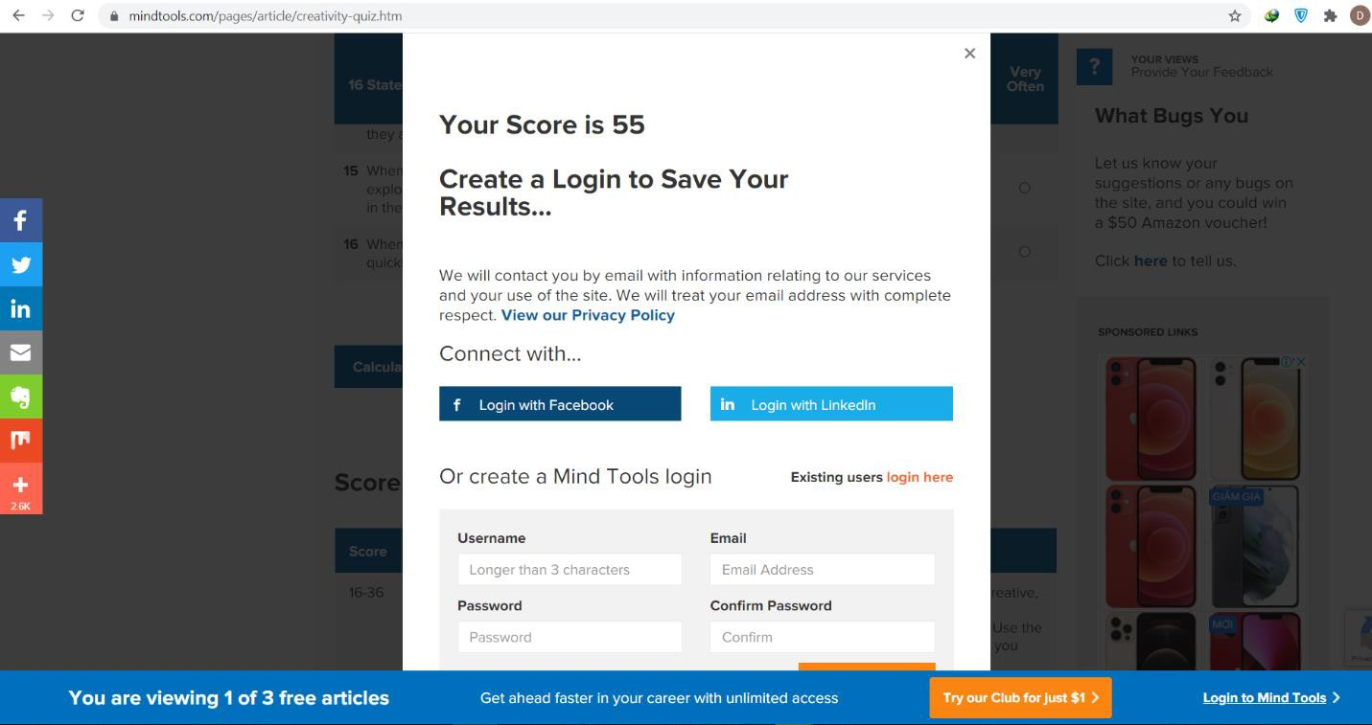

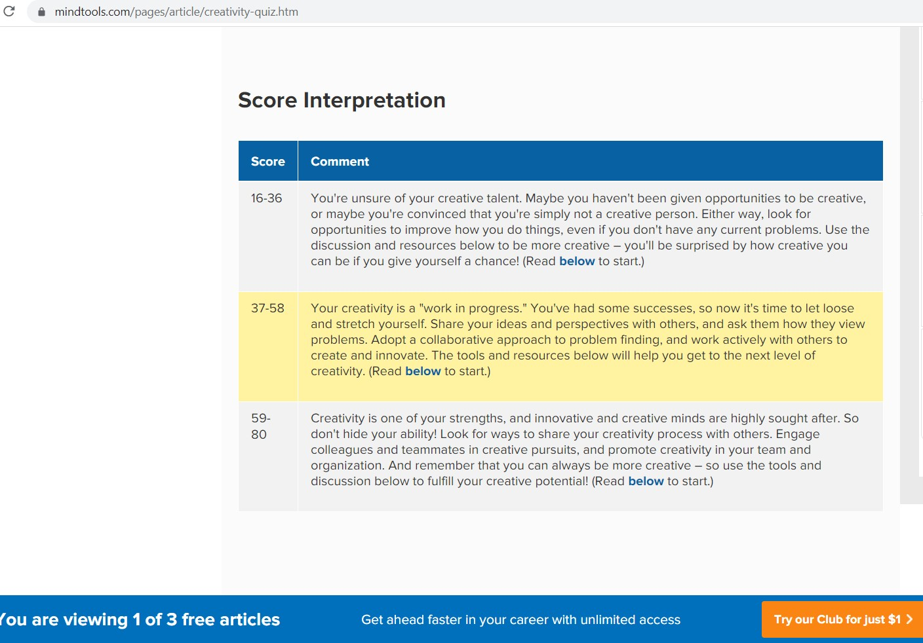

# What do the results of these tests mean for you?

I think the result delivered the purpose of the test. The 16personalities test states I am an adventurer which gave me insight about my personal characteristic like open minds, welcome new adventure, and grounded warm personality.

# How do you think these results may influence your behavior in a team?

Regarding the influence of result affect my behavior that in a way I think the test result suggest that what I should do with my personality like how I should react and interact with other members in a team.

# How should you take this into account when forming a team?

To me when being in a team everyone has their opinions, so it isn’t a big issue since the team is heading towards a common problem. Although the personalities may different, the idea and solution would be shared since that is what good teamwork all about.

# Overview:

In this project, I will create a simple game via Unity game engine. The reason I use this project to announce a game that I created since game to me is an enjoyable and relaxing activity I often do in my free time. Although I like playing strategy or action gameplay, this one is my first simple game that I can produce. It can be played on PC or mobile and web application.

However, I think I will make it as a PC application due to the game simplicity and easy to control. My game can be played by many users to compete by scores.

Motivation:

I think which make my game interesting is the simplicity of it and the most time-consuming part in which I like most, it will be later discussed in the description session. That part I think will make user who play interested since they would not know what is lied ahead and what is waiting for them after each level. Regarding the simple gameplay, I found it interesting because where it is easy to control, it’s also easy to fail. I will use the popular mobile game “Flappy bird” as an example where player has to carefully adjust the object movement without hitting the obstacles.

# Description:

I will start by setting my Unity game engine to sync with Visual Studio tool for C# implementation in order to code the game. The whole idea of how to play the game is that user will control a continually moving - cube where it is set gravitationally on a plat surface and then it must dodge the obstacle to reach the destination. Each level passing will become harder to overcome so the player has to try at best to get to the next level. It is designed harder and more complex level by level to make the game more addictive, however the length of the journey remains the same only the placement of obstacles is changed. There is also a scoring board to compete with other players. The score will be counted when the cube doges an obstacle and the last result appear when the level is finished. As regards to the control of the cube movement player only needs to use 2 keyboards, the “←” or “→” keyboard. The reason I made it with only 2 keyboards since the edges on the left and right is nothing meaning the cube can fall of the surface due to gravity, so if the player moves the cube far left or too much right force it will fall off. As I mentioned earlier, gravitational force is applied.

As I’ve already explained the feature and instruction of gameplay, I discus how I created it step by step. Firstly, I start off by creating a long plain surface for the cube to travel, it can be at any length at first since I can extend it later for more obstacle. Next, I will create my cube which is the key role of the game and set it to be stationary on the surface. Then I adjust the camera where the viewer sees there is a cube on an endless plain board facing toward the empty space which I will put in a score board later. Now that I have set up the basic, I will implement the movement with C# via Visual Studio. I will then make the make the camera to follow the cube as it moves forward. To make the game feel more realistic I also implement the collision between objects. For example, the travelling cube when it hits an object I will bounce to a side, either left or right direction. After I have achieved my logical of gameplay, I put a scoreboard to record the result of each player. Different maze of obstacles is also designed as mentioned above. I think this is part where I like most when I’m adjust the difficult of the game which I don’t even know I will finish it or not. Therefore, it interests me most. It is also the part which I spent time most, I have to redesign the maze over and over to make it passable level. After everything is done the only ting left is to publish the game which Unity gave me several options like via PC, Mobile or Web application.

# Tools and Technologies:

For the creation of this game, I used two tools, the first is Unity game engine and the other is Visual Studio. Regarding the Unity software it is very popular in creating games from PC to mostly mobile application. However, it is at first not a friendly – user interface where beginners can just jump right in. It uses most of graphical for user to visualized easily what is they working on. The game engine mainly uses 2D or 3D dimensions for users to create their objects on. User can use more features to make their games more realistic by adding “asset”.

# Skills Required:

The requirement in this project I think is that user has to know the basic of programming language C# and a good knowledge in Unity game engine since it isn’t easy to start off with. Another skill is required is the mathematics where I need to calculate the effect on my main object or the force impact on it. I use math in the game logic quite a lot of which equations were made to apply the force on the movement control. In addition, the knowledge of algebra is also needed since the game is worked on 2D and 3D dimensions.

# Outcome:

The reason I created the game out of creativity and passion purpose, it is also used to present this project so there on intention profiting from it. Therefore, I may suggest a few outcomes of my game like player will have a relaxing time with passionate gameplay. It is very convenient when it can be easily accessed whenever in free time since it isn’t a heavy game. Despite the fact that it isn’t much of a useful impact but the key thing I like to introduce is that it was also very easy to create make it such a good practice for beginners.