**Profile:**

My name is Pham Vo Dong and my student number is s3891968. You can contact me on the main email [phamvodong0811@gmail.com](mailto:phamvodong0811@gmail.com) or the optional email [s3891968@rmit.edu.vn](mailto:s3891968@rmit.edu.vn). I am a motivated Vietnamese student who can learn and receive new information using logical thinking. I graduated from high school in Vietnam with a 4.0 GPA, and mathematics and physics are my best subjects. I began learning English in sixth grade and am now fluent in both Vietnamese and English. Since grade 11, I've been studying information technology and competing in robotics competitions. For the time being, I am pursuing a Bachelor of Information Technology at RMIT, and in my spare time, I enjoy playing basketball and taking photographs. And the main reason why I choose to spend my time in IT is that in the current era, information technology plays an essential role in our lives, directly affecting personal daily activities that no one can ignore. In my opinion, the advancement of information technology makes a person's life better and more convenient. IT, for example, makes it easier for people to weather the storm of COVID-19 without difficulty because they can do everything online, which does not require face-to-face contact, such as shopping online, studying online, and working from home. Since I was a child, I've had a strong interest in technology. When my family got their first computer, I was introduced to a new world where I expanded my knowledge of technology. As a result, it piqued my interest. Through my high school robotics club, I decided to participate in some competitions and make some small projects, such as automatic watering systems, light bulbs, and balance cars. In addition, I have worked as a graphic designer since I was in high school and I know Python, HTML. Therefore, I expect to learn the skills necessary to manage an IT project and bring my fantastic idea to fruition after finishing my studies.

**Ideal Job:**

* My ideal job is Ai engineer. The link: [https://www.vietnamworks.com/ai-engineerartificial-intelligence-1-1434129-](https://www.vietnamworks.com/ai-engineer-artificial-intelligence-1-1434129-jv/?source=searchResults&searchType=2&placement=1434130&sortBy=date&source=searchResults&searchType=2&placement=1431510&sortBy=date&utm_source=vnw_homepage&utm_medium=HotCategories&ignoreLocation=true)

[jv/?source=searchResults&searchType=2&placement=1434130&sortBy=date&sourc e=searchResults&searchType=2&placement=1431510&sortBy=date&utm_source=vn w_homepage&utm_medium=HotCategories&ignoreLocation=true](https://www.vietnamworks.com/ai-engineer-artificial-intelligence-1-1434129-jv/?source=searchResults&searchType=2&placement=1434130&sortBy=date&source=searchResults&searchType=2&placement=1431510&sortBy=date&utm_source=vnw_homepage&utm_medium=HotCategories&ignoreLocation=true) (Vietnam works,

2021)

* This job appeals to me because I can work closely with a team of technicians in Artificial Intelligence (AI) algorithms. I also have a chance to communicate directly with global customers to provide solutions, design, implementation, and validate the proposed AI data.
* The requirements for jobs:
  + Machine learning, Python, MATLAB, C++, Java
  + Degrees in Computer Science, Engineering, Information Systems, Computer

Engineering, Mathematics, Statistics

* + Having experience in one or more areas of AI
  + Working knowledge of one or more deep learning frameworks (TensorFlow, Caffe,

Theano, PyTorch)

* + Hands-on technical experience in system integration
  + Strong English communication skills and documentation skills, adaptability, and a team player.
* Currently, I am satisfied with my language skills in Python and C++. Moreover, I am a hard-working person who is appropriate for every environment and works well. In high school, the average mathematics and physics score is above 9.0, with a 4.0 GPA. Studying in an international environment allows me to interact fluently with multinational co-workers and employers. Furthermore, my high school team received a consolation prize from an IoT competition for high school students about balancing cars.
* The plan through which I will get the necessary abilities, credentials, and experience for this role has two phases: short-term and long-term. I plan to complete my degrees and certifications in machine learning, Java, MATLAB, and computer science which will be received when I finish sophomore year. This will be a certification of LinkedIn some extra classes of IBM, Cognitive Class of machine learning, and learning more about AI of DeepLearning.AI. In the long run, increasing my English communication abilities and learning another language would be beneficial which will be advanced throughout the RMIT learning process.

**Personal Profile:**

**Myers-Briggs test**:

<https://www.16personalities.com/enfj-personality> (16personalities, 2021)

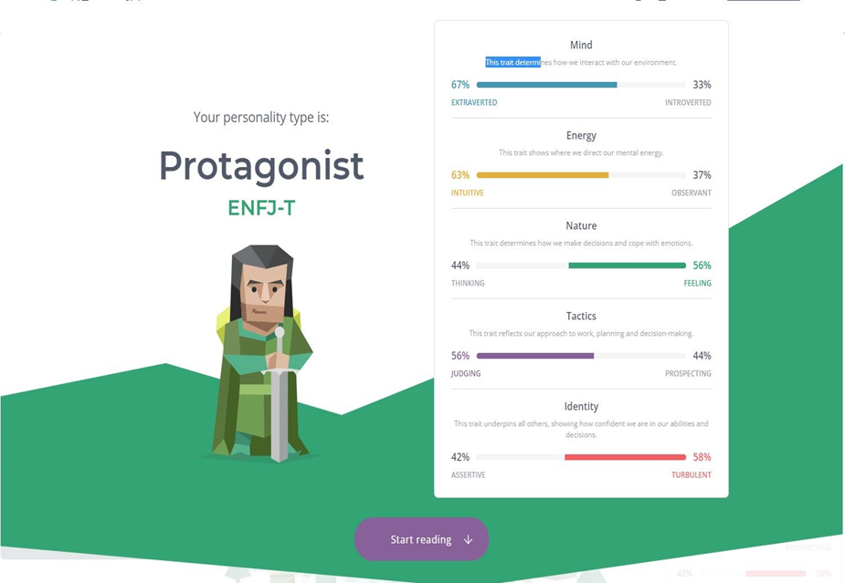

**learning style test:**

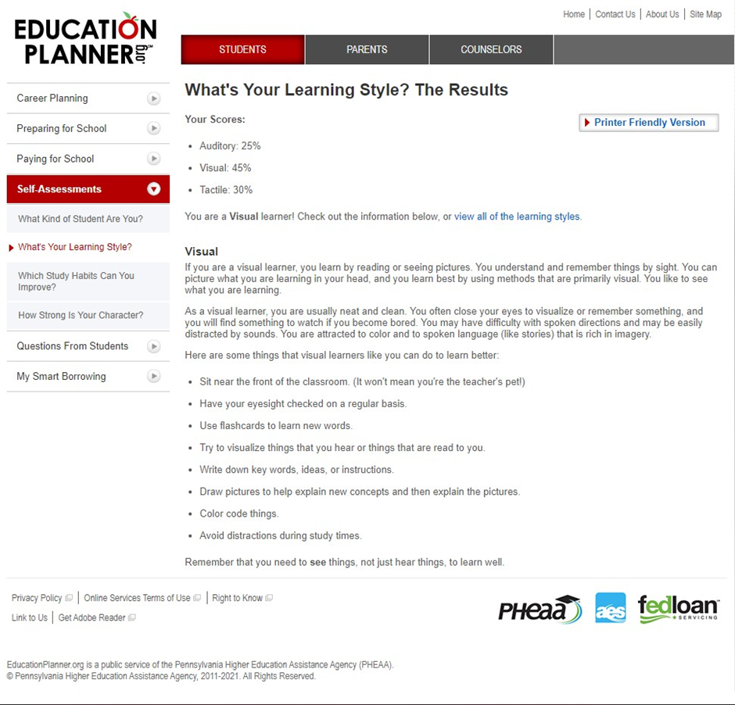

[http://www.educationplanner.org/students/self-assessments/learning-stylesquiz.shtml?event=results&A=5&V=9&T=6](http://www.educationplanner.org/students/self-assessments/learning-styles-quiz.shtml?event=results&A=5&V=9&T=6) (Education Planner.org, 2021)

**Creative style:**

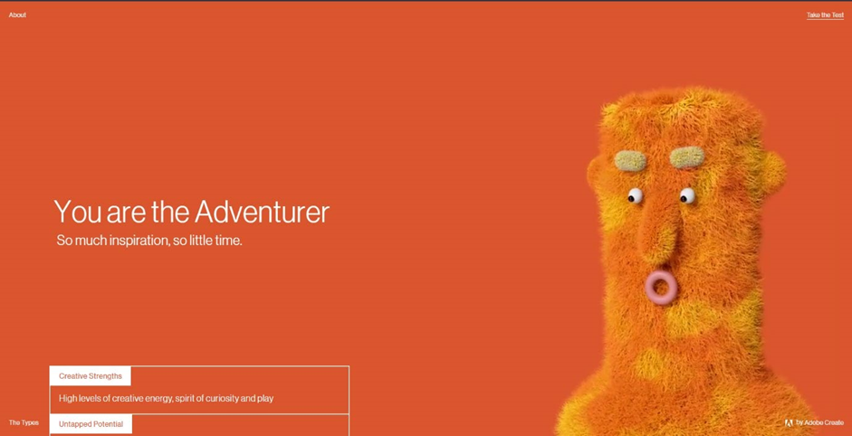

<https://mycreativetype.com/share/adventurer/> [(Creative Types by Adobe Create,](https://mycreativetype.com/) 2021)

* These tests show that I am an extrovert person, and I could become a potential leader. I will take on well my position as a header of the team with my helpful skill such as idealistic, charismatic, creative, social which leads me and my teammate to reach success. Moreover, I create a better environment that is the most comfortable to make them feel not just motivated but also inspired. Every people in my team will help a good chance to perform their strongest skill to join hand my the project successful.