**Personal Information**

* Name: Mai Chi Nghi
* Student Number: s3864219
* E-mail: s3864219@rmit.edu.vn

I am living in Binh Duong, Vietnam, and I graduated from my 12 years of school 2 years ago so that I can communicate with everyone in two languages: Vietnamese and English. I started to study at RMIT University in 2019. I am studying an English course to get a Bachelor of Information Technology for now. Besides that, I already joined the Flag Football Club (FFC) as a member at university and when I have free time I play games, along with going to coffee shops with my friends.

**Ideal job**

* My ideal job is as a security engineer. Including the link below: <https://itviec.com/> (Seek, 2021).

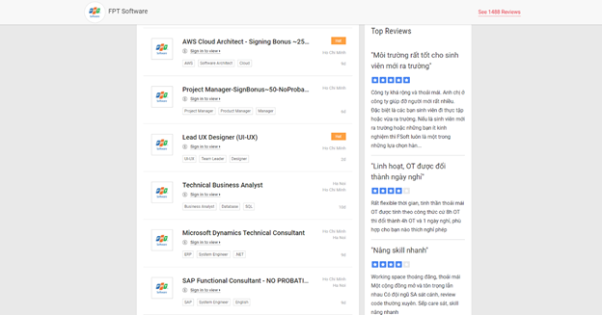

* The role of this position is that people have to do teamwork and have the responsibility, highly concentrated, that helps us manage time better and work more flexibly when working together.
* The security engineer requires:
  + High concentrate
  + Be carefully
  + Following step by step
* From my current experience, qualifications and skills are careful at work when I work on the team by checking after each step that my teammate did the deadline, which takes me 3 years or more. This knowledge will help us fix many problems, which we have to confront during group work. Due diligence makes it possible for me to see each member’s issue in the team, then each person has to give suggestions on the solution and explain why they have those issues to learn from and improve their skills to work better in the future.
* My plan to obtain this position, that I need to learn more new knowledge and get experience from my teachers and friends at RMIT University. Besides that, I will improve my English communication skills, understanding ability and listening or reading my feedback from my friends or teachers, which support my job in the future.

**Interest in IT**

In this day and age, the world is growing faster and faster. Technology has entered and influenced our daily lives in many different ways, so it is fair to say that IT has made our lives less difficult. In this day and age, we can do online shopping, study online, and work online. People can do those things through smartphones or computers and laptops. Since 2020, my friends and I have studied IT online because of COVID-19, but in fewer weeks we have to come back to school face-to-face, which helps us more and more and more develop teamwork skills. So I decided to add more knowledge for myself which will help me in the future.

The reason I chose RMIT, led to my visit to RMIT University when I studied in high school. I have signed up to reserve my seat for the Bachelor of IT at the same time. That makes me decide to study at RMIT and I am happy to enjoy and take this attempt.

During this term, my goal is to face many new challenges and create new relationships. The important thing is to pass assignments for this semester. Those things are also my target in my studies at RMIT.