RMIT Vietnam School of Science and Technology

COSC2083

Assignment 1:

My Profile

Lecturer: Mr. Long Nguyen Minh

**Student name:** Le Anh Quan

**Student ID:** s3877457

**1/Personal Information**

Name: Le Anh Quan

Student number: s3877457

Email: [s3877457@rmit.edu.vn](mailto:s3877457@rmit.edu.vn)

Background Information: I was born in Ninh Hoa, a small district near Nha Trang city. My parents were very open minded and allow me to find my path on my own. They had first aim for me to be a doctor but after they discover my hobby in programming, they let me study for programming jobs instead. I choose software engineer as my RMIT major because I think it would help me develop my programming skill and help me make use of my English. I am quite an introvert but I am trying to improve myself to work better with my teammates. My dream is to be able to get a well-paying job so I can help provide for my parents when they get older. I like to play video games in my free time, and one of my favorite things to do with games is to mess with the code or the value of the game to break the game balance, that is what got me into software programming.

**2/ Interest in IT**

I am very interested in coding. it has been my passion since I was a kid. My interest in IT as an interest in coding, when I was around 10, my dad showed me that I can modify a number game’s code to make a character’s power 100 time more than what it originally was. That simple action sparks my interest in coding, I am mesmerized by the way every line of code impacts the program in some way and if you change one line of code or even a number, the program may cease to run. Since then, I made it my goal to get into a good college with a degree that will help me in programming.

When I got older and able to do more research, I choose IT as my major because of it just started to bloom in Vietnam, IT have the potential to explode when I graduate and I think I have qualities that are fit for IT such as focus, commitment and a willingness to change and adapt. I choose RMIT as the place to study in because of its international presence, internal environment and its great facilities and specialization in IT. It also helps that my sister is a RMIT graduate at that time and she was able to get a good job thanks to RMIT job finding support service. Even though she studied business it helps convince my parents of the opportunities that RMIT will be able to give me in the future if I graduate.

When I study in RMIT I expect to learn all the knowledge require to step into the IT field, I also want to use the general elective to learn more about the other branch of computer related majors such as robotics and software engineering. Since I know that RMIT gives their student free linkdn learning account I want to use it to study from professional all over the world. Finally, I want to make friends and relationships through group work and clubs since it can help me a lot in the future since programmers usually work as a team rather than alone.

**3/ Ideal Job**

Link: <https://www.vietnamworks.com/fresher-java-1-1436391-jv/?source=searchResults&searchType=2&placement=1436392&sortBy=date>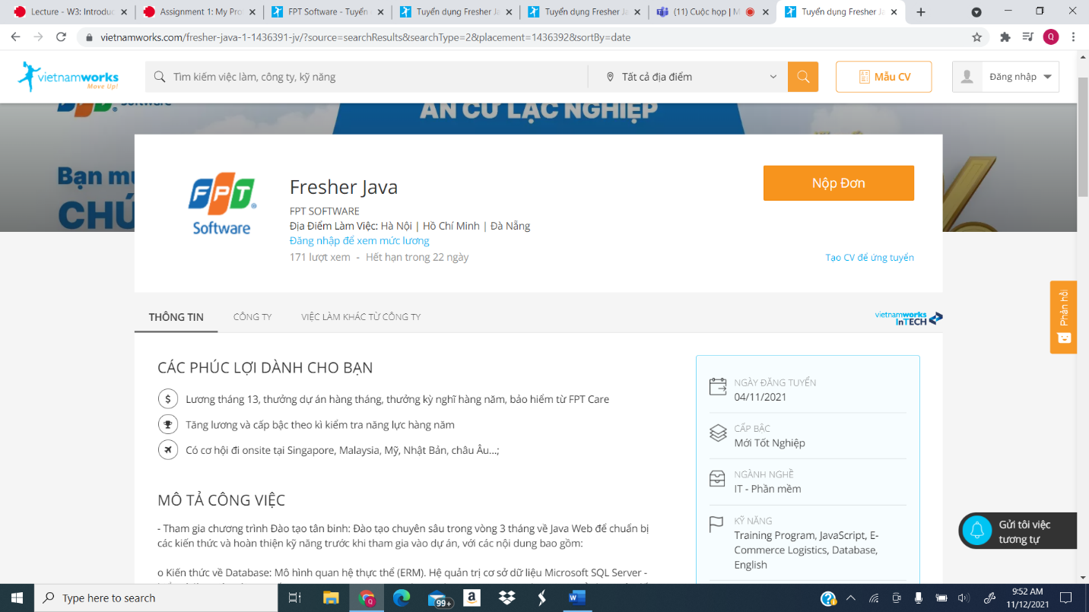

**Job description:**

- Participating in the Rookie Training program: Intensive training for 3 months on Java Web to prepare knowledge and perfect skills before participating in the project, with the following contents:

- Knowledge of Database: Entity Relational Model (ERM). Microsoft SQL Server database management system - understand and work with SQL queries: T-SQL Statements, Advanced DML, SQL Join, Index, View., using advanced Database Objects: Transactions, Stored Procedure, User Defined Function, Trigger.

- Java Web Programming: Java Core – Java SE 8 (Basic concepts: control-flow, keyword…Classes and Objects; OOP; String, static, Collections, Java IO, Concurrency, Lambda Expressions, Exceptions; JDBC); Web design with HTML5/ CSS3/ Bootstrap 4, JS, jQuery, AJAX. JSP/Servlet Basics, Exception Handling, MVC Pattern; Hibernate (Configuration; Hibernate Mapping; Queries and Criteria; Performance; Stored Procedure); Proficient in using Spring Framework (Spring core: Spring MVC; XML, Javabase, Annotation; Spring Data JPA; Spring); Build Tools: Maven, Gradle.

- Software development according to professional process: Understand the project implementation steps, including application design, GUI making, code design, Code Review implementation (using StyleCop, FXCop), Unit Test (Nunit), Project quality check. Practice coding skills in projects with technology experts & experienced programmers.

- English: Participate in 90-120 minutes training every day on communicating English with foreign teachers or practice grammar and vocabulary according to the TOEIC test structure.

- Opportunity to participate and become a "key member" in FPT Software's big projects in the fields of: E-commerce, Logistics, Aviation, Healthcare... with modern technology of Web, Cloud/AWS…and a team of experienced professionals.

**Reason of interested:**

* A chance to work in one of the top IT companies in Vietnam
* Chance for sponsor for further education
* Opportunities to work with professionals and big clients from Europe and the US
* Good benefits and chances of further promotions.

**Job requirement:**

- Are students who have / are about to graduate majoring in Information Technology, Mathematics, Computer Science, Software Engineering, Electronics and Telecommunications… or related majors.

- Basic knowledge of Object-Oriented Programming and Java.

- Can participate in training / work Full-time from Monday - Friday.

- Eager to learn, enthusiastic, ready to face difficult challenges in big software projects. Have discipline & be responsible for work.

- Preference will be given to candidates with good English reading and comprehension skills.

**Skill currently has:**

- Basic knowledge of Object-Oriented Programming and Java.

-Good English reading and comprehension skills- have an 8.0 IELT.

-Have skills in other branches of programming.

-1-year worth of RMIT experience.

- Discipline and time-management skill

**Plan:**

-Finish my RMIT course and get my degree (4 years)

-Study more programming languages, especially object-oriented ones. (in RMIT and up to 1 year after graduation)

-Join workshops to work on soft skills, more specifically communication skills. (in RMIT and up to 1 year after graduation)

**4/ Personal Profile:**

**Myers-Briggs test**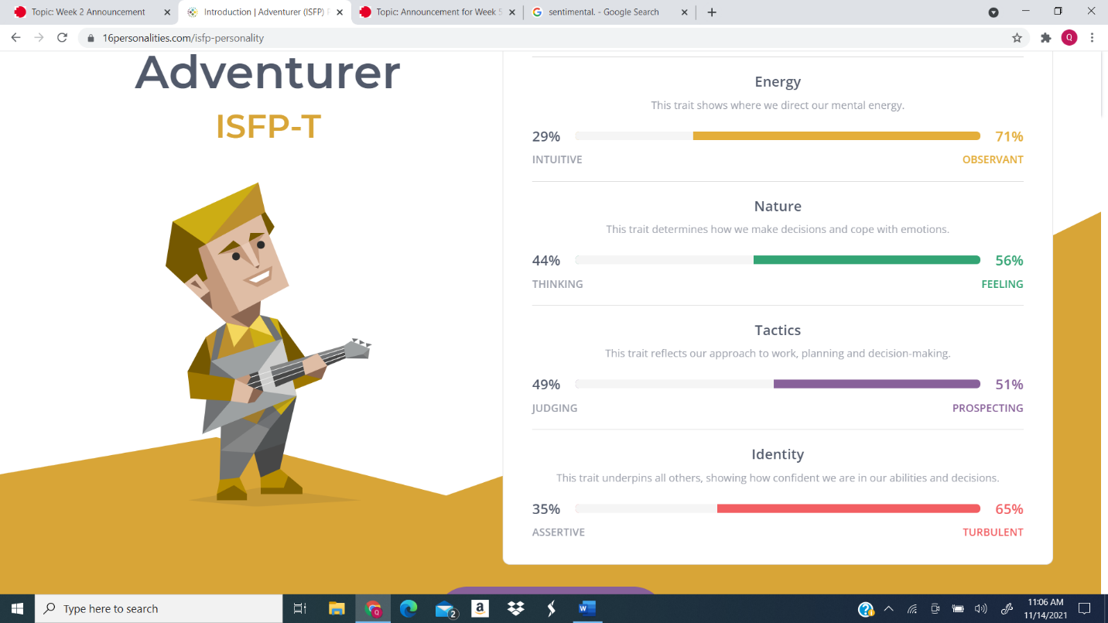

**Learning style test**

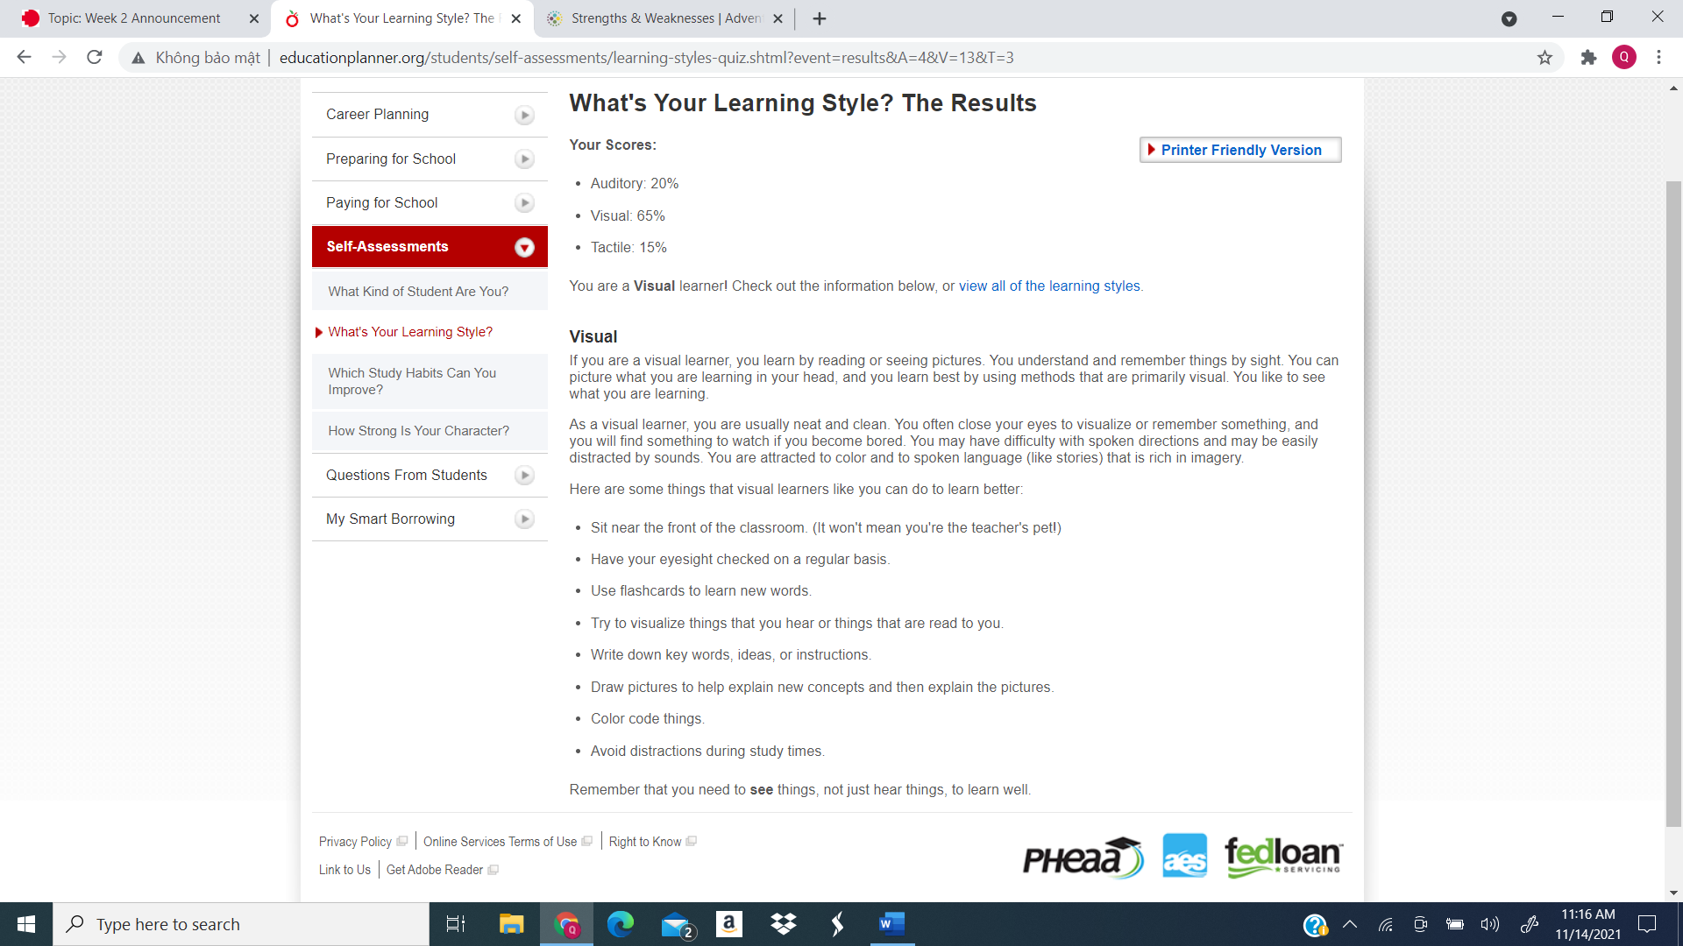

**5 big personalities test**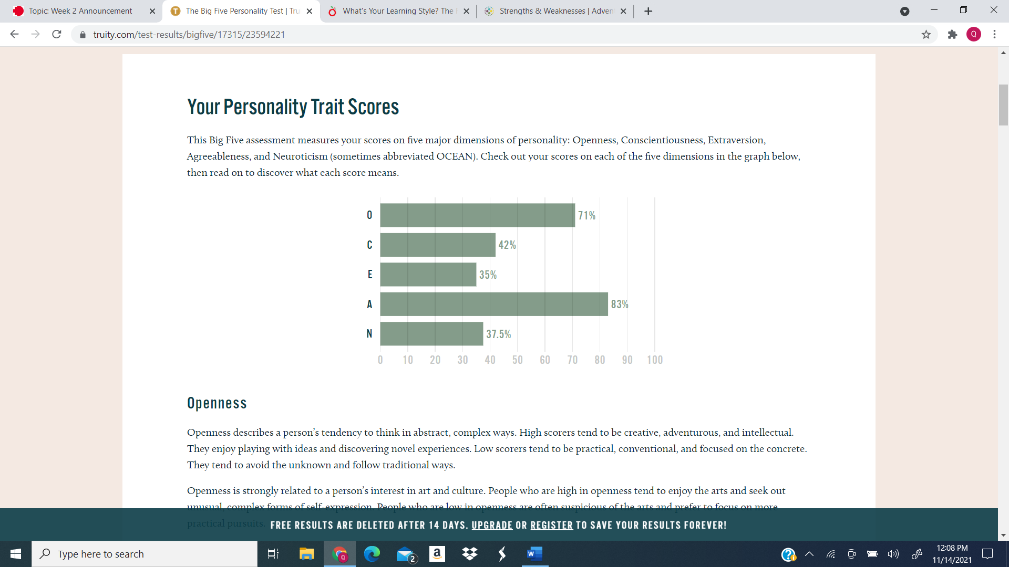

These tests give me information about my personalities, strengths and weaknesses and my preferred learning style. After answering the questions, I can see some of my traits being correct with the traits shown. While these tests may not be entirely correct and the result may change over time as I develop, they give me a good base line so I can start working on myself. These tests shows that I am creative and observant, which means I am fit to be someone who brainstorm ideas for the team. The test also shown that I am a highly introverted person, that mean I shouldn’t be a first choice if we need a spokesperson for the group and I need to work on my presentation skills and communication skills. When forming a team, I should find people who cover my weaknesses so that we can cover more areas, but I also can’t let my weaknesses stop me from trying new position of taking a role that is missing in the team.

**5/ Project Ideas:**

***Overview:***I have always wanted to create a game of my own when I was young. And with the existence of tools such as Unity making a game is getting easier every day. For my project I want to create a game, more specifically a rogue-lite game. The game will be make using Unity as it is a well-known tool for game developers especially for those who want to make 2d games. After I make the game, I would like to monetize it on steam because it is a very famous platform and it will help me attract attention and if I am lucky opportunity.

***Motivation:*** [1] According to estimates, there were over 1.5 billion video gamers in Asia Pacific in 2020, generating a combined revenue of 78.3 billion U.S. dollars. This combine with the fact that indie games are getting more recognition with some of them winning prizes inspire me to make a game of my own. I also pick rogue-lite as the genre of the game I make because it is one of my favorite genres of games and it randomize nature allow me to make addictive games with high replay value with limited resource. Rogue-lite when done right can go a long way as the winner of the 2021 Game Developer Choice Awards is a rogue-lite.

***Description:*** Some features are not finalized but this is what I currently picture my game to be:

1/Concept: I already want my game to be an action rogue-lite because this type of game requires many user inputs since actions happens in real time. This will cause the player to be more engage in the game and the fast-pace of action games will keep players excited and entertain.

2/ Mechanics: Mechanics keeps the game interesting and make them more unique. This part is subjects to change as time went on but I want my game is one where the character can collect treasures that have simple abilities but when combine with abilities of other treasure can create powerful synergies.

3/ Story: A good story help make the player feel more immerse and keep the player interest in the game, at this moment the story is not decided but I want it to be a light-hearted story where the player can laugh while reading it.

4/ Graphic: The game will be a 3d game since 3d games nowadays are easier to create thanks to tools being more automated. 3d game also allow freedom of movement and more detailed and beautiful graphic.

5/ Customization: The game will allow customization in the form of the player can make their character unique by changing their traits to make their own avatar, the customization also come in the form of abilities. Like I said in the mechanic section one of the mechanics that I want to be in the game, abilities start small and basic but when combine with other abilities allow the characters to become much stronger. The abilities will also work like a puzzle piece in which one ability when combine with different ability will give out different results.

6/ Randomization: One of the basics of rogue-lite, the place you appear at, the items you collect, the enemies you face and even the boss will be chosen randomly. This create endless combinations of the game’s elements which will allow every run will be different from the last. The game will have high replay value with limited resources and even after you complete the game, you can always come back, click the play button and get a new experience.

7/ Additional content: After the games is finished, I will continue to work on the game, fixing bugs while making new content for it such as new items, new levels and even new mechanics. This will allow the game to continue to develop past its completion date and will make the game more complex and fun.

***Tools and Technologies:*** These are the tools I will need to create the game:

-Unity, one of the best game making tools in the world. Unity contains many tools to help new game designers like me to create good 3d games. It also contains other tools to help me through many steps in making the game.

-C++ for programming. The game runs on codes, so it would be natural to learn to code since every line of code impact the game in some way, this will also help in bug fixing later on.

-Art designing tools like adobe to create assets for the game since the game will need to look good.

***Skills Required:*** These are the skill I need to be working on to help with my game:

-Learn to use Unity, this is the most important step and it can help the game making process later on if I can master Unity basic and advance tools.

-Learn to code in C++ so the game can actually run.

-Practice drawing in adobe to design elements of the game.

-Practice problem solving skills and planning because it will be helpful when making the game.

-Good communication skills to that I can work well with others in my team.

***Outcome:***After the game is complete, I will put it for sale on Steam. I will earn money from the player that bought the games and from players review I will start to polish the game by fixing bug, make the design more detail and working on additional content. After that, I will start to look for opportunities, either by looking for ideas for a new game or adding the game into my CV to help me in the future.

**Reference:**

[1] Number of active video gamers worldwide from 2015 to 2023(in billions), J. Clement, Jun 1, 2021, link: <https://www.statista.com/statistics/748044/number-video-gamers-world/>