

**Lecturer**: Dr. Long Nguyen Minh

**Group:** 26

**Team members**:

Pham Vo Dong – s3891968

Bui Quang Thanh Dat – s3927551

Mai Chi Nghi – s3864219

Le Anh Quan – s3877457

**Date**:

**COSC2083 – Intro to IT**

**OUR IT PROJECT**

Table of Contents

**A.** **Team Profile:** 3

❖ **Team name: DDQN** 3

❖ **Personal information:** 3

**Pham Vo Dong - s3891968:** 3

**Bui Quang Thanh Dat - s3927551:** 4

**Mai Chi Nghi - s3864219:** 4

**Le Anh Quan - s3877457:** 5

❖ **Team Profile:** 6

**Pham Vo Dong** 6

**Bui Quang Thanh Dat** 8

**Mai Chi Nghi** 10

**Le Anh Quan** 11

❖ **Group processes:** 12

❖ **Career Plans:** 13

**B.** **Tools:** 13

**C.** **Project Description:** 14

❖ **Overview:** 14

• **Topic:** 14

• **Motivation:** 14

• **Landscape:** 15

❖ **Detailed Description:** 16

• **Aims:** 16

• **Plans and Progress:** 16

• **Roles:** 18

• **Scope and Limits** 19

• **Tools and Technologies:** 20

• **Testing:** 20

• **Timeframe:** 21

• **Risks:** 23

• **Group processes and communications:** 23

**D.** **Skills and Jobs:** 24

**E.** **Group Reflection:** 25

**1.** **Group:** 25

**2.** **Dat:** 26

**3.** **Dong:** 26

**4.** **Quan:** 27

**5.** **Nghi:** 27

F. Appendix: 27

**OUR IT PROJECT**

# **Team Profile:**

## **Team name: DDQN**

This name represents the team's spirit, which shows all the expectations and the interest in the IT World. These letters take from the first letter of an individual member's name that shows each person is a piece of the puzzle indispensable in the team.

## **Personal information:**

### **Pham Vo Dong - s3891968:**

My name is Pham Vo Dong, and my student number is s3891968. You may reach me at phamvodong0811@gmail.com or s3891968@rmit.edu.vn, which is my primary email. I am a dedicated Vietnamese student who uses logical thinking to study and comprehend new things. I received a 4.0 GPA in high school in Vietnam, and my strongest subjects were mathematics and physics. I started learning English when I was in sixth grade and am now bilingual (Vietnamese and English). I've been studying information technology and competing in robots contests since I was in eighth school.

I am now doing a Bachelor of Information Technology at RMIT, and I like playing basketball and shooting photography in my leisure time. And the main reason I chose to spend my time in IT is that in today's world, information technology plays such an important role in our lives, affecting our daily activities in such a way that no one can ignore it. Information technology advancements, in my opinion, make a person's life better and more convenient. IT, for example, makes it simpler for individuals to weather the COVID-19 storm since they can do things online that doesn't require face-to-face interaction, such as shopping, learning, and working from home. I've had a great interest in technology since I was a youngster. When my family received their first computer, it opened up a whole new world for me, and I was able to enhance my technological expertise. It aroused my curiosity as a consequence. I competed in various tournaments and built some minor projects, such as autonomous watering systems, light bulbs, and balancing vehicles, through my high school robotics club. In addition, I've worked as a graphic designer since high school and am proficient in Python and HTML. As a result, I anticipate learning the skills required to manage an IT project and bringing my brilliant concept to life after completing my studies.

### **Bui Quang Thanh Dat - s3927551:**

I am originally from Vietnam, and Hue is my hometown. A fun fact about me is that, despite the fact that my father is from the Central – area, I still have a Southern accent. I believe this is because he spent a long time settling in the South, and my mother is from the South. I'm addressing this since a handful of my friends or new acquaintances often mistook my accent for something different, such as a mixed accent. I am bilingual (Vietnamese and English).

I'm fascinated by technology in general, which is why I selected this subject in the first place. I have to say that games are my main passion in IT. I've known about it since I was in elementary school and first engaged with it. The game was started by my brother. I recall watching him perform and feeling that it was a mind-opening experience. I thought it was intriguing at the time, and everything about the game was so thrilling and addicting; the game is called StarCraft, and after playing it, I dreamed of becoming a game producer. However, I did not find designing games to be as entertaining as playing them throughout my studies. I prefer to play games than create them, so I changed my major to RMIT. I anticipate gaining a great deal of information and a broad understanding of IT.

### **Mai Chi Nghi - s3864219:**

I was born and raised in Binh Duong, Vietnam, and graduated from high school two years ago with the ability to speak in two languages: Vietnamese and English. In 2019, I began my studies at RMIT University. I'm pursuing a bachelor’s in information technology by taking an English course. Aside from that, I am a member of the Flag Football Club (FFC) at university, and in my spare time, I enjoy playing video games and going to coffee shops with my friends. The globe is expanding at a breakneck speed these days. In many ways, technology has infiltrated and affected our everyday lives, thus it's reasonable to claim that IT has made our lives easier. We may now buy, learn, and work all from the comfort of our own homes. Smartphones, PCs, and laptops can be used to carry out these tasks. Because of COVID-19, my friends and I have been studying IT online since 2020, but we have to return to school face-to-face in less weeks, which helps us improve teamwork skills more and more. As a result, I made the decision to expand my education in order to benefit myself in the future.

### **Le Anh Quan - s3877457:**

Ninh Hoa, a little hamlet near Nha Trang, is where I was born. My parents were very accepting of me and let me choose my own route. They wanted me to be a doctor at first, but after learning about my programming passion, they decided to let me study for programming positions instead. I picked software engineering as my RMIT major because I believe it will allow me to further enhance my programming skills while also allowing me to practice my English. I'm an introvert, but I'm working on improving myself so that I can work better with my co-workers.

My ambition is to find a well-paying career so that I can assist support my aging parents. In my spare time, I enjoy playing video games, and one of my favorite things to do with them is to tamper with the code or the game's value in order to disrupt the game's balance; this is what first drew me to software engineering. When I was older and had more time to explore, I decided on IT as my major because it was just getting started in Vietnam. When I graduate, I believe IT will explode, and I believe I possess attributes that are appropriate for IT, such as attention, devotion, and a readiness to learn and adapt. Because to its worldwide presence, internal climate, outstanding facilities, and expertise in IT, I picked RMIT to study. It also helped that my sister was an RMIT graduate at the time, and she was able to get work owing to the RMIT job placement program. Despite the fact that she studied business, she was able to persuade my parents of the benefits RMIT will provide me in the future.

## **Team Profile:**

### **Pham Vo Dong**

#### **Myers-Briggs test:**

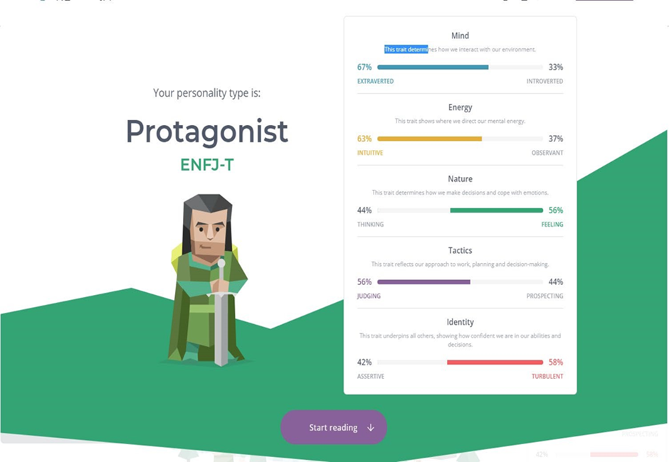

[**https://www.16personalities.com/enfj-personality**](https://www.16personalities.com/enfj-personality) **(16personalities, 2021)**

#### **Learning style test:**

****[http://www.educationplanner.org/students/self-assessments/learning-stylesquiz.shtml?event=results&A=5&V=9&T=6](http://www.educationplanner.org/students/self-assessments/learning-styles-quiz.shtml?event=results&A=5&V=9&T=6) (Education Planner.org, 2021)

#### **Creative style:**

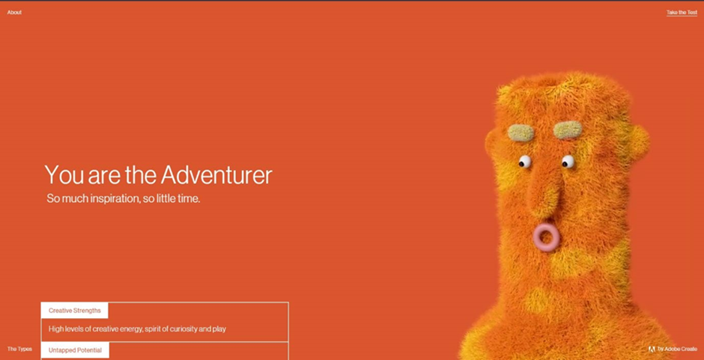<https://mycreativetype.com/share/adventurer/> [(](https://mycreativetype.com/)Creative Types by Adobe Create[,](https://mycreativetype.com/) 2021)

* These tests show that I am an extrovert, and I could become a potential leader. I will take on my position as a team leader with valuable skills such as idealistic, charismatic, creative, and social, which leads my teammate and me to success. Moreover, I create a better environment that is the most comfortable, making them feel motivated and inspired. Every person in my team will have an excellent chance to perform their most vital skill to join and complete the project successful

### **Bui Quang Thanh Dat**

#### **The results of an online Myers-Briggs test:**

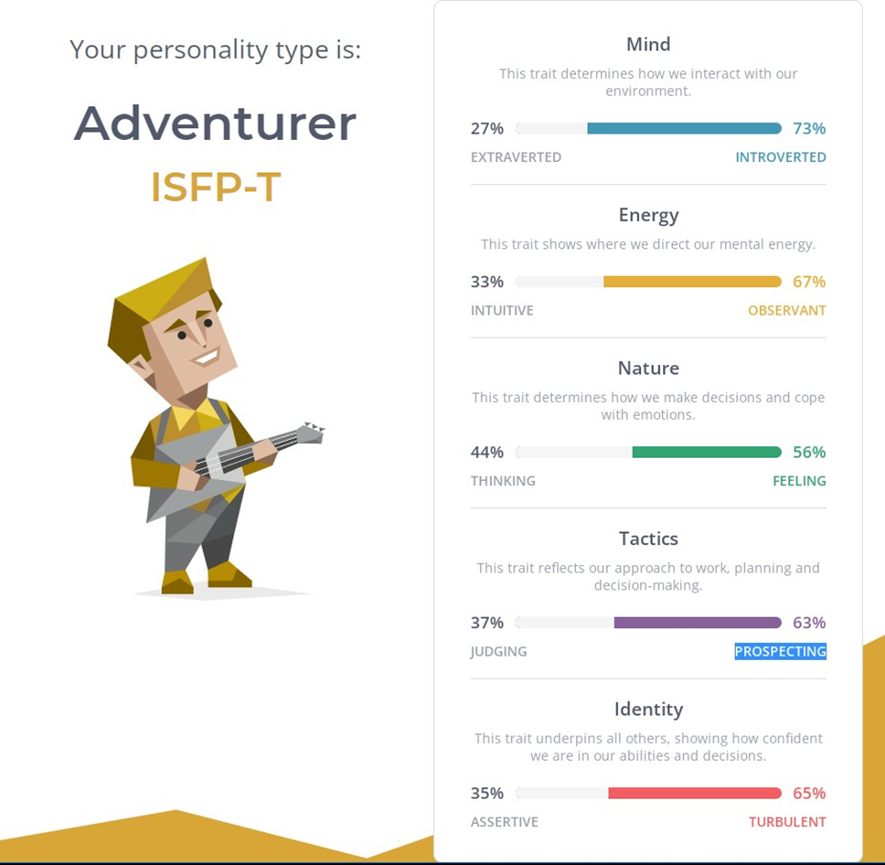

[**https://www.16personalities.com/articles/tactics-judging-vs-prospecting**](https://www.16personalities.com/articles/tactics-judging-vs-prospecting)

The results of an online learning style test:



[**http://www.educationplanner.org/students/self-assessments/learning-styles-quiz.shtml**](http://www.educationplanner.org/students/self-assessments/learning-styles-quiz.shtml)

#### **The results of one further online test of your choosing:**

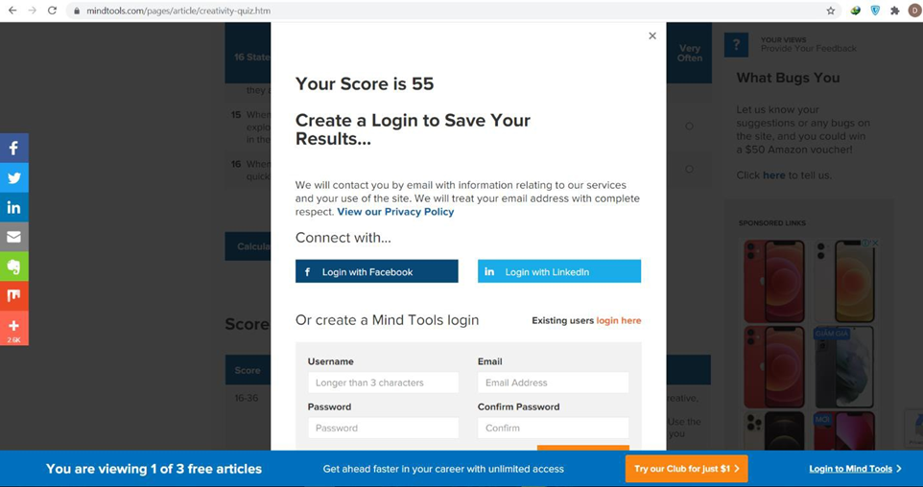

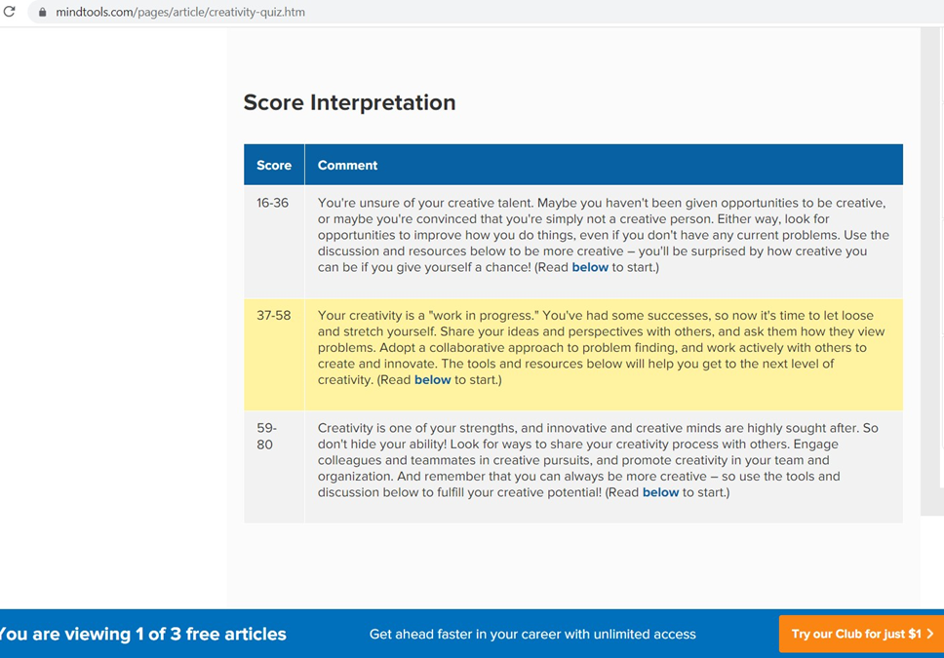

[**https://www.mindtools.com/pages/article/creativity-quiz.htm**](https://www.mindtools.com/pages/article/creativity-quiz.htm)

* I believe the outcome met the test's objectives. According to the 16personalities test, I am an adventurer, who revealed qualities such as open minds, a desire for new experiences, and a grounded, warm personality. In terms of the test result's impact on my behaviour, I believe it advises what I should do with my character, such as how I should behave and engage with other team members. When you're in a group, everyone has an opinion, therefore it's not a huge deal because the team is working on a common problem. and the personalities may make sharing the concept and solution difficult.

### **Mai Chi Nghi**

#### **Humanmetrics Jung Typology Test:**

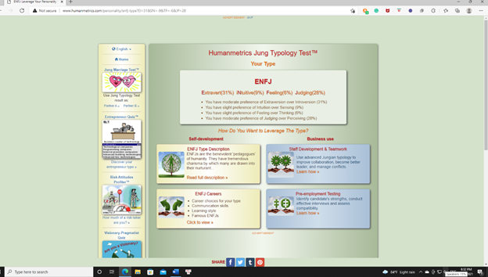

<http://www.humanmetrics.com/personality> (Humanmetrics Jung Typology Test, 2021)

#### **Learning style test:**

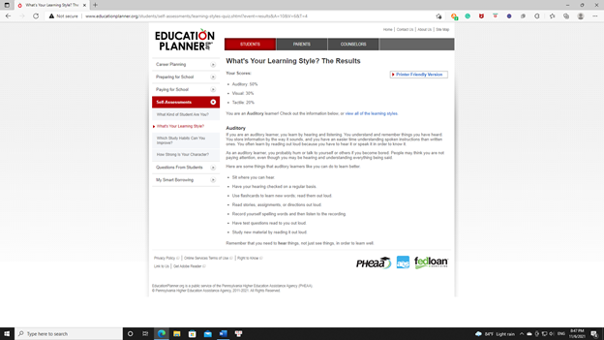

<http://www.educationplanner.org/students/self-assessments/learning-styles-quiz.shtml> (Education Planner.org, 2021)

#### **Personality Test:**

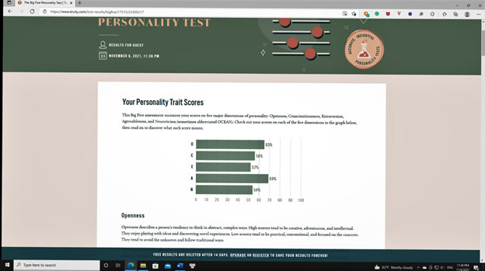  
<https://www.truity.com/test/type-finder-personality-test-new> (Personality Test, 2021)

* Based on those findings, I'll introduce myself and assist those who wish to work on a team with me, allowing everyone to connect and learn about one another and encouraging me to work well together in the future.

### **Le Anh Quan**

#### **Myers-Briggs test:**

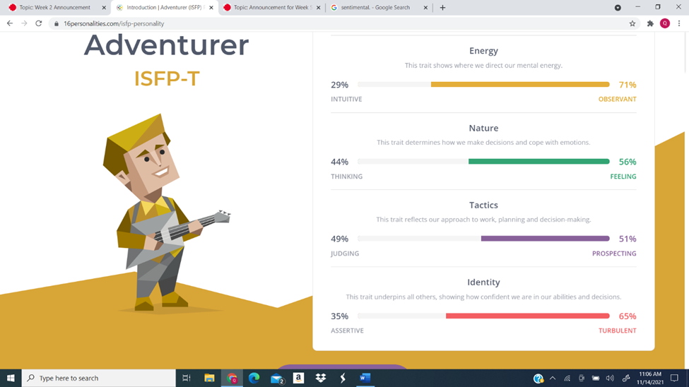

#### **Learning style test:**

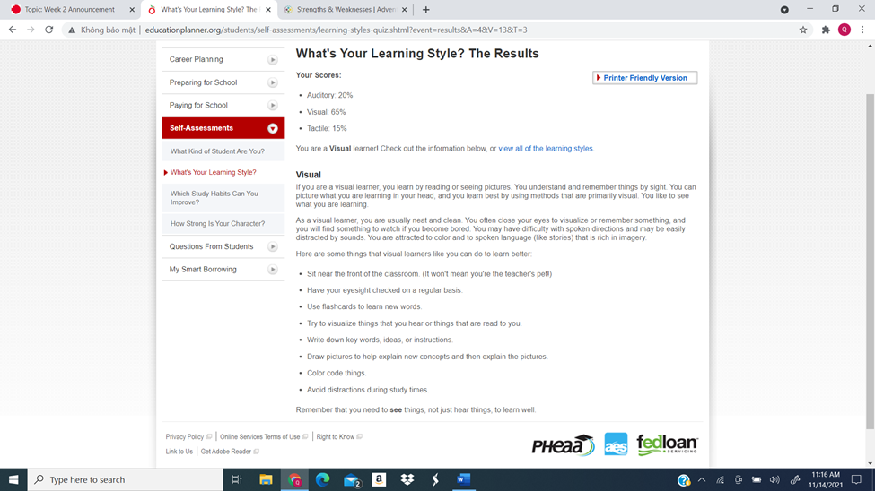

#### **5 big personalities test:**

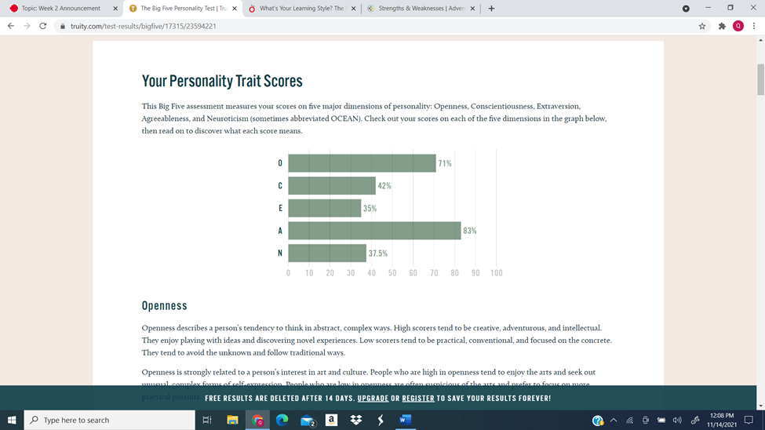

* These exams provide me with information about my personality, strengths and limitations, and learning style preferences. After answering the questions, I saw that several of my attributes match those listed. While these tests may not be completely accurate, and the results may alter over time as I grow, they provide me with a great starting point for improving myself. These exams reveal that I am creative and perceptive, indicating that I am qualified to help the team create ideas. The exam also revealed that I am a highly introverted individual, indicating that I should not be the first pick if the organization need a spokesman and that I need to improve my presenting and communication abilities. When establishing a team, I should look for people who can compensate for my limitations in order to cover more ground, but I also shouldn't let my flaws prevent me from trying a new position or filling a gap in the team.

## **Group processes:**

* Our team had a better connection than the previous assignment due to working together for long periods from assignment two to now. We are more flexible and professional in business; for example, all team members are familiar with working speed, so we are keeping up on the track, which smoothly operates the project. Moreover, we can use the git hub easier than before, making it easy to control the project. Consequently, we improved almost all our mistakes in the previous work, developing teamwork skills and connections. Therefore, we are becoming a better team.

## **Career Plans:**

* Our team members' dream occupations are all quite diverse and have nothing in common except that they all include programming. Nghi aspires to be a security engineer, Dong to be an AI engineer, Dat to be a front-end developer, and Quan to be a back-end developer (in the form of a java programmer). With our team's different aims, there are both advantages and disadvantages. The disadvantages are that we will have a more difficult time discussing more specialized topics since our specialities are so dissimilar, and it will be more challenging to provide comments or assistance on a member's job because of this disparity. On the other hand, the advantages outweigh the disadvantages; our differences in experience allow us to provide feedback from different perspectives to advance our project. We can also cover various aspects of our project because other elements may require different specializations. Furthermore, working with people with varied backgrounds allows you to understand their occupations better and collaborate with others who do similar tasks in the future. We see this as an excellent chance to learn about the various disciplines of programming and how people with diverse backgrounds can collaborate to build a cohesive product.
* In addition, this project is an opportunity for each member to try a new role different from the dream job for having a unique experience that makes them improve themselves in the future. In the project, Dong becomes a head manager, letting Dong have an affair with appropriate with his test. After this project, he can learn how to become a good manager in the future. And with Quan, he is an AI developer who is familiar with his dream jobs which helps him more experience in the career path. Dat is a technical designer who works like a front-end developer and hardware engineer. Finally, Nghi is a tester which helps him practice his senses finding the problems and bugs in the product serving for his career working as a security engineer.

# **Tools:**

* **Group website:**
* **Project website:**
* **Git repository (GitHub):**
* The Git repository aids in the organization of team progress by displaying all of the tasks that individuals are working on in respective branches. Furthermore, the leader has easy control over colleagues' work; therefore, the final result is uploaded into the main branch, which is more accurate and convenient. Furthermore, we can work on a mobile device, ideal for those working online in the pandemic period, when people do not allow face-to-face meetings to break the rule of not becoming sick. Because we contacted GitHub through the previous assignment; thus, this repository is neater and more logical than before.

# **Project Description:**

## **Overview:**

### **Topic:**

In this project, my team planned on innovating the ergonomic chair with the combination of AI technology, making it a unique feature that none other ergonomic chairs have. The idea is that we will replicate many of the ergonomic chair models available on the market and create a new appearance for our product along with a range of features. The additional features and improvements are designed to resolve issues regarding the spine, especially Herniated Disc and Scoliosis. To achieve that, my team uses computing methods and machine learning so that it will be able to operate efficiently and effortlessly. Next, we cooperate with D'ERGO to manufacture the ergonomic chair for the production process. Lastly, the additional adjustment package and the embedded technology behind it would be the calculation of investment expenses to minimize as much as possible. Therefore, becoming a high-quality product, however, the accomplishment will not be accurate without a significant quality assurance process.

Having researched the market, we can state that the uniqueness of our ergonomic chair is genuinely incomparable, which can resolve the issue of spine problems, especially in young adults. Our product will bring the most comfortable feelings despite hours of sitting or occasional movement with different positions. Overall, it will relieve many of users' fatigue body parts like the head, neck, and arm, mainly protecting your spine and reducing your lower back pain. Therefore, by creating the ergonomic chair, we hope to bring benefits and satisfaction to consumers, especially the solution to correct positioning seating. The final stage is to cooperate with D'ERGO to produce the product for commercial use. If everything goes according to the plan, we believe it becomes a breakthrough in intelligent furniture. Its impact on society will significantly contribute since it's a brilliant chair and a supportive healthcare figure.

### **Motivation:**

Our project intends to improve the ergonomic chair includes AI technology, to address the issue of Scoliosis mainly happening in the wrong seating position, especially in young people. During the Covid – 19 quarantines, people have to study or work remotely. Therefore, working with people and students who are not used to sitting for a long time to learn might cause back pain and reduce learning motivation. Although ergonomic chairs were widely used among offices and home users to address these issues, Scoliosis still exists and is on the rise. Because of the pandemic quarantine, students must sit in whatever chair they have to study online. The effectiveness of the ergonomic chairs was not enough since children tend to bore or tire with the lecture or sitting for an extended period causing back fatigue, and sometimes some children move around or put their leg on the table and lean back due to back pain. The AI Ergonomic Chair project was created to resolve spine issues, typically Herniated Disc and Scoliosis. My team had integrated AI into our ergonomic chair to constantly adjust its back to correspond with the user's back. Like the product, my team used one of the latest technology, artificial intelligence. It primarily uses visual assistance similar to Google Assistant, Siri, and Alexa. The project's implementation requires teamwork, which includes AI development using Python programming, Technical design, and quality assurance.

### **Landscape:**

The differentiation within our product compared to others on the market is the wide range of adjustments, and the most critical feature is AI integration. Firstly, we added the adjustment package, which will provide customers with many adjustable features. Those are height and seat depth adjustments; customers can also move around quickly with the independent seat and back angles adjustability. Another essential feature of the ergonomic chair is the synchro-tilt mechanism which allows the customer to lean back independently with the support of recline function. Overall, it will give the customer comfortable seating with an adjustable armrest and headrest, and the back will receive the most comfortable feeling, especially the protection of a straight spine. The most important feature of our product is the AI integration which will control all the movement automatically. The integrated AI is what differentiate our product and others on the market. The AI functionality is as it will scan the user's back and control the chair back position to the correct shape of the user's back. For example, if the user makes any movement regarding the back, like the seat straight, the ergonomic chair will automatically adjust to follow the back's exercise of the user.

## **Detailed Description:**

### **Aims:**

Our main goal will be considered successful if there is a reduction in the number of people who might or will be suffering from scoliosis, especially children. Due to the fact that the bone issue regarding the spine is one of the most crucial parts needed for early development in children's growth. The benefits of bringing the most comfortable moments in stress relief and relaxation on the whole body, especially your back. Additionally, it's known that whenever your body feels comfort and joy, people will become energetic in doing things, therefore, increase the productivity of working or learning. We hope that our project will positively impact individuals, typically office workers and parents, in search of reliable equipment to support their children's online study. It is needless to state that it may be considered in the future a scientific invention.

### **Plans and Progress:**

In this project, my teammates and I have planned and developed an AIErgonomic Chair, which we want to help people's spines do not have any bone issues when they are old and minimize the risk of scoliosis. My team started this project because it has been famous for people in the 4.0 era, mainly because the COVID-19 pandemic makes them work and study at home. That is the reason people choose to use AI Ergonomic chairs. They will demonstrate how we approach this project and how far we've progressed in AI Ergonomic Chair features and outcomes.

In the Covid-19 age, people must work from home. That implies that some companies are shifting from traditional office work to online labour and using seats that look to be trusted co-workers increases the efficiency of online employees. Many young people have confronted the spine because they often sit in the wrong posture, especially this problem that happens in children aged 10 to 15 years old, both genders are affected equally. Scoliosis has impacted individuals at the Covid-19, according to figures from the American Academy of Neurological Surgeons (AANS). This causes people to work and study online from home. If this amount is maintained, it will be hazardous to people's physical health in the future, particularly for youngsters, who require the highest degree of protection possible for their growth and development. The AI Ergonomic Chair project, on the other hand, was created to address this issue and protect people's spines.

According to those problems, our project has improved the product to avoid bone issues such as scoliosis, which have increased significantly, and current ergonomic chairs are lacking. That means our project needs the bending design of the chair to provide complete back support and adjust to maintain a slight backward tilt. Along with adding or removing additional elements, they may customize their chairs to suit each body form so that the chair is made of net, which absorbs sweat better than canvas, commonly used in chairs. That means our project wants to help people feel more comfortable and reduce the likelihood of getting it from the spine or skin, which helps us increase productivity. The AI Ergonomic Chair is popular with two types of users: office workers and people who have a computer setup such as PewDiePie and employees who use the chair to design their room for work or study online. Besides that, we have chosen two stores to sell our products, which have a delivery that helps people do online shopping, such as GEARVN and Phong Vu. Hence, we need and want development, and we choose technology stores to serve people's lives.

The AI Ergonomic Chair has several built-in features that help people feel more comfortable by detecting the back of their bodies and automatically adjusting to fix the proper posture and adapt as their bodies move. These factors indicate that the AI will use the sensor to scan the user's body form and determine the ideal chair design for everyone. First, the AI will utilize the sensor to track the user's body type and determine which chair design is optimal for everyone. If a person has a long back and a broad waist, artificial intelligence will adjust a chair to have a long back and a huge seat. Artificial intelligence will also learn the user's sitting form and alter the chair's look automatically. Consider a person sitting on a seat cushion with their legs crossed; artificial intelligence will expand or develop a little flat in the middle of the leg chair for people to rest their feet.

Furthermore, due to the flexible connection with the chair, the chair adapts its shape to the activity being done, such as typing, which needs a strange chair, reading, which necessitates a soft, sofa-like chair, and gaming, among other things. Those may control the AI chair by giving it complete directions, such as moving the seat cushion up and down or playing music, because we'll equip it with small speakers on both sides to help people who want to relax while listening to music. People may use their phones to operate the chair and do more intricate actions and utilize the command by chair app on their phones. As a result of the integration of artificial intelligence (AI) with ergonomic chairs, the chair becomes wiser. It's also more suited to respond to each customer's posture, offering superior illness prevention. Therefore, innovation and solutions for our project can develop our products to serve people who want to have a better life.

We believe that many ordinary folding chairs are utilized in the office and school, which have vertical forms and cause individuals to sit for long periods, creating back discomfort. Furthermore, some seats are of lower quality than the AI Ergonomic Chair, causing backaches and causing people to sit with their faces down, leading to scoliosis twisting. Many schools in Vietnam, for example, have employed these ordinary folding chairs for kids who do not sit properly. That is why we must investigate the various sorts of chairs available, ranging from business chairs to gaming chairs. However, everything always has many negative things. The office seats, for example, are tiny and rough, while the gaming and manager's chairs are made of leather, which does not absorb sweat properly.

As a result, we've opted to employ the ergonomic chair, which has both pros and downsides. When individuals use an ergonomic chair, they get a large of benefits for themselves, such as a healthy workplace, which means that ergonomic chairs have a variety of health benefits, such as enhanced blood circulation and reduced mental and physical exhaustion. Along with the greater productivity that I have mentioned above, the ergonomic chair helps people have a heightened comfort level, supporting them to concentrate and do high-quality work. Besides that, this chair has some disadvantages that raise the likelihood of developing health problems related to a sedentary lifestyle. Users who are too short or tall and weigh more than the chairs are designed to hold may not use ergonomic chairs to their full potential. When using ill-fitting seats, such folks are bound to feel uncomfortable. According to those advantages and disadvantages, that is the reason my team has improved this chair by adding AI technology for people to avoid any issues. Hence, there are all things we have developed our product for people can use a better chair.

Currently, we are making the start-up investment to call for capital for the project. Because, in the estimate, this project will spend much money on improving AI technology, and our partnership has a discomposure in this term. However, we believe in our project, which will bring vastly outcomes based on their benefits effect on society. To attract investors, we are progressing an AI that can automatically be scanning the customers back, showing our ability to make this project coming reality.

If we handed this project to other teams at the end of the semester, they would want to know how much the project spent, what technologies are used, and its purpose.

### **Roles:**

This is the role of each member in the project of COSC22083_Introduction to IT.

Our group have four members and their role/tasks:

**1. Pham Vo Dong (s3891968):** Dong has the position of Lead Developer, what it means is the work as a manager that he has to check all tasks when we finish the process, which helps us fix many issues by reading the report from the tester to know the situation of this project. That will support our team and product very much to get many experiences and knowledge.

**2. Bui Quang Thanh Dat (s3827551):** Technical Designer, which installs a chair with sensor and A (Front End). That means he has to be responsible for the look and feel of a website and the architecture of the user experience. When he wants to do his task carefully, he must fulfil these objectives; the founders' front-end must have the primary features of three main languages: HTML, CSS, and JavaScript.

**3. Le Anh Quan (s3877457):** The role of Quan is an AI Developer that has to develop AI technology in the chair (Back-end developer). A back-end developer creates and maintains the technology that allows the user interface part to function. To enable communication between the server, application, and database.

**4. Mai Chi Nghi (s3864219):** My task on this project is to be a tester, and he is testing the chair's operation to find some issues before generating them for markets. Besides that, my roles are as a supporter and a reporter. He has to check our products carefully and write some reports for Lead Developers, which helps us develop our products to serve our customers.

### **Scope and Limits**

In 3 months, we cannot make a “true” AI chair with the personnel and fund we have, so our goal is to create a backrest that is connected to an AI that can switch between 2 to 3 preset modes depending on the data is recorded from the user when they sit on it. We made only the backrest since it is one of the essential but most crucial parts of the ergonomic chair, and it can show our project’s potential in how easy it is to see it change the user’s posture. We only do 2 to 3 preset modes due to the complexity of both AI programming and the settings we can produce with many moving parts; because of that, we settled for 2 or 3 preset modes as the option for the AI to decide to simplify the process while still accomplishing the goal of the prototype. We choose our goal because it can show both the basics and the potential of our project: A chair that records your physical data and analyze it to give you the best setting for your health and comfort. It can also serve as a baseline so we can make improvements since we can continue the project by building upon it by adding more moving parts to the chair for more flexible settings, updating the AI to increase its speed and accuracy and even making the AI able to flexibly change the details of the chair to fit the user best instead of restraining it to the preset setting. Since our goal is just a step on the roadmap we made (more detail in testing), if unknown risks or accidents affect our workflow, we can fall back to a stage that, while not as detailed, will still accomplice our goal of showing the basics of the project. In reverse, if we reach the goal before the deadline, we plan to make a more impressive prototype that will have more chances to attract investors.

### **Tools and Technologies:**

* An ergonomic chair from a trusted brand
* 3D scanning machine from Scantech3D Vietnam called GOM SCAN 1 to scan data from user in the beginning stages.
* Microsoft Azure AI Platform to create the AI because it is popular for AI development and easy to use. Dong has some experience in this application.
* Human sized dummy for testing.
* Sensors and parts to modify the chair as the prototype will be a normal ergonomic chair modified with parts that adjust the chard base on recorded data.

### **Testing:**

The testing will be done after the chair's backrest has been linked with the computer and will be done in parallel with the project to make sure the project is going in the right direction. The first test would be if the chair backrest would change setting with a computer command. After that is complete, the next test would be for the backrest to switch smoothly while a dummy sits on it. At the same time, the AI would be tested to see if it recognized the different heights of the sitter. The final test that we hope to reach is to connect the AI to the chair backrest and put another dummy on it to see if it can use the height of the dummy to switch between 2 to 3 settings that we premade. The test would need the prototype product and 2 to 3 dummies with different sizes and will only need two computers and a minimum of 2 members to do. The final test is where we hope to reach before the deadline. If we get it early, we would add more premade settings to test the AI with a more diverse dummy and have a team member sit on it to give feedback on how smoothly the transition between stages was. With these tests, we would track our project based on the goals of completing these tests and make sure we are moving in the right direction. By the time the final test is complete, we will have a working AI backrest that can be used to showcase our potential to investors.

### **Timeframe:**

|  |  |
| --- | --- |
| Week | Activities |
| 1 | Assigning roles in project and parts on assignment 3 |
| 2 | -Dong finish team profile  -Dat finish overview  -Nghi finish plan and progress  -Quan finish Scope and Limits + Tools and Technologies |
| 3 | -Dong begin to code the website, finish tool +skill and jobs  -Dat finish aim  -Nghi finish roles + testing  -Quan finish risks+ group processes and communications |
| 4 | -Dong finish coding the website  -Dat help Dong put data on the website  -Nghi check the parts for typo and wrong information  -Quan finish timeframe |
| 5 | -Dong and Nghi (team AI) research about AI  -Quan and Dat (team chair) research about ergonomic chair |
| 6 | -Team AI continue their research  -Team chair determine which brand’s chair to use as design |
| 7 | -Team AI continue their research and start testing with AI  -Team chair research on a newly order ergonomic chair |
| 8 | -Team AI continue their research and testing  -Team chair testing the chair backrest. |
| 9 | -Team AI start building the AI for the chair  -Team chair start working on mechanic parts for the chair |
| 10 | -Team AI continue building the AI for the chair  -Team chair build and test mechanic parts for the chair |
| 11 | - Quan connect computer to chair backrest and sensor to AI  - Dat begin testing the chair using manual command and AI using dummy.  -Nghi and Dong continue to work on AI base on feedback |
| 12 | - Quan connect AI to chair backrest  -Dat start basic AI chair testing using dummy  -Nghi and Dong continue to work on AI base on feedback. |
| 13 | -Quan work on wireless connection  -Dat continue testing using dummy  -Nghi and Dong continue to work on AI base on feedback. |
| 14 | -Quan install wireless connection  -Dat testing the respond speed of prototype  -AI team work on polishing and improving the AI |
| 15 | -Quan check and polish wireless connection  -Dat testing using real people.  -AI team work on polishing the AI and check AI for bugs |
| 16 | -Quan and Dat run as many tests as possible  -AI team check AI for bugs and finalizing the project  -Team finalizing the project |

### **Risks:**

Like every project, there would be risks that we might meet while doing it; it would be best if we could identify them and plan to prevent them or deal with them and mitigate their damage. The first risk we identified is the difficulty of designing an AI, and we have to tackle this first since the project will need an AI that will work with high precision. Because developing an AI will not be an easy task, our solution to this problem is to give our AI engineer four weeks of researching in contrast to the 2 to 3 weeks that other members will have for their research. The second risk we might have to deal with is the safety issue when connecting the chair backrest with the AI. Because the prototype will not be wireless, there might be a risk of electric shock when used. To deal with this risk, we will check the backrest very carefully when we connect it to the AI and recheck it every time we test it. The third risk we thought about is the backrest working not as intended during the testing process, hurting the user; this would be a terrible thing to happen and should be avoided at all costs. Because of that, we will use a human-size dummy during all tests instead of a natural person; the real person test will only be done during the final weeks when we are sure the risk won’t happen.

### **Group processes and communications:**

Communication between group members is one of the most critical parts of our project and one of the elements that we have to consider first. Experience and some researches have shown that communication breakdowns between group members are the most common cause of project failures. Because of that, the first thing we do is find a time backrest where all members are free so the meetings can take place. After consideration, we have decided to have a weekly team meeting every Sunday afternoon and a quick appointment for progress checking every Thursday night aside from the time we spend at school after class. The team meeting is long and is usually for deciding plans based on the information and progress of the group or for the group to finish a part together. In contrast, the quick meeting is only 20 minutes max and is used to check everyone’s progress. We use Microsoft Teams for team meetings because we all have a Teams account link to our student number, and we all have experience using it. For a short discussion, we usually use messenger because of its ease of access. If a group member does not arrive at the meetings on time without reason, we will contact them on messenger first. Then we would call them using their phone number. If they do not answer, we will have to catch them up during the next meeting, and if they do not have a reason for their absence, they would be assigned to help other members with their job and their part. These decisions and rules are decided and agreed upon by team members in the first meeting to make sure everyone knows the rules and time.

# **Skills and Jobs:**

* This project took a long time to develop in 6 months; therefore, the numbers of the members in our teams in current time cannot make running the business successful. Thus, we want to employ four positions in the marketing department who advertise our product with potential customers and the following position that we shall hire:
  + **Receptionist**: This is the essential position role in the project about the product. As the business representative, a receptionist is the first person the customers will meet in the company. In this position, we need extroverted people to talk with customers to answer their questions, phones, and social media. Moreover, people who apply for this position must know our product well for having the right advice for customers when they have a problem. An essential trait is a positive attitude that defines a perfect front desk clerk, and they must have the communication skills to keep guests entertained.
  + **Marketing Manager:** Marketing managers are in charge of developing and implementing marketing campaigns to raise our brand awareness and increase sales. They create marketing plans, manage marketing teams, write advertising contracts, and negotiate advertising conditions are all part of the job description. To apply for this position, people need to have a lot of soft skills like communication, creativity, collaboration, and some hard skills in the marketing field. And we always appropriate people who have innovative thinking which brings fresh air in our product marketing.
  + **Graphic designer:** This role will be responsible for the front-end developer who will design the websites, apps, advertisements, and they will combine with the marketing manager for the marketing online to bring our product overseas. The graphic designer might have professional IT skills, especially with design and photo-editing and be familiar with some programming languages such as HTML, SQL, Bootstrap, JavaScript. And have team working skills when working in the business environment.
  + **Logistics:** Because our project is about the chair, we need a factor responsible for importing the component for installing the product and exporting the final product outside. Therefore, we need professional knowledge of reading business documents, freight forwarding, and running orders. Moreover, they must be good at foreign languages to communicate with foreign cooperation, communicate, and control situations flexibly.

# **Group Reflection:**

### **Group:**

Looking back to the previous assignment, we did very well in working as a professional team in this assignment. That is the result of working together for a long time, from assignment two to now. We are better at connecting all team members, and the operational flow of each member has been improving day by day. During the period, we work as a team, which makes us become a family where all members can come and feel comfortable when working. We have a messenger group on Facebook for updating the project's status each day for other members to know, and every week, we always spend our time meeting on the Microsoft teams; the average time of the conference is from one hour to one a half hours. Because of being familiar with GitHub, we are efficiently working in this platform (see Appendix 1); therefore, the graph of working flow grow up. With each member in our team, they improve almost all the mistakes they make in the previous assignment. Dat had developed the operational flow that he was committed to working on tasks faster than before, Quan was very confident in his representation, Nghi's part was the most important in the group process, and he did very well, which showed all the spirit of the project for the reader. And the last one is Dong – leader of teams. He did very on the website of the group and the project that was improved compared with the previous task.

The mistake is inevitable in the working because the time of meeting for the presentation is not enough; therefore, we had a lot of errors in the presentation we received after the presentation in class. For example, we missed the AI technology application in the slide to be done more carefully in the future.

However, we were surprised by the improvisation skills in the presentation of all team members. They made the unreal project available and made an innovation in our world, especially in health care.

All members learn a lot of knowledge and essential skills together in teams. Their teamwork skill had been improved during the period time of working as a group.

In the end, our GitHub log of activity is the same as the complete picture of the puzzle with each member's work is a piece of the vital fragment. A photo will not be complete without any component of the puzzle.

### **Dat:**

I think the thing that makes everyone worried is the presentation itself, which we must present the idea briefly but concisely. Thankfully, we did a rehearsal meeting which took about 48 minutes and 39 seconds, and we also planned to do another rehearsal before the present day just to make sure. As we have covered the power point issue, however the first rehearsal just not too well, I think so that the reason we have to do it again another day, I am optimistic that it will achievable. Aside from that, we are working on is the assignment 3, we need to provide insight on each aspect of the project. Personally, it’s useful to research the project which open new ideas and knowledge regarding new technologies. For my part, I was researching the Innovation part of the project, it helped me open my mind to new aspect of technology. What surprises me was the PowerPoint in which the designing aspect and motion pictures which I even thought it was a visual effect. The effect is so realistic and fascinating. I think my GitHub log of activities contributing to the completion of the project, I worked on different pieces of the puzzle and every other member filled up that puzzle.

### **Dong:**

The role and responsibility in this project are the same as with the ones I did before in the previous assignment, which is the teams' manager. And in this assignment, I am self-aware of the excellent communication between us, which results from working together for a long time. I was strongly confident to advise other team members and readily received recommendations about my mistake, which made the project successful. Not only my soft skills improving but also my technical skills about designing a website have increased during the time I was doing the assignment because I had learned bootstrap throughout this period and found out more extension libraries that serve for web development. However, this assignment helped me recognize my mistake in managing the team. For example, I was hesitant to pick work roles in our group, making us start slower. Honestly, I was amazed because all members kept me on the head chair of the teams after I did in assignment two, which was not as I expected. Moreover, I learned a lot of things from my teammate, especially the representation skill because each member had a unique style of representation that created their personalities. I learned from that to improve my confidence in talking before the crowd. About my GitHub log of activity is one piece of Lego to build a project which is essential equally with other members in the team.

### **Quan:**

### **Nghi:**

# Appendix:

Figure : Working flow on GitHub