Commander Chess

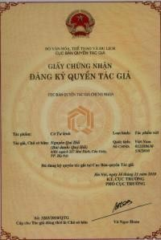
CERTIFICATE OF THE COPYRIGHT OFFICE
Founder commander chess (COTULENH) Nguyễn Quí Hải

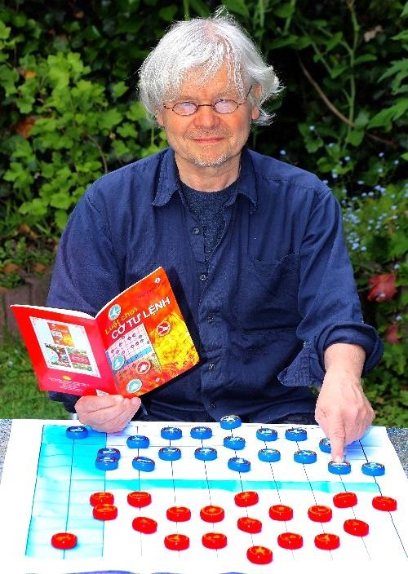

Dr. RENE GRALLA. media the Federal Republic of Germany specialist Chess, International Chess.

* CO TU LENH - Interview für deutsche Medien

Sehr geehrter Herr Oberst HAI, mit sehr großem Interesse habe ich von der wunderbaren neuen Version
des CO TUONG gelesen, die Sie entwickelt haben, nämlich von Ihrem …

BASIC DIFFERENCES BETWEEN COMMANDER CHESS, CHESS AND CHINESE CHESS
- Chessboard: Chessboard of Chess is square checkered board numbered by row and column with center area and pieces move by squares. Chessboard of Commander Chess has sky field, sea field and river field with reef-base segments. Pieces move by vertical axis (VA) and horizontal axis (HA) with 0 origin located at the left corner of the blue sea similar to Cartesian coordinate system in common education program.
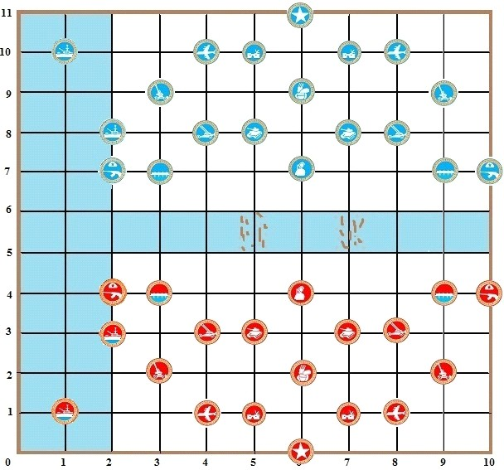

- Chess piece: Chinese Chess piece is round block printed with Chinese character and Chess piece is black and white block .Chinese Chess and Chess pieces have King, Minister, Bishop, Rook, Cannon, Knight, Pawn…Commander Chess has red and blue round piece set. Commander Chess pieces have the symbols of Commander, infantries and artilleries, tanks, civil engineers, anti-aircraft cannons, missiles, aircrafts, warships... and also long hair militiawoman. Warship piece is regarded as a combination of anti-warship missile, gunboat (Only capture troops on the ground), and anti-aircraft cannon.
- Move: Move and capture tactic of Commander Chess is flexible. Pieces can freely move vertically and horizontally depending on player’s tactic. The commander doesn’t just stand still inside headquarter but can move to the frontline during emergency. Some pieces can capture straightly, some diagonally. Some pieces can leap over the other pieces to capture like artillery and aircraft. When capturing, they can occupy the position of captured piece or move back to the initial position like bombarding aircraft. Anti-warship cannon can capture piece in the mainland; or vice versa, piece in the mainland can capture warship piece on the sea without moving.
Especially when in need to push forward quickly, the pieces of the commander chess (COTULENH) can piggyback others pieces on it and the group can capture in many direction, of course with some restrictions.
- Moving tactic and strategy: There are various moving tactic and strategy by arranging infantry on ground, aircraft in the sky and warship on the sea. An anti-aircraft cannon creates firewall to prevent aircraft. Players who want to attack the other party are forced to find their way to break through the firewall.

Heroic piece: Any piece gains checkmate the opponent’s commander can be brevetted as heroic piece. This heroic piece will get added bonus on moving segment and capturing one more segment. A heroic aircraft will become a stealth aircraft; it can fly over and shoot anti-aircraft cannon and anti-aircraft missile without being shot down. Heroic tank and infantry can move and capture along the diagonal line of 45⁰.
- Rules: Play by game or by battle ( sea battle, sky battle or full power battle… or break through the headquarter and checkmate the commander. Play by point calculation or time control or human chess.
- Philosophical meaning difference: Chinese Chess and Chess have a historical meaning of the past; nowadays, they are only mental games. Commander Chess is also a mental game but has a deep history of past wars, and at the same time educates mindset of generations about the meaning of defending the country. Through the game, the author would like to give a message of peace, hoping that in the future, weapons are nothing but game pieces for chess like this.

Rules of CO TU LENH
(Revised version with additional parts)

GOAL OF THE GAME
The game is played between 2 people, RED and BLUE. Each person will find his/her own strategy in order to defeat the opponent’s Commander or the opponent’s strategy.
This game brings entertainment to both young and older players, especially the military forces. Not only that, it allows them to further develop their skill set in making strategies, decisions and to improve their military abilities overall.

BOARD STRUCTURE

Commander Chess is a two-player board game played on a chessboard with pieces move by vertical axis (VA) and horizontal axis (HA). VA and HA are numbered as rule of decimal base with the origin of axes is numbered 0 at the bottom left corner of the chessboard is the area of blue sea. (See Figure)
Each intersection has particular name in accordance with the reading rule: reading number at the VA first then the number at the HA. For example, point 3,5 (read as three five); point 0,0 (read as zero zero), point 0,7, point 0,10, point 11,10, point 11,0, point 8,4.

Figure 2 :
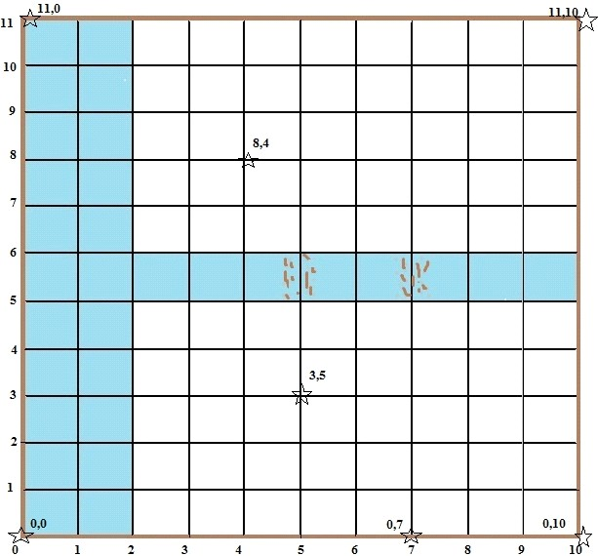

area.
Unlike Chinese Chessboard and Chessboard, Commander Chessboard has Sky, Sea and River

River separates two frontiers. There are two dry river segments bedded with reef-base. All land

pieces are permitted to cross over by the reef-base.

PIECES
There are 11 different piece types in a Commander Chess game with 38 pieces in total divided into two equal sets with 19 pieces in each Red and Blue set. Certainly, name, symbol and play rule of the two sets are the same.
In each set, there is a piece called commanding headquarter just standing still to function as a bunker. It cannot move, attack or capture the opponent's pieces.
Commander Chess set made with round pieces printed with symbol of each army division.
Tanks, artilleries, missiles etc…like charming red and blue statues in order to attract teen players.
Symbol and quantity of 11 different piece types are shown in Figure 3 as below:

Piece | Symbol | Number
Commander C | 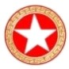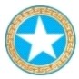 | 1
Infantry In | 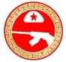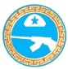 | 2
Tank T | 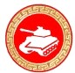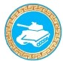 | 2
Militia M | 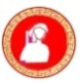 | 1
Engineer E | 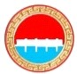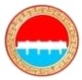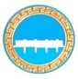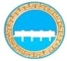 | 2
Artillery A | 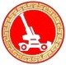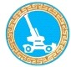 | 2
Anti-aircraft gun Aa | 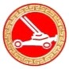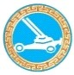 | 2
Missile Ms | 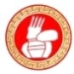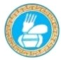 | 1
Air force Af | 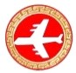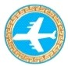 | 2
Navy N | 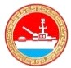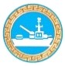 | 2
Headquarter H | 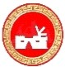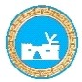 | 2

COMMANDER CHESS RULES:

      - Movement and capture

- Bridges soldiers, infantry, and anti-aircraft gun move and capture right, left, forward, back, straight along VA and HA of the chessboard by one segment.
- Militia ("long hair woman") moves in all direction, by one segment.
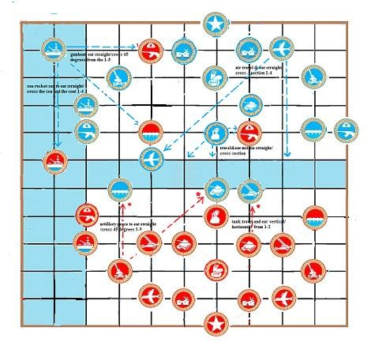
- Tank moves and captures straight along the VA and HA from one to two segments. For attacking an opponent’s piece at sea, tank can stand still to capture the piece and is not required to occupy the position of captured piece (without moving).
- Artillery can move straight in all directions, from one to three segments. When capture an opponent's piece on the other side of the river, it is allowed to pass the river, but when only moving to cross the river, it has to cross over by the reef-base. When artillery captures an opponent’s piece on the ground, it needs to occupy the position of captured piece. Artillery can stand still to capture opponent’s pieces at sea in the range from one to three segments.
- Missile moves and captures opponent’s piece on the ground and piece in the sky inside the fire ring with a radius of two segments (meaning 2 segments on VA, HA and 1 segment diagonally).
- Air Force moves and captures straight in all directions, from one to four segments. Air Force can fly across any blockage and must replace when capture, with an exception: if targeting a land piece (not an Aircraft) and taking its place is not safe (meaning that the Air Force would be immediately captured after), Aircraft can go back to its initial position.
An Air Force inadvertently flying through the opponent’s fire ring of anti-aircraft gun and missile will be shot down immediately. If an Air Force targets an opponent’s anti-aircraft gun or missile or any other targets inside the opponent’s ring of fire (created by anti-aircraft gun and missile), then both will be destroyed, that is one exchange one. If the aircraft is carried by a Warship, it is not threatened by this ring of fire. Aircraft cannot finish a move into the sea.

- Navy move and capture straight from one to four segments, in all directions. Navy is equipped with anti-aircraft gun providing a ring of fire (one segment radius), gunboat and anti-ship missile. When fighting, gunboat on Navy can stand still to shoot and capture object in mainland as play rule for artillery in mainland (maximum 3 segments). If gunboat captures an opponent’s piece along the coast then it is required to occupy the position of captured piece.
The sole objective of the anti-ship missile is the enemy's Navy. (1-4 segments).
Figure 5. Move and Capture
When an anti-ship missile captures a Navy, the Navy is required to occupy the position of captured piece. Navy can move into the deep-water river segment but only outside of the reef-base segment.
In a general way, if there is land between Navy and his target, it is allowed to stay in place for capture this target (using gunboat or anti-ship missile).
Navy is not blocked by friendly pieces when moving. It cannot cross the reef-base segments.
- Commander
Commander is not necessary staying in the commanding headquarter.
Commander is allowed to move around, even move to the opposite frontline to direct its soldiers and checkmate the opponent’s commander.
Commander can’t be face to face with the opponent’s commander. It will be captured by the opponent’s commander if revealed.
Commander moves freely along VA and HA by any segments provided that it doesn’t encounter blockage. However, commander can only capture an opponent’s piece by only one segment. And it cannot move diagonally. Moreover, only commander can go on the headquarter.
Commander can't pass face each other except if carried by tank, Air Force or Navy.
Commander can ignore sea when joining Navy

Headquarter rules
- On a chessboard, each side has two bunkers. They form the headquarters of the commander.
- Bunkers can’t move or capture an opponent’s piece.
- In emergency, the commander can hide in the bunker if necessary. However other pieces can break the fortification to capture opponent’s commander.

River crossing rules
- River has two reef-base segments (see Figure 2), where all pieces can pass to cross over.
- Besides the two reef-based segments, the rest of the river is the deep water segment where only tanks, infantries, militias, commanders and bridges soldiers can pass freely. Heavy vehicles such as anti-aircraft cannon, artillery and anti-aircraft missile have to be carried from one river bank to the other by the engineer. However, these heavy vehicles can cross the river without engineer when capturing an opponent’s piece at the other side of the river. A heavy vehicle accidentally maneuver through the deep water without the purpose of capturing an opponent’s piece at the other side of the river, this move is considered against the rule, as a result, the piece has to move back and the second player will take turn.

Restricted area in the sky
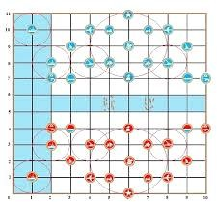
An Air Force inadvertently flying through the opponent’s fire ring of anti-aircraft gun and missile will be shot down immediately. If an Air Force targets an opponent’s anti-aircraft gun or missile or any other targets inside the opponent’s ring of fire (created by anti-aircraft gun and missile), then both will be destroyed, that is one exchange one. If the aircraft is carried by a Warship, it is not threatened by this ring of fire. Aircraft cannot finish a move into the sea.Figure 6. Restricted area in the sky
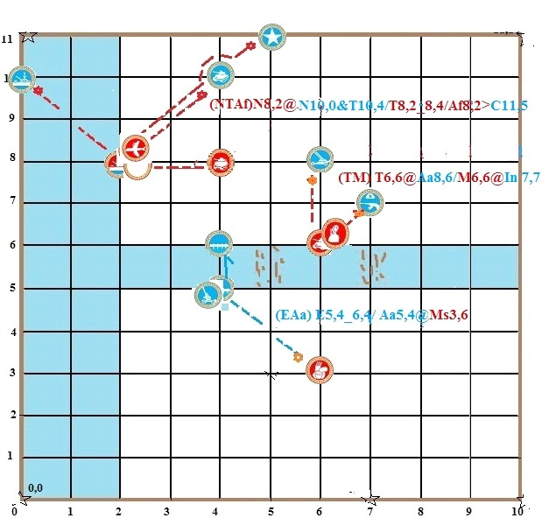

Rule of terrific speed operation
3 types of pieces: commander, infantries and militias, when needed to moves quickly, can be carried by tanks, Air Force and Navy.
When infantries want to join the tanks, Air Force or the tank, Air Force come and pick up the infantries, player will have to forego one turn. This rule also applies when Air Force or tank lands on the Navy (carrier).
Navy, Air Force or tank can carry up more other troops.
(Navy can carry up 2 aircrafts or 2 tanks or 1 aircraft+1 tank or 1 aircraft+ 1 person)
( Air Force can carry up more only 1 tank or 1 person)
(Tank can carry up only 1 person)
If it is the turn of the combined piece to go, up to 3 pieces can go and take one or two, three different directions. It means in one turn you can capture up to three pieces. The stack always split from the same point
When a combined piece is shot down, the points earned are based on the total points of every piece on it and itself.

Heroic piece rules
Any piece that put in check the opponent’s commander can be brevetted as heroic piece. This heroic piece will get added on moving: one segment and can move and capturing all straight and diagonal. For example, infantry often moves and captures by one segment only but after being brevetted as heroic it can move and capture from one to two segments. Normally, tank move and capture from one or two segments but a heroic tank can move and capture up to three segments. ...
Additionally, heroic Air Force will become a stealth Air Force; it can shoot anti-aircraft cannon and anti-aircraft missile without crashing, and ignore anti-aircraft rings of fire.
Air Force can put in check or checkmate a Commander who is into an anti-aircraft ring, even if it is the last Aircraft remaining. By the way, if another ring of fire would destroy it before, this Air Force cannot check the Commander.
For defending party, the last piece that protects its commander becomes the heroic also; including the headquarters. When the headquarters becomes a hero piece, it is allowed to move and capture like the heroic infantry that is to move and capture straight, diagonally two steps.

Score rules
If play basing on score rule, the basis for score calculation as follows:
Military civil engineer, infantry, anti-aircraft cannon, long hair militiawoman: 10 points. Tanks, anti-aircraft missile: 20 points.
Artillery: 30 points. Air Force: 40 points.
Navy is equipped with missile, anti-aircraft cannon and artillery can get bonus score of triple weapons: anti-aircraft cannon 10 points + gun boat 30 points + anti-navy missile 40 points = 80 points.
Commander: 100 points

MOVES NOTATIONS
Sometimes, it is necessary to take note of moving tactic of the two players to study excellent tactics or find out the reason for losing.
A secretary can provide evidences to support the referee by taking note the moving process of the two players from the beginning to the end. A player can remember and write down the ecstatic moving tactics to find tactics for the later games in the future.
Some simple, easy to remember symbols:
- Capture: @
- Stand still and capture @ K…@... (Blue air force stands still and capture like bombarding) @ H…@... (Red Navy stands still and shoots towards mainland)
- Air Force catch fire @” (bold red) for example: K9,8@”P5,8 (K9, 8 intends to capture P5, 8
but crash into a fire range)
- Pieces that contains other pieces notation: Pieces that contains other pieces for example infantries on tank can be written as (TIn). Air force and tanks on Navy (carrier) move from 5.2 to9,2 can be written as (NTAf)5.2_9.2
- Pieces that contain other pieces moving and capturing can be written
as: (NTAf)N9.2@N11.2/T9.2_9.4/ Af9.2>C11.4
- Move _ (long dash underline)
- Check >
- Checkmate ^ (Not only checkmate the commander, but also sea battle and sky battle. )
- One exchange one > <
- Lose !!
- Heroic piece brevetting H K B (bold symbol)
- Good move +
- Excellent move ++
- Bad move -
- Terrible move --
- Draw =
- Suspicious move ?
- Break rule moving $

END OF THE GAME

A- Tactical play with full number of pieces of time 15 minutes

1- Marine battle: stops as soon as one side destroys first 2 enemies Navy. 2 - Air battle: stops as soon as one side destroys first 2 enemies Air Force.
3 - Land battle: stops as soon as one side destroys first 2 tanks + 2 infantry + 2 artillery. 4 - Raid battle: stops as soon as one side destroys first with the enemy commander.
The winning side of the strategy is awarded 50 points.
If neither side wins the strategy, after 15 minutes the game stops and the game will win or lose based on the total score.
If Party A wins the strategy and is already awarded 50 points and the total points are still worse than Party B, Party B is the winner.

B - Play total force with of time 30 minutes

The match only stops as soon as one side destroys first the enemy commander. The winner is awarded 50 points. If neither side wins the strategy, after 30 minutes the game stops and wins and losses according to the total points as above.

B- Play sea battle, air battle with 9 pieces in 15 minutes. The rules of the game are like the basic rules of the game

The game stops as soon as one side destroys first 2 enemies Navy or 2 enemies Air Force. If neither side wins the match, after 15 minutes the game stops and wins and losses according to the total points as above.

