

AWS First Cloud AI Journey – Project Plan

Happy Code – FPT University – FitAI Challenge

Table of Contents
1 BACKGROUND and motivation 3
1.1 executive summary 3
1.2 PROJECT SUCCESS CRITERIA 3
1.3 Assumptions 3
2 SOLUTION ARCHITECTURE / ARCHITECTURAL DIAGRAM 3
2.1 Technical Architecture Diagram 3
2.2 Technical Plan 4
2.3 Project Plan 4
2.4 Security Considerations 4
3 Activities AND Deliverables 5
3.1 Activities and deliverables 5
3.2 OUT OF SCOPE 5
3.3 PATH TO PRODUCTION 5
4 EXPECTED AWS COST BREAKDOWN BY SERVICES 5
5 TEAM 6
6 resources & cost estimates 6
7 Acceptance 7

1. BACKGROUND AND MOTIVATION

1.1 Executive Summary

Customer Background
FitAI Challenge is a project developed by a student team from FPT University, aiming to build an intelligent fitness training platform for Vietnamese users. The application encourages users to maintain a consistent workout habit through challenges, gamification, and AI Camera–based movement scoring.

Business and Technical Objectives
- Build a modern, transparent, and interactive workout platform.
- Leverage AI and serverless architecture to reduce initial operational costs.
- Optimize performance, latency, and security using AWS Cloud.
- Integrate AI to analyze posture, count reps, and provide personalized feedback via Amazon Bedrock.

Use Cases
- Detect and count workout repetitions (push-ups, squats…).
- Participate in individual or group challenges.
- Track workout history and earn FitPoints for rewards.
- AI-generated feedback on posture and technique suggestions.
- Leaderboards and social sharing.

Summary of Professional Services Delivered
The project includes the design and deployment of a full serverless architecture on AWS:
- Build VPC, CloudFront, S3, API Gateway, Cognito.
- Deploy Lambda (Java), RDS MySQL, VPC Endpoints, and security configurations.
- Implement AI Pipeline using SQS, Step Functions, and Bedrock.
- Configure CI/CD, logging, monitoring, and cost optimization.

1.2 Project Success Criteria
- AI movement recognition accuracy > 90%.
- Support up to 10,000 concurrent users.
- Maintain operational cost at 10–12 USD/month during MVP.
- Low-latency AI processing (< 2 seconds per request).
- 100% services running within a Private VPC for data security.
- CI/CD pipeline with ≥ 95% stable builds.

1.3 Assumptions
- AWS provides full access to required cloud services.
- Users have devices with compatible cameras for recording.
- Workout videos stored in S3 will be deleted periodically after processing.
- AI models are accessed via Bedrock; no custom model training required.
- Early-stage user base < 500 users.
- RDS runs in auto-stop mode to reduce costs.
- Certain advanced features are not part of the MVP.

2. SOLUTION ARCHITECTURE / ARCHITECTURAL DIAGRAM

2.1 Technical Architecture Diagram
The system uses AWS Serverless with a Private VPC architecture:
- User → Route 53 → WAF → CloudFront → S3 Static Web Hosting
- API Gateway → Lambda (Java) → RDS MySQL / S3 (via VPC Endpoint)
- AI Pipeline: Lambda → SQS → Step Functions → Bedrock (Interface Endpoint)
- CloudWatch for logs and performance monitoring
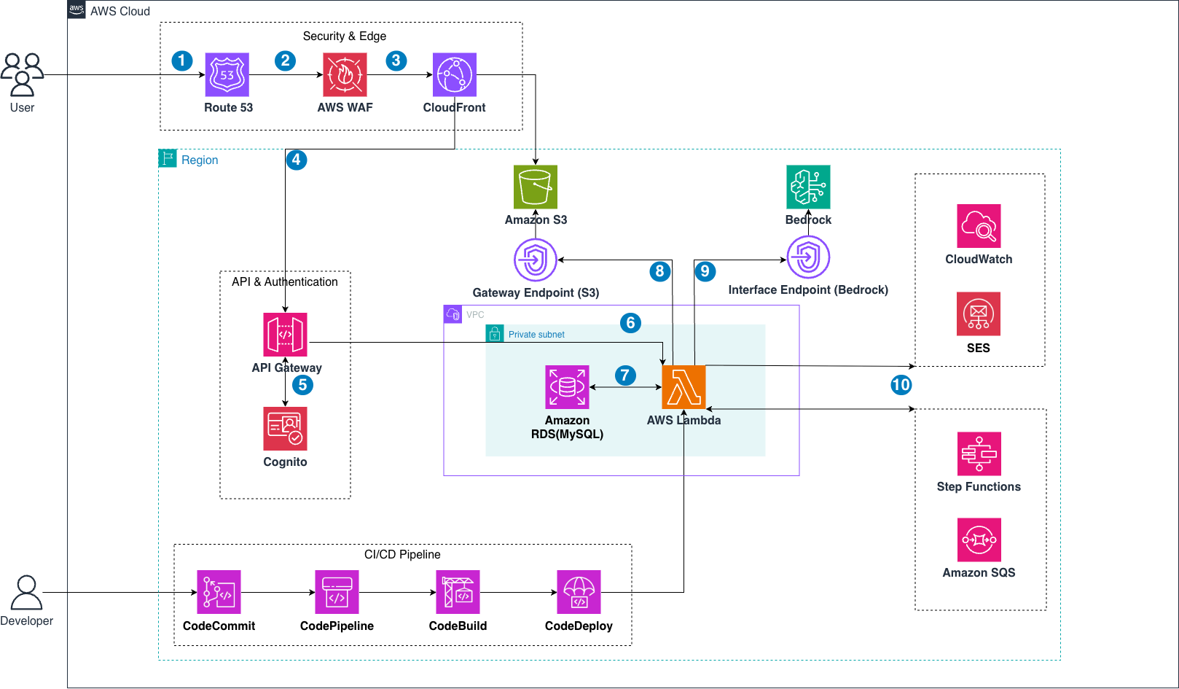

Tools Used
- AWS CloudFormation / IaC
- AWS CodePipeline
- AWS CloudWatch
- Amazon Bedrock

2.2 Technical Plan
- Design VPC (2 Private Subnets + 2 Public Subnets).
- Configure API Gateway as backend entry point.
- Implement Lambda (Java) for Auth, Upload, AI Pipeline, Save Result.
- Store structured data in RDS MySQL.
- Store raw and processed videos/images in S3.
- Build AI Pipeline with SQS and Step Functions.
- Use Bedrock for AI feedback generation.
- Deploy frontend (React/Next.js) to S3 + CloudFront.

2.3 Project Plan
Agile methodology with 6 sprints (2 weeks each):
- Sprint 1: AWS infrastructure setup (VPC, Subnets, IAM, S3, CloudFront, RDS).
- Sprint 2: Backend core – API Gateway, Lambda Auth & Upload, Cognito integration.
- Sprint 3: AI Pipeline (SQS, Step Functions, Bedrock Endpoint).
- Sprint 4: Frontend development (Next.js), video upload, dashboard UI.
- Sprint 5: Frontend–Backend–AI integration, performance optimization.
- Sprint 6: System testing, bug fixing, demo preparation, handover.

2.4 Security Considerations

Access
- Mandatory MFA for AWS account access
- IAM role-based access control

Infrastructure
- Private VPC
- VPC Endpoints for S3 and Bedrock

Data
- S3 encrypted using SSE-S3
- RDS MySQL encrypted at rest

Detection
- CloudTrail enabled for all API calls
- CloudWatch alarms for errors and cost thresholds

Incident Management
- Runbook for AI Pipeline failures
- Automatic rollback via CodeDeploy

3. ACTIVITIES AND DELIVERABLES

3.1 Activities and Deliverables
Project Phase | Timeline (Sprint) | Activities | Deliverables | Man-day
Assessment | Week 1–2 (Sprint 1) | Requirement gathering & architecture analysis | Architecture Draft | X
Setup Base Infrastructure | Week 3–4 (Sprint 2) | Deploy VPC, IAM, RDS, S3, CloudFront, Endpoints | AWS Infrastructure | X
Setup Backend Core | Week 5–6 (Sprint 3) | API Gateway, Lambda Auth & Upload, Cognito | Backend Core API | X
Setup AI Pipeline | Week 7–8 (Sprint 4) | SQS, Step Functions, Bedrock Endpoint | AI Workflow | X
Frontend Dev + Integration | Week 9–10 (Sprint 5) | Next.js + Backend/AI integration | Web UI MVP | X
Testing & Go-live | Week 11–12 (Sprint 6) | System testing & optimization | Go-live Release | X
Handover | End of Week 12 | Documentation & knowledge transfer | Documentation | X

3.2 Out of Scope
- Native mobile applications (iOS/Android).
- Advanced NLP or custom AI model training.
- Real payment gateway or real-world reward redemption system.

3.3 Path to Production
- MVP includes essential features only.
- Production version will require advanced error handling, retry logic, autoscaling, and optimized CI/CD.
- Additional gamification features will be developed post-MVP.

4. EXPECTED AWS COST BREAKDOWN BY SERVICES
AWS Service | Estimated Monthly Cost
API Gateway | 0.38 USD
Bedrock | 0.32 USD
CloudFront | 1.20 USD
CloudWatch | 1.85 USD
Cognito | 0.00 USD
Route 53 | 0.51 USD
S3 | 0.04 USD
SES | 0.30 USD
SQS | 0.00 USD
Lambda | 0.00 USD
Step Functions | 0.00 USD
WAF | 6.12 USD
RDS MySQL | 0–3 USD
Total Estimated Cost: ~10.7 – 12 USD / month

5. TEAM

Partner Executive Sponsor
Name | Title | Description | Email
(To be filled) | (To be filled) | Executive Sponsor | (To be filled)

Project Stakeholders
Name | Title | Stakeholder For | Email
(To be filled) | (To be filled) | (To be filled) | (To be filled)

Partner Project Team
Name | Title | Role | Email
Phạm Vũ Nhật Minh (Leader) | Student | AI | minhpvnse180448@fpt.edu.vn
Phan Minh Triết | Student | AI | trietpmse180036@fpt.edu.vn
Võ Thiên Phú | Student | AI | phuvo05kid@gmail.com
Phạm Văn Đức | Student | Dev | ducpvse181771@fpt.edu.vn

Project Escalation Contacts
(To be filled)

6. RESOURCES & COST ESTIMATES
Resource | Responsibility | Rate (USD/Hour)
Solution Architects | AWS architecture design | 0 (Student Project)
Engineers | Backend, AI pipeline, frontend development | 0 (Student Project)
Other | – | 0

7. ACCEPTANCE
Upon completion of each project phase, the Provider will submit the corresponding deliverables along with an Acceptance Form. The Customer will review, evaluate, and/or test the deliverables within eight (8) business days to determine compliance with the acceptance criteria.
If the deliverables meet the criteria, the Customer will issue a written acceptance confirmation.
If not, the Customer will provide a Rejection Notice detailing the issues. The Provider will correct these issues and resubmit the deliverables for reevaluation. The Customer will review only the corrected items and any impacted areas.
If the Customer does not provide a Rejection Notice within the Acceptance Period, the deliverables will be considered accepted by default.

