I/ Software Preparation:

1. Arduino IDE (generic eps8266 board module)
2. Python (pyqtgraph, matlab python api, PyQt5)
3. Fake Pl2303 driver (<http://wp.brodzinski.net/hardware/fake-pl2303-how-to-install/>)

To Use SmartShoe, You Must Turn Power Switch On.

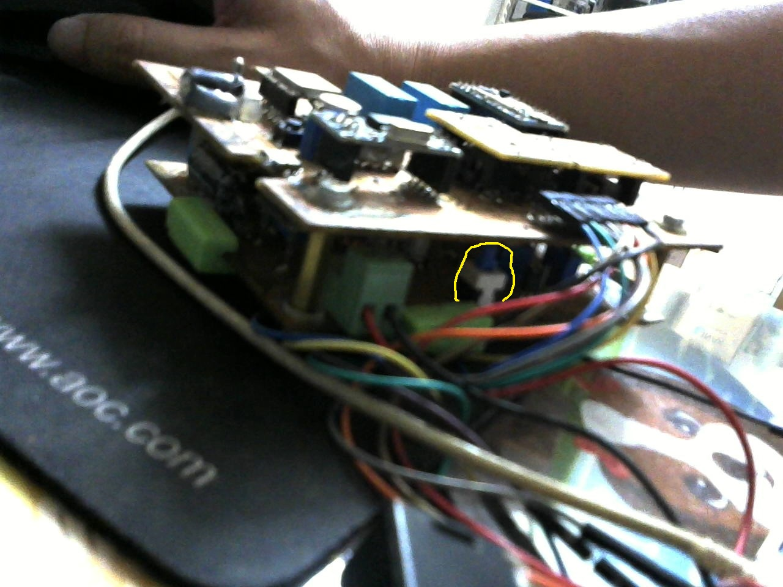

Caution: 5 seconds after pressing Power Switch, you should see a blink led. If not, battery should be replaced.

Caution: sometimes things do not work, try pressing RE (reset esp8266) or RA (reset arduino) buttons

II/ Flash ESP8266 With Correct Wifi Configuration:

1. Physical connection from micro Usb on DAQ board to computer

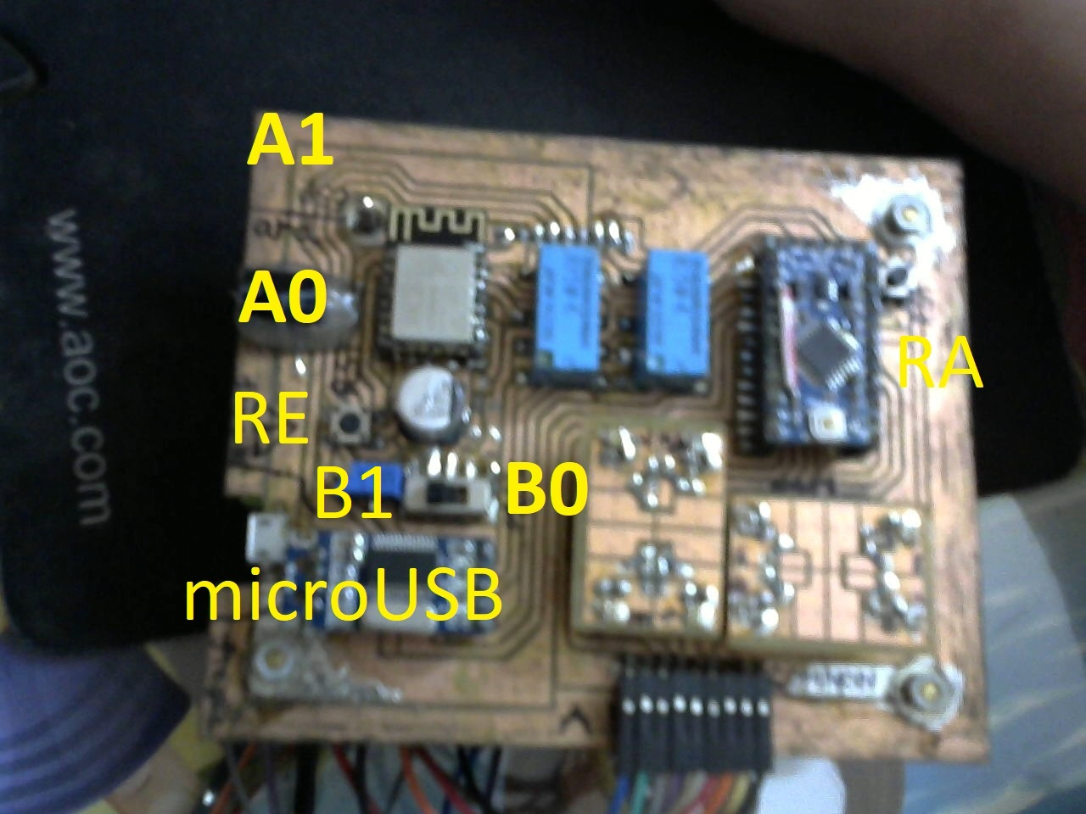

1. Switches: A1, B0
2. Configure Arduino IDE, board: generic ESP8266 module, choose correct port COM.
3. Open SmartShoeMonitorWith cmd

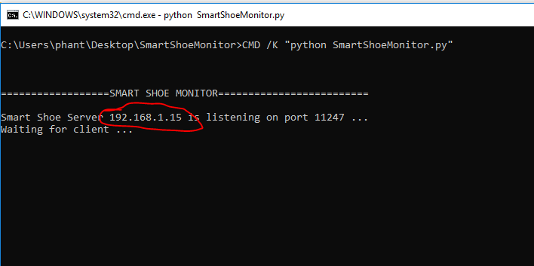

or type /> ipconfig /all

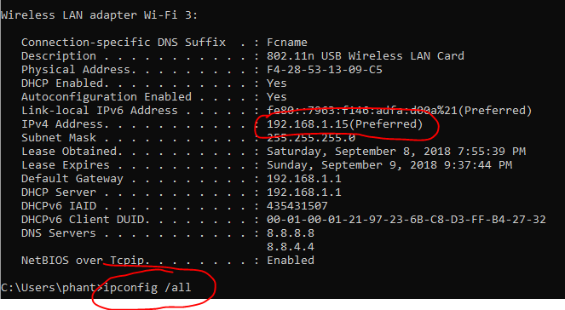

1. Modify wifi parameter in esp8266 file

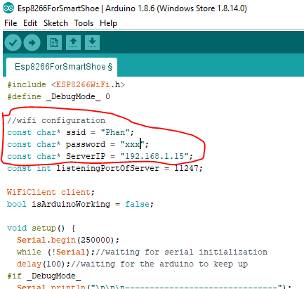

1. Then click upload button on Arduino IDE until things done

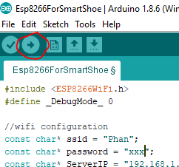

III/ Setting DAQ Board to using mode

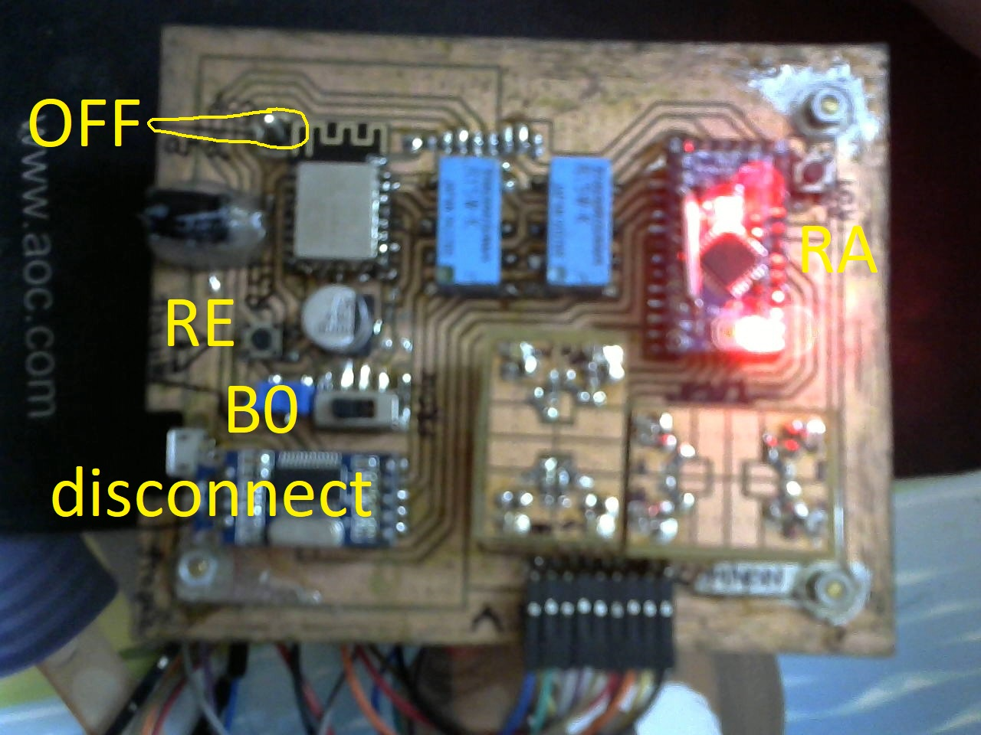

1. Disconnect usb cable
2. Switches: OFF, B0

IV) turn on Smart Shoe Monitor