**SOFTWARE DESIGN**

**FunixPricingChain**

**1. Architecture**

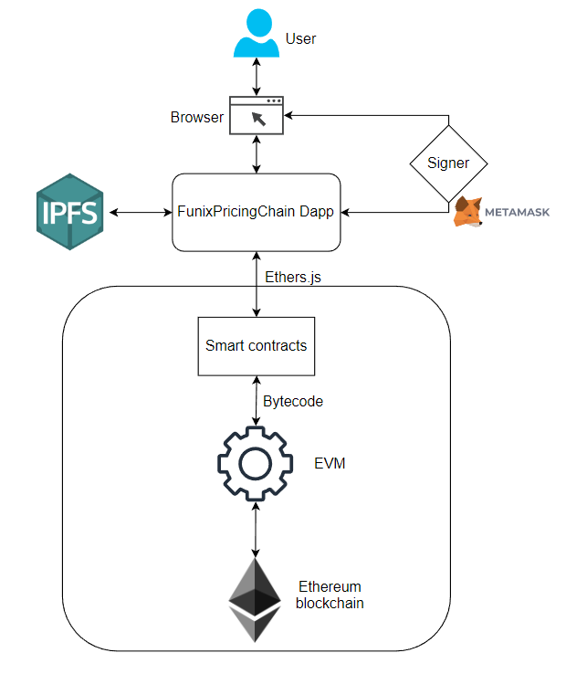

Figure High level architecture of FunixPricingChain Dapp

**2. Application Design**

**2.1. Main contract**

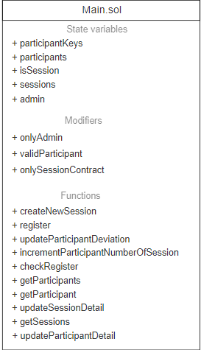

Figure main contract design

**2.2. Session contract**

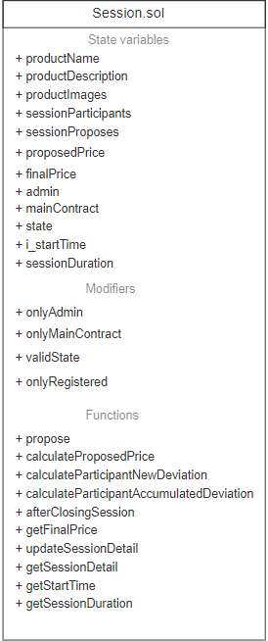

**3. Functional Design**

3.1. Main contract

3.1.1 createNewSession

* + - Function name: createNewSession
    - Function purpose: create new session
    - List of parameters:
      * string memory _productName,
      * string memory _productDescription,
      * string[] memory _productImages
      * uint256 _sessionDuration
    - Return type: Session

3.1.2 updateSessionDetail

* + - Function name: updateSessionDetail
    - Function purpose: change session information
    - List of parameters:
* address _sessionAddress,
* string memory _productName,
* string memory _productDescription,
* string[] memory _productImages
  + - Return type: Session

3.1.3 getSessions

* + - Function name: getSessions
    - Function purpose: get all sessions information
    - List of parameters: none
    - Return type: SessionDetail[] memory

3.1.4 register

* + - Function name: register
    - Function purpose: sign up for new user
    - List of parameters:
      * string memory _fullName
      * string memory _email
    - Return type: bool

3.1.5 updateParticipantDetail

* + - Function name: updateParticipantDetail
    - Function purpose: change user information (full name, email)
    - List of parameters:
      * string memory _fullName
      * string memory _email
    - Return type: void

3.1.6 getParticipant

* + - Function name: getParticipant
    - Function purpose: get user information
    - List of parameters: none
    - Return type: Participant memory

3.1.7 getParticipants

* + - Function name: getParticipants
    - Function purpose: get all users information
    - List of parameters: none
    - Return type: Participant[] memory

3.1.8 incrementParticipantNumberOfSession

* + - Function name: incrementParticipantNumberOfSession
    - Function purpose: increase number of session of participant who joins session by 1
    - List of parameters: address _account
    - Return type: void

3.1.9 updateParticipantDeviation

* + - Function name: updateParticipantDeviation
    - Function purpose: update user deviation
    - List of parameters:
      * address _account
      * uint256 _deviation
    - Return type: void

3.2. Session contract

3.2.1. propose

* + - Function name: propose
    - Function purpose: propose price
    - List of parameters:
* uint256 _price
  + - Return type: void

3.2.2 calculateProposedPrice

* + - Function name: calculateProposedPrice
    - Function purpose: calculate propose price based on given formula
    - List of parameters: none
    - Return type: void

3.2.3 calculateParticipantNewdeviation

* + - Function name: calculateParticipantNewdeviation
    - Function purpose: calculate user deviation based on given formula
    - List of parameters: none
    - Return type: uint256

3.2.4 calculateParticipantAccumulatedDeviation

* + - Function name: calculateParticipantAccumulatedDeviation
    - Function purpose: calculate user accumulated deviation based on formula
    - List of parameters:
      * uint256 _currentDeviation,
      * uint256 _numberOfJoinedSession,
      * uint256 _newDeviation
    - Return type: uint256

3.2.5 afterClosingSession

* + - Function name: afterClosingSession
    - Function purpose: set final price, update user’s deviation, number of joined session and change state to “CLOSED”
    - List of parameters:
      * uint256 _finalPrice
    - Return type: void

3.2.6 updateSessionDetail

* + - Function name: updateSessionDetail
    - Function purpose: change session information (name, description, images)
    - List of parameters:
      * string memory _productName,
      * string memory _productDescription,
      * string[] memory _productImages
* Return type: none

3.2.7 getSessionDetail

* + - Function name: getSessionDetail
    - Function purpose: get session detail
    - List of parameters: none
* Return type: SessionDetail memory

3.2.8 getFinalPrice

* + - Function name: getFinalPrice
    - Function purpose: get session final price
    - List of parameters: none
* Return type: uint256

3.2.9 getStartTime

* + - Function name: getStartTime
    - Function purpose: get session starting time
    - List of parameters: none
* Return type: uint256

3.2.10 getSessionDuration

* + - Function name: getSessionDuration
    - Function purpose: get session duration
    - List of parameters: none
* Return type: uint256