**SOFTWARE DESIGN**

**FunixPricingChain**

**1. Architecture**

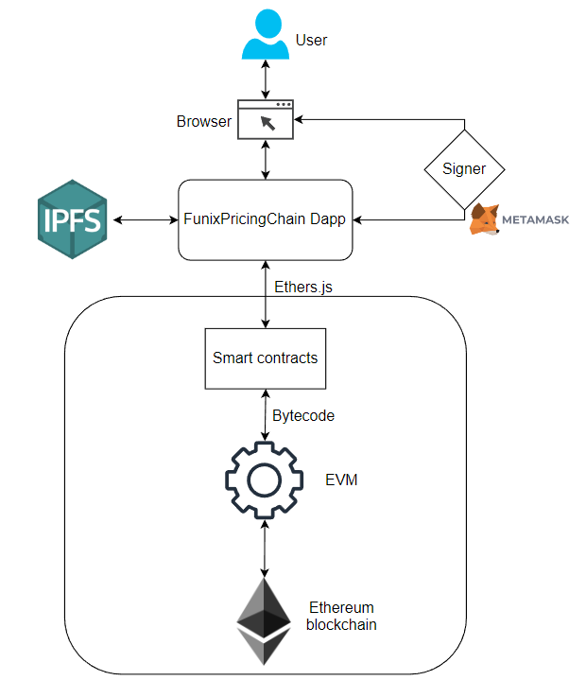

Figure 1 High level architecture of FunixPricingChain Dapp

**2. Application Design**

**2.1. Main contract**

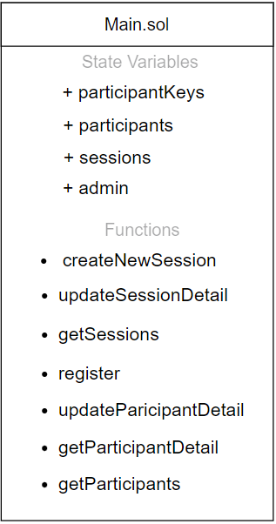

Figure 2 main contract design

**2.2. Session contract**

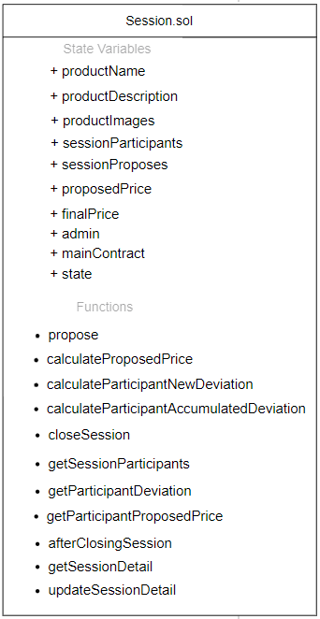

**3. Functional Design**

3.1. Main contract

3.1.1 createNewSession

* + - Function name: createNewSession
    - Function purpose: create new session
    - List of parameters:
      * string memory _productName,
      * string memory _productDescription,
      * string[] memory _productImages
    - Return type: Session

3.1.2 updateSessionDetail

* + - Function name: updateSessionDetail
    - Function purpose: change session information
    - List of parameters:
* address _sessionAddress,
* string memory _productName,
* string memory _productDescription,
* string[] memory _productImages
  + - Return type: Session

3.1.3 getSessions

* + - Function name: getSessions
    - Function purpose: get all sessions information
    - List of parameters: none
    - Return type: SessionDetail[] memory

3.1.4 register

* + - Function name: register
    - Function purpose: sign up for new user
    - List of parameters:
      * string memory _fullName
      * string memory _email
    - Return type: Session

3.1.5 updateParticipantDetail

* + - Function name: updateParticipantDetail
    - Function purpose: change user information (full name, email)
    - List of parameters:
      * string memory _fullName
      * string memory _email
    - Return type: none

3.1.6 getParticipant

* + - Function name: getParticipant
    - Function purpose: get user information
    - List of parameters: none
    - Return type: Participant memory

3.1.7 getParticipants

* + - Function name: getParticipants
    - Function purpose: get all user information
    - List of parameters: none
    - Return type: Participant[] memory

3.1.8 incrementParticipantNumberOfSession

* + - Function name: incrementParticipantNumberOfSession
    - Function purpose: increase number of session of participant who joins session by 1
    - List of parameters: address _account
    - Return type: none