##### Bài tập Tuần 5: JPA

1. Entity (model)

2. Util (Kết nối Database)

- tạo Entity manager factory

- Entity

3 DAO (interface)

4.. DAOImpl

5. Controller (Servlet)

6. JSP

Demo Bài 8: Quản lý điện thoại

**Cấu trúc tạo Web Application:**

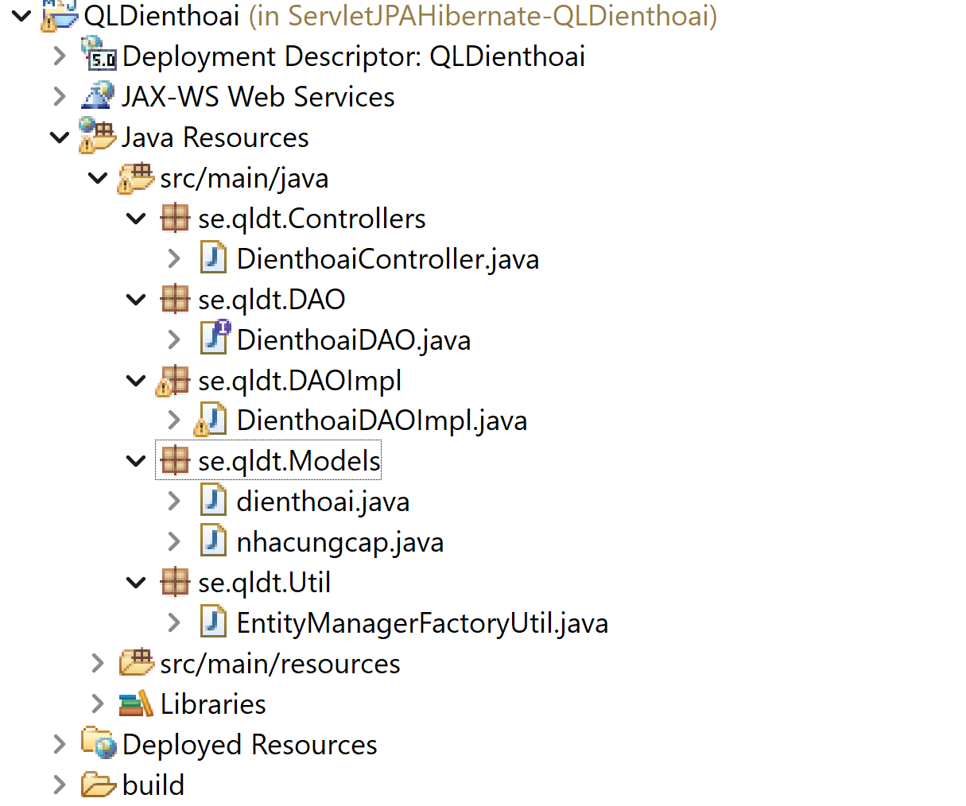

beans.xml

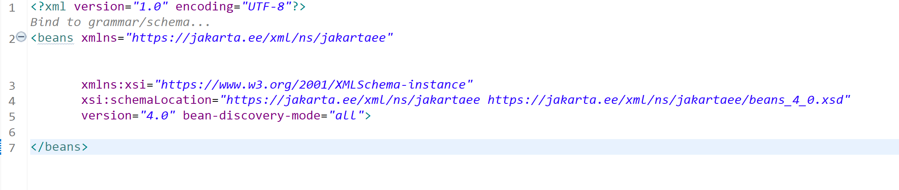

web.xml

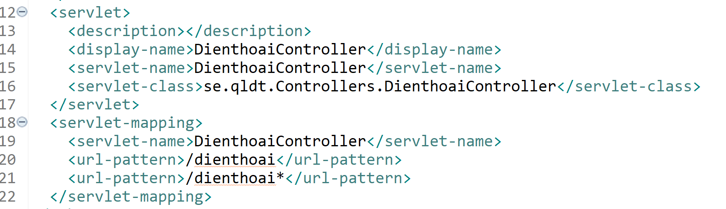

Tạo file persistence.xml đúng cấu trúc folder của web application

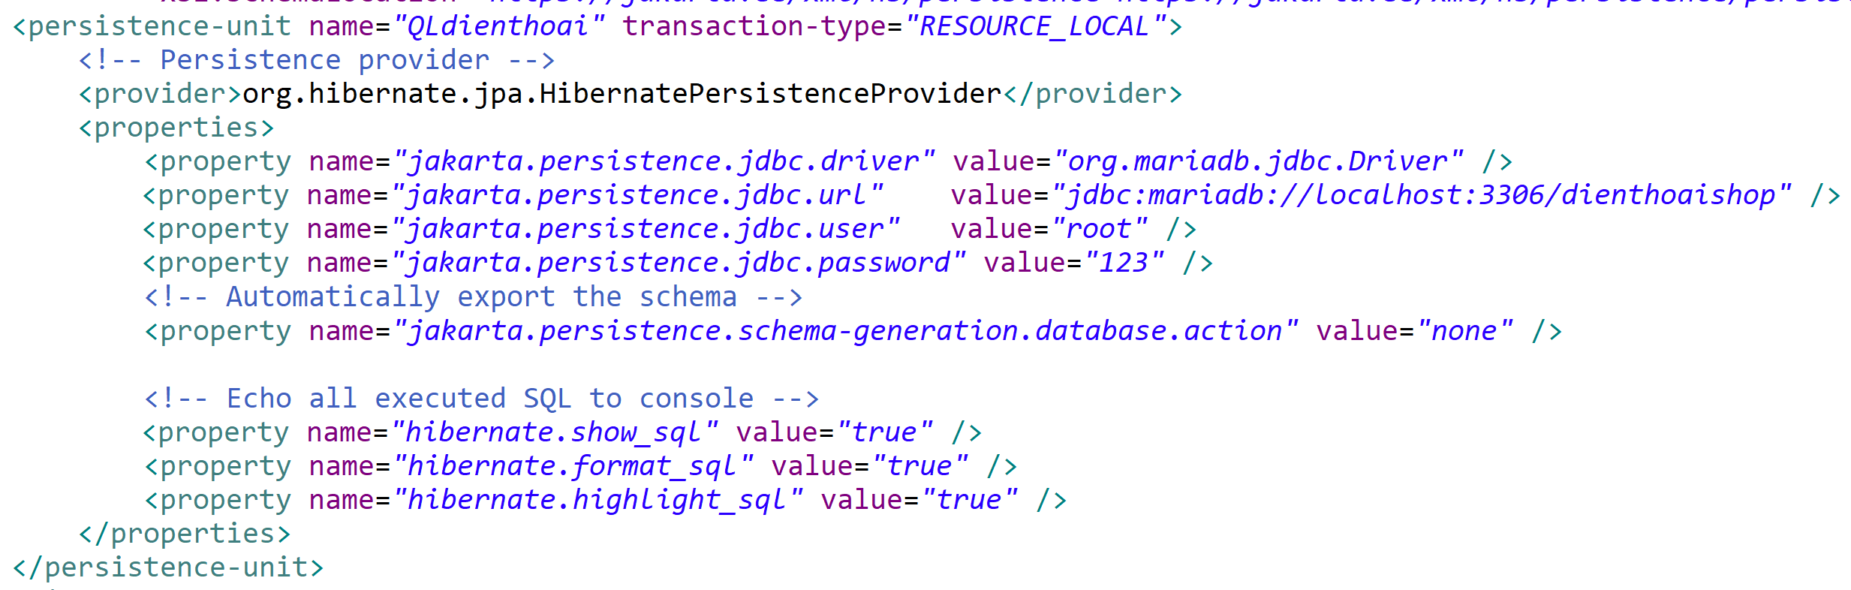

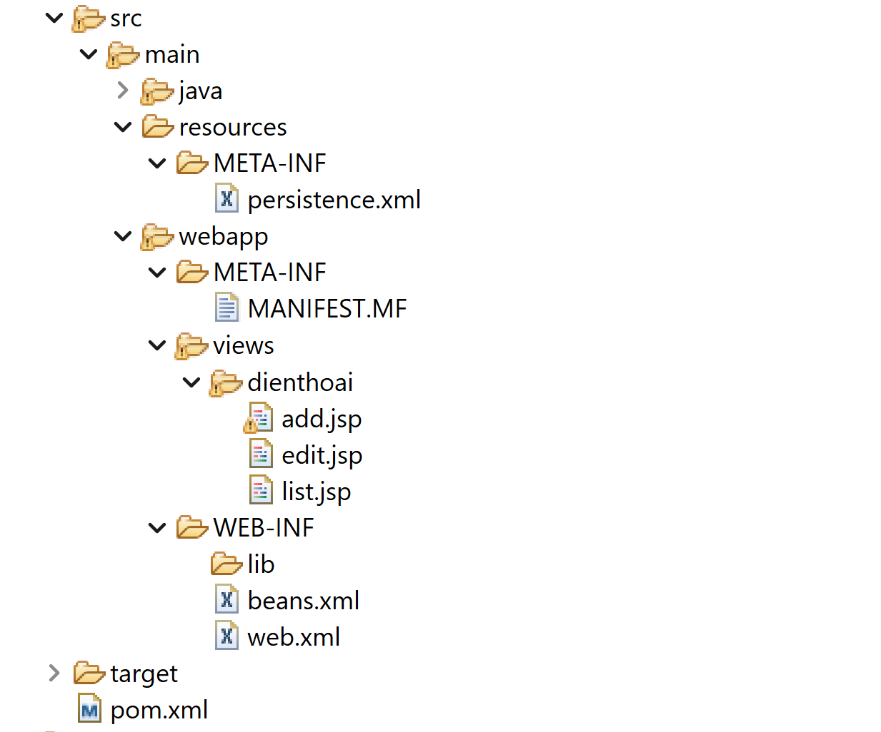

**Yêu cầu:**

1. JPA – Hibernate

- validation phía client: javaScript,jQuery

- validation

**Bước 0: Thiết lập dependencies**

- JSP

<https://mvnrepository.com/artifact/jakarta.servlet/jakarta.servlet-api>

<https://mvnrepository.com/artifact/jakarta.servlet.jsp/jakarta.servlet.jsp-api>

<https://mvnrepository.com/artifact/jakarta.servlet.jsp.jstl/jakarta.servlet.jsp.jstl-api>

<https://mvnrepository.com/artifact/org.glassfish.web/jakarta.servlet.jsp.jstl>

- Jakarta persistence API 3.1,3.2 <https://mvnrepository.com/artifact/jakarta.persistence/jakarta.persistence-api>

- Hibernate core 6.4 <https://mvnrepository.com/artifact/org.hibernate/hibernate-core>

- Hibernate-validator server <https://mvnrepository.com/artifact/org.hibernate.validator/hibernate-validator/8.0.1.Final>

- MariaDB maven MariaDB Java Client <https://mvnrepository.com/artifact/org.mariadb.jdbc/mariadb-java-client/3.0.8>

- Servlet <https://mvnrepository.com/artifact/org.jboss.weld.servlet/weld-servlet>

**Tham khảo link:**

<https://jakarta.ee/learn/docs/jakartaee-tutorial/current/beanvalidation/bean-validation/bean-validation.html>

Project: package

<https://jakarta.ee/specifications/bean-validation/3.0/jakarta-bean-validation-spec-3.0.html>

Thực hiện:

Bước 1: Entity:

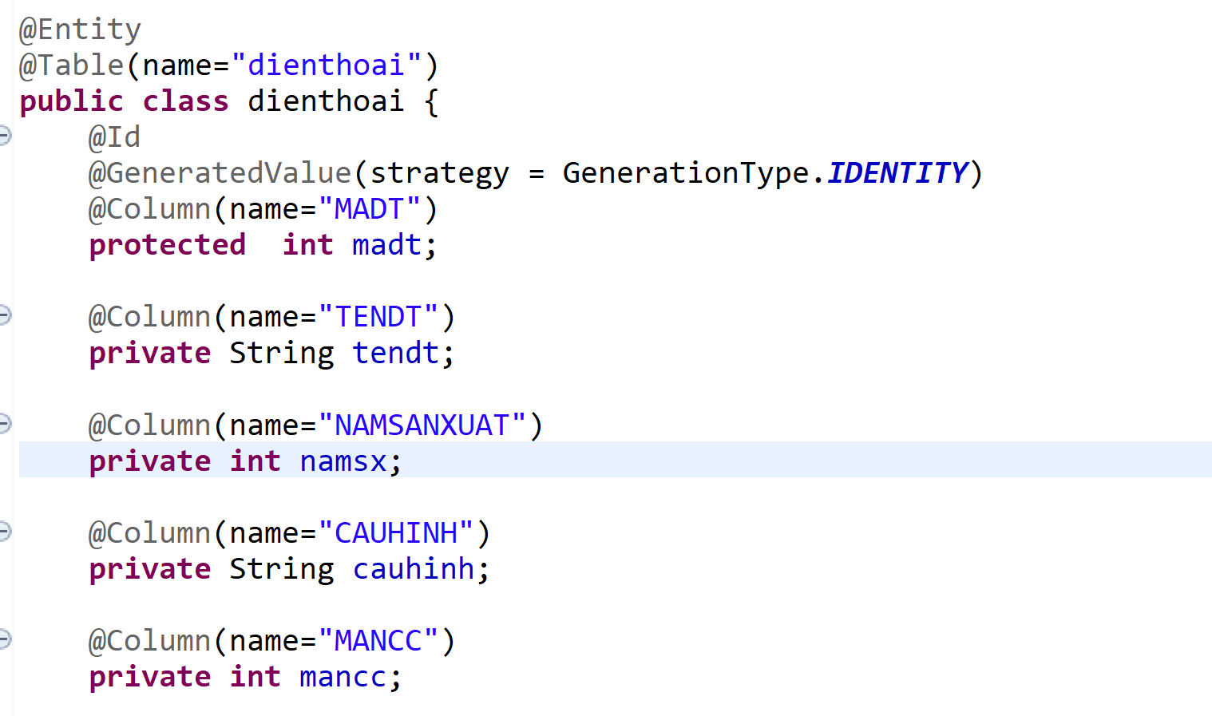

Bước 2: Util :

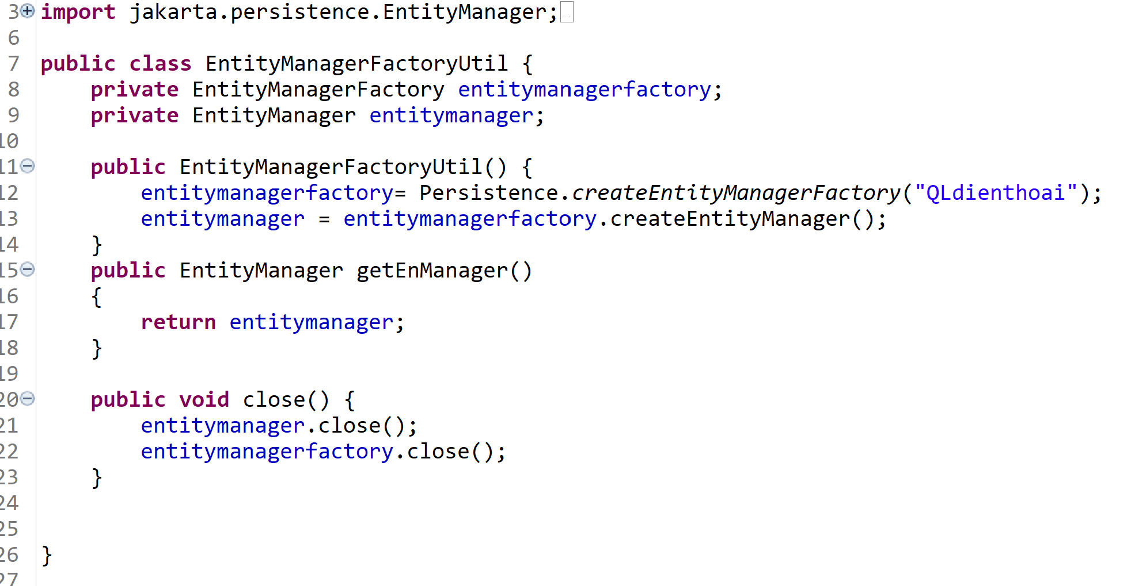

Bước 3: InterfaceDAO

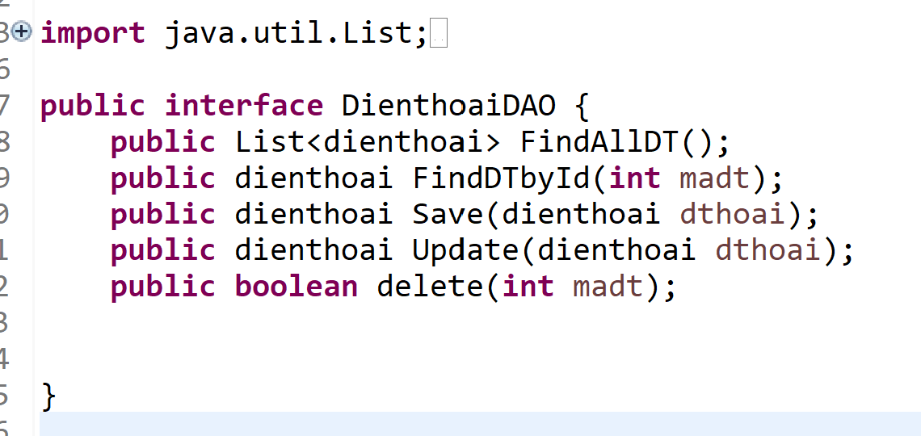

Bước 4: DAO Impl

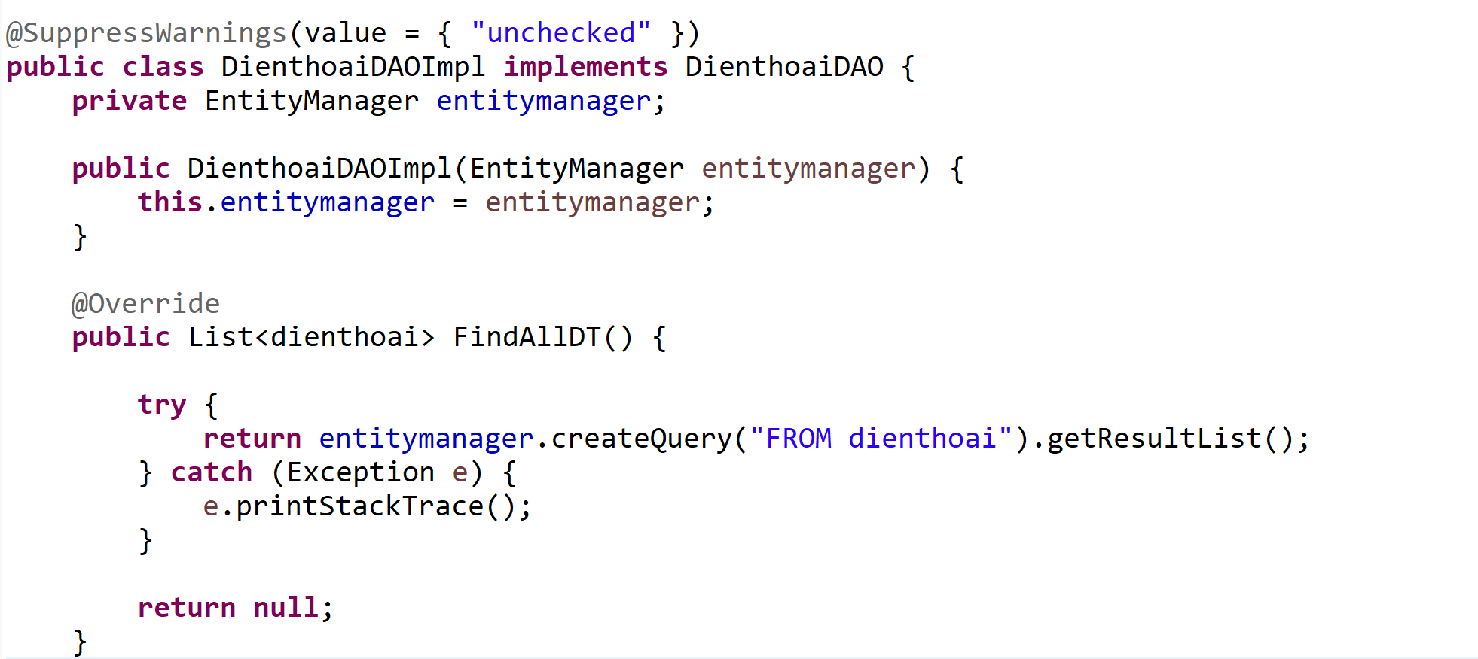

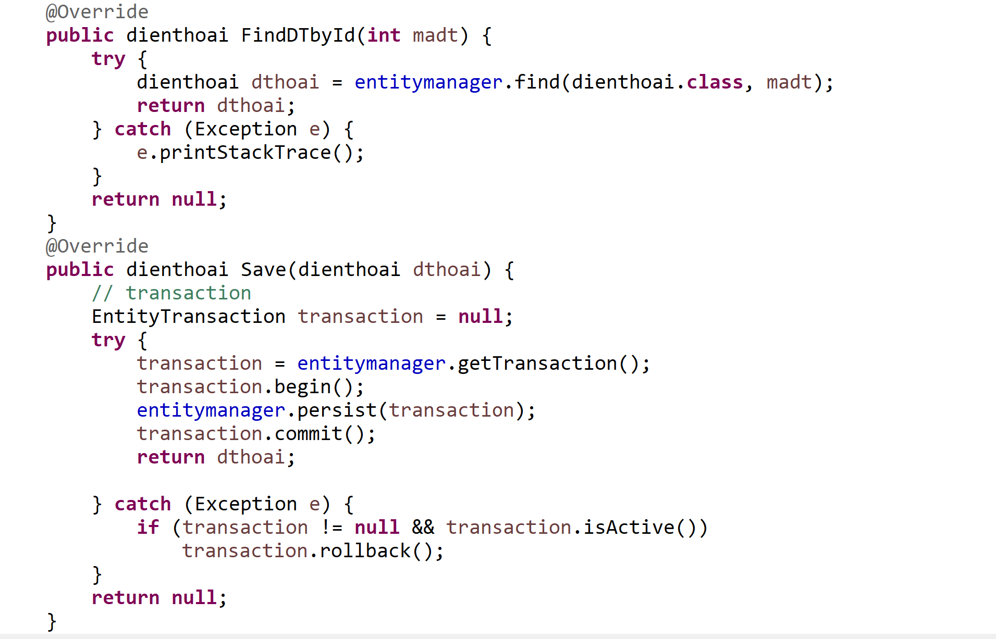

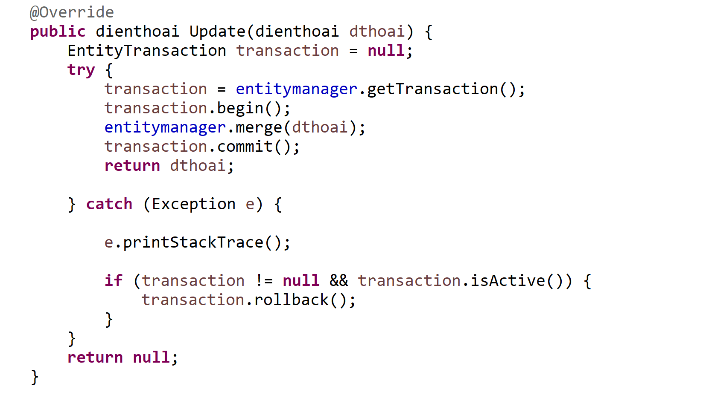

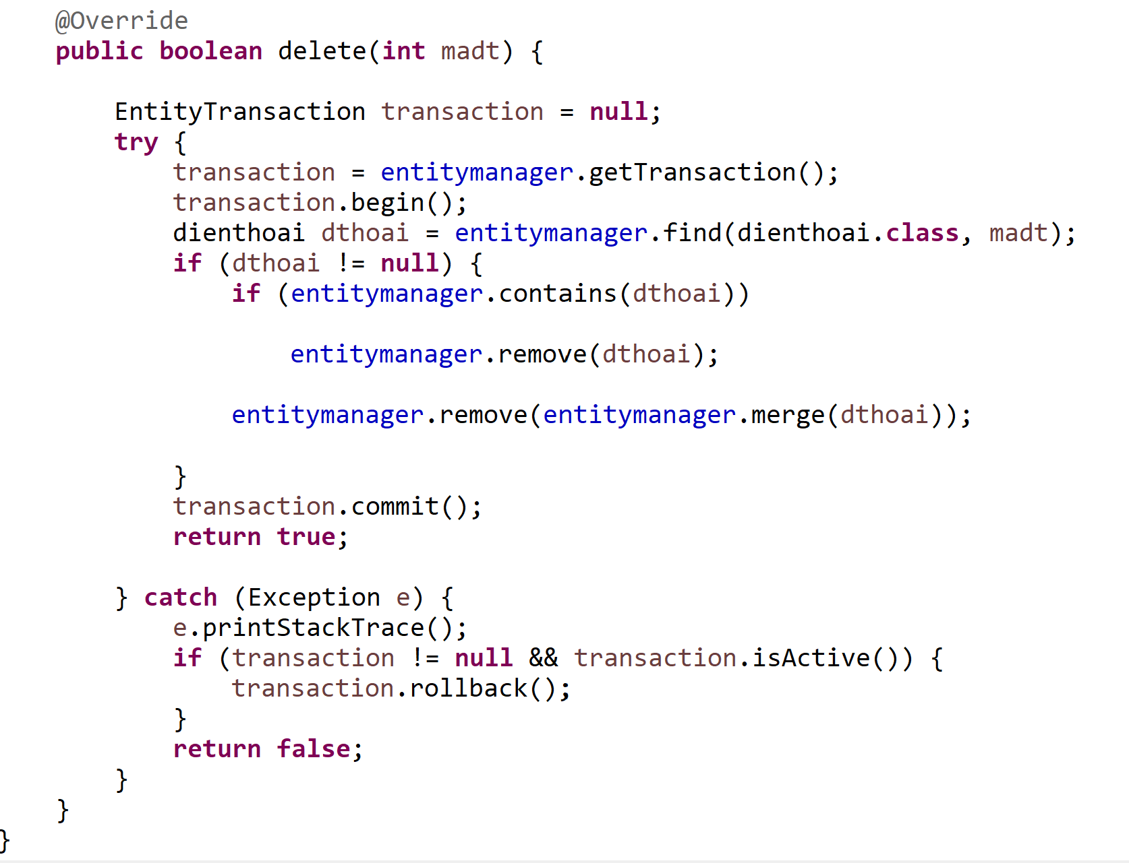

Bước 5: Controller

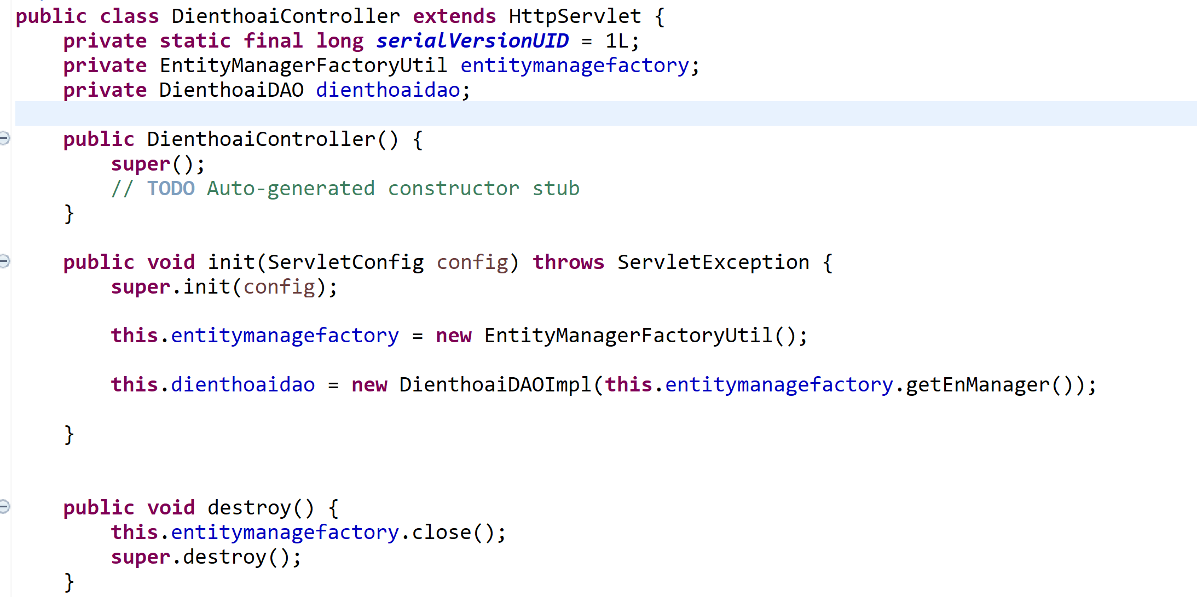

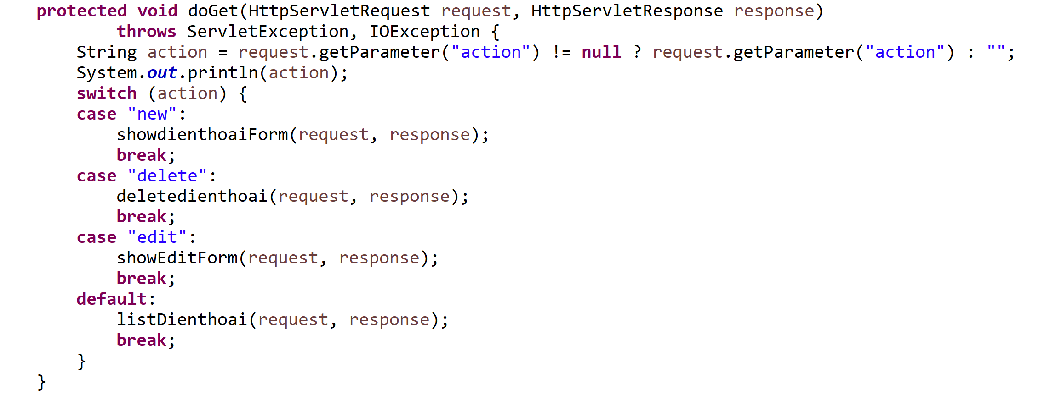

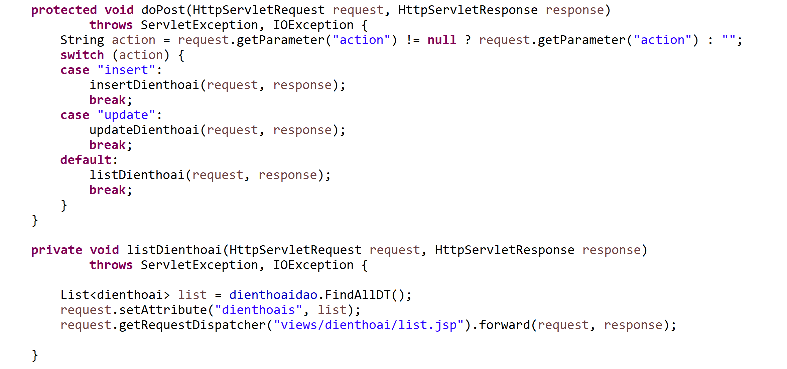

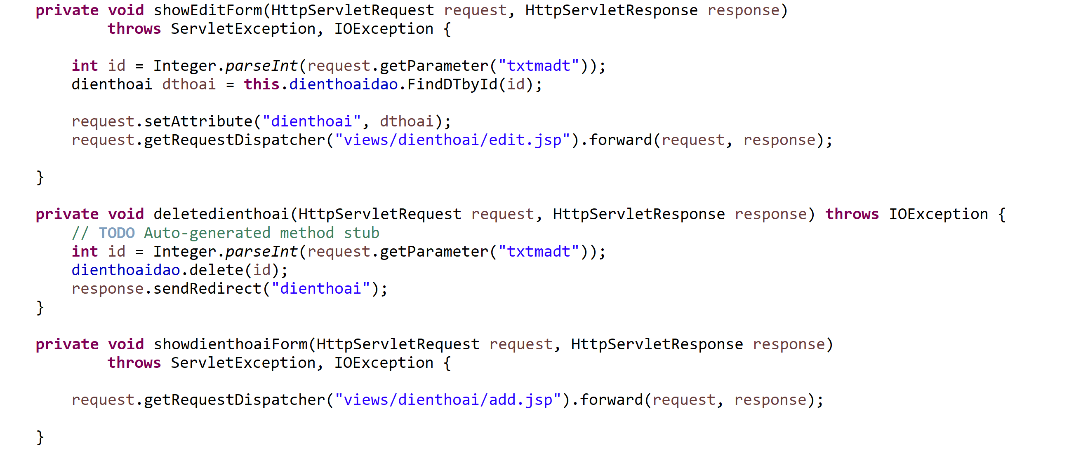

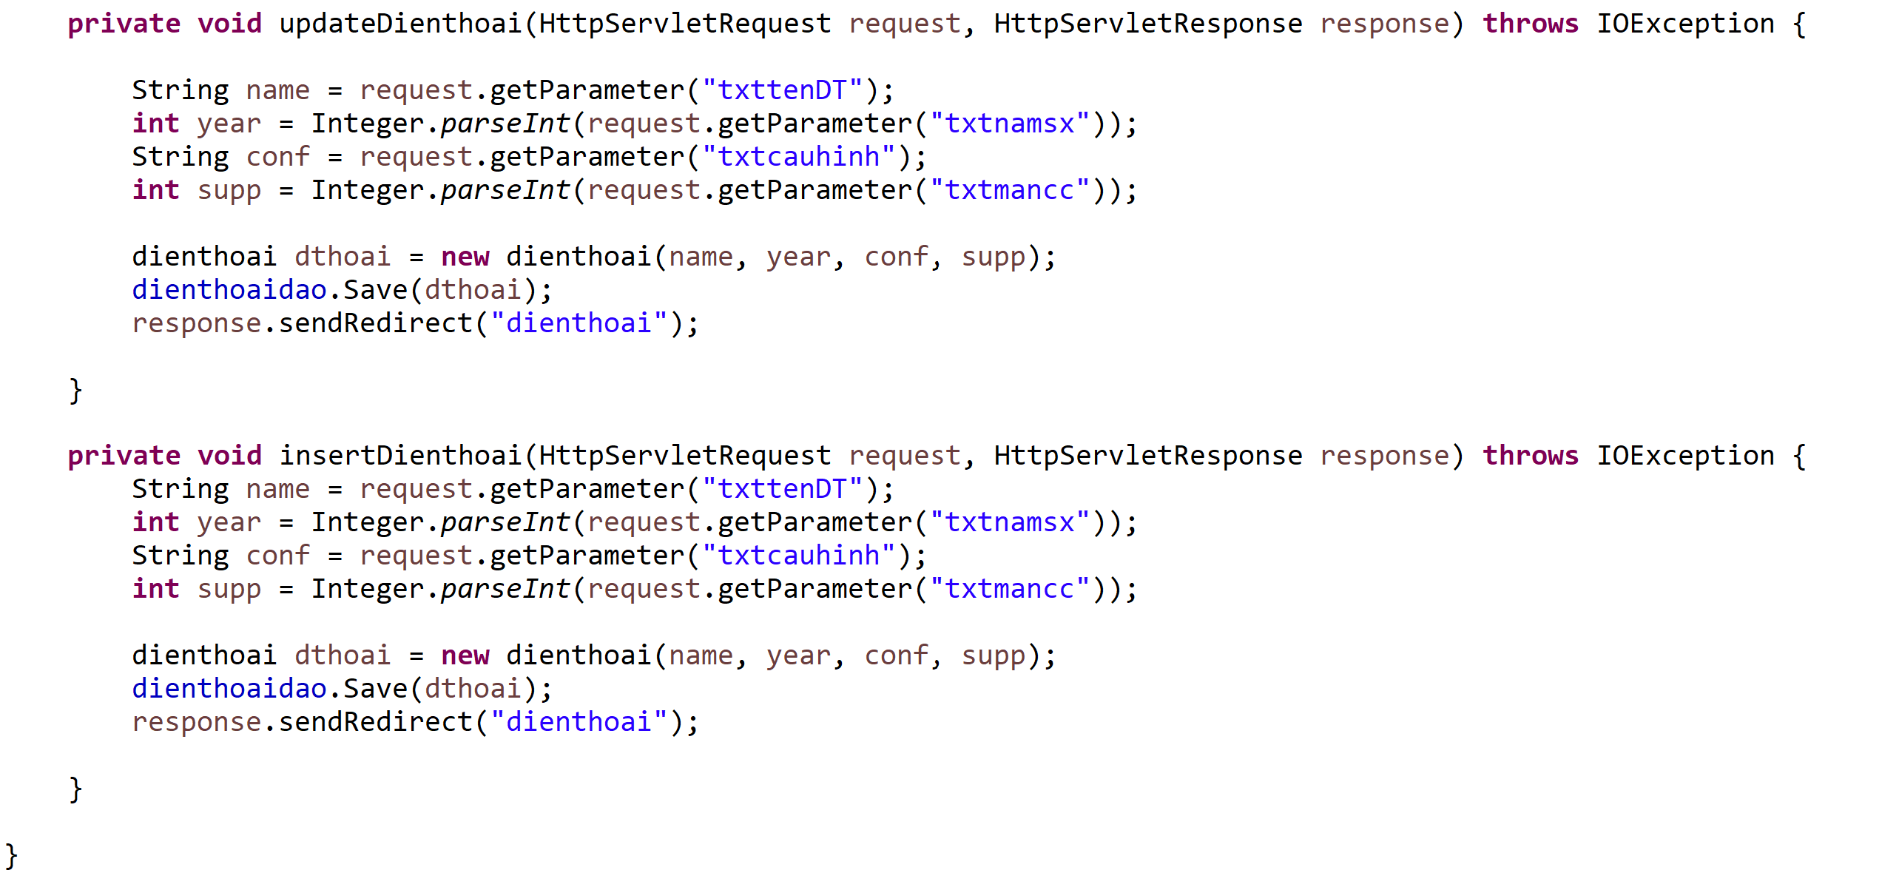

Bước 6: Tạo các views .jsp

list.jsp

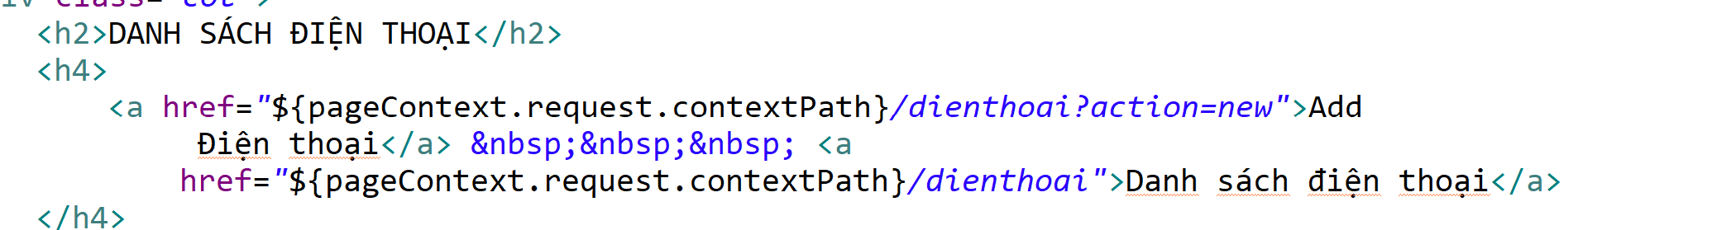

….

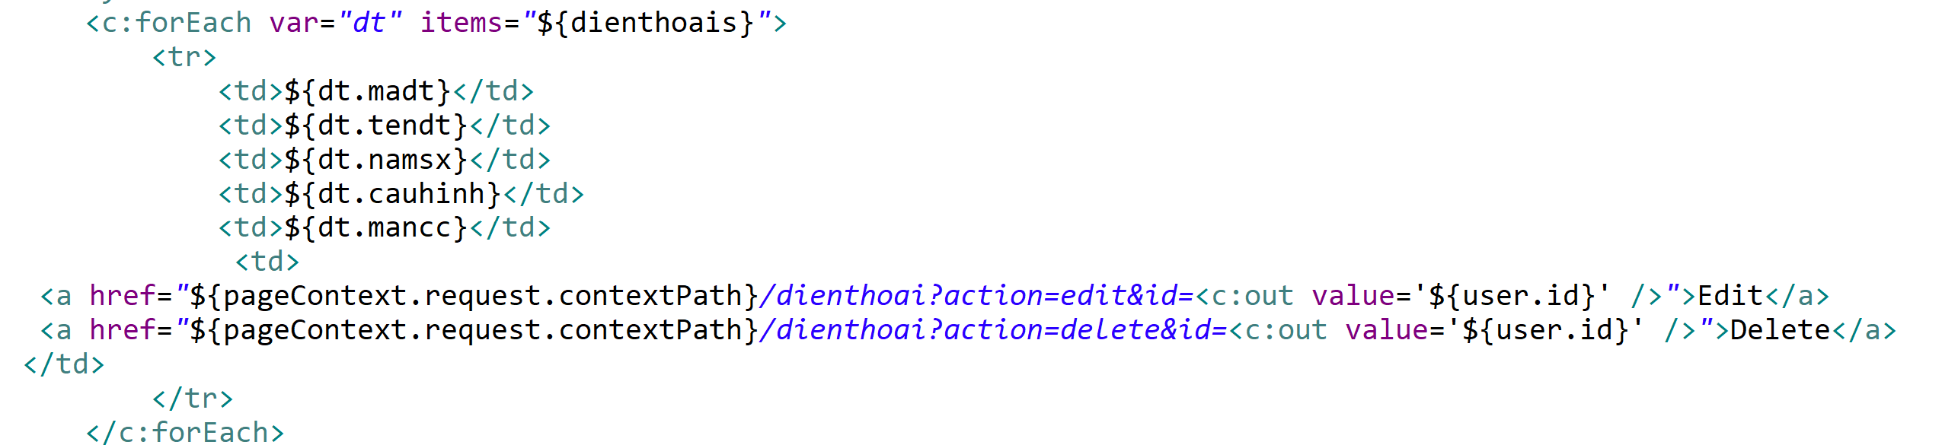

add.jsp

