Scene Text Detection and Recognition by CRAFT and a Four-Stage Network demo

By Phan Dinh Tuong

References:

Main demo page: <https://towardsdatascience.com/pytorch-scene-text-detection-and-recognition-by-craft-and-a-four-stage-network-ec814d39db05>

(Detection) CRAFT : <https://github.com/clovaai/CRAFT-pytorch>

(Recognition) <https://github.com/clovaai/deep-text-recognition-benchmark>

Main:

Step 1: Clone this repo

(do it yourself)

Step 2: Install Requirements (idk if this works, I already did it or something)

Step 3: put your test image files in testFolder folder

Step 4: Detect text region:

WARNING: From this step, the path may not be correct for different devices, please change it to match yours.

Open terminal and cd to CRAFT-pytorch, run pipeline.py:

Result:

Step 5: Crop the text region (word actually)

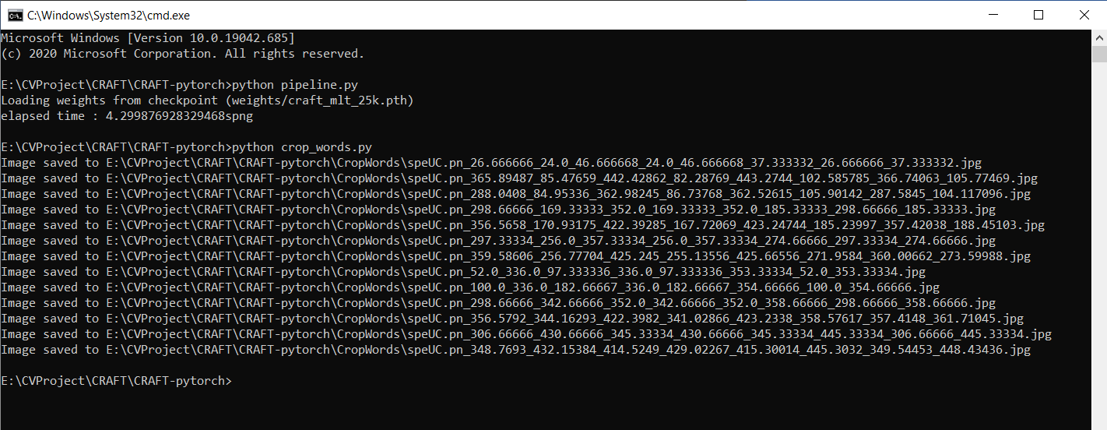

Result:

Step 6: Recognition

Cd to deep-text… and run, watch result:

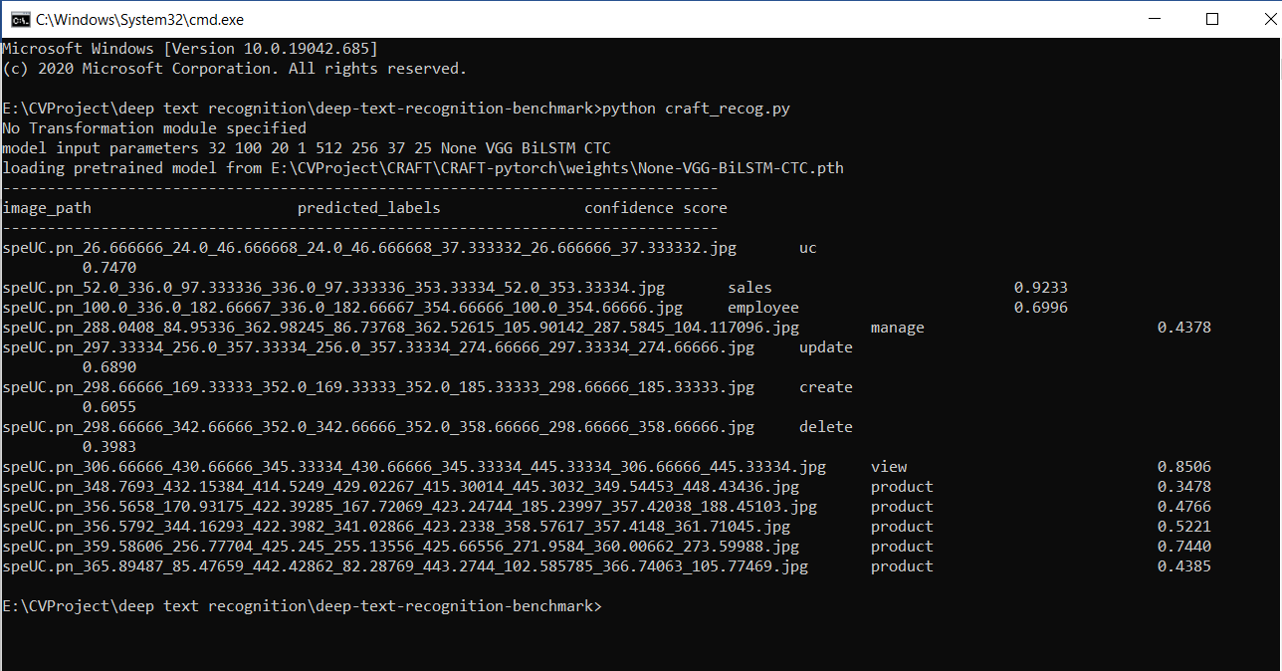

Result also saved in:

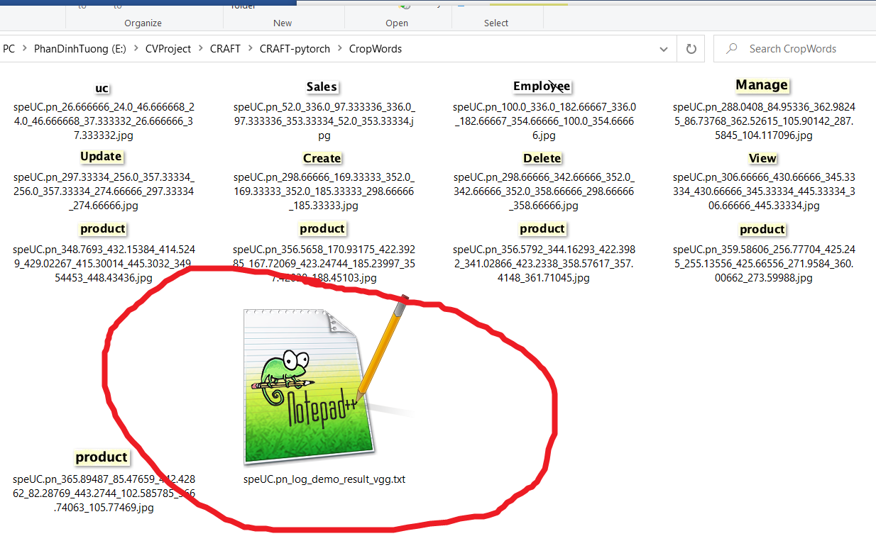

Open that file:

