DIMS(96, 96, 3)

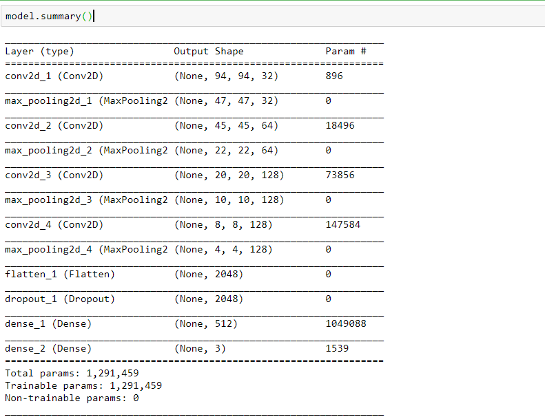

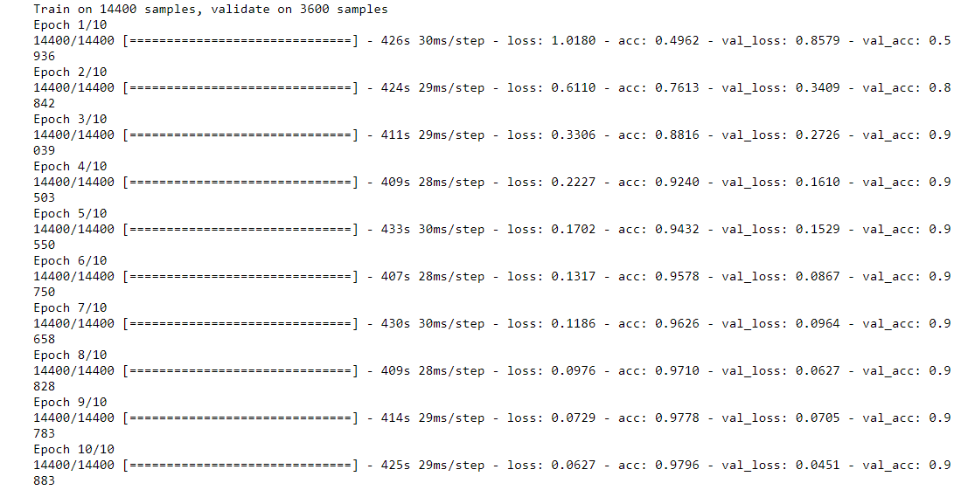

tensorboard --logdir=my_log_dir

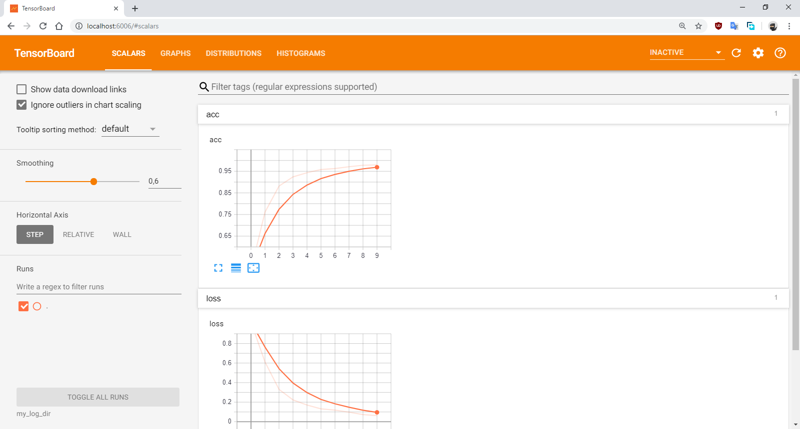

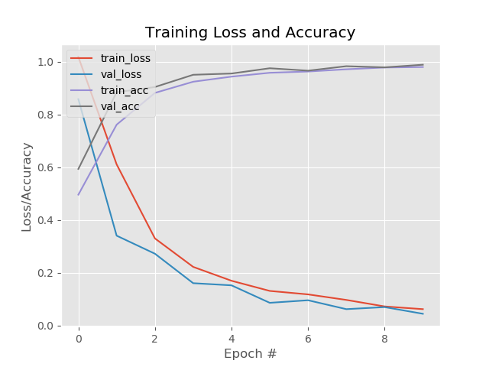

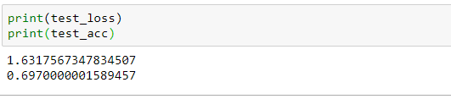

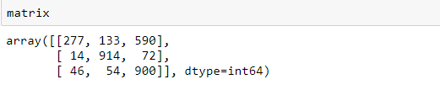

DIMS(50, 50, 3)

+ smallCNN

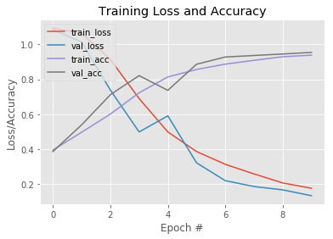

print(test_loss): 1.5466697259346645

print(test_acc):

0.6543333333333333

Fusion matrix:

[[376 112 512]

[ 58 811 131]

[165 59 776]]

+ leNet5

