**OS MINI PROJECT**

**Project Name**:

SETTING REMINDER

Submitted by

M Phaneendhar reddy 411642

M Bala Subramanyeswara reddy 411649

**Overview**

It is a piece of code that beginners could understand as a  
practical and useful starting point to learn simple shell scripting.  
It is called 'Setting reminder' and generates a seriously annoying pop-up for the given time(secs), programmable, with a reminder text of  
your choice.

**Goals**

* To be notified for your friend’s birthday
* Your mom sees that you are messing with your machine and says something like, "can you keep an eye on the dinner, I am going out shopping", and you look up glazed eyed and say, "yes mom, absolutely".Sadly you forget and the dinner is burnt…WW III is about to start...

In these cases it will be really helpful

* This is just superb for remembering your anniversary, the wife's  
  birthday, etc, etc, as it is SOOOO annoying...

**Specifications**

* The project is written in shell script(GNU bash version 4.4.23)
* The shell script is run on Ubuntu
* Basic linux commands were used in the code

**Working of shell script(program)**

On program entry place the first program argument "$1" into a variable called "text".Now place "$2" into a variable called "countdown".

Clear the terminal window using terminal ANSI escape sequences. Now take "$1" OR "$2" and compare them as a _string_ literal to a NULL _string_, then if true goes to if statement.

Ensure that the default timer countdown value at least exists. ensure that a valid _string_ literal exists. print a usage message to the terminal window. Ensure a valid working numerical value for the timer countdown. If any characters other than contiguous numbers exist then set the default countdown value. Now ensure it is within given the limits, 30 to 300...

Print the __arguments__ in parent window. Now create a zero length file, (in this case), into /tmp/reminder.sh. Ensure that once created it is able to be executed. Now create the relevant file to run externally. A shebang line is the first one to be APPENDED to the zero length file.

Using "printf" to print the "text" and ANSI escape, "\", codes to set the "text" to bold, 12 lines.down and 3 spaces in. Reset the "text" back to normal and then APPEND again to /tmp/reminder.sh.

The "\n" are just newlines to remove the cursor away from your string when printed. Add a delay to this code and APPEND again to /tmp/reminder.sh. Ensure that after the delay this new script exits with a return code of 0 and APPEND to /tmp/reminder.sh.

echo "exit 0" >> /tmp/reminder.sh

The new script is now ready to be called.

Now loop this new script indefinitely until "Ctrl-C" is pressed in the parent terminal window to stop. Display your reminder for about 3 seconds.

Use Ctrl-C to stop during this "countdown" break after xterm has closed down.

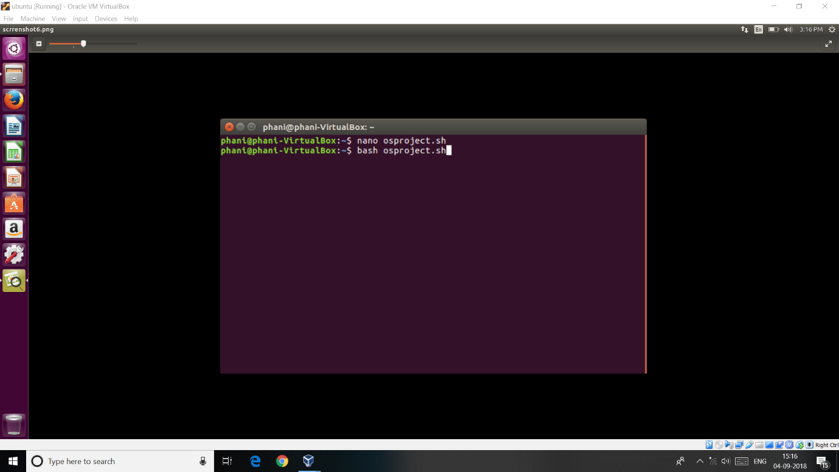

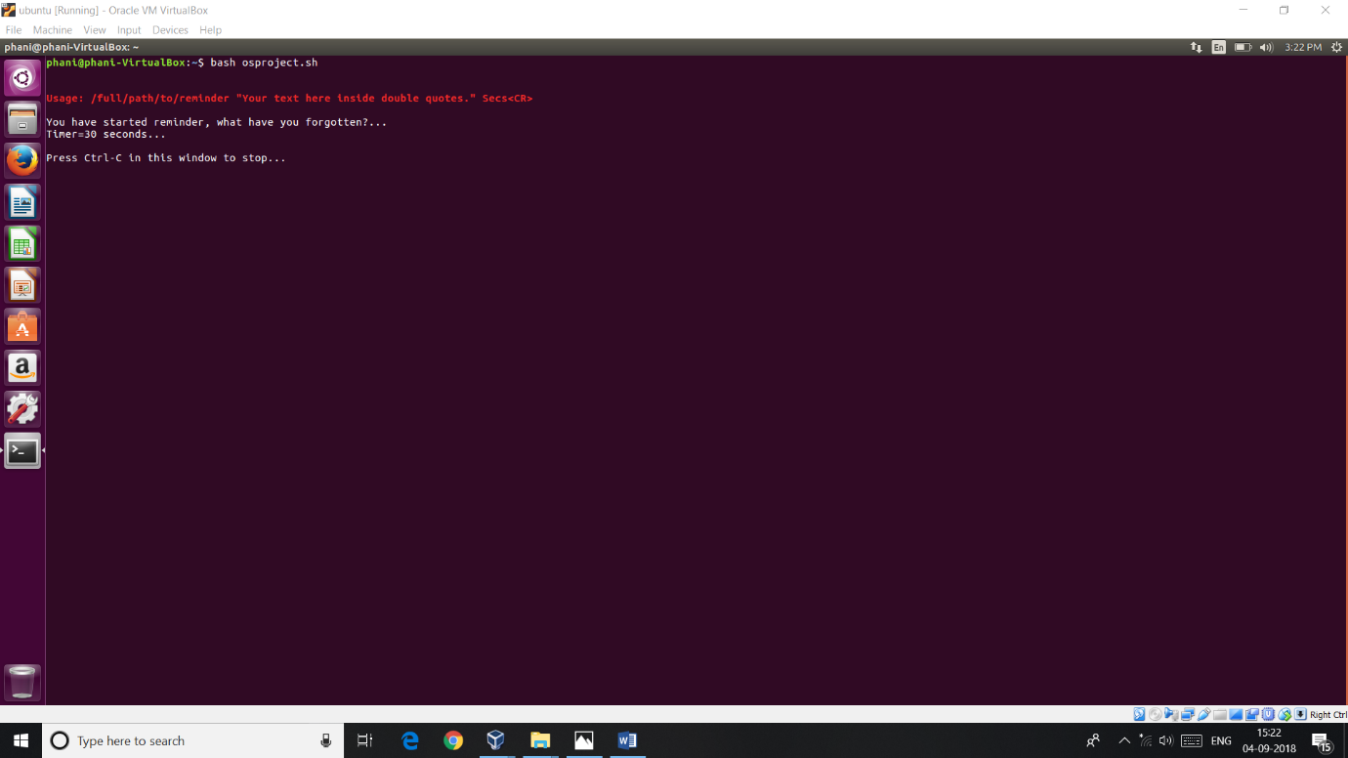

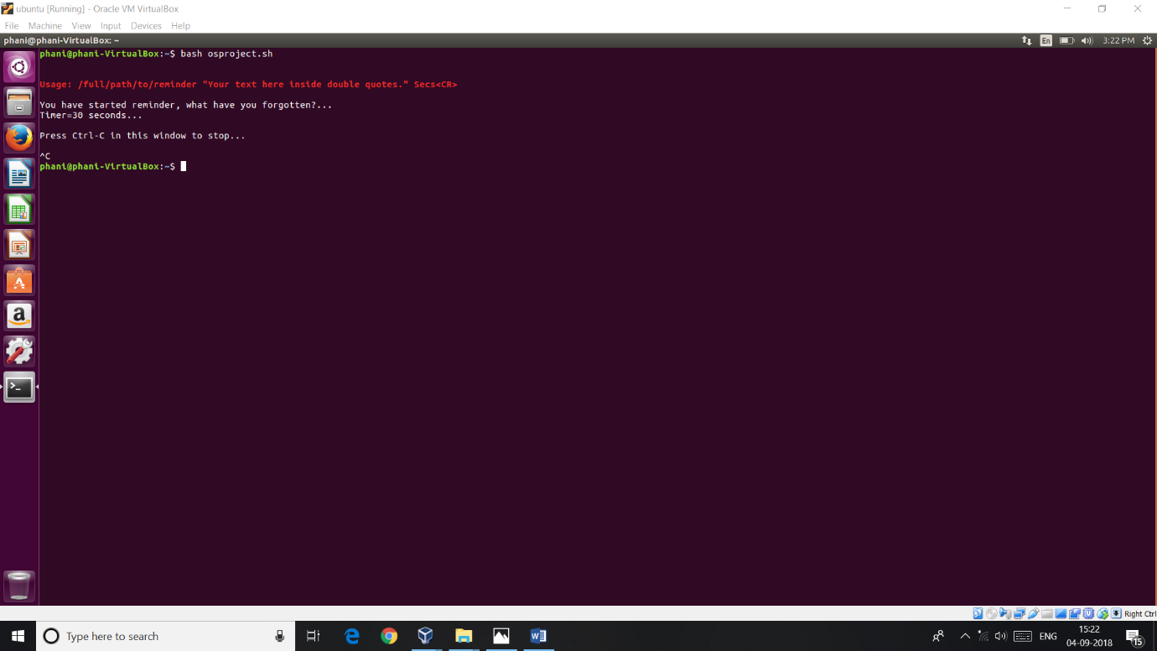

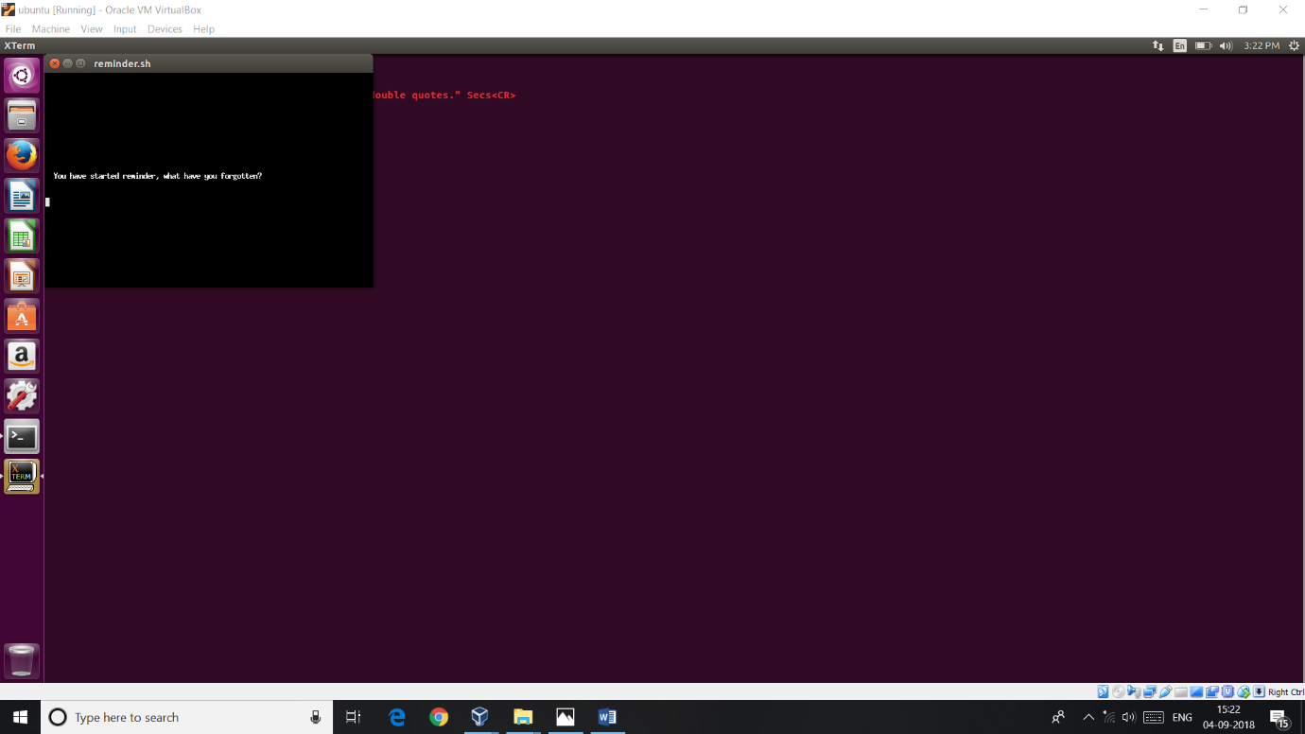

**Outcome**

Thus you can set your reminder when ever you want and also especially during the important events that you cannot miss.

**Limitations:**

This project works only when the process is running,if the process get killed then it will not generate any kind of notification.