ARM7TDMI PROGRAMMING
WEEK-5

PHANEESH
PES1UG20CS584
J SECTION
1. Write a program in ARM7TDMI–ISA to generate fibonacci Series and store them in an array.
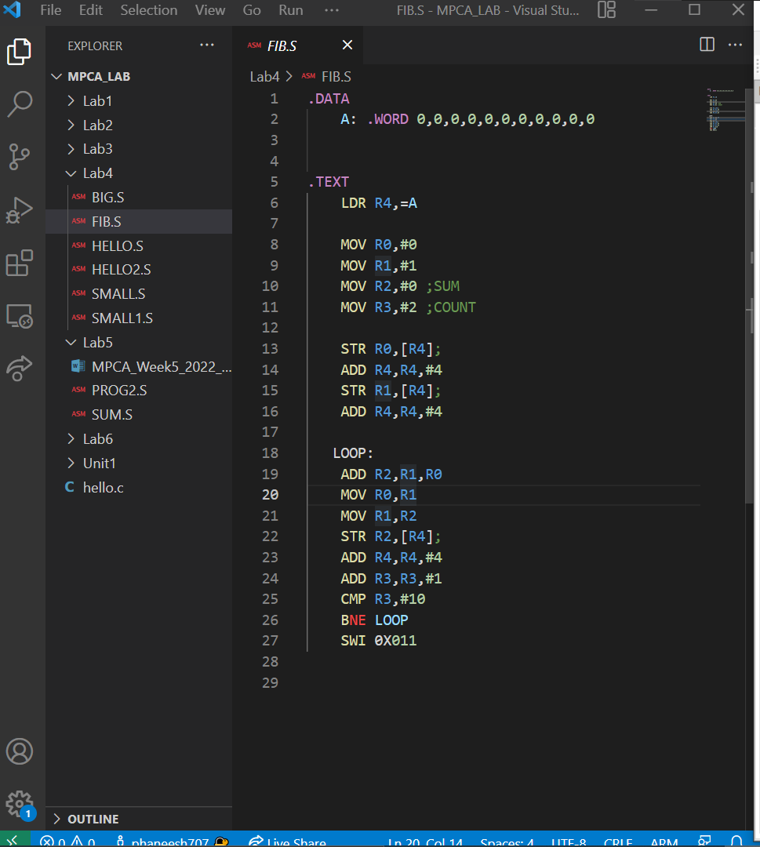
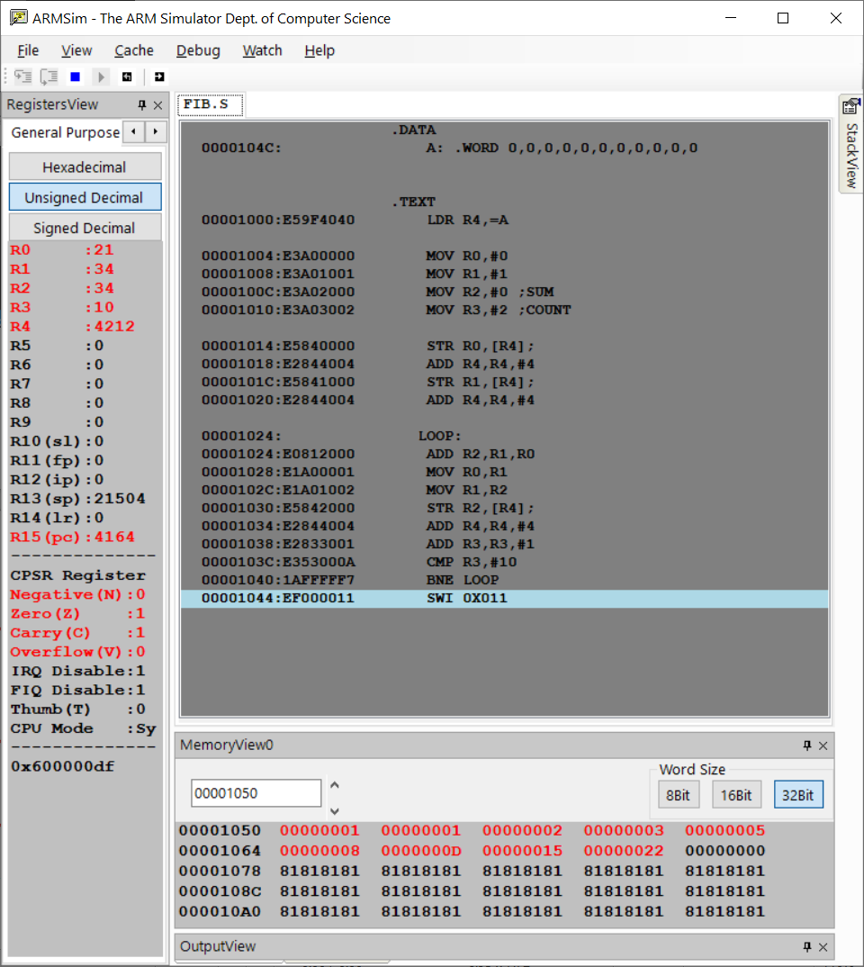

2. Write a program in ARM7TDMI–ISA to find smallest number in an array of n 32 bit numbers. Display the element if found.
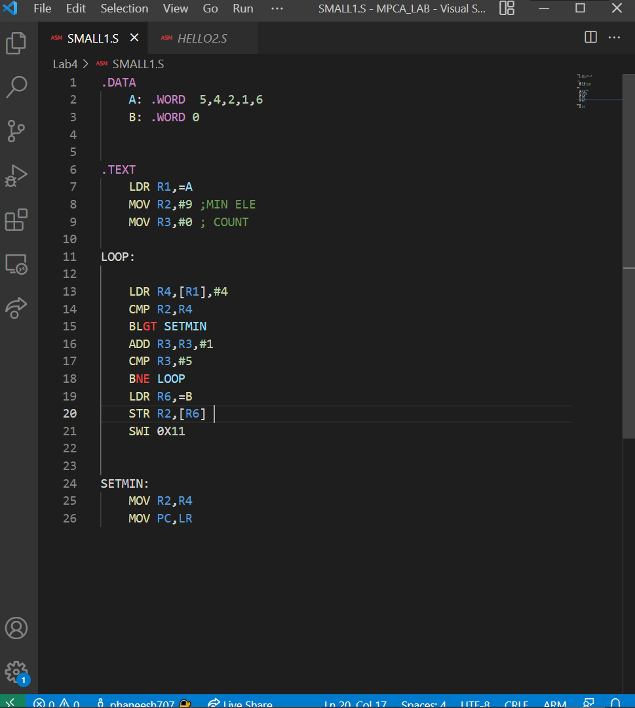
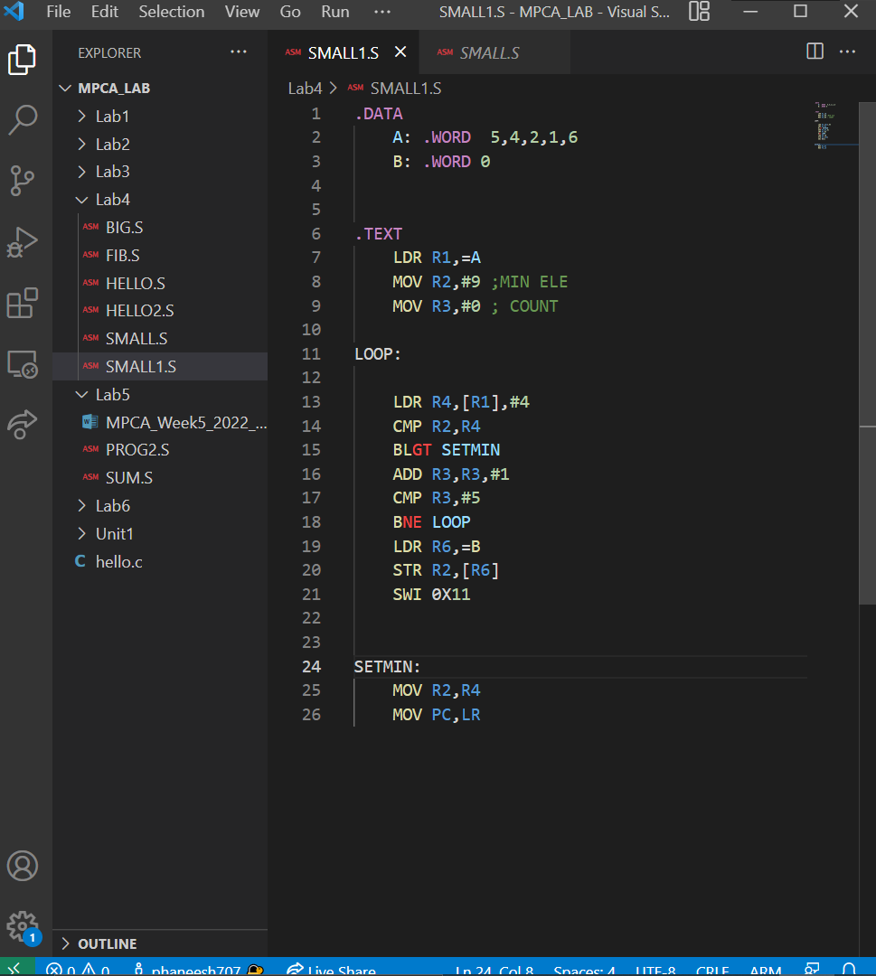
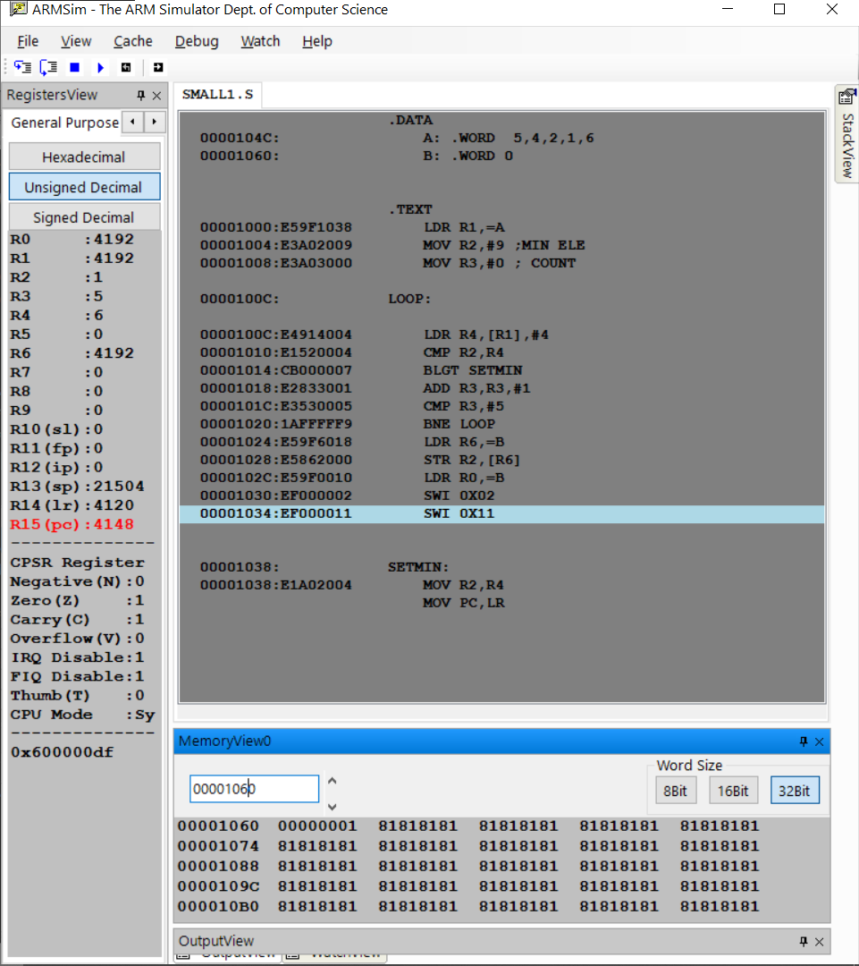

3. Write a program in ARM7TDMI–ISA to add 2 matrices of order3. i.e., implement c[i][j] = a[i][j] + b[i][j].
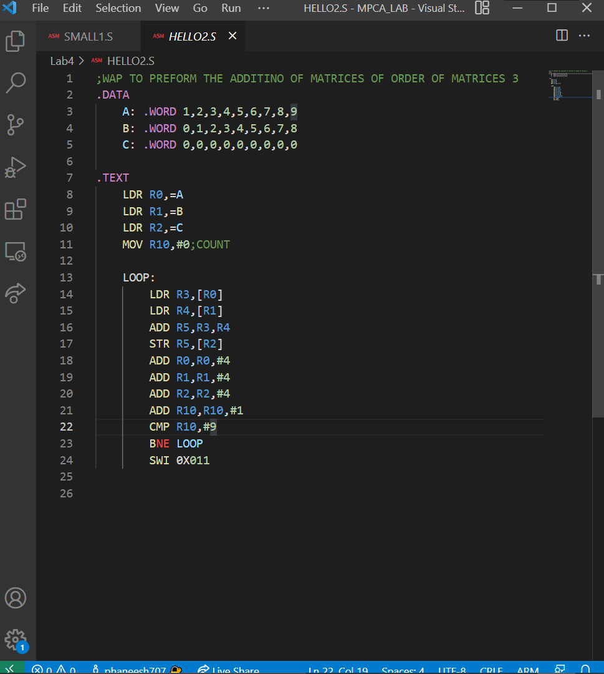
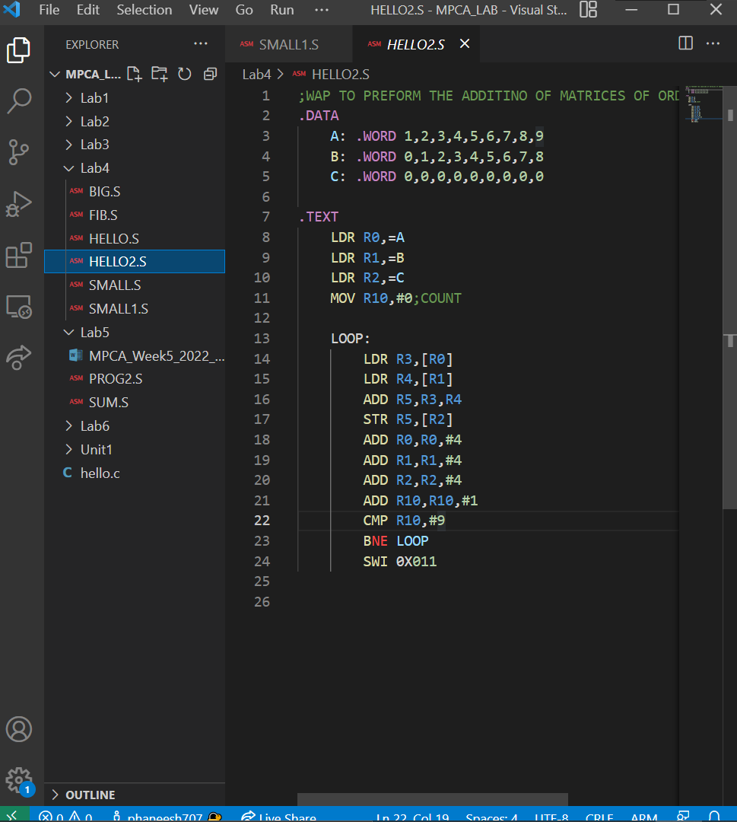
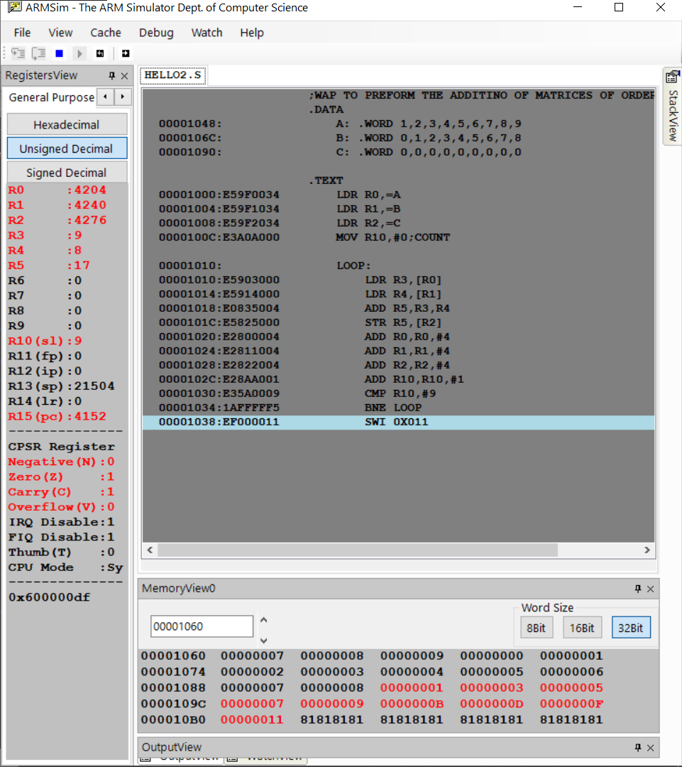

4. Write a program in ARM7TDMI–ISA to transfer a block of 256 words stored at memory location X to memory location Y using Load Multiple and Store Multiple instructions. The rate of transfer is 32 bytes.
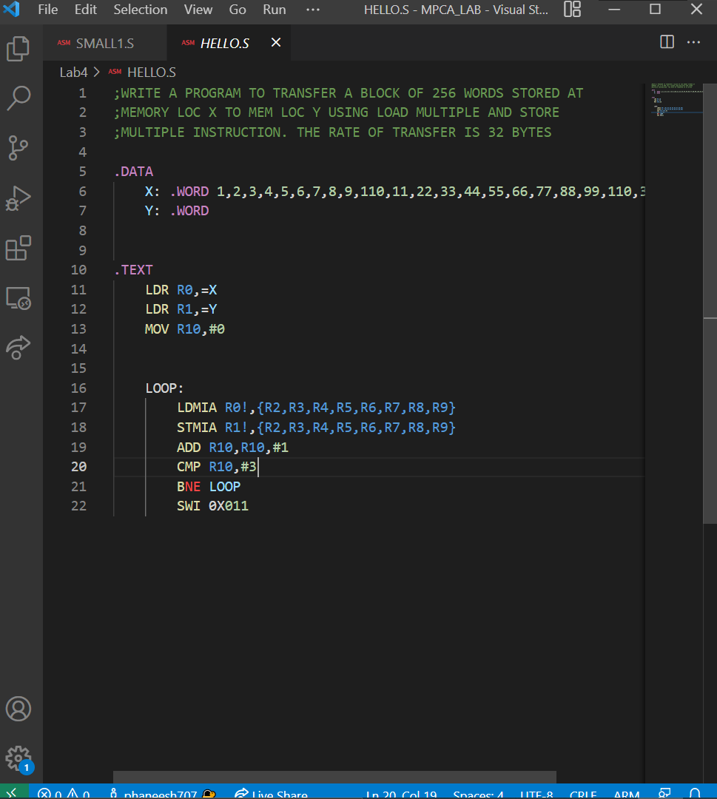
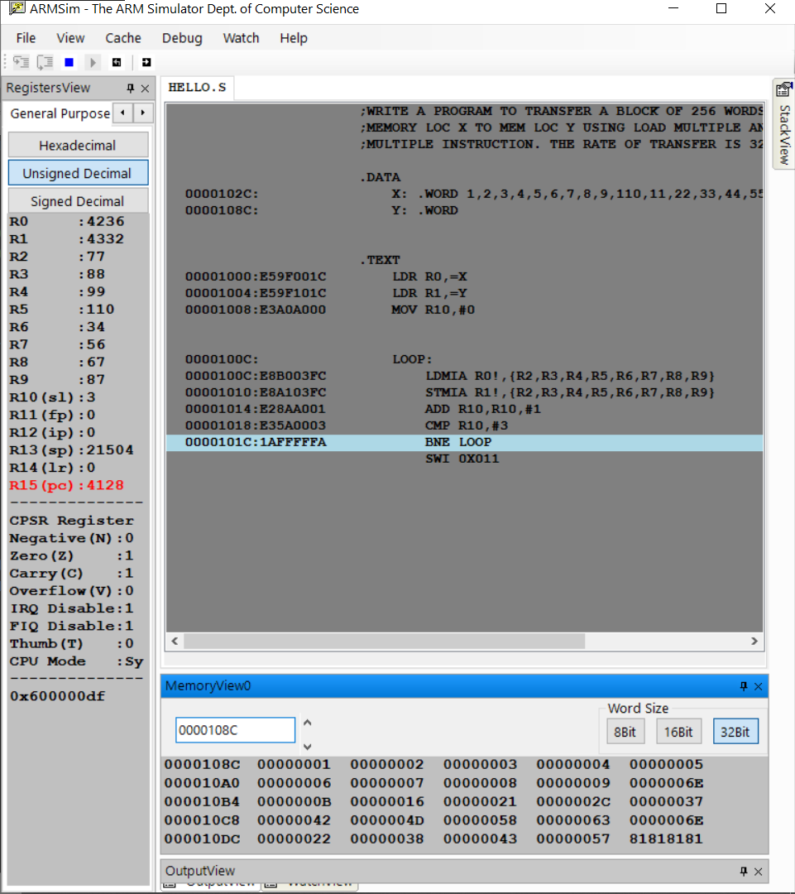

Student exercises:
1. Write a program in ARM7TDMI–ISA to multiply 2 matrices of order3. i.e., implement c[i][j] = c[i][j] + a[i][j] x b[i][j].
a. Use MLA instruction
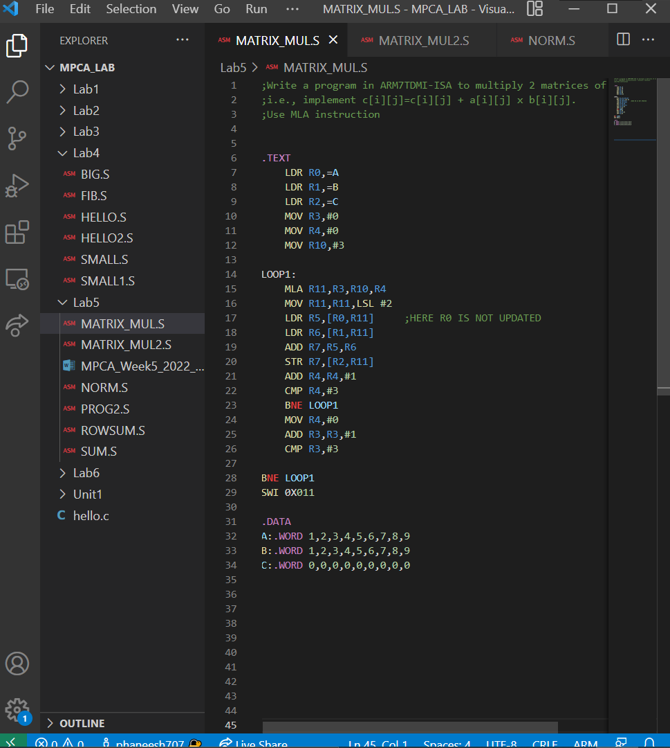
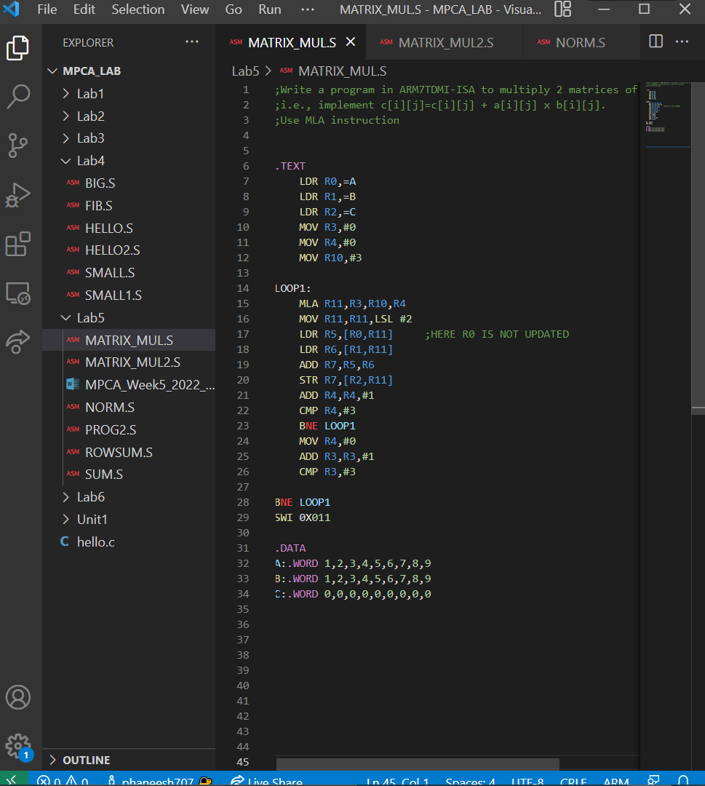
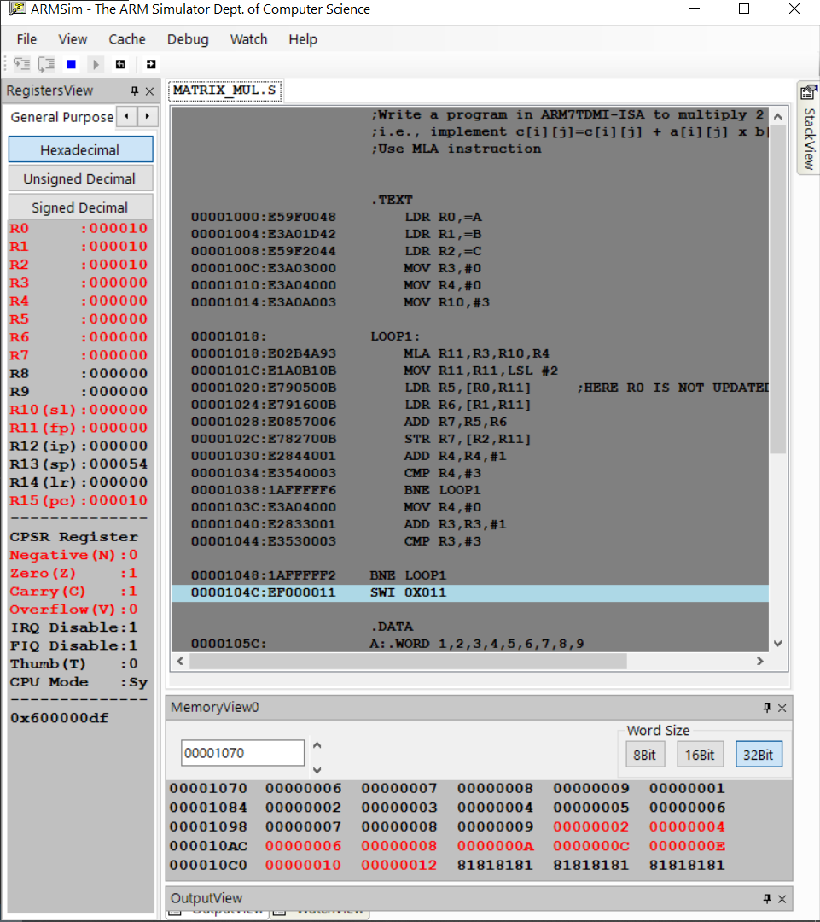

b. Use MUL instruction
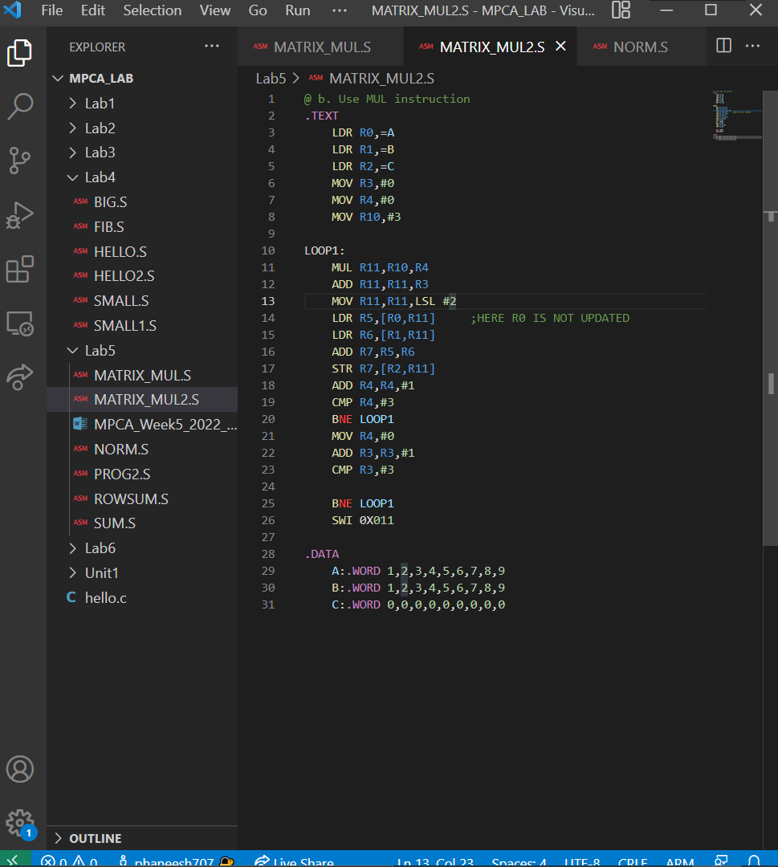
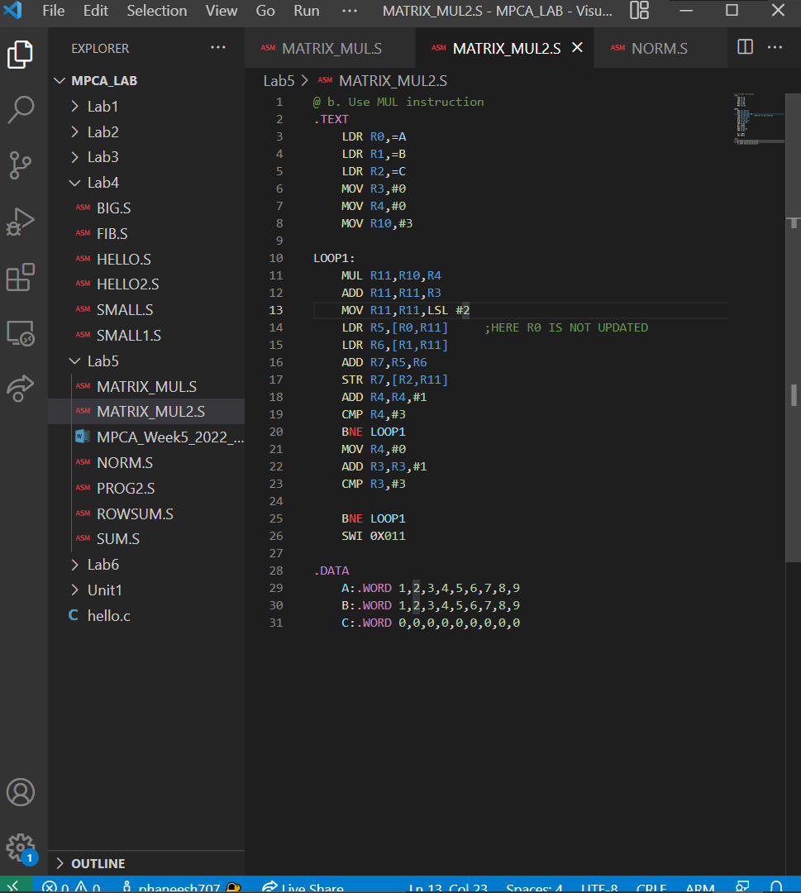
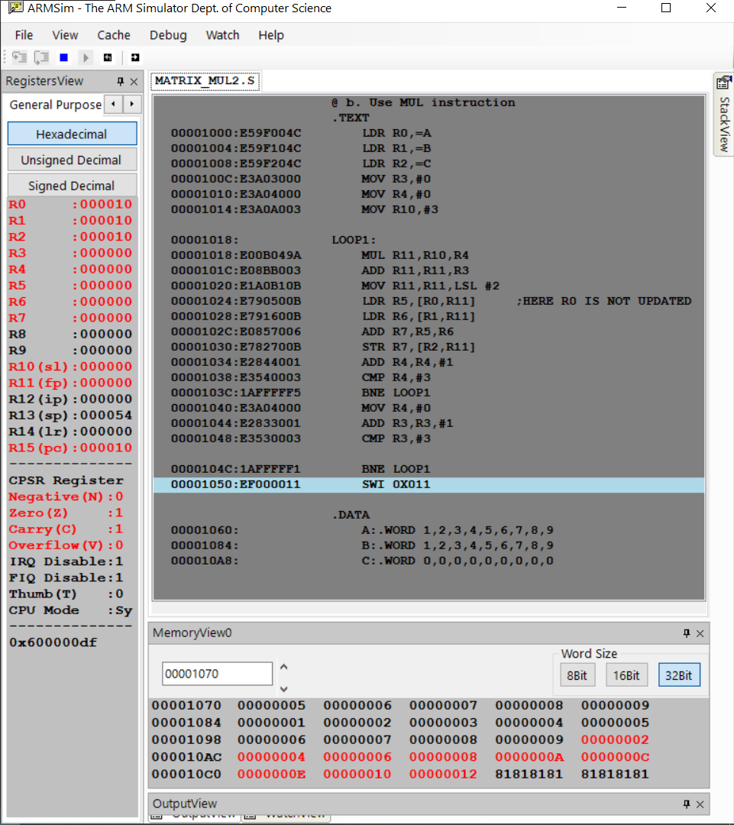

2. Write a program in ARM7TDMI–ISA to find the NORM of a square matrix of order n.

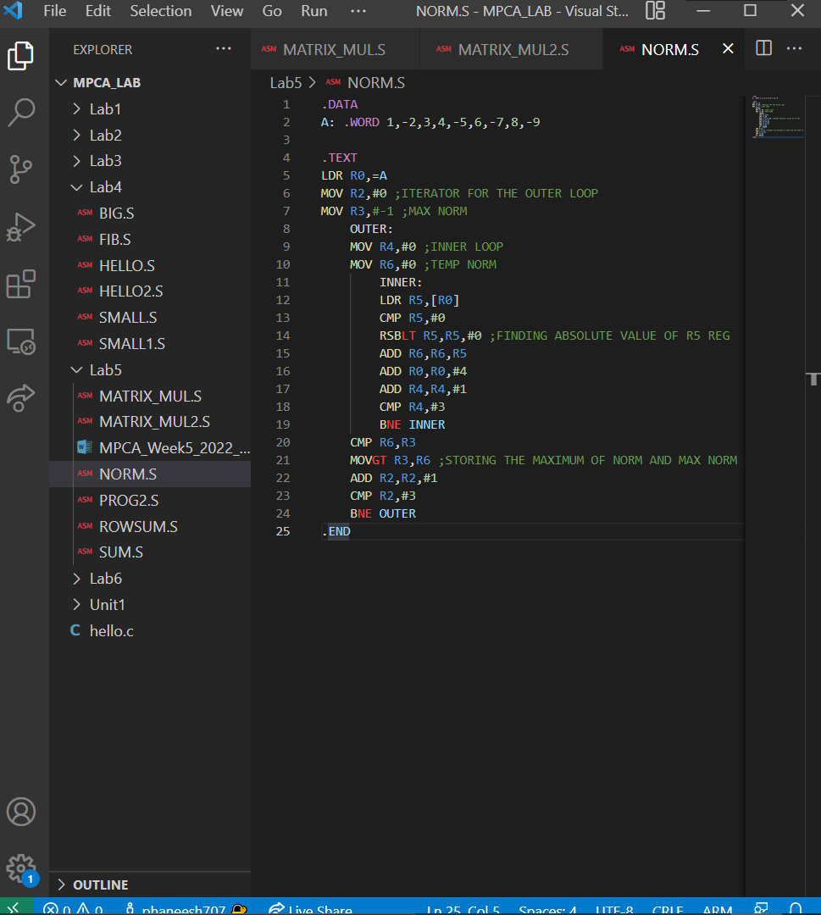
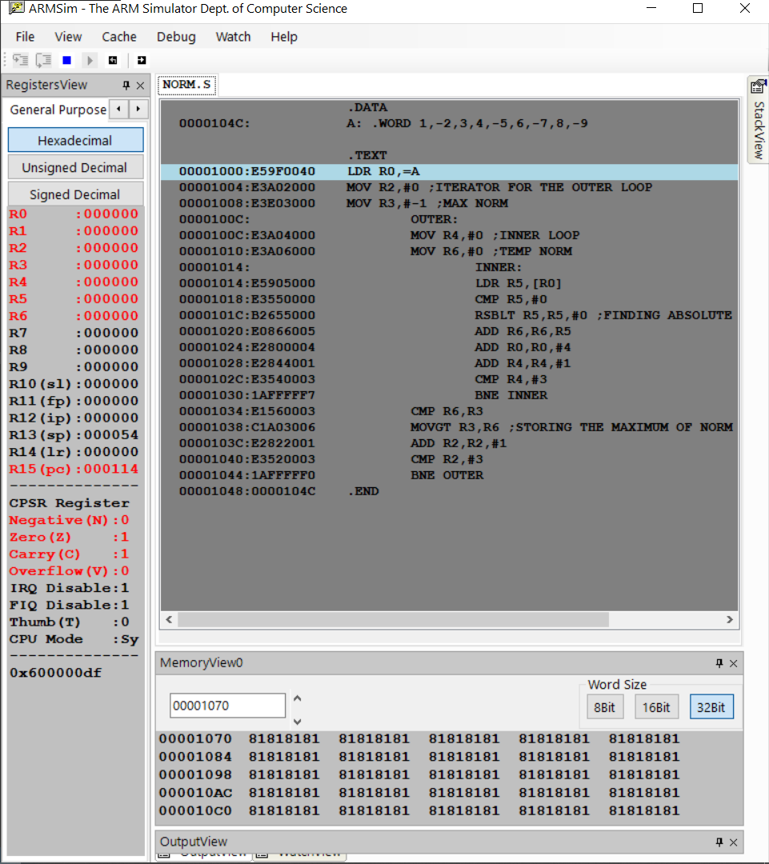

3. Write a program in ARM7TDMI–ISA to find the ROWSUM of matrix
