ARM7TDMI PROGRAMMING
WEEK-2

PHANEESH
PES1UG20CS584
J SECTION

1. Write a program in ARM7TDMI–ISA to copy a block of N data items from Location A to Location B.
a) Use Full word (.word directive)
CODE:
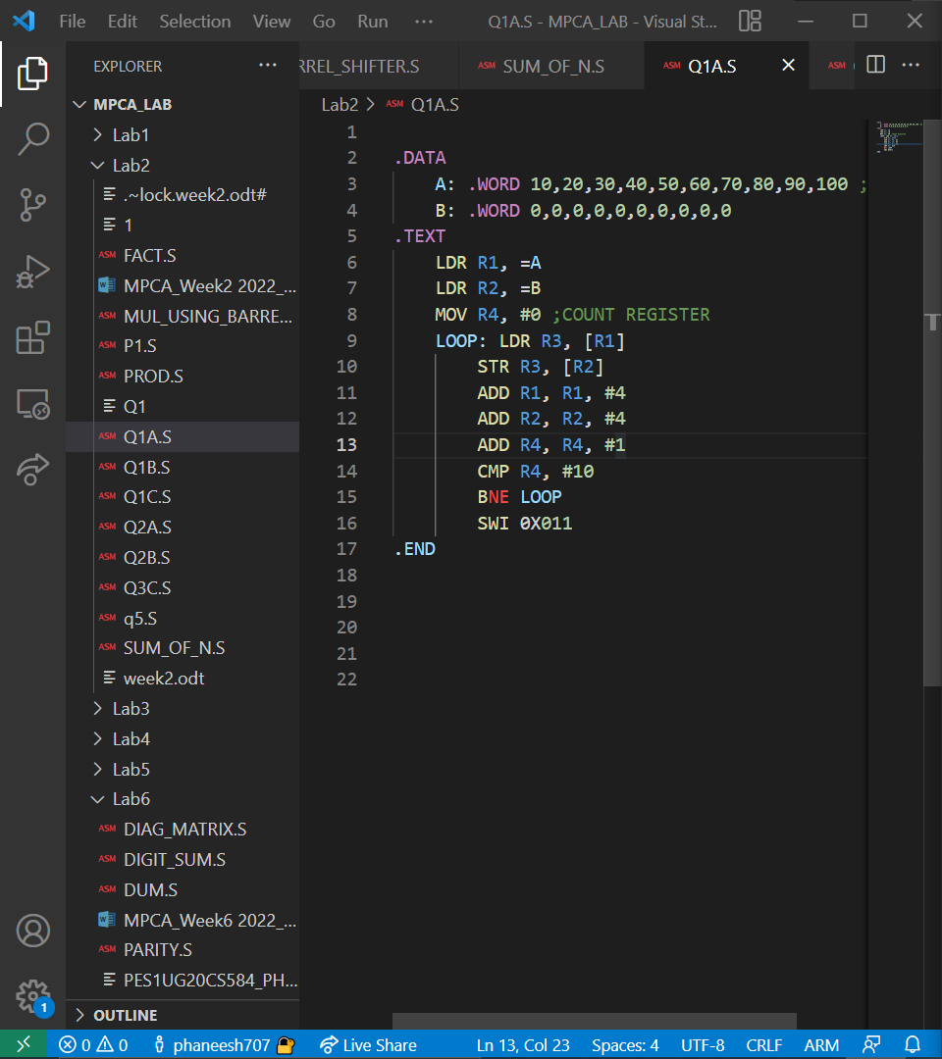

OUTPUT:
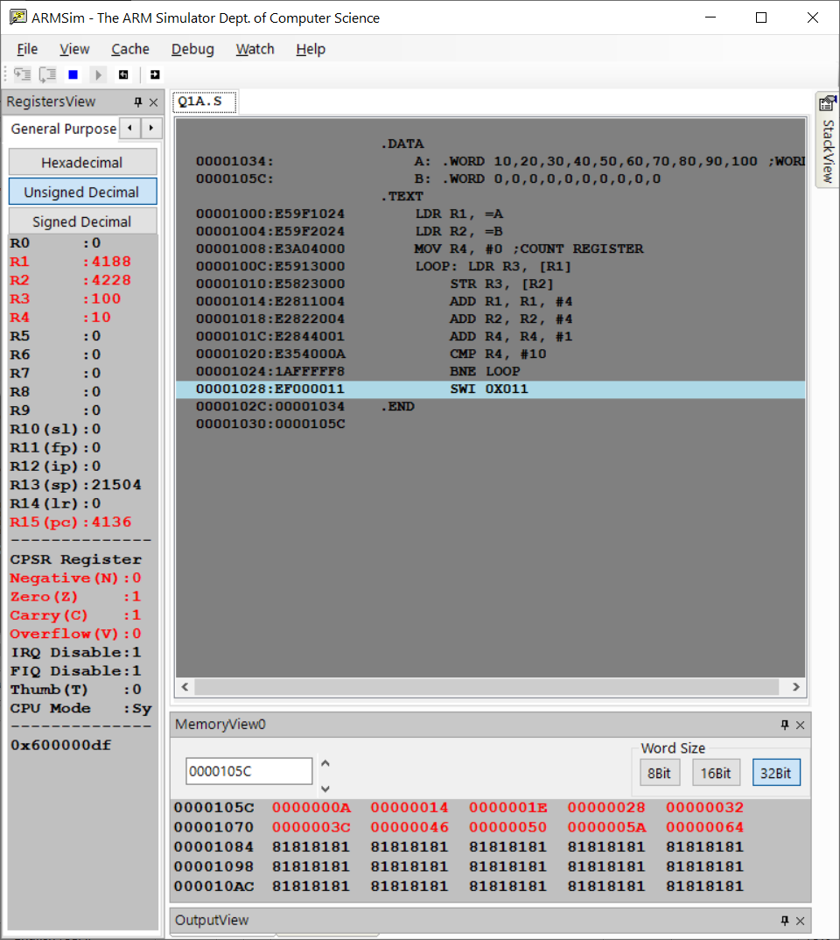

b) Use Half word(.Hword directive)
CODE:
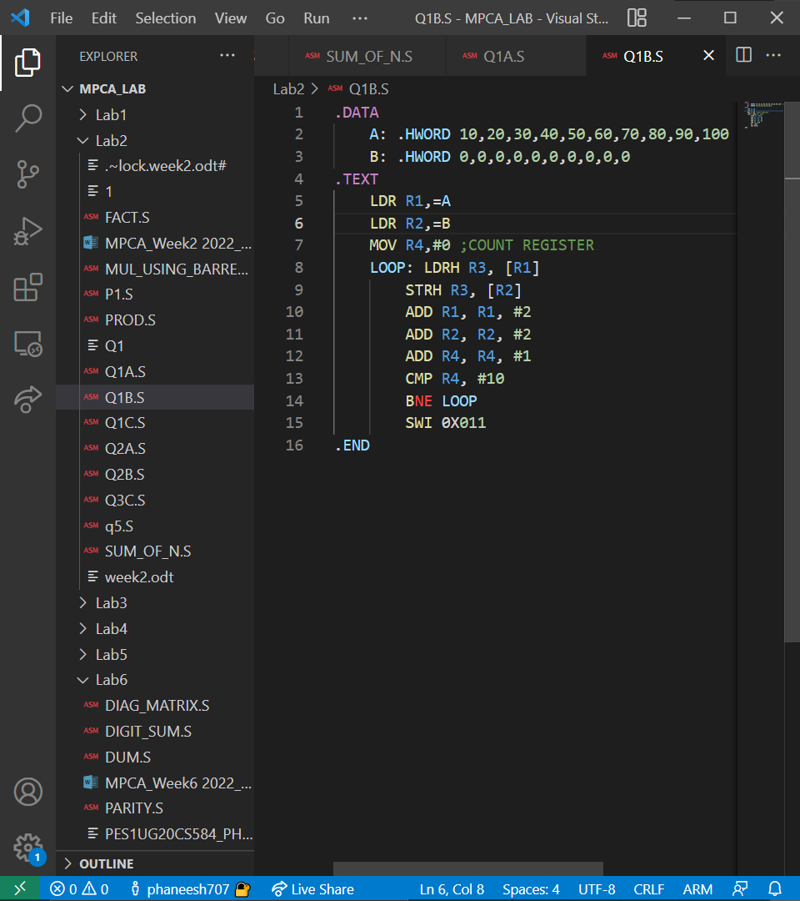

OUTPUT:
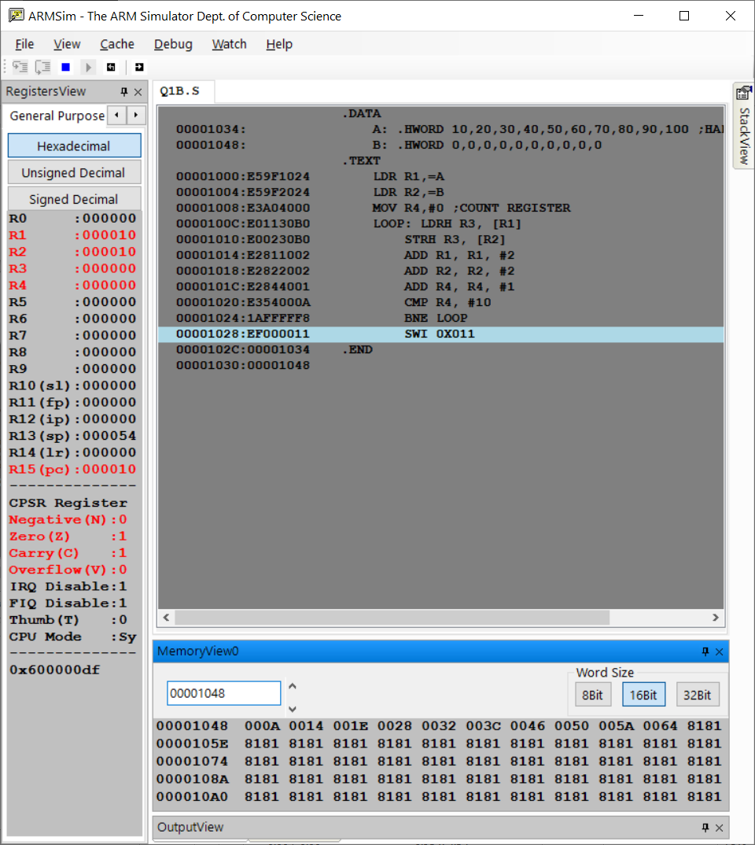

c) Use Byte wise (.Byte directive)
CODE:
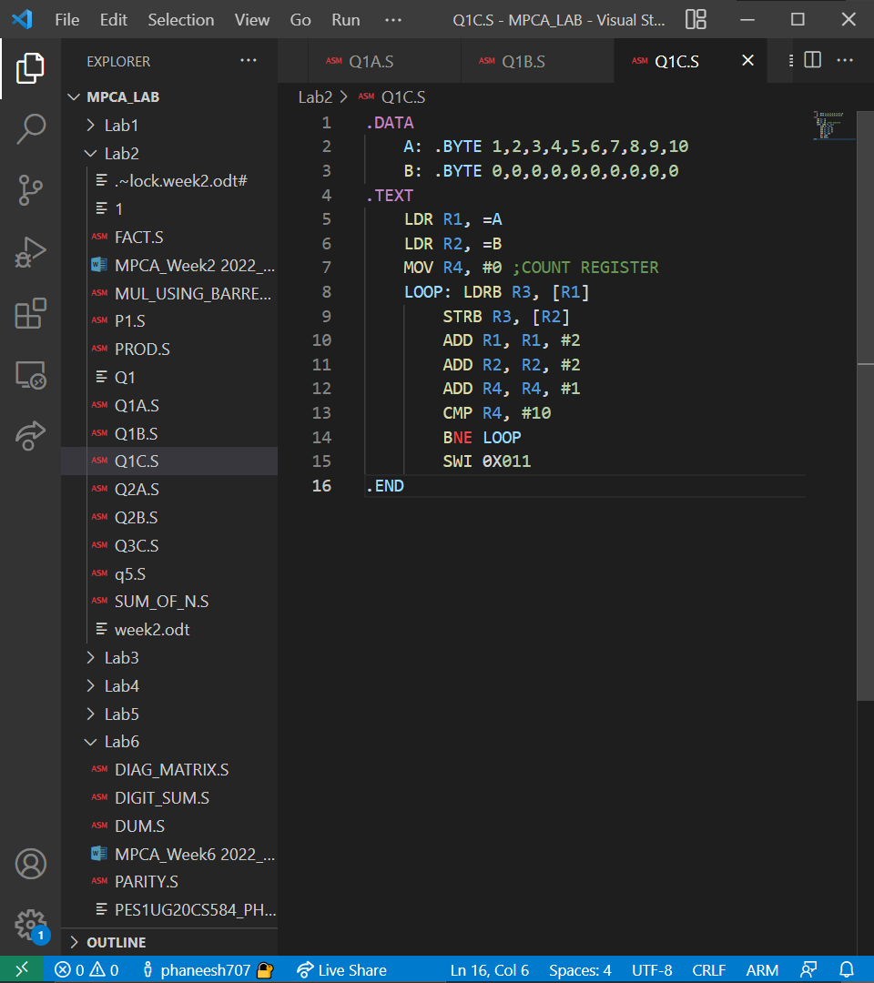

OUTPUT:

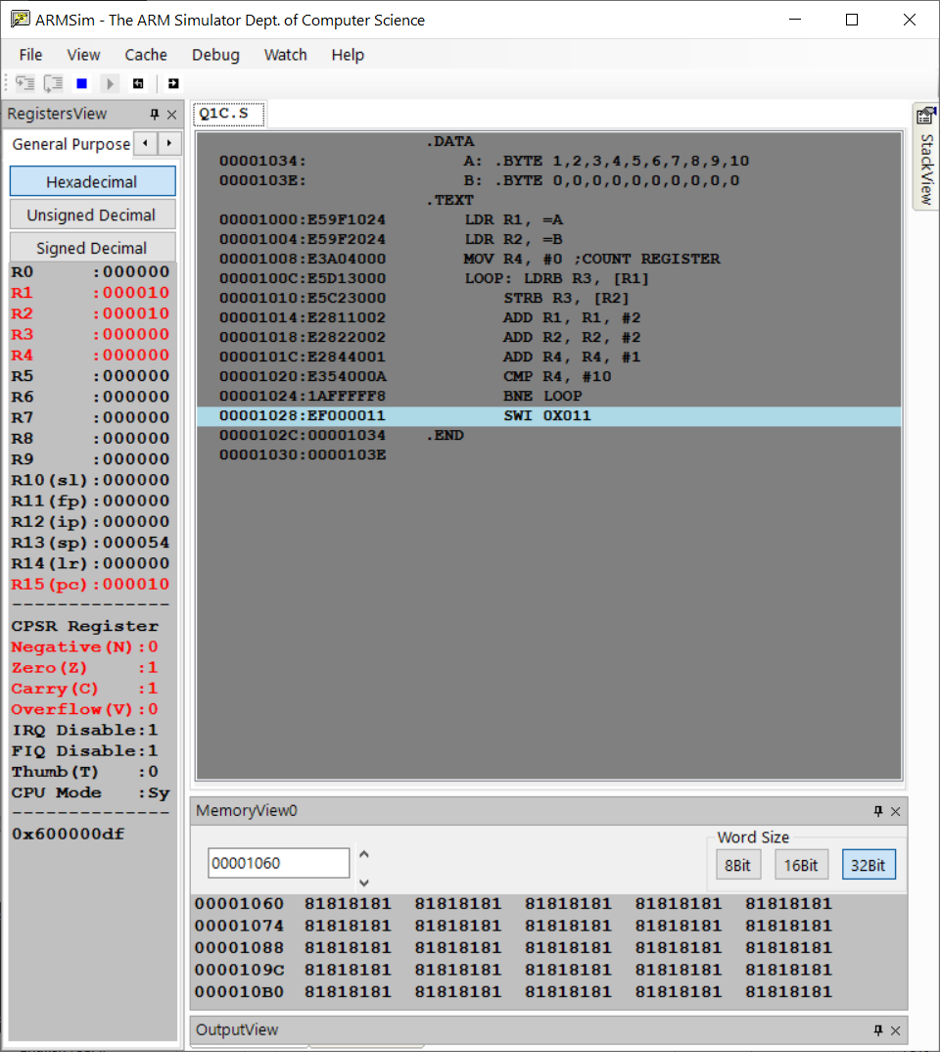

2. Write a program in ARM7TDMI–ISA to find the sum of N data items in the memory. Store the result in the memory location.
a) Use Full word (.word directive)
CODE:
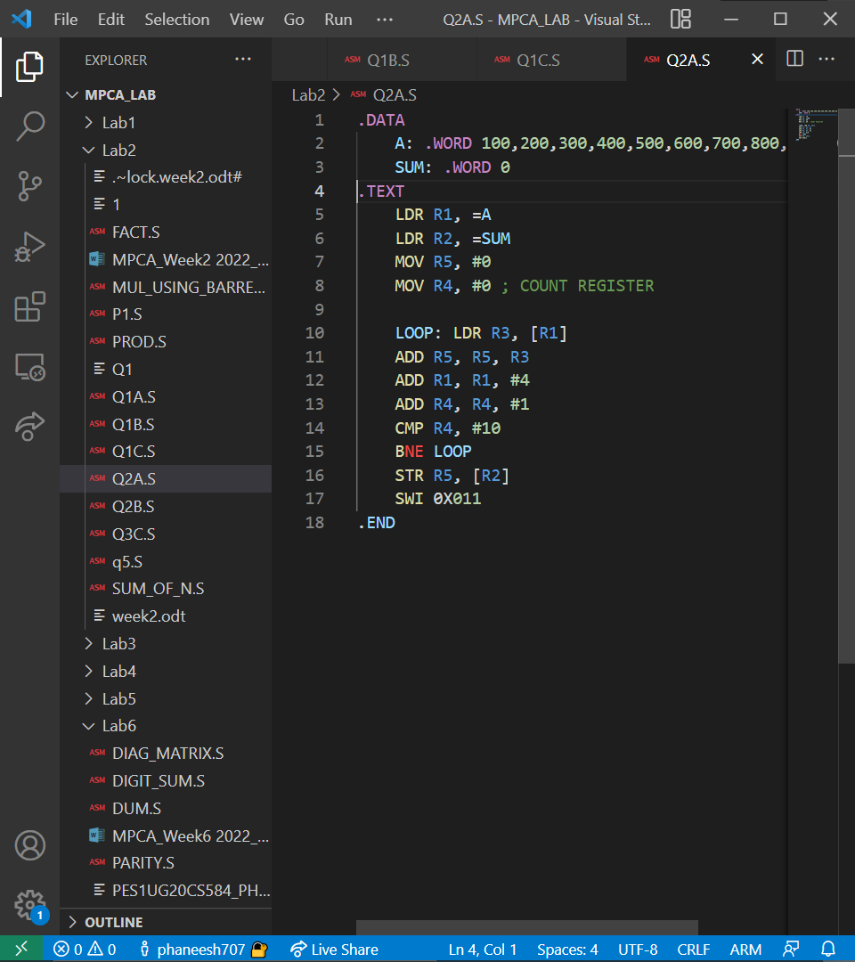
OUTPUT:
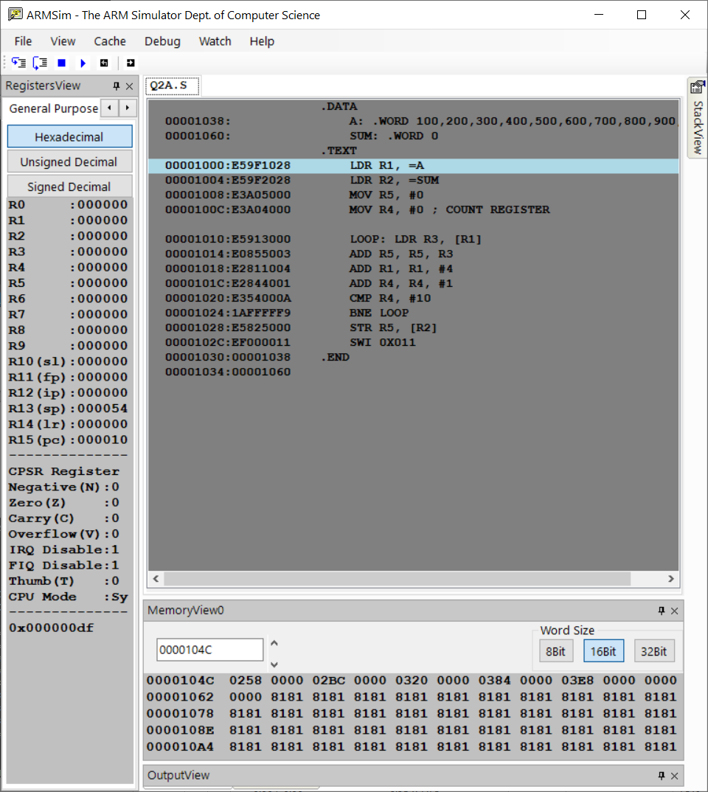

b) Use Half word(.Hword directive)
CODE:
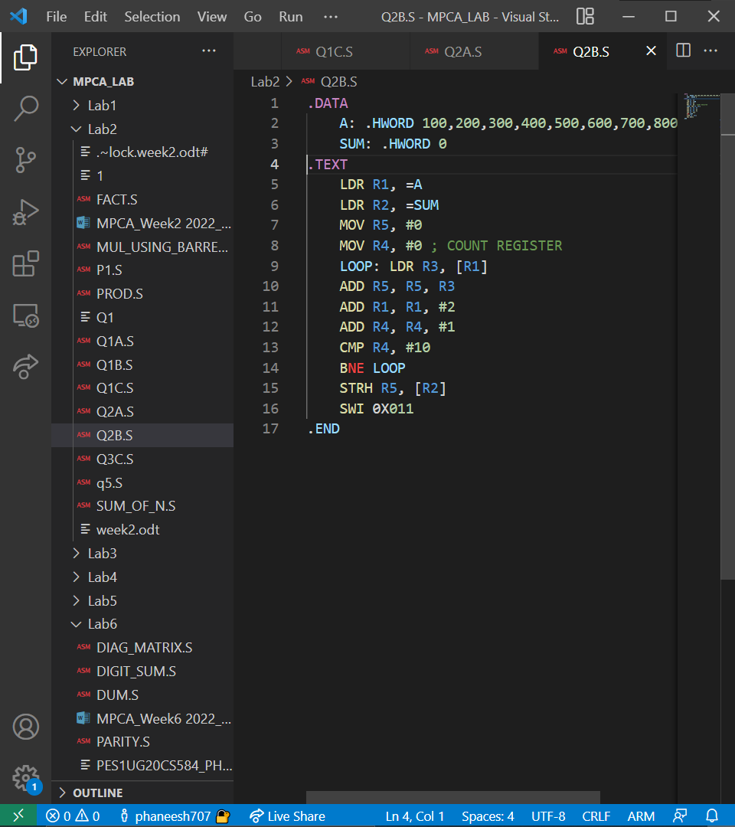

OUTPUT:
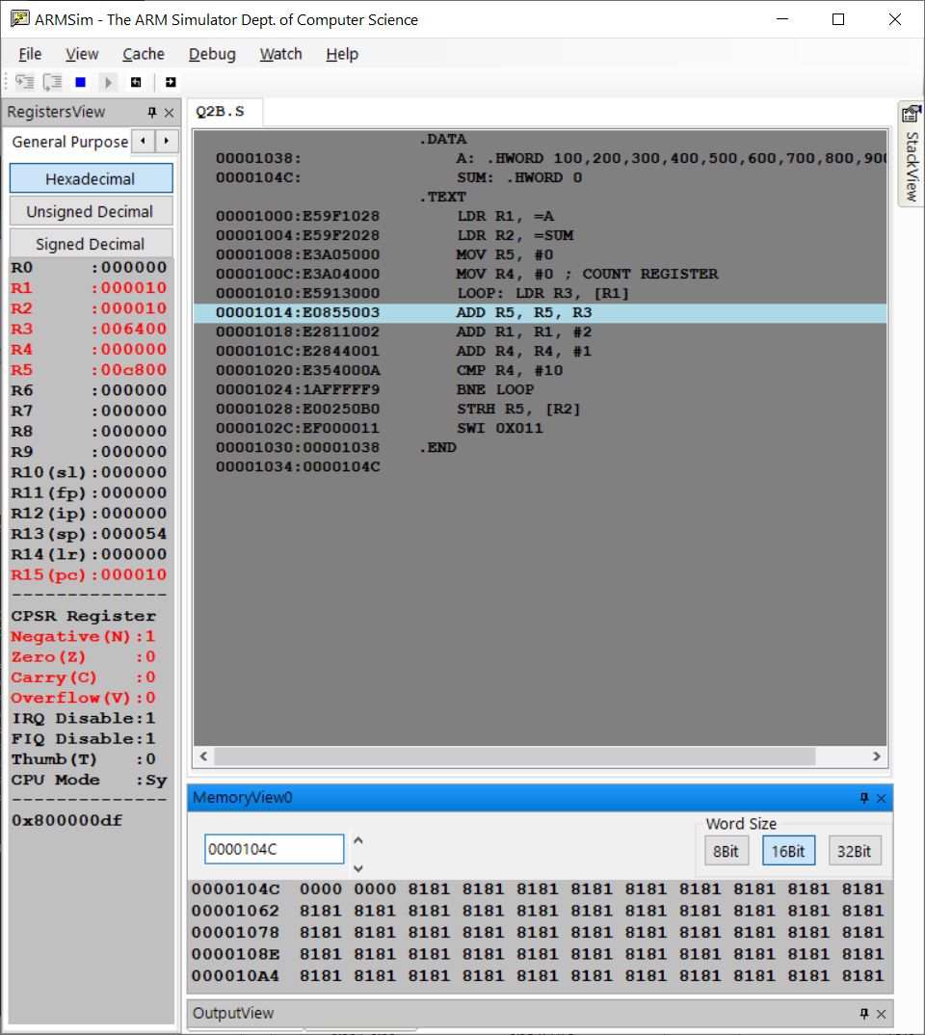

c) Use Byte wise (.Byte directive)
CODE:
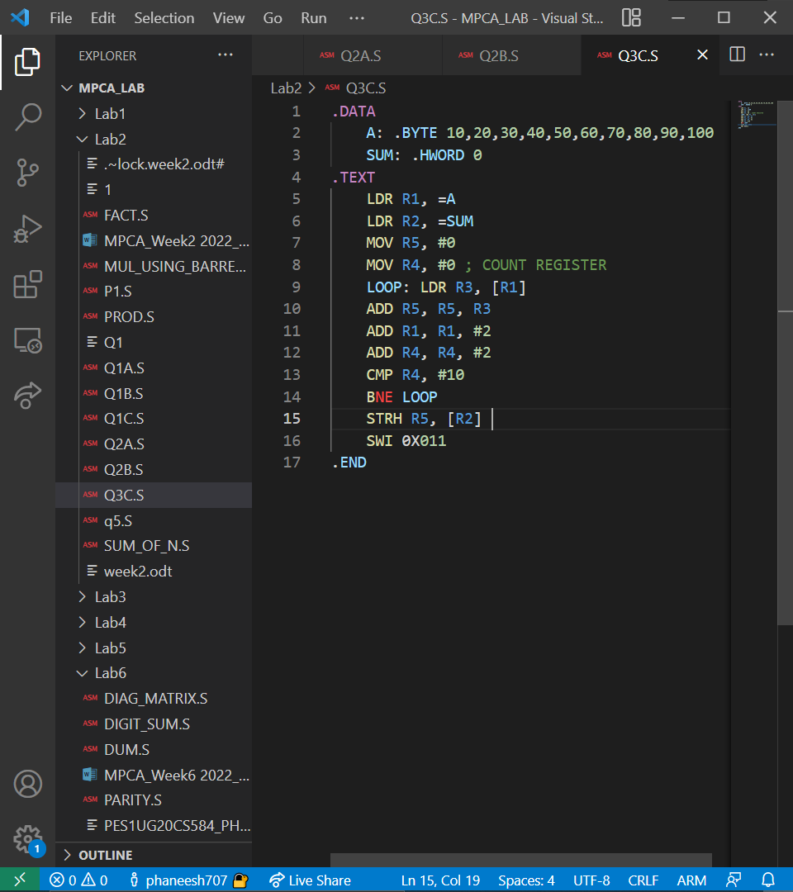

OUTPUT:
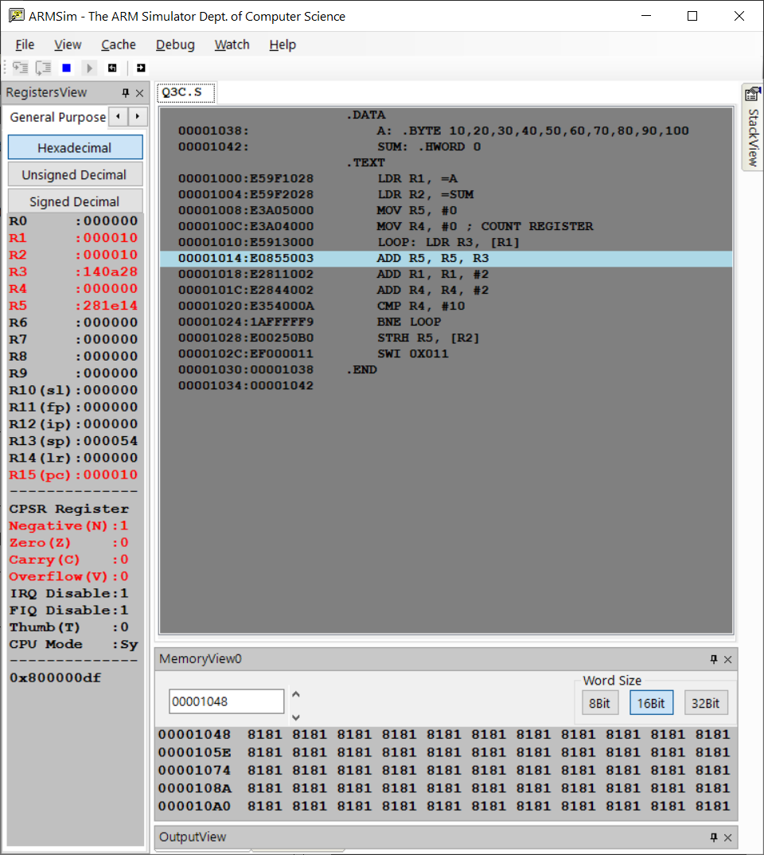

3. Write a program in ARM7TDMI–ISA to find the sum of N natural numbers. Store the result in the memory location.

CODE:
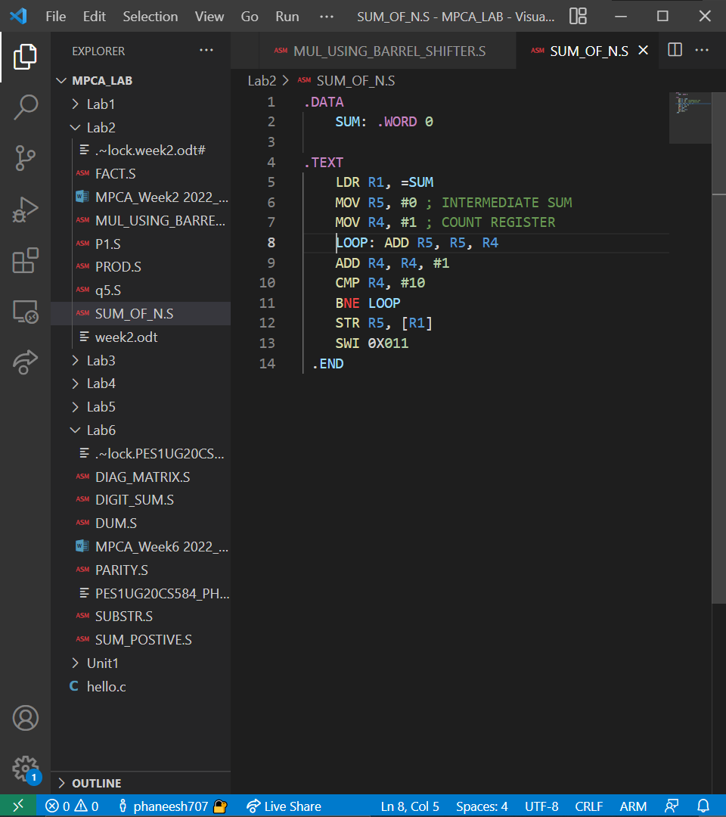
OUTPUT:

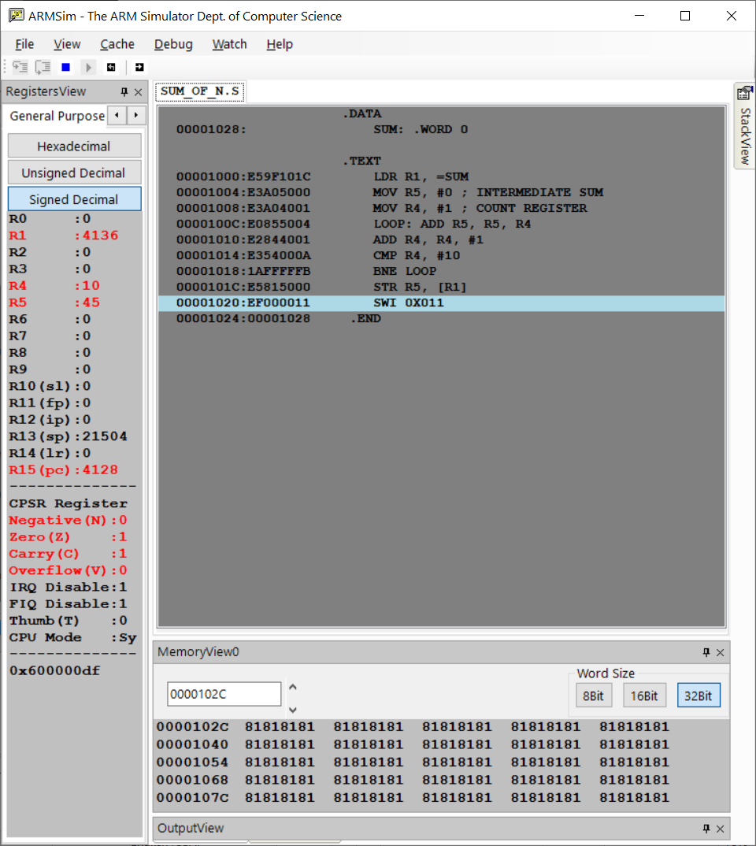

4. Write a program in ARM7TDMI–ISA to find the product of two 32–bit numbers using barrel shifter.
CODE:
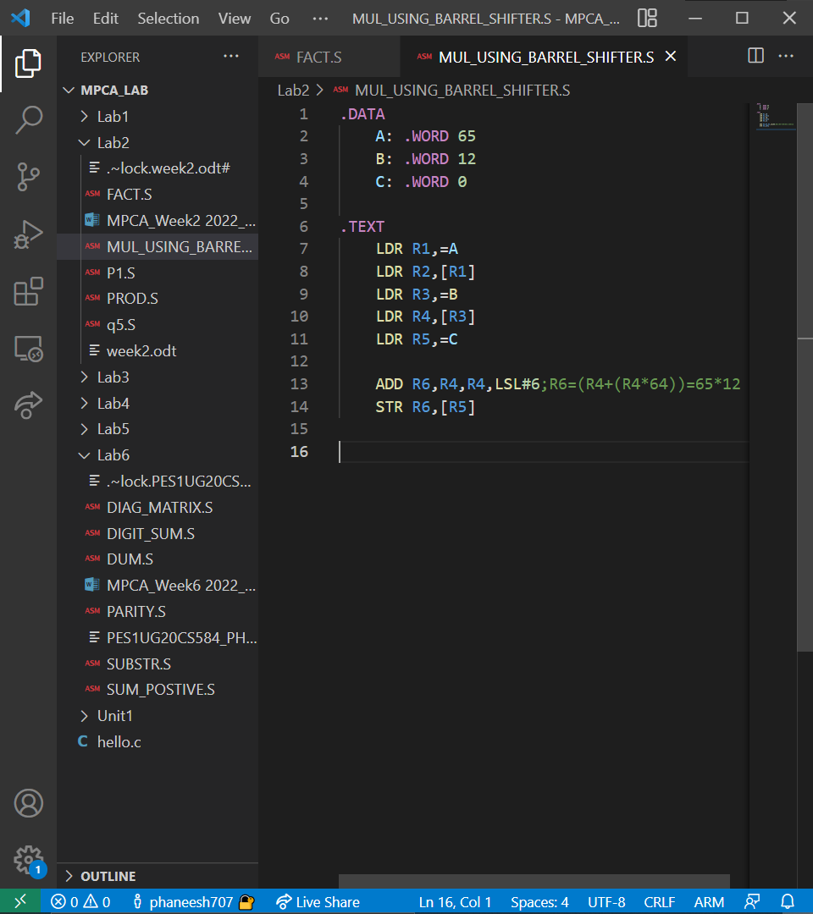

OUTPUT:

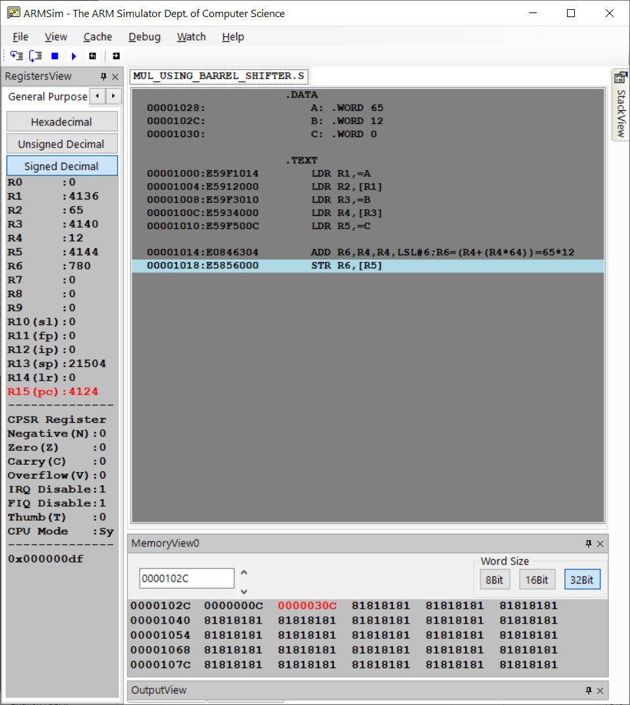
5. Convert the following statement in C language into an ALP using ARM7TDMI – ISA.
IF([A]==[B]) then C=[A]+[B];
ELSE IF ([B]==[C]) D=[A]-[B];
ELSE E=[A]*[B]

CODE:
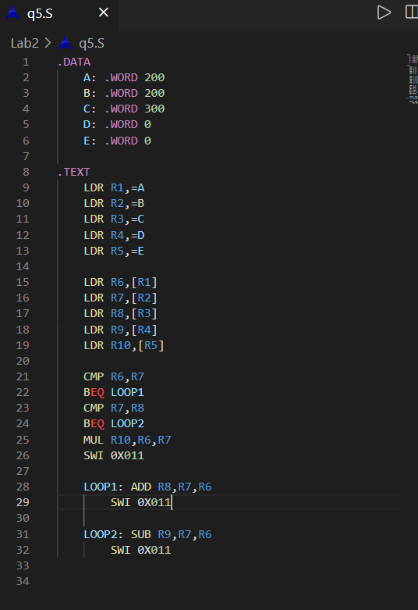

OUTPUT :
1.WHEN A = B
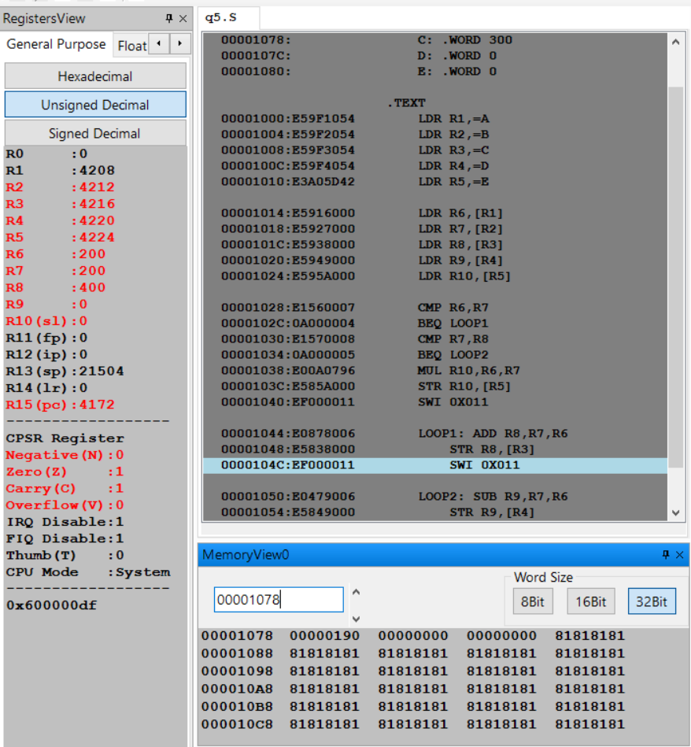

2. WHEN B=C
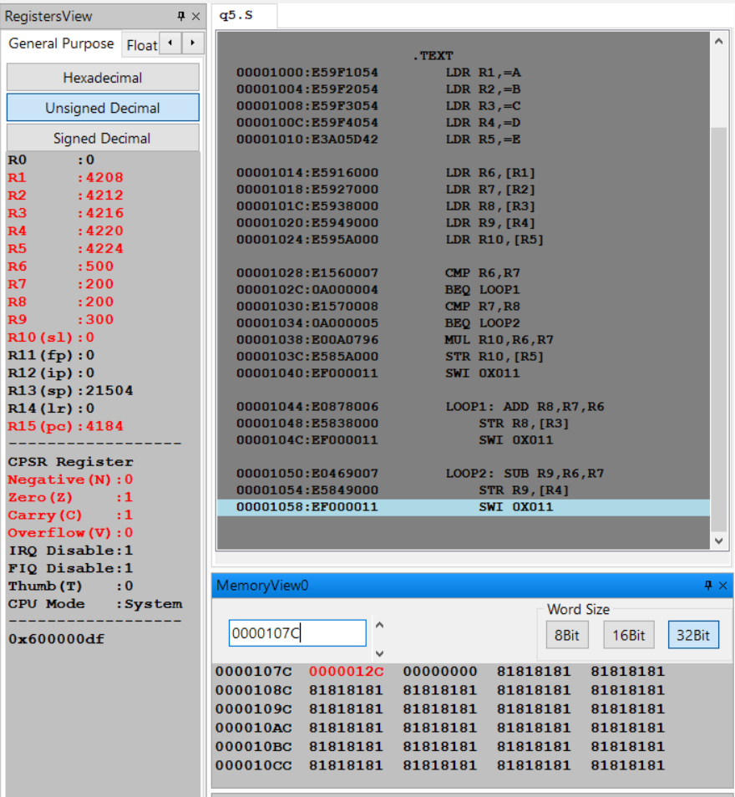

3.IN ALL OTHER CASES
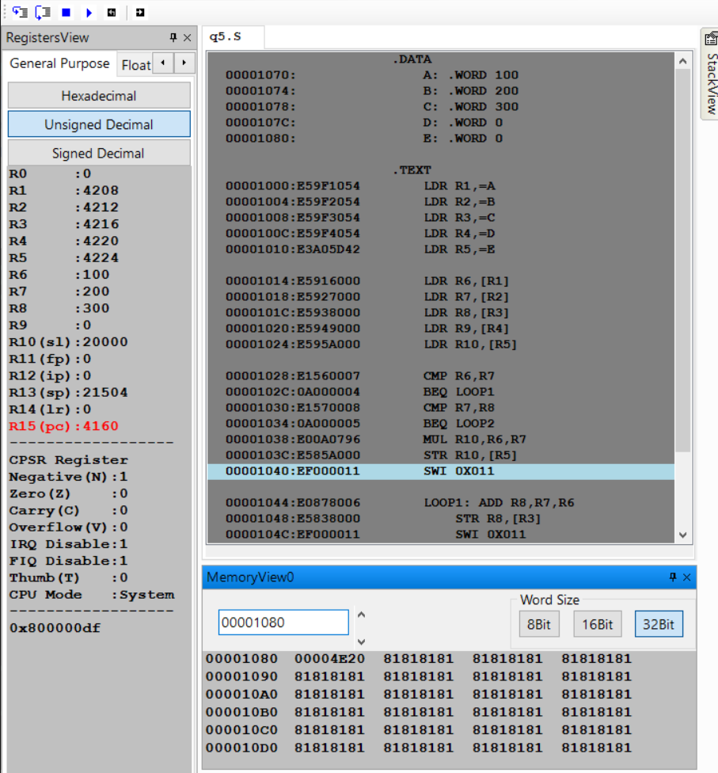

6. Write a program in ARM7TDMI–ISA to find the factorial of a number.

CODE:

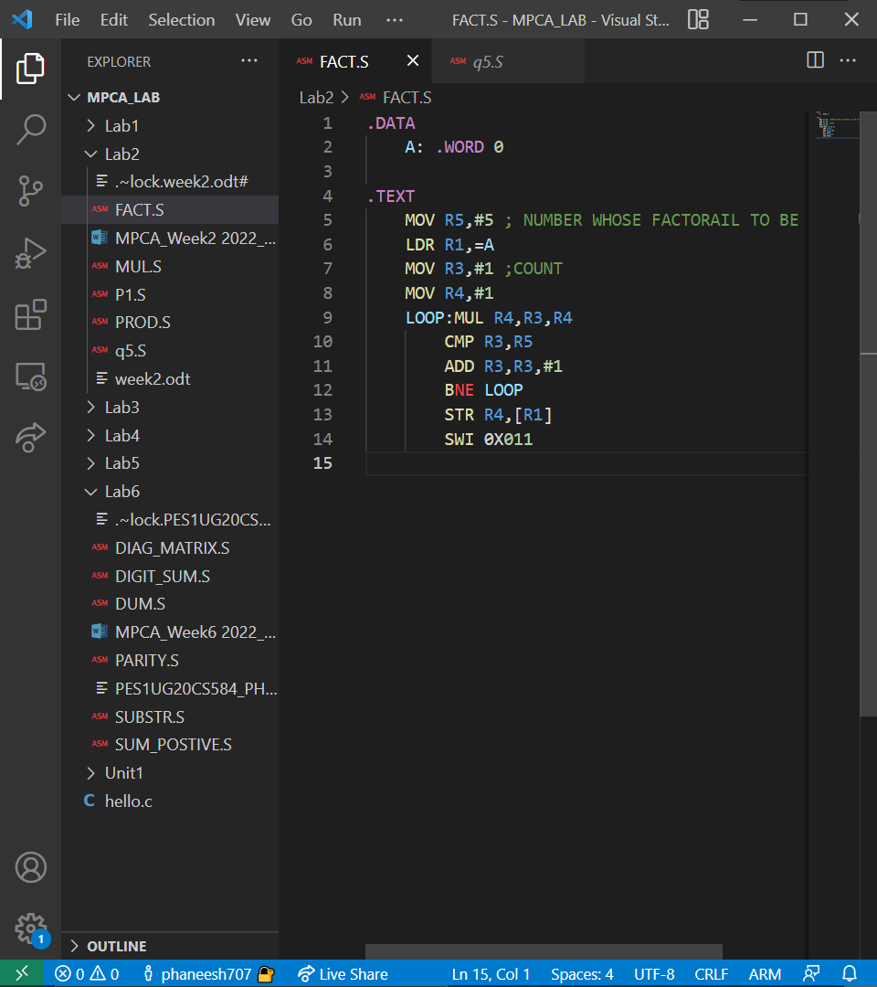

OUTPUT:



