ARM7TDMI PROGRAMMING
WEEK-6

PHANEESH
PES1UG20CS584
J SECTION

2.SUM OF POSITIVE NUMBERS IN ARRAY

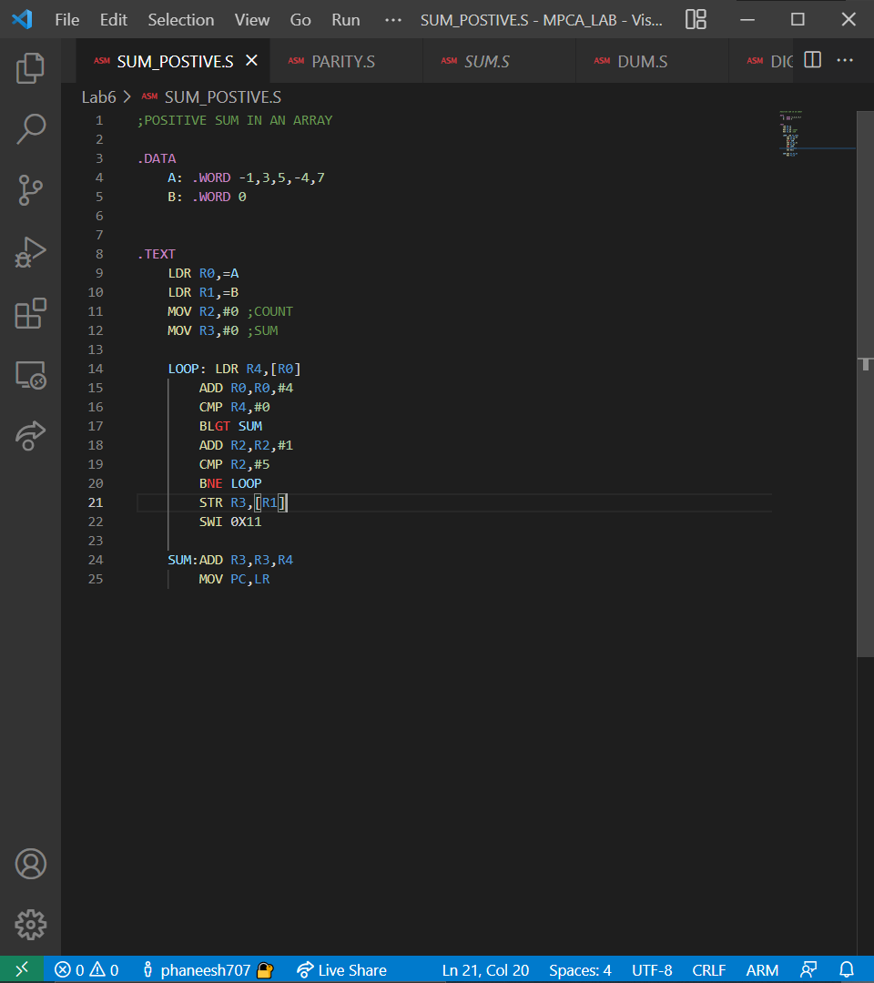

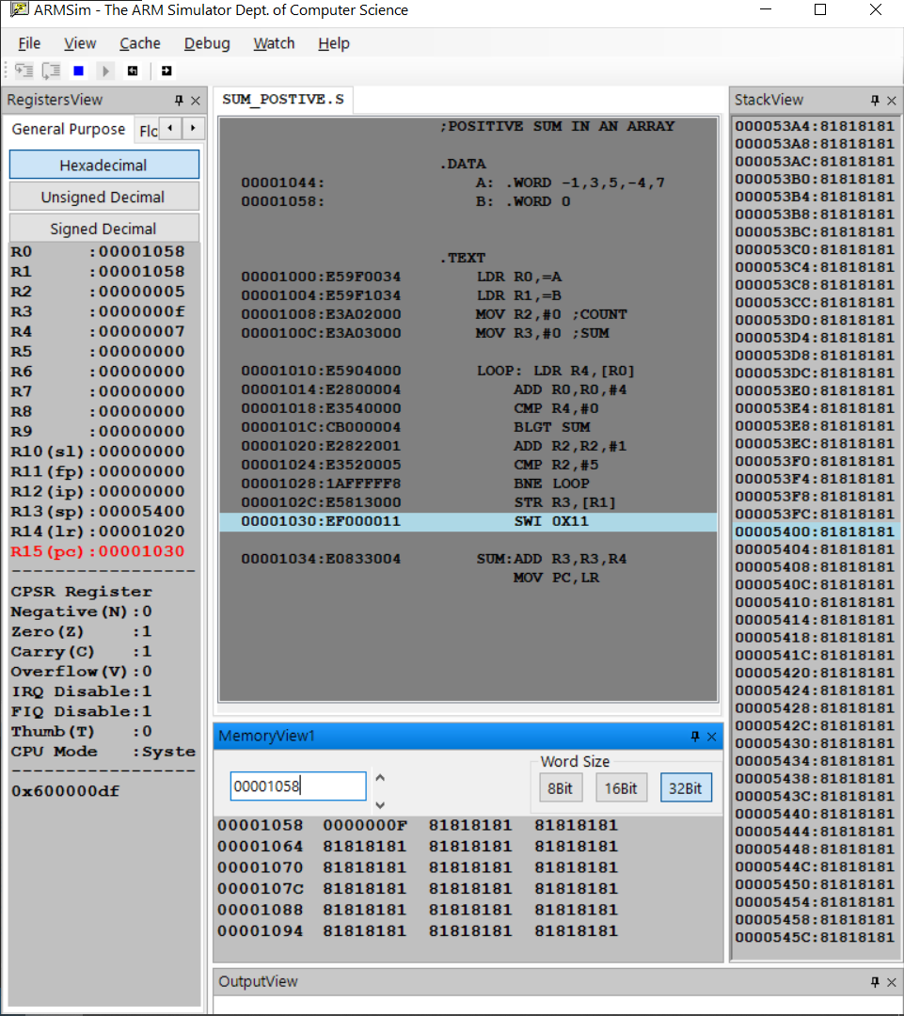
OUTPUT

STUDENT EXERCISE -
1.PARITY OF A NUMBER

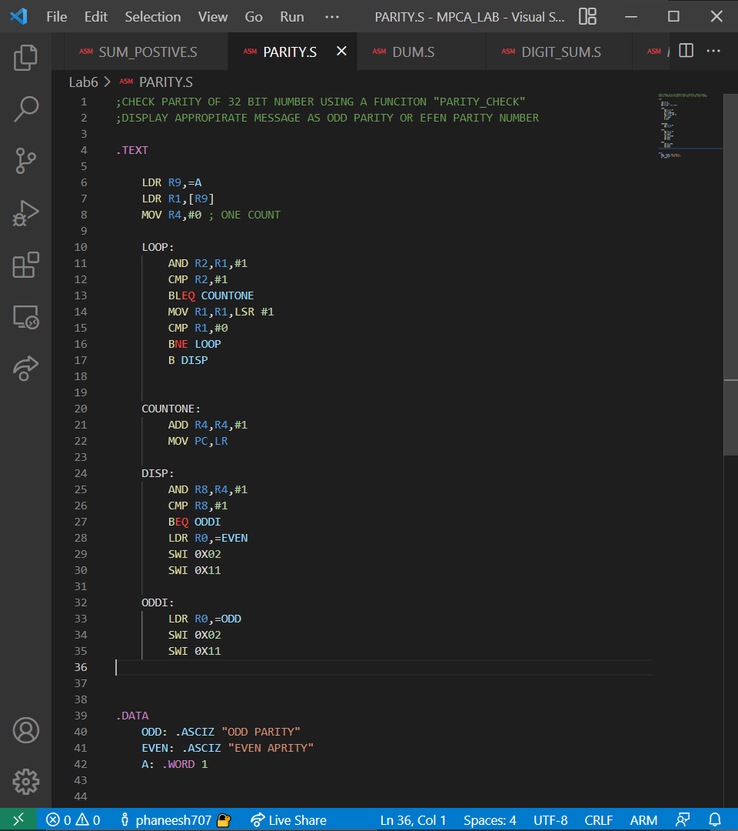

OUTPUT
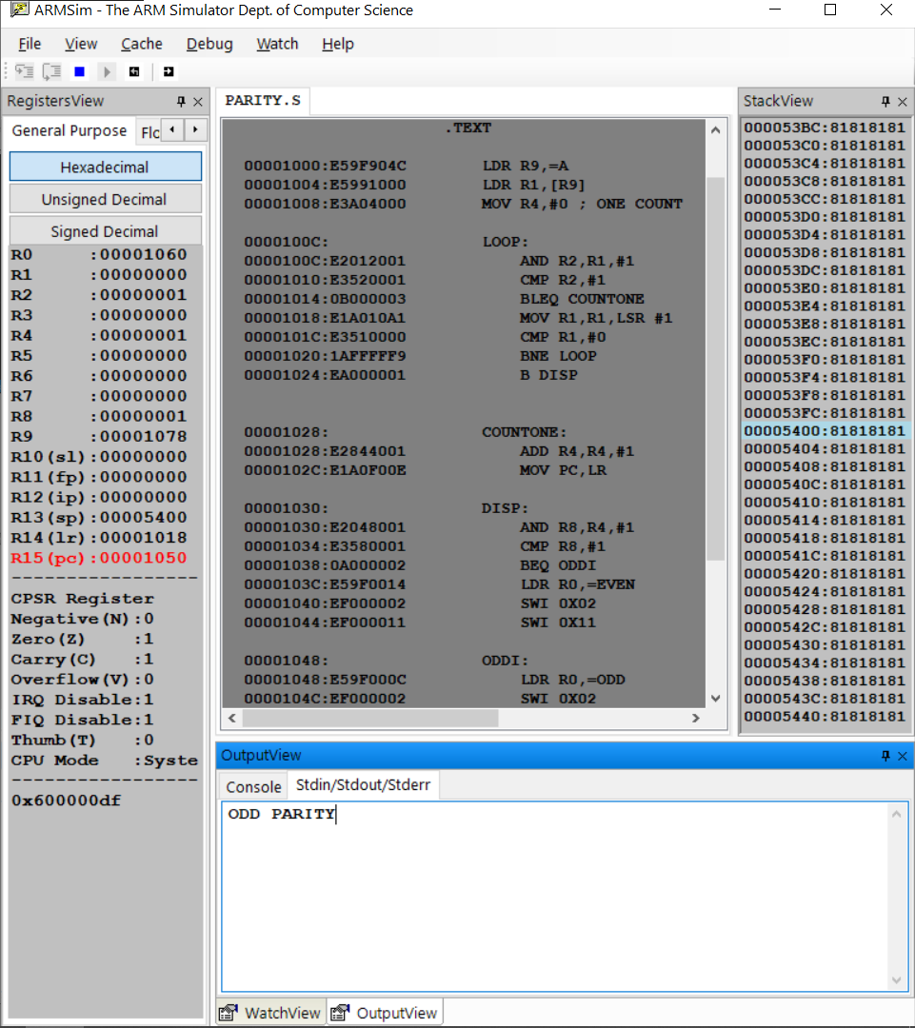

2.FREQUENCY OF CHARACTER IN STRING

