**EXTENSION OF THE LEXICON ALGORITHM FOR SARCASM**

**DETECTION**

Lexicon algorithm can be used to detect sentiments from sentences and this sentiments will help in almost all fields such as online product selling, social networks etc to know the products condition or about person behaviour on social networks. Lexicon algorithm good at predicting sentiments but it cannot predict sarcasm (sarcasm means one person insulting another person by using positive words, so by using words positivity lexicon will detect it as positive but in nature it has negativity). So in this paper author has introduce two systems to predict sentiments and sarcasm from any message such as social networking messages or products reviews. Below are the two system propose by author of this paper

First System: in this module author calculate polarity of sentences such as positive polarity, negative polarity and neutral polarity and then calculate sarcastic by checking positive polarity. If positive and neutral polarity is high and contains some negative words in messages then it will consider as sarcastic otherwise non-sarcastic. Take below example sentence/tweet

**‘Mark Zuckerberg used to be a hero of the digital age, but now he has lived long enough to see himself become the villain’**

In above sentence person saying hero to Mark Zuckerberg in one sentence and in other sentence proving him villain. So we can see in above positive sentence user is giving some negativity or using insulting words and such tweets/messages consider as sarcastic.

Second System: In second module we will calculate sentiments from sentences and if sentence is positive or neutral and if positive sentence contains negative words then display/predict sentence as positive with sarcasm else positive without sarcasm.

To implement this project we are using VADER sentiment API from python which built on Naïve Bayes algorithm and using this API we can calculate polarity from sentences. All tweets used in this project for testing saved inside dataset folder.

Install python software and then using pip command install below package

pip install vaderSentiment

after installing above package then run project

Screen shots

To run project double click on run.bat file to get below screen

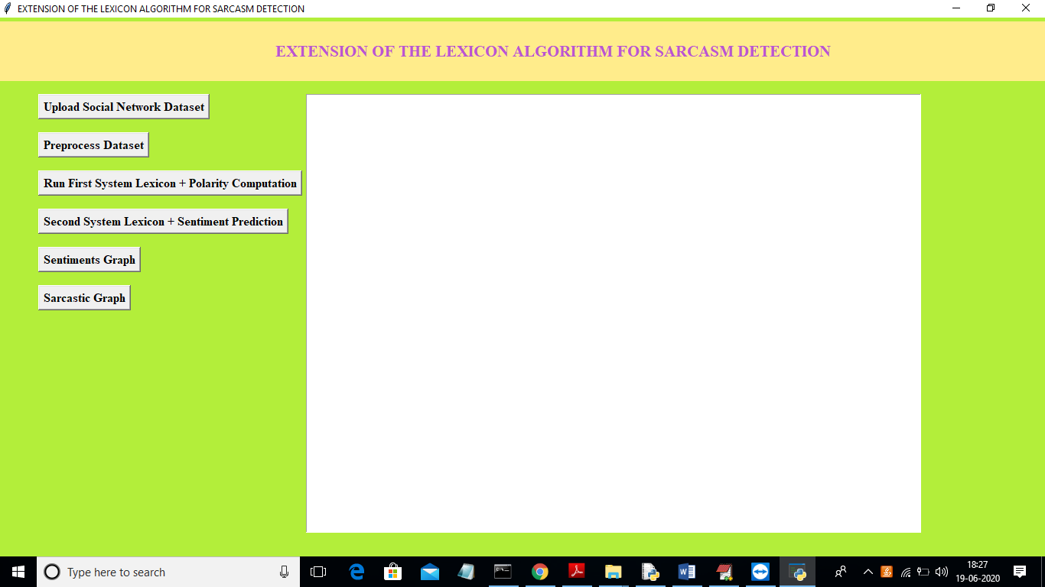

In above screen click on ‘Upload Social Network Dataset’ button and upload tweets messages

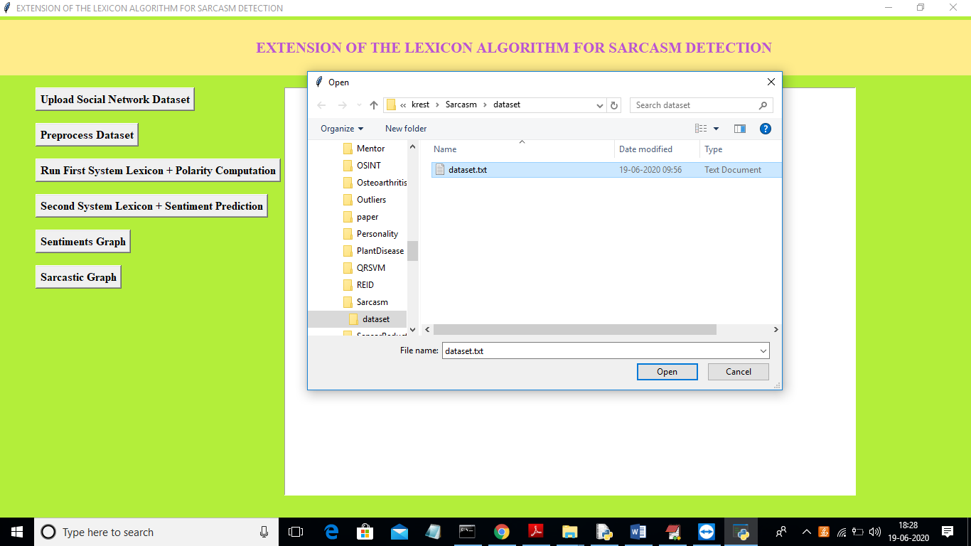

In above screen uploading ‘dataset.txt’file and now click on ‘Open’ button to load dataset and to get below screen

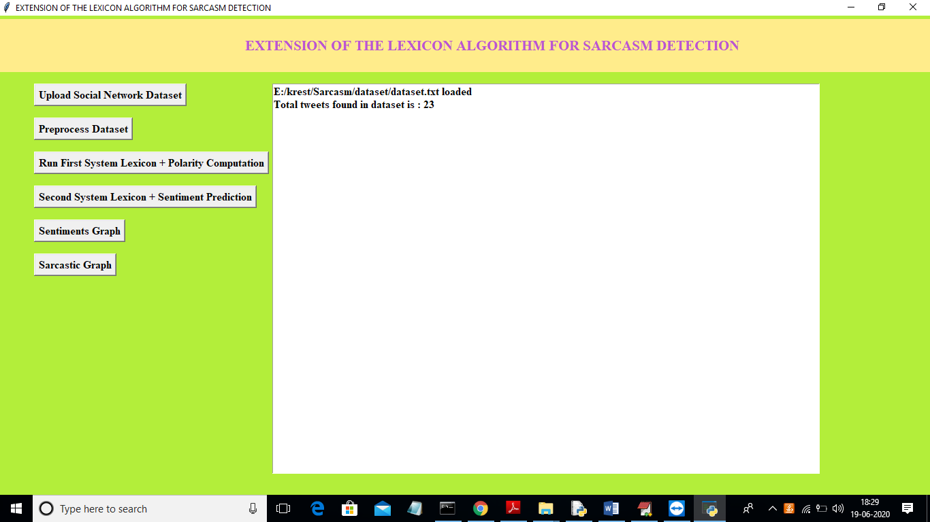

In above screen in dataset 23 tweets messages found. Now click on ‘Preprocess Dataset’ button to remove special symbols and stop words from messages

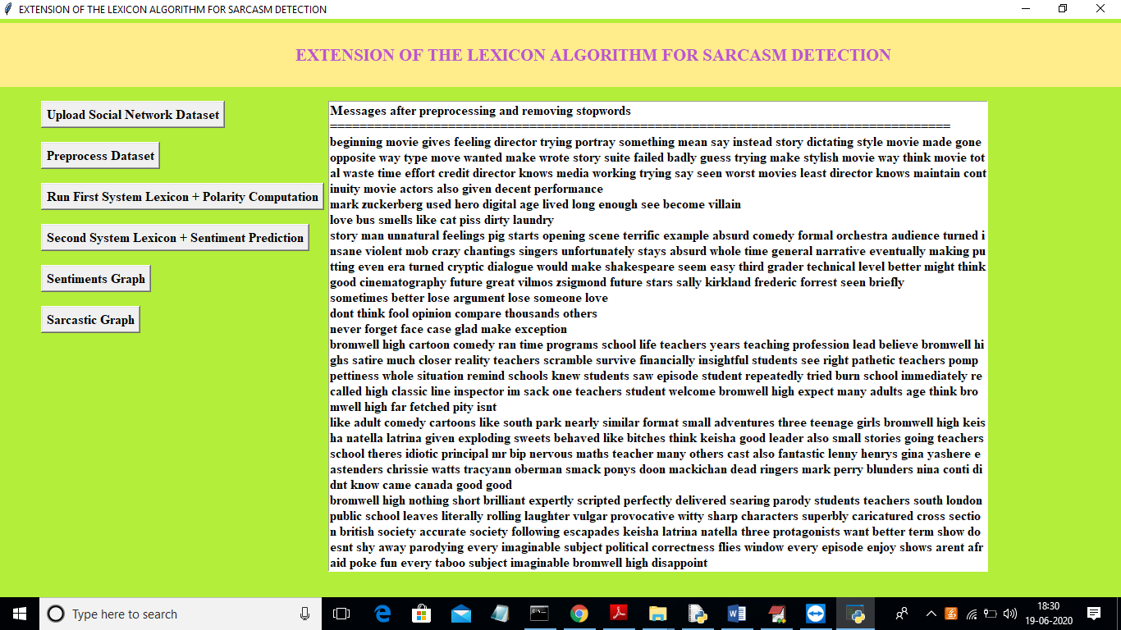

In above screen we can see all messages after removing special symbols and stop words. Now click on ‘Run First System Lexicon + Polarity Computation’ button to calculate polarity of messages

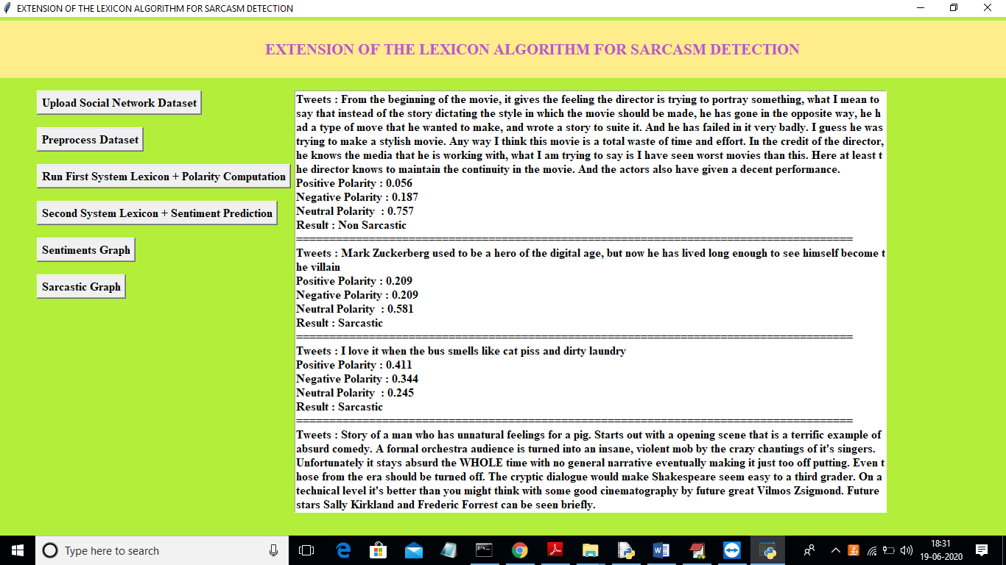

In above screen for each message we can see tweet data and positive, negative and neutral polarity score and the message in tweets is sarcastic or non-sarcastic. The tweets will be classified to positive, negative or neutral based on its high score for example in first tweet neutral got high score as 0.757 so tweet will consider as neutral. If that neutral tweets contains some negative words then consider as sarcastic. You can scroll down above screen text area to see all messages details. Now click on ‘Second System Lexicon + Sentiment Prediction’ button to predict sentiments of sentences/tweets.

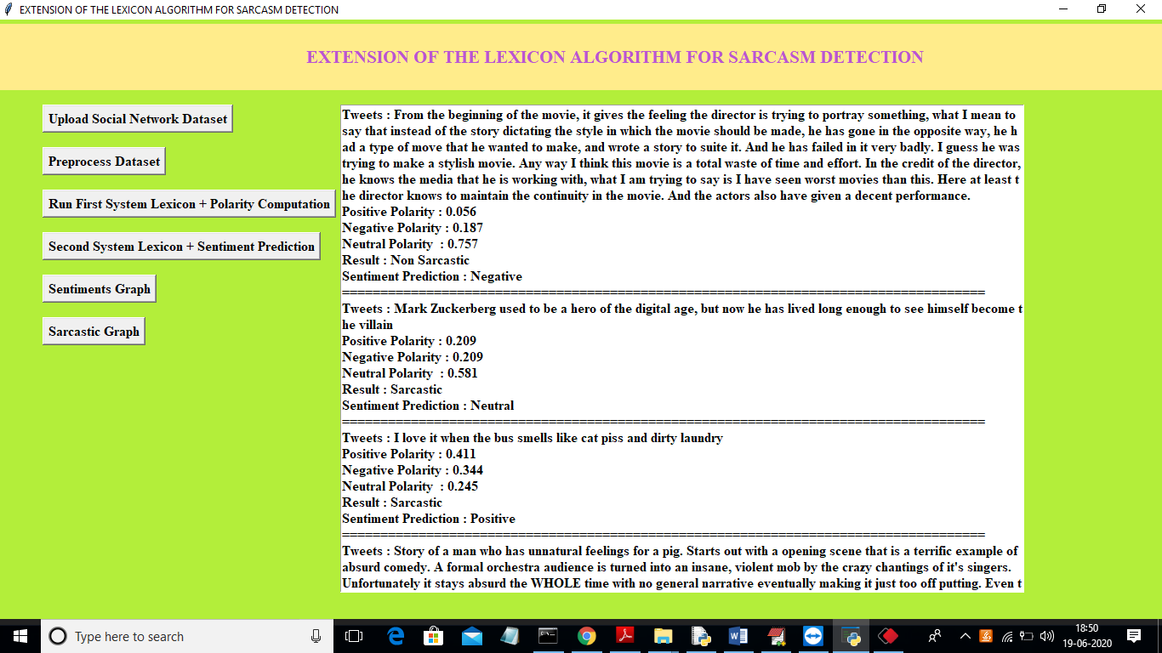

In above screen we can see same results with extra details such as whether tweet/message is positive or negative or neutral. You can scroll down above text area to see all messages. Now click on ‘Sentiments Graph’ button to get below graph.

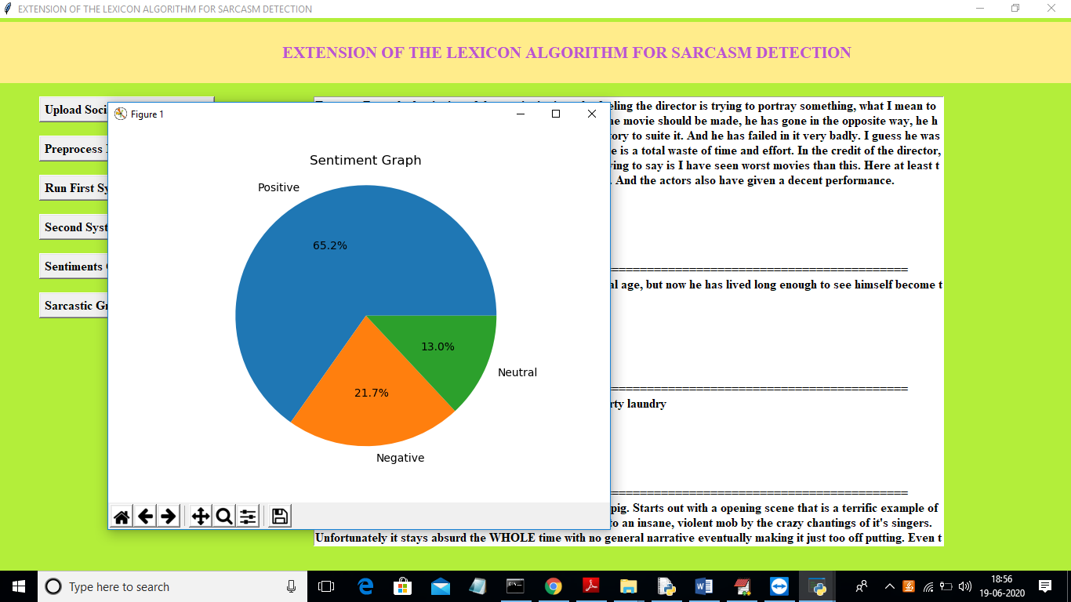

In above screen using pie chart we can see percentage of positive, negative or neutral tweets. Now click on ‘Sarcastic Graph’ button to get below graph

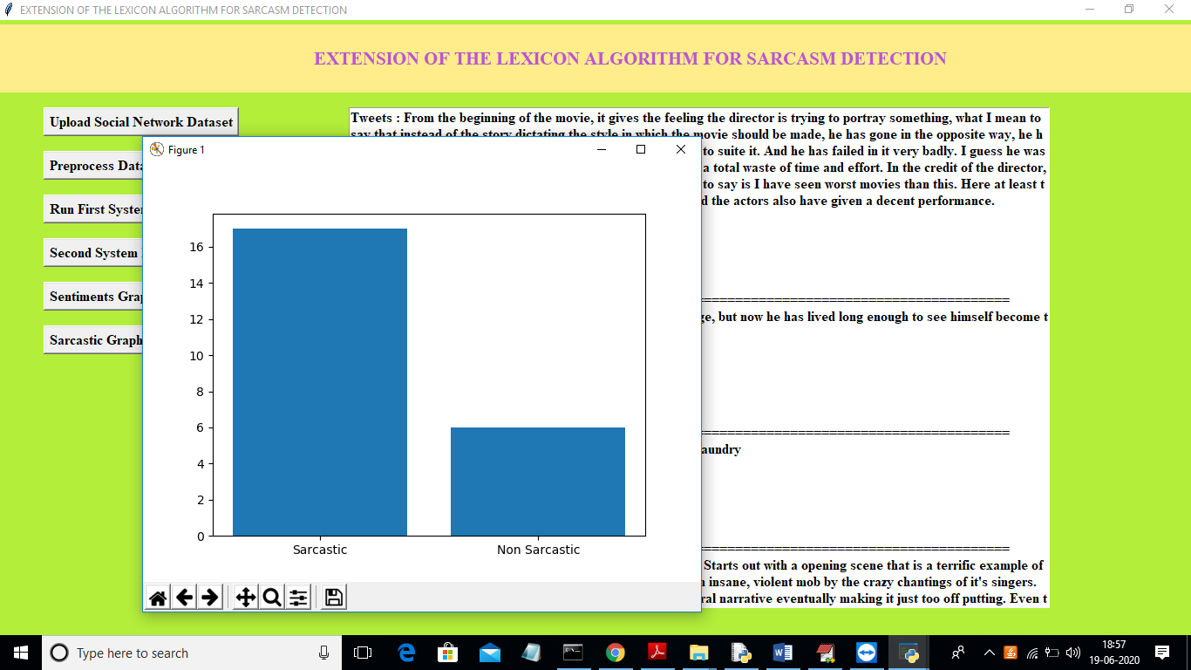

In above graph x-axis represents type of tweets and y-axis represents count of sarcastic or non-sarcastic tweets.