The verdict is in the test: naive baselines, dry controls, and operating points in open flood-model validation
Submission type: Advances in Modelling Practice (problem-and-solution). Author, affiliation, venue details TBD. Corresponding author: phang.daniel@gmail.com.

Abstract
Comparative validation of urban flood models is more fragile than it looks. Using a fully open multi-hazard model for Singapore scored against the official PUB flood-prone register, we show that the same model on the same data yields four different verdicts depending only on how the test is set up. (i) Scored by hit-rate or ROC-AUC against the register alone, the model looks “validated” (AUC 0.65). (ii) Add the naive baseline a practitioner would otherwise use — a topographic wetness index (TWI) — and it scores higher (0.75): the calibrated model does not out-locate free topography. (iii) Compare specificity at a fixed depth threshold and the model looks “significantly more specific” (it floods 1.85% of land versus TWI’s 15%) — but that is an artifact of operating at far lower sensitivity; at matched specificity TWI’s hit-rate (0.71) beats the model’s (0.39). (iv) The verdict even swings with the negatives chosen: against random land the model discriminates significantly better (ΔAUC +0.14, 95% CI [+0.04, +0.24], stable across samples), yet against low-lying-but-dry developed areas — the decision-relevant case — the two are statistically indistinguishable (0.65 vs 0.75; ΔAUC −0.10, CI spans zero). We distil a documented-register benchmark and a short checklist that make such comparisons honest: include naive baselines and two tiers of documented dry controls, prefer threshold-free metrics, compare at matched operating points, and attach paired bootstrap confidence intervals. The lesson is general: a flood model’s measured “skill” is as much a property of the test as of the model.
Keywords: flood model validation; modelling practice; naive baselines; ROC-AUC; operating point

1. The problem in practice
Comparative flood-model validation is usually reported as a single number — a hit-rate or a ROC-AUC against an inventory of known flood locations — and read as evidence that the model works, or that calibration beats a simpler alternative. That number is more fragile than it appears.
Most of what a flood register records is low-lying convergent ground, which any method that flags low ground will capture; a model that floods the wettest fraction of the terrain, with no rainfall and no calibration, can match a calibrated hydraulic model on such a test. And the outcome of a comparison turns on choices that are rarely stated: whether a naive baseline is included at all; which negatives (if any) are used; at what operating point the methods are compared; and which metric. Change those, and — as we show below — the same model on the same register can read as “validated,” “no better than topography,” “significantly more specific,” or “better only against the general landscape.”
This is a problem of modelling practice, not of any one model, and it is cheap to fix. We demonstrate it concretely on an open model for Singapore and give a small, reproducible discipline that makes the comparison robust and honest.

2. The discipline: a documented-register benchmark
The benchmark has five ingredients, each closing one route by which a comparison misleads. Every component is reproducible in any city that publishes a flood register.
(a) Positives from an authoritative register. Use the official register the responsible authority maintains (for Singapore, the PUB List of Flood-Prone Areas), and geocode each entry with an authoritative gazetteer rather than by hand; cross-check coordinates against the terrain, because a hand-placed pin in the wrong hollow silently corrupts the score.
(b) Documented dry controls — in two tiers, and treated as a design choice. A hit-rate-only score is gamed by flooding everything; documented negatives stop that. Include elevated sites (robust true negatives) and low-lying developed areas conspicuously absent from the comprehensive register (discriminating negatives). Crucially, the negative set is itself a choice that changes the verdict (§3): a method can look strong against random land and weak against low-lying-but-dry land. Report against both, and select all controls by a neutral rule before inspecting any model output.
(c) Naive open baselines. Score, on identical points, the open methods a practitioner would otherwise reach for: a Topographic Wetness Index (TWI = ln(a/tan β); Beven & Kirkby, 1979), and, to triangulate, a second structurally independent index such as Topographic Position Index (local depression depth). Beating these by a clear margin — not merely beating chance — is the real test of whether calibration adds value.
(d) Threshold-free metrics, compared at matched operating points. Report a threshold-free ROC-AUC (Hanley & McNeil, 1982), not only a single depth cutoff. A fixed cutoff confounds “specificity” with how much land a method floods: a conservative model that wets little land will reject most negatives regardless of skill. If a fixed operating point is reported, compare methods at matched sensitivity or specificity, not at each method’s arbitrary default. Pair this with the gaming-resistant True Skill Statistic (TSS; Peirce, 1884; Hanssen & Kuipers, 1965) computed against the dry controls.
(e) Uncertainty. Registers are modest (tens of points), so attach a paired bootstrap confidence interval (Efron & Tibshirani, 1993) to every model-vs-baseline difference, and treat a comparative claim as supported only when the interval excludes zero. Fix the scoring parameters (neighbourhood radius, depth threshold, anchor return period) before seeing results.

3. Worked example: one model, four verdicts
The model (the vehicle, not the contribution). We built a fully open, commercial-safe, screening-grade multi-hazard model for Singapore at 30 m: a local-inertial rain-on-grid pluvial layer (Bates et al., 2010) on an independently derived bare-earth surface — Copernicus GLO-30 (ESA/Airbus, 2022) with buildings removed using Google Open Buildings footprints (Sirko et al., 2021), avoiding the non-commercial FABDEM — plus Height-Above-Nearest-Drainage fluvial (Nobre et al., 2011) and a bathtub coastal layer on tide-gauge GEV levels (Coles, 2001; Caldwell et al., 2015) with AR6 sea-level rise (Fox-Kemper et al., 2021). The pluvial layer carries the comparison; full model details are reported separately. One fact matters for what follows: the rain-on-grid is forced by a net-excess depth (design rainfall minus design drainage capacity), which at a 50-year return period is only ~4 cm, so the model floods just 1.85% of land at ≥0.10 m — versus TWI’s 15% by construction. It is, by design, conservative.
We score the pluvial layer against all 36 PUB flood-prone areas (authoritatively geocoded) plus two depth-bearing historical events — 38 positives — and 20 documented dry controls. The same model and data give four verdicts:
Verdict 1 — “validated.” Hit-rate / ROC-AUC against the register alone: AUC 0.65. Reported on its own, the model reads as validated.
Verdict 2 — “no better than topography.” Add the naive wetness index on the same points: TWI scores AUC 0.75, higher than the model, and the paired difference is not significant (ΔAUC −0.10, 95% CI [−0.32, +0.11]); the TSS comparison is likewise indistinguishable. The register is mostly low convergent ground a free index already captures (its hit-rate is 0.92). The calibrated model does not out-locate topography.
Verdict 3 — “significantly more specific” (an operating-point artifact). At a fixed 0.10 m threshold the model correctly rejects 65% of dry controls versus TWI’s 30%, which reads as a large specificity win. But the model floods one-eighth the land of TWI, so it is being compared at a far lower sensitivity. Hold specificity equal — threshold TWI to the same correct-reject rate — and TWI’s hit-rate is 0.71 against the model’s 0.39. The “advantage” is a property of the operating point, not of discrimination.
Verdict 4 — “better, but only against the general landscape.” The verdict swings with the negatives chosen (Figure 1). Against random land the model discriminates flood-prone terrain significantly better than TWI (ΔAUC +0.14, 95% CI [+0.04, +0.24] at n=300, point estimate +0.12 to +0.28 and excluding zero in five of six random samples) — a genuine, threshold-free edge. But against the low-lying-but-dry developed areas — the case that governs false alarms in a low-lying city — the two are statistically indistinguishable (model 0.65, TWI 0.75; ΔAUC −0.10, 95% CI [−0.32, +0.11]): TWI is nominally higher, but the difference is within sampling noise. The model finds flood-prone ground in the landscape better than a wetness index; it does not distinguish flood-prone low ground from ordinary low ground any better than topography does.
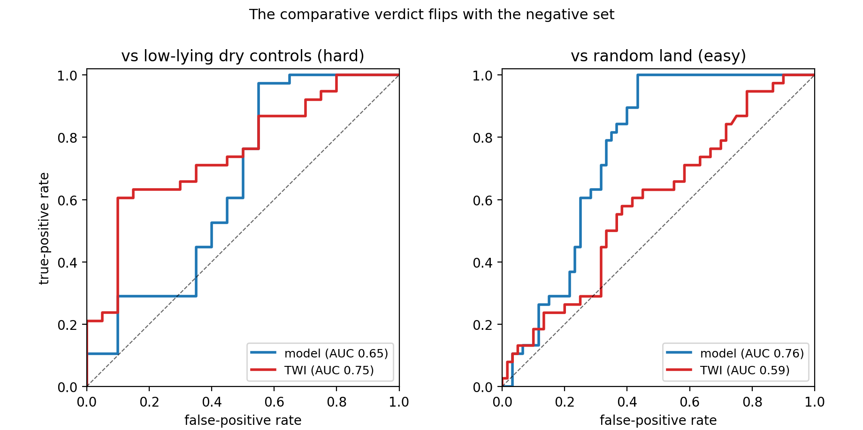
Figure 1. The comparative verdict swings with the negative set (present-day field, 38 flood positives). Left: against low-lying-but-dry developed areas (the decision-relevant negatives), the naive wetness index (TWI) is nominally higher than the calibrated model (AUC 0.75 vs 0.65) but the difference is not significant (paired ΔAUC −0.10, 95% CI [−0.32, +0.11]) — a tie. Right: against random land, the model ranks significantly better (0.76 vs 0.59; ΔAUC +0.14, CI excludes zero). The same two methods, opposite conclusions, from the choice of negatives alone.
Figure 1. The same two methods give opposite verdicts depending only on the negative set.
Synthesis. From one model and one register we obtained “validated,” “no better than topography,” “significantly more specific,” and “better only against random land” — the conclusion was set by the test design, not by the model. The model’s defensible value is not superior location skill but the things a wetness index cannot provide at all: a physical depth field, an explicit drainage mechanism, and climate-scenario projection. A validation that reports only a hit-rate would have claimed far more.

4. Tangible takeaways
A checklist to make open flood-model comparisons honest and portable:
- Anchor positives to an authoritative, current register; geocode with a real gazetteer (not hand-typed pins) and cross-check against the terrain.
- Always include at least one naive open baseline (a wetness index). If free topography matches your model, calibration has not earned a location claim — say so.
- Include documented dry controls in two tiers — elevated, and low-lying developed sites absent from the register — selected model-blind. Report against both random and discriminating negatives, and expect the verdict to depend on which: a model can win against the landscape and lose against low-lying-but-dry land.
- Prefer threshold-free metrics (ROC-AUC). A fixed depth cutoff confounds “specificity” with how much land a model floods; a conservative model looks specific for the wrong reason.
- If you report a fixed operating point, compare at matched sensitivity or specificity — never at each method’s arbitrary default (15% wettest land for an index, a depth threshold for a model).
- Attach paired bootstrap confidence intervals; claim a comparative result only when the interval excludes zero.
- Pre-register the scoring parameters and resist moving them to improve the verdict.

5. Transferability and limitations
The benchmark is city-agnostic: every ingredient is reproducible wherever an authority publishes a flood-prone register, and the whole test runs in seconds once the rasters exist. We demonstrate it on a single city and a single comparative hazard (pluvial); establishing how strong a baseline naive topography is across cities is the natural next study, strongest where mapped event extents also exist (enabling an extent-based Critical Success Index). The register is modest (38 positives, 20 controls), so no model-vs-topography ranking is supportable in either direction with confidence — which is itself the point. The contribution here is not the Singapore numbers but the practice: a documented-register benchmark with naive baselines, two-tier dry controls, threshold-free metrics, matched operating points and confidence intervals turns “my model flags the known flood spots” — which proves little — into a defensible, reproducible statement about whether, and on which axis, calibration adds value.

Data and code availability
The model, the documented register (positives and dry controls), the validation code, and the figure scripts are openly available at [repository / DOI — TBD]; reported numbers are frozen at commit [hash — TBD]. All inputs are open and licensed for commercial use.

References
Bates, P. D., Horritt, M. S., & Fewtrell, T. J. (2010). A simple inertial formulation of the shallow water equations for efficient two-dimensional flood inundation modelling. Journal of Hydrology, 387(1–2), 33–45.
Beven, K. J., & Kirkby, M. J. (1979). A physically based, variable contributing area model of basin hydrology. Hydrological Sciences Bulletin, 24(1), 43–69.
Caldwell, P. C., Merrifield, M. A., & Thompson, P. R. (2015). Sea level measured by tide gauges from global oceans — the Joint Archive for Sea Level holdings (NCEI Accession 0019568). University of Hawaii Sea Level Center. https://doi.org/10.7289/V5V40S7W
Coles, S. (2001). An introduction to statistical modeling of extreme values. Springer.
Efron, B., & Tibshirani, R. J. (1993). An introduction to the bootstrap. Chapman & Hall/CRC.
European Space Agency, & Airbus. (2022). Copernicus Global Digital Elevation Model (GLO-30). Copernicus DEM Product Handbook.
Fox-Kemper, B., Hewitt, H. T., Xiao, C., et al. (2021). Ocean, cryosphere and sea level change. In Climate change 2021: The physical science basis (pp. 1211–1362). Cambridge University Press.
Hanley, J. A., & McNeil, B. J. (1982). The meaning and use of the area under a receiver operating characteristic (ROC) curve. Radiology, 143(1), 29–36.
Hanssen, A. W., & Kuipers, W. J. A. (1965). On the relationship between the frequency of rain and various meteorological parameters. Mededelingen en Verhandelingen, 81. KNMI.
Nobre, A. D., Cuartas, L. A., Hodnett, M., et al. (2011). Height Above the Nearest Drainage — a hydrologically relevant new terrain model. Journal of Hydrology, 404(1–2), 13–29.
Peirce, C. S. (1884). The numerical measure of the success of predictions. Science, 4(93), 453–454.
PUB, Singapore’s National Water Agency. (2025). List of flood-prone areas in Singapore (as at Nov 2025). https://www.pub.gov.sg
Sirko, W., Kashubin, S., Ritter, M., et al. (2021). Continental-scale building detection from high-resolution satellite imagery (arXiv:2107.12283).

