Ho Chi Minh University of Technology

7/12/2019

**Project Proposal: A Smart LTD System**

# Background

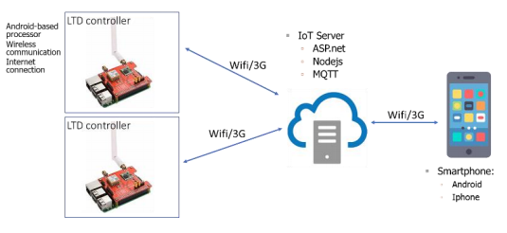The dry food can be preserved for a longer duration and is less susceptible to spoilage caused by the growth of bacteria, molds, and insects. One of the most common techniques for the dry food is the use of Low Temperature Dehydration (LTD). LTD is a process of reducing moisture of food to low level in low temperature environments. The dry food using LTD can improve palatability, digestibility, color, flavor and appearance. In the industry, many machines that embed the LTD technique for food preservation. Most of these machines are imported, stand-alone, locally controlled and expensive. These machines mainly operate continuously or periodically or fixed conditions. It leads to wasting energy, decreasing the machine life expectancy, increasing labor cost. Most importantly, it does not save the sensor data that can be used to improve the system for the next operation.

# Objectives

* The system must have basic operations: start the heater, heatpump, turn them off, control the fans.
* Sensors must be highly reliable(accuracy up to more than 90%) or data processing requires delicate methods to get the best possible results.
* Can be set TEMPERATURE RANGE and HUMIDITY RANGE remotely.
* The system can work for a short amount of time when there is no electricity.
* Must have an “auto restart” mode just in case the system strikes an unusual event(thunder, magnetic field corruption,…).
* Low-power consumption, the utilization shouldn’t surpass 30%.
* Feedback regularly about the state of the food(temperature, humidity, the numbers of time temperature reaches MAXIMUM,…).
* The system should have an mobile interface.
* Can transfer data without wifi.
* The system can record the state of the room in a day(during working mode only).

# Timeframe

|  |  |  |
| --- | --- | --- |
|  | Description of Work | Start and End Dates |
| Phase one | Choose the right MCUs and design basic plan | …(3 days) |
| Phase two | * Implement firmware functions and control flow, testing basic cases * Design and draw circuits with the chosen MCUs * Work with IOT server and create application interface and database | …(2 weeks) |
| Phase three | Testing:   * Testing the behaviour of the circuit under normal conditions * Burn the program into the MCU and test the hardware under practical conditions(extreme conditions if possible) * Testing the connection between the LTD and server * Run the application | …(2 weeks) |
| Phase four | Put it all together |  |
| Phase five | Practical tests the whole system under:   * Practical conditions * Lab conditions to simulate extreme situations | …(2 weeks) |

# Project budget

FREE!!!!!!

# Key skateholders

|  |  |
| --- | --- |
| Client | Someone |
| Sponsor | Noone |
| Project manager | Anyone |

# Possible solutions

|  |  |
| --- | --- |
| Basic Operations | * Can connect and control fans, heaters and heatpumps using analog signals(PWM) * Using current sensors to detect wheather the device is working or not |
| Sensors | * Using good sensors(DS18B20, TM100, LM75, Thermocouple,…) * Otherwise, choose cheaper sensors and use data processing methods: Best range algo, focus algo, kalman filter, Gauss distribution,… |
| Remote control | Connect to the server, using wifi, 3G, ethernet,… |
| Work without electricity | * External energy sources: batteries, natural energy(solar, heat,…) * Real time clock |
| Unusual events | * Use protections for the system: faraday cage, magnetic shielding,… * Using watchdog timer to restart anytime there is a weird behaviour |
| Low-power consumption | * The system goes into sleep mode when the operations are done * Set the periodical interval to wake up the MCU |
| Feedback regularly | * Use 3G, ethernet, CAN or Lora to send back data in case there was no wifi * Build database to check out daily data and adjust the system |
| Store the data in a day | * Using external memory(ICs) * Set the frequency of sampling to an approriate rate |