

Software requirement specification

Dictionary x Flashcard



January 17, 2020

FPT University

Dictionary Group

Phan Hoàng Minh Luân – SE63241  
Trần Minh Khoa – SE 63525  
Nguyễn Quang Khải – SE63503

1. **User Requirement Specification**
   1. Guest Requirement

Guest is a person who doesn’t have access to the system. Guest can use some functions in the system. To use all functions, guest must login. These are some functions guest can use:

* Signup
* Login
* Search word in database
* Report wrong word’s meaning
  1. Member Requirement

Member is a person who was signup the system. Member can use all functions guest can use plus:

* Logout
* Manage flashcard
* Update account’s info
  1. Admin Requirement

Admin is a person who have all access to the system. Admin can use these functions:

* Manage word in database
* View word’s reports
* Manage flashcard
* Manage account

1. **System Requirement Specification**
   1. External Interface Requirement
      1. User Interface

* Using Material Design as a main convention for mobile app and Web app
* Screen layout for website: 1920 x 1080
* Screen layout for mobile app: 1334 x 750
  + 1. Hardware Interface
* Smartphone with Wi-Fi connection, touch screen and screen resolution at least 1334 x 750
  + 1. Software Interface
* Web application: Firefox (v30 above), IE (v7 above) and Chrome, Safari
* Mobile application: run Android 5.0 above
  + 1. Communication Protocol
* HTTP protocol
  1. System Overview Use Case

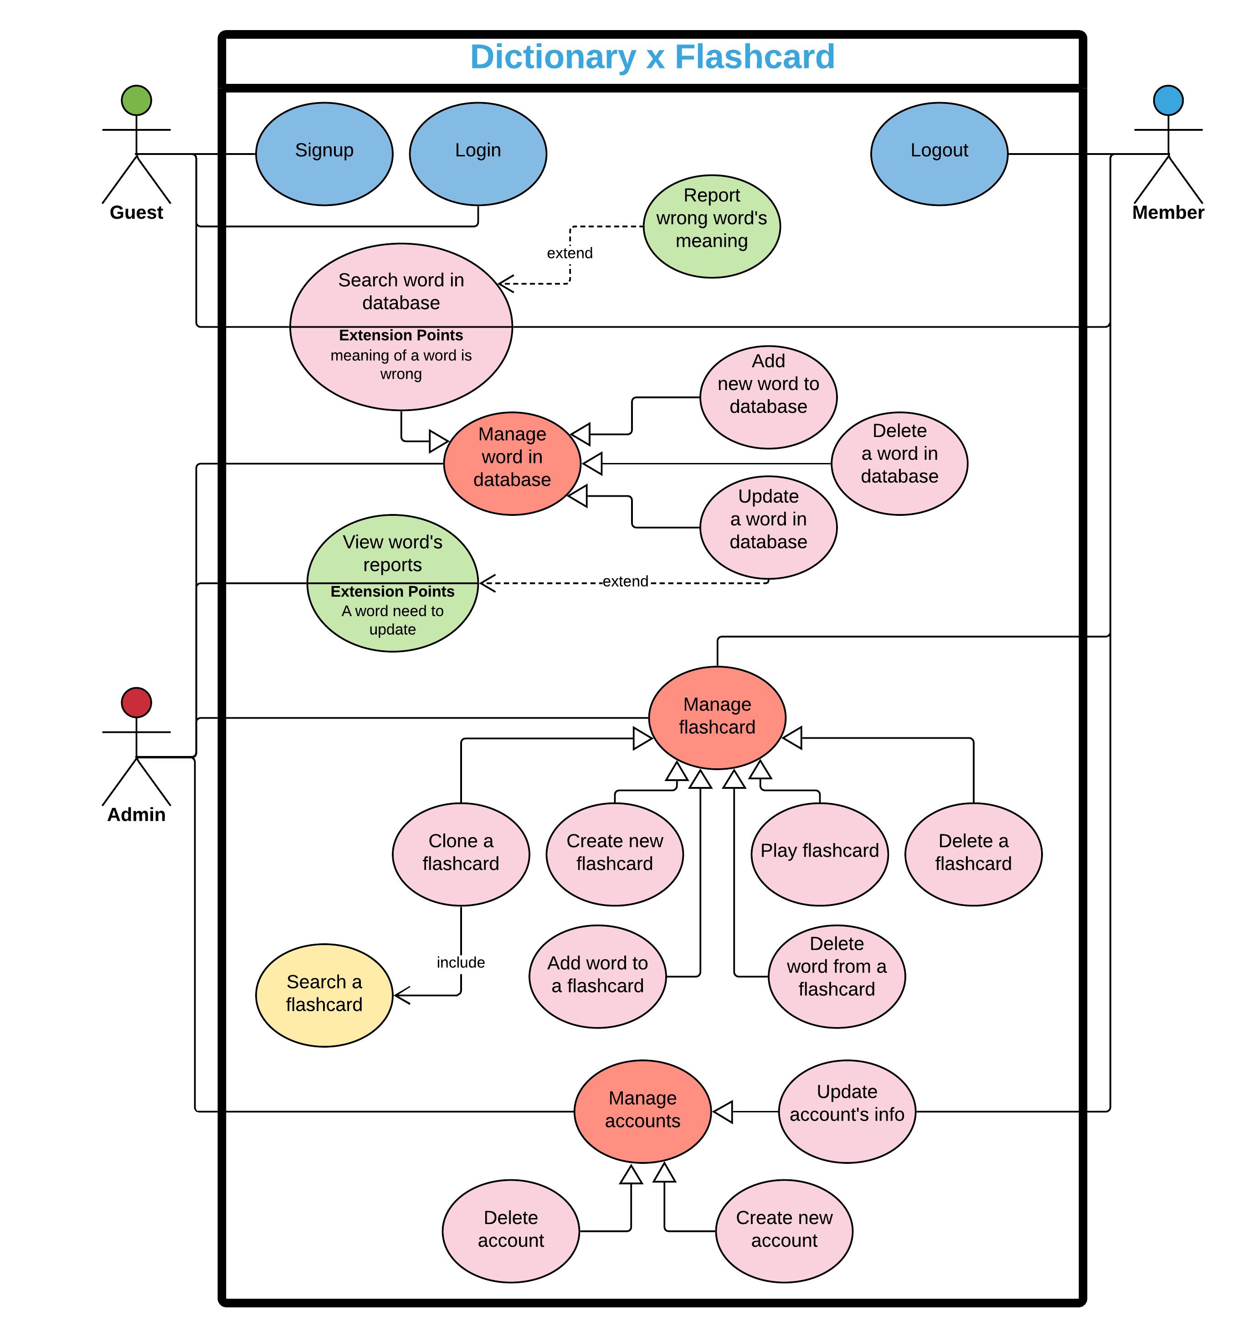

1. **Software System Attribute**
   1. Usability

* Ease to learn with search bar’s location that shall be recognized at the first glance
* The desire of user shall be achieved straightforwardly with instant recommendation when user types keywords into search bar
* Only one step (that is typing) to reach their goal, it’s crystal clear, there is no complex action, that is the reason why it is very easy to remember
  1. Reliability
* Some failure would appear during the system in operation such as virus attacks, bad hard drive disk, lost connection to internet. And the mean time between these problems shall be at least 6 months
  1. Availability
* The system shall be at least 98% available from 6:00 AM to 12:00 PM because that period time is when user actively used our application
* There are certain periods that our application is inaccessible (downtime for maintenance purpose). When it is, it shall not be counted in available calculation (because downtime on purpose)
  1. Security
* There are 3 privilege level (admin, registered member and guest) which shall be restricted based on role
* Password rules: at least 1 number, 1 uppercase letter, 1 special letter, and the required length shall be more than 10 letters
* Password must be change periodically (6 months)
* Only registered member could be able to see their private information. However, admin can use personal information for tracking and management purpose, not for advertisement as well as sell information for the other parties.
* The application shall be able to resist the interference of virus, Trojan House, malware by using Kaspersky Internet Security 2020
  1. Maintainability
* Document shall be easy to understand for later developer who will edit or upgrade this software
  1. Portability
* The application shall be able to run on different mobile operating system: iOS, Android
  1. Performance
* To adapt instant recommendation when user types keyword, the response time shall be under 1 second for each request
* Database shall be able to store at least 10 million records to allow user to have precise and ample choices
* This system shall be able to handle 10,000 concurrent users and it shall not be influencing the user experience