


PROJECT REPORT

Pea Cosmestic

Class: | PF1118
Group: | Group 13
Instructor | Nguyen Dinh Cuong
Team members: | Do Phuong Anh

Induction

New technologies and applications are being successfully applied in many fields and the retail business is no exception. Sales software is the best way to manage sales from importing, exporting, and managing employees. If a traditional business store often encounters inadequacies such as loss of goods, slow reporting, financial risks when managing books, loss of time in sales management, etc. and using sales software is an urgent task to effectively overcome the above difficulties.

From those things, I planned and launched the PEA_COSMESTIC, Cosmestic system sales management software.

Contents
Pea Cosmestic 1
I. Project Introduction 3
1. Proposed system 4
2. The scope of the project to be applied 4
3. Name System 4
4. Development Tools 4
5. Functions of system 4
II. Analyze System Requirements 5
1. Use case 6
1.1 Use case 6
1.2. Login 6
1.3 Register 8
1.4 Search Product 9
1.5 View Customer 10
1.6 Add Product 12
1.7 Create Order 13
1.8 Confirm Order 13
2. Activity Diagram 14
2.1 Login 15
2.2 Register 16
2.3: Search Product 17
2.4 Search Product by Brand 18
2.5: Order 19
2.6: Log Out 20
III. Design Detail 21
1. UI Design 21
1.1: Main Menu 21
1.2: Register 23
1.3: Seller Menu 24
1.4: Product management 25
1.5 Check order 27
- View All Order 27
- Confirm Order 27
1.6 Menu Customer 28
1.7: Search Product 29
1.7 Order 30
1.8 Setting Account 31
2. Code Desgin (Class Diagram) 32
3. Sequence Diagram 33
3.1: Log In 33
3.2: Search Product 34
3.3: Search Product by Name 35
3.4 Log Out 36
4. DataBase Design 37
4.1 DataBase Design Details 37
VI. Test 40
1. Login Test 40
2. Seach Product Test 42
3. Register Test 46
V. Task Assign (to each team member) 50
VI. Installation Instructions 51
1. Deployment Diagram 51
2. Installation Steps 51

I. Project Introduction
The sales management system will have the following basic features:
There are 2 main functions including Create Orders and Manage Products along with other functions such as viewing customer information, managing accounts, searching for products.

1. Proposed system
The management system is for those who are and will be owners of retail business models, the customers of those business services.

2. The scope of the project to be applied
- The system object is for retail store owners and their customers.

3. Name System

- Cosmestic System.

4. Development Tools
- Visual Studio Code.
- Mysql Workbench
- Star.Uml

5. Functions of system
- Login
- Register
- Search Product
- Order
- My Order
- Create Order
- CheckOrder
- View All Order
- Confirm Order
- Setting Account
- Product Management
- Update Product Information
- Add Product
- Display Product
- View Customer
- Exit

II. Analyze System Requirements
- The system is built to make it easier for cosmetic stores to manage orders. It can help the seller to have more information about the products in the store, that information will include product brand, price, quantity, etc., so that the seller can advise more specifically to the seller. purchase according to the needs of the customer. The main function of the system is to help sellers manage products including adding, editing and deleting products. Help shoppers create their orders from your store's products. In addition, the system also helps buyers manage their accounts when they want to change their own personal information.

1. Use case

1.1 Use case

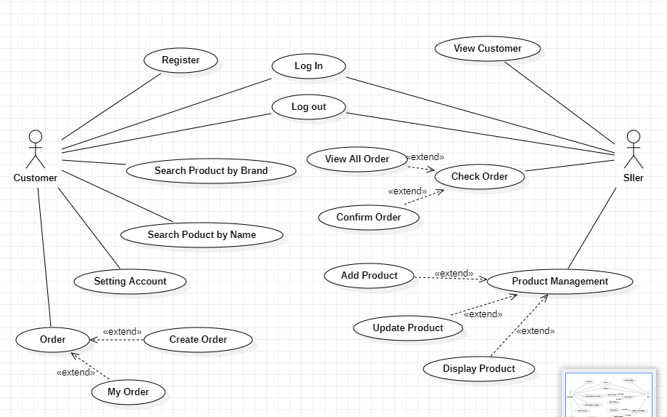

1.2. Login

NAME | LOGIN
Description | Used to access the program and define the accessible features depending on the account type.
Actor | Seller and customer.
Organization Benefits | This feature was created to define the features and data that merchants and customers can access the program,.
Trigger | Login will be automatically enabled right after starting the program.
Preconditions | The correct username and password must be entered, the database must be connected, the account must exist in the database.
Postconditions | Success: the account will log into the system, the main menu of the program displays. Failed: could not login to the system.
Main course | 1. Enter UserName and Password  2. Verify information  3. Show main menu
Alternate Courses | AC 2.1: User entered wrong PassWord or UserName  1. Display error message  2. Show the login screen again  3.Re-enter required
Exceptions | EX 1.1: Enter UserName and PassWord  1. Display: “Your PassWord and UserName is wrong!” and ask to re-enter until correct  2. Re-enter username and password  EX 2.1:  1. Step 1: Display “Error!!!Can’t connect to database”  2. Check internet connections  .

1.3 Register

NAME | REGISTER
Description | Used to register an account in the system.
Actor | Customer
Organization Benefits | This feature is created so that customers can create an account in the system, from which they can use all customer functions in the system such as ordering, viewing products, changing account information, etc. account,…
Trigger | After registration, the account will immediately exist in the database.
Preconditions | It is necessary to enter the correct information required for successful account registration.
Postconditions | Success: the account will be created in the database and can be logged in immediately with that account.  Failed: the account could not be added to the system.
Main course | 1. Enter FullName, UserName, PassWord, Phone, Age  2. Receiving information  3. Show the login screen again
Alternate Courses | AC 2.1: User enters an already existing User Name 1. Show Existing User Name 2.Re-enter request
Exceptions | EX1: Failed to connect to database  1. Request to recheck connections  2. Request to restart the program.

1.4 Search Product

NAME | Search Product
Description | Use to search for products
Actor | Customer
Organization Benefits | Customers can search for cosmetics in the system
Trigger | Log in to the program with the customer's account and the customer can use this feature.
Preconditions | There must be at least 1 product created in the database.
Postconditions | Success: Showing the list of searched cosmetics  Failed: No valid product
Main course | 1. Enter the name of the product/cosmetic brand you want to search for  2. Show list of cosmetics found
Alternate Courses | AC3: 1. The data does not exist in the database. Display: “No product you are looking for”
Exceptions | EX1: Failed to connect to database  1. Request to recheck connections  2. Request to restart the program.

1.5 View Customer

NAME | View All Customer
Description | Use to view customer information
Actor | Seller
Organization Benefits | Seller can see all customer information
Trigger | Log in to the program with the merchant account and can use this function.
Preconditions | Must have at least one customer.
Postconditions | Success: Show all customers Failed: No display
Main course | 1.Display information of all customers
Alternate Courses
Exceptions | EX1: Failed to connect to database  1. Request to recheck connections  2. Requires a reboot

1.6 Add Product

NAME | Add Product
Description | Use to add new product
Actor | Seller
Organization Benefits | Seller can add one or many new product to their store
Trigger | Log in to the program with the seller's account and you can use this feature.
Preconditions | It is necessary to enter the correct information necessary to successfully add a new product.
Postconditions | Success: Product will be created in the database and customer can buy it.  Failed: Product could not be added to the system store .
Main course | 1. Enter Name, Amount, Price, Brand of Product  2. Receiving information  3. Show :”Successfully added new product”
Alternate Courses | AC 2.1: If the seller enters the quantity less than 1, they will have to re-enter the product quantity.
Exceptions | EX1: Failed to connect to database  1. Request to recheck connections  2. Requires a reboot

1.7 Create Order

NAME | Create Order
Description | Use to create orders
Actor | Customer
Organization Benefits | Customers can create orders based on the shop's products.
Trigger | Log in to the program with the customer's account and use the order function
Preconditions | There must be at least 1 product in the store
Postconditions | Success: Order has been created  Failed: Unable to create order
Main course | 1. Enter the product code, the quantity customers want to add to the order  2. Valid data  3. Successful order creation
Alternate Courses | AC 2.1: Invalid product number or product ID 1. Error display 2. Re-enter request
Exceptions | EX1: Failed to connect to database  1. Request to recheck connections  2. Requires a reboot

1.8 Confirm Order
NAME | Confirm Order
Description | Use to Confirm orders
Actor | Seller
Organization Benefits | The seller can confirm which orders have been delivered to the carrier
Trigger | Log in to the program with the seller's account and use the order function
Preconditions | There must be at least 1 order is pending in the store
Postconditions | Success: Order has been delivery  Failed: Unable to confirm order
Main course | 1. Enter the order Id that seller want to confirm  2. Valid data  3. Successful changed order status
Alternate Courses | AC 2.1: Invalid orderId 1. Error display 2. Re-enter request
Exceptions | EX1: Failed to connect to database  1. Request to recheck connections  2. Requires a reboot

2. Activity Diagram

2.1 Login

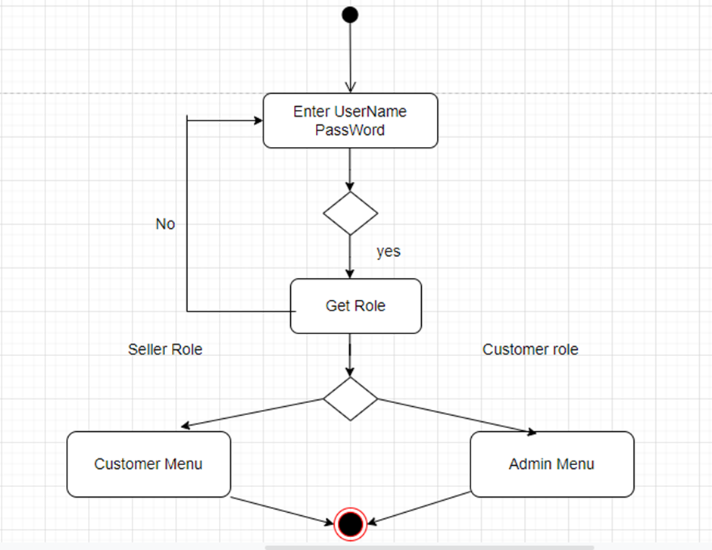

2.2 Register

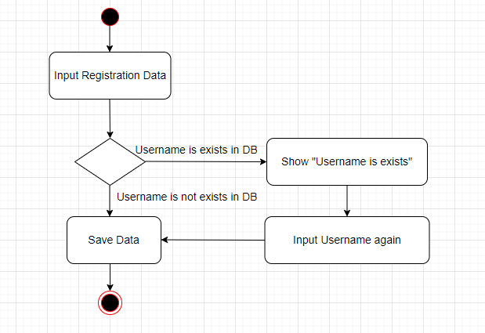

2.3 Search Product
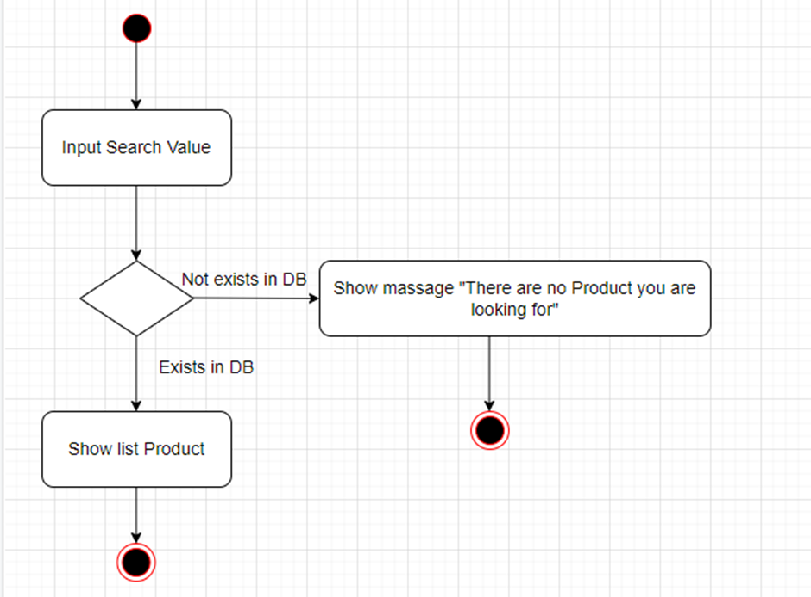

2.4: Search Product by Brand

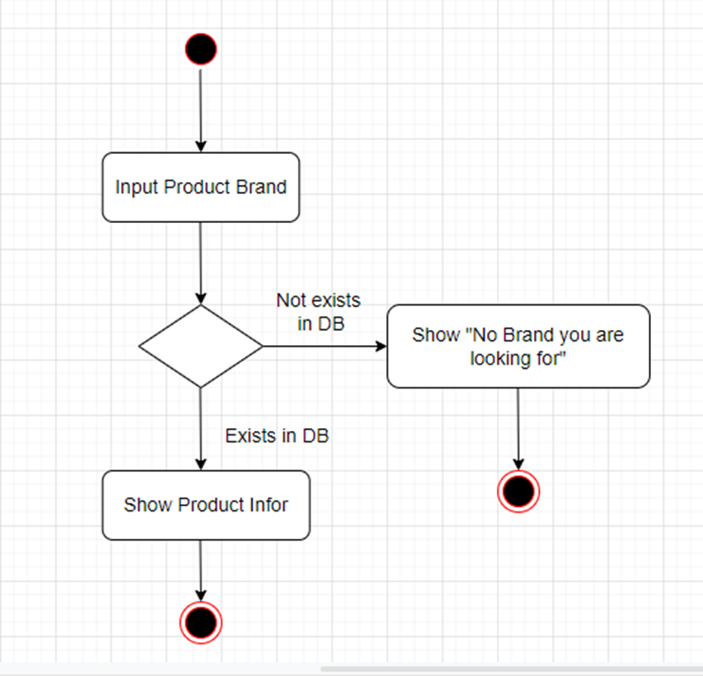

2.5 Order
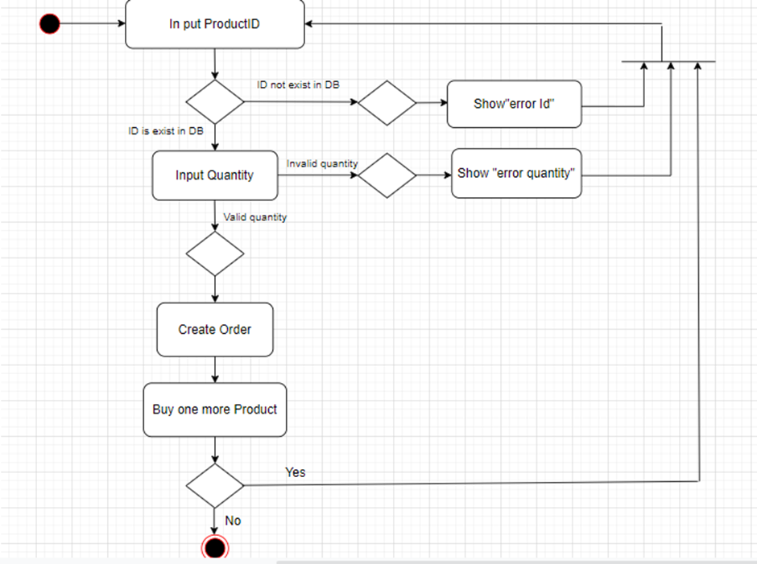

2.6: Log Out

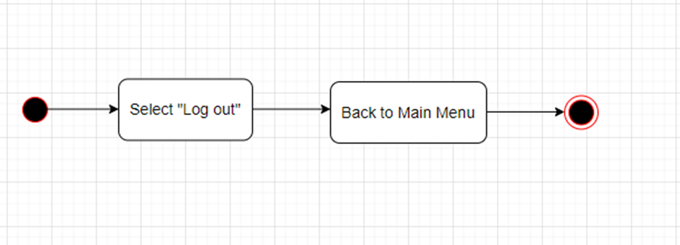

III. Design Detail

1. UI Design

1.1: Main Menu


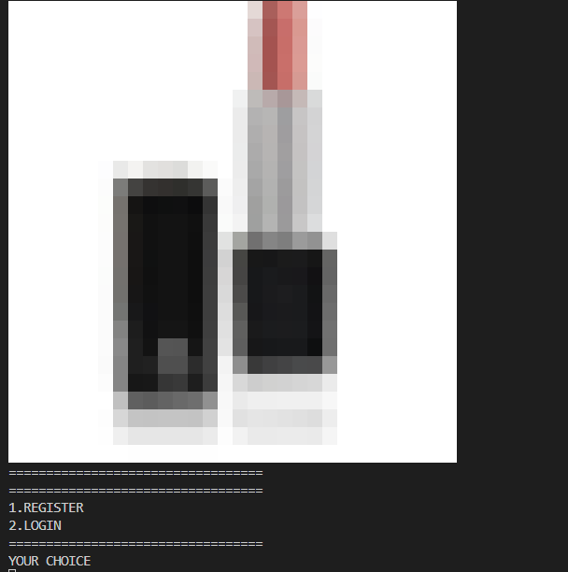

1.2: Register

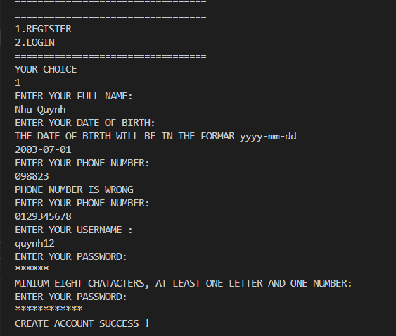

1.3: Seller Menu

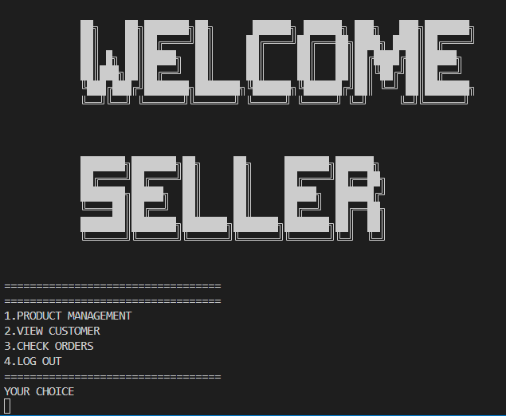

1.4: Product management
- Add Product
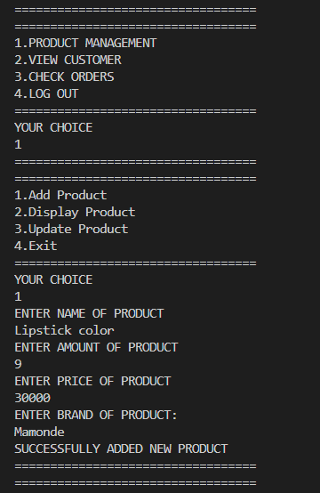

- Update Product
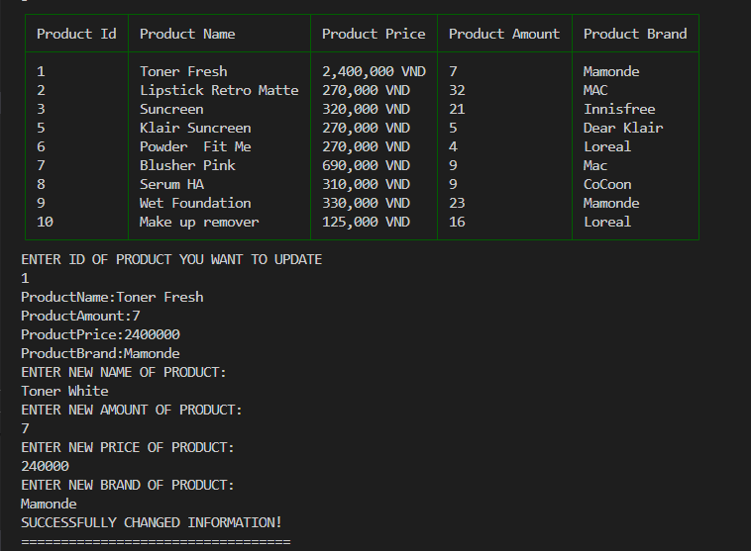
- Display Product
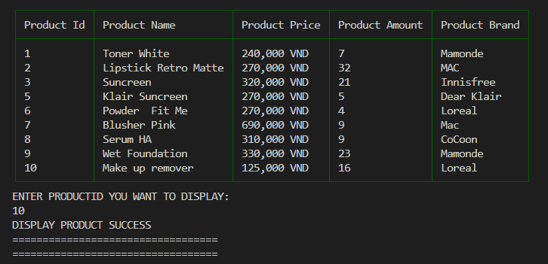

1.5 Check order

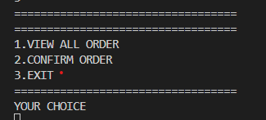

View All Order

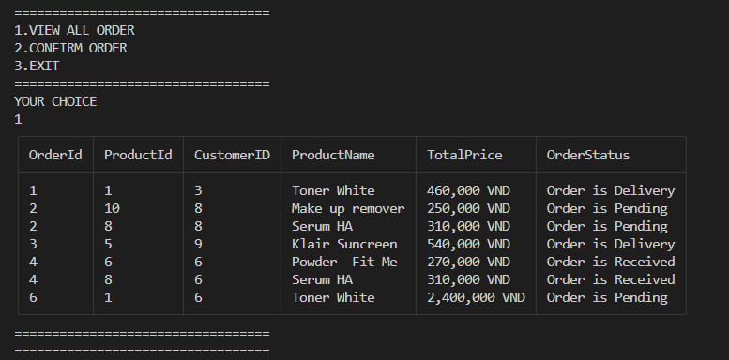

Confirm Order

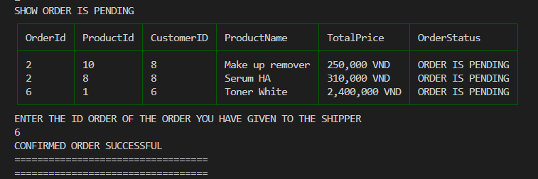

1.6 Menu Customer

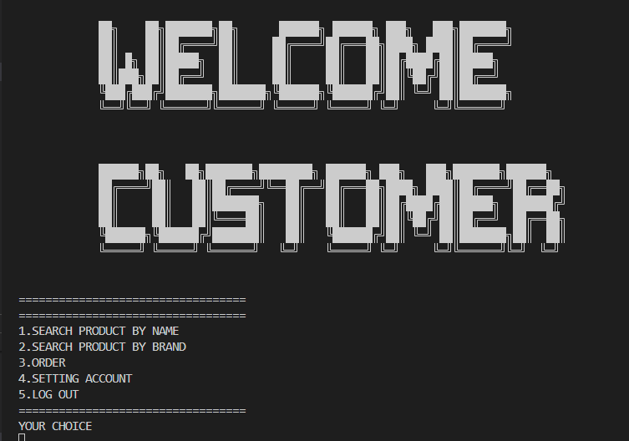

1.7: Search Product
- Search Product by Brand
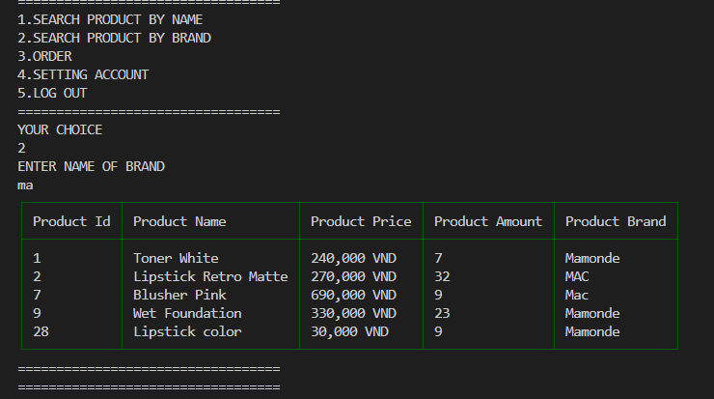
- Search Product by Name
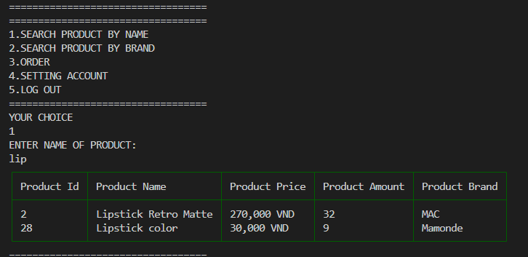

1.7 Order

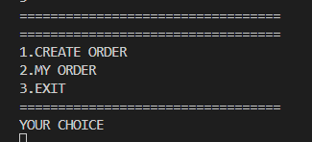
- Create Order
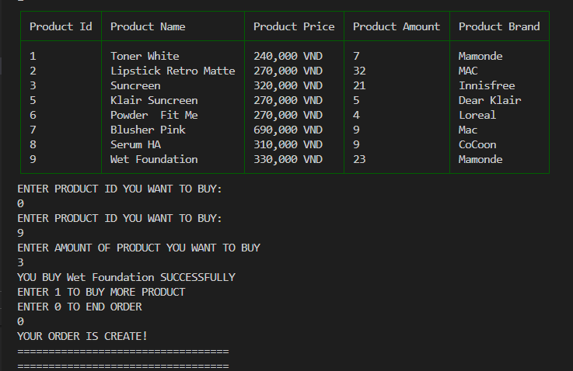
- My Order
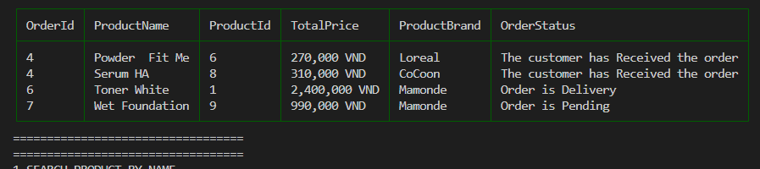

1.8 Setting Account

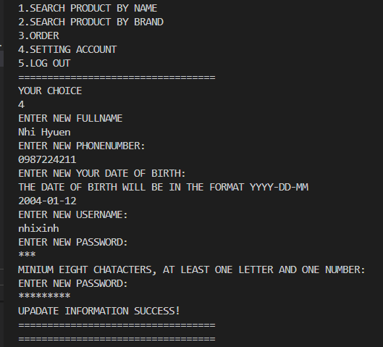

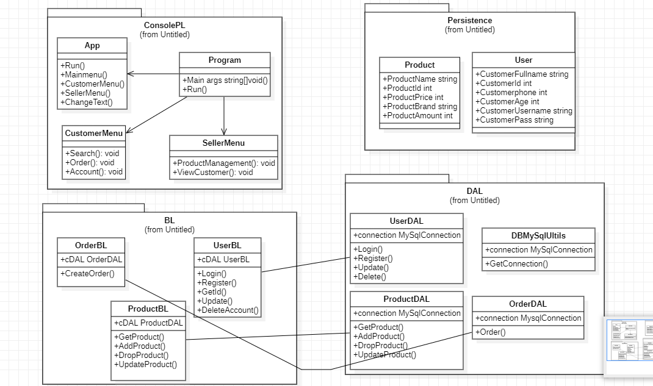
2. Code Desgin (Class Diagram)

3. Sequence Diagram

3.1: Log In
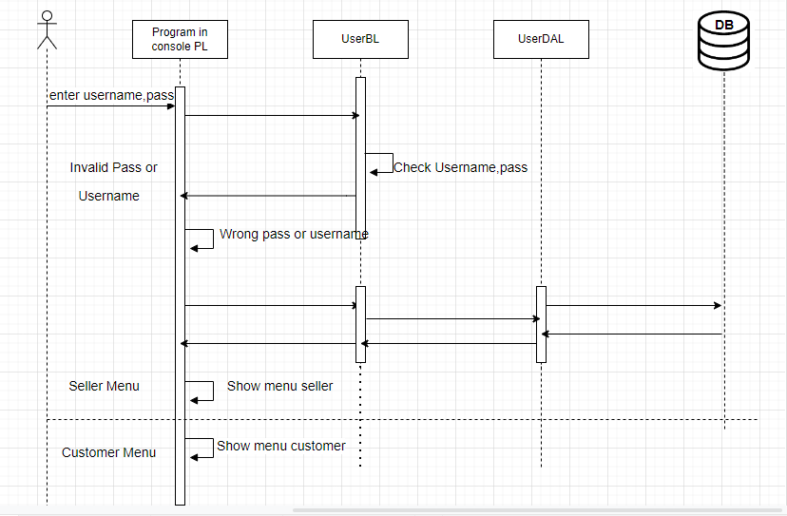

3.2: Search Product
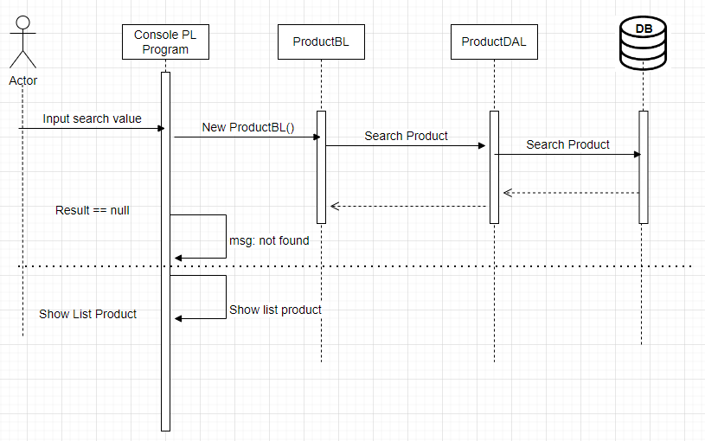

3.3: Search Product by Name

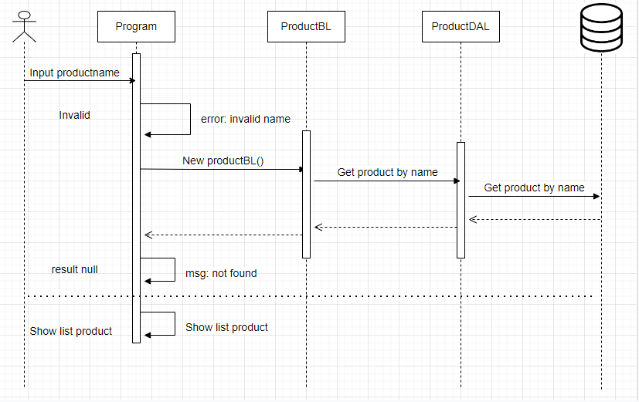

3.4 Log Out

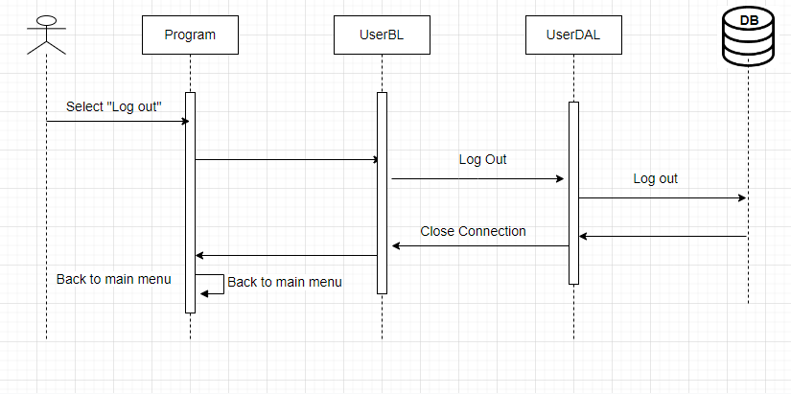

4. DataBase Design

4.1 DataBase Design Details

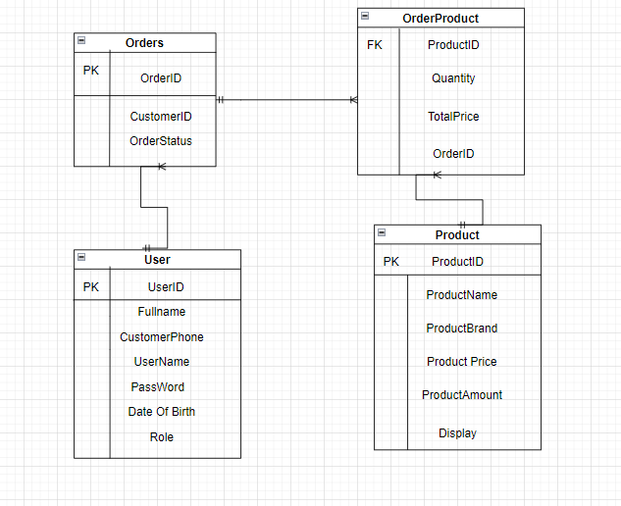

Users
Column Name | Data Type | Constraints | Description
CustomerId | int | Primary Key, Autoincrement
FullName | varchar(200) | NOT NULL | Customer’s name
CustomerNumber | int | NOT NULL
Password | Varchar(100) | NOT NULL
UserName | Varchar(100) | NOT NULL
Role | Varchar(100) |  | 1. Seller  2.Customer
Date of Birth | Date

Product
Column Name | Data Type | Constraints | Description
ProdudctId | int | Primary Key, Autoincrement
ProductName | varchar(200) | NOT NULL | Product’s name
ProductAmount | int | NOT NULL | Product’s amount
ProductPrice | int | NOT NULL | Product’s price
ProductBrand | Varchar(200) | NOT NULL | Product’s brand
Display | int | NOT NULL

orders
Column Name | Data Type | Constraints | Description
OrderID | int | Primary Key
ProductName | varchar(200) | NOT NULL
OrderStatus | int | NOT NULL | 1. Order is Pending  2.Order is Delivery  3.Order is received

OrderProduct
Column Name | Data Type | Constraints | Description
ProdudctId | int | NOT NULL
Quantity | int | NOT NULL
TotalPrice | int | NOT NULL
OrderID | int | NOT NULL

VI. Test

1. Login Test
1.1 Login Test 1

Test case number | 001
Test case name | Login test1()
Test case description | This test case checks UserName and PassWord correct or not
Preconditons | UserName and PassWord must exists in Database
Test case input | “phanhpea” “01928364a”  “nhihuyen” “1111111i”
Test case expected output | A staff
Test case steps | New Staff  New StaffDAL  Call Login Method  Compare output with expected output
Default value preverving

1.2: Login Test 2

Test case number | 001
Test case name | Login test1()
Test case description | This test case checks UserName and PassWord correct or not
Preconditons
Test case input | “seller012” “01928364bc”  “cus123o4” “2221111i”
Test case expected output | Null
Test case steps | New Staff  New StaffDAL  Call Login Method  Compare output with expected output
Default value Preverving

2. Seach Product Test
2.1 Search Product by Name Test 1

Test case number | 001
Test Case Came | Seacrh Products test1()
Test Case Description | Search for products in the system
Preconditons | Logged in
Test Case Input | “Clean”  “Mascara”  “T”
Test Case Expected Output | List Product
Test Case Steps | New ProductDAL  Call Search Method  Compare output with expected output
Default Value Preverving

2.2 Search Product by Brand test 2

Test case number | 002
Test Case Came | Seacrh Laptop test2()
Test Case Description | Search for products in the system
Preconditons | Logged in
Test Case Input | “Mamon”  “Olay”  “L”
Test Case Expected Output | List Product
Test Case Steps | New ProductDAL  Call Search Method  Compare output with expected output
Default Value Preverving

2.3 Search Product Test 3

Test case number | 001
Test Case Came | Seacrh Laptop test1()
Test Case Description | Search for products in the system
Preconditons | Logged in
Test Case Input | “Clean@@”  “Mascara091”  “Ol!!”
Test Case Expected Output | NULL
Test Case Steps | New ProductDAL  Call Search Method  Compare output with expected output
Default Value Preverving

2.4 Search Product test 4

Test case number | 001
Test Case Came | Seacrh Laptop test1()
Test Case Description | Search for products in the system
Preconditons | Logged in
Test Case Input | “*^%(&%”  “Olay# Toner”  “Ol##”
Test Case Expected Output | NULL
Test Case Steps | New ProductDAL  Call Search Method  Compare output with expected output
Default Value Preverving

3. Register Test
3.1 Register 1

Test case number | 001
Test Case Came | Register test1 ()
Test Case Description | Create a new account in system
Preconditons | Eter form register right
Test Case Input | “Mai Ngoc”,”1992-03-21”,”0129287411”,”mai12”,”11111111w”
Test Case Expected Output | Create account successfull
Test Case Steps | New UserDAL  Call Register Method  Compare output with expected output
Default Value Preverving

3.2 Test register 2

Test case number | 002
Test Case Came | Register test 2 ()
Test Case Description | Create a new account in system
Preconditons | Eter form register right
Test Case Input | “Mai Ngoc”,”1992-03-212”,”0129287”,”mai12”,”11111111”
Test Case Expected Output | Show ‘Enter wrong’  Enter again
Test Case Steps | New UserDAL  Call Register Method  Compare output with expected output
Default Value Preverving

4. Order Test
4.1: Order Test 1

Test case number | 001
Test Case Came | Order Test 1 ()
Test Case Description | Create a new order in system
Preconditons | Eter form create order right
Test Case Input | “3”, “1”  “11” “6”
Test Case Expected Output | Create Order successfull
Test Case Steps | New OrderDAL  Call Order Method  Compare output with expected output
Default Value Preverving

4.2: Test order 2

Test case number | 002
Test Case Came | Order test 2 ()
Test Case Description | Create a new order in system
Preconditons | Eter form account right
Test Case Input | “23”,”1000”  “0”,”1”
Test Case Expected Output | NULL
Test Case Steps | New UserDAL  Call Register Method  Compare output with expected output
Default Value Preverving

V. Task Assign (to each team member)
Group 13 | Pea _Cosmestic
No | Task name | Description | Start Date | End Date | Member | Self assessment
1 | Code |  | 17/08 | 22/08 | Ph.Anh
2 | Code |  | 29/08 | 06/09 | Ph.Anh
3 | Code |  | 16/09 | 18/09 | Ph.Anh
4 | Control |  | 20/09 | 21/09 | Ph.Anh
5 | Write report |  | 25/09 | 28/09 | Ph.Anh

VI. Installation Instructions

1. Deployment Diagram

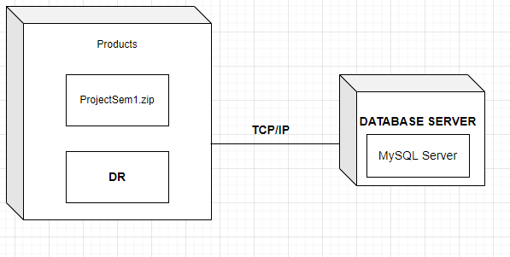

2. Installation Steps
- Database Install
- Server Install
- Application Install

END

