**ASSIGNMENT 1 FRONT SHEET**

|  |  |  |  |
| --- | --- | --- | --- |
| **Qualification** | **BTEC Level 5 HND Diploma in Computing** | | |
| **Unit number and title** | Unit 13:Computing Research Project | | |
| **Submission date** | 08th/March/ 2024 | **Date Received 1st submission** |  |
| **Re-submission Date** |  | **Date Received 2nd submission** |  |
| **Student Name** | PHAM VIET ANH | **Student ID** | BH00005 |
| **Class** | IT0502 | **Assessor name** | Nguyen Thanh Trieu |
| **Student declaration**  I certify that the assignment submission is entirely my own work and I fully understand the consequences of plagiarism. I understand that making a false declaration is a form of malpractice. | | | |
|  |  | **Student’s signature** | Anh |

**Grading grid**

|  |  |  |  |  |  |  |  |  |  |
| --- | --- | --- | --- | --- | --- | --- | --- | --- | --- |
| P1 | P2 | P3 | P4 | P5 | M1 | M2 | M3 | D1 | D2 |
|  |  |  |  |  |  |  |  |  |  |

|  |  |  |
| --- | --- | --- |
| **❒ Summative Feedback: ❒ Resubmission Feedback:** | | |
| **Grade:** | **Assessor Signature:** | **Date:** |
| **Internal Verifier’s Comments:** | | |
| **Signature & Date:** | | |

Contents

I. Introduction 6

II. Produce a research proposal that clearly defines a research question or hypothesis supported by a literature review. (P1) 6

**1.1** **Research Topic** 7

**1.2** **Project Type** 7

**1.3** **Abstracts** 7

**1.4** **Situation** 7

**1.5** **Define the main aims and objectives of the project** 7

1.**5.1**. **Aims** 8

**1.5.2**. **Objectives** 8

**1.6** **Project plan** 8

III. Examine appropriate research methods and approaches to primary and secondary research. (P2) 11

**2. Research methods** 11

**2.1. Primary methods** 11

**2.1.1. Types of primary research** 11

**2.1.2. Advantages of primary research** 12

**2.1.3. Disadvantages of primary research** 13

**2.2. Secondary research** 14

**2.2.1 Steps involved conducting secondary research** 14

**2.2.2 Advantages of Secondary research** 15

**2.2.3 Disadvantages of Secondary research** 16

**2.3. Compare Primary Research with Secondary Research** 17

**2.4. Qualitative Research** 18

**2.4.1 Qualitative Research Methods** 18

**2.4.2 Qualitative data analysis** 18

**2.4.3 Advantages of Qualitative research** 18

**2.4.4 Disadvantages of Qualitative research** 19

**2.5 Quantitative research** 20

**2.5.1 Quantitative research methods** 21

**2.5.2 Quantitative data analysis** 21

**2.5.3 Advantages of Quantitative research** 21

**2.5.4 Disadvantages of Quantitative research** 22

**2.6 Compare Qualitative Research with Quantitative Research** 23

**2.7. Scientific Method** 24

**2.7.1 The Scientific method in technology and computers** 24

**2.7.2 Steps of scientific method** 25

**2.8. Research Process** 26

**2.8.1 Steps** 26

**2.9. Population in Research** 28

**2.9.1 Collecting data from population** 28

IV. Conduct primary and secondary research using appropriate methods for a computing research project that consider costs, access and ethical issues. (P3) 29

**3.1 Secondary Research** 29

**3.1.1. Sources** 29

**3.1.2. Interpretation and implications of findings** 30

3.**2 Primary Research** 31

**3.2.1 Interviews** 33

**3.2.2 Survey** 34

V. Apply appropriate analytical tools, analyze research findings and data. (P4) 36

**4.1. Interview** 36

**4.1.1 Interview 1** 36

**4.1.2 Interview 2** 37

**4.1.3 Interview 3** 38

**4.1.4 Interview 4** 39

**4.1.5 Interview 5** 40

**4.2. Interview Summary** 41

**4.3 Survey** 41

**4.4 Survey summary** 47

**4.5 Analyze the results of primary research** 48

VI. Communicate research outcomes in an appropriate manner for the intended audience. (P5) 49

**5.1. Conclusion** 49

**5.2. Recommendations** 50

VII. Conclusion 51

References 52

*Figure 1: Structure diagram 9*

*Figure 2: Ganttchart 11*

*Figure 3: The survey 1 42*

*Figure 4: The survey 2 42*

*Figure 5: The survey 3 43*

*Figure 6: The survey 4 43*

*Figure 7: The survey 5 44*

*Figure 8: The survey 6 45*

*Figure 9: The survey 7 45*

*Figure 10: The survey 8 46*

*Figure 11: The survey 9 47*

1. **Introduction**

In an era marked by exponential growth in digital data, the environmental impact of big data storage models has emerged as a critical concern. As the volume of data generated worldwide continues to skyrocket, traditional storage methods have come under scrutiny for their significant contribution to resource depletion, energy consumption, electronic waste generation, and pollution. Recognizing the urgent need to address these environmental challenges, the research project "Environmental Impacts and the Search for Alternative Materials in Big Data Storage Models" seeks to explore innovative solutions that balance the demands of data storage with sustainability imperatives.

This report presents the findings and insights gleaned from an in-depth investigation into the environmental impacts of current big data storage models and the ongoing search for alternative materials and sustainable practices. Through a combination of primary research methods, including interviews with industry experts, environmental scientists, policymakers, technology company representatives, and environmental advocates, as well as surveys of relevant stakeholders, this project aims to shed light on the multifaceted nature of the environmental challenges facing the technology sector.

The report begins by examining the awareness and perceptions of stakeholders regarding the environmental impacts associated with current data storage methods. It then delves into the identification of the most significant environmental impacts of existing storage models, providing valuable insights into areas of concern and areas for improvement. Additionally, the report explores the awareness and adoption of alternative materials and sustainable practices within the industry, highlighting potential pathways towards greener data storage solutions.

Furthermore, the report investigates the barriers hindering the widespread adoption of alternative materials and sustainable solutions in big data storage models, as well as the recommendations for overcoming these challenges. By synthesizing the perspectives and expertise of diverse stakeholders, this report aims to inform and guide efforts to promote environmental sustainability in the technology sector.

1. **Produce a research proposal that clearly defines a research question or hypothesis supported by a literature review. (P1)**
   1. **Research Topic**

“Environmental Impacts and the Search for Alternative Materials in Big Data Storage Models”.

* 1. **Project Type**

Research and Alnalysis

* 1. **Abstracts**

The rapid growth of digital data storage and processing in the modern era has brought to light the environmental challenges posed by data storage models. This research delves into the adverse environmental impacts of data storage models, such as data centers and cloud computing, and explores the potential for discovering and utilizing alternative materials and practices to mitigate these impacts. The study investigates the energy consumption, resource utilization, and climate effects associated with data storage, offering insights into the environmental toll of big data. Moreover, it examines alternative resource sources, including renewable energy and eco-friendly materials, to reduce the ecological footprint of data storage. Strategies and policies to promote sustainability in data storage are also explored. Through digital modeling and cost-benefit analysis, this research estimates the potential environmental benefits and economic advantages of adopting alternative measures in data storage. The findings aim to provide a foundation for developing environmentally responsible data storage solutions in the age of big data.

* 1. **Situation**

The situation revolves around the pressing issue of environmental impacts associated with data storage models and the urgent need to explore alternative materials and practices to mitigate these effects. As the digital age continues to advance, the demand for data storage and processing has surged exponentially. This surge has led to a proliferation of data centers, cloud computing infrastructure, and large-scale data storage facilities. While these technological advancements have brought about tremendous benefits, they have also raised significant environmental concerns. Data storage models, including data centers and cloud systems, consume substantial amounts of energy, contribute to resource depletion, and release greenhouse gases into the atmosphere. These environmental impacts pose a threat to the delicate balance of our ecosystem and exacerbate climate change issues.

In response to these concerns, this situation calls for comprehensive research and action to address the environmental impacts of data storage models. Researchers and policymakers must explore alternative materials, energy sources, and sustainable practices to reduce the ecological footprint of data storage. By addressing this situation, we can work towards more environmentally responsible and sustainable data storage solutions that align with our evolving technological landscape while preserving our planet for future generations.

* 1. **Define the main aims and objectives of the project**

1.5.1. **Aims**

* Assess the environmental impacts associated with current big data storage models and technologies.
* Identify the key challenges and limitations of existing data storage materials in terms of sustainability and environmental concerns.
* Explore and evaluate alternative materials and technologies for big data storage that are environmentally friendly and sustainable.
* Analyze the potential benefits and drawbacks of adopting alternative materials in big data storage models.
* Propose recommendations and guidelines for the adoption of sustainable materials and practices in the field of big data storage

1.5.2. **Objectives**

* Conduct a comprehensive review of literature and research to understand the environmental implications of existing big data storage models and technologies.
* Analyze data on resource consumption, energy usage, and waste generation associated with current big data storage practices.
* Research and assess alternative materials and technologies that have the potential to reduce the environmental impact of big data storage.
* Consider sustainable materials such as recycled plastics, bio-based polymers, and carbon-neutral materials for data storage devices.
* Conduct a comparative analysis of the environmental performance of traditional and alternative materials in terms of energy efficiency, resource consumption, and environmental impact.
* Evaluate the economic feasibility, technical feasibility, and scalability of adopting alternative materials in large-scale data storage infrastructure.
* Develop actionable recommendations and guidelines for industry stakeholders, policymakers, and researchers to promote the adoption of sustainable materials and practices in big data storage.
* Highlight best practices and case studies of organizations that have successfully implemented environmentally friendly approaches to data storage.
  1. **Project plan**

We are a multidisciplinary research team comprising enthusiastic young experts in environmental science, technology, and data science. With a diversity of skills and experiences, we have organized and closely collaborated to execute a detailed and comprehensive research plan.

Our team consists of five members: Quang, Duc, Dung, Viet Anh, Hiep, each assuming specific roles in the project. The projected timeframe for the project is three months, with activities allocated and conducted systematically and flexibly.

Our plan encompasses specific steps from survey preparation, data collection, evaluation of alternative materials and technologies, to the development of specific solutions and strategies to mitigate the environmental impact of data storage. Each team member is responsible for distinct roles and tasks, from collecting quantitative data to analyzing content from interviews and group discussions, as well as developing strategies and preparing detailed reports.

This is my structure diagram about the phases of the project by drawing in website “Draw.io”:

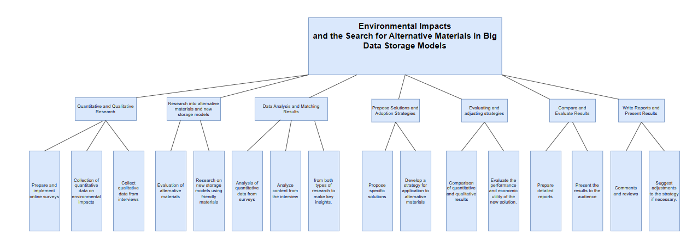

Figure 1: Structure diagram

and a table detailing the timeline in the project phases:

|  |  |
| --- | --- |
| Preparing and conducting online surveys with experts and managers. | 1 week – Quang, Hiep |
| Collecting quantitative data on the environmental impact of current models. | 2 weeks – Duc |
| Gathering qualitative data from interviews. | 3 days- Dung |
| Evaluating alternative materials for data storage. | 2 weeks- Viet Anh |
| Researching new storage models using environmentally friendly materials. | 2 weeks- Duc, Hiep |
| Analyzing quantitative data from surveys and material research. | 3 days- Viet Anh |
| Analyzing content from interviews and group discussions. | 3 days- Viet Anh |
| Synthesizing insights from both types of research. | 1 day- Hiep |
| Proposing specific solutions to mitigate environmental impact. | 1 week- Dung |
| Developing an implementation strategy for alternative materials and new storage models. | 2 weeks- Viet Anh |
| Comparing quantitative and qualitative results to provide an overall perspective. | 1 week- Quang, Duc, Dung, Hiep, Viet Anh |
| Evaluating the performance and economic utility of new solutions. | 3 days- Hiep |
| Preparing a detailed report on the research and results. | 1 week- Viet Anh |
| Presenting the results to relevant stakeholders and the research community. | 1 day- Viet Anh |
| Reflecting on and evaluating the research process. | 3 days- Viet Anh |

My granttchart will give you an overview about my project plan, here is my ganttchart was created by application: MindView:

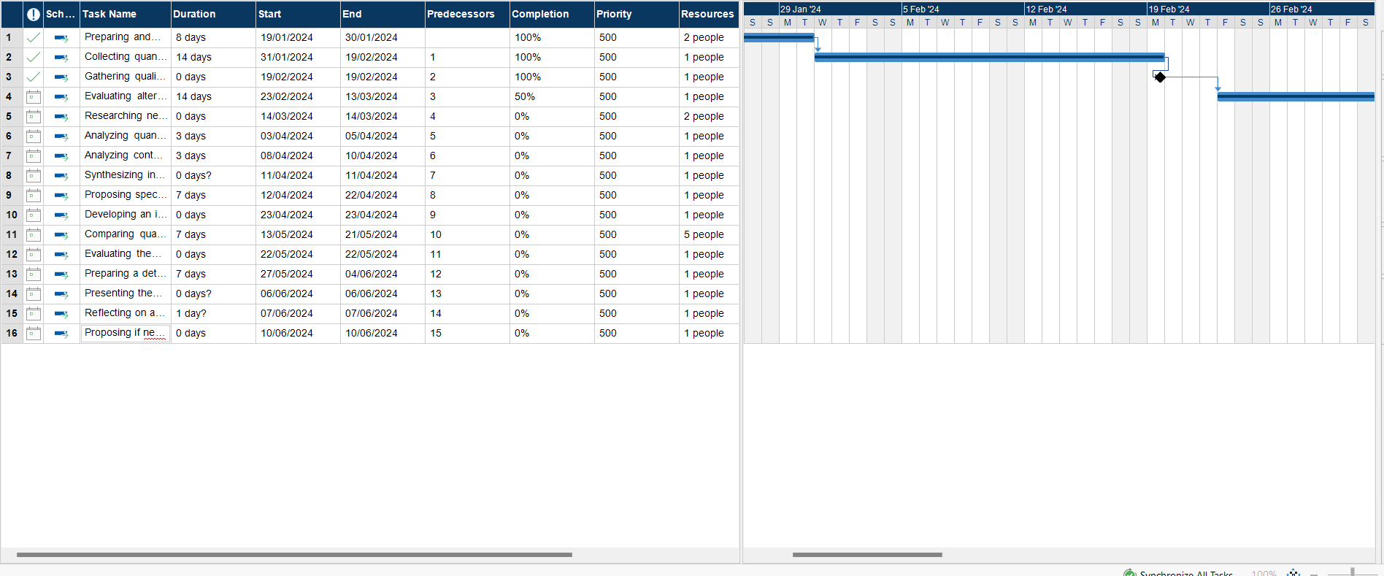

Figure 2: Ganttchart

1. **Examine appropriate research methods and approaches to primary and secondary research**. (**P2**)

**2. Research methods**

Research methods are crucial for the success and validity of my research project. In this part,

I will introduce some of common methods for research projects

**2.1. Primary methods**

Primary research refers to the process of collecting original data directly from the source, rather than relying on existing data or literature. It involves firsthand investigation and analysis conducted by researchers to address specific research questions or objectives. Primary research methods typically involve direct interaction with subjects or sources of information and can take various forms, including surveys, interviews, experiments, observations, and focus groups. (AdiBhat, 2023)

**2.1.1. Types of primary research**

Some types of primary research methods include:

* **Surveys**: Administering questionnaires or interviews to collect data directly from respondents.
* **Interviews**: Conducting structured, semi-structured, or unstructured interviews with individuals or groups to gather in-depth information.
* **Experiments**: Setting up controlled experiments to test hypotheses and observe the effects of manipulated variables.
* **Observations**: Systematically observing and recording behaviors, events, or phenomena in natural or controlled settings.
* **Focus Groups**: Facilitating group discussions with selected participants to explore opinions, attitudes, or perceptions on a specific topic.

**2.1.2. Advantages of primary research**

Primary research refers to the process of gathering original data directly from the source. So, here are the advantages of primary research (RAHMAN, 2023):

* **Specific to Research Objectives**: Primary research allows researchers to tailor data collection methods to address specific research questions or objectives. This ensures that the data gathered is directly relevant to the study's purpose, leading to more focused and targeted insights.
* **Control over Data Collection**: Researchers have control over the design, execution, and analysis of primary research, allowing them to ensure the quality and validity of the data collected. This control enables researchers to minimize potential biases and errors, leading to more reliable results.
* **Freshness of Data:** Primary research provides access to up-to-date and current information, as data is collected directly from the source at the time of the study. This freshness of data is particularly valuable in fields where trends and circumstances may change rapidly.
* **Customization and Flexibility**: Primary research methods offer flexibility in terms of study design, sample selection, and data collection techniques. Researchers can adapt their approach based on emerging insights or unexpected findings, allowing for greater customization and responsiveness to research needs.
* **Uniqueness and Originality**: Since primary research involves collecting new data, it often leads to unique and original findings that contribute to the advancement of knowledge in a particular field. This originality can enhance the significance and impact of the research findings.
* **Opportunity for In-Depth Analysis**: Primary research provides opportunities for in-depth analysis of data collected directly from participants or sources. Researchers can explore nuances, patterns, and relationships within the data, leading to deeper insights and richer interpretations.
* **Potential for Publication and Recognition**: Conducting primary research and generating new findings may increase the likelihood of publication in academic journals, presentation at conferences, or recognition within the research community. This can enhance the researcher's reputation and contribute to career advancement.

**2.1.3. Disadvantages of primary research**

While primary research offers numerous advantages, it also comes with certain disadvantages, including (RAHMAN, 2023):

* **Time-consuming**: Primary research can be time-consuming, as it involves designing and implementing data collection methods, recruiting participants, conducting interviews or experiments, and analyzing data. This process can take considerable time and resources, particularly for large-scale studies or longitudinal research.
* **Costly:** Conducting primary research can be expensive, especially when it requires specialized equipment, personnel, or participant incentives. Costs may include expenses related to survey administration, participant recruitment, data collection tools, and data analysis software.
* **Resource-intensive**: Primary research often requires a significant investment of resources, including personnel, equipment, and expertise. Researchers may need to hire skilled staff, secure research facilities, or purchase specialized equipment to carry out experiments or data collection activities.
* **Limited Generalizability**: Findings from primary research may have limited generalizability beyond the specific context or population studied. Since data is collected from a sample of participants or sources, it may not accurately represent the broader population or applicable to different settings or groups.
* **Potential for Bias**: Primary research may be susceptible to various forms of bias, including selection bias, response bias, or researcher bias. These biases can arise from factors such as sample selection methods, participant characteristics, survey wording, or researcher influence, potentially affecting the validity and reliability of the findings

**2.2. Secondary research**

Secondary research, also known as desk research, involves the collection and analysis of existing data, information, and literature that has been previously gathered by others. Rather than collecting new data directly from primary sources, secondary research relies on sources such as books, journal articles, government reports, market research reports, and databases. (George., 2023)

**2.2.1 Steps involved conducting secondary research**

Conducting secondary research typically involves the following steps:

* **Define Research Objectives**: Clearly define the research objectives and questions that secondary research aims to address. Determine the scope of the research and the specific information or data needed to achieve the research goals.
* **Identify Relevant Sources**: Identify relevant sources of secondary data and information that are likely to contain data related to the research topic. This may include academic databases, online libraries, government websites, industry reports, and other reputable sources.
* **Conduct Literature Review**: Conduct a comprehensive literature review to gather relevant studies, articles, and publications related to the research topic. Reviewing existing literature helps identify gaps in knowledge, understand key concepts and theories, and inform the research approach.
* **Search for Secondary Data**: Use appropriate search strategies to locate secondary data relevant to the research objectives. This may involve keyword searches, Boolean operators, and advanced search techniques to retrieve relevant information from databases, journals, and other sources.
* **Evaluate Data Quality**: Evaluate the quality, relevance, and reliability of the secondary data sources. Assess the credibility of the sources, consider factors such as authorship, publication date, peer review status, and methodology used in data collection and analysis.
* **Extract and Synthesize Information**: Extract relevant data, statistics, and findings from the selected sources. Organize and synthesize the information in a systematic manner, making note of key themes, trends, and patterns that emerge from the literature review and data analysis.
* **Analyze and Interpret Data**: Analyze the extracted data to identify trends, relationships, and insights relevant to the research objectives. Use appropriate analytical techniques and tools to interpret the data and draw meaningful conclusions.
* **Document and Cite Sources:** Properly document and cite all sources of secondary data and information used in the research. Follow standard citation formats and guidelines to acknowledge the original authors and provide proper attribution for the information used.
* **Summarize and Report Findings:** Summarize the key findings, insights, and conclusions derived from the secondary research. Present the findings in a clear, concise manner, using tables, charts, graphs, or other visual aids to enhance clarity and readability.

**2.2.2 Advantages of Secondary research**

Secondary research offers several advantages, making it a valuable method for gathering information and insights for research projects. Some of the key advantages include (RAHMAN, 2023):

* **Cost-Effectiveness**: Secondary research is generally more cost-effective than primary research because it involves using existing data and literature that are readily available. Researchers do not need to incur expenses associated with data collection, such as participant recruitment, survey administration, or experimental setup.
* **Time Efficiency**: Conducting secondary research is often quicker than primary research, as researchers can access and analyze existing data and literature without the need for lengthy data collection periods. This enables researchers to obtain insights and information in a relatively short timeframe, making secondary research ideal for projects with time constraints.
* **Wider Scope**: Secondary research allows researchers to access a wide range of sources and data sets, including academic journals, books, government reports, industry publications, and online databases. This broad scope enables researchers to gather diverse perspectives, data points, and insights from various sources, enriching the research findings.
* **Accessibility**: Secondary research sources are often readily accessible and publicly available, making them easily accessible to researchers regardless of location or resources. Researchers can access secondary data and literature through libraries, online databases, websites, and other repositories, facilitating convenient and widespread access to information.
* **Reduction of Bias**: Secondary research can help mitigate bias associated with primary data collection methods, such as interviewer bias, response bias, or participant selection bias. Since secondary data are collected and analyzed by third parties, researchers are less likely to introduce subjective biases into the research process, enhancing the objectivity and reliability of the findings.
* **Historical Analysis**: Secondary research provides access to historical data and literature, enabling researchers to conduct longitudinal or trend analysis over time. By examining trends, patterns, and changes documented in historical sources, researchers can gain insights into the evolution of phenomena or trends, informing future research and decision-making.

**2.2.3 Disadvantages of Secondary research**

While secondary research offers several advantages, it also has certain limitations and disadvantages that researchers should be aware of. Some of the key disadvantages of secondary research include (RAHMAN, 2023):

* **Quality and Reliability Concerns**: The quality and reliability of secondary data sources can vary widely, depending on factors such as the credibility of the original sources, the accuracy of data collection methods, and the rigor of data analysis. Researchers must critically evaluate the trustworthiness of secondary sources to ensure the validity and integrity of their findings.
* **Limited Control over Data Collection**: Unlike primary research, where researchers have control over data collection methods and procedures, secondary research relies on data collected by others. This lack of control can lead to limitations in the scope, depth, and relevance of available data, potentially affecting the accuracy and completeness of research findings.
* **Availability and Accessibility Issues**: Some secondary data sources may be unavailable, inaccessible, or restricted due to copyright, licensing, or privacy considerations. Researchers may encounter challenges in accessing certain data sets, publications, or databases, limiting their ability to gather comprehensive information or conduct thorough analyses.
* **Potential for Biases and Inaccuracies:** Secondary data sources may contain biases, errors, or inaccuracies introduced by the original data collectors, authors, or publishers. These biases can arise from factors such as sampling methods, measurement errors, selective reporting, or publication bias, undermining the reliability and validity of research findings based on secondary data.
* **Lack of Contextual Information**: Secondary data sources may lack contextual information or detailed documentation about the methods, assumptions, and limitations of data collection and analysis. Without sufficient context, researchers may struggle to interpret the data accurately or draw meaningful conclusions, leading to potential misinterpretations or misrepresentations of research findings.
* **Outdated or Incomplete Data**: Secondary data sources may contain outdated or incomplete information, particularly in rapidly evolving fields or industries. Researchers must carefully assess the currency and completeness of available data to ensure its relevance and applicability to their research objectives.

**2.3. Compare Primary Research with Secondary Research**

|  |  |  |
| --- | --- | --- |
| Aspect | Primary Research | Secondary Research |
| Data Collection | Original data collected directly from source | Existing data collected by others |
| Purpose | Addresses specific research questions | Provides background information or context |
| Time | Time-consuming | Generally quicker |
| Cost | Expensive due to data collection efforts | Cost-effective, as data already exists |
| Control | Researchers have control over data collection | Limited control over data collection methods |
| Bias | Potential for researcher bias | Potential for bias from original sources |
| Freshness | Provides up-to-date information | May contain outdated or incomplete data |
| Depth of Analysis | Allows for in-depth analysis | Analysis may be limited by available data |
| Generalizability | Findings may be specific to study context | Findings may have broader applicability |
| Ethical Considerations | Involves ethical considerations with participants | May involve ethical considerations related to data use |
| Examples | Surveys, experiments, interviews | Literature reviews, meta-analyses, data mining |

**2.4. Qualitative Research**

Qualitative research is a type of research method used to explore and understand phenomena in depth by examining subjective experiences, attitudes, behaviors, and motivations. Unlike quantitative research, which focuses on numerical data and statistical analysis, qualitative research emphasizes the collection and analysis of non-numerical data, such as text, images, or observations. Qualitative research aims to uncover meanings, patterns, and relationships within the data, providing insights into the complexity and richness of human experiences. (Bhandari, 2020)

**2.4.1 Qualitative Research Methods**

Qualitative research methods typically involve techniques such as interviews, focus groups, observations, case studies, and content analysis. These methods allow researchers to gather rich, detailed data directly from participants or sources, capturing the context, nuances, and perspectives of the phenomenon under study. Qualitative research often employs an iterative and flexible approach, allowing researchers to adapt their methods and explore emergent themes or insights as they emerge from the data. (Bhandari, 2020)

**2.4.2 Qualitative data analysis**

Qualitative data analysis (QDA) is the process of systematically examining and interpreting qualitative data to uncover patterns, themes, meanings, and insights within the data. qualitative data analysis involves analyzing non-numerical data, such as text, images, or observations, to understand the underlying meanings and contexts.

Qualitative data analysis is a rigorous and systematic process that involves transforming qualitative data into meaningful insights and understanding. By following established methods and techniques, researchers can uncover rich and nuanced findings that contribute to knowledge in their field.

**2.4.3 Advantages of Qualitative research**

Qualitative research offers several advantages that make it a valuable approach for exploring complex phenomena and understanding human experiences in depth. Some of the key advantages of qualitative research include (Bhandari, 2020):

* **Rich and Detailed Data**: Qualitative research generates rich, detailed data that provide deep insights into the complexity and depth of human experiences, attitudes, and behaviors. Through techniques such as interviews, observations, and open-ended questions, researchers can capture nuanced perspectives and contexts that may be overlooked in quantitative research.
* **Exploratory and Flexible**: Qualitative research is exploratory and flexible, allowing researchers to explore research questions in depth and adapt their methods as new insights emerge. This flexibility enables researchers to delve into unexpected areas, follow leads, and explore emergent themes, contributing to a more comprehensive understanding of the phenomenon under study.
* **Contextual Understanding**: Qualitative research emphasizes understanding phenomena within their social, cultural, and environmental contexts. By examining the context in which behaviors, attitudes, and experiences occur, researchers can uncover the social norms, cultural values, and situational factors that shape individuals' perceptions and actions.
* **Insights into Meaning and Process**: Qualitative research focuses on understanding the meanings, interpretations, and processes underlying human experiences and behaviors. Through methods such as in-depth interviews, researchers can explore participants' subjective perspectives, motivations, and decision-making processes, providing insights into the "how" and "why" of human phenomena.
* **Flexibility in Data Collection**: Qualitative research offers a variety of data collection methods, including interviews, focus groups, observations, and document analysis. Researchers can select methods that are most appropriate for the research questions and participants, tailoring the data collection process to capture diverse perspectives and experiences.

**2.4.4 Disadvantages of Qualitative research**

While qualitative research offers numerous advantages, it also has several limitations and challenges that researchers should consider. Some of the key disadvantages of qualitative research include (Bhandari, 2020):

* **Subjectivity and Bias**: Qualitative research is inherently subjective, as it relies on the interpretation and judgment of researchers in analyzing data and identifying themes. Researchers' biases, preconceptions, and perspectives may influence the selection of participants, data collection methods, coding decisions, and interpretations of findings, potentially introducing bias into the research process.
* **Limited Generalizability**: Qualitative research often involves small, non-random samples and focuses on specific contexts or cases, limiting the generalizability of findings to broader populations or settings. While qualitative research provides rich, detailed insights into the experiences and perspectives of participants, the findings may not be representative of larger populations or applicable to different contexts.
* **Time-Intensive Data Analysis**: Qualitative data analysis can be time-consuming and labor-intensive, requiring careful coding, categorization, and interpretation of textual or visual data. The iterative nature of qualitative analysis, along with the need for multiple rounds of coding and validation, can prolong the data analysis process and delay the reporting of findings.
* **Difficulty in Replication**: Qualitative research may be challenging to replicate due to its reliance on context-specific data, subjective interpretations, and nuanced insights. While researchers may provide detailed descriptions of the research methods and findings, replicating qualitative studies exactly as conducted by the original researchers may be impractical or impossible, reducing the replicability and reliability of findings.
* **Potential for Data Saturation**: Qualitative research relies on the principle of data saturation, wherein researchers continue data collection until no new themes or insights emerge from the data. However, achieving data saturation can be challenging, particularly in complex or rapidly changing environments, leading to uncertainty about the completeness of the data and potential for overlooking important perspectives or experiences.
* **Ethical Considerations**: Qualitative research involves ethical considerations related to participant confidentiality, informed consent, and privacy. Researchers must ensure that participants' rights and welfare are protected throughout the research process, particularly when collecting sensitive or personal information. Ethical dilemmas may arise in situations where participants disclose sensitive information or express conflicting interests.

**2.5 Quantitative research**

Quantitative research is a systematic investigation that uses statistical, mathematical, or computational techniques to collect and analyze numerical data. Unlike qualitative research, which focuses on understanding subjective experiences and meanings, quantitative research aims to quantify relationships, patterns, and trends within a population or sample. This type of research typically involves measuring variables, testing hypotheses, and drawing conclusions based on numerical data (Bhandari, 2020).

**2.5.1 Quantitative research methods**

Quantitative research methods involve systematic approaches for collecting, analyzing, and interpreting numerical data to investigate relationships, patterns, and trends within a population or sample. These methods are commonly used in disciplines such as social sciences, natural sciences, health sciences, and business to study phenomena, test hypotheses, and make evidence-based decisions.

**2.5.2 Quantitative data analysis**

Quantitative data analysis involves the systematic process of examining numerical data to uncover patterns, trends, relationships, and associations within a dataset. This type of analysis aims to quantify and measure variables, test hypotheses, and draw conclusions based on statistical analysis techniques.

quantitative data analysis involves a systematic and rigorous process of examining numerical data to uncover insights, test hypotheses, and make evidence-based decisions. By following established statistical techniques and procedures, researchers can derive meaningful conclusions from quantitative data and contribute to knowledge in their field.

**2.5.3 Advantages of Quantitative research**

Quantitative research offers several advantages that make it a valuable approach for studying various phenomena and making evidence-based decisions. Some of the key advantages of quantitative research include (Bhandari, 2020):

* **Objectivity**: Quantitative research is based on numerical data and statistical analysis, which allows for objective measurement and analysis of variables. Researchers use standardized methods and instruments to collect data, minimizing bias and subjectivity in the research process.
* **Generalizability**: Quantitative research often involves large sample sizes and random sampling techniques, which enhance the generalizability of findings to broader populations or settings. By collecting data from representative samples, researchers can make reliable inferences about the population as a whole.
* **Replicability**: Quantitative research is characterized by its replicability, as it follows systematic procedures and standardized methods for data collection and analysis. Researchers can replicate studies using the same methods and procedures to verify findings and assess the reliability of results.
* **Statistical Analysis:** Quantitative research allows for sophisticated statistical analysis techniques to be applied to numerical data. Researchers can use statistical tests to test hypotheses, identify patterns, and determine the strength and significance of relationships between variables.
* **Precision and Reliability**: Quantitative research provides precise and reliable measurements of variables, allowing for accurate comparisons and predictions. Statistical techniques such as standard deviation and confidence intervals help assess the variability and reliability of findings.
* **Efficiency:** Quantitative research often involves efficient data collection methods, such as surveys or experiments, which allow researchers to collect data from large samples in a relatively short period. Statistical software packages facilitate data analysis and streamline the research process.

**2.5.4 Disadvantages of Quantitative research**

While quantitative research offers numerous advantages, it also has several limitations and disadvantages that researchers should consider. Some of the key disadvantages of quantitative research include (Bhandari, 2020):

* **Lack of Depth and Detail**: Quantitative research may provide numerical data and statistical analysis, but it often lacks the depth and detail needed to understand complex phenomena fully. Quantitative methods may not capture the richness of human experiences, attitudes, and behaviors, leading to oversimplification or reductionism.
* **Limited Scope of Inquiry**: Quantitative research tends to focus on measurable variables and observable behaviors, which may limit the scope of inquiry to aspects that can be quantified. Certain phenomena, such as emotions, beliefs, and cultural practices, may be difficult to quantify and analyze using quantitative methods alone.
* **Inability to Capture Context**: Quantitative research may struggle to capture the contextual nuances and social dynamics that shape human behavior and interactions. Variables measured in isolation may overlook the broader social, cultural, and environmental contexts in which phenomena occur, leading to incomplete or biased interpretations.
* **Potential for Reductionism**: Quantitative research may oversimplify complex phenomena by reducing them to numerical data and statistical relationships. This reductionism may overlook important qualitative aspects of the research topic, such as meaning, context, and subjective experiences, leading to incomplete understanding.
* **Reliance on Predefined Measures**: Quantitative research often relies on predefined measures and standardized instruments for data collection, which may not capture the full range of variability within the research topic. Researchers may miss important nuances or dimensions of the phenomenon that are not captured by existing measures.
* **Difficulty in Addressing Complexity**: Quantitative research may struggle to address the complexity and multidimensionality of certain phenomena, particularly those that involve multiple interacting factors or nonlinear relationships. Statistical models may oversimplify complex systems, leading to inaccurate predictions or interpretations.

**2.6 Compare Qualitative Research with Quantitative Research**

|  |  |  |
| --- | --- | --- |
| Aspect | Qualitative Research | Quantitative Research |
| Focus | Explores subjective experiences, meanings, and perspectives. | Quantifies variables, measures, and observes observable phenomena. |
|  |  |  |
| Data Type | Non-numerical (text, images, audio, video). | Numerical (quantitative) data. |
| Data Collection Methods | Interviews, focus groups, observations,  ethnography, content analysis. | Surveys, experiments, observations, secondary data analysis. |
| Sample Size | Small, often non-representative samples. | Large, often representative samples. |
| Analysis Techniques | Coding, thematic analysis, content analysis. | Descriptive statistics, inferential statistics, regression analysis. |
| Generalizability | Findings are context-specific and may not be generalizable. | Findings are generalizable to broader  populations or settings. |
| Depth of Understanding | Provides rich, in-depth insights into individual experiences and perspectives. | Provides breadth of understanding, statistical trends, and patterns. |
| Flexibility | Flexible and adaptable to evolving research questions and contexts. | Less flexible due to standardized methods and procedures. |
| Subjectivity | Emphasizes researcher's interpretation and subjectivity. | Seeks to minimize researcher bias and ensure objectivity. |
| Time and Resources | Time-consuming and resource-intensive. | Efficient data collection and analysis with large samples. |
| Validity and Reliability | Relies on validity through triangulation of data sources and researcher reflexivity. | Relies on reliability through consistency of measurements and replication of findings. |

**2.7. Scientific Method**

The scientific method is a systematic approach used by scientists to investigate natural phenomena, acquire new knowledge, and test hypotheses through empirical observation, experimentation, and analysis. It involves a series of steps that help researchers formulate hypotheses, design experiments, collect data, analyze results, and draw conclusions. The scientific method is characterized by its emphasis on objectivity, reproducibility, and the systematic testing of hypotheses (khanacademy, 2023).

**2.7.1 The Scientific method in technology and computers**

In the realm of technology and computers, the scientific method plays a crucial role in advancing knowledge, solving problems, and developing innovative solutions. While the application of the scientific method in technology may have some variations compared to traditional scientific disciplines, the fundamental principles remain the same. Here's how the scientific method is applied in technology and computer science:

* **Problem Identification**: The process typically begins with identifying a problem, opportunity, or need within the domain of technology. This could range from improving the efficiency of a computer algorithm to developing new software applications or designing hardware systems.
* **Research and Background Review**: Researchers review existing literature, theories, and technologies related to the problem to gain insights and understand the current state of the art. This phase involves gathering information, analyzing previous studies, and identifying gaps or areas for improvement.
* **Hypothesis Formulation**: Based on the research, researchers formulate hypotheses or research questions that propose potential solutions or approaches to address the problem. These hypotheses serve as the foundation for subsequent experimentation and analysis.

**2.7.2 Steps of scientific method**

The scientific method consists of several steps that scientists follow to investigate natural phenomena, acquire new knowledge, and test hypotheses. While there may be some variations in the specific terminology used or the order of steps, the core process generally includes the following steps:

* **Observation**: The scientific method typically begins with observation of a natural phenomenon or the identification of a problem or question that requires investigation. Observations can arise from everyday experiences, previous research findings, or theoretical considerations.
* **Question Formulation**: Based on observations, researchers formulate a research question or hypothesis that seeks to explain the observed phenomenon or address the problem. A hypothesis is a testable statement or prediction that can be supported or refuted through empirical evidence.
* **Hypothesis Development**: Researchers develop hypotheses based on existing knowledge, theories, or conceptual frameworks. A hypothesis typically states the relationship between variables and predicts the outcome of an experiment or observation.
* **Experiment Design**: Researchers design experiments or observational studies to test the hypothesis and collect relevant data. The experiment involves manipulating one or more independent variables and measuring their effects on dependent variables. Experimental design aims to control for confounding factors and ensure the validity and reliability of results.
* **Data Collection**: Researchers collect data through systematic observations, measurements, or experiments. Data may be quantitative (numerical) or qualitative (non-numerical) and can be collected using various methods, such as surveys, interviews, experiments, or observations.
* **Data Analysis**: Once data is collected, researchers analyze it using statistical or qualitative analysis techniques, depending on the nature of the data and research question. Statistical analysis involves summarizing, organizing, and interpreting numerical data to identify patterns, relationships, and trends. Qualitative analysis involves coding, categorizing, and interpreting textual or non-numerical data to uncover themes, meanings, and insights.
* **Results Interpretation**: Researchers interpret the results of data analysis in the context of the research question and hypothesis. They evaluate whether the data support or refute the hypothesis and draw conclusions based on the evidence. Results interpretation involves critical thinking, logical reasoning, and consideration of alternative explanations.
* **Conclusion and Communication**: Based on the results, researchers draw conclusions and communicate their findings to the scientific community through research papers, presentations, or publications. Conclusions may lead to revisions of existing theories, the formulation of new hypotheses, or practical applications in various fields.
* **Peer Review and Replication:** Scientific findings undergo peer review by experts in the field to evaluate their validity, reliability, and significance. Peer review ensures the quality and integrity of research and helps identify potential flaws or biases. Replication of experiments by independent researchers further verifies the reliability and generalizability of findings.

**2.8. Research Process**

The research process refers to the systematic and organized series of steps that researchers follow to investigate a specific topic, answer research questions, or test hypotheses. It involves planning, conducting, analyzing, and interpreting research findings to generate new knowledge and contribute to the existing body of literature in a particular field.

**2.8.1 Steps**

The research process involves several systematic steps that researchers follow to conduct a study and contribute new knowledge to their field. Here are the typical steps of the research process:

* **Identifying the Research Topic**: The process begins with selecting a research topic or identifying a research problem. This may involve reviewing existing literature, observing phenomena, or consulting with experts in the field.
* **Reviewing Existing Literature**: Researchers conduct a thorough review of existing literature related to their topic of interest. This step helps researchers understand the current state of knowledge, identify gaps in existing research, and refine the research questions or hypotheses.
* **Formulating Research Questions or Hypotheses**: Based on the research topic and literature review, researchers formulate specific research questions or hypotheses that they aim to answer or test in their study. Research questions guide qualitative research, while hypotheses guide quantitative research.
* **Designing the Research Methodology**: Researchers design the methodology or approach for their study. This includes decisions about the research design (e.g., experimental, correlational, descriptive), sampling strategy, data collection methods, and data analysis techniques.
* **Collecting Data**: Researchers collect data according to the chosen methodology. Data collection methods may include surveys, interviews, observations, experiments, or the analysis of existing datasets. Researchers must ensure that data collection procedures are ethical and reliable.
* **Analyzing Data:** Once data is collected, researchers analyze it to answer the research questions or test the hypotheses. Data analysis techniques vary depending on the nature of the data and the research design. Quantitative data may be analyzed using statistical methods, while qualitative data may be analyzed using thematic analysis or content analysis.
* **Interpreting Results:** Researchers interpret the results of their data analysis in the context of the research questions or hypotheses. This involves identifying patterns, trends, relationships, or significant findings and discussing their implications for the research topic or problem.
* **Drawing Conclusions**: Based on the interpretation of results, researchers draw conclusions about their study findings. Conclusions should be supported by evidence from the data analysis and should address the research questions or hypotheses.
* **Communicating Findings**: Researchers communicate their research findings to the academic community, practitioners, or other stakeholders through research papers, presentations, or reports. Clear and concise communication of findings is essential for sharing knowledge and contributing to the advancement of the field.

**2.9. Population in Research**

In research, a population refers to the entire group of individuals, items, or elements that meet specific criteria and are the focus of study. The population is the broader group from which a researcher selects a sample to study and make inferences about the characteristics or behaviors of the entire population.

**2.9.1 Collecting data from population**

Collecting data from a population involves systematically gathering information from all members of the defined population or a representative subset of it. The process of collecting data from a population can vary depending on factors such as the size of the population, the nature of the research question, available resources, and ethical considerations. Here are some common methods used to collect data from populations:

* **Census**: Conducting a census involves collecting data from every member of the population. While census data provides comprehensive information about the entire population, it can be resource-intensive, time-consuming, and impractical for large populations.
* **Surveys**: Surveys involve administering questionnaires or interviews to a sample of individuals selected from the population. Surveys can be conducted through various methods, including in-person interviews, phone interviews, mail surveys, online surveys, or a combination of these approaches. Surveys allow researchers to collect data efficiently and cost-effectively, but the representativeness of the sample is crucial for generalizing findings to the population.
* **Sampling**: Sampling involves selecting a subset of individuals, items, or elements from the population to represent the larger population. Sampling methods may include random sampling, stratified sampling, cluster sampling, or convenience sampling, depending on the research objectives and population characteristics. By collecting data from a representative sample, researchers can make inferences about the population with a certain degree of confidence.
* **Secondary Data Analysis**: Researchers can also collect data from existing sources, such as government databases, archival records, academic journals, or organizational reports. Secondary data analysis involves analyzing data that were collected for other purposes but can be relevant to the researcher's study. Secondary data analysis can be cost-effective and time-efficient but may be limited by the availability and quality of existing data.
* **Experimental Methods:** In experimental research, researchers manipulate one or more variables and observe the effects on the population. Experimental methods allow researchers to establish cause-and-effect relationships but may require strict control over variables and ethical considerations when conducting experiments with human subjects.

1. **Conduct primary and secondary research using appropriate methods for a computing research project that consider costs, access and ethical issues. (P3)**

**3.1 Secondary Research**

Secondary research plays a significant role in research projects, including yours, focusing on the Environmental Impacts and the Search for Alternative Materials in Big Data Storage Models.

Secondary research allows me to gain a comprehensive understanding of the existing literature, theories, and findings related to the environmental impact of digital transformation. By reviewing previous studies, reports, and academic papers, you can identify key concepts, trends, and gaps in knowledge.

It helps me identify and prioritize key environmental issues and challenges associated with digital transformation. By examining existing research, I can pinpoint specific areas where further investigation or intervention is needed.

Furthermore, Secondary research provides a basis for benchmarking and comparing my findings with existing data and trends. By analyzing historical data and established benchmarks, I can assess the effectiveness of current practices and measure progress over time.

**3.1.1. Sources**

1. Title: “The Role of Big Data in Environmental Sustainability”

Source: Web Development

Link: [The Role of Big Data in Environmental Sustainability - Grace Themes](https://gracethemes.com/the-role-of-big-data-in-environmental-sustainability/?fbclid=IwAR1vU_cV_jiXbWDYGGFw8tu-ZRob8L_au0aW2mBC5of-Wsg1nb62UjqodMA)

Summary: This source gave me understand: Bigdata plays a great role in promoting environmental sustainability by providing solutions to address ecological challenges. And, there are a lot of benefits to using big data and its impact on the environment.

Bigdata plays a crucial role in environmental sustainability. There are a lot of benefits to using big data and its impact on the environment. Big data enables us to measure various environmental parameters on a scale which we have never seen before. It provides us with a comprehensive understanding of the state of our planet.

1. Title: “Big data and natural environment. How does different data support different green strategies?”

Source: FrancescoCalza

Link: [Big data and natural environment. How does different data support different green strategies? - ScienceDirect](https://www.sciencedirect.com/science/article/pii/S2666188820300228?fbclid=IwAR0UhdHpahu_7PaEkQ0PMWTzd-wJfrInOBKieXWCybowfvZ4BCowGfBRcOY)

Summary: This source gave me the aspect of capture value from big data in the industry 4.0 and understand about the keywords: Green strategy, Green innovation, Conceptual framework

Big data is an increasing trend in strategic management. Notwithstanding, just few studies envisage the potentiality offered by big data to sustain different green strategy typologies. The paper wants to explore how firms can capture value from big data to improve green engagement by providing a conceptual model through a comprehensive and panoramic literature that relates big data sources to the adoption of different green strategies.

1. Title: “Bigdata”

Source: Wikipedia

Link: [Big data - Wikipedia](https://en.wikipedia.org/wiki/Big_data?fbclid=IwAR3ULQBJqWpzT1W6T0i0gdk9SNWjrj0N_DjPT22_5rJ3tRSKcSPQAh9gQZg)

Summary: the basic of Big data and large collections of data

Big data primarily refers to data sets that are too large or complex to be dealt with by traditional data-processing application software. Data with many entries (rows) offer greater statistical power, while data with higher complexity (more attributes or columns) may lead to a higher false discovery rate. Though used sometimes loosely partly due to a lack of formal definition, the best interpretation is that it is a large body of information that cannot be comprehended when used in small amounts only.

**3.1.2.** **Interpretation and implications of findings**

In summary, the finding of the research on “Environmental Impacts and the Search for Alternative Materials in Big Data Storage Models” is crucial for informing decisions, driving innovation, and addressing environmental concerns.

Interpretation begins with analyzing the data collected on the environmental impacts associated with current big data storage models. This involves examining factors such as energy consumption, resource depletion, carbon emissions, and waste generation. Implications may include identifying the most significant environmental stressors and their potential long-term consequences. Understanding the implications of the findings involves identifying the key challenges and limitations of existing data storage materials in terms of sustainability and environmental concerns. This may include factors such as the use of non-renewable resources, toxic materials, or inefficient storage technologies. Implications could focus on the urgency of addressing these challenges and the need for innovative solutions.

The research likely explores and evaluates alternative materials and technologies for big data storage that are environmentally friendly and sustainable. Interpretation involves assessing the effectiveness, feasibility, and scalability of these alternatives in mitigating environmental impacts. Implications may include recommendations for adopting promising technologies or further research needed to overcome existing limitations. Interpreting the findings requires analyzing the potential benefits and drawbacks of adopting alternative materials in big data storage models. This involves weighing factors such as cost-effectiveness, performance, scalability, and environmental impact reduction. Implications may include identifying trade-offs and guiding decision-making regarding the adoption of alternative materials.

By thoroughly interpreting the findings and understanding their implications, stakeholders can make informed decisions, implement effective strategies, and contribute to a more sustainable and resilient future in the realm of big data storage and beyond.

3.**2** **Primary Research**

1. Overall Research Design:

a primary research study involves careful consideration of various factors to ensure the validity, reliability, and relevance of the findings. By carefully designing the primary research study with attention to considerations, researchers can generate robust evidence and insights that contribute to "Environmental Impacts and the Search for Alternative Materials in Big Data Storage Models"

1. Interviews

When creating interviews for a study on "Environmental Impacts and the Search for Alternative Materials in Big Data Storage Models," it's essential to consider several aspects to ensure the interviews gather relevant and insightful information from participants. Here are some key aspects to consider:

* Research Objectives: Start by clarifying the specific objectives of the study. Determine what information you hope to gather from the interviews and how it will contribute to addressing the research questions or hypotheses.
* Participant Selection: Identify the target participants for the interviews based on their expertise, experience, and relevance to the research topic. This may include stakeholders such as industry professionals, researchers, policymakers, environmental experts, or representatives from technology companies.
* Interview Structure: Decide on the structure and format of the interviews. Will they be structured, semi-structured, or unstructured? Structured interviews follow a predetermined set of questions, while semi-structured interviews allow for flexibility and follow-up questions based on participant responses. Unstructured interviews provide the most flexibility, allowing for open-ended conversations.
* Interview Questions: Develop a set of interview questions that align with the research objectives and explore relevant topics related to environmental impacts and alternative materials in big data storage models. Questions should be clear, concise, and focused on gathering specific information from participants.
* Topic Areas: Identify key topic areas to cover in the interviews. These may include:
* Current practices and challenges in big data storage.
* Perceptions of environmental impacts associated with current storage models.
* Awareness and interest in alternative materials or sustainable practices.
* Barriers to adopting alternative materials or implementing sustainable solutions.
* Suggestions for improving environmental sustainability in big data storage.

1. Surveys

Designing a survey for a study on "Environmental Impacts and the Search for Alternative Materials in Big Data Storage Models" involves considering various aspects to collect relevant and reliable data from respondents Here's how to approach designing the survey:

* Research Objectives: Clearly define the objectives of the survey. Determine what specific information you aim to gather from respondents regarding environmental impacts and alternative materials in big data storage models.
* Target Population: Identify the target population for the survey. This may include stakeholders such as industry professionals, researchers, policymakers, environmental experts, or representatives from technology companies who have knowledge or experience relevant to the research topic.
* Survey Design: Decide on the design of the survey, including the structure, format, and length. Determine whether the survey will be self-administered online, conducted through interviews, or distributed in print format. Consider using a combination of closed-ended and open-ended questions to gather quantitative and qualitative data.
* Question Development: Develop survey questions that align with the research objectives and explore relevant topics related to environmental impacts and alternative materials in big data storage models. Ensure that questions are clear, concise, and unbiased to facilitate accurate responses from participants.
* Question Types: Choose appropriate question types based on the information you want to collect. Closed-ended questions provide respondents with predefined response options, while open-ended questions allow respondents to provide free-text responses. Consider using Likert scales, ranking scales, or semantic differential scales for attitudinal questions.

**3.2.1** **Interviews**

Title: Exploring Environmental Impacts and Alternative Materials in Big Data Storage Models: Stakeholder Interview

Participant Selection:

For this interview, we will select stakeholders who have expertise and experience relevant to the research topic of environmental impacts and alternative materials in big data storage models. This includes industry professionals, researchers, policymakers, environmental experts, and representatives from technology companies.

Interview Structure:

The interview will adopt a semi-structured format to allow for flexibility and in-depth exploration of key topics. While a predetermined set of questions will guide the conversation, participants will have the opportunity to elaborate on their responses and provide additional insights.

Interview Questions:

1. Can you provide an overview of current practices and challenges in big data storage, particularly regarding environmental impacts?
2. What are your perceptions of the environmental impacts associated with current data storage models, and how significant do you believe these impacts are?
3. Are you aware of any alternative materials or sustainable practices being explored or implemented in the field of big data storage to mitigate environmental impacts?
4. From your experience, what are the main barriers or challenges hindering the adoption of alternative materials or sustainable solutions in big data storage models?
5. How do you think industry stakeholders can overcome these barriers and promote the adoption of more environmentally sustainable practices in data storage?
6. What suggestions do you have for improving environmental sustainability in big data storage, both in terms of materials and practices?
7. How do you envision the future of big data storage models evolving in response to growing environmental concerns?
8. What role do you believe policymakers and regulatory bodies should play in promoting environmental sustainability in the technology sector, specifically in data storage?
9. In your opinion, what are the most critical considerations for balancing technological innovation with environmental sustainability in the development of big data storage models?
10. Are there any additional insights or perspectives you would like to share regarding environmental impacts and alternative materials in big data storage?

Topic Areas:

The interview will cover key topic areas related to current practices and challenges in big data storage, perceptions of environmental impacts, awareness of alternative materials or sustainable practices, barriers to adoption, suggestions for improvement, and the role of stakeholders in promoting environmental sustainability.

**3.2.2** **Survey**

Title: Survey on Environmental Impacts and Alternative Materials in Big Data Storage Models

* Introduction:

Thank you for participating in this survey. Your input is valuable in helping us understand the environmental impacts associated with big data storage models and the search for alternative materials. Please answer the following questions to the best of your ability.

* Research Objectives:

The objective of this survey is to gather information from respondents regarding their perceptions, knowledge, and opinions regarding environmental impacts and alternative materials in big data storage models. The data collected will contribute to addressing the research questions and hypotheses related to this topic.

* Target Population:

We are targeting stakeholders such as industry professionals, researchers, policymakers, environmental experts, and representatives from technology companies who have knowledge or experience relevant to the research topic.

* Survey Design:

This survey is designed to be self-administered online and consists of a combination of closed-ended and open-ended questions. It should take approximately [estimated time] to complete. Your responses will be kept confidential and only used for research purposes.

* Question Development:

The survey questions have been developed to align with the research objectives and explore relevant topics related to environmental impacts and alternative materials in big data storage models. Please answer each question honestly and thoughtfully.

* Question Types:

The survey includes a variety of question types to gather both quantitative and qualitative data:

* Closed-ended questions with predefined response options
* Open-ended questions allowing for free-text responses
* Likert scales, ranking scales, or semantic differential scales for attitudinal questions
* Survey Content:

Demographic Information:

* Age: How old are you?
* Gender: what is your gender?
* Occupation: what is your occupation
* Awareness and Perception of Environmental Impacts: how do you think about the current Environment?
* How aware are you of the environmental impacts associated with current big data storage models? (Likert scale)
* What do you perceive as the most significant environmental impacts of current data storage methods? (Open-ended)
* Are you aware of any alternative materials or sustainable practices being explored or implemented in big data storage models? (Yes/No)

If yes, please specify the alternative materials or practices you are aware of. (Open-ended)

* What do you see as the main barriers or challenges hindering the adoption of alternative materials or sustainable solutions in big data storage models? (Ranking scale)
* Please elaborate on any specific challenges you mentioned above. (Open-ended)
* What suggestions do you have for improving environmental sustainability in big data storage models? (Open-ended)

1. **Apply appropriate analytical tools, analyze research findings and data. (P4)**

**4.1.** **Interview**

The purpose of this part is to gather insights and perspectives on environmental sustainability in big data storage models. Anticipant’s expertise and experiences are valuable in informing our research on this important topic

We invited 5 people, include:

* Technology Industry Expert: Nguyen Quang Phi Hung
* Environmental Scientist: Vu Tien Duy
* Policy Maker: Nguyen Duc Quy
* Technology Company Representative: Pham Viet Anh
* Environmental Advocate: Vu Thanh Do

**4.1.1** **Interview 1**

Interview with Nguyen Quang Phi Hung

Interviewer: Thank you for taking the time to speak with us, Mr. Hung. Can you provide an overview of your role at XYZ Tech Solutions and your experience in the technology industry?

Nguyen Quang Phi Hung: Of course. As the Chief Technology Officer at XYZ Tech Solutions, I oversee the development and implementation of our technology solutions, including data storage systems. I have been in the technology industry for over 20 years, with a focus on innovation and sustainability.

Interviewer: Great, thank you. From your perspective, what are the primary environmental impacts associated with current big data storage models?

Nguyen Quang Phi Hung: The primary environmental impacts stem from the energy consumption and hardware requirements of traditional data storage systems. These systems often require large amounts of power to operate and maintain, leading to significant carbon emissions and environmental degradation.

Interviewer: That's insightful. What challenges do you foresee in the adoption of alternative materials or sustainable solutions in big data storage models?

Nguyen Quang Phi Hung: One challenge is the upfront cost associated with transitioning to alternative materials and sustainable practices. While these solutions may offer long-term environmental benefits, companies may be hesitant to invest in them initially due to financial constraints. Additionally, there may be technical barriers and compatibility issues that need to be addressed.

Interviewer: Thank you, Mr. Hung, for sharing your expertise on this topic. Your insights will certainly contribute to our understanding of environmental sustainability in big data storage.

Nguyen Quang Phi Hung: My pleasure. I'm glad to be able to contribute to the conversation.

**4.1.2** **Interview 2**

Interview with Vu Tien Duy

Interviewer: Thank you for joining us, Dr. Tien Duy. Could you please introduce yourself and tell us about your role at the GreenEarth Institute?

Vu Tien Duy: Certainly. I am Dr. Vu Tien Duy, an environmental researcher at the GreenEarth Institute. My work primarily focuses on assessing environmental impacts and finding sustainable solutions across various industries, including technology.

Interviewer: How do you believe alternative materials or sustainable practices can help mitigate these environmental impacts?

Vu Tien Duy: Alternative materials, such as recyclable and biodegradable components, can reduce the environmental footprint of data storage systems. Additionally, adopting sustainable practices like energy-efficient data center designs and responsible e-waste management can minimize environmental impacts throughout the lifecycle of data storage infrastructure.

Interviewer: What challenges do you foresee in the adoption of alternative materials or sustainable solutions in big data storage models?

Vu Tien Duy: One major challenge is the inertia of existing infrastructure and practices within the technology industry. Transitioning to alternative materials and sustainable practices requires investment in research, development, and infrastructure upgrades, which may be met with resistance due to cost and technical complexities. Furthermore, ensuring compatibility and performance standards with alternative materials poses another challenge.

Interviewer: Thank you, Dr. Tien Duy, for sharing your insights and expertise on this important topic. Your perspective will certainly inform our research on environmental sustainability in big data storage.

Dr. Emily Green: You're welcome. I'm glad to contribute to the conversation and support efforts towards more sustainable data storage solutions.

**4.1.3 Interview 3**

Interview with Nguyen Duc Quy

Interviewer: Thank you for joining us, Ms. Quy. Could you please introduce yourself and tell us about your role at the Department of Environmental Protection?

Nguyen Duc Quy: My pleasure. I am Nguyen Duc Quy, an Environmental Policy Analyst at the Department of Environmental Protection. In my role, I analyze environmental policies and regulations, including those related to technology and data storage, to ensure compliance and promote sustainability.

Interviewer: Your expertise in environmental policy will be instrumental for our discussion on environmental impacts in big data storage. From your perspective, what are the primary environmental impacts associated with current big data storage models?

Nguyen Duc Quy: Current big data storage models pose significant environmental challenges, particularly in terms of energy consumption, electronic waste generation, and carbon emissions. The energy-intensive operations of data centers and the disposal of obsolete hardware contribute to these impacts.

Interviewer: How do you believe policy measures can help mitigate these environmental impacts?

Nguyen Duc Quy: Policy measures play a crucial role in driving the adoption of sustainable practices and incentivizing the use of alternative materials in big data storage. Regulations that promote energy efficiency standards, waste reduction, and responsible disposal practices can encourage industry stakeholders to adopt environmentally sustainable approaches.

Interviewer: Thank you, Ms. Quy, for sharing your insights and expertise on this important topic. Your perspective will certainly inform our research on environmental sustainability in big data storage.

Nguyen Duc Quy: You're welcome. I'm glad to contribute to the conversation and support efforts towards sustainable data storage solutions through effective policy measures.

**4.1.4 Interview 4**

Interview with Pham Viet Anh

Interviewer: Thank you for joining us, Ms. Viet Anh. Could you please introduce yourself and tell us about your role at the Department of Environmental Protection?

Pham Viet Anh: My pleasure. I am Pham Viet Anh, an Environmental Policy Analyst at the Department of Environmental Protection. In my role, I analyze environmental policies and regulations, including those related to technology and data storage, to ensure compliance and promote sustainability.

Interviewer: Your expertise in environmental policy will be instrumental for our discussion on environmental impacts in big data storage. From your perspective, what are the primary environmental impacts associated with current big data storage models?

Pham Viet Anh: Current big data storage models pose significant environmental challenges, particularly in terms of energy consumption, electronic waste generation, and carbon emissions. The energy-intensive operations of data centers and the disposal of obsolete hardware contribute to these impacts.

Interviewer: How do you believe policy measures can help mitigate these environmental impacts?

Pham Viet Anh: Policy measures play a crucial role in driving the adoption of sustainable practices and incentivizing the use of alternative materials in big data storage. Regulations that promote energy efficiency standards, waste reduction, and responsible disposal practices can encourage industry stakeholders to adopt environmentally sustainable approaches.

Interviewer: Thank you, Ms. Viet Anh, for sharing your insights and expertise on this important topic. Your perspective will certainly inform our research on environmental sustainability in big data storage.

Pham Viet Anh: You're welcome. I'm glad to contribute to the conversation and support efforts towards sustainable data storage solutions through effective policy measures.

**4.1.5 Interview 5**

Interview with Vu Thanh Do

Interviewer: Thank you for taking the time to speak with us, Mr. Do. Could you please introduce yourself and tell us about your role at Tech Innovations Inc.?

Vu Thanh Do: Certainly. I'm Vu Thanh Do, the Sustainability Manager at Tech Innovations Inc. My role involves overseeing sustainability initiatives within the company, including efforts to minimize environmental impacts across our technology products and services.

Interviewer: Your role as a Sustainability Manager provides valuable insight into our discussion on environmental impacts in big data storage. From your perspective, what are the primary environmental impacts associated with current big data storage models?

Vu Thanh Do: The primary environmental impacts of current big data storage models include energy consumption, electronic waste generation, and resource depletion. Data centers require significant amounts of energy to operate and cool servers, contributing to carbon emissions. Additionally, the disposal of obsolete hardware components contributes to electronic waste accumulation.

Interviewer: How do you believe companies like Tech Innovations Inc. can contribute to mitigating these environmental impacts?

Vu Thanh Do: Companies like Tech Innovations Inc. can contribute to mitigating environmental impacts through various strategies. This includes investing in energy-efficient infrastructure and technologies, implementing sustainable sourcing practices for materials, and prioritizing product design for recyclability and longevity. Additionally, collaborating with stakeholders to promote circular economy principles and responsible end-of-life management of electronic products is essential.

Interviewer: Thank you, Mr. Do, for sharing your insights and expertise on this important topic. Your perspective as a Sustainability Manager will undoubtedly inform our research on environmental sustainability in big data storage.

Vu Thanh Do: You're welcome. I'm glad to contribute to the conversation and advocate for more sustainable practices within the technology industry.

**4.2.** **Interview Summary**

The interviews provided valuable insights into the environmental impacts of big data storage and the search for alternative materials and sustainable practices. Common themes included the importance of energy efficiency, waste reduction, and collaboration among stakeholders to achieve environmental sustainability in data storage models.

Mr. Hung highlighted the environmental impacts of current big data storage models, emphasizing energy consumption and hardware requirements. He suggested that alternative materials and sustainable practices offer promising solutions but acknowledged challenges such as upfront costs and technical barriers.

Dr. Anh discussed the environmental impacts associated with big data storage, including energy consumption and electronic waste generation. She emphasized the importance of alternative materials and sustainable practices in mitigating these impacts but noted challenges related to inertia and compatibility.

Ms. Quy emphasized the role of policy measures in addressing environmental impacts in big data storage. She discussed challenges in implementing policy measures, including balancing environmental objectives with industry innovation and ensuring compliance across stakeholders.

Mr. Do highlighted the environmental impacts of big data storage models and discussed strategies for mitigating these impacts within the technology industry. He emphasized the importance of investing in energy-efficient infrastructure, sustainable sourcing practices, and stakeholder engagement.

**4.3** **Survey**

I do a Survey on Environmental Impacts and Alternative Materials in Big Data Storage Models by GoogleForm to gather information from respondents regarding their perceptions, knowledge, and opinions regarding environmental impacts and alternative materials in big data storage models. The data collected will contribute to addressing the research questions and hypotheses related to this topic.

You can refer it in this link: <https://docs.google.com/forms/d/e/1FAIpQLScoo4pk-EKgy8JB9HjyyZjk55VOTywdf1_UsGRCUzmjskfO_w/viewform?usp=sf_link>

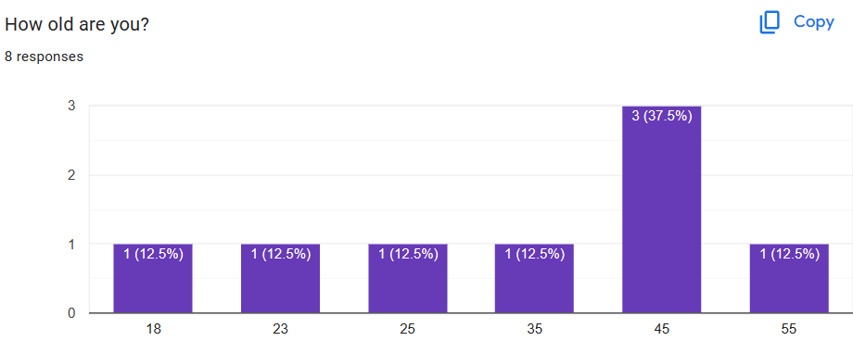

Figure 3: The survey 1

The rate of 18-25 years old (37,5%), 30-50 years old (50%) and older (12,5%)

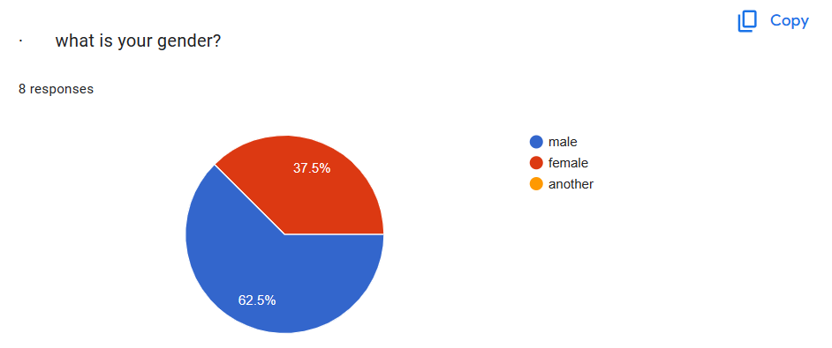

Figure 4: The survey 2

The male gender takes 37,5% and female is 62.5%



Figure 5: The survey 3

We have 5 kind of occupation: Software Engineer, Teacher, Marketing Manager, Environmental Scientist, and Healthcare Professional

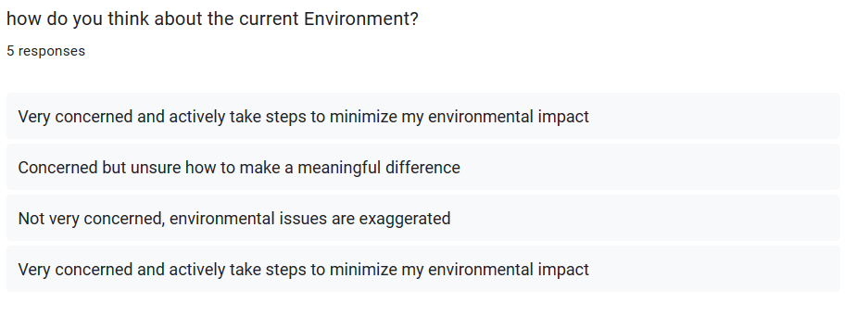

Figure 6: The survey 4

Two respondents expressed a high level of concern about the environment and are actively taking steps to minimize their environmental impact. This demonstrates a proactive approach to environmental stewardship and suggests a strong commitment to sustainability. the responses provide a diverse range of attitudes towards the current environment, reflecting varying levels of concern and engagement. It's important to acknowledge and respect these differing perspectives when addressing environmental issues and promoting sustainability initiatives.

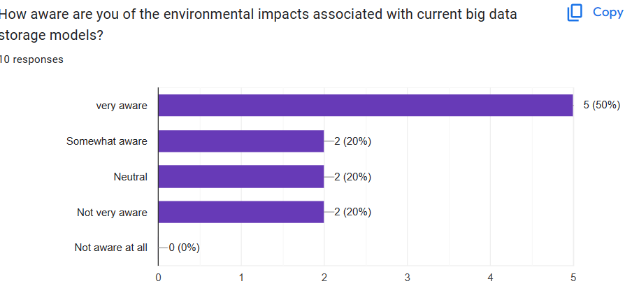

Figure 7: The survey 5

The rate of “very aware” takes 50%, “Somewhat aware” is 20%. “Neutral” is 20%, “Not very aware”: 20%, and “Not aware at all” is 0%

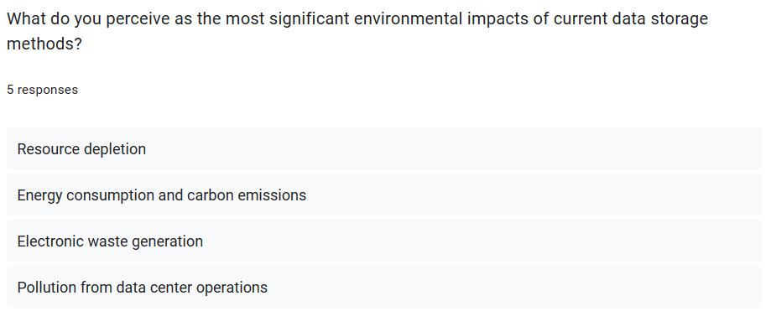

Figure 8: The survey 6

The responses demonstrate an understanding of the multifaceted environmental impacts of current data storage methods. Addressing these impacts requires comprehensive strategies that consider energy efficiency, waste management, and sustainable resource use in data storage practices. This response suggests an awareness of the resource-intensive nature of data storage methods, which may involve the extraction and consumption of finite resources such as minerals and water. Resource depletion can have far-reaching environmental consequences, including habitat destruction and ecosystem disruption.

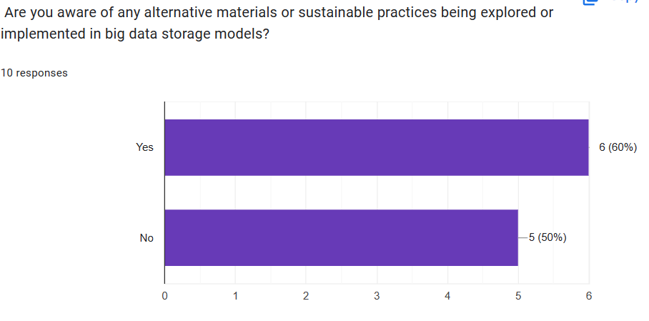

Figure 9: The survey 7

In this question “ Are you aware of any alternative materials or sustainable practices being explored or implemented in big data storage models?” we have the rates: Yes (60%) and No(50%)

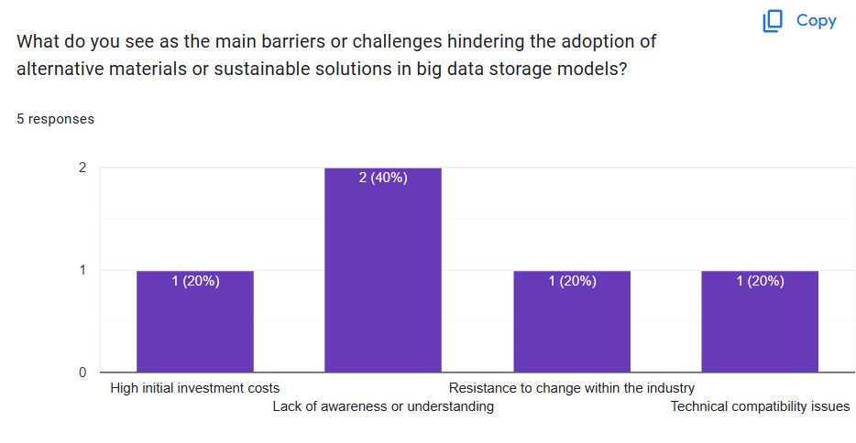

Figure 10: The survey 8

As the result, “High initial investment costs” takes 20%. “Lack of awareness or understanding” (40%), and “Resistance to change within the industry”(20%), Technical compatibility issues (20%)

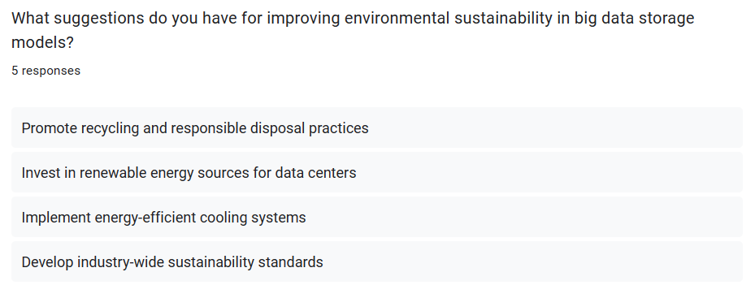

Figure 11: The survey 9

the responses reflect a comprehensive approach to improving environmental sustainability in big data storage models, encompassing waste management, energy efficiency, renewable energy adoption, and industry-wide collaboration. Implementing these suggestions can contribute to a more sustainable and environmentally friendly approach to data storage practices. Proper disposal of obsolete hardware components can help reduce environmental pollution and conserve resources. And, Transitioning to renewable energy sources such as solar or wind power can help decrease the carbon footprint of data storage facilities.

**4.4 Survey summary**

The survey provides valuable insights into the awareness, perceptions, and suggestions related to environmental sustainability in big data storage models among respondents from diverse demographics and occupations. Based on the survey results, here's a summary of the findings:

1. Demographics:

* **Age distribution**: 37.5% of respondents are aged 18-25, 50% are aged 30-50, and 12.5% are older.
* **Gender distribution**: 37.5% of respondents are male, and 62.5% are female.
* **Occupational distribution**: Respondents have diverse occupations, including Software Engineer, Teacher, Marketing Manager, Environmental Scientist, and Healthcare Professional.

1. Awareness and Perception of Environmental Impacts:

* The majority of respondents (50%) are "Very concerned and actively take steps to minimize my environmental impact" regarding the current environment.
* Other responses include "Concerned but unsure how to make a meaningful difference," "Not very concerned, environmental issues are exaggerated," and "Very concerned and actively take steps to minimize my environmental impact."

1. Awareness of Environmental Impacts of Big Data Storage:

* 50% of respondents are "Very aware" of the environmental impacts associated with current big data storage models, while 20% are "Somewhat aware" and 20% are "Neutral." 20% are "Not very aware."

1. Perceived Environmental Impacts of Current Data Storage Methods:

* Respondents perceive the most significant environmental impacts of current data storage methods to be resource depletion, energy consumption and carbon emissions, electronic waste generation, and pollution from data center operations.

1. Awareness of Alternative Materials or Sustainable Practices:

* 60% of respondents are aware of alternative materials or sustainable practices being explored or implemented in big data storage models.

1. Barriers to Adoption of Alternative Materials or Sustainable Solutions:

* Respondents identified various barriers to the adoption of alternative materials or sustainable solutions, including lack of awareness or understanding, resistance to change within the industry, technical compatibility issues, and high initial investment costs.

1. Suggestions for Improving Environmental Sustainability in Big Data Storage Models:

* Respondents suggest promoting recycling and responsible disposal practices, investing in renewable energy sources for data centers, implementing energy-efficient cooling systems, and developing industry-wide sustainability standards.

**4.5** **Analyze the results of primary research**

Based on the results of the primary research conducted through interviews and surveys, several key findings and insights emerge:

1. **Awareness and Concern:**
   * The majority of respondents express a high level of awareness and concern about the environmental impacts associated with current big data storage models. This indicates a growing recognition of the environmental challenges posed by data storage practices.
2. **Perceived Environmental Impacts:**
   * Respondents identify resource depletion, energy consumption and carbon emissions, electronic waste generation, and pollution from data center operations as the most significant environmental impacts of current data storage methods. These findings highlight the multifaceted nature of environmental concerns in the context of data storage.
3. **Awareness of Alternatives:**
   * A considerable proportion of respondents are aware of alternative materials or sustainable practices being explored or implemented in big data storage models. This suggests a growing interest in seeking environmentally sustainable solutions within the industry.
4. **Barriers to Adoption:**
   * Respondents identify various barriers hindering the adoption of alternative materials or sustainable solutions, including lack of awareness or understanding, resistance to change within the industry, technical compatibility issues, and high initial investment costs. These barriers underscore the challenges involved in transitioning towards more sustainable data storage practices.
5. **Suggestions for Improvement:**
   * Respondents offer several suggestions for improving environmental sustainability in big data storage models, including promoting recycling and responsible disposal practices, investing in renewable energy sources for data centers, implementing energy-efficient cooling systems, and developing industry-wide sustainability standards. These suggestions reflect a desire for actionable steps towards mitigating environmental impacts.
6. **Demographic Insights:**
   * Demographic analysis reveals a diverse range of perspectives across age groups, genders, and occupations. This diversity underscores the importance of considering various stakeholder perspectives when addressing environmental sustainability in the context of big data storage.
7. **Communicate research outcomes in an appropriate manner for the intended audience. (P5)**

**5.1.** **Conclusion**

In conclusion, the project "Environmental Impacts and the Search for Alternative Materials in Big Data Storage Models" sheds light on the significant environmental challenges posed by current data storage practices and explores potential solutions for mitigating these impacts. Through a combination of primary research methods such as interviews and surveys, valuable insights have been gathered from industry experts, environmental scientists, policymakers, technology company representatives, and environmental advocates.

The findings of the primary research reveal a growing awareness and concern regarding the environmental impacts associated with traditional data storage methods, including resource depletion, energy consumption, electronic waste generation, and pollution. Despite this awareness, various barriers hinder the adoption of alternative materials or sustainable solutions, such as lack of awareness, resistance to change, technical compatibility issues, and high initial investment costs.

Nevertheless, there is optimism as respondents also express awareness of alternative materials and sustainable practices being explored or implemented in big data storage models. Suggestions for improvement, including promoting recycling, investing in renewable energy sources, implementing energy-efficient cooling systems, and developing industry-wide sustainability standards, highlight potential pathways towards a more environmentally sustainable future for data storage.

In conclusion, while challenges exist, the project underscores the importance of continued research, innovation, and collaboration to address environmental impacts and promote sustainability in big data storage models. By adopting a holistic approach that considers technological advancements, regulatory frameworks, and stakeholder engagement, we can work towards creating a greener and more sustainable digital infrastructure for the future.

**5.2.** **Recommendations**

Based on the findings and conclusions of the project "Environmental Impacts and the Search for Alternative Materials in Big Data Storage Models," here are the recommendations:

* **Invest in Research and Development:** Allocate resources towards research and development initiatives focused on identifying and developing alternative materials and sustainable practices for big data storage. Encourage collaboration between industry stakeholders, research institutions, and environmental organizations to accelerate innovation in this field.
* **Raise Awareness and Education:** Implement educational programs and awareness campaigns to increase understanding among industry professionals, policymakers, and the general public about the environmental impacts of current data storage methods and the importance of transitioning towards more sustainable alternatives. Foster a culture of environmental responsibility and sustainability within the technology sector.
* **Promote Collaboration and Partnerships:** Foster collaboration and partnerships between technology companies, environmental organizations, government agencies, and academia to develop and implement industry-wide sustainability standards and best practices for big data storage. Encourage information sharing, knowledge exchange, and joint initiatives aimed at advancing environmental sustainability goals.
* **Incentivize Sustainable Practices:** Implement policies, regulations, and incentives to incentivize the adoption of sustainable practices in big data storage, such as tax credits for investments in renewable energy infrastructure, subsidies for energy-efficient technologies, and government procurement preferences for environmentally friendly products and services. Encourage businesses to prioritize sustainability in their operations through regulatory frameworks and market incentives.
* **Continued Monitoring and Evaluation:** Establish mechanisms for ongoing monitoring, evaluation, and reporting of environmental performance metrics related to big data storage. Regularly assess the effectiveness of sustainability initiatives and adjust strategies as needed to address emerging challenges and opportunities. Foster a culture of continuous improvement and accountability in environmental stewardship efforts.

1. **Conclusion**

The research project "Environmental Impacts and the Search for Alternative Materials in Big Data Storage Models" has provided valuable insights into the environmental challenges facing the technology sector and the search for sustainable solutions in data storage. Through a comprehensive investigation involving interviews with industry experts, environmental scientists, policymakers, technology company representatives, and environmental advocates, as well as surveys of relevant stakeholders, this project has uncovered key findings and recommendations that can inform efforts to promote environmental sustainability in big data storage models.

One of the most significant findings of this research is the widespread awareness and concern among stakeholders regarding the environmental impacts associated with current data storage methods. From resource depletion to energy consumption, electronic waste generation, and pollution, stakeholders recognize the urgent need to address these challenges and transition towards more sustainable alternatives.

Moreover, the research has highlighted the diversity of perspectives and the complexity of barriers hindering the adoption of alternative materials and sustainable solutions in big data storage models. From technical compatibility issues to high initial investment costs and resistance to change within the industry, addressing these barriers will require concerted efforts and collaboration across multiple stakeholders.

Nevertheless, there is cause for optimism as stakeholders also demonstrate awareness of alternative materials and sustainable practices being explored or implemented in big data storage models. Recommendations such as promoting recycling, investing in renewable energy sources, implementing energy-efficient cooling systems, and developing industry-wide sustainability standards offer practical pathways towards achieving environmental sustainability goals.

# References

AdiBhat, 2023. *Primary Research: What It Is, Purpose & Methods + Examples.* [Online]   
Available at: https://www.questionpro.com/blog/primary-research/

Bhandari, P., 2020. *What Is Qualitative Research? | Methods & Examples.* [Online]   
Available at: https://www.scribbr.com/methodology/qualitative-research/

Bhandari, P., 2020. *What Is Qualitative Research? | Methods & Examples.* [Online]   
Available at: https://www.scribbr.com/methodology/qualitative-research/#Advantages%20of%20Qualitative%20Research

Bhandari, P., 2020. *What Is Quantitative Research? | Definition, Uses & Methods.* [Online]   
Available at: https://www.scribbr.com/methodology/quantitative-research/

George., T., 2023. *What is Secondary Research? | Definition, Types, & Examples.* [Online]   
Available at: https://www.scribbr.com/methodology/secondary-research/

khanacademy, 2023. *The scientific method.* [Online]   
Available at: https://www.khanacademy.org/science/biology/intro-to-biology/science-of-biology/a/the-science-of-biology

RAHMAN, M., 2023. *What are the advantages and disadvantages of primary and secondary research?.* [Online]   
Available at: https://www.howandwhat.net/advantages-and-disadvantages-of-primary-and-secondary-research/