**ASSIGNMENT 1 Application Development**

|  |  |  |  |
| --- | --- | --- | --- |
| **Qualification** | **BTEC Level 5 HND Diploma in Computing** | | |
| **Unit number and title** | Unit 30: Application Development | | |
| **Submission date** |  | **Date Received 1st submission** |  |
| **Re-submission Date** | 12/3/2024 | **Date Received 2nd submission** |  |
| **Student Name** | PHAN HUU QUY | **Student ID** | BH00037 |
| **Class** | IT0502 | **Assessor name** | Nguyen Thanh Trieu |
| **Student declaration**  I certify that the assignment submission is entirely my own work and I fully understand the consequences of plagiarism. I understand that making a false declaration is a form of malpractice. | | | |
|  |  | **Student’s signature** | quy |

**Grading grid**

|  |  |  |  |  |  |
| --- | --- | --- | --- | --- | --- |
| P1 | P2 | P3 | M1 | M2 | D1 |
|  |  |  |  |  |  |

|  |  |  |
| --- | --- | --- |
| **❒ Summative Feedback: ❒ Resubmission Feedback:** | | |
| **Grade:** | **Assessor Signature:** | **Date:** |
| **Lecturer Signature:** | | |

Contents

**A.** **Introduction** 4

**B.** **Body** 5

**I.** **Research the use of software development tools and techniques and identify any that have been selected for the development of this application** 5

**1.** **UML** 5

**1.1** **UML definition** 5

**1.2** **Some popular UML diagram** 5

**1.3** **Use the UML tool** 9

**2.** **Chosen design tools** 11

**3.** **Development Tools and Techniques** 12

**3.1** **C# ("C sharp)** 12

**3.2** **ASP.NET** 14

**3.3** **Visual Studio 2022** 15

**3.4** **SQL Server** 16

**C.** **Conclusion** 18

Bibliography 19

Figure 1 Diagrams (Padmanabhan, 2012) 5

Figure 2 Class diagram (Padmanabhan, 2012) 6

Figure 3 Use case diagram 7

Figure 4 Activity diagram (Padmanabhan, 2012) 8

Figure 5 Component diagram (Padmanabhan, 2012) 9

Figure 6 Draw.io 9

Figure 7 Microsoft Visio (Robert, 2024) 11

Figure 8 Creately 11

Figure 9 Database Diagram 12

Figure 10 C# 13

Figure 11 Visual studio 15

Figure 12 SQL Server 16

1. **Introduction**

In this assignment, the focus is on exploring the realm of application development and the essential software tools and techniques that play a pivotal role in the creation of software-intensive systems. The assignment delves into the significance of Unified Modeling Language (UML) as a standardized graphical language that aids in visualizing, specifying, constructing, and documenting software artifacts

The use of UML diagrams, such as class diagrams, use case diagrams, activity diagrams, and component diagrams, is highlighted for their ability to represent system structures, user interactions, dynamic behaviors, and system components effectively . These diagrams serve as blueprints for understanding system functionalities from various perspectives and are instrumental in guiding the development process .

Moreover, the assignment sheds light on popular websites like Draw.io, Microsoft Visio, and Creately that offer users the capability to create UML diagrams with ease and efficiency. These platforms provide diverse features and functionalities to support the creation of professional-looking diagrams without requiring advanced design skills

Furthermore, the assignment delves into the selection of specific design tools for the FPT training system, emphasizing the use of Draw.io for drawing use case diagrams, activity diagrams, and database diagrams. Additionally, Microsoft Visio is chosen for creating UML diagrams to facilitate the development process effectively

The development tools and techniques essential for building the FPT training app are also discussed in detail. The assignment highlights the indispensable role of tools like C#, ASP.NET, Visual Studio 2022, and SQL Server in developing robust and scalable applications. These tools offer a rich set of features, strong typing capabilities, object-oriented programming support, cross-platform capabilities, efficient data access mechanisms, web application frameworks, integrated development environments (IDEs), database management systems (DBMS), and more to streamline the development process and ensure high-quality outcomes

In conclusion, this assignment sets the stage for a comprehensive exploration of application development methodologies and software tools that are fundamental in creating sophisticated software systems. By leveraging these tools effectively, developers can enhance productivity, streamline collaboration, and build high-quality applications that meet user needs effectively.

1. **Body**
2. **Research the use of software development tools and techniques and identify any that have been selected for the development of this application**
3. **UML**
4. **UML definition**

Unified Modeling Language (UML) is a standardized graphical language for visualizing, specifying, constructing, and documenting the artifacts of a software-intensive system. It provides a common way to write a system's blueprints, including conceptual things such as business processes and system functions, as well as concrete things such as programming language statements, database schemas, and reusable software components (Padmanabhan, 2012)

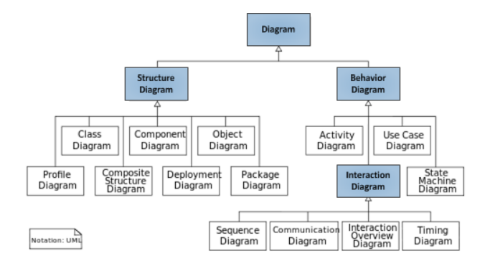

Figure 1 Diagrams (Padmanabhan, 2012)

1. **Some popular UML diagram**

* Class diagram

A class diagram in UML (Unified Modeling Language) is a type of static structure diagram that describes the structure of a system by showing the classes, their attributes, operations (or methods), and the relationships among objects. Class diagrams are primarily used for modeling the static structure of a system, focusing on the classes and their associations. They depict the structure of a system by showing the classes of the system, their attributes, methods, relationships, and constraints (Padmanabhan, 2012)

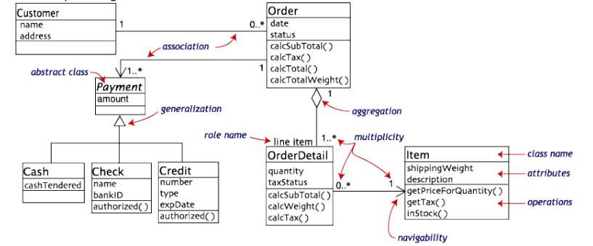

Figure 2 Class diagram (Padmanabhan, 2012)

* Use case diagram

A use case diagram in UML is a powerful and essential tool for system design, providing a visual representation of how users interact with a system. It serves as a blueprint for understanding the functional requirements of a system from a user's perspective, aiding in communication between stakeholders and guiding the development process. By illustrating the interactions between users (actors) and the system under consideration, use case diagrams play a crucial role in capturing and visualizing functional requirements from a user's perspective. (Padmanabhan, 2012)

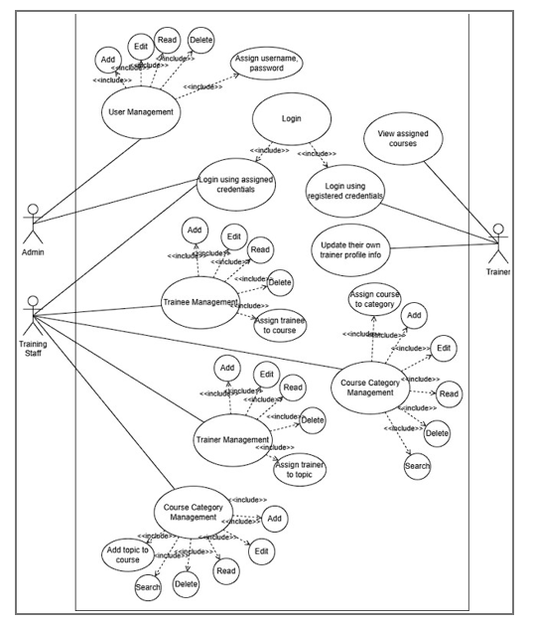

Figure 3 Use case diagram

* Activity diagram

An activity diagram in UML is a dynamic behavior diagram that visually represents the flow of activities within a system or business process. It outlines the sequence of actions or steps required to accomplish a specific task or achieve a particular goal. These diagrams are instrumental in modeling the dynamic aspects of a system, including workflows, business processes, use cases, and system behaviors (Padmanabhan, 2012)

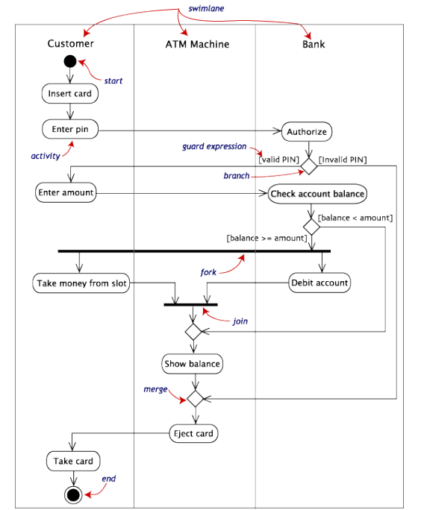

Figure 4 Activity diagram (Padmanabhan, 2012)

* Component diagram

A component diagram in UML is a structural diagram that illustrates the components of a system and their relationships. It provides a high-level view of the physical components or modules that make up a software system and shows how they are interconnected. Component diagrams are particularly useful for modeling the architecture and dependencies of a system, including the deployment of components across different hardware or software environments (Padmanabhan, 2012)

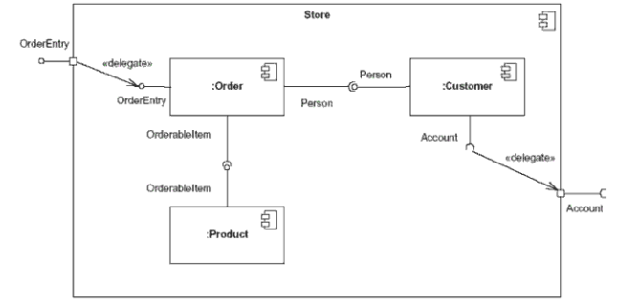

Figure 5 Component diagram (Padmanabhan, 2012)

1. **Use the UML tool**

There are several popular websites that offer the ability to create UML diagrams. These websites provide various features and pricing plans, including free versions with limited functionality and premium plans with additional features and storage options. Here are some of the popular websites for creating UML diagrams: (online.visual-paradigm, n.d.)

* Draw.io

draw.io is a free online diagram software that allows users to create a wide variety of diagrams, including flowcharts, network diagrams, UML diagrams, entity-relationship diagrams, and more. It provides a user-friendly interface with a drag-and-drop functionality, making it easy for users to create professional-looking diagrams without the need for advanced design skills (Wikipedia, 2024)



Figure 6 Draw.io

Benefits and Applications:

* Easy-to-use interface with drag-and-drop functionality.
* Supports a wide range of diagram types, including UML diagrams.
* Integration with Jira and Trello for collaborative diagram creation.
* Ability to import diagrams from other tools like Gliffy™ and Lucidchart™.

In summary, draw.io is a versatile online diagramming tool that offers a wide range of features and supports UML diagrams, making it a popular choice for creating professional-looking diagrams and charts.

* Microsoft Visio

Microsoft Visio is a robust diagramming and flowcharting software included in the Microsoft Office suite. It provides a diverse array of features and tools for crafting professional diagrams, flowcharts, and organizational charts. With an extensive library of shapes, templates, and visual elements, Visio enables users to create visually engaging diagrams to effectively communicate information. Its integration with Microsoft 365 allows for easy viewing, printing, sharing, and commenting on diagrams. Whether creating flowcharts, network diagrams, UML diagrams, or entity-relationship diagrams, Visio offers flexibility with automatic layout functions and customizable options. Additionally, its compatibility with older versions ensures seamless access and editing of existing diagrams. The online version available through Microsoft 365 offers cloud-based accessibility, eliminating the need for manual updates and enhancing collaboration capabilities. Microsoft Visio stands as a versatile tool for professionals seeking to create impactful visual representations of complex information. (Robert, 2024)

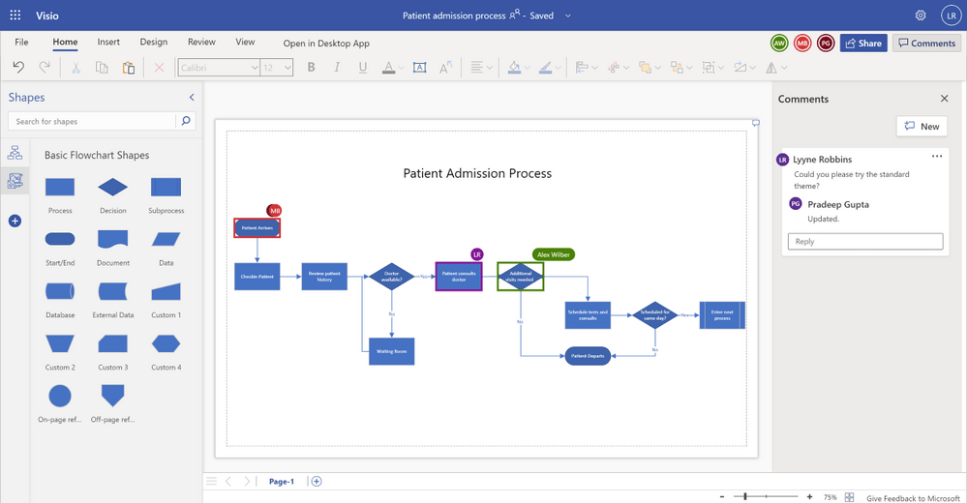

Figure 7 Microsoft Visio (Robert, 2024)

* Creately

Creately is a sophisticated online diagramming tool designed to empower users in creating a diverse range of diagrams with ease and efficiency. Offering a user-friendly interface, Creately stands out as a versatile platform for crafting visually appealing diagrams, flowcharts, and organizational charts without the need for advanced design skills (Wikipedia, 2023)

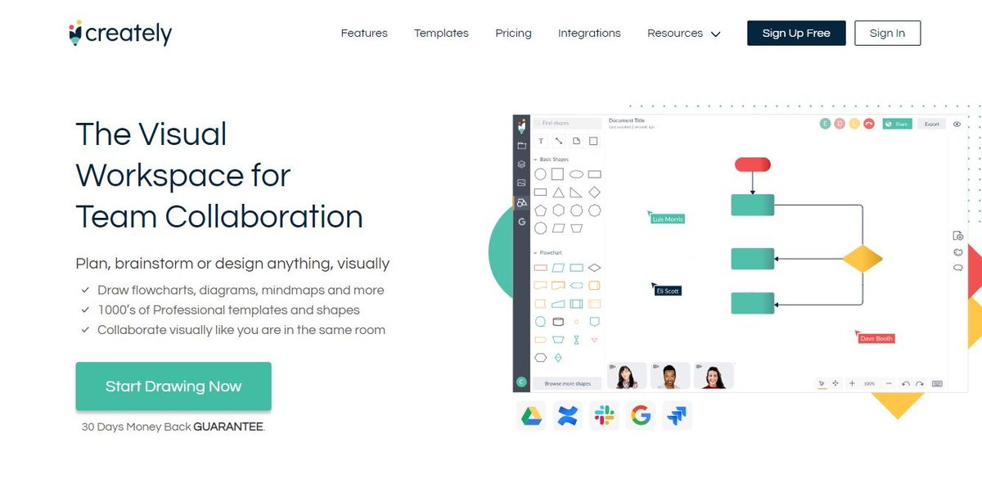

Figure 8 Creately

1. **Chosen design tools**

In my FPT training system, I chose Draw.io to draw my use case diagrams and Activity diagrams and Database Diagrams. using Microsoft Visio to draw my UML diagrams,

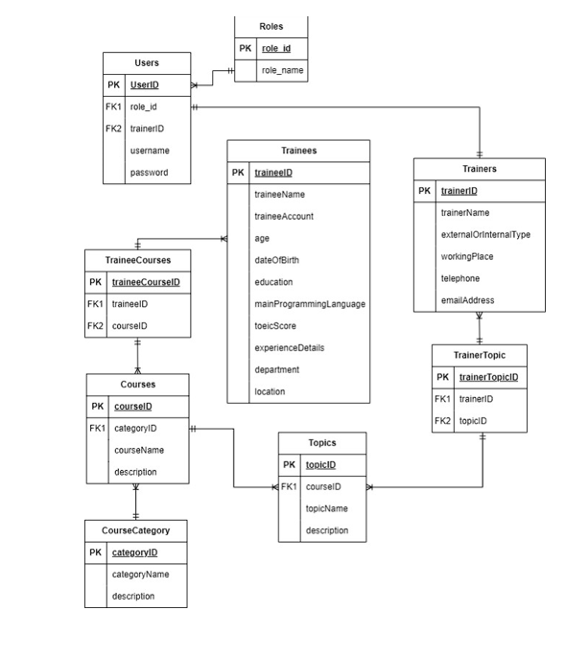

Figure 9 Database Diagram

1. **Development Tools and Techniques**

To build the FPT training app, I use these following tools. I absolutely cannot build the app without them

1. **C# ("C sharp)**

For this project, we have chosen C# as our primary programming language. C# is a modern, object-oriented language developed by Microsoft as part of the .NET framework. It offers several advantages that make it well-suited for developing robust and scalable applications, particularly for the web and enterprise domains

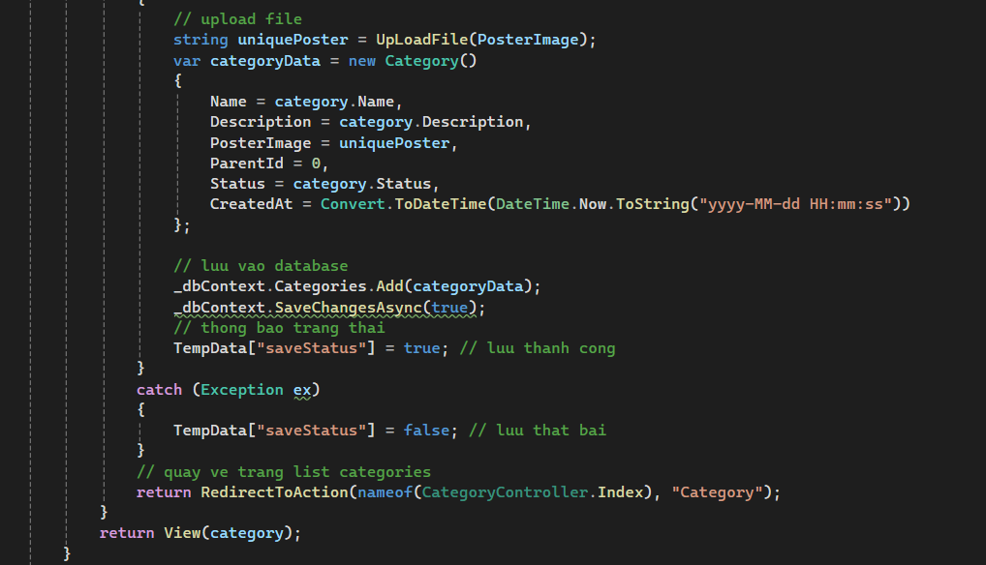

Figure 10 C#

* Strong Typing: C# is a strongly-typed language, which means that variables must be explicitly declared with their data types. This feature helps catch type-related errors during compile-time, improving code reliability and maintainability.
* Object-Oriented Programming (OOP): C# fully supports object-oriented programming principles such as encapsulation, inheritance, and polymorphism. This allows for better code organization, reusability, and modularity, which is essential for large-scale projects.
* Language Interoperability: C# seamlessly integrates with other .NET languages, enabling developers to leverage existing code libraries and components written in languages like Visual Basic or F#, promoting code reuse and collaboration.
* Robust Framework and Libraries: The .NET framework provides a vast collection of pre-built classes, libraries, and APIs for various tasks, such as database connectivity, networking, file I/O, and user interface development. This rich ecosystem accelerates development and promotes consistency across projects.
* Cross-Platform Capabilities: With the introduction of .NET Core, C# applications can now run on multiple platforms, including Windows, macOS, and Linux, making it a versatile choice for modern software development.
* Automatic Memory Management: C# incorporates automatic memory management through garbage collection, relieving developers from the burden of manual memory allocation and deallocation, reducing the likelihood of memory-related bugs.
* Advanced Language Features: C# continuously evolves, incorporating modern language features such as asynchronous programming, lambda expressions, LINQ (Language Integrated Query), and pattern matching, which enhance developer productivity and code readability.

By choosing C# as our primary programming language, we can leverage its powerful features, rich ecosystem, and cross-platform capabilities to develop a robust and scalable training management system. The language's strong typing, object-oriented nature, and extensive libraries will contribute to code quality, maintainability, and efficient development processes (Wikipedia, 2024)

1. **ASP.NET**

ASP.NET is a powerful and versatile web application framework developed by Microsoft, built on top of the .NET platform. It provides a comprehensive and feature-rich environment for building dynamic and scalable web applications and services using C# or Visual Basic programming languages.

One of the key strengths of ASP.NET is its support for the Model-View-Controller (MVC) architectural pattern, which promotes separation of concerns and facilitates the development of complex web applications. It also offers Web Forms, a more traditional approach for building event-driven web applications.

ASP.NET comes with built-in security features such as authentication, authorization, and data validation, ensuring that applications are secure from the ground up. It seamlessly integrates with Visual Studio, Microsoft's powerful Integrated Development Environment (IDE), providing developers with a rich set of tools and features for efficient coding, debugging, and deployment.

The framework promotes code reusability and extensibility through its support for user controls, custom controls, and integration with third-party components and libraries. With the introduction of .NET Core, ASP.NET applications can now run cross-platform, supporting Windows, macOS, and Linux operating systems.

ASP.NET applications are known for their scalability and high performance, leveraging features such as caching mechanisms, asynchronous processing, and optimized resource management to handle high traffic loads efficiently.

By leveraging ASP.NET for our web-based training management system, we can benefit from its robust architecture, rich feature set, and seamless integration with the .NET ecosystem, enabling us to develop a secure, scalable, and maintainable application (Microsoft, n.d.)

1. **Visual Studio 2022**

Visual Studio 2022 is a significant release of Microsoft's integrated development environment (IDE) that offers a comprehensive set of tools for software development, debugging, testing, and deployment. This powerful and versatile IDE caters to the diverse needs of development teams, providing a modern and efficient environment for building high-quality applications across various platforms and technologies

.One of the key strengths of Visual Studio 2022 lies in its access to a rich set of libraries and frameworks within the .NET ecosystem. For instance, developers working on projects like the FPT Training app can leverage technologies such as ASP.NET Core for web development and Entity Framework Core for efficient data access (Wikipedia, 2024)

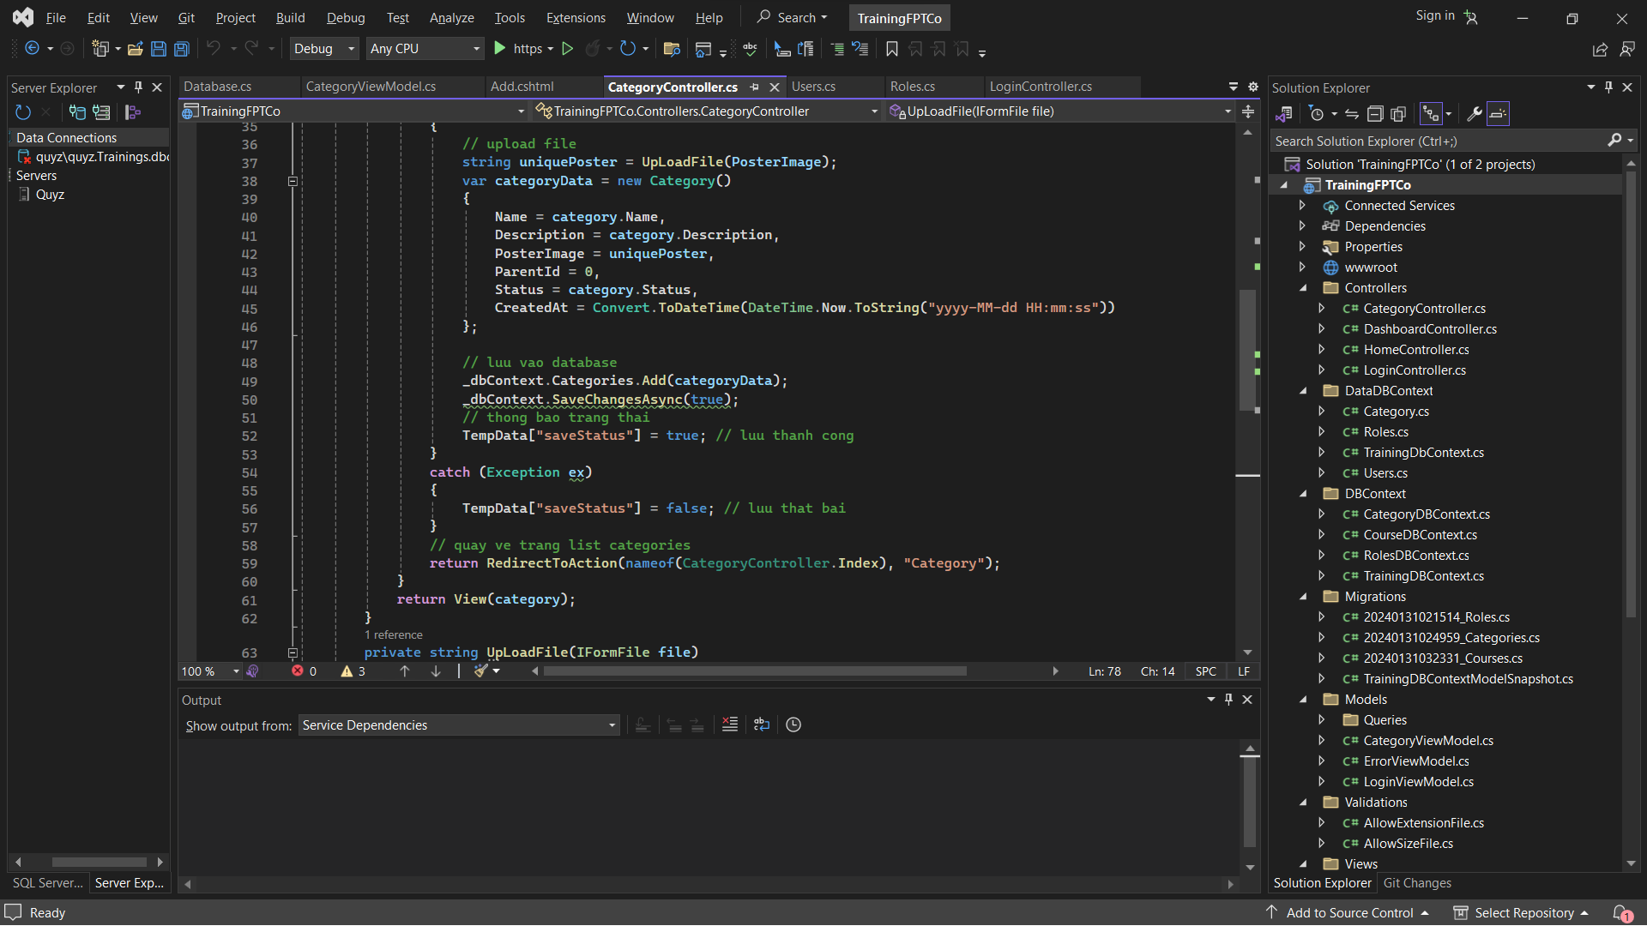

Figure 11 Visual studio

* Flexible and highly customizable interface: Visual Studio Code provides an intuitive and user-friendly interface, allowing developers to customize the layout, window arrangement, and keyboard shortcuts according to their preferences.
* Efficient programming tools: The IDE comes integrated with a compiler and debugger, supporting full programming concepts such as auto-complete, error highlighting, and syntax highlighting. It also supports static code analysis and type checking.
* Extensibility: Visual Studio Code has a rich ecosystem with thousands of extensions, allowing customization and enhancement of functionality for specific languages, tools, and frameworks.
* Git integration: The IDE is well-integrated with the distributed version control system Git, enabling developers to track changes, create branches, commit, and push code.
* Integrated Terminal panel: An integrated Terminal panel allows developers to execute command-line instructions and third-party tools directly within the IDE.
* Cross-platform support: Visual Studio Code is available for Windows, macOS, and Linux, ensuring a consistent development environment across multiple platforms.

1. **SQL Server**

Regarding Database Management Systems (DBMS), tools like MySQL, SQL Server, PostgreSQL, or MongoDB are essential for efficiently storing and managing data within the application. For this project, we have chosen to utilize Microsoft SQL Server as our database management platform, with the following key reasons:

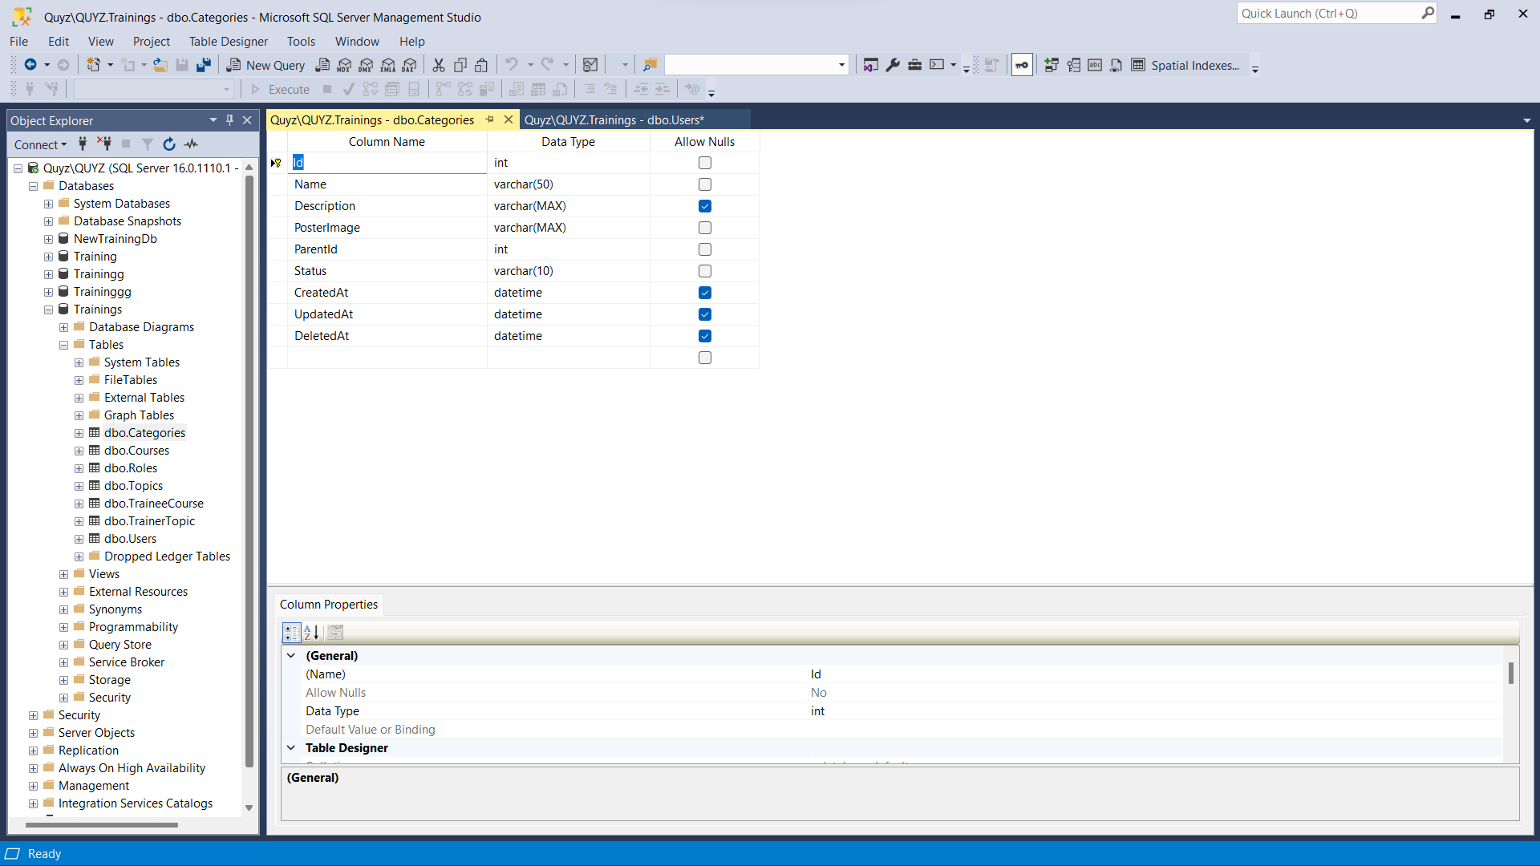

Figure 12 SQL Server

* **Tight Integration with .NET Framework**: SQL Server is developed by Microsoft and seamlessly integrates with the .NET Framework, the application development platform we have chosen to use. This simplifies the development process and enhances performance by allowing direct data access from .NET code.
* **Scalability and High Performance**: SQL Server is designed to efficiently handle complex data processing tasks and store large amounts of data. It offers high scalability, allowing our system to grow and expand according to future business requirements.
* **Robust Security Features**: SQL Server provides robust security features, including authentication, data encryption, access control, and auditing. This helps ensure data integrity, security, and compliance with regulations for sensitive data in our training management system.
* **Data Synchronization Support**: SQL Server offers tools and techniques for data synchronization, allowing us to easily integrate and synchronize data from various sources, if needed in the future.
* **Data Management and Analytics Tools**: SQL Server includes powerful data management, reporting, and data mining tools, enabling us to easily analyze and extract valuable insights from training data.
* **Rich Support and Resources**: With a large user community and abundant support resources, we can easily find support, guidance, and solutions for any SQL Server-related issues during development and deployment.

By selecting SQL Server as our database management platform, we ensure that our training management system will have the capability to store and process data efficiently, meeting the requirements for performance, security, and scalability in the future.

SQL Server's tight integration with the .NET ecosystem, robust feature set, and extensive support resources make it an ideal choice for managing the data needs of our application effectively and reliably. Its proven performance and scalability will allow our system to handle growing data volumes and user loads seamlessly

1. **Conclusion**

In this assignment, the focus has been on exploring the use of software development tools and techniques in the context of application development. Specifically, the utilization of Unified Modeling Language (UML) has been highlighted, showcasing its relevance in visualizing, specifying, constructing, and documenting the artifacts of a software-intensive system.

Throughout the assignment, various UML diagrams have been discussed, each serving a unique purpose in the development process. Class diagrams, for instance, describe the structure of a system by showing classes, their attributes, operations, and relationships. Use case diagrams, on the other hand, represent the functionality of a system from a user's perspective, illustrating the interactions between users (actors) and the system under consideration. Activity diagrams outline the sequence of actions or steps required to accomplish a specific task or achieve a particular goal, while component diagrams illustrate the components of a system and their relationships, providing a high-level view of the physical components or modules that make up a software system.

Moreover, the assignment has touched upon popular websites that offer the ability to create UML diagrams, such as Draw.io, Microsoft Visio, and Creately. These platforms provide a user-friendly interface and a wide range of features to support the creation of professional-looking diagrams without requiring advanced design skills.

In the context of the FPT training system, Draw.io has been chosen to draw use case diagrams, activity diagrams, and database diagrams, while Microsoft Visio has been utilized to draw UML diagrams. Additionally, specific development tools and techniques, such as C#, ASP.NET, Visual Studio 2022, and SQL Server, have been discussed as essential for building the FPT training app.

In conclusion, the effective utilization of software development tools and techniques, such as UML diagrams and development tools like C#, ASP.NET, and SQL Server, plays a crucial role in the development of high-quality software applications. By leveraging these tools and techniques, developers can enhance productivity, streamline collaboration, and build robust and scalable applications that meet user needs effectively.

# Bibliography

*Microsoft*. (n.d.). Retrieved from What is ASP.NET?: .NET: https://dotnet.microsoft.com/en-us/learn/aspnet/what-is-aspnet

*online.visual-paradigm*. (n.d.). Retrieved from Online UML diagram tool: https://online.visual-paradigm.com/diagrams/features/uml-tool/

Padmanabhan, B. (2012, 2 21). *people.eecs.ku.edu.* Retrieved from UNIFIED MODELING LANGUAGE: https://people.eecs.ku.edu/~hossein/810/Readings/UML-diagrams.pdf

Robert. (2024, Feb 15). *ClickUp*. Retrieved from 10 best UML Diagram Software Solutions of 2024: https://clickup.com/blog/uml-diagram-software/

*Wikipedia*. (2023, December 23). Retrieved from Creately: https://en.wikipedia.org/wiki/Creately

*Wikipedia*. (2024). Retrieved from Diagrams.net: https://en.wikipedia.org/wiki/Diagrams.net

*Wikipedia*. (2024, Feb 20). Retrieved from C sharp (programming language): https://en.wikipedia.org/wiki/C_Sharp_%28programming_language%29#:~:text=C%23%20%28%2F%20%CB%8Csi%CB%90%20%CB%88%CA%83%C9%91%CB%90rp%20%2F%20see%20SHARP%29%20%5Bb%5D,%3A%E2%80%8A22%20object-oriented%20%28class%20-based%29%2C%20and%20component-oriented%20p

*Wikipedia*. (2024, March 03). Retrieved from https://en.wikipedia.org/wiki/Visual_Studio