Apache Spark

Apache Spark is a lightning-fast cluster computing designed for fast computation. It was built on top of Hadoop MapReduce and it extends the MapReduce model to efficiently use more types of computations which includes Interactive Queries and Stream Processing. This is a brief tutorial that explains the basics of Spark Core programming.

Industries are using Hadoop extensively to analyze their data sets. The reason is that Hadoop framework is based on a simple programming model (MapReduce) and it enables a computing solution that is scalable, flexible, fault-tolerant and cost effective. Here, the main concern is to maintain speed in processing large datasets in terms of waiting time between queries and waiting time to run the program.
Evolution of Apache Spark

Spark is one of Hadoop’s sub project developed in 2009 in UC Berkeley’s AMPLab by Matei Zaharia. It was Open Sourced in 2010 under a BSD license. It was donated to Apache software foundation in 2013, and now Apache Spark has become a top level Apache project from Feb-2014.
Features of Apache Spark
Apache Spark has following features.
- Speed − Spark helps to run an application in Hadoop cluster, up to 100 times faster in memory, and 10 times faster when running on disk. This is possible by reducing number of read/write operations to disk. It stores the intermediate processing data in memory.
- Supports multiple languages − Spark provides built-in APIs in Java, Scala, or Python. Therefore, you can write applications in different languages. Spark comes up with 80 high-level operators for interactive querying.
- Advanced Analytics − Spark not only supports ‘Map’ and ‘reduce’. It also supports SQL queries, Streaming data, Machine learning (ML), and Graph algorithms.

The following diagram shows three ways of how Spark can be built with Hadoop components.
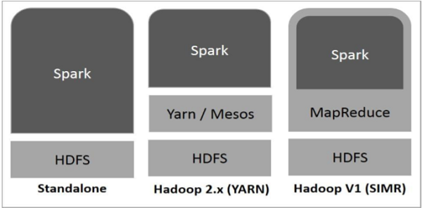
Standalone − Spark Standalone deployment means Spark occupies the place on top of HDFS(Hadoop Distributed File System) and space is allocated for HDFS, explicitly. Here, Spark and MapReduce will run side by side to cover all spark jobs on cluster.
- Hadoop Yarn − Hadoop Yarn deployment means, simply, spark runs on Yarn without any pre-installation or root access required. It helps to integrate Spark into Hadoop ecosystem or Hadoop stack. It allows other components to run on top of stack.
- Spark in MapReduce (SIMR) − Spark in MapReduce is used to launch spark job in addition to standalone deployment. With SIMR, user can start Spark and uses its shell without any administrative access.
Components of Spark
The following illustration depicts the different components of Spark.
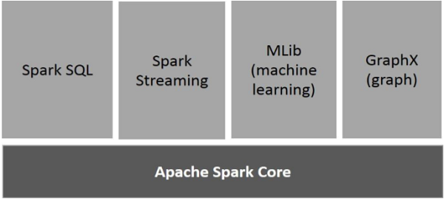

Apache Spark Core
Spark Core is the underlying general execution engine for spark platform that all other functionality is built upon. It provides In-Memory computing and referencing datasets in external storage systems.

Spark SQL
Spark SQL is a component on top of Spark Core that introduces a new data abstraction called SchemaRDD, which provides support for structured and semi-structured data.

Spark Streaming
Spark Streaming leverages Spark Core's fast scheduling capability to perform streaming analytics. It ingests data in mini-batches and performs RDD (Resilient Distributed Datasets) transformations on those mini-batches of data.

MLlib (Machine Learning Library)
MLlib is a distributed machine learning framework above Spark because of the distributed memory-based Spark architecture. It is, according to benchmarks, done by the MLlib developers against the Alternating Least Squares (ALS) implementations. Spark MLlib is nine times as fast as the Hadoop disk-based version of Apache Mahout (before Mahout gained a Spark interface).

GraphX
GraphX is a distributed graph-processing framework on top of Spark. It provides an API for expressing graph computation that can model the user-defined graphs by using Pregel abstraction API. It also provides an optimized runtime for this abstraction.

Resilient Distributed Datasets
Resilient Distributed Datasets (RDD) is a fundamental data structure of Spark. It is an immutable distributed collection of objects. Each dataset in RDD is divided into logical partitions, which may be computed on different nodes of the cluster. RDDs can contain any type of Python, Java, or Scala objects, including user-defined classes.
Formally, an RDD is a read-only, partitioned collection of records. RDDs can be created through deterministic operations on either data on stable storage or other RDDs. RDD is a fault-tolerant collection of elements that can be operated on in parallel.
There are two ways to create RDDs − parallelizing an existing collection in your driver program, or referencing a dataset in an external storage system, such as a shared file system, HDFS, HBase, or any data source offering a Hadoop Input Format.
Spark makes use of the concept of RDD to achieve faster and efficient MapReduce operations. Let us first discuss how MapReduce operations take place and why they are not so efficient.
Data Sharing is Slow in MapReduce
MapReduce is widely adopted for processing and generating large datasets with a parallel, distributed algorithm on a cluster. It allows users to write parallel computations, using a set of high-level operators, without having to worry about work distribution and fault tolerance.
Unfortunately, in most current frameworks, the only way to reuse data between computations (Ex − between two MapReduce jobs) is to write it to an external stable storage system (Ex − HDFS). Although this framework provides numerous abstractions for accessing a cluster’s computational resources, users still want more.
Both Iterative and Interactive applications require faster data sharing across parallel jobs. Data sharing is slow in MapReduce due to replication, serialization, and disk IO. Regarding storage system, most of the Hadoop applications, they spend more than 90% of the time doing HDFS read-write operations.

Iterative Operations on MapReduce

Reuse intermediate results across multiple computations in multi-stage applications. The following illustration explains how the current framework works, while doing the iterative operations on MapReduce. This incurs substantial overheads due to data replication, disk I/O, and serialization, which makes the system slow.
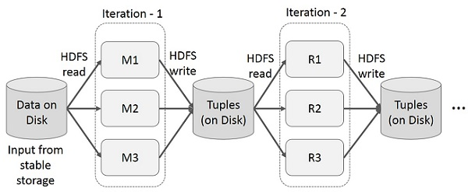

Interactive Operations on MapReduce

User runs ad-hoc queries on the same subset of data. Each query will do the disk I/O on the stable storage, which can dominate application execution time.
The following illustration explains how the current framework works while doing the interactive queries on MapReduce.
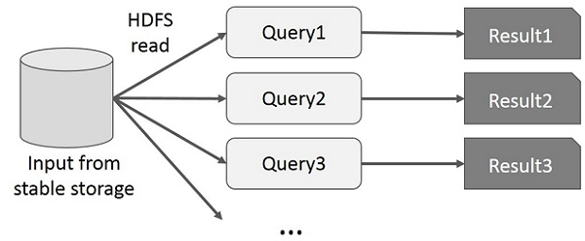

Data Sharing using Spark RDD

Data sharing is slow in MapReduce due to replication, serialization, and disk IO. Most of the Hadoop applications, they spend more than 90% of the time doing HDFS read-write operations.
Recognizing this problem, researchers developed a specialized framework called Apache Spark. The key idea of spark is Resilient Distributed Datasets (RDD); it supports in-memory processing computation. This means, it stores the state of memory as an object across the jobs and the object is sharable between those jobs. Data sharing in memory is 10 to 100 times faster than network and Disk.
Let us now try to find out how iterative and interactive operations take place in Spark RDD.

Iterative Operations on Spark RDD
The illustration given below shows the iterative operations on Spark RDD. It will store intermediate results in a distributed memory instead of Stable storage (Disk) and make the system faster.
Note − If the Distributed memory (RAM) is not sufficient to store intermediate results (State of the JOB), then it will store those results on the disk.
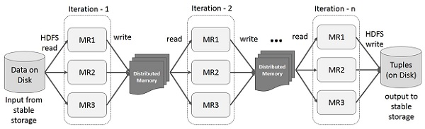

Interactive Operations on Spark RDD

This illustration shows interactive operations on Spark RDD. If different queries are run on the same set of data repeatedly, this particular data can be kept in memory for better execution times.
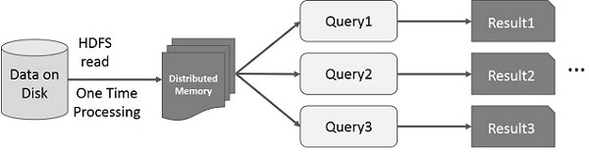
By default, each transformed RDD may be recomputed each time you run an action on it. However, you may also persist an RDD in memory, in which case Spark will keep the elements around on the cluster for much faster access, the next time you query it. There is also support for persisting RDDs on disk, or replicated across multiple nodes.

The Spark RDD API introduces few Transformations and few Actions to manipulate RDD.
RDD Transformations
RDD transformations returns pointer to new RDD and allows you to create dependencies between RDDs. Each RDD in dependency chain (String of Dependencies) has a function for calculating its data and has a pointer (dependency) to its parent RDD.
Spark is lazy, so nothing will be executed unless you call some transformation or action that will trigger job creation and execution. Look at the following snippet of the word-count example.
Therefore, RDD transformation is not a set of data but is a step in a program (might be the only step) telling Spark how to get data and what to do with it.
Given below is a list of RDD transformations.

S.No | Transformations & Meaning
1 | map(func)  Returns a new distributed dataset, formed by passing each element of the source through a function func.
2 | filter(func)  Returns a new dataset formed by selecting those elements of the source on which func returns true.
3 | flatMap(func)  Similar to map, but each input item can be mapped to 0 or more output items (so func should return a Seq rather than a single item).
4 | mapPartitions(func)  Similar to map, but runs separately on each partition (block) of the RDD, so func must be of type Iterator<T> ⇒ Iterator<U> when running on an RDD of type T.
5 | mapPartitionsWithIndex(func)  Similar to map Partitions, but also provides func with an integer value representing the index of the partition, so func must be of type (Int, Iterator<T>) ⇒ Iterator<U> when running on an RDD of type T.
6 | sample(withReplacement, fraction, seed)  Sample a fraction of the data, with or without replacement, using a given random number generator seed.
7 | union(otherDataset)  Returns a new dataset that contains the union of the elements in the source dataset and the argument.
8 | intersection(otherDataset)  Returns a new RDD that contains the intersection of elements in the source dataset and the argument.
9 | distinct([numTasks])  Returns a new dataset that contains the distinct elements of the source dataset.
10 | groupByKey([numTasks])  When called on a dataset of (K, V) pairs, returns a dataset of (K, Iterable<V>) pairs.  Note − If you are grouping in order to perform an aggregation (such as a sum or average) over each key, using reduceByKey or aggregateByKey will yield much better performance.
11 | reduceByKey(func, [numTasks])  When called on a dataset of (K, V) pairs, returns a dataset of (K, V) pairs where the values for each key are aggregated using the given reduce function func, which must be of type (V, V) ⇒ V. Like in groupByKey, the number of reduce tasks is configurable through an optional second argument.
12 | aggregateByKey(zeroValue)(seqOp, combOp, [numTasks])  When called on a dataset of (K, V) pairs, returns a dataset of (K, U) pairs where the values for each key are aggregated using the given combine functions and a neutral "zero" value. Allows an aggregated value type that is different from the input value type, while avoiding unnecessary allocations. Like in groupByKey, the number of reduce tasks is configurable through an optional second argument.
13 | sortByKey([ascending], [numTasks])  When called on a dataset of (K, V) pairs where K implements Ordered, returns a dataset of (K, V) pairs sorted by keys in ascending or descending order, as specified in the Boolean ascending argument.
14 | join(otherDataset, [numTasks])  When called on datasets of type (K, V) and (K, W), returns a dataset of (K, (V, W)) pairs with all pairs of elements for each key. Outer joins are supported through leftOuterJoin, rightOuterJoin, and fullOuterJoin.
15 | cogroup(otherDataset, [numTasks])  When called on datasets of type (K, V) and (K, W), returns a dataset of (K, (Iterable<V>, Iterable<W>)) tuples. This operation is also called group With.
16 | cartesian(otherDataset)  When called on datasets of types T and U, returns a dataset of (T, U) pairs (all pairs of elements).
17 | pipe(command, [envVars])  Pipe each partition of the RDD through a shell command, e.g. a Perl or bash script. RDD elements are written to the process's stdin and lines output to its stdout are returned as an RDD of strings.
18 | coalesce(numPartitions)  Decrease the number of partitions in the RDD to numPartitions. Useful for running operations more efficiently after filtering down a large dataset.
19 | repartition(numPartitions)  Reshuffle the data in the RDD randomly to create either more or fewer partitions and balance it across them. This always shuffles all data over the network.
20 | repartitionAndSortWithinPartitions(partitioner)  Repartition the RDD according to the given partitioner and, within each resulting partition, sort records by their keys. This is more efficient than calling repartition and then sorting within each partition because it can push the sorting down into the shuffle machinery.

Actions
Action − These are the operations that are applied on RDD, which instructs Spark to perform computation and send the result back to the driver.

The following table gives a list of Actions, which return values.
S.No | Action & Meaning
1 | reduce(func)  Aggregate the elements of the dataset using a function func (which takes two arguments and returns one). The function should be commutative and associative so that it can be computed correctly in parallel.
2 | collect()  Returns all the elements of the dataset as an array at the driver program. This is usually useful after a filter or other operation that returns a sufficiently small subset of the data.
3 | count()  Returns the number of elements in the dataset.
4 | first()  Returns the first element of the dataset (similar to take (1)).
5 | take(n)  Returns an array with the first n elements of the dataset.
6 | takeSample (withReplacement,num, [seed])  Returns an array with a random sample of num elements of the dataset, with or without replacement, optionally pre-specifying a random number generator seed.
7 | takeOrdered(n, [ordering])  Returns the first n elements of the RDD using either their natural order or a custom comparator.
8 | saveAsTextFile(path)  Writes the elements of the dataset as a text file (or set of text files) in a given directory in the local filesystem, HDFS or any other Hadoop-supported file system. Spark calls toString on each element to convert it to a line of text in the file.
9 | saveAsSequenceFile(path) (Java and Scala)  Writes the elements of the dataset as a Hadoop SequenceFile in a given path in the local filesystem, HDFS or any other Hadoop-supported file system. This is available on RDDs of key-value pairs that implement Hadoop's Writable interface. In Scala, it is also available on types that are implicitly convertible to Writable (Spark includes conversions for basic types like Int, Double, String, etc).
10 | saveAsObjectFile(path) (Java and Scala)  Writes the elements of the dataset in a simple format using Java serialization, which can then be loaded using SparkContext.objectFile().
11 | countByKey()  Only available on RDDs of type (K, V). Returns a hashmap of (K, Int) pairs with the count of each key.
12 | foreach(func)  Runs a function func on each element of the dataset. This is usually, done for side effects such as updating an Accumulator or interacting with external storage systems.  Note − modifying variables other than Accumulators outside of the foreach() may result in undefined behavior. See Understanding closures for more details.
To apply any operation in PySpark, we need to create a PySpark RDD first. The following code block has the detail of a PySpark RDD Class −

class pyspark.RDD (
jrdd,
ctx,
jrdd_deserializer = AutoBatchedSerializer(PickleSerializer())
)
Let us see how to run a few basic operations using PySpark. The following code in a Python file creates RDD words, which stores a set of words mentioned.
words = sc.parallelize (
["scala",
"java",
"hadoop",
"spark",
"akka",
"spark vs hadoop",
"pyspark",
"pyspark and spark"]
)
We will now run a few operations on words.

count()
Number of elements in the RDD is returned.
----------------------------------------count.py---------------------------------------
from pyspark import SparkContext
sc = SparkContext("local", "count app")
words = sc.parallelize (
["scala",
"java",
"hadoop",
"spark",
"akka",
"spark vs hadoop",
"pyspark",
"pyspark and spark"]
)
counts = words.count()
print "Number of elements in RDD -> %i" % (counts)
----------------------------------------count.py---------------------------------------
$SPARK_HOME/bin/spark-submit count.py
Output − The output for the above command is −
Number of elements in RDD → 8

collect()
All the elements in the RDD are returned.
----------------------------------------collect.py---------------------------------------
from pyspark import SparkContext
sc = SparkContext("local", "Collect app")
words = sc.parallelize (
["scala",
"java",
"hadoop",
"spark",
"akka",
"spark vs hadoop",
"pyspark",
"pyspark and spark"]
)
coll = words.collect()
print "Elements in RDD -> %s" % (coll)
----------------------------------------collect.py---------------------------------------
Command − The command for collect() is −
$SPARK_HOME/bin/spark-submit collect.py
Output − The output for the above command is −
Elements in RDD -> [
'scala',
'java',
'hadoop',
'spark',
'akka',
'spark vs hadoop',
'pyspark',
'pyspark and spark'
]

foreach(f)
Returns only those elements which meet the condition of the function inside foreach. In the following example, we call a print function in foreach, which prints all the elements in the RDD.
----------------------------------------foreach.py---------------------------------------
from pyspark import SparkContext
sc = SparkContext("local", "ForEach app")
words = sc.parallelize (
["scala",
"java",
"hadoop",
"spark",
"akka",
"spark vs hadoop",
"pyspark",
"pyspark and spark"]
)
def f(x): print(x)
fore = words.foreach(f)
----------------------------------------foreach.py---------------------------------------
Command − The command for foreach(f) is −
$SPARK_HOME/bin/spark-submit foreach.py
Output − The output for the above command is −
scala
java
hadoop
spark
akka
spark vs hadoop
pyspark
pyspark and spark

filter(f)
A new RDD is returned containing the elements, which satisfies the function inside the filter. In the following example, we filter out the strings containing ''spark".
----------------------------------------filter.py---------------------------------------
from pyspark import SparkContext
sc = SparkContext("local", "Filter app")
words = sc.parallelize (
["scala",
"java",
"hadoop",
"spark",
"akka",
"spark vs hadoop",
"pyspark",
"pyspark and spark"]
)
words_filter = words.filter(lambda x: 'spark' in x)
filtered = words_filter.collect()
print "Fitered RDD -> %s" % (filtered)
----------------------------------------filter.py----------------------------------------
Command − The command for filter(f) is −
$SPARK_HOME/bin/spark-submit filter.py
Output − The output for the above command is −
Fitered RDD -> [
'spark',
'spark vs hadoop',
'pyspark',
'pyspark and spark'
]

map(f, preservesPartitioning = False)
A new RDD is returned by applying a function to each element in the RDD. In the following example, we form a key value pair and map every string with a value of 1.
----------------------------------------map.py---------------------------------------
from pyspark import SparkContext
sc = SparkContext("local", "Map app")
words = sc.parallelize (
["scala",
"java",
"hadoop",
"spark",
"akka",
"spark vs hadoop",
"pyspark",
"pyspark and spark"]
)
words_map = words.map(lambda x: (x, 1))
mapping = words_map.collect()
print "Key value pair -> %s" % (mapping)
----------------------------------------map.py---------------------------------------
Command − The command for map(f, preservesPartitioning=False) is −
$SPARK_HOME/bin/spark-submit map.py
Output − The output of the above command is −
Key value pair -> [
('scala', 1),
('java', 1),
('hadoop', 1),
('spark', 1),
('akka', 1),
('spark vs hadoop', 1),
('pyspark', 1),
('pyspark and spark', 1)
]

reduce(f)
After performing the specified commutative and associative binary operation, the element in the RDD is returned. In the following example, we are importing add package from the operator and applying it on ‘num’ to carry out a simple addition operation.
----------------------------------------reduce.py---------------------------------------
from pyspark import SparkContext
from operator import add
sc = SparkContext("local", "Reduce app")
nums = sc.parallelize([1, 2, 3, 4, 5])
adding = nums.reduce(add)
print "Adding all the elements -> %i" % (adding)
----------------------------------------reduce.py---------------------------------------
Command − The command for reduce(f) is −
$SPARK_HOME/bin/spark-submit reduce.py
Output − The output of the above command is −
Adding all the elements -> 15

join(other, numPartitions = None)
It returns RDD with a pair of elements with the matching keys and all the values for that particular key. In the following example, there are two pair of elements in two different RDDs. After joining these two RDDs, we get an RDD with elements having matching keys and their values.
----------------------------------------join.py---------------------------------------
from pyspark import SparkContext
sc = SparkContext("local", "Join app")
x = sc.parallelize([("spark", 1), ("hadoop", 4)])
y = sc.parallelize([("spark", 2), ("hadoop", 5)])
joined = x.join(y)
final = joined.collect()
print "Join RDD -> %s" % (final)
----------------------------------------join.py---------------------------------------
Command − The command for join(other, numPartitions = None) is −
$SPARK_HOME/bin/spark-submit join.py
Output − The output for the above command is −
Join RDD -> [
('spark', (1, 2)),
('hadoop', (4, 5))
]

cache()
Persist this RDD with the default storage level (MEMORY_ONLY). You can also check if the RDD is cached or not.
----------------------------------------cache.py---------------------------------------
from pyspark import SparkContext
sc = SparkContext("local", "Cache app")
words = sc.parallelize (
["scala",
"java",
"hadoop",
"spark",
"akka",
"spark vs hadoop",
"pyspark",
"pyspark and spark"]
)
words.cache()
caching = words.persist().is_cached
print "Words got chached > %s" % (caching)
----------------------------------------cache.py---------------------------------------
Command − The command for cache() is −
$SPARK_HOME/bin/spark-submit cache.py
Output − The output for the above program is −
Words got cached -> True
These were some of the most important operations that are done on PySpark RDD.

StorageLevel decides how RDD should be stored. In Apache Spark, StorageLevel decides whether RDD should be stored in the memory or should it be stored over the disk, or both. It also decides whether to serialize RDD and whether to replicate RDD partitions.
The following code block has the class definition of a StorageLevel −
class pyspark.StorageLevel(useDisk, useMemory, useOffHeap, deserialized, replication = 1)
Now, to decide the storage of RDD, there are different storage levels, which are given below −
- DISK_ONLY = StorageLevel(True, False, False, False, 1)
- DISK_ONLY_2 = StorageLevel(True, False, False, False, 2)
- MEMORY_AND_DISK = StorageLevel(True, True, False, False, 1)
- MEMORY_AND_DISK_2 = StorageLevel(True, True, False, False, 2)
- MEMORY_AND_DISK_SER = StorageLevel(True, True, False, False, 1)
- MEMORY_AND_DISK_SER_2 = StorageLevel(True, True, False, False, 2)
- MEMORY_ONLY = StorageLevel(False, True, False, False, 1)
- MEMORY_ONLY_2 = StorageLevel(False, True, False, False, 2)
- MEMORY_ONLY_SER = StorageLevel(False, True, False, False, 1)
- MEMORY_ONLY_SER_2 = StorageLevel(False, True, False, False, 2)
- OFF_HEAP = StorageLevel(True, True, True, False, 1)
Let us consider the following example of StorageLevel, where we use the storage level MEMORY_AND_DISK_2, which means RDD partitions will have replication of 2.
------------------------------------storagelevel.py-------------------------------------
from pyspark import SparkContext
import pyspark
sc = SparkContext (
"local",
"storagelevel app"
)
rdd1 = sc.parallelize([1,2])
rdd1.persist( pyspark.StorageLevel.MEMORY_AND_DISK_2 )
rdd1.getStorageLevel()
print(rdd1.getStorageLevel())
------------------------------------storagelevel.py-------------------------------------
Command − The command is as follows −
$SPARK_HOME/bin/spark-submit storagelevel.py
Output − The output for the above command is given below −
Disk Memory Serialized 2x Replicated

