Gibs Search Keystroke Issue
Search functionality in Gibs planning application is generating a server request call for each keystroke when typing the search keyword in the search Text input field.
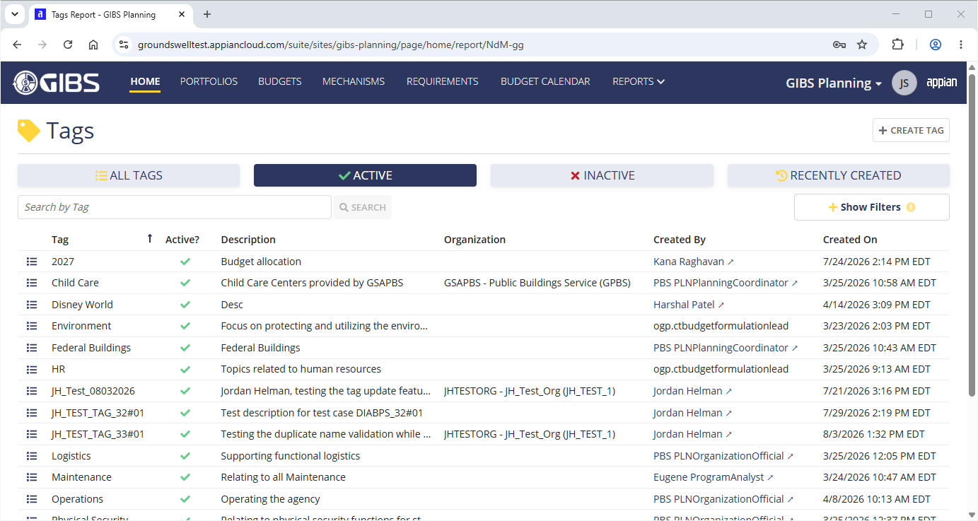

Below are the screenshots to view separate requests generated in JMeter script for each keystroke when typing the search keyword.
Even deleting a character from the keyword is generating a request.
