

Odette School of Business
Analyzing Aviation Occurrences, Weather Conditions, and Safety Trends, 2018-2025
Design Document
Prepared by GROUP 5
Phani Keerthana Lakkaraju (110214939)
Tahmidur Rahman (110216668)
Yaswin Paul Rajasekar (110214823)
Master of Management – Business Data Analytics
BSMM 8730 — Data Acquisition & Management
Repository: https://github.com/phani-lakkaraju/Aerosafe
Professor/Instructor’s Name: Dr. Andreas Maniatis
Submission Date: October 30, 2026
Table of Contents
1.0 Introduction 4
1.1 System Purpose & Project Context 4
1.2 Problem Background 4
1.3 System Scope & Boundaries 4
Out-of-Scope System Boundaries: 4
1.4 Requirements Traceability Matrix 5
2.0 Goals & Non-Goals 6
2.1 System Objectives & Core Goals 6
2.2 Measurable Success Criteria & Performance Thresholds 6
2.3 Explicit Non-Goals & System Limitations 7
3. Interface Design 7
3.1 User Interface: Dashboard Wireframes 7
3.2 User Interactions 9
3.3 Data Interface Definitions 9
4. Logical Architecture 10
4.1 Overview 10
4.2 Logical Architecture Components 10
4.3 Component Interaction and Data Flow 11
5. Physical Architecture 11
5.1 Overview 11
5.2 Hardware and Software Requirements 11
5.3 Physical Deployment Structure 11
6. Data Model 12
6.1 Main Database Entities 12
6.2 Entity Relationship Diagram 13
6.3 Database Relationships and Integrity 13
6.4 Analytical Data Preparation 13
6.5 Data Flow Diagram 14
7. Component Design 14
7.1 Algorithms and Techniques 15
7.2 Algorithmic Pseudocode 15
7.3 Future Work 17
8. Constraints & Security 17
8.1 Hardware and Software Limits 17
8.2 Performance Bottlenecks 18
8.3 Data Constraints 18
8.4 Outside Rules and Licences 19
8.5 Security Considerations 19
8.6 Delivery Risks 20
9. Design Rationale 20
9.1 Technology Choices 20
9.2 Method Choices 21
9.3 Scope Decisions and Trade-offs 22
9.4 Optional Extension 22

1.0 Introduction

1.1 System Purpose & Project Context
This is a System Design Document that will define the architectural design and technical requirements of AeroSafe designed for BSMM 8730 - Data Acquisition and Management at the Odette School of Business of the University of Windsor. The system is designed from the ground up based on the architecture defined in the document titled “D.4.1 User Requirements and Analysis.” This document defines how data is to be turned into a normalized MySQL database and displayed using Microsoft Power BI visualization tools.

1.2 Problem Background
Management of Canadian civil aviation safety depends greatly on knowledge of complex failure modes of operations, environment, and structures. Although Transport Canada tracks occurrences systematically through the Civil Aviation Daily Occurrence Reporting System (CADORS), occurrence records are available only in the form of separate tabular incident files that lack local meteorological observations and thorough investigations. Moreover, important details are scattered between third-party weather data sources (Open-Meteo API) and narrative investigation reports published by the Transportation Safety Board of Canada (TSB).
AeroSafe addresses this issue through building an automated and reproducible Python data pipeline. It standardizes 8 years of historical Canadian occurrences (2018-2025), geocodes aerodromes using OurAirports, aligns daily weather records (temperature, precipitation, snow, and wind) for five major airports, scrapes investigation reports summaries, and maintains referential integrity in MySQL.

1.3 System Scope & Boundaries
In-Scope Functional Boundaries:
- Time Period: Any occurrences between January 1st, 2018 and December 31st, 2025. (8yr timespan). Excluded data before 2018 to ensure weather consistency and keep processing times reasonable on 8 GB workstations.
- Geographic Area: All Canadian airspace and airports. All provinces and territories included. All overseas Atlantics and Arctic areas were specifically noted.
- Data Types: CADORS data in CSV format (Occurrences, Categories, Aircraft). Weather data from Open-Meteo in JSON/CSV REST API format. Narrative summary data from the TSB ASIS dataset (CSV) and TSB investigation report pages (HTML).
- Location Matching: Airport codes matched with OurAirports data to get latitude and longitude. Time zone conversion from UTC (occurrence time) to local time (New York time). Five major airports were converted (Toronto: CYYZ, Calgary: CYYC, Vancouver: CYVR, Montreal: CYUL, and Edmonton: CYEG).
- Database: Data is stored in a relational database (MySQL 8.0) with keys and constraints. Data is viewed using an interactive 3 page Power BI dashboard.

Out-of-Scope System Boundaries:
Causal Inference: This is purely descriptive and cannot show any causal relationships or legal responsibility. Visualisations do not suggest any causal links.
Flight Density: Visualisations are based on actual numbers because there is no freely available data on flight density per hour.
AeroSafe is a historic batch processing decision support tool. It is not real time. Transport Canada Civil Aviation Safety Alerts (CASA) had to be removed to focus on the most impactful TSB reports. Partial data from 2026 was also removed to avoid skewing the trend between years.

1.4 Requirements Traceability Matrix
D.4.1 Req ID | Requirement Description | Priority | Design Document Mapping
FR-01 | Import CADORS CSVs, Open-Meteo weather JSON/CSV, and TSB scraped HTML text | High | Section 3.3 (Data Interfaces) & Data Acquisition Engine
FR-02 | Identify missing values, remove duplicates, standardize dates/times/operators (2018–2025 Canada filter) | High | Section 7.2 (Algorithm 1) & Section 8.3 (Data Constraints)
FR-03 | Store integrated occurrences, weather, and TSB reports in MySQL relational database | High | Section 6 (Data Model) & Section 3.3 (Python to MySQL Interface)
FR-04 | Summarize occurrences by year, month, province, category, and aircraft category | High | Section 3.1 (Page 1 Overview Wireframe) & Section 6.4 Aggregations
FR-05 | Compare occurrences with weather metrics (precipitation, wind, temp) across regions | High | Section 3.1 (Page 3 Weather Wireframe) & Section 7.2 (Algorithm 3)
FR-06 | Provide interactive Power BI dashboard with filters (year, province, category, aircraft) | High | Section 3.1 (UI Wireframes) & Section 3.2 (User Interactions)
FR-07 | Identify recurring safety themes in TSB report narratives using keyword analysis | Medium | Section 3.1 (Page 3 TSB Visuals) & Section 7.2 (Algorithm 2)
FR-08 | Display summary KPI scorecards (occurrences, fatalities, injuries, flagged missing codes) | Low | Section 3.1 (Page 1 Overview KPI Cards)
NFR-01/02 | Maintain data integrity, enforce foreign keys, and document incomplete records | High | Section 6.3 (Integrity Constraints) & Section 8.3 (Data Constraints)
NFR-03 | Process pipeline within 30 minutes on 8 GB laptop; filter latency <10s | High | Section 8.1 (Hardware Limits) & Section 8.2 (Bottleneck Handling)
NFR-04/05 | Protect credentials (.env file), adhere to CC BY 4.0 license and TSB scraping rules | High | Section 8.4 (Licensing) & Section 8.5 (Security Safeguards)

2.0 Goals & Non-Goals

2.1 System Objectives & Core Goals
- Multi-Format Data Ingestion: Construct a modular, reproducible Python ETL pipeline using pandas, requests, and BeautifulSoup to automatically acquire CADORS tabular CSVs, Open-Meteo REST API JSON/CSV weather payloads, and TSB HTML investigation narrative text.
- Normalized Relational Storage: Design and instantiate a 3rd Normal Form MySQL schema enforcing primary/foreign keys, entity constraints, check constraints (fatalities ≥ 0), and index structures across occurrences, airports, daily weather, and TSB reports.
- Spatial-Temporal Resolution: Synchronize Canadian aerodromes with OurAirports latitude/longitude coordinates (resolving ~99.8% of valid codes) and align UTC occurrence timestamps with local weather daily boundaries.
- Interactive Visual Analytics: Deliver an intuitive 3-page Power BI report enabling dynamic cross-filtering across geography, time, occurrence categories, aircraft categories, weather conditions, and investigative keyword themes.
- Reproducibility & Compliance: Ensure 100% pipeline reproducibility on standard 8 GB workstations within a 30-minute execution window while strictly adhering to CC BY 4.0 weather licensing, TSB website scraping terms (robots.txt), and credential security (.gitignore).

2.2 Measurable Success Criteria & Performance Thresholds
To objectively verify system performance and satisfy non-functional requirements (NFR-03, NFR-04, NFR-05), AeroSafe must meet the explicit quantitative benchmarks detailed below:
Metric ID | Performance Dimension | Target Quantitative Threshold | Verification Method
SC-01 | ETL Processing Runtime | ≤ 30 minutes total execution time for CADORS, weather, and TSB cleaning scripts on an 8 GB RAM laptop (NFR-03) | Automated Python logging execution timer
SC-02 | Dashboard Filter Latency | ≤ 10 seconds refresh/cross-filter update latency across Power BI pages (NFR-03) | Power BI Performance Analyzer audit
SC-03 | Aerodrome Code Resolution | ≥ 99.0% matching rate for CADORS records with valid aerodrome IDs against OurAirports reference table (Actual: 99.8%) | SQL data quality reconciliation query
SC-04 | Data Filtering Integrity | About 148,883 Canadian 2018–2025 occurrences retained from 406,693 raw CADORS records | Post-cleaning SQL count verification
SC-05 | API Throttling Compliance | 0 HTTP 429 errors during Open-Meteo weather queries by staying under 600 calls/min | API request status log audit
SC-06 | Database Integrity | 0 foreign-key violations, 0 unhandled duplicate primary keys, 100% row reconciliation | MySQL DDL constraint checks
SC-07 | Clean-Machine Reproducibility | End-to-end pipeline execution from raw sources using README instructions on a clean machine | Peer clean-machine execution test

2.3 Explicit Non-Goals & System Limitations
- No causal analysis, only visualisation of raw data (frequencies and co-occurrences). No inference or proof of legal or physical causality between weather measures and occurrence frequencies.
- No predictive analytics/ML available within the core. The main deliverables are visual analytics. However this can be extended using predictive models such as Random Forest or Poisson regression.
- No normalisation to flight density due to no open data on hourly movement.
- No real time telemetry. AeroSafe works with batch static data. Streaming data or live dispatch monitoring is out of scope.
- No bespoke web application or cloud server. The user can only interact with the data using Power BI Desktop (.pbix). There is no bespoke web application (React/Django) or cloud database (AWS RDS). The database is run locally within MySQL.

3. Interface Design
AeroSafe has no custom website or mobile app. Its only user interface is a Power BI report (the dashboard). Everything behind it (collecting, cleaning and storing the data) is run by the project team with Python scripts and a MySQL database. This section describes the screens the user sees and then the connections (interfaces) between the system and each data source.

3.1 User Interface: Dashboard Wireframes
The report has three pages. A filter panel (slicers) on the left of every page narrows the data by year, province, airport, occurrence category and aircraft category. Clicking any chart also filters the other charts on that page. Every page carries a footer that states that the figures are raw counts and do not prove causation (non-functional requirement 4) and credits the data sources (Open-Meteo requires attribution under its CC BY 4.0 licence, and the TSB terms require that copied report material names the original). The wireframes show the planned layout; the exact charts may change slightly once the final data is loaded.
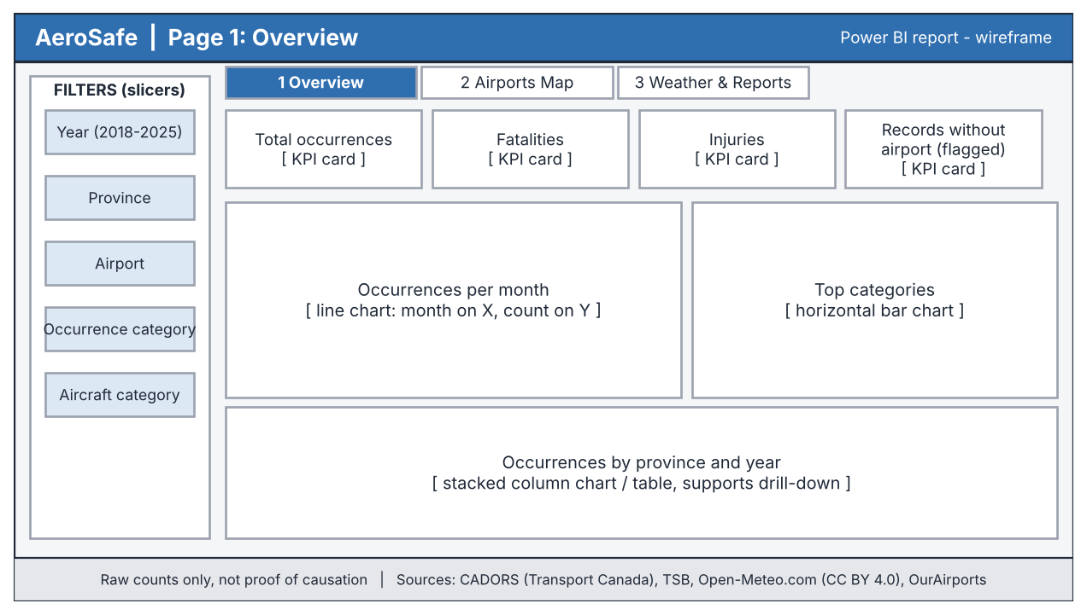
Figure 3.1: Page 1 (Overview) wireframe
Page 1: Overview. Covers functional requirements 4 and 8. Four summary cards (total occurrences, fatalities, injuries, and the number of records with no airport, which are flagged and not hidden), a monthly trend line, the top categories, and a breakdown by province and year. Totals on this page include every valid occurrence from 2018 to 2025, so they add up to the database total.
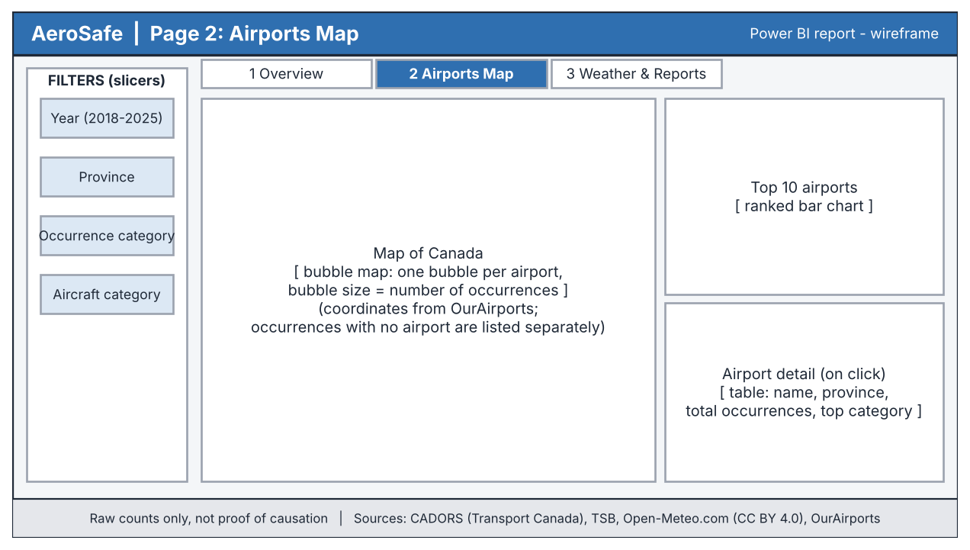
Figure 3.2: Page 2 (Airports Map) wireframe
Page 2: Airports Map. Shows where occurrences happen. Each airport is a bubble on a map of Canada (position from OurAirports) and a bigger bubble means more occurrences. A ranked list shows the top 10 airports, and clicking an airport shows its details. Occurrences without an airport code cannot be placed on the map, so they are listed separately and not dropped.
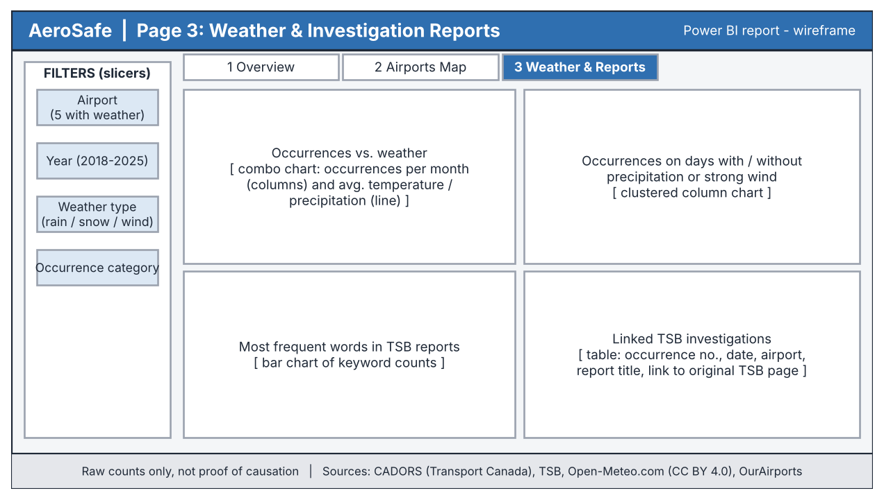
Figure 3.3: Page 3 (Weather & Reports) wireframe
Page 3: Weather & Reports. Covers functional requirements 5 and 7. It compares occurrences with daily weather (temperature, rain, snow, wind) for the five airports that have weather data: Toronto, Calgary, Vancouver, Montréal and Edmonton. It also shows the most frequent words found in the linked TSB occurrence summaries and reports and a table linking each report to its occurrence.

3.2 User Interactions
- Slicers: year, province, airport, occurrence category, aircraft category and weather type.
- Cross-filtering: clicking a bar, bubble or line point filters the other charts on the page.
- Drill-down: year, then month, then the individual occurrence in the occurrence table.
- Tooltips: hovering over a chart element shows the exact number.
- Target response: a filter change refreshes the page in 10 seconds or less (acceptance criterion 11; see Section 8.2).

3.3 Data Interface Definitions
The system exchanges data with its sources and with the database through the interfaces below. The first five bring data in. The last two move the stored data to the database and on to the dashboard.
Interface | Direction | Protocol / format | Key details
Open-Meteo Historical Weather API | Internet to Python | HTTPS GET; CSV or JSON response | Endpoint: archive-api.open-meteo.com/v1/archive. Parameters: latitude, longitude, start_date, end_date, daily, timezone (America/New_York). Daily variables used: weather_code, temperature_2m_max and _min, precipitation_sum, rain_sum, snowfall_sum, wind_speed_10m_max, wind_gusts_10m_max, wind_direction_10m_dominant. Limits: 600 calls per minute, 5,000 per hour, under 10,000 per day.
OurAirports | Internet to Python | HTTPS file download; CSV (airports.csv) | Gives ident (airport code), name, latitude, longitude and region. Matched to CADORS aerodromeid.
CADORS open data | Internet to Python | Manual or scripted file download; 5 CSV files | Occurrence, category, event, aircraft and aircraft-event files from the Canada Open Government Portal. All five link through cadorsnumber.
TSB ASIS dataset | Internet to Python | Manual or scripted download; CSV tables (occurrence, aircraft, injuries, events and phases, survivability) | Official TSB occurrence data from 1995, updated monthly. The occurrence table holds the written summary of each occurrence, coordinates and the occurrence number (OccNo), which matches tsboccurrencenumber in CADORS. Duplicate rows are removed (one row per OccID).
TSB investigation report pages | Internet to Python | HTTPS GET; HTML read with requests and BeautifulSoup | Scraped for the investigated occurrences (classes 2 to 4) to add report title, findings and URL, matched through the investigation number. A 1 to 2 second pause is kept between requests, and robots.txt is checked first.
Python to MySQL | Python to database | SQLAlchemy / MySQL Connector over TCP, port 3306 | Loads the cleaned tables (airports, occurrences, weather, TSB reports). Database login details are read from a local settings file and are not stored in the repository.
MySQL to Power BI | Database to dashboard | Power BI MySQL connector (Import mode) | Uses a separate read-only database account. Power BI can read the data but cannot change it.

4. Logical Architecture

4.1 Overview
AeroSafe follows a modular, six-layer architecture that collects, prepares, integrates, stores, analyzes, and presents Canadian aviation occurrence and weather data for 2018–2025. Each layer has one job, so a problem can be traced to a single layer and any layer can be rerun on its own.
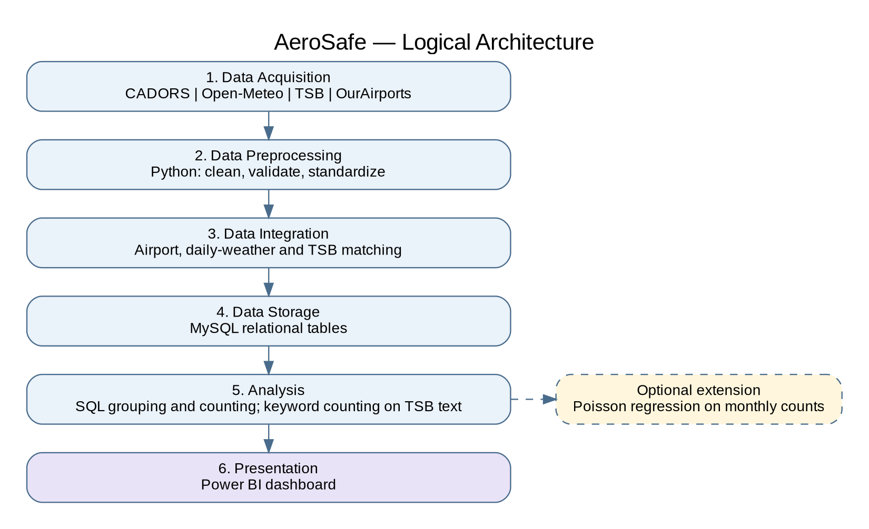
Figure 4.1: Logical architecture

4.2 Logical Architecture Components
Layer | Description
1. Data Acquisition | Collects CADORS occurrence files, Open-Meteo daily weather for five airports, TSB occurrence data and investigation report pages, and OurAirports airport coordinates using Python.
2. Data Preprocessing | Uses pandas to remove duplicates, flag missing values, convert UTC times, and validate records.
3. Data Integration | Joins occurrences to airports (airport code), to daily weather (airport and date), and to TSB reports (TSB occurrence number). Records that cannot be matched are flagged, not dropped.
4. Data Storage | Uses MySQL to store airports, occurrences, categories, aircraft, daily weather, and TSB reports with keys and constraints.
5. Analysis | Groups and counts occurrences in SQL (by year, month, province, category, and aircraft category), compares occurrences with daily weather, and counts keywords in TSB text.
6. Presentation | Uses Power BI to show the three-page dashboard with trends, an airport map, weather comparisons, and TSB report themes.

4.3 Component Interaction and Data Flow
Data moves in one direction, from acquisition and preprocessing through integration into MySQL storage. The analysis layer reads the stored tables and writes summary tables, and Power BI reads both through a read-only account. An optional extension (Poisson regression on monthly counts) can use the summary tables without changing the other layers.

5. Physical Architecture

5.1 Overview
AeroSafe runs on standard personal computers using free or widely available tools. Python handles data processing, MySQL provides structured storage, and Power BI Desktop (Windows) supports reporting. The system processes historical records in batches and does not monitor live aviation operations.
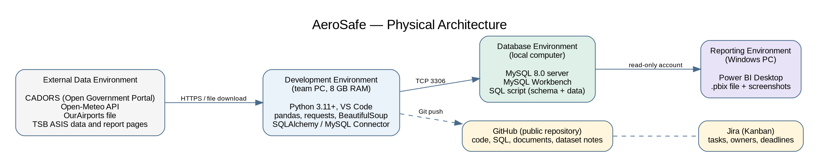
Figure 5.1: Physical architecture

5.2 Hardware and Software Requirements
Component | Technology | Purpose
Development hardware | Personal computer, 8 GB RAM target | Data processing
Programming environment | Python 3.11+, VS Code | Script development
Data processing | pandas, NumPy | Cleaning and transformation
Data acquisition | requests, BeautifulSoup | API retrieval and web scraping
Database management | MySQL 8.0, MySQL Workbench | Structured storage and queries
Database connectivity | SQLAlchemy / MySQL Connector | Python–MySQL integration
Visualization | Power BI Desktop (Windows) | Interactive dashboard
Version control and tracking | GitHub, Jira (Kanban) | Collaboration, documentation, and task tracking
Optional extension only | statsmodels or scikit-learn | Poisson regression

5.3 Physical Deployment Structure
The implementation consists of four environments and two support tools.
- External Data Environment: CADORS, Open-Meteo, OurAirports, and the TSB provide the historical datasets.
- Development Environment: Python scripts run on team computers and perform cleaning, integration, and analysis.
- Database Environment: A local MySQL server stores the validated records and summary tables, and MySQL Workbench supports administration. The database is also delivered as a SQL script.
- Reporting Environment: Power BI Desktop connects to MySQL with a read-only account to show the dashboard. The report is delivered as a .pbix file with screenshots.
- GitHub keeps the scripts, database definitions, and documentation, and Jira tracks the tasks.

6. Data Model
AeroSafe uses a MySQL relational database to hold airports, occurrences, their categories and aircraft, daily weather, and TSB reports. Primary and foreign keys keep the tables consistent.

6.1 Main Database Entities
Entity | Main attributes
AIRPORTS | airport_id (PK, airport code), airport_name, province, latitude, longitude
OCCURRENCES | cadorsnumber (PK), airport_id (FK, nullable), tsb_occurrence_no (FK, nullable, filled only when the TSB summary exists), tsb_number_raw (text), occurrence_date, occurrence_datetime_utc, province, occurrence_class, fatalities, injuries, flag columns (missing airport, missing time, missing country)
OCCURRENCE_CATEGORIES | cadorsnumber (PK, FK), category (PK)
AIRCRAFT | cadorsnumber (PK, FK), aircraftnumber (PK), make, model, aircraft_category, operator_id, operator_name_std
WEATHER_DAILY | weather_id (PK), airport_id (FK), weather_date, weather_code, temp_max, temp_min, precipitation, rain, snowfall, wind_speed_max, wind_gusts_max
TSB_REPORTS | tsb_occurrence_no (PK), summary_text, language, report_title, findings, report_url, keywords
FORECAST_RESULTS (optional extension) | result_id (PK), airport_id (FK), target_month, predicted_count, mae
The two CADORS event files (occurrence events and aircraft events) use the same keys and can be added later. The dashboard does not use them.

6.2 Entity Relationship Diagram
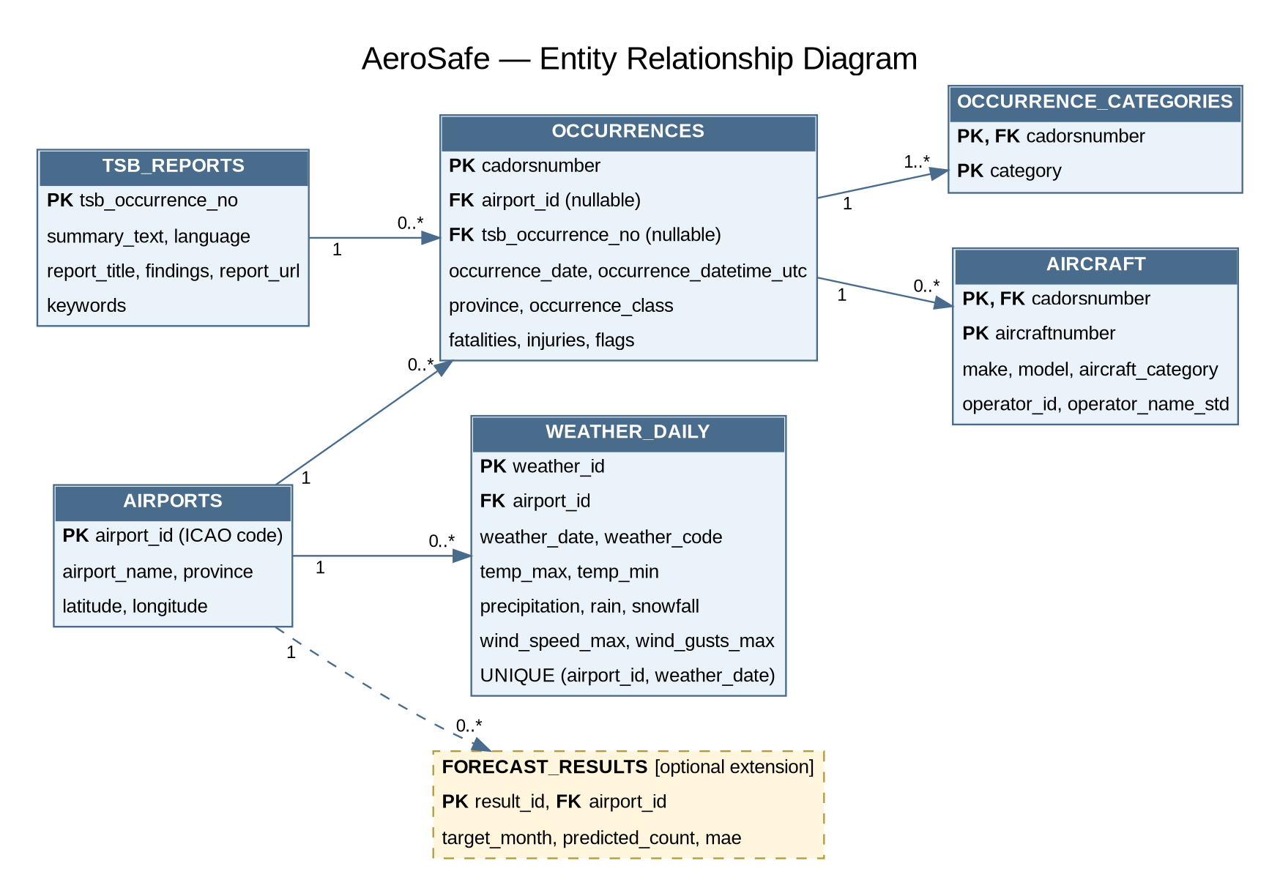
Figure 6.1: Entity relationship diagram

6.3 Database Relationships and Integrity
- One airport has many occurrences and many daily weather records. One occurrence has one or more categories and zero or more aircraft rows.
- Many occurrences can point to one TSB report. The link is optional, because only about 4% of occurrences carry a TSB number, and about 430 of those numbers are not in the TSB dataset. For those, the number is kept as text in tsb_number_raw and the foreign key stays empty, so no foreign-key rule is broken.
- The occurrence airport and TSB links are nullable, so records without an airport or a TSB number stay in the database and in the totals.
- WEATHER_DAILY has a UNIQUE constraint on (airport_id, weather_date), so a day is never stored twice for the same airport.
- CHECK constraints keep fatalities and injuries at zero or above. Indexes on cadorsnumber, airport_id, and the date columns keep filters fast.
- Every count in the analysis uses distinct cadorsnumber values, because one occurrence appears on many rows in the category, event, and aircraft files.

6.4 Analytical Data Preparation
Grouped counts (by year, month, province, category, aircraft category, and airport) are prepared as SQL views or summary tables, so Power BI does not have to join the large tables on every click. For the weather page, each of the five airports is expanded to every calendar day, occurrences are counted per day (including days with zero), and each day is joined to its weather record. For the optional extension, the same counts are summed by airport and month.

6.5 Data Flow Diagram
Figure 6.2 shows how the data moves from the four sources, through cleaning, linking, and storage, to analysis and the dashboard.
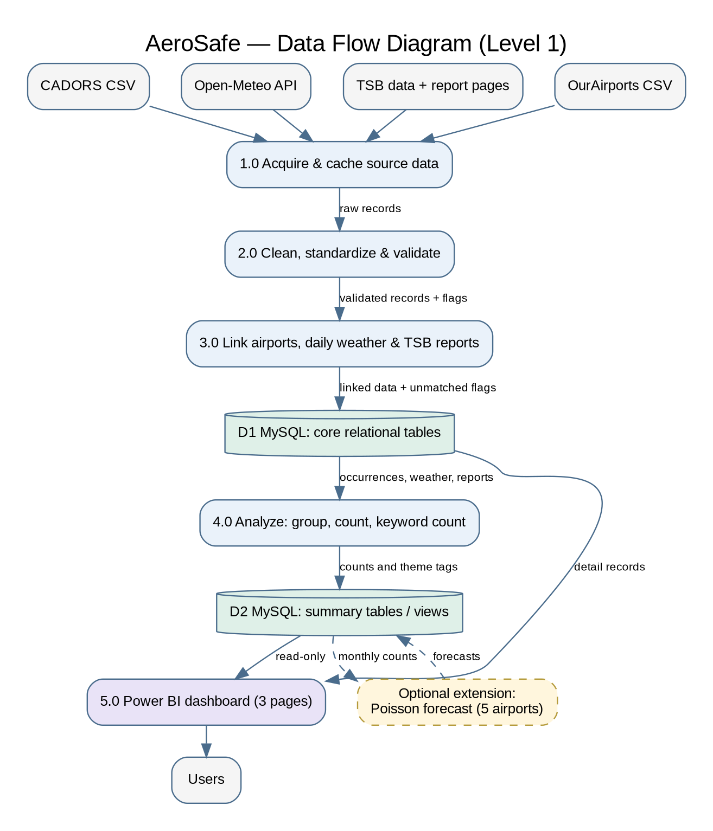
Figure 6.2: Data flow diagram (Level 1)

7. Component Design
AeroSafe has five core modules that turn raw data into the results shown on the dashboard, plus one optional extension.
Module | Function
Data Acquisition | Retrieve the CADORS files, OurAirports file, Open-Meteo daily weather, TSB occurrence data, and TSB report pages, and save each download.
Data Cleaning | Remove duplicates, standardize formats, convert times, and validate records.
Data Integration | Link occurrences to airports, daily weather, and TSB reports, and flag records that cannot be matched.
Analysis | Group and count occurrences in SQL, compare occurrences with daily weather, and count keywords in TSB text.
Visualization | Show the results in the three-page Power BI report.
Optional extension: Forecast | Fit a Poisson regression to monthly counts for the five airports (Algorithm 4).

7.1 Algorithms and Techniques
The methods are deliberately simple so they can be explained, tested, and repeated.
Technique | Used for | Module
Key-based duplicate detection | Removing duplicate records | Cleaning
Rule-based standardization by operator ID | Merging the many spellings of one operator name | Cleaning
UTC-to-local date conversion | Placing each occurrence on the same day as the weather record | Integration
Key lookup (hash join) | Attaching airport coordinates and TSB reports by key | Integration
Inner and left joins | Combining the MySQL tables without losing unmatched records | Integration, Analysis
Paginated crawling with a fixed delay | Collecting TSB report pages politely | Acquisition
HTML parsing | Extracting the text of TSB report pages | Acquisition
Retry with waiting (exponential backoff) | Staying inside Open-Meteo limits and surviving errors | Acquisition
Group-by aggregation | Counts by year, month, province, category, and airport | Analysis
Threshold binning | Labelling weather days (for example rain, snow, or strong wind) | Analysis
Keyword matching (regular expressions) | Tagging themes such as icing or loss of control in English and French | Analysis
Poisson regression (optional extension) | Estimating expected monthly counts | Forecast

7.2 Algorithmic Pseudocode
Algorithm 1: Data Cleaning and Integration
INPUT: CADORS tables, AirportReference (OurAirports), DailyWeather, TSBData
OUTPUT: Validated tables saved to MySQL, plus a cleaning report
BEGIN
FILTER occurrences to 2018-2025 AND (country = Canada OR country is blank)
REMOVE exact duplicate rows (and keep one TSB row per occurrence ID)
CONVERT fatalities and injuries to whole numbers
PARSE UTC date-time from date and time text (leave blank if invalid)
STANDARDIZE operator names using the operator ID
FOR EACH occurrence DO
IF aerodrome code EXISTS in AirportReference THEN
LINK airport
IF airport has DailyWeather THEN
IF UTC time EXISTS THEN
localDate <- ConvertToNewYorkDate(UTC time)
ELSE
localDate <- occurrence date
END IF
weather <- LookupWeather(airport, localDate)
IF weather EXISTS THEN LINK weather ELSE FLAG missing weather
ELSE
FLAG no weather coverage
END IF
ELSE
FLAG missing airport
END IF
IF TSB occurrence number EXISTS in TSBData THEN LINK TSB report ELSE keep the number in tsb_number_raw
END FOR
CHECK keys are unique AND no orphan rows AND dates are inside 2018-2025
SAVE tables TO MySQL
RECORD the number of rows removed or flagged at every step
END
Algorithm 2: Keyword Counting on TSB Text
INPUT: TSBReports (summary text and findings), KeywordList (English and French)
OUTPUT: Theme tags per report and theme counts
BEGIN
FOR EACH report IN TSBReports DO
text <- lowercase(summary text + findings)
FOR EACH theme IN KeywordList DO
IF any keyword of theme APPEARS IN text THEN
ADD theme TO report.keywords
END IF
END FOR
END FOR
FOR EACH theme IN KeywordList DO
count[theme] <- number of reports tagged with theme
END FOR
SAVE report.keywords AND count TO MySQL
END
Algorithm 3: Occurrence Counts and Weather Comparison
INPUT: Occurrences, Categories, Aircraft, DailyWeather (five airports)
OUTPUT: Summary tables for the dashboard
BEGIN
FOR EACH dimension IN [year, month, province, category, aircraft category, airport] DO
count[dimension] <- COUNT DISTINCT cadorsnumber GROUP BY dimension
END FOR
FOR EACH airport IN the five weather airports DO
FOR EACH day FROM 2018-01-01 TO 2025-12-31 DO
n <- number of occurrences at airport on day (0 if none)
weather <- DailyWeather(airport, day)
label <- BIN weather (rain, snow, strong wind, or none) using documented thresholds
SAVE airport, day, n, label
END FOR
END FOR
FOR EACH label IN [rain, snow, strong wind, none] DO
average[label] <- mean of n over days with that label
END FOR
SAVE counts AND averages AS summary tables
END
Algorithm 4 (Optional Extension): Monthly Occurrence Forecast
INPUT: Monthly occurrence counts and monthly weather summaries for the five airports
OUTPUT: Predicted monthly counts and error measures
BEGIN
AGGREGATE occurrences BY airport and month (include months with zero)
CREATE features: month of year, airport, weather summaries
TrainingData <- 2018-2023
ValidationData <- 2024
TestingData <- 2025
model <- TrainPoissonRegression(TrainingData)
FOR EACH data IN [ValidationData, TestingData] DO
predicted <- Predict(model, data)
MAE <- mean absolute error of predicted versus actual
RMSE <- root mean squared error of predicted versus actual
END FOR
SAVE predictions, MAE, and RMSE TO FORECAST_RESULTS
END

7.3 Future Work
Random Forest regression could be added as a comparison model for the optional forecast once there is more weather data (more airports, hourly values, or cloud cover). With weather for only five airports (about 480 airport-months), it is outside the scope of this project.

8. Constraints & Security
This section lists the limits the design must work within (hardware, performance, data, outside rules and delivery) and the safeguards that protect the data and the project. Each item is tied back to the requirements in the User Requirements and Analysis Document (D.4.1).

8.1 Hardware and Software Limits
Limit | Detail | Effect on the design
Memory | Target computer is a standard laptop with 8 GB of RAM. The five CADORS files are about 256 MB in total (the main occurrence file has 406,693 rows). | Files are read in chunks, only the needed columns are kept, and the data is cut down to 2018–2025 Canadian records early.
Run time | Data preparation must finish within 30 minutes (non-functional requirement 3; acceptance criterion 11). | Slow steps (weather download, web scraping) are run once, saved to files and not repeated in every run.
Software versions | Python 3.11 or newer, MySQL Server 8.0, Power BI Desktop, Git and GitHub. | Versions are listed in the README and a requirements.txt file so every teammate gets the same setup.
Power BI platform | Power BI Desktop runs only on Windows. | Dashboard work is done on a Windows computer (a teammate's PC or a university lab computer). The report is also delivered as a .pbix file and screenshots.
Local database | MySQL runs on one computer, with no cloud server. | The database is delivered as a SQL script (schema and data) that anyone can import. The dashboard shows the data as of the last refresh.
GitHub file size | GitHub rejects files over 100 MB and warns above 50 MB. The CADORS occurrence file is about 94 MB. | The repository stores the 2018–2025 cleaned subset (compressed if needed) and the download links for the original files, as the course asks for dataset sources.

8.2 Performance Bottlenecks
Bottleneck | Why it matters | How the design handles it
Weather API limits | Open-Meteo allows 600 calls per minute, 5,000 per hour and under 10,000 per day. Long date ranges count as several calls. Sending requests too fast returns a limit-exceeded error. | One airport per request, waits between requests, retry after a short pause, and every response saved to a file so it is never downloaded twice.
Web scraping speed | Every TSB report is a separate page, and the site must not be overloaded. | 1 to 2 seconds between requests; pages saved after the first download. Scraping is limited to the investigated occurrences (about 270 in classes 2 to 4 for 2018–2025), so the run is short.
Large CADORS files | Loading all five files at once could slow or crash an 8 GB laptop. | Chunked reading, selected columns, and early filtering.
Dashboard filters | Joining several large tables on every click can be slow (target: 10 seconds or less). | Indexes on the join keys (cadorsnumber, airport code, date), summary tables prepared in advance, and Import mode in Power BI.

8.3 Data Constraints
- Valid record count: of 406,693 raw CADORS rows, about 148,883 occurrences are Canadian (or have a blank country) and fall in 2018–2025. Only these are used.
- No coordinates and no narrative in CADORS: coordinates come from OurAirports and narrative text from the TSB ASIS dataset and report pages. The official CADORS metadata files could not be downloaded (the links no longer work), so the team writes its own data dictionary.
- Missing airport codes: about 20.7% of occurrences have no aerodrome ID. They stay in the totals, are flagged, and are left out of the map and weather pages. Of the 118,119 records that do have a code, 99.8% match OurAirports (27 of the 917 distinct codes do not). About 1.3% of records also have no province.
- Weather covers only five airports: Toronto, Calgary, Vancouver, Montréal and Edmonton. Together they hold about 13.7% of the 2018–2025 occurrences (480 airport-months), so weather findings apply only to these airports.
- Weather detail: the downloaded weather is daily, not hourly, and has no cloud cover. The requirements mention hourly values and cloud cover, so the team must either add them later or record this as a known limit. Weather files cover 2010–2025 but only 2018–2025 is used.
- Weather is an estimate: Open-Meteo gives modelled values for a grid cell around the airport, not readings from an airport weather station.
- Narrative text covers only some occurrences: the TSB ASIS dataset has a written summary for each of the 7,514 occurrences in 2018–2025 (about 690 characters on average), but only 6,055 CADORS records (4.1% of 148,883) carry a TSB number that links to one. Roughly 18% of the summaries are in French, so keyword lists are needed in English and French. ASIS lists some occurrences more than once (8,479 rows for 7,514 occurrences), so duplicates are removed. Its weather fields are filled for only about 6% of records, so Open-Meteo stays the weather source.
- Time alignment: CADORS times are in UTC, while the weather files use New York time for all five airports. Each occurrence time is converted to New York time before taking its date, so it lands on the same day boundary as the weather data.
- Known data errors: fatalities and injuries are stored as 0E-18 style numbers and are converted to whole numbers. About 28% of aircraft rows have no operator, and operator names are inconsistent, so they are standardized and flagged.
- Counting rule: one occurrence appears on many rows in the category, event and aircraft files, so every count uses distinct cadorsnumber values and not rows.
- Descriptive scope: the system shows what happened, where and when. It places weather beside occurrences but does not claim cause, and it shows raw counts, not rates (there is no flight-traffic data).

8.4 Outside Rules and Licences
Source | Rule and what the team does
Open-Meteo | Free use is under the CC BY 4.0 licence for non-commercial use only, so the project (a university course) qualifies. Credit is given in the dashboard footer and the README.
TSB website | The TSB terms and conditions allow reproducing its materials for non-commercial purposes, without charge or further permission, if the user (1) takes care that the material is accurate, (2) gives the full title and the author where available, and (3) states that it is a copy of the version at the original web address. The team follows these three conditions: each stored report keeps its title and URL, the dashboard links back to the original, and the footer credits the TSB. The terms also say that TSB findings do not assign fault or liability and are not made for legal proceedings, which matches the project's no-causation scope. The TSB publishes the ASIS dataset as is and states that the user must verify its accuracy and completeness, that some fields are left out for privacy, and that some occurrences were never validated by the TSB; this is repeated in the README and the dashboard notes. The team also reads robots.txt before scraping, uses polite delays, and collects only public report pages. If a page is not allowed, it is not scraped.
CADORS | Public data from the Canada Open Government Portal. The team follows the licence terms shown on the dataset page and credits Transport Canada.
OurAirports | Community-maintained open data (public domain), not an official source. This is stated as a limitation, and unmatched codes are flagged, not guessed.
University rules | All sources are cited and the work follows University of Windsor academic integrity policy.

8.5 Security Considerations
Risk | Safeguard
Passwords on GitHub | The repository is public, so passwords and keys are never committed. They sit in a local settings file listed in .gitignore, and the repository holds only a blank example file (.env.example). The repository is checked for secrets before submission, and any password found is changed at once.
Too much access | Python scripts use their own database account (not the root account). Power BI uses a separate read-only account, so the dashboard cannot change data.
Accidental data changes | Raw downloads are never edited. Cleaning scripts write new files, and the database can be rebuilt from the saved SQL script at any time.
Unsafe database commands | Scripts send values to MySQL through parameterised queries or SQLAlchemy and never build SQL from raw text. The dashboard only reads data.
Different versions on different computers | Package versions are pinned in requirements.txt, and every change is tracked in Git.
Privacy | The data is public and describes aircraft occurrences, not private individuals. No personal data is collected, and scraped text is used only for keyword counts.
Sharing the dashboard | The report and database script are shared only with the team, the instructor and the graders.

8.6 Delivery Risks
- Hosted application link: the D.4 instructions ask for a link where graders can run the application, preferably without installing anything. Publishing a Power BI report to the web usually needs a work or school Microsoft account, and a personal account may not be accepted. Plan: confirm with the instructor early; if online hosting is not possible, deliver the .pbix file, the SQL script, the README and a short screen recording of the dashboard.
- Team availability: a team member without Windows cannot open Power BI Desktop, so dashboard tasks are assigned to people with access.
- Scope drift: requirements and files must say the same thing (daily or hourly weather, years covered). Any change is recorded in the Revision History.

9. Design Rationale
This section explains why each technology, method and scope decision was chosen. Three ideas guided every choice: (1) use free, well-known tools that a team new to programming can learn in one term, (2) make every result repeatable and checkable, and (3) be honest about what the data can and cannot show. The course also asks that the project centre on core data analytics: acquiring, preparing, storing and visualizing data.

9.1 Technology Choices
Choice | Why it was chosen | Alternatives considered | Supports
Python (pandas, requests, BeautifulSoup) | Free, widely taught, and good at reading large CSV files, calling APIs and scraping web pages. The professor allows Python for data preparation. | Excel and OpenRefine alone (too slow for 400,000 rows and cannot call APIs) | FR 1, 2, 3, 7
OpenRefine (optional) | Helps profile and standardize text such as operator names before loading. | Doing all cleaning in Python | FR 2
MySQL 8.0 | The course prefers MySQL. It is free, keeps tables linked by keys, enforces rules, and connects to Power BI. | Loading CSV files straight into Power BI (allowed, but gives no database design, keys or integrity checks) | FR 3; NFR 1, 2
Power BI | Free desktop version, interactive maps and filters without coding, and a MySQL connector. It is on the professor's list. | Tableau, Apache Superset and KNIME (evaluated in the proposal; less familiar to the team or harder to set up) | FR 4, 5, 6, 8
Open-Meteo | Free, no sign-up key, history back to well before 2018, and requests by latitude and longitude. CC BY 4.0 licence. | Environment Canada station data (scattered across many stations and harder to match to airports) | FR 5
OurAirports | CADORS has no coordinates. This free file has coordinates and 99.8% of the airport codes that are present match. | Geocoding airport names (slower and less accurate) | FR 3, 5, 6
TSB ASIS dataset and report pages | The only source of narrative, because CADORS has no free text. The official ASIS CSV gives a summary for about 6,000 linked occurrences, and scraping the report pages adds findings for the investigated ones. It also meets the web-scraping requirement. | Scraping every report page alone (1,333 listed investigations; slower, and misses the summaries of minor occurrences) | FR 1, 7
GitHub | Required by the course. Holds code, documents and dataset notes in one place for graders. | GitLab (not required) | NFR 6
Jira (Kanban) | The team already knows it. It shows tasks, owners and deadlines for the project-management marks. | Hive and Asana (suggested alternatives) | Project management

9.2 Method Choices
- Exact-key joins: tables are linked on identical IDs (cadorsnumber, airport code, airport plus date). Exact matches are easy to test and give the same answer every time.
- Rule-based cleaning: clear rules (remove duplicates, fix dates and counts, flag missing airports) are easy to explain and review. Records that cannot be matched are flagged, never guessed.
- Counting distinct occurrences: counting cadorsnumber and not rows prevents double counting across the five files.
- Keyword counting on TSB text: counting key terms (for example icing or loss of control) is simple and fast, and fits roughly 6,000 short summaries. Keyword lists cover English and French. Heavier text methods need far more text.
- Saved, throttled and retried API calls: waiting between calls, saving each result and retrying after errors keeps the team inside Open-Meteo's limits.
- Grouping and counting in SQL and Power BI: trends, hotspots and categories need only counts and groups, so no complex model is needed. This keeps the project descriptive and focused on data acquisition and management.

9.3 Scope Decisions and Trade-offs
Decision | Reason | Trade-off
Years 2018–2025 | Records weather conditions that are more comparable and keeps the data size manageable on an 8 GB laptop. Recorded in Revision History version 3. | Fewer years for long-term trends.
Daily weather | Smaller files, fewer API calls and enough to compare weather days with occurrence counts. Already downloaded and checked for the five airports. | Cannot link weather to the exact hour of an occurrence.
Five airports with weather | The busiest hubs (Toronto, Calgary, Vancouver, Montréal, Edmonton) fit the API limits. | Weather results cover only about 13.7% of occurrences.
Descriptive analysis, no forecasting | Matches the course focus on core data analytics, the stated scope, and the small weather data set. | The system explains the past but does not predict.
CASA alerts left out | Keeps the scraper reliable and the project finishable on time. | The proposal's alert-timeline question is dropped.
Relational schema in MySQL | Shows database design (keys, constraints, indexes), which the course requires. | More setup work than reading CSV files directly.

9.4 Optional Extension
If time remains after the pipeline and dashboard work, a simple forecast of monthly occurrence counts (Poisson regression) could be tested on the five airports that have weather data. It is an extra and not a required deliverable, because the weather data covers only about 480 airport-months and the project scope is descriptive.

References
Canada Open Government Portal. Civil Aviation Daily Occurrence Reporting System (CADORS). Transport Canada. https://open.canada.ca/data/en/dataset/a348c1d1-2392-4595-b5e2-c6a244a7e87f

Open-Meteo. Historical weather API documentation. https://open-meteo.com/en/docs/historical-weather-api

OurAirports. Airport data (airports.csv). https://ourairports.com/data/

Transportation Safety Board of Canada. Aviation safety information system (ASIS) dataset and aviation investigation reports. https://www.tsb.gc.ca/eng/rapports-reports/aviation/index.html

Microsoft. Power BI Desktop. https://powerbi.microsoft.com/

Oracle. MySQL 8.0 and MySQL Workbench. https://dev.mysql.com/downloads/

Python Software Foundation. Python open-source libraries: pandas, NumPy, requests, BeautifulSoup, SQLAlchemy. https://www.python.org/

GitHub & Atlassian. GitHub code repository and Atlassian Jira Kanban task board. https://github.com/ ; https://www.atlassian.com/software/jira

Group 5. (2026, October). User requirements and analysis document (D.4.1). Odette School of Business, University of Windsor ; https://github.com/phani-lakkaraju/Aerosafe

