4-Bit ALU Using Verilog HDL

Introduction: A 4-bit Arithmetic Logic Unit (ALU) is a digital circuit that performs arithmetic and logical operations on two 4-bit inputs, A and B. The operation is selected using a 3-bit select signal. The design is implemented using Verilog HDL and simulated in Xilinx Vivado.

Design:The ALU performs the following eight operations based on the select input:
For any unspecified select value, the output is set to 4'b0000.
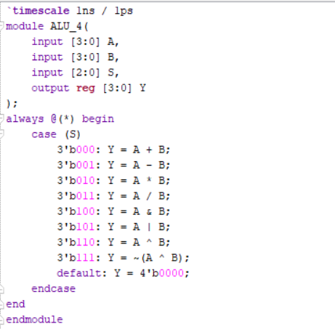

Testbench: A testbench is created to apply different input values to A and B and test all eight operations. The output is checked against the expected result for each select signal.

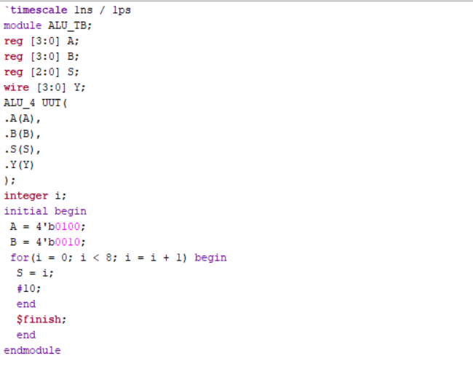

Waveform: The simulation waveform displays inputs A and B, the select signal, and output Y. It is used to verify the arithmetic and logical operations.

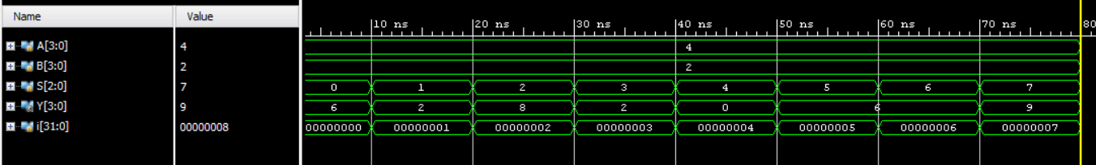

Schematic: The RTL schematic shows the ALU design and its internal logic connections between the inputs, operation-selection logic, and output.

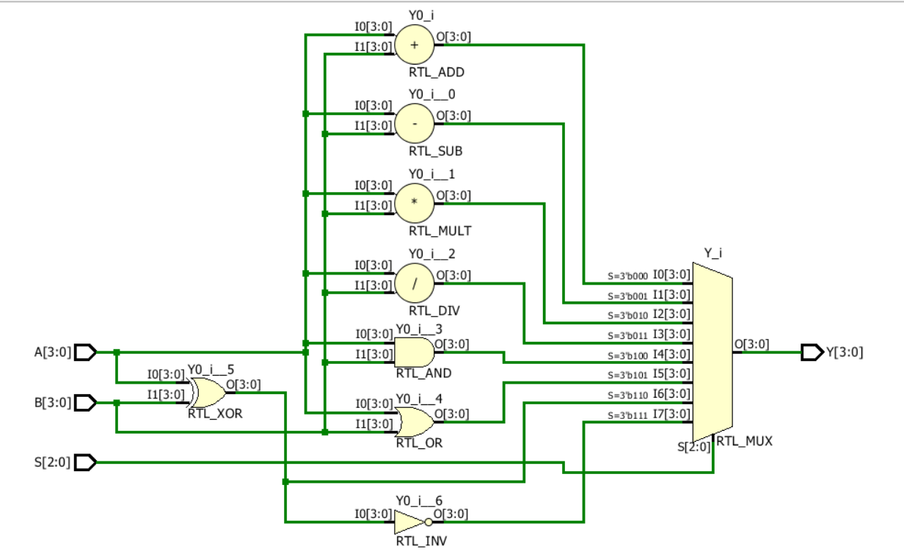

Observation: The 4-bit ALU performs the selected arithmetic and logical operations according to the 3-bit select signal. The simulation waveform is used to verify the output for each operation.

#PHANEENDRA.SINGUDASU

