Day 51 – Basic Gates Using DEMUX

1. NOT Gate Using DEMUX
Design: The NOT gate is implemented using a DEMUX by connecting the input variable to the select line and setting the data input to logic HIGH.
Boolean Expression: Y = A'
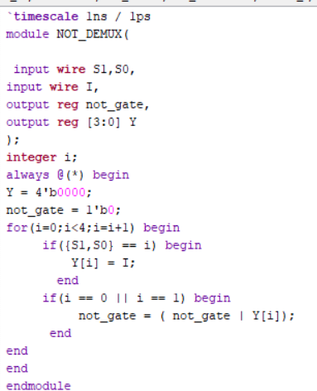
Testbench: The testbench applies both possible input values to verify the NOT gate operation.
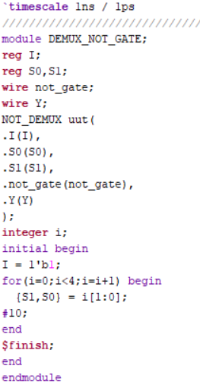
Waveform: The waveform verifies that the output is the complement of the input.
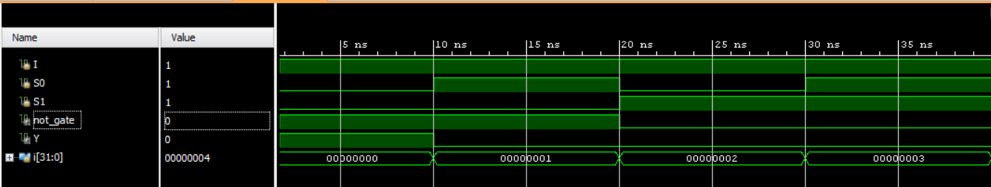
Schematic: The RTL schematic of the NOT gate implemented using DEMUX is generated using Xilinx Vivado.
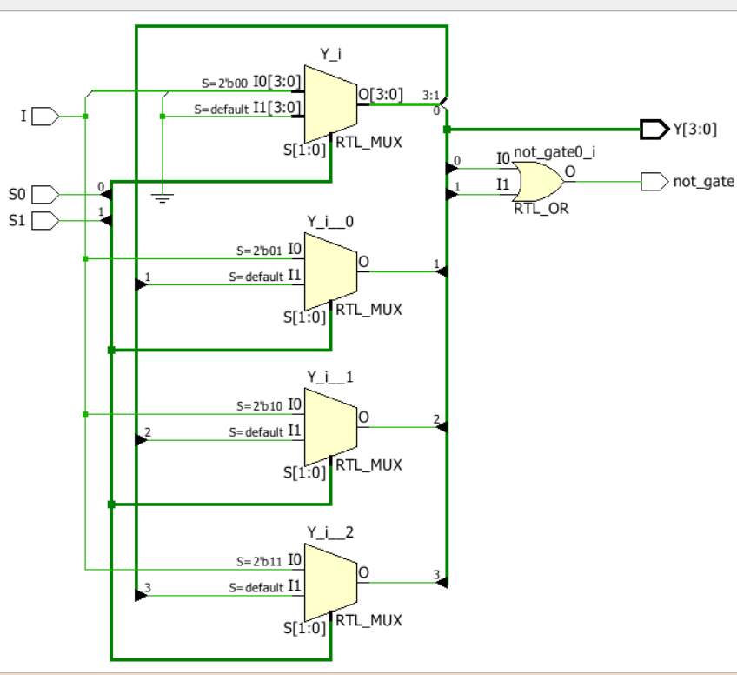

2. AND Gate Using DEMUX
Design: The AND gate is implemented using a DEMUX by connecting A and B to the select lines and selecting the output corresponding to A = 1 and B = 1.
Boolean Expression: Y = A · B;
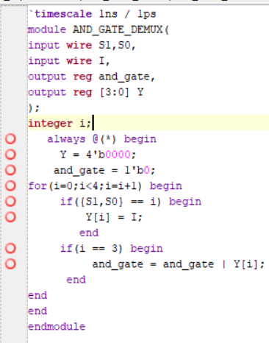
Testbench: The testbench applies all four possible input combinations of A and B.
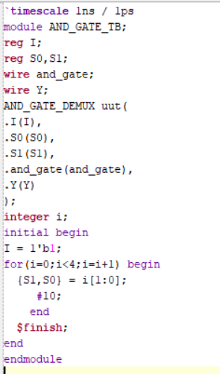

Waveform: The waveform verifies that the output is HIGH only when both inputs are HIGH.
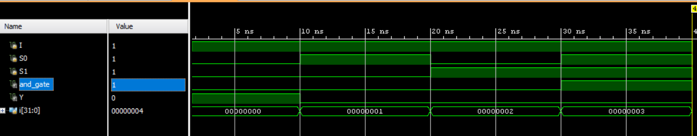
Schematic: The RTL schematic of the AND gate implemented using DEMUX is generated using Xilinx Vivado.
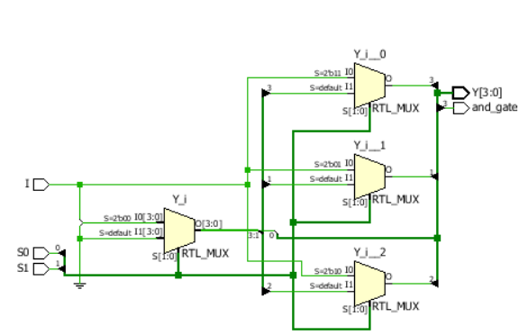

3. OR Gate Using DEMUX
Design: The OR gate is implemented using a DEMUX by connecting A and B to the select lines and combining the outputs corresponding to at least one input being HIGH.
Boolean Expression: Y = A + B;
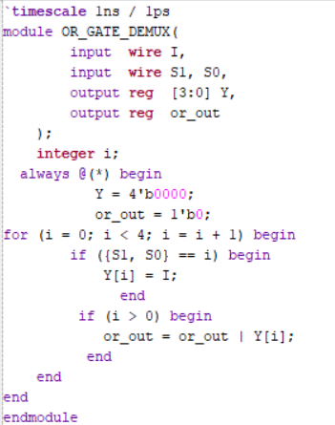
Testbench: The testbench applies all four possible input combinations of A and B.
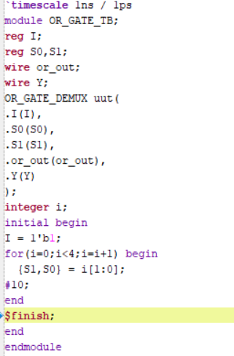

Waveform: The waveform verifies that the output is HIGH when at least one input is HIGH.
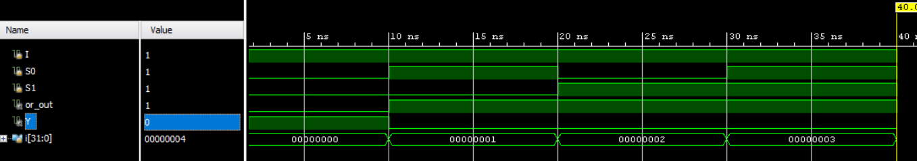
Schematic: The RTL schematic of the OR gate implemented using DEMUX is generated using Xilinx Vivado.
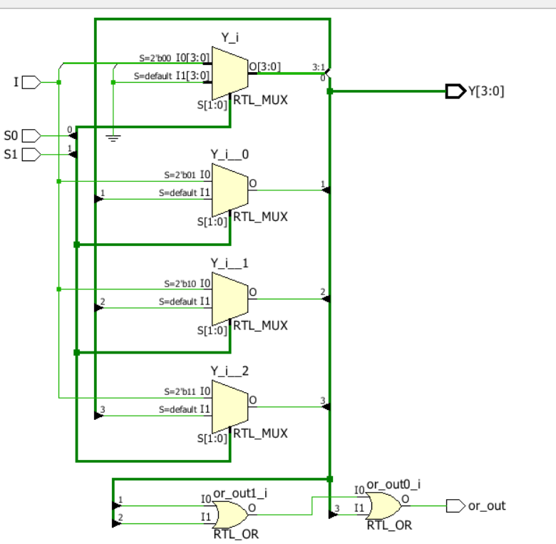

Observation
The basic logic gates were implemented using DEMUX and verified through simulation. The outputs were checked against their respective Boolean expressions.
#PHANEENDRA.SINGUDASU

