Day 56: Implementation of 256:1 MUX Using 2:1 MUX

Introduction A 256:1 Multiplexer selects one input from 256 input lines based on 8 select lines. It can be implemented using multiple 2:1 multiplexers.

Design:
- Inputs: 256 data inputs (I[255:0])
- Select lines: 8 (S[7:0])
- Output: 1 bit (Y)
- Basic component: 2:1 MUX
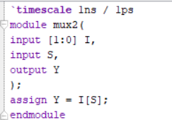

Working Principle: The 256:1 MUX is constructed using 255 2:1 multiplexers arranged in 8 stages.
- Stage 1: 128 MUXes ,Stage 2: 64 MUXes
Stage 3: 32 MUXes
- Stage 4: 16 MUXes
- Stage 5: 8 MUXes
- Stage 6: 4 MUXes
- Stage 7: 2 MUXes
- Stage 8: 1 MUX
The select lines determine which input reaches the final output.
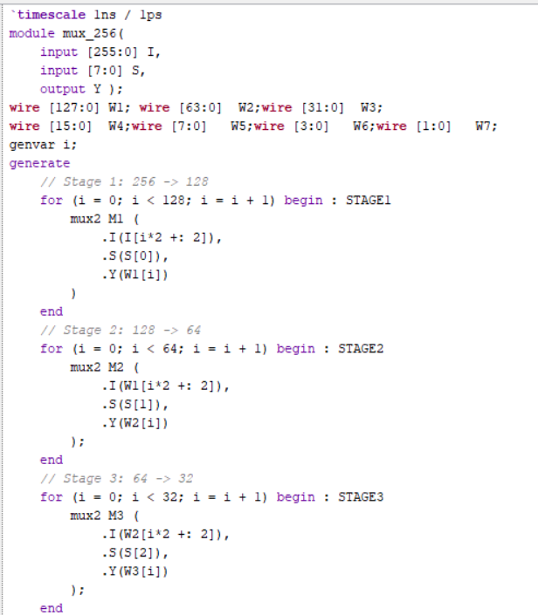
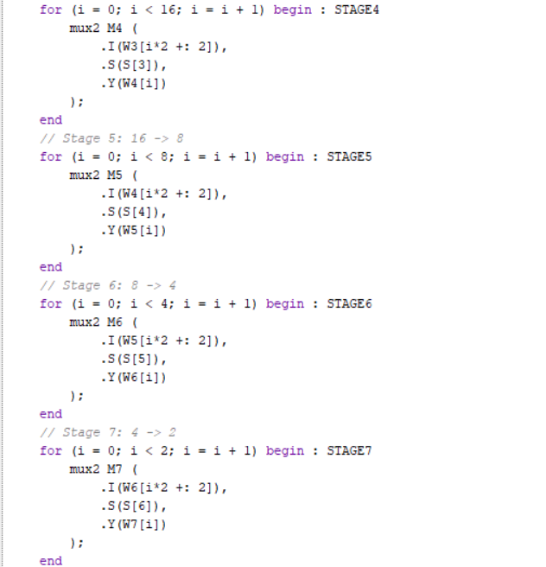
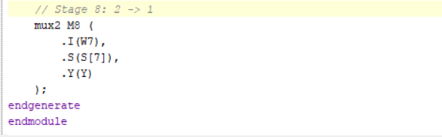

Testbench
A testbench is used to apply different input patterns and select-line combinations to verify the output.
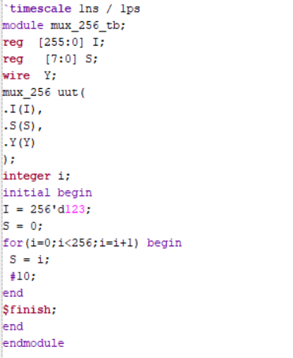
WAVEFORM:
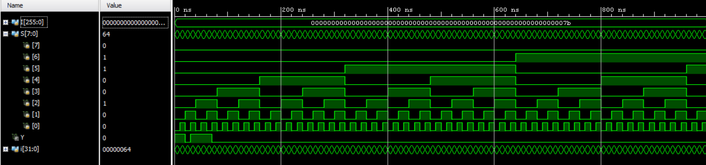

SCHEMATIC:
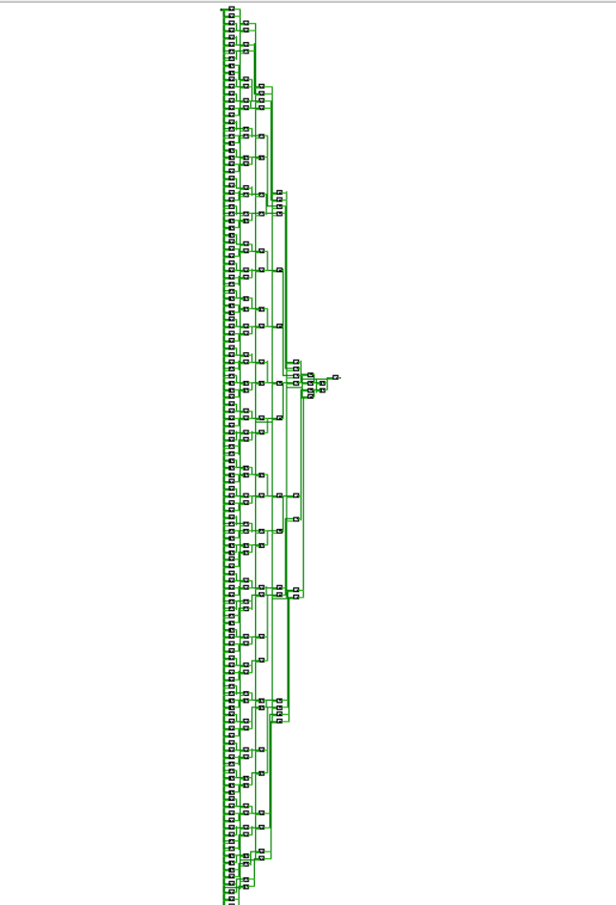

Observation: The 256:1 MUX successfully selects one of the 256 inputs using 8 select lines and can be constructed using 255 2:1 MUXes.

#PHANEENDRA.SINGUSAU

