Node JS
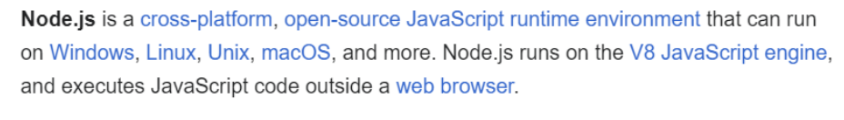
- Node.js is a JavaScript runtime built on Chrome's V8 JavaScript engine.
- It is maintained by the OpenJS Foundation.
- Node.js allows JavaScript to be executed outside of a web browser.
This means that while JavaScript is traditionally associated with the web and browsers, Node.js extends its reach, allowing you to run JavaScript code on servers, desktops, and even embedded systems. This is why Node.js is often described with the phrase "Run JavaScript Everywhere."
- Node.js features an event-driven architecture and supports asynchronous I/O (non-blocking I/O).
Q: What is a server?
A server is essentially a remote computer. You can think of it as a computer whose CPU works remotely.
Servers can be accessed over a network to provide resources and services to other computer programs.
A server is a computer or system that provides data, services, resources, or programs to other computers, known as clients, over a network.
Behind the scenes, when a computer needs to communicate with a server, it sends a request to the server using its IP address. Initially, JavaScript could only be executed within web browsers, limiting its use to client-side tasks. However, with the introduction of Node.js, JavaScript can now also be executed on servers, allowing developers to use the same language for both client-side and server-side programming
What is v8?
- The V8 JavaScript engine is written in C++.
- V8 can be embedded into any C++ program, which is a crucial feature
- The process works as follows: JavaScript code is executed by V8 (written in C++), which then compiles it down to machine code that the computer can execute.

NODEJS is a c++ application with v8 embedded into it

Module Export & Requirements.
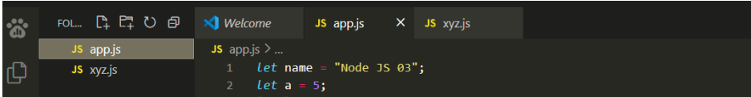

These two files, app.js and xyz.js, have different code that is not related to each other, so in NodeJS we call them separate modules.
Q: How do you make two modules work together?
-using a require function
Q: What is the required function?
In Node.js, the require() function is a built-in function that allows you to include or require other modules into your main modules.

Now, let's write our code using the require function.

Task: Our objective is to execute the code written in the xyz.js module by running the app.js module.
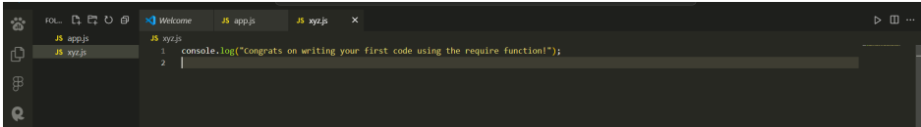
Steps:
1. Open the app.js module.
2. First, include the xyz module using the require function.
3. Then, run the code using Node.js.
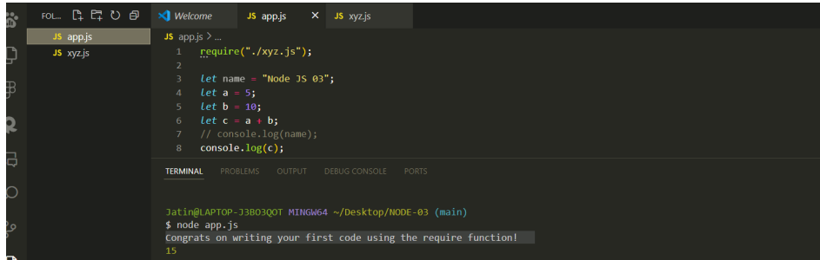

Q: If I write a function in another module, can I use that function in a different module? Will it work or not?
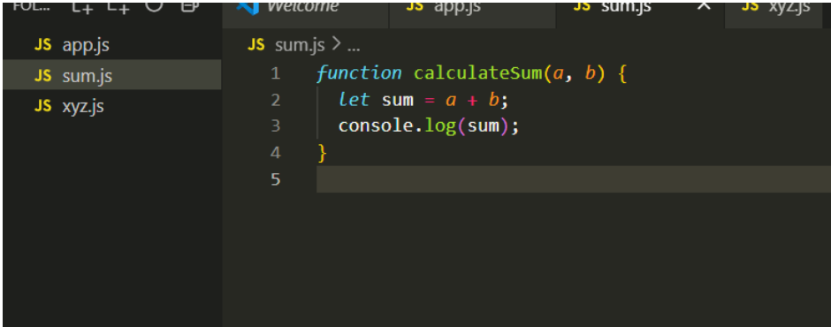
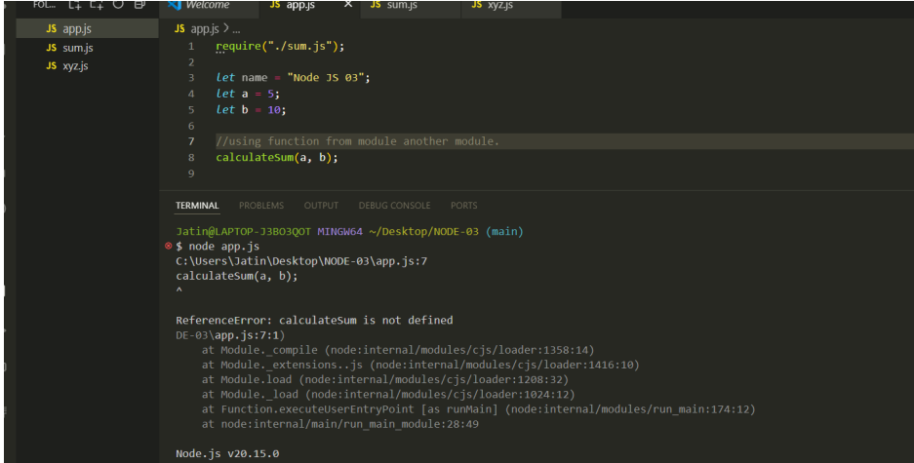
Ans: It will not work 🤯
Reason(very Imp): Modules protect their variables and functions from leaking by default.
So, how do we achieve that?
We need to export the function using with module.exports
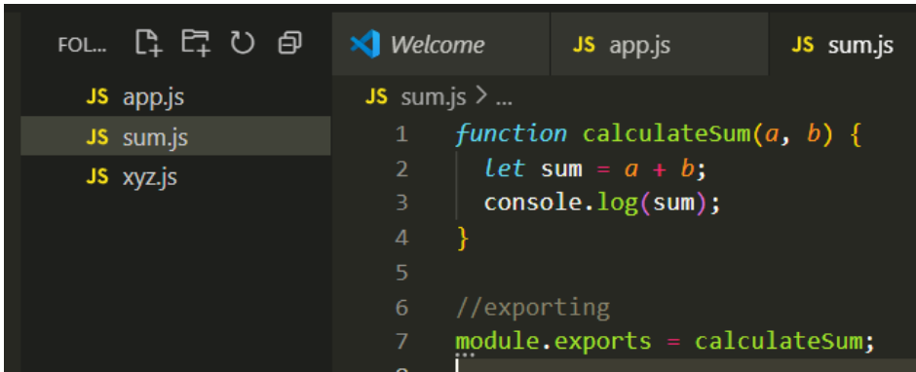
You also need to import.
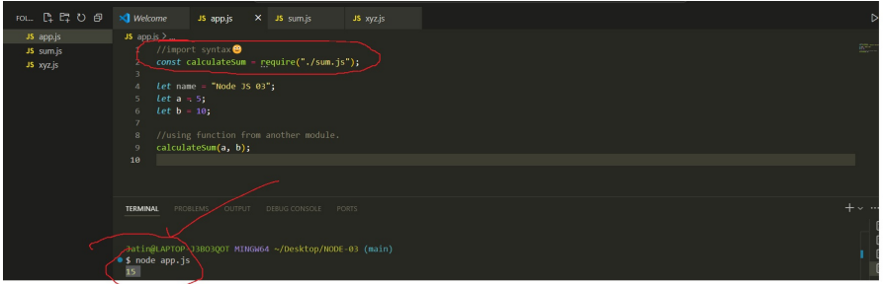

Libuv
- Node.js is popular just because of libuv
- libuv plays a critical role in enabling Node.js's high performance and scalability. It provides the underlying infrastructure for asynchronous I/O, event handling, and cross-platform compatibility

Q: What is Thread?
A thread is the smallest unit of execution within a process in an operating system. It represents a single sequence of instructions that can be managed independently by a scheduler. Multiple threads can exist within a single process, sharing the same memory space but executing independently. This allows for parallel execution of tasks within a program, improving efficiency and responsiveness.
Threads can be either:
- Single-threaded
- Multi-threaded
Q: What type of threading does JavaScript use?
- JavaScript is a synchronous, single-threaded language, meaning there is only one thread in which the JavaScript engine (such as the V8 engine) runs. In JavaScript, code is executed line by line within this single thread.
- In other languages like C++ or Java, code can be executed across multiple threads. For example, a portion of the code might be executed in one thread, while another part runs simultaneously in a different thread. However, JavaScript handles this process more straightforwardly—executing code one line after the other in sequence.

Synchronous vs Asynchronous JavaScript
Q: What is a Synchronous System?
In a synchronous system, tasks are completed one after another
Q: What is an Asynchronous System?
In this system, tasks are completed independently.
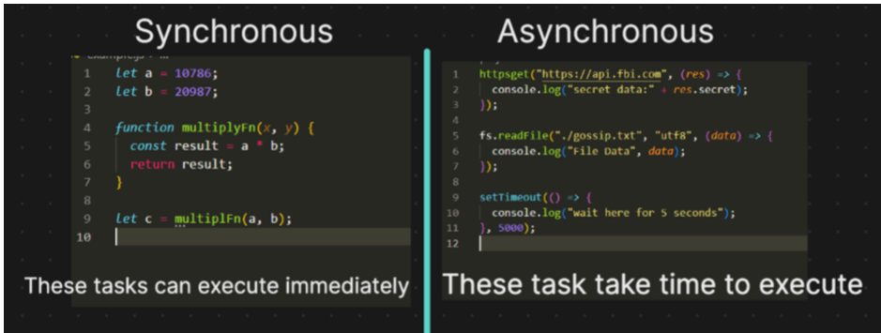
Q: what are the portions inside the JS engine and How synchronous code is executed By JS Engine ?
- The JavaScript engine operates with a single call stack, and all the code you write is executed within this call stack. The engine runs on a single thread, meaning it can only perform one operation at a time.
- In addition to the call stack, the JavaScript engine also includes a memory heap. This memory heap stores all the variables, numbers, and functions that your code uses.
- One key feature of the JavaScript V8 engine is its garbage collector. The garbage collector automatically identifies and removes variables that are no longer in use, freeing up memory. Unlike languages like C++, where developers need to manually allocate and deallocate memory, JavaScript handles this process automatically. This means you don't have to worry about memory management—it's all taken care of by the engine.
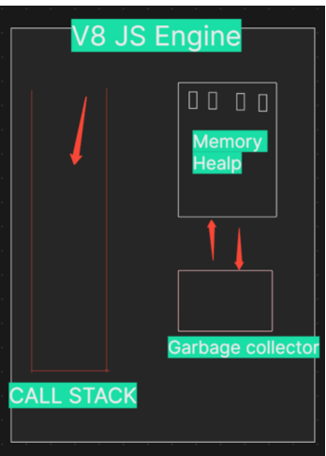
Now, lets see how code is executed inside
Step 1: Global Execution Context Creation
As soon as the JavaScript engine begins executing the code, it creates a Global Execution Context. This is the main environment where the top-level code is executed. The global execution context is unique and is always the first to be pushed onto the call stack.
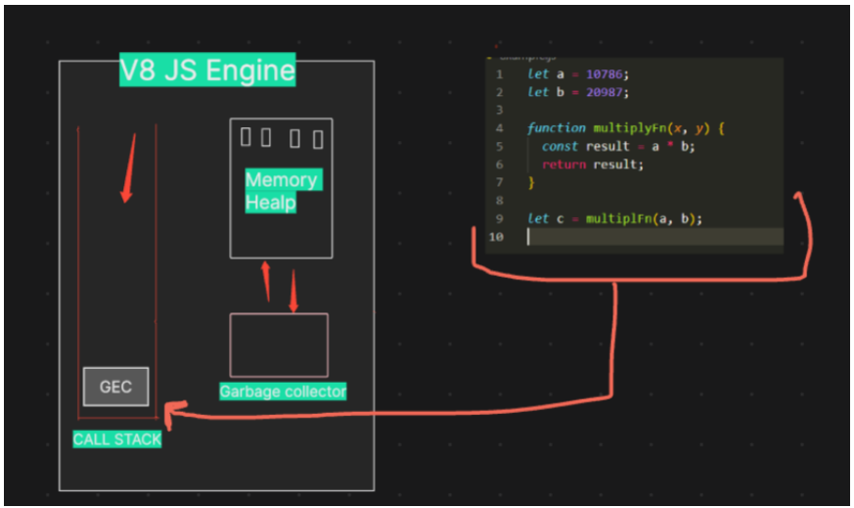
Step 2: Memory Creation Phase
Before any code is executed, the JavaScript engine enters the memory creation phase. During this phase: Variables a and b are declared in memory and initialized to undefined . The function multiplyFn is also stored in memory, with its value set to the entire function definition.
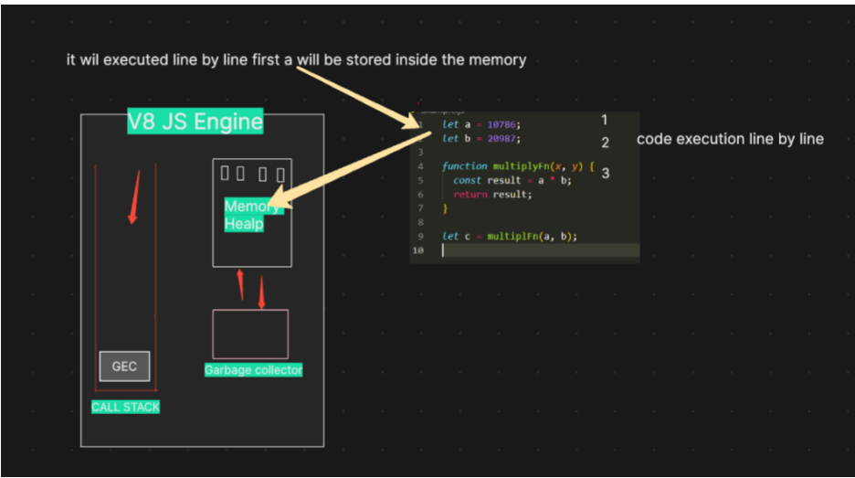
Step 3: Code Execution Phase
Once the memory creation phase is complete, the engine moves to the code execution phase:
- Execution of let a = 10786; and let b = 20987; : The variables a and b are now assigned their respective values.
- Execution of let c = multiplyFn(a, b); : The function multiplyFn is invoked, creating a new execution context specifically for this function
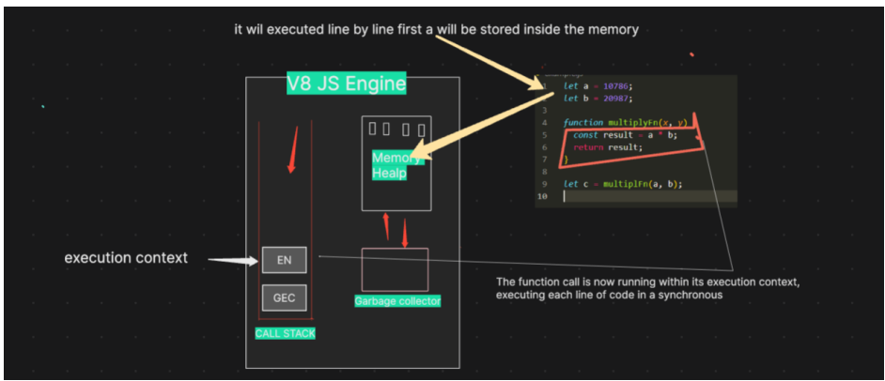

Step 4: Function Execution Context Creation
When multiplyFn(a, b) is called, the JavaScript engine:
- Creates a new execution context for multiplyFn and pushes it onto the top of the call stack.
- In this new context, the parameters x and y are assigned the values of a and b .
Step 5: Memory Creation and Code Execution Inside multiplyFn
Inside multiplyFn , the memory creation phase initializes result in memory with undefined .
- Execution of const result = a * b; : The multiplication is performed, and result is assigned the value 226215682 .
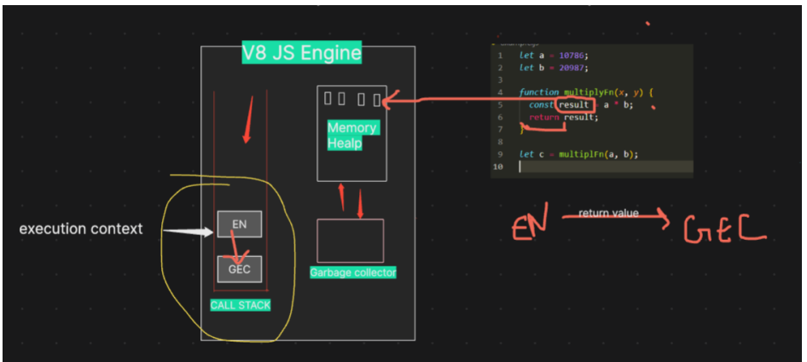
- Execution of return result; : The function returns 226215682 , and the multiplyFn execution context is popped off the call stack
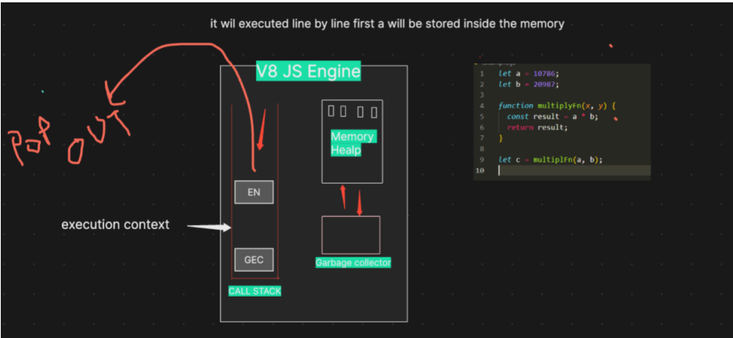
Step 6: Resuming Global Execution Context
Back in the global execution context, the returned value from multiplyFn ( 226215682 ) is assigned to the variable c .
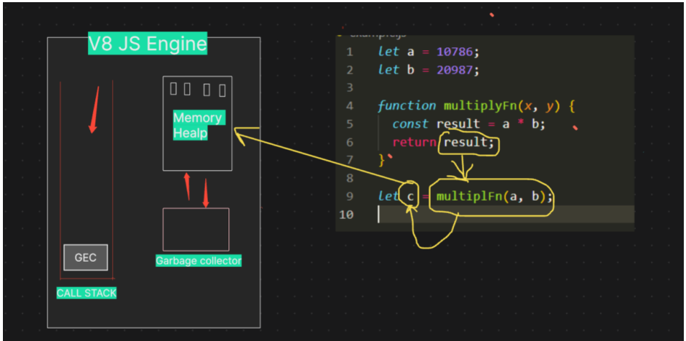
Step 7: Once the entire code is executed, the global execution context is also popped out, and the call stack becomes empty.

Q: How asynchronous code executed?
The JavaScript engine cannot do this alone; it needs superpowers. This is where Node.js comes into the picture, giving it the ability to interact with operating system functionalities.
The JS engine gains its superpowers from Node.js. Node.js grants these powers through a library named Libuv—our superhero
The JS engine cannot directly access OS files, so it calls on Libuv. Libuv, being very cool and full of superpowers, communicates with the OS, performs all the necessary tasks, and then returns the response to the JS engine. He offloads the work and does wonders behind the scene
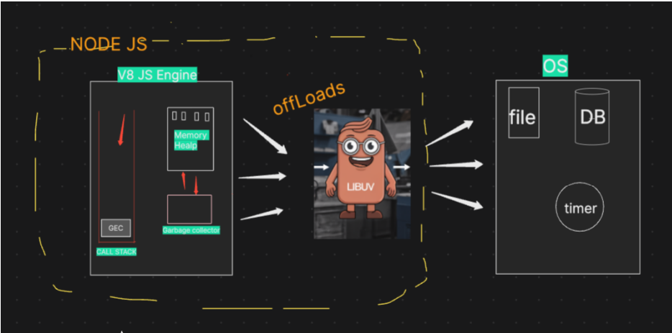
- The variables let a and let b are executed within the GEC (Global Execution Context) during the synchronous phase of the code execution process.
- However, when the code encounters an API call, the V8 engine, while still operating within the GEC, recognizes that it's dealing with an asynchronous operation. At this point, the V8 engine signals libuv —the superhero of Node.js —to handle this API call.
- What happens next is that libuv registers this API call, including its associated callback function (name - A), within its event loop, allowing the V8 engine to continue executing the rest of the code without waiting for the API call to complete.
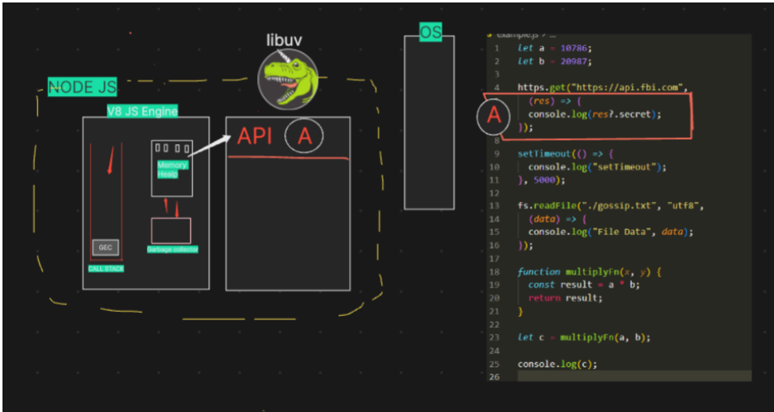
- Next, when the code encounters a setTimeout function, a similar process occurs.
- The V8 engine identifies this as another asynchronous operation and once again notifies libuv .
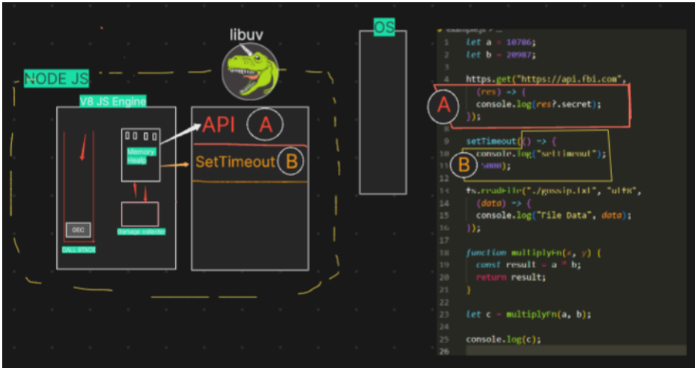
- Following this, when the code reaches a file operation (like reading or writing a file), the process is similar.
- The V8 engine recognizes this as another asynchronous task and alerts libuv .
- libuv then registers the file operation and its callback in the event loop.
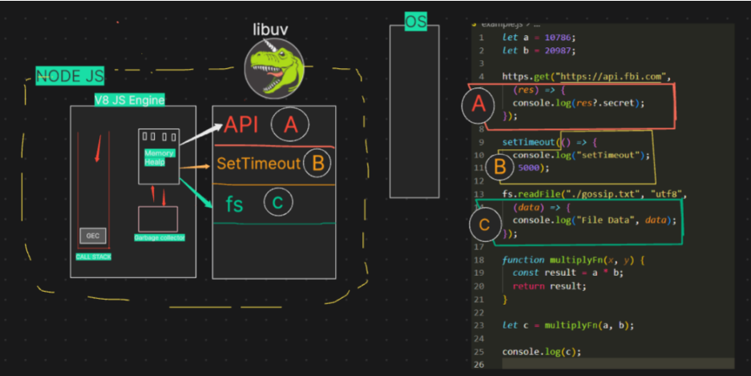
Next, when the code executes let c = multiplyFn(a, b); , the JavaScript engine creates a new function context for multiplyFn and pushes it onto the call stack.
The function takes two parameters, x and y , and within the function, the engine multiplies these values ( a * b ) and stores the result in the result variable.
The JavaScript engine handles this operation as part of the synchronous code execution
Next, when the code executes let c = multiplyFn(a, b); , the JavaScript engine creates a new function context for Episode-06 | libuv & async IO 24 multiplyFn and pushes it onto the call stack.
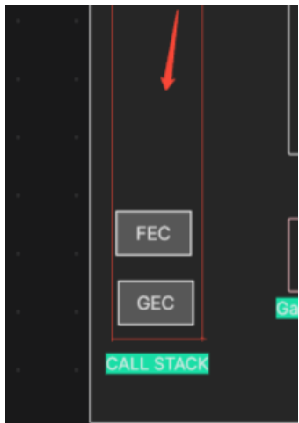
Once the multiplyFn completes its execution and returns the result, the function context is popped off the call stack, and the result is assigned to the variable c
imp concept :
- When the function execution context is popped off the call stack, the garbage collector may clear any memory allocated for that context in the memory heap, if it is no longer needed.
- After console.log(c) is executed and the value of c is printed to the console, the global execution context will also eventually be removed from the call stack if the code execution is complete.
- With the global context popped off the call stack, the JavaScript engine has finished processing, and the program ends.
- Now the call stack becomes empty, the JavaScript engine can relax, as there is no more code to execute.
- At this point, libuv takes over the major tasks. It handles operations such as processing timers, managing file system calls, and communicating with the operating system.
- libuv performs these heavy tasks in the background, ensuring that asynchronous operations continue to be managed effectively.
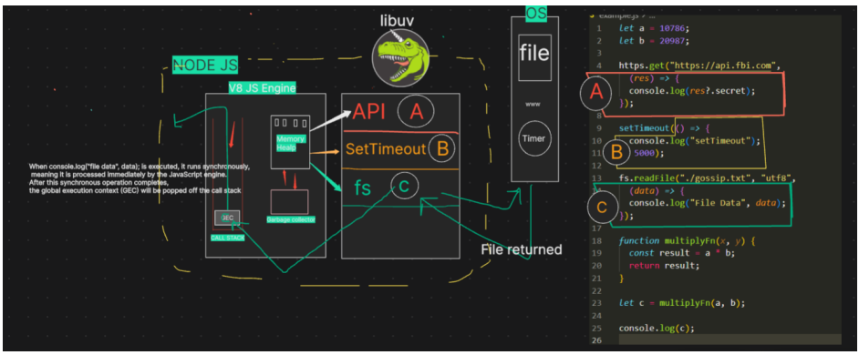
In summary, Node.js excels in handling asynchronous I/O operations, thanks to its non-blocking I/O model.
- As a developer, it’s important to understand that while Node.js and the V8 engine give you the capability to block the main thread using synchronous methods, this is generally not recommended.
- Synchronous methods like fs.readFileSync() are still available in Node.js, but using them can cause performance issues because the code execution will be halted at that point (e.g., line 7) until the file reading operation is complete.
- Avoid using synchronous methods in production code whenever possible, especially in performance-critical applications, because they can slow down your application by blocking the event loop.
- Instead, use asynchronous methods like fs.readFile() that allow other operations to continue while the file is being read, keeping the application responsive.

libuv & Event Loop
diving into the core of Node.js's asynchronous handling with libuv .
Understanding how libuv manages the event loop, callback queues, and thread pools is crucial, especially for non-blocking I/O tasks.
The event loop in libuv is the heart of how Node.js handles asynchronous operations. It allows Node.js to perform non-blocking I/O operations, even though JavaScript is single-threaded. Tasks that are offloaded to libuv include file system operations, DNS lookups, and network requests, among others.
The callback queue is where callbacks are stored after an asynchronous operation is completed. The event loop processes this queue to execute the callbacks when the call stack is empty.
The thread pool, on the other hand, is used for handling more time-consuming tasks that cannot be handled within the event loop without blocking it, such as file system operations or cryptographic functions.
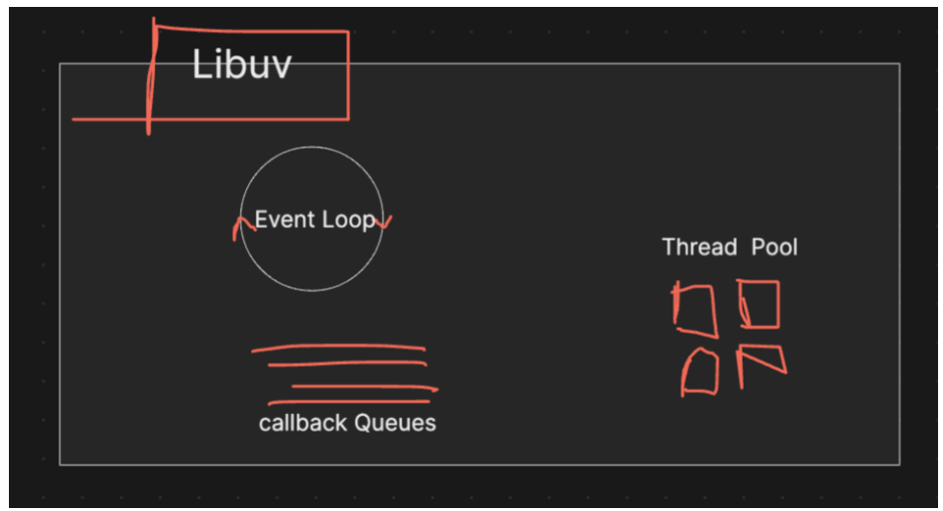
When a task is offloaded to libuv , libuv internally performs several operations. For instance, if you initiate a file read operation, once the data is received back from the operating system (OS), it is libuv 's responsibility to handle the callback function and eventually send it to the call stack for execution.
Now, imagine there are millions of lines of JavaScript code running within the JavaScript engine. If an asynchronous task like an API call returns data very quickly from the OS to libuv , that API call must wait in the callback queue within libuv until the V8 engine is free to process it. This ensures that the non-blocking nature of Node.js is maintained, as the V8 engine can continue executing other code without being blocked by these asynchronous operations
So, let's say multiple asynchronous tasks, like an API call returning results, a setTimeout , and a file read operation, are completed simultaneously. To manage this, libuv maintains separate callback queues for different types of tasks, such as timers, API calls, and file reads.
This is where the event loop comes into play. The event loop continuously monitors the call stack, checking if it's empty. If the stack is empty, the event loop Episode-09 | libuv & Event Loop 5 takes tasks from the callback queues and pushes them onto the call stack for execution.
The event loop's main responsibility is to ensure that all pending tasks in the callback queues are executed at the appropriate time and in the correct order of priority. But how does the event loop prioritize these tasks? How does it manage the timing and efficient execution of tasks behind the scenes?
Let's take a closer look at what happens internally inside the event loop
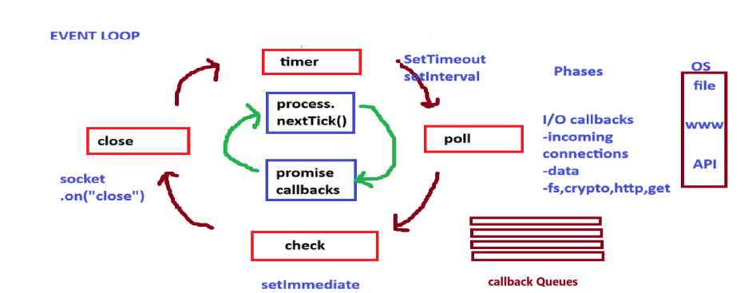
The event loop in LIBUV operates in four major phases:
- Timers Phase: In this phase, all callbacks that were set using setTimeout or setInterval are executed. These timers are checked, and if their time has expired, their corresponding callbacks are added to the callback queue for execution.
- Poll Phase: After timers, the event loop enters the Poll phase, which is crucial because it handles I/O callbacks. For instance, when you perform a file read operation using fs.readFile , the callback associated with this I/O operation will be executed in this phase. The Poll phase is responsible for handling all I/Orelated tasks, making it one of the most important phases in the event loop.
- Check Phase: Next is the Check phase, where callbacks scheduled by the setImmediate function are executed. This utility API allows you to execute callbacks immediately after the Poll phase, giving you more control over the order of operations.
- Close Callbacks Phase: Finally, in the Close Callbacks phase, any callbacks associated with closing operations, such as socket closures, are handled. This phase is typically used for cleanup tasks, ensuring that resources are properly released.
Event Loop Cycle with process.nextTick() and Promises [very important]
Before the event loop moves to each of its main phases (Timers, I/O Callbacks, Episode-09 | libuv & Event Loop 8 Poll, Check, and Close Callbacks), it first processes any pending microtasks. Microtasks include tasks scheduled using process.nextTick() and Promise callbacks. This ensures that these tasks are handled promptly before moving on to the next phase.
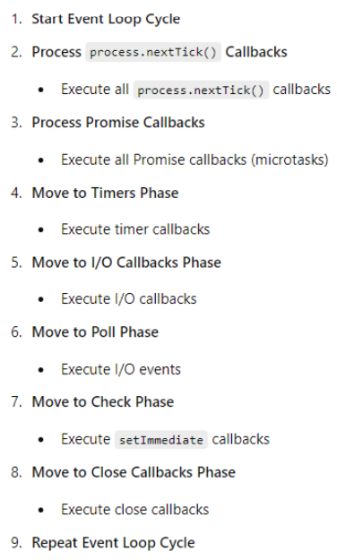
When the event loop is empty and there are no more tasks to execute, it enters the poll phase and essentially waits for incoming events
Thread pool in libuv
Whenever there's an asynchronous task, V8 offloads it to libuv. For example, when reading a file, libuv uses one of the threads in its thread pool. The file system (fs) call is assigned to a thread in the pool, and that thread makes a request to the OS. While the file is being read, the thread in the pool is fully occupied and cannot perform any other tasks. Once the file reading is complete, the engaged thread is freed up and becomes available for other operations. For instance, if you're performing a cryptographic operation like hashing, it will be assigned to another thread. There are certain functions for which libuv uses the thread pool.
In Node.js, the default size of the thread pool is 4 threads:
Now, suppose you make 5 simultaneous file reading calls. What happens is that 4 file calls will occupy 4 threads, and the 5th one will wait until one of the threads is free
Q: When does libuv use the thread pool?
Whenever you perform tasks like file system (fs) operations, DNS lookups (Domain Name System), or cryptographic methods, libuv uses the thread pool.

Is Node.js single threaded or multi-threaded?
If you're dealing with synchronous code, Node.js is single-threaded. But if you're dealing with asynchronous tasks, it utilizes libuv's thread pool, making it multithreaded. the order of execution is not guaranteed over here which thread executes first will win
Q: Can you change the size of the thread pool?
Yes, you can change the size of the thread pool by setting the UV_THREADPOOL_SIZE environment variable. For example, you can set it to 8 like this.
Q: Suppose you have a server with many incoming requests, and users are hitting APIs. Do these APIs use the thread pool?
No
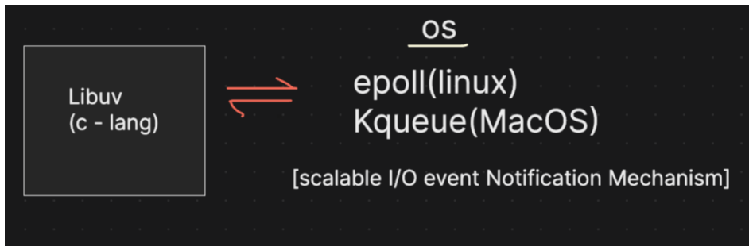
In the libuv library, when it interacts with the OS for networking tasks, it uses sockets. Networking operations occur through these sockets. Each socket has a socket descriptor, also known as a file descriptor (although this has nothing to do with the file system).
When an incoming request arrives on a socket, and you want to write data to this connection, it involves blocking operations. To handle this, a thread is created for each request. However, creating a separate thread for each connection is not practical, especially when dealing with thousands of requests.
Instead, the system uses efficient mechanisms provided by the OS, such as epoll (on Linux) or kqueue (on macOS). These mechanisms handle multiple file descriptors (sockets) without needing a thread per connection.
Here’s how it works:
- epoll (Linux) and kqueue (macOS) are notification mechanisms used to manage many connections efficiently.
- When you create an epoll or kqueue descriptor, it monitors multiple file descriptors (sockets) for activity.
- The OS kernel manages these mechanisms and notifies libuv of any changes or activity on the sockets.
- This approach allows the server to handle a large number of connections efficiently without creating a thread for each one.
The kernel-level mechanisms, like epoll and kqueue , provide a scalable way to manage multiple connections, significantly improving performance and resource utilization in a high-concurrency environment.
File Descriptors (fds) and Socket Descriptors
File Descriptors (FDs) are integral to Unix-like operating systems, including Linux and macOS. They are used by the operating system to manage open files, sockets, and other I/O resources.
Socket descriptors are a special type of file descriptor used to manage network connections. They are essential for network programming, allowing processes to communicate over a network
Event Emitters
Event Emitters are a core concept in Node.js, used to handle asynchronous events. They allow objects to emit named events that can be listened to by other parts of the application. The EventEmitter class is provided by the Node.js events module. Here's a brief overview:
- Creating an EventEmitter: You create an instance of EventEmitter and use the on method to register event listeners.
- Emitting Events: Use the emit method to trigger events and pass data to listeners.
- Handling Events: Listeners (functions) handle the emitted events and perform actions based on the event data.
Streams
Streams in Node.js are objects that facilitate reading from or writing to a data source in a continuous fashion. Streams are particularly useful for handling large amounts of data efficiently.
Buffers
Buffers are used to handle binary data in Node.js. They provide a way to work with raw memory allocations and are useful for operations involving binary data, such as reading files or network communications.

Pipes in Node.js
Pipes in Node.js are a powerful feature for managing the flow of data between streams. They simplify the process of reading from a readable stream and writing to a writable stream, facilitating efficient and seamless data processing.

Core module in Node js
The Built-in HTTP Module
Node.js includes a powerful built-in HTTP module that enables you to create HTTP servers and make HTTP requests.
This module is essential for building web applications and APIs in Node.js.
Key Features
- Create HTTP servers to handle requests and send responses
- Make HTTP requests to other servers
- Handle different HTTP methods (GET, POST, PUT, DELETE, etc.)
- Work with request and response headers
- Handle streaming data for large payloads

Including the HTTP Module
To use the HTTP module, include it in your application using the require() method:
// Using CommonJS require (Node.js default)
const http = require('http');
// Or using ES modules (Node.js 14+ with "type": "module" in package.json)
// import http from 'http';
Creating an HTTP Server
The HTTP module's createServer() method creates an HTTP server that listens for requests on a specified port and executes a callback function for each request.
Basic HTTP Server Example
// Import the HTTP module
const http = require("http");

// Create a server object
const server = http.createServer((req, res) => {
// Set the response HTTP header with HTTP status and Content type
res.writeHead(200, { "Content-Type": "text/plain" });

// Send the response body as 'Hello, World!'
res.end("Hello, World!\n");
});

// Define the port to listen on
const PORT = 3000;

// Start the server and listen on the specified port
server.listen(PORT, "localhost", () => {
console.log(`Server running at http://localhost:${PORT}/`);
});

Understanding the Code
- http.createServer() - Creates a new HTTP server instance
- The callback function is executed for each request with two parameters:
  - req - The request object (http.IncomingMessage)
  - res - The response object (http.ServerResponse)
- res.writeHead() - Sets the response status code and headers
- res.end() - Sends the response and ends the connection
- server.listen() - Starts the server on the specified port

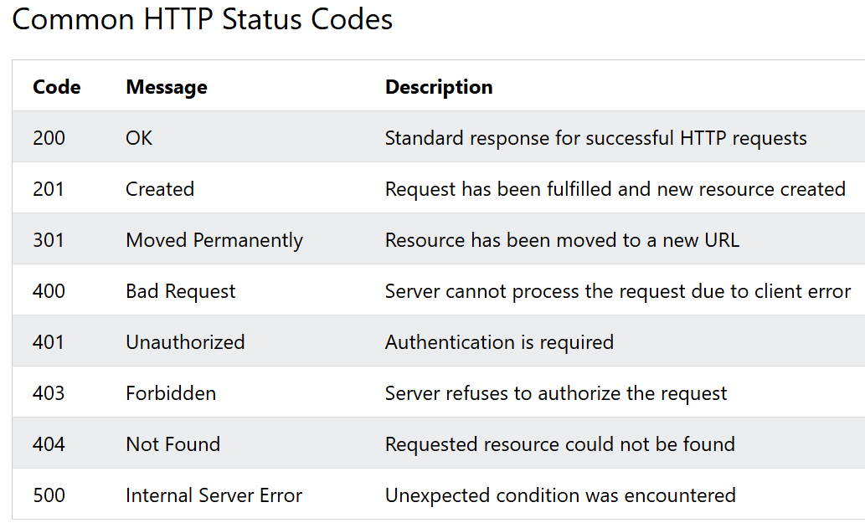

Best Practices for HTTP Methods
- GET: Retrieve a resource or collection of resources (should be idempotent)
- POST: Create a new resource (not idempotent)
- PUT: Update an existing resource or create it if it doesn't exist (idempotent)
- PATCH: Partially update a resource
- DELETE: Remove a resource (idempotent)
- HEAD: Same as GET but without the response body
- OPTIONS: Describe the communication options for the target resource
Error Handling
Always include proper error handling and appropriate HTTP status codes:
- 200 OK - Successful GET/PUT/PATCH
- 201 Created - Successful resource creation
- 204 No Content - Successful DELETE
- 400 Bad Request - Invalid request data
- 401 Unauthorized - Authentication required
- 403 Forbidden - Not enough permissions
- 404 Not Found - Resource doesn't exist
- 500 Internal Server Error - Server-side error

HTTPS vs HTTP API

The HTTPS module has the same interface as the HTTP module, with the main difference being that it creates connections using TLS/SSL.
This means all the methods and events available in the HTTP module are also available in the HTTPS module.
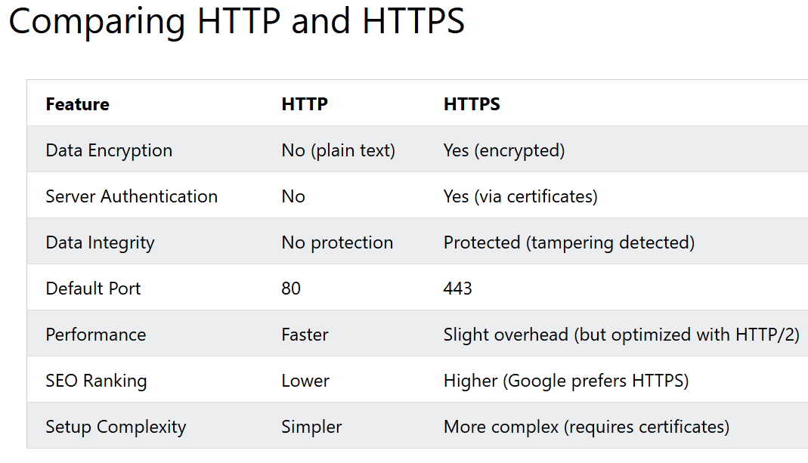
Node.js File System Module
The Node.js File System module (fs) provides a comprehensive set of methods for working with the file system on your computer.
It allows you to perform file I/O operations in both synchronous and asynchronous ways.
You can import the File System module using CommonJS require() or ES modules import syntax:

1. Important File System methods in Node.js
Method Purpose
- fs.readFile() Reads a file asynchronously
- fs.readFileSync() Reads a file synchronously
- fs.writeFile() Creates a file or overwrites existing content
- fs.appendFile() Adds content to the end of a file
- fs.unlink() Deletes a file
- fs.rename() Renames or moves a file
- fs.mkdir() Creates a directory
- fs.readdir() Reads the contents of a directory
- fs.rmdir() Removes an empty directory; legacy API
- fs.rm() Removes files or directories
- fs.stat() Gets file or directory metadata
- fs.copyFile() Copies a file
- fs.access() Checks accessibility or permissions
- fs.createReadStream() Reads a file in chunks
- fs.createWriteStream() Writes data using a stream

What is the Path Module in Node.js?
The Path module in Node.js is a built-in module used to work with file and directory paths. It helps us create, join, resolve, normalize, and extract information from paths in a platform-independent way.
For example, Windows uses backslashes (\) in paths, while Linux and macOS commonly use forward slashes (/). The Path module helps handle these differences.
Important Path module methods
Here are the methods you should know for Node.js interviews.
Method | Purpose
path.join() | Joins path segments into one path
path.resolve() | Resolves segments into an absolute path
path.basename() | Returns the filename from a path
path.dirname() | Returns the directory portion of a path
path.extname() | Returns the file extension
path.parse() | Splits a path into its components
path.format() | Creates a path from components
path.normalize() | Normalizes path separators and . / .. segments
path.isAbsolute() | Checks whether a path is absolute
path.relative() | Finds the relative path between two paths
path.sep | Returns the platform-specific path separator
path.delimiter | Returns the platform-specific path delimiter
path.toNamespacedPath() | Converts a path to a namespaced path where supported
What is the difference between path.join() and path.resolve()?
This is one of the most important Node.js interview questions.
path.join() | path.resolve()
Joins segments into a normalized path | Resolves segments into an absolute path
May return a relative path | Returns an absolute path
Does not automatically start from the current working directory unless the input dictates it | Uses the current working directory if no absolute segment is provided
Useful for constructing paths | Useful when an absolute path is required
Interview-ready answer to memorize
The Path module is a built-in Node.js module used to handle file and directory paths in a platform-independent manner. Its important methods include join(), resolve(), basename(), dirname(), extname(), parse(), and normalize(). For example, path.join() combines path segments, while path.resolve() generates an absolute path. We commonly use the Path module with the File System module to read, write, and manage files reliably across operating systems

OS Module in Node.js
The OS (Operating System) module is a built-in Node.js module that provides information about the operating system and the machine on which a Node.js application is running.
It helps us retrieve details such as the operating system platform, CPU information, available memory, system uptime, hostname, and network interfaces.
Interview definition to remember:
The OS module in Node.js is a built-in module that allows us to retrieve operating system and hardware-related information. It is useful for system monitoring, debugging, performance analysis, and building applications that need to adapt to different operating systems.
Final interview-ready answer
Memorize this answer for a basic Node.js interview question:
The OS module in Node.js is a built-in module that provides information about the operating system and the machine running the application. We can import it using require('node:os'). Some important methods are os.platform() to identify the operating system, os.arch() to get the CPU architecture, os.cpus() to retrieve CPU information, os.totalmem() and os.freemem() to inspect system memory, and os.uptime() to get system uptime. It is useful for system monitoring, debugging, diagnostics, and writing cross-platform applications.

URL Module in Node.js
What is the URL Module in Node.js?
The URL module in Node.js is a built-in module used to parse, construct, manipulate, and retrieve information from URLs (Uniform Resource Locators).
It helps us work with URL components such as the protocol, hostname, port, pathname, query parameters, and hash.
Interview definition to remember:
The URL module in Node.js is a built-in module that helps us parse and manipulate URLs. It allows us to extract URL components, read query parameters, construct URLs, and modify URL values. It is commonly used when developing backend

Events Module in Node.js
What is the Events Module in Node.js?
The Events module is a built-in Node.js module that allows us to create, emit, and handle custom events.
It provides the EventEmitter class, which lets one part of an application notify other parts when something happens.
For example:
- A user registers successfully.
- An order is placed.
- A payment is completed.
- A file finishes processing.
These actions can trigger events, and registered listener functions can respond to them.
Interview definition to remember:
The Events module in Node.js is a built-in module that supports event-driven programming. It provides the EventEmitter class, which allows us to register event listeners using on() and trigger events using emit(). We can use once() to execute a listener only once and off() to remove a listener. EventEmitter is commonly used for custom notifications, streams, and application-level event handling. By default, its listeners execute synchronously in registration order..

Node.js Streams Module
What is the Streams module in Node.js?
The Streams module in Node.js is used to process data in small chunks instead of loading the entire data into memory at once.
Streams are useful when working with large files, HTTP requests and responses, video streaming, and data transfers.
For example, if you need to read a 2 GB file, using fs.readFile() typically loads the entire file into memory. Using a readable stream allows you to process the file chunk by chunk, reducing memory consumption.
Interview definition to memorize:
Streams in Node.js are objects that allow us to read or write data continuously in chunks. They are useful for processing large amounts of data efficiently without loading the entire data into memory. Node.js provides four types of streams: Readable, Writable, Duplex, and Transform.
What are the four types of streams?
1. Readable stream
Used to read data from a source.
Examples: fs.createReadStream(), HTTP request bodies.
Remember: Data comes out of the stream.
2. Writable stream
Used to write data to a destination.
Examples: fs.createWriteStream(), HTTP responses.
Remember: Data goes into the stream.
3. Duplex stream
Used for both reading and writing independently.
Examples: TCP sockets.
4. Transform stream
A type of Duplex stream that transforms data while it passes through.
Examples: compression using zlib.createGzip() and encryption streams.

Final interview-ready answer to memorize
The Streams module in Node.js allows us to process data in chunks rather than loading the entire data into memory. Node.js provides four types of streams: Readable, Writable, Duplex, and Transform. Important methods include pipe(), pipeline(), read(), write(), and end(). Streams are useful for large file processing, HTTP communication, file uploads, downloads, and compression. One important concept is backpressure, which controls data flow when the destination cannot process data as quickly as the source produces it. Streams help build memory-efficient and scalable backend applications.

Buffer module
What is the Buffer module in Node.js?
The Buffer module in Node.js is used to handle binary data directly in memory. It allows Node.js to work with data that is represented as bytes rather than ordinary JavaScript text.
JavaScript strings represent text, but many backend operations involve binary data, such as files, images, network packets, audio, and video. The Buffer class helps Node.js process this data efficiently.
Interview definition to memorize:
The Buffer module in Node.js is a built-in feature used to handle binary data in memory. A Buffer represents a sequence of bytes and is commonly used when working with file systems, streams, network communication, and binary data processing. Node.js provides methods such as Buffer.from(), Buffer.alloc(), Buffer.byteLength(), and Buffer.isBuffer() to create and manipulate buffers.
Final interview-ready answer
The Buffer module in Node.js is used to handle binary data directly in memory. It is particularly useful for file system operations, streams, network communication, and processing images or other binary payloads. Important methods include Buffer.from() to create a buffer from existing data, Buffer.alloc() to create a zero-initialized buffer, Buffer.concat() to combine buffers, Buffer.byteLength() to calculate byte length, and Buffer.isBuffer() to check whether a value is a Buffer. Streams often use Buffers to process data in chunks, which helps build memory-efficient backend applications.

Crypto module
What is the Crypto module in Node.js?
The Crypto module is a built-in Node.js module that provides cryptographic functionality to secure data. It supports hashing, encryption, decryption, digital signatures, message authentication codes (HMAC), and secure random number generation.
It is commonly used in backend applications for data integrity, token generation, secure communications, and cryptographic operations.
Interview definition to memorize:
The Crypto module in Node.js is a built-in module used to perform cryptographic operations such as hashing, encryption, decryption, digital signatures, and secure random number generation. It provides methods like createHash(), createHmac(), createCipheriv(), createDecipheriv(), and randomBytes(). It is useful for protecting sensitive data, verifying data integrity, and implementing security-related functionality in backend applications.
Final interview-ready answer
The Crypto module in Node.js is a built-in module that provides cryptographic functionality for securing data. It supports hashing, encryption and decryption, digital signatures, HMAC, and secure random number generation. Important methods include createHash() for hashing, createHmac() for message authentication, randomBytes() for secure random values, createCipheriv() and createDecipheriv() for encryption and decryption, and scrypt() for password-based key derivation. It is commonly used in backend applications to verify data integrity, authenticate messages, generate secure tokens, and protect sensitive information.

Node.js Timers Module
What is the Timers module in Node.js?
The Timers module in Node.js allows us to schedule the execution of functions after a specified delay or repeatedly at a given interval.
It provides functions such as setTimeout(), setInterval(), and setImmediate().
These functions are available globally in Node.js, so you generally do not need to import the Timers module explicitly.
Interview definition to memorize:
The Timers module in Node.js is used to schedule the execution of callbacks after a specified delay or at recurring intervals. Its main functions are setTimeout(), setInterval(), and setImmediate(). It also provides corresponding cancellation methods such as clearTimeout(), clearInterval(), and clearImmediate(). These functions are useful for scheduling tasks, retry logic, periodic operations, and deferring execution within the Node.js event loop.
Final interview-ready answer
The Timers module in Node.js is used to schedule the execution of callbacks. Its main methods are setTimeout() for executing a callback once after a delay, setInterval() for recurring execution, and setImmediate() for scheduling a callback in the check phase of the event loop. We use clearTimeout(), clearInterval(), and clearImmediate() to cancel scheduled callbacks. Timer callbacks are coordinated by the event loop, and their execution is not guaranteed at an exact time. These methods are useful for delayed operations, polling, retry mechanisms, and scheduled tasks.

Node.js DNS Module
1. What is the DNS module in Node.js?
The DNS (Domain Name System) module is a built-in Node.js module that allows applications to perform DNS lookups and resolve domain names into IP addresses, as well as retrieve other DNS records.
For example, when you enter google.com, DNS helps determine which IP address should be used to connect to the server.
Interview definition to memorize:
The DNS module in Node.js is a built-in module used to resolve domain names into IP addresses and retrieve DNS records such as A, AAAA, MX, and TXT records. It provides methods like dns.lookup(), dns.resolve(), and dns.reverse(). It is useful for network communication, domain resolution, email configuration checks, and troubleshooting DNS-related issues.

What is the Assert Module?
The Assert module provides a simple yet powerful set of assertion tests for validating invariants in your code.
It's a core Node.js module that doesn't require installation.
Key features include:
- Simple truthy/falsy assertions
- Strict and loose equality checks
- Deep object comparison
- Error throwing and handling
- Support for async/await patterns

