What is React
React is a JavaScript library developed by Facebook for building user interfaces, especially for single-page applications where you need fast, dynamic updates without reloading the entire page.
Features of React.
- Component-Based Architecture: UI is broken down into reusable components.
- Declarative: You describe what the UI should look like, and React handles the rendering.
- Virtual DOM: React uses a lightweight copy of the DOM to efficiently update only what changes, improving performance.
- Unidirectional Data Flow: Data flows in one direction (from parent to child), making state management predictable.
Why We Use React.
- High performance due to Virtual DOM.
- Easy to maintain because of modular components.
- Huge ecosystem and community support.
- Works well with other libraries and frameworks.
Common use Case React can be used
- Web applications
- Mobile apps (React Native)
- Interactive UI components for websites.
What is Virtual Dom
ReactJS Virtual DOM is an in-memory representation of the actual DOM (Document Object Model). React uses this lightweight JavaScript object to track changes in the application state and efficiently update the actual DOM only where necessary.
How It Works
- When your app’s state changes, React updates the Virtual DOM first, not the real DOM.
- React then compares the new Virtual DOM with the previous one using a process called diffing.
- It finds the minimal set of changes needed and updates only those parts in the real DOM.
This process is called reconciliation.
Why is it Important?
- Direct manipulation of the real DOM is slow because it involves re-rendering and layout calculations.
- The Virtual DOM makes updates fast and efficient, improving performance for dynamic UIs.
Components
In React, components are the building blocks of the user interface. They allow you to break down the UI into small, reusable pieces.
A component is essentially a JavaScript function or class that:
- Accepts props (input data).
- Returns React elements (UI representation).
- Can manage its own state (data that changes over time).
Types of Components
- Class Components
- Functional Components
Class Components
Which follows life cycle methods
Example
class Greeting extends React.Component {
render() {
return <h1>Hello, {this.props.name}!</h1>;
}
Functional Components
Simple JavaScript functions
Use React Hooks (like useState, useEffect) for state and lifecycle.
Example
function Greeting(props) {
return <h1>Hello, {props.name}!</h1>;
}
State
In React, state refers to a built-in object that stores dynamic data for a component and determines how that component renders and behaves.
state is local and mutable within the component.
Key Characteristics of State
- Local to the component: Each component can have its own state.
- Mutable: You can update state using React’s setState (in class components) or useState (in functional components).
- Triggers re-render: When state changes, React automatically re-renders the component to reflect the new data.
Prop
In React, props (short for properties) are a way to pass data from a parent component to a child component.
Key Characteristics of Props
- Read-only: A child component cannot modify the props it receives.
- Passed down: Data flows one-way from parent to child.
- Used for customization: You can change how a component behaves or looks by passing different props.
Difference between props and state
Props | State
Passed from parent | Managed inside component
Immutable | Mutable
Used for configuration | Used for dynamic data

Life cycle methods in react
In React, lifecycle methods are special functions that run at specific points in a component’s life cycle

Three Phases of Component Lifecycle
- Mounting – When the component is created and inserted into the DOM.
- Updating – When the component’s state or props change.
- Unmounting – When the component is removed from the DOM.

Lifecycle Methods in Class Components
Mounting Phase
- constructor() – Initialize state and bind methods.
- componentDidMount() – Runs after the component is rendered. Commonly used for API calls or DOM operations.
Updating Phase
- shouldComponentUpdate() – Decide whether to re-render (performance optimization).
- componentDidUpdate(prevProps, prevState) – Runs after updates. Useful for reacting to prop/state changes.
Unmounting Phase
- componentWillUnmount() – Cleanup tasks like removing event listeners or canceling network requests.

What are hooks in react
In React, Hooks are special functions that let you use state and other React features in functional components without writing class components. They were introduced in React 16.8 to simplify component logic and make code more reusable.
Why Hooks?
Before hooks, only class components could use state and lifecycle methods. Hooks allow functional components to:
- Manage state.
- Handle side effects.
- Access context.
- Reuse logic easily.
Common React Hooks
- useState
- useEffect
- useContext
- useMemo
- useReducer
- useRef
- useCallback
- useSelector
- useDispatch
- useParams
Rules of Hooks
- Only call hooks at the top level (not inside loops or conditions).
- Only call hooks inside React components or custom hooks.
Benefits
- No need for class components.
- Cleaner, reusable logic.
- Easier to share stateful logic via custom hooks.

What are the lifecycle methods are replaced by hooks.
Phase | Class Method | Hook Equivalent
Mounting | componentDidMount | useEffect (empty dependency)
Updating | componentDidUpdate | useEffect (with dependencies)
Unmounting | componentWillUnmount | Cleanup function in useEffect

useState hook
The useState hook in React is one of the most commonly used hooks. It allows you to add state to functional components without converting them into class components.
Syntax
const [state, setState] = useState(initialValue);

example code
import React, { useState } from 'react';

function Counter() {
const [count, setCount] = useState(0);

return (
<div>
<p>Count: {count}</p>
<button onClick={() => setCount(count + 1)}>Increment</button>
</div>
);
}
useEffect Hook
The useEffect hook in React is used to handle side effects in functional components. Side effects are anything that affects something outside the component, such as:
- Fetching data from an API
- Subscribing to events
- Updating the DOM manually
- Setting up timers
Syntax
useEffect(() => {
// Side effect logic here
return () => {
// Cleanup logic here (optional)
};
}, [dependencies]);

- Effect function: Runs after the component renders.
- Cleanup function: Runs before the component unmounts or before the next effect runs.
- Dependencies array: Controls when the effect runs.

How It Works
- No dependencies ([]) → Runs once after initial render (componentDidMount).
- With dependencies ([value]) → Runs whenever value changes (componentDidUpdate).
- No array → Runs after every render.

UseContext Hook

Context provides a way to share data (like theme, user info, language settings) across the component tree without prop drilling.

The useContext hook in React allows components to consume values from the React context. React’s context API is primarily designed to pass data down the component tree without manually passing props at every level. useContext is a part of React's hooks system, introduced in React 16.8, that enables functional components to access context values.
It helps avoid the problem of "prop drilling," where props are passed down multiple levels from parent to child components.

- Simplifies accessing shared state across components.
- Avoids prop drilling by eliminating the need to pass props down multiple levels.
- Works seamlessly with React's Context API to provide global state.
- Ideal for managing themes, authentication, or user preferences across the app.

useMemo Hook
The useMemo Hook is a built-in React Hook that helps optimize performance by memoizing the result of a computation and reusing it unless its dependencies change. This prevents expensive computations from being re-executed unnecessarily during component re-renders.

What is memorizing in React
In React, memoizing refers to the technique of caching the result of a function or component so that it doesn't need to be recalculated or re-rendered unless its inputs (props or dependencies) change. This helps improve performance by avoiding unnecessary computations or renders.

Syntax of useMemo hook
const expensiveValue = useMemo(() => {
return computeExpensiveValue(input);
}, [input]);

Program of using useMemo hook
import React, { useState, useMemo } from "react";

function App() {
const [number, setNumber] = useState(0);
const squaredNum = useMemo(() => squareNum(number), [number]);
const [counter, setCounter] = useState(0);
const onChangeHandler = (e) => {
setNumber(e.target.value);
};
const counterHander = () => {
setCounter(counter + 1);
};
return (
<div className="App">
<h1>Welcome to Geeksforgeeks</h1>
<input
type="number"
placeholder="Enter a number"
value={number}
onChange={onChangeHandler}
></input>

<div>OUTPUT: {squaredNum}</div>
<button onClick={counterHander}>Counter ++</button>
<div>Counter : {counter}</div>
</div>
);
}
function squareNum(number) {
console.log("Squaring will be done!");
return Math.pow(number, 2);
}
export default App.

useCallback Hook

The useCallback Hook is a built-in React Hook that memoizes a callback function, preventing it from being recreated on every render unless its dependencies change. This is useful for optimizing performance, especially when passing functions as props to child components.

Syntax

const memoizedCallback = useCallback(() => {

// Function logic

}, [dependencies]);

- The function to be memoized is passed as a parameter to useCallback.
- An array of dependencies determines when the function should be recreated.

When to Use useCallback?

You should use useCallback when
- Passing functions as props to child components to prevent unnecessary re-renders.
- Avoiding unnecessary function re-creations inside useEffect or event handlers.
- Ensuring function references remain stable across renders.

UseRef Hook
What is useRef?
useRef is a React Hook that lets you create a mutable reference that persists across renders. It’s commonly used for:
- Accessing DOM elements directly
- Storing mutable values that don’t trigger re-renders

The useRef Hook is a built-in React Hook that returns a mutable reference object (ref) that persists across renders. Unlike state variables, updating a ref does not trigger a component re-render.

Syntax
const refContainer = useRef(initialValue);
In the above syntax:
- useRef returns an object { current: initialValue }.
- The current property can be updated without re-rendering the component.

Implementing the useRef hook

1. Accessing the DOM using useRef hook.

import React, { Fragment, useRef } from 'react';

function App() {

const focusPoint = useRef(null);

const onClickHandler = () => {

focusPoint.current.value =

"The quick brown fox jumps over the lazy dog";

focusPoint.current.focus();

};

return (

<Fragment>

<div>

<button onClick={onClickHandler}>

ACTION

</button>

</div>

<label>

Click on the action button to

focus and populate the text.

</label><br />

<textarea ref={focusPoint} />

</Fragment>

);

};

export default App

2. Persisting Values Across Renders

import React, { useState, useRef, useEffect } from "react";

function PreviousValue() {

const [count, setCount] = useState(0);

const prevCountRef = useRef();

useEffect(() => {

prevCountRef.current = count;

}, [count]);

return (

<div>

<p>Current count: {count}</p>

<p>Previous count: {prevCountRef.current}</p>

<button onClick={() => setCount(count + 1)}>Increment</button>

</div>

);

}

export default PreviousValue;

Why Use useRef?

- Direct DOM Manipulation: You can directly access and manipulate DOM elements without triggering a re-render.
- Persisting Values Across Renders: Use useRef to store values (such as previous state values) that should persist across renders without triggering unnecessary updates.
Optimizing Performance: Avoiding re-renders useRef can help optimize performance, especially when managing timers, DOM references, or other non-UI values.

Difference between useEffect and useMemo hook
UseEffect Hook
Purpose:
Runs side effects after rendering (e.g., data fetching, subscriptions, DOM manipulation).
Syntax
useEffect(() => {
// Side effect logic
}, [dependencies]);
Key Points:
- Executes after render.
- Commonly used for:
  - API calls
  - Event listeners
  - Updating external systems
- Does not return a value.
- Can include a cleanup function.

UseMemo
Purpose:
Memoizes the result of a computation to avoid recalculating it on every render.
const memoizedValue = useMemo(() => computeExpensiveValue(a, b), [a, b]);
Key Points:
- Executes during render.
- Used for:
  - Expensive calculations
  - Avoiding unnecessary recalculations
- Returns a value.
- No side effects or cleanup.

Summary Table
Feature | useEffect | useMemo
Purpose | Side effects | Memoize computed values
Runs | After render | During render
Returns | Nothing (can return cleanup) | A memoized value
Use Case | API calls, subscriptions, etc. | Expensive calculations
Cleanup Support | ✅ Yes | ❌ No

useCallback vs useMemo

The useCallback and useMemo Hooks are similar, but they serve different purposes:
- useCallback returns a memoized function, ensuring its reference remains stable across renders.
- useMemo returns a memoized value, optimizing expensive calculations by caching the result.
- Use useCallback for passing stable function references, and useMemo for optimizing computations.

Here's a comparison table of the React hooks: useMemo, useRef, and useCallback, highlighting their purpose, usage, and differences:

Hook | Purpose | Returns | Common Use Case | Dependencies Required | Re-renders Triggered?
useMemo | Memoizes a computed value to avoid recalculating on every render | The memoized value | Expensive calculations, derived data | ✅ Yes | ❌ No
useRef | Stores a mutable reference that persists across renders | A ref object ({ current: ... }) | Accessing DOM elements, storing instance variables | ❌ No | ❌ No
useCallback | Memoizes a function to avoid re-creating it on every render | The memoized function | Passing stable function references to child components | ✅ Yes | ❌ No

🔍 Summary:
- useMemo: Use when you want to cache a value (e.g., result of a calculation).
- useRef: Use when you want to persist a value without causing re-renders (e.g., DOM access or timers).
- useCallback: Use when you want to cache a function to prevent unnecessary re-renders in child components

UseReducer Hook
The useReducer hook is an alternative to the useState hook that is preferred when you have complex state logic. It is useful when the state transitions depend on previous state values or when you need to handle actions that can update the state differently.
const [state, dispatch] = useReducer(reducer, initialState);
- reducer: A function that defines how the state should be updated based on the action. It takes two parameters: the current state and the action.
- initialState: The initial value of the state.
- State The current state returned from the useReducer hook.
- dispatch: A function used to send an action to the reducer to update the state.
Implementing the useReducer hook
import React, { useReducer } from 'react';
const counterReducer = (state, action) => {
switch (action.type) {
case 'INCREMENT':
return { count: state.count + 1 };
case 'DECREMENT':
return { count: state.count - 1 };
default:
return state;
}
};
function Counter() {
const [state, dispatch] = useReducer(counterReducer, { count: 0 });
return (
<div>
<p>Count: {state.count}</p>
<button onClick={() => dispatch({ type: 'INCREMENT' })}>Increment</button>
<button onClick={() => dispatch({ type: 'DECREMENT' })}>Decrement</button>
</div>
);
}
export default Counter;
UseParam Hook
useParams is a hook provided by React Router (from react-router-dom) that allows you to access dynamic URL parameters inside your component.
When you define a route with dynamic segments (like :id), useParams gives you those values as an object.
Example with Data Fetching
import React, { useEffect, useState } from 'react';
import { useParams } from 'react-router-dom';

function UserDetails() {
const { id } = useParams();
const [user, setUser] = useState(null);

useEffect(() => {
fetch(`https://jsonplaceholder.typicode.com/users/${id}`)
.then(response => response.json())
setUser(data));
}, [id]);

if (!user) return <p>Loading...</p>;

return (
<div>
<h1>{user.name}</h1>
<p>Email: {user.email}</p>
</div>
);
}

export default UserDetails;
Custom Hook
A custom hook in React is a JavaScript function that starts with the prefix use and allows you to reuse stateful logic across multiple components.
Instead of duplicating logic in different components, you can extract it into a custom hook.
Custom hooks do not render UI; they only encapsulate logic.
Why use Custom Hooks?
- To reuse logic (e.g., fetching data, form handling, authentication).
- To keep components clean and focused on UI.
- To share stateful logic without using HOCs or render props.
Example how to use custom hook
useFetch.js file Example: Custom Hook for Fetching Data
import { useState, useEffect } from 'react';

// ✅ Custom Hook
function useFetch(url) {
const [data, setData] = useState(null);
const [loading, setLoading] = useState(true);
const [error, setError] = useState(null);

useEffect(() => {
const fetchData = async () => {
try {
const response = await fetch(url);
if (!response.ok) throw new Error('Network response was not ok');
const result = await response.json();
setData(result);
} catch (err) {
setError(err.message);
} finally {
setLoading(false);
}
};

fetchData();
}, [url]);

return { data, loading, error };
}

export default useFetch;
Using the Custom Hook
import React from 'react';
import useFetch from './useFetch';

function data, loading, error } = useFetch('https://jsonplaceholder.typicode.com/users');

if (loading) return <p>Loading...</p>;
if (error) return <p>Error: {error}</p>;

return (
<ul>
{data.map(user => (
<li key={user.id}>{user.name}</li>
))}
</ul>
);
}

export default Users;
Example 2 of using custom hook
import { useState, useEffect } from 'react';

function useFetch(url) {
const [data, setData] = useState(null);
const [loading, setLoading] = useState(true);

useEffect(() => {
fetch(url)
.then((response) => response.json())
.then((data) => {
setData(data);
setLoading(false);
});
}, [url]);

return { data, loading };
}
function DataComponent() {
const { data, loading } = useFetch("https://jsonplaceholder.typicode.com/todos/1");

return (
<div>
{loading ? <p>Loading...</p> : <p>Data: {JSON.stringify(data)}</p>}
</div>
);
}

export default DataComponent;

Redux

Redux is a state management library for JavaScript applications, commonly used with React. It helps manage application state in a predictable, centralized, and debuggable way.

Redux follows a unidirectional data flow:
Component → Dispatch → Action → Reducer → Store → Component

🔄 Flow Breakdown:
- Component: UI triggers an action (e.g., button click).
- Dispatch: Sends an action to the Redux store.
- Action: A plain JS object describing what happened ({ type: 'INCREMENT' }).
- Reducer: A pure function that takes current state and action, returns new state.
- Store: Holds the entire app state and notifies components of changes.
- Component: Subscribed components re-render with updated state.

📦 Redux Core Concepts
Concept | Description
Store | Central place that holds the state
Action | Describes what happened
Reducer | Pure function to update state
Dispatch | Sends actions to the store

important principles of redux
1.Single source of truth: It helps to create universal apps. The state of the application is stored in one object tree called store. It means one app, one store.
2.State is read-only (Immutability): It means that we don’t change the state object and its properties directly. Instead of this make a new object, recalculate the new application state and update it with our newly created object. And this is important because all the changes are happening in the same place so everything is needed to be done in strict order and one by one.
3.Changes are made with pure functions (reducers): Reducers are pure functions that take previous state and action and return the new state.
Building Parts of redux:
- Action
- Reducer
- Store
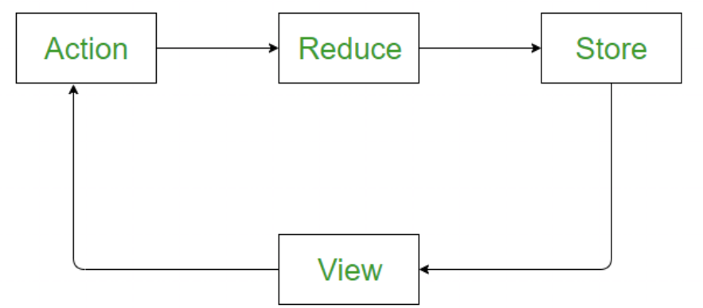

Action and Action Creators
Actions: Actions are a plain JavaScript object that contains information. Actions are the only source of information for the store. Actions have a type field that tells what kind of action to perform and all other fields contain information or data. And there is one other term called Action Creators, these are the function that creates actions. So actions are the information (Objects) and action creator are functions that return these actions.
Example: The easiest example we can take try is To-do. So we will create two action creators one for adding a task in to-do and for removing.
function addTask(task) { ///// this function is a action creator
return {
type: 'ADD_TODO', //// action
task: task //// action
}
}
function removeTask(task) { ///// this function is a action creator
return {
type: 'REMOVE_TODO', //// action
task: task //// action
}
}
So, the above two functions are action creators. One is for adding a task and one for removing, and see both have a type which tells what is the purpose of actions creator and they will be used with reducers.
Reducer
Reducers: As we already know, actions only tell what to do, but they don't tell how to do, so reducers are the pure functions that take the current state and action and return the new state and tell the store how to do.
Let's create a reducer for our TO-do.
Example
function task(tasks = [], action) {
if (action.type === 'ADD_TODO') {
return [...tasks, action.task];
} else if (action.type === 'REMOVE_TODO') {
return tasks.filter(task => task !== action.task);
}
return tasks;
}
So, In the above reducer, a function created with two arguments first is the current state and next is the action we want to perform, First initialize the current state empty array because at first task list is gonna be empty.
Then check the action type, different type of actions will have different functionality, In the above case if task is added, then it returns the array containing older list of task and with one new added, but the older state are not gonna mutate the older state we gonna return new one, this is needed to be kept in mind. Same for remove, if none of the above two then just return the list. Return the new state, Never mutate the older state.
For more complex apps use combineReducers() to combine them so that it can pass to store.
Store: The store is the object which holds the state of the application.
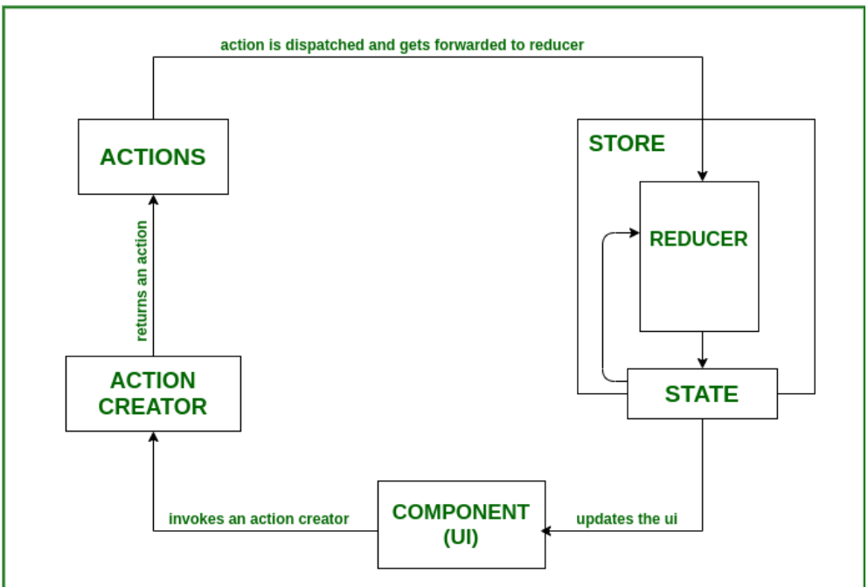

Redux Tool Kit
Redux Toolkit is a set of utilities that simplifies Redux development by reducing boilerplate code and providing best practices out of the box.
It includes:
- configureStore – Easier store setup
- createSlice – Combines reducers and actions
- createAsyncThunk – Handles async logic (like API calls)
- Built-in Immer for immutable updates
Why RTK?
- Less boilerplate compared to traditional Redux
- Built-in support for thunks and middleware
- Encourages best practices
How to install
npm install @reduxjs/toolkit react-redux

how to create a slice
import { createSlice } from '@reduxjs/toolkit';

const counterSlice = createSlice({
name: 'counter',
initialState: { value: 0 },
reducers: {
increment: (state) => {
state.value += 1; // Immer allows direct mutation
},
decrement: (state) => {
state.value -= 1;
},
incrementByAmount: (state, action) => {
state.value += action.payload;
}
}
});

export const { increment, decrement, incrementByAmount } = counterSlice.actions;
export default counterSlice.reducer;

Configure Store
import { configureStore } from '@reduxjs/toolkit';
import counterReducer from './counterSlice';

const store = configureStore({
reducer: {
counter: counterReducer
}
});

export default store;

Provide Store in App
import React from 'react';
import ReactDOM from 'react-dom/client';
import { Provider } from 'react-redux';
import store from './store';
import App from './App';

const root = ReactDOM.createRoot(document.getElementById('root'));
root.render(
<Provider store={store}>
<App />
</Provider>
);
Use in Component
import React from 'react';
import { useSelector, useDispatch } from 'react-redux';
import { increment, decrement, incrementByAmount } from './counterSlice';

function Counter() {
const count = useSelector((state) => state.counter.value);
const dispatch = useDispatch();

return (
<div>
<h1>{count}</h1>
<button onClick={() => dispatch(increment())}>+</button>
<button onClick={() => dispatch(decrement())}>-</button>
<button onClick={() => dispatch(incrementByAmount(5))}>+5</button>
</div>
);
}
Async Example with createAsyncThunk
import { createSlice, createAsyncThunk } from '@reduxjs/toolkit';

// Thunk for fetching data
export const fetchUsers = createAsyncThunk('users/fetchUsers', async () => {
const response = await fetch('https://jsonplaceholder.typicode.com/users');
return response.json();
});

const usersSlice = createSlice({
name: 'users',
initialState: { data: [], loading: false, error: null },
reducers: {},
extraReducers: (builder) => {
builder
.addCase(fetchUsers.pending, (state) => {
state.loading = true;
})
.addCase(fetchUsers.fulfilled, (state, action) => {
state.loading = false;
state.data = action.payload;
})
.addCase(fetchUsers.rejected, (state, action) => {
state.loading = false;
state.error = action.error.message;
});
}
});

export default usersSlice.reducer;
Key Points
- createSlice → defines state, reducers, and actions in one place.
- configureStore → sets up Redux store with sensible defaults.
- createAsyncThunk → handles async logic easily.
- Built-in Immer → allows writing "mutating" code safely.

