useMemo Hook
The useMemo Hook is a built-in React Hook that helps optimize performance by memoizing the result of a computation and reusing it unless its dependencies change. This prevents expensive computations from being re-executed unnecessarily during component re-renders.
What is memorizing in React
In React, memoizing refers to the technique of caching the result of a function or component so that it doesn't need to be recalculated or re-rendered unless its inputs (props or dependencies) change. This helps improve performance by avoiding unnecessary computations or renders.

Syntax of useMemo hook
const expensiveValue = useMemo(() => {
return computeExpensiveValue(input);
}, [input]);

Program of using useMemo hook
import React, { useState, useMemo } from "react";

function App() {
const [number, setNumber] = useState(0);
const squaredNum = useMemo(() => squareNum(number), [number]);
const [counter, setCounter] = useState(0);
const onChangeHandler = (e) => {
setNumber(e.target.value);
};
const counterHander = () => {
setCounter(counter + 1);
};
return (
<div className="App">
<h1>Welcome to Geeksforgeeks</h1>
<input
type="number"
placeholder="Enter a number"
value={number}
onChange={onChangeHandler}
></input>

<div>OUTPUT: {squaredNum}</div>
<button onClick={counterHander}>Counter ++</button>
<div>Counter : {counter}</div>
</div>
);
}
function squareNum(number) {
console.log("Squaring will be done!");
return Math.pow(number, 2);
}
export default App.

Difference between useEffect and useMemo hook

UseEffect Hook
Purpose:
Runs side effects after rendering (e.g., data fetching, subscriptions, DOM manipulation).
Syntax
useEffect(() => {
// Side effect logic
}, [dependencies]);
Key Points:
- Executes after render.
- Commonly used for:
  - API calls
  - Event listeners
  - Updating external systems
- Does not return a value.
- Can include a cleanup function.

UseMemo
Purpose:
Memoizes the result of a computation to avoid recalculating it on every render.
const memoizedValue = useMemo(() => computeExpensiveValue(a, b), [a, b]);
Key Points:
- Executes during render.
- Used for:
  - Expensive calculations
  - Avoiding unnecessary recalculations
- Returns a value.
- No side effects or cleanup.

Summary Table
Feature | useEffect | useMemo
Purpose | Side effects | Memoize computed values
Runs | After render | During render
Returns | Nothing (can return cleanup) | A memoized value
Use Case | API calls, subscriptions, etc. | Expensive calculations
Cleanup Support | ✅ Yes | ❌ No

✅ Here's where memoized data is stored:
Memoization in React (via useMemo, useCallback, or React.memo) stores data in memory, specifically:
- Inside the React component's internal memory during its lifecycle.
- It’s temporary and scoped to the component — it gets reset when the component unmounts or when dependencies change.
"Remembering something just for now, while the component is alive and the inputs haven't changed."
--------------------------------------------------------------------------------------------------------------
UseRef Hook
What is useRef?
useRef is a React Hook that lets you create a mutable reference that persists across renders. It’s commonly used for:
- Accessing DOM elements directly
- Storing mutable values that don’t trigger re-renders

The useRef Hook is a built-in React Hook that returns a mutable reference object (ref) that persists across renders. Unlike state variables, updating a ref does not trigger a component re-render.

Syntax
const refContainer = useRef(initialValue);
In the above syntax:
- useRef returns an object { current: initialValue }.
- The current property can be updated without re-rendering the component.

Implementing the useRef hook

1. Accessing the DOM using useRef hook.

import React, { Fragment, useRef } from 'react';

function App() {

const focusPoint = useRef(null);

const onClickHandler = () => {

focusPoint.current.value =

"The quick brown fox jumps over the lazy dog";

focusPoint.current.focus();

};

return (

<Fragment>

<div>

<button onClick={onClickHandler}>

ACTION

</button>

</div>

<label>

Click on the action button to

focus and populate the text.

</label><br />

<textarea ref={focusPoint} />

</Fragment>

);

};

export default App

2. Persisting Values Across Renders

import React, { useState, useRef, useEffect } from "react";

function PreviousValue() {

const [count, setCount] = useState(0);

const prevCountRef = useRef();

useEffect(() => {

prevCountRef.current = count;

}, [count]);

return (

<div>

<p>Current count: {count}</p>

<p>Previous count: {prevCountRef.current}</p>

<button onClick={() => setCount(count + 1)}>Increment</button>

</div>

);

}

export default PreviousValue;

Why Use useRef?

- Direct DOM Manipulation: You can directly access and manipulate DOM elements without triggering a re-render.
- Persisting Values Across Renders: Use useRef to store values (such as previous state values) that should persist across renders without triggering unnecessary updates.
- Optimizing Performance: Avoiding re-renders useRef can help optimize performance, especially when managing timers, DOM references, or other non-UI values.

-----------------------------------------------------------------------------------------------------------

useCallback Hook

The useCallback Hook is a built-in React Hook that memoizes a callback function, preventing it from being recreated on every render unless its dependencies change. This is useful for optimizing performance, especially when passing functions as props to child components.

Syntax

const memoizedCallback = useCallback(() => {

// Function logic

}, [dependencies]);

- The function to be memoized is passed as a parameter to useCallback.
- An array of dependencies determines when the function should be recreated.

When to Use useCallback?

You should use useCallback when
- Passing functions as props to child components to prevent unnecessary re-renders.
- Avoiding unnecessary function re-creations inside useEffect or event handlers.
- Ensuring function references remain stable across renders.

useCallback vs useMemo

The useCallback and useMemo Hooks are similar, but they serve different purposes:
- useCallback returns a memoized function, ensuring its reference remains stable across renders.
- useMemo returns a memoized value, optimizing expensive calculations by caching the result.
- Use useCallback for passing stable function references, and useMemo for optimizing computations.

Here's a comparison table of the React hooks: useMemo, useRef, and useCallback, highlighting their purpose, usage, and differences:

Hook | Purpose | Returns | Common Use Case | Dependencies Required | Re-renders Triggered?
useMemo | Memoizes a computed value to avoid recalculating on every render | The memoized value | Expensive calculations, derived data | ✅ Yes | ❌ No
useRef | Stores a mutable reference that persists across renders | A ref object ({ current: ... }) | Accessing DOM elements, storing instance variables | ❌ No | ❌ No
useCallback | Memoizes a function to avoid re-creating it on every render | The memoized function | Passing stable function references to child components | ✅ Yes | ❌ No

🔍 Summary:
- useMemo: Use when you want to cache a value (e.g., result of a calculation).
- useRef: Use when you want to persist a value without causing re-renders (e.g., DOM access or timers).
- useCallback: Use when you want to cache a function to prevent unnecessary re-renders in child components.

-----------------------------------------------------------------------------------------------------------

Redux

Redux is a state management library for JavaScript applications, commonly used with React. It helps manage application state in a predictable, centralized, and debuggable way.

Redux follows a unidirectional data flow:
Component → Dispatch → Action → Reducer → Store → Component

🔄 Flow Breakdown:
- Component: UI triggers an action (e.g., button click).
- Dispatch: Sends an action to the Redux store.
- Action: A plain JS object describing what happened ({ type: 'INCREMENT' }).
- Reducer: A pure function that takes current state and action, returns new state.
- Store: Holds the entire app state and notifies components of changes.
- Component: Subscribed components re-render with updated state.

📦 Redux Core Concepts
Concept | Description
Store | Central place that holds the state
Action | Describes what happened
Reducer | Pure function to update state
Dispatch | Sends actions to the store

important principles of redux
1.Single source of truth: It helps to create universal apps. The state of the application is stored in one object tree called store. It means one app, one store.
2.State is read-only (Immutability): It means that we don’t change the state object and its properties directly. Instead of this make a new object, recalculate the new application state and update it with our newly created object. And this is important because all the changes are happening in the same place so everything is needed to be done in strict order and one by one.
3.Changes are made with pure functions (reducers): Reducers are pure functions that take previous state and action and return the new state.
Building Parts of redux:
- Action
- Reducer
- Store
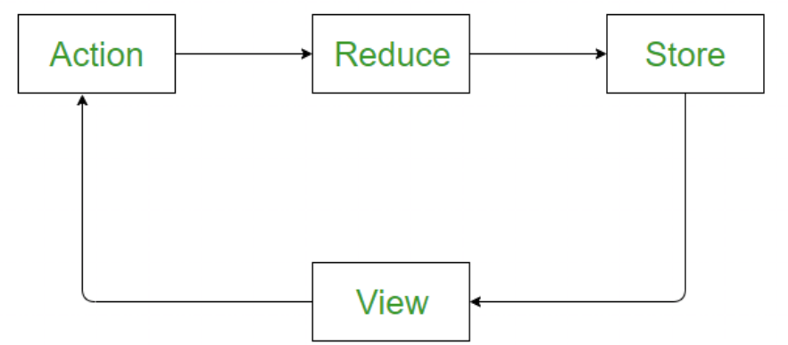

Action and Action Creators
Actions: Actions are a plain JavaScript object that contains information. Actions are the only source of information for the store. Actions have a type field that tells what kind of action to perform and all other fields contain information or data. And there is one other term called Action Creators, these are the function that creates actions. So actions are the information (Objects) and action creator are functions that return these actions.
Example: The easiest example we can take try is To-do. So we will create two action creators one for adding a task in to-do and for removing.
function addTask(task) { ///// this function is a action creator
return {
type: 'ADD_TODO', //// action
task: task //// action
}
}
function removeTask(task) { ///// this function is a action creator
return {
type: 'REMOVE_TODO', //// action
task: task //// action
}
}
So, the above two functions are action creators. One is for adding a task and one for removing, and see both have a type which tells what is the purpose of actions creator and they will be used with reducers.
Reducer
Reducers: As we already know, actions only tell what to do, but they don't tell how to do, so reducers are the pure functions that take the current state and action and return the new state and tell the store how to do.
Let's create a reducer for our TO-do.
Example
function task(tasks = [], action) {
if (action.type === 'ADD_TODO') {
return [...tasks, action.task];
} else if (action.type === 'REMOVE_TODO') {
return tasks.filter(task => task !== action.task);
}
return tasks;
}
So, In the above reducer, a function created with two arguments first is the current state and next is the action we want to perform, First initialize the current state empty array because at first task list is gonna be empty.
Then check the action type, different type of actions will have different functionality, In the above case if task is added, then it returns the array containing older list of task and with one new added, but the older state are not gonna mutate the older state we gonna return new one, this is needed to be kept in mind. Same for remove, if none of the above two then just return the list. Return the new state, Never mutate the older state.
For more complex apps use combineReducers() to combine them so that it can pass to store.
Store: The store is the object which holds the state of the application.
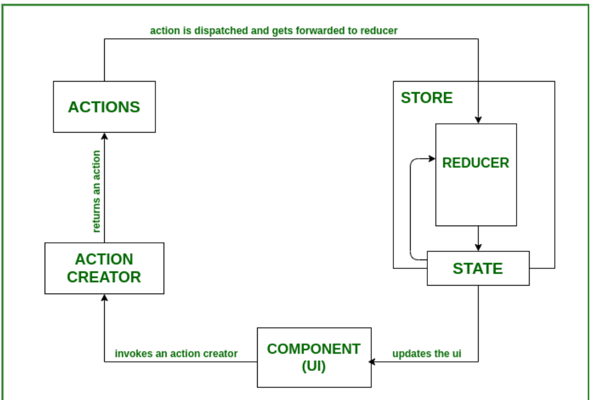

--------------------------------------------------------------------------------------------------------------

useContext Hook
In React Applications, sometimes managing state across deeply nested components can become very difficult. The useContext hook offers a simple and efficient solution to share state between components without the need for prop drilling.
Syntax
const contextValue = useContext(MyContext);
- MyContext: The context object is created using React.createContext().
- contextValue: The current context value that we can use in our component.

var arr = [
'first item',
'second item is longer than the third one',
'third longish item'
];

var test="";
for(var i=0;i<arr.length;i++){
// console.log(arr[i]);
if(arr[i].length>test.length){
// console.log("test",test);
test=arr[i];
}else{
continue;
}
}

console.log(test);
-------------------------------------------------------------------------------------------------------------
const users = [
{ id: 1, name: "Alice", age: 25, active: true },
{ id: 2, name: "Bob", age: 30, active: false },
{ id: 3, name: "Charlie", age: 35, active: false },
{ id: 4, name: "David", age: 40, active: true },
];

const test = users.filter((x)=>{
return (x.age<=30 && x.active === true);
}).map(x=>x.name);

// const test1=test.map(x=>x.name);

console.log(test);
--------------------------------------------------------------------------------------------------------------
Remove duplicates of array
const nums = [1, 2, 3, 4,1,2,6,4,8];

const test = nums.filter((value,index)=>{
return nums.indexOf(value) === index;
});

console.log(test);
------------------------------------------------------------------------------------------------------------
Convert array of strings to uppercase
const names = ['alice', 'bob', 'charlie'];

const test = names.map((x)=>{
return x.toUpperCase();
})
console.log(test);
-------------------------------------------------------------------------------------------------------------
Extract names from array of objects
const users = [{name: 'Alice'}, {name: 'Bob'}, {name: 'Charlie'}];
const test = users.map((x)=>{
return x.name;
})
console.log(test);

------------------------------------------------------------------------------------------------------------
Filter strings longer than 5 characters
const words = ['apple', 'banana', 'kiwi', 'grapefruit'];

const test = words.filter((x)=>{
if(x.length>5){
return x;
}
})
console.log(test);
--------------------------------------------------------------------------------------------------------------
Find the longest word in an array
const words = ['short', 'medium', 'longestword'];
const test = words.reduce((acc,curr)=>{
if(acc.length>curr.length){
return acc
}else{
return curr
}
})
console.log(test);
--------------------------------------------------------------------------------------------------------------
const people = [
{name: 'Alice', city: 'Hyderabad'},
{name: 'Bob', city: 'Delhi'},
{name: 'Charlie', city: 'Hyderabad'}
];
// Output: { Hyderabad: ['Alice', 'Charlie'], Delhi: ['Bob'] }

const people = [
{ name: 'Alice', city: 'Hyderabad' },
{ name: 'Bob', city: 'Delhi' },
{ name: 'Charlie', city: 'Hyderabad' }
];
const groupedByCity = people.reduce(function(acc, person) {
const city = person.city;
const name = person.name;
if (acc[city]) {
acc[city].push(name);
} else {
acc[city] = [name];
}
return acc;
}, {});
console.log("Grouped by City:", groupedByCity);
--------------------------------------------------------------------------------------------------------------
Promises
A Promise in JavaScript is an object that represents the eventual completion (or failure) of an asynchronous operation and its resulting value.
JavaScript Promises make handling asynchronous operations like API calls, file loading, or time delays easier. Think of a Promise as a placeholder for a value that will be available in the future. It can be in one of three states
- Pending: The task is in the initial state.
- Fulfilled: The task was completed successfully, and the result is available.
- Rejected: The task failed, and an error is provided.
let promise = new Promise((resolve, reject) => {
// Perform async operation
if (operationSuccessful) {
resolve("Task successful");
} else {
reject("Task failed");
}
});
Different methods in promises
1. Promise.all() Method
Waits for all promises to resolve and returns their results as an array. If any promise is rejected, it immediately rejects.
Promise.all([
Promise.resolve("Task 1 completed"),
Promise.resolve("Task 2 completed"),
Promise.reject("Task 3 failed")
])
.then((results) => console.log(results))
.catch((error) => console.error(error));
output
Task 3 failed
2. Promise.allSettled() Method
Waits for all promises to settle (fulfilled or rejected) Method and returns an array of their outcomes.
Promise.allSettled([
Promise.resolve("Task 1 completed"),
Promise.reject("Task 2 failed"),
Promise.resolve("Task 3 completed")
])
.then((results) => console.log(results));
Output
[
{ status: 'fulfilled', value: 'Task 1 completed' },
{ status: 'rejected', reason: 'Task 2 failed' },
{ status: 'fulfilled', value: 'Task 3 completed' }
]
3. Promise.race() Method
Promise.race([
new Promise((resolve) =>
setTimeout(() =>
resolve("Task 1 finished"), 1000)),
new Promise((resolve) =>
setTimeout(() =>
resolve("Task 2 finished"), 500)),
]).then((result) =>
console.log(result));
4. Promise.any() Method
Promise.any([
Promise.reject("Task 1 failed"),
Promise.resolve("Task 2 completed"),
Promise.resolve("Task 3 completed")
])
.then((result) => console.log(result))
.catch((error) => console.error(error));
5. Promise.resolve() Method
Promise.resolve("Immediate success")
.then((value) => console.log(value));
6. Promise.reject() Method
Promise.reject("Immediate failure")
.catch((error) => console.error(error));
7. Promise.finally() Method
Promise.finally() Method runs a cleanup or final code block regardless of the promise’s result (fulfilled or rejected).
Promise.resolve("Task completed")
.then((result) => console.log(result))
.catch((error) => console.error(error))
.finally(() => console.log("Cleanup completed"));
Task completed
Cleanup completed
Promise Chaining
Instead of nesting, you can chain .then() calls to make the code cleaner.
getUser()
.then(user => getPosts(user.id))
.then(posts => getComments(posts[0].id))
.then(comments => console.log(comments))
.catch(error => console.error(error));
Each .then() returns a new Promise, allowing the next .then() to wait for it.

async/await: Cleaner Syntax for Promises
async/await is syntactic sugar over Promises. It makes asynchronous code look like synchronous code.

async function loadData() {
try {
const user = await getUser();
const posts = await getPosts(user.id);
const comments = await getComments(posts[0].id);
console.log(comments);
} catch (error) {
console.error(error);
}
}
Benefits:
- Easier to read
- No chaining or nesting
- Better error handling with try/catch
--------------------------------------------------------------------------------------------------------------
Dummy api call to using fetch and axios
Dummy API response.
https://jsonplaceholder.typicode.com/users
Fetch
import React, { useEffect, useState } from 'react';
function UserList() {
const [users, setUsers] = useState([]);
useEffect(() => {
// Fetch data from dummy API
fetch('https://jsonplaceholder.typicode.com/users')
.then(response => response.json())
.then(data => setUsers(data))
.catch(error => console.error('Error fetching users:', error));
}, []);
return (
User List
{users.map(user => (
<li key={user.id}></li key={user.id}>
{user.name} - {user.email}

))}

);
}
export default UserList;
Axios
import React, { useEffect, useState } from 'react';
import axios from 'axios';
function UserList() {
const [users, setUsers] = useState([]);
useEffect(() => {
axios.get('https://jsonplaceholder.typicode.com/users')
.then(response => setUsers(response.data))
.catch(error => console.error('Error fetching users:', error));
}, []);
return (

User List

{users.map(user => (
<li key={user.id}></li key={user.id}>
{user.name} - {user.email}

))}

);
}
export default UserList;

--------------------------------------------------------------------------------------------------------------
how to use async/await inside useEffect for cleaner syntax
fetch
import React, { useEffect, useState } from 'react';

function UserList() {
const [users, setUsers] = useState([]);

useEffect(() => {
// Define an async function inside useEffect
const fetchUsers = async () => {
try {
const response = await fetch('https://jsonplaceholder.typicode.com/users');
const data = await response.json();
setUsers(data);
} catch (error) {
console.error('Error fetching users:', error);
}
};

// Call the async function
fetchUsers();
}, []);

return (
<div>
<h2>User List < /h2>
<ul>
{
users.map(user => (
<li key= { user.id } >
<strong>{ user.name } < /strong> - {user.email}
< /li>
))
}
</ul>
< /div>
);
}

export default UserList;
Axios
import React, { useEffect, useState } from 'react';
import axios from 'axios';
function UserList() {
const [users, setUsers] = useState([]);
useEffect(() => {
const fetchUsers = async () => {
try {
const response = await axios.get('https://jsonplaceholder.typicode.com/users');
setUsers(response.data);
} catch (error) {
console.error('Error fetching users:', error);
}
};
fetchUsers();
}, []);
return (

User List

{users.map(user => (
<li key={user.id}></li key={user.id}>
{user.name} - {user.email}

))}

);
}
export default UserList;
--------------------------------------------------------------------------------------------------------------

React form program
import React,{useState} from "react";

const App = () => {

const [formData,setFormData] = useState({name : "",email:""});
const [submitData,setSubmitData] =useState(null);

const handleChange = (e) => {
const {name, value} = e.target;
setFormData((prev)=>({
...prev,[name]:value,
}))
console.log("formData",formData);
}

const handleSubmit = (e) =>{
e.preventDefault();
console.log("formData",formData);
setSubmitData(formData);
setFormData({name : "",email:""})
}
return(
<div>
<h2>sample form</h2>
<form onSubmit={handleSubmit}>
<div>
<label>Name </label>
<input type="text" name="name" placeholder="enter your name" onChange={handleChange}></input>
</div>
<div>
<label>Email </label>
<input type="email" name="email" placeholder="enter your email" onChange={handleChange}></input>
</div>
<button>submit</button>
</form>
{submitData && (
<div>
<p>
<h1>{submitData.name}</h1>
</p>
<p>
<h1>{submitData.email}</h1>
</p>
</div>
)}
</div>
)
}

export default App;

