Stage 1 — CRUD Runbook
Secure User Service | Reproducible hands-on guide
Purpose: establish the basic Spring Boot REST + service + repository + H2 CRUD foundation.

1. Outcome
- Created the Spring Boot Maven project.
- Configured H2 and Spring Data JPA/Hibernate.
- Created User entity, repository, service and controller layers.
- Implemented create, read, update and delete APIs.
- Tested the APIs with Postman.

2. Technology
- Java 21
- Spring Boot
- Maven
- Spring Web
- Spring Data JPA
- H2 Database
- Hibernate
- Postman

3. Project Structure
src/main/java/com/example/secureservice/
├── SecureUserServiceApplication.java
├── config/
│ └── SecurityConfig.java
├── controller/
│ └── UserController.java
├── entity/
│ └── User.java
├── repository/
│ └── UserRepository.java
└── service/
├── UserService.java
└── UserServiceImpl.java

4. Maven Project Creation
The project was created as a Maven project in Spring Tools for Eclipse. The Maven archetype wizard was used during the setup.
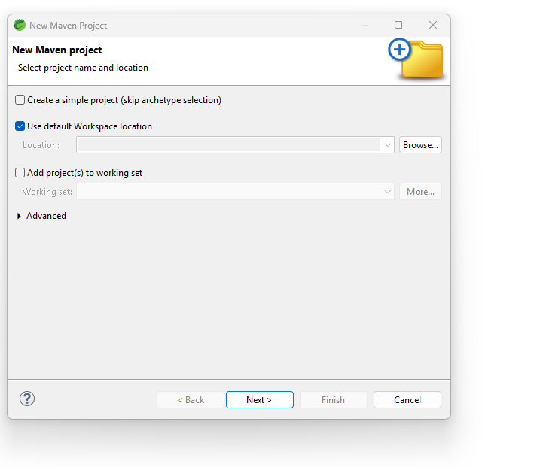
Figure 1 — New Maven Project wizard used during project creation.

5. Layered CRUD Flow
Postman
↓
UserController
↓
UserService / UserServiceImpl
↓
UserRepository
↓
H2 Database
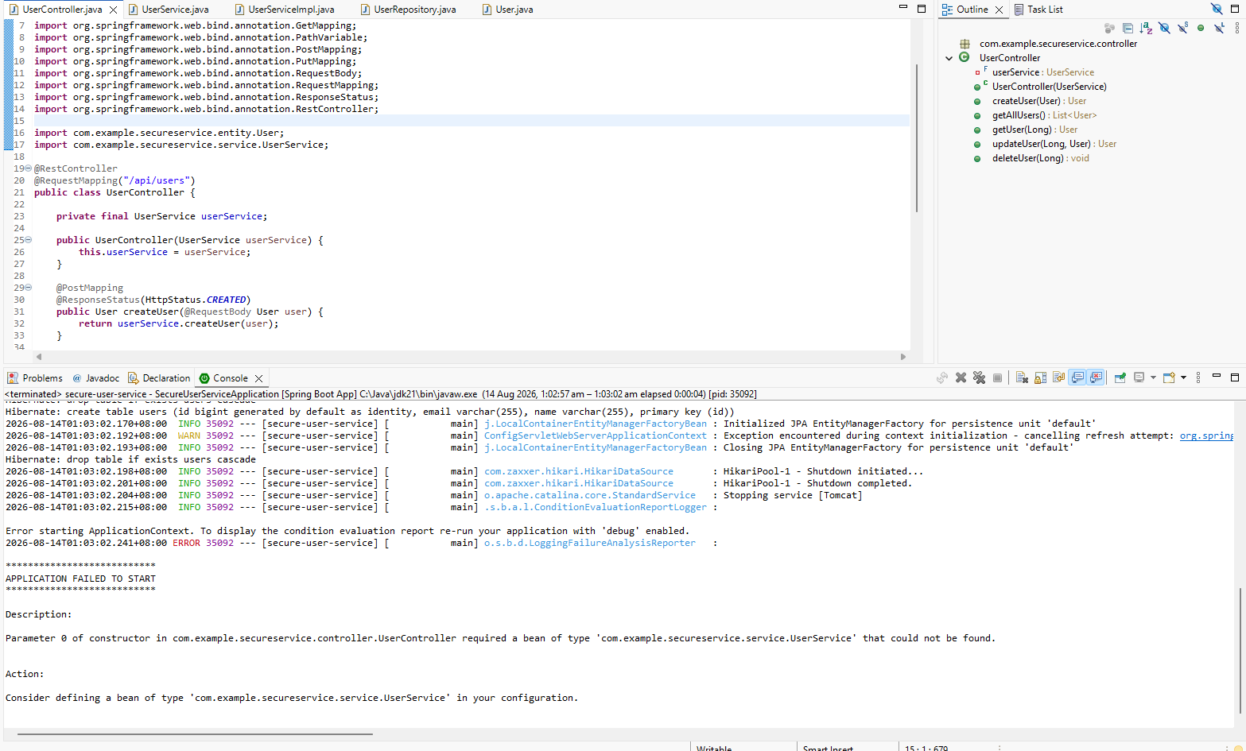
Figure 2 — UserController and service wiring in STS. The screenshot also captures a startup issue encountered during the learning setup.

6. REST Endpoints
Operation | HTTP | Endpoint
Create | POST | /api/users
Read all | GET | /api/users
Read one | GET | /api/users/{id}
Update | PUT | /api/users/{id}
Delete | DELETE | /api/users/{id}
Development base URL used in the later secured setup: http://localhost:8081

7. Example Request
POST /api/users
{
"name": "John",
"email": "john@test.com"
}
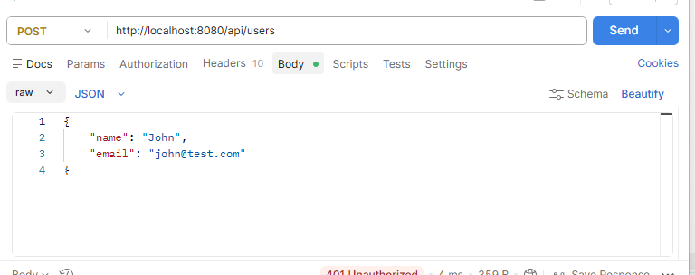
Figure 3 — Postman request body used while testing the user API. This particular screenshot shows the API protected by the later security stage; for Stage 1 the same endpoint was used for CRUD testing.

8. Troubleshooting Notes
- If a service bean is not found, verify @Service, package structure, imports and that the source file is saved.
- If STS itself has Maven plugin/class-loading issues, verify the STS installation is running against a compatible local JDK.
- H2 is an in-memory development database; data is not intended to survive application restarts unless the configuration is changed.

9. Stage 1 Verification
Stage 1 is complete when create, read, update and delete operations work successfully through the controller → service → repository → H2 flow.

