Stage 2 — DTO, Validation & Exception Handling Runbook
Secure User Service | Reproducible hands-on guide
Purpose: improve the Stage 1 API with a clean API boundary, validation and predictable error handling.

1. Outcome
- Introduced DTOs for the API boundary.
- Added request validation.
- Added centralized validation error handling.
- Introduced UserNotFoundException.
- Handled missing-user cases for GET, PUT and DELETE.
- Standardized application error responses.
- Tested validation and error scenarios with Postman.

2. Request Flow
HTTP Request
↓
User DTO
↓
Validation
↓
Service
↓
User Entity
↓
Repository
↓
H2

3. DTO Validation
The request DTO uses Jakarta Bean Validation annotations and the controller triggers validation with @Valid.
@NotBlank
private String name;
@NotBlank
@Email
private String email;

4. Validation Exception Handling
Invalid request bodies raise MethodArgumentNotValidException. The exception handler extracts a useful field-level message and returns an ErrorResponse with HTTP 400.
@ExceptionHandler(MethodArgumentNotValidException.class)
public ErrorResponse handleValidationException(
MethodArgumentNotValidException ex) {
String message = ex.getBindingResult()
.getFieldErrors()
.stream()
.map(error -> error.getField() + ": " + error.getDefaultMessage())
.findFirst()
.orElse("Validation failed");
return new ErrorResponse(
HttpStatus.BAD_REQUEST.value(),
message
);
}

5. Missing User Handling
UserNotFoundException is thrown by the service when a requested user does not exist and is converted into a 404 response by the exception handler.
GET /api/users/999
↓
UserNotFoundException
↓
404 Not Found

6. DELETE Behaviour
A key Stage 2 correction was to make DELETE consistent with GET and PUT: attempting to delete a non-existing user returns 404 instead of silently succeeding.
DELETE /api/users/999
↓
User does not exist
↓
UserNotFoundException
↓
404 Not Found
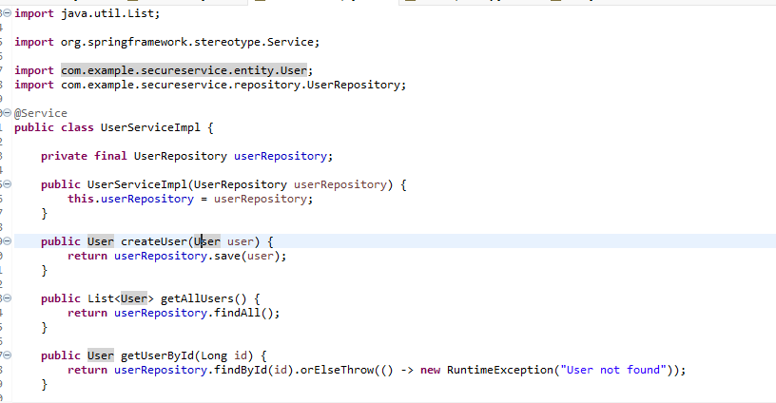
Figure 1 — UserServiceImpl showing repository-backed CRUD methods, including lookup by ID.

7. Error Response
{
"status": 404,
"message": "User not found"
}

8. Test Matrix
Scenario | Expected
Valid create/update | 2xx
Invalid DTO | 400 Bad Request
Existing user lookup | 200 OK
Missing user lookup | 404 Not Found
Update missing user | 404 Not Found
Delete missing user | 404 Not Found

9. Troubleshooting
- If validation is not triggered, verify the DTO annotations and @Valid on the controller request parameter.
- If UserNotFoundException is not handled, verify the exception handler and that the service actually throws the exception.
- The serialVersionUID warning on a custom exception is a Java warning and is unrelated to runtime Stage 2 behavior.

10. Stage 2 Verification
Stage 2 is complete when valid requests succeed, invalid DTOs return 400, missing users return 404, and DELETE handles missing users consistently.

