Stage 3 — OAuth2, JWT, Keycloak & Authorization Runbook
Secure User Service | Reproducible hands-on guide
Purpose: secure the REST API using Keycloak-issued JWT access tokens and Spring Security authorization.

1. Outcome
- Started Keycloak locally.
- Created secure-user-realm.
- Created secure-user-client.
- Created USER and ADMIN realm roles.
- Created separate USER and ADMIN test users.
- Obtained Keycloak access tokens.
- Configured Spring Boot as an OAuth2 Resource Server.
- Mapped Keycloak realm roles to Spring Security authorities.
- Implemented role-based CRUD authorization.
- Verified 401 and 403 behavior.

2. Architecture
Keycloak :8080
│
secure-user-realm
│
JWT token
↓
Postman ── Bearer JWT ──→ Spring Boot :8081
│
Spring Security
│
KeycloakRoleConverter
│
ROLE_USER / ROLE_ADMIN
↓
Controller
↓
Service
↓
Repository
↓
H2

3. Prerequisites & Startup
- Java 21
- Maven
- Keycloak 26.7.1 (version used during this stage)
- Postman
cd C:\Keycloak\keycloak-26.7.1\bin
kc.bat start-dev
Keycloak was run on port 8080. Spring Boot was moved to port 8081 to avoid the port conflict.
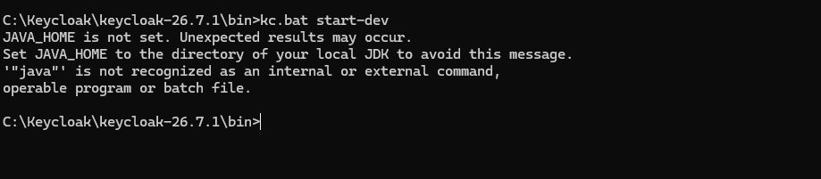
Figure 1 — Keycloak startup command/session from the hands-on setup.

4. Create Realm
Create the realm:
secure-user-realm
Keep it enabled. No resource JSON file was required for the manual setup.
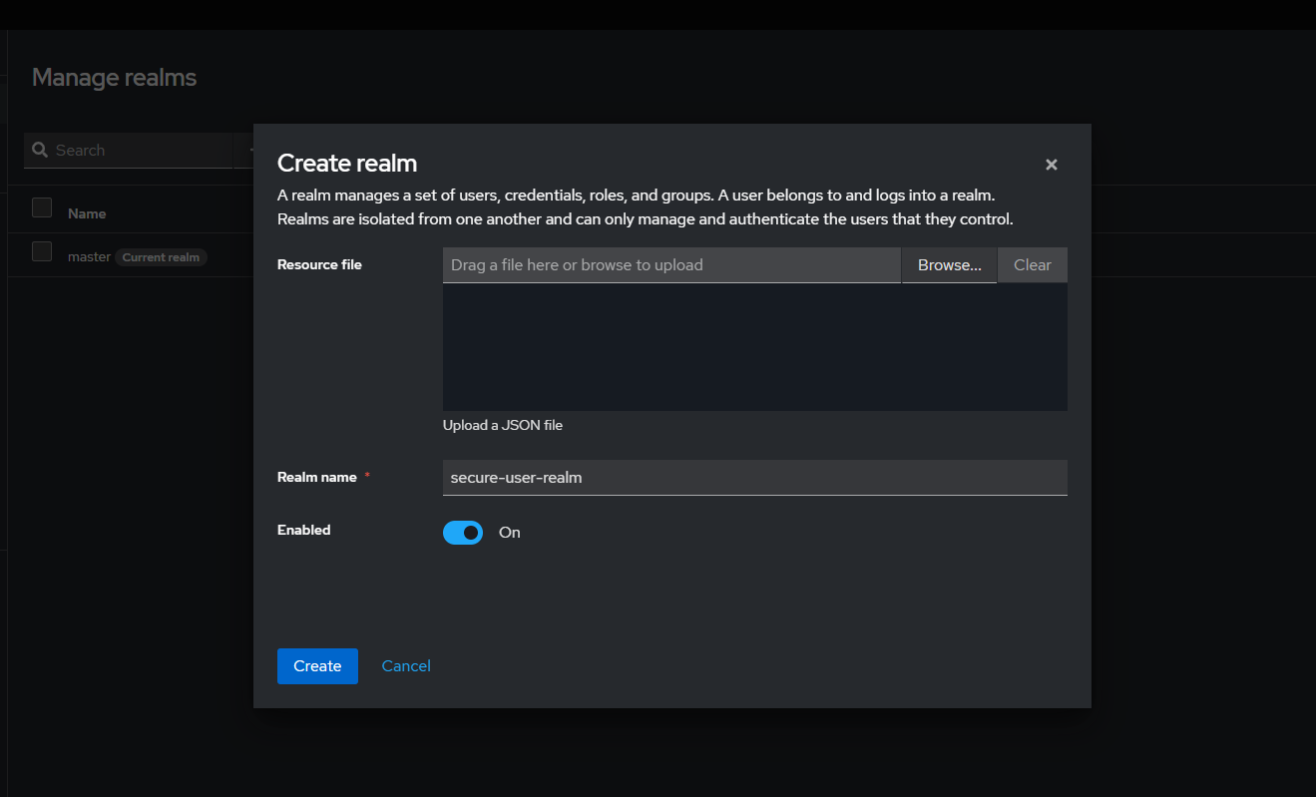
Figure 2 — Keycloak Create Realm screen with secure-user-realm.

5. Create OIDC Client
Create an OpenID Connect client:
secure-user-client
The learning setup enabled a direct username/password token flow so a token could be obtained easily from Postman. Do not use this training configuration as a production recommendation.
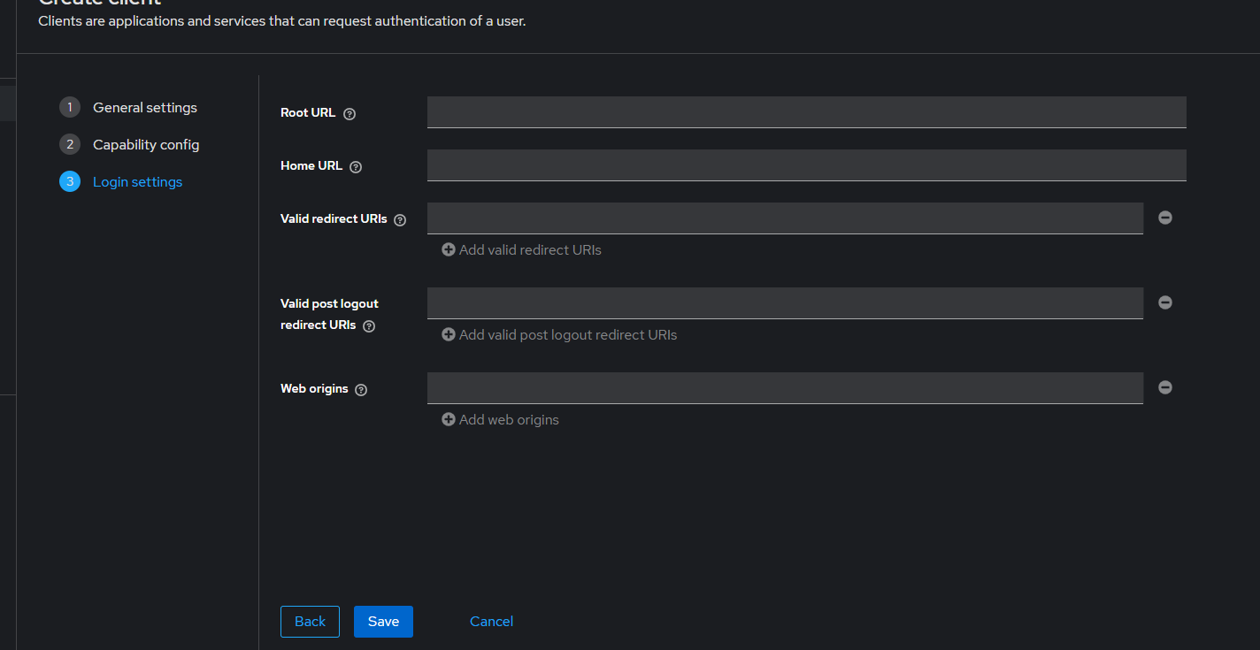
Figure 3 — Keycloak client Login settings screen used during setup.

6. Create Roles and Users
User | Realm role
phani | USER
admin | ADMIN
Do not store the actual passwords, client secrets or tokens in the repository.

7. Token Endpoint
POST http://localhost:8080/realms/secure-user-realm/protocol/openid-connect/token
Use Postman to obtain a fresh access token when testing. Never paste the real token into the runbook or Git repository.

8. Spring Boot Resource Server
The project uses the current Spring Boot security resource-server starter already present in the project.
<dependency>
<groupId>org.springframework.boot</groupId>
<artifactId>spring-boot-starter-security-oauth2-resource-server</artifactId>
</dependency>

9. Issuer URI
spring.security.oauth2.resourceserver.jwt.issuer-uri=http://localhost:8080/realms/secure-user-realm
Issuer URI identifies the trusted Keycloak realm. It is different from the token endpoint.

10. Keycloak Role Conversion
Keycloak puts realm roles under realm_access.roles. Spring Security needs those values converted into authorities.
Keycloak JWT
↓
realm_access.roles
↓
USER / ADMIN
↓
ROLE_USER / ROLE_ADMIN
converter.setJwtGrantedAuthoritiesConverter(
new KeycloakRoleConverter()
);

11. Authorization Model
Endpoint | USER | ADMIN
GET /api/users/** | ALLOW | ALLOW
POST /api/users | DENY (403) | ALLOW
PUT /api/users/** | DENY (403) | ALLOW
DELETE /api/users/** | DENY (403) | ALLOW

12. Authentication vs Authorization
Authentication answers: “Who are you?” Authorization answers: “What are you allowed to do?”
401 → authentication problem
403 → authorization problem
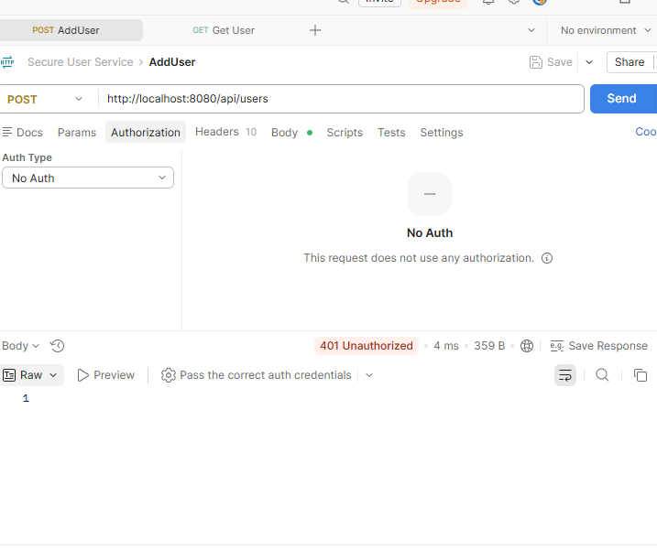
Figure 4 — Postman 401 response when the protected endpoint is called without valid authorization.

13. Verification
- USER token + GET /api/users → 200 OK.
- USER token + POST /api/users → 403 Forbidden.
- ADMIN token + GET /api/users → 200 OK.
- ADMIN token + POST /api/users → successful 2xx response.
- ADMIN token was also used successfully for PUT and DELETE.

14. Important Security Notes
- Never commit access tokens or refresh tokens.
- Never commit client secrets or user passwords.
- Development-mode Keycloak is for local learning/testing, not production.
- If roles are changed, obtain a fresh token before testing so the new role claims are present.

15. Reproduction Checklist
- Start Keycloak.
- Create secure-user-realm.
- Create secure-user-client.
- Create USER and ADMIN roles.
- Create the USER and ADMIN test users and assign roles.
- Configure Spring Boot issuer-uri.
- Start Spring Boot on 8081.
- Obtain fresh Keycloak token.
- Run USER and ADMIN authorization tests.

16. Stage 3 Verification
Stage 3 is complete when Keycloak authentication, JWT validation, role conversion and CRUD authorization all work as tested above.

