Problem 1:Notification System (Strategy + DI)
public interface INotification
{
Task SendAsync(string message);
}
public class EmailNotification : INotification
{
public async Task SendAsync(string message)
{
Console.WriteLine("Email Sent: " + message);

await Task.CompletedTask;
}
}
public class SmsNotification : INotification
{
public async Task SendAsync(string message)
{
Console.WriteLine("SMS Sent: " + message);
await Task.CompletedTask;
}
}
public class NotificationFactory
{
private readonly Dictionary<string, INotification> _services;
public NotificationFactory(IEnumerable<INotification> services)
{
_services = services.ToDictionary(s => s.GetType().Name);
}
public INotification Get(string type)
{
if (_services.ContainsKey(type))
return _services[type];
throw new Exception("Invalid Type");
}
}
public class NotificationService
{
private readonly NotificationFactory _factory;
public NotificationService(NotificationFactory factory)
{
_factory = factory;
}
public async Task Send(string type, string msg)
{
var service = _factory.Get(type);
try
{

await service.SendAsync(msg);
}
catch
{
Console.WriteLine("Retrying...");
await service.SendAsync(msg);
}
}
}
Problem 2:
Thread-Safe Cache
public class CacheItem
{
public string Value { get; set; }
public DateTime Expiry { get; set; }
}
public class CacheService
{
private static readonly object _lock = new();
private static Dictionary<string, CacheItem> _cache = new();
public void Set(string key, string value, int seconds)
{
lock (_lock)
{
_cache[key] = new CacheItem
{
Value = value,
Expiry = DateTime.Now.AddSeconds(seconds)
};
}
}

public string Get(string key)
{
lock (_lock)
{
if (_cache.ContainsKey(key))
{
var item = _cache[key];
if (item.Expiry > DateTime.Now)
return item.Value;
_cache.Remove(key);
}
return null;
}
}
}

Problem 3: JWT Authentication (Basic)
public string GenerateToken(string userId)
{
var key = new SymmetricSecurityKey(Encoding.UTF8.GetBytes("secretkey123"));
var creds = new SigningCredentials(key, SecurityAlgorithms.HmacSha256);
var token = new JwtSecurityToken(
claims: new[] { new Claim("UserId", userId) },
expires: DateTime.Now.AddMinutes(15),
signingCredentials: creds);
return new JwtSecurityTokenHandler().WriteToken(token);
}
Problem 4: Rate Limiter
public class RateLimiter
{
private Dictionary<string, List<DateTime>> _requests = new();
public bool IsAllowed(string user)
{
if (!_requests.ContainsKey(user))
_requests[user] = new List<DateTime>();
var now = DateTime.Now;
_requests[user].RemoveAll(t => (now - t).TotalSeconds > 10);
if (_requests[user].Count >= 5)
return false;
_requests[user].Add(now);
return true;
}
}

Problem 5:Deadlock Example
object lock1 = new object();
object lock2 = new object();
void Method1()
{
lock (lock1)
{
Thread.Sleep(100);
lock (lock2)
{
Console.WriteLine("Method1");
}
}
}
void Method2()
{
lock (lock2)
{
Thread.Sleep(100);
lock (lock1)

{
Console.WriteLine("Method2");
}
}
}
Problem 6:Custom HashMap (Simple)
public class MyHashMap
{
private List<(int key, string value)>[] buckets;
public MyHashMap(int size)
{
buckets = new List<(int, string)>[size];
}
private int Hash(int key) => key % buckets.Length;
public void Add(int key, string value)
{
int index = Hash(key);
if (buckets[index] == null)
buckets[index] = new List<(int, string)>();
buckets[index].Add((key, value));
}
public string Get(int key)
{
int index = Hash(key);
if (buckets[index] != null)
{
foreach (var item in buckets[index])
{
if (item.key == key)
return item.value;
}
}
return null;
}
}

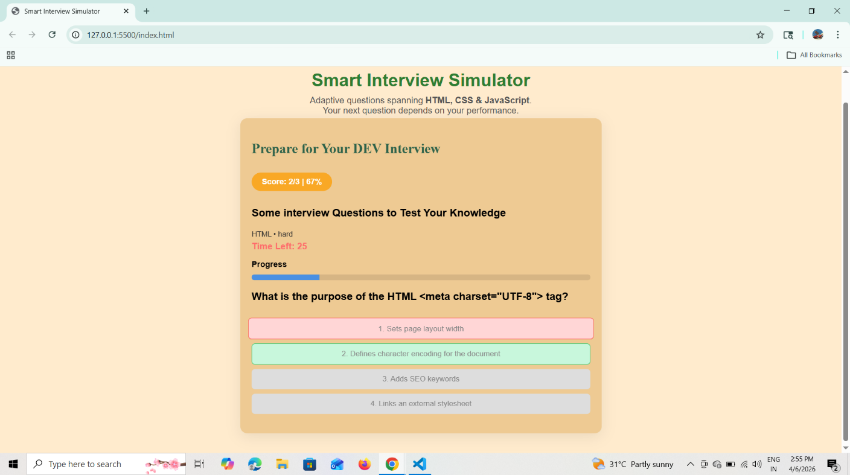
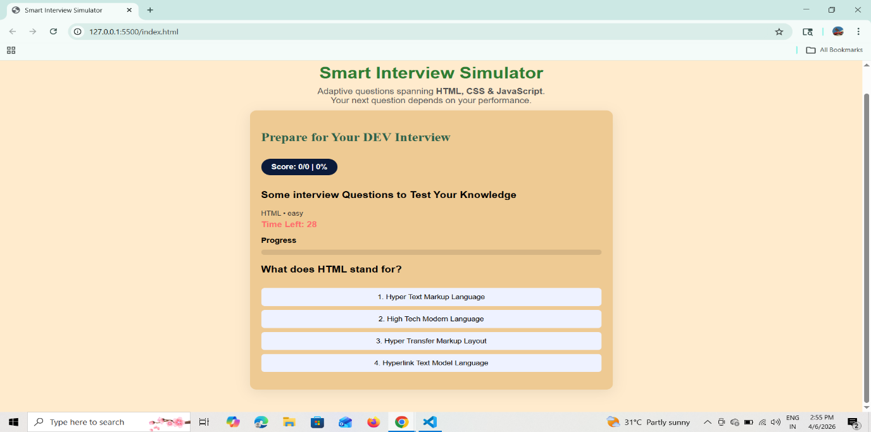
Smart Interview Simulator
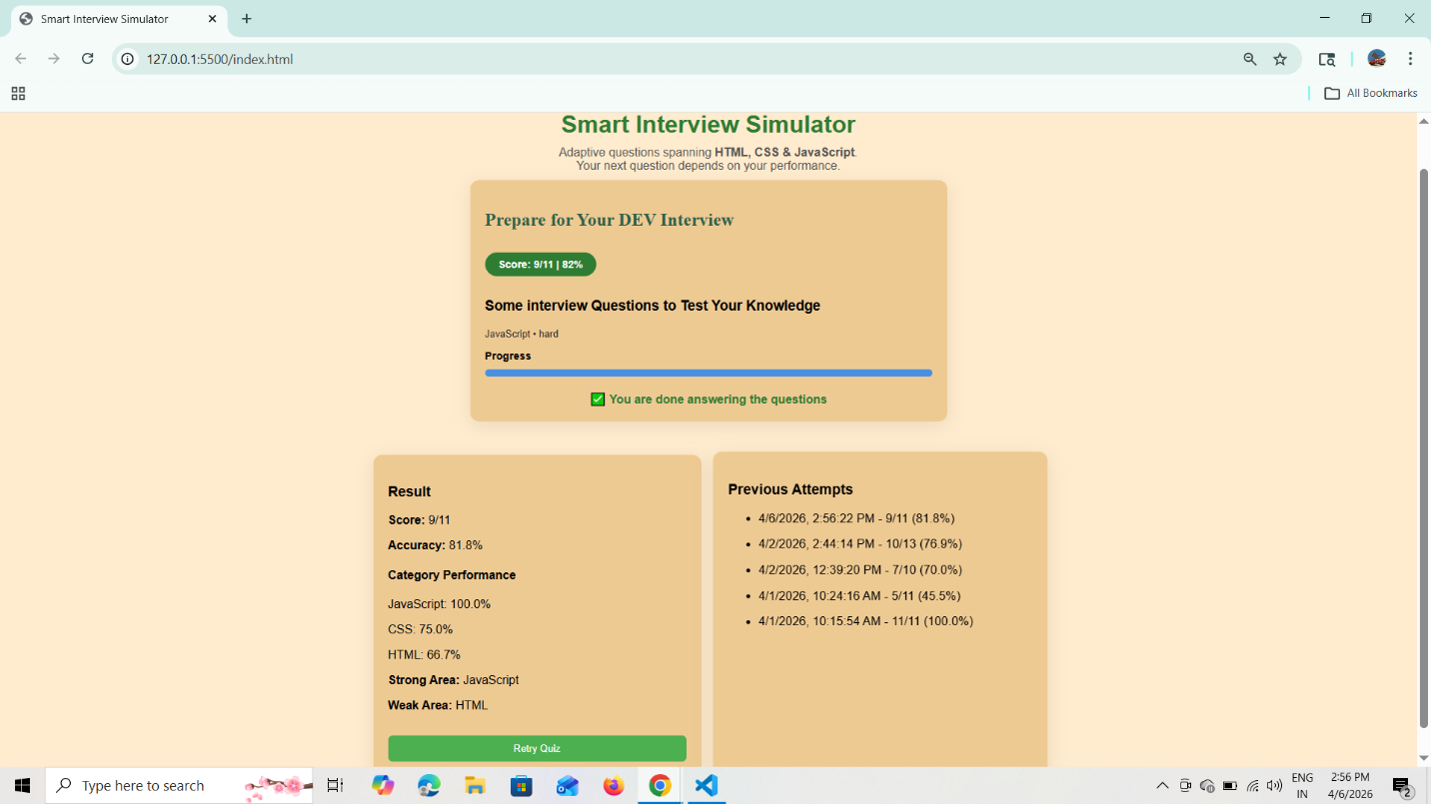


HealthCare App
