**PREDICTIVE DIABETIC ANALYSIS**

**A PROJECT REPORT**

***Submitted by***

**K.POOJITH RA2211030020006**

**V.M.KARTHIK RA2211030020032 K.BHARATH SRI RAM RA2211030020039**

Under the guidance of

**Mrs. J.ARTHY M.E.,Ph.D.,**

(Assistant Professor, Department of Computer Science and Engineering)

**21CSC205P/DATA BASE MANAGEMENT SYSTEM PROJECT REPORT**

**IV SEMESTER/II YEAR**

**COMPUTER SCIENCE AND ENGINEERING**

**WITH**

**SPECIALIZTION IN CYBER SECURITY**

COLLEGE OF ENGINEERING AND TECHNOLOGY



**SRM INSTITUTE OF SCIENCE AND TECHNOLOGY RAMAPURAM, CHENNAI**

MAY 2024

**ABSTRACT**

In recent years, the prevalence of diabetes has surged globally, necessitating innovative approaches to early detection and management. This project explores a predictive analysis framework using machine learning to enhance the early diagnosis and prognosis of diabetes. The primary objective is to develop a predictive model that can accurately forecast the likelihood of diabetes onset based on patient health data. The project leverages a comprehensive dataset comprising demographic, clinical, and lifestyle information from diabetic and non-diabetic individuals. Various machine learning algorithms, including Logistic Regression, Decision Trees, Random Forests, and Gradient Boosting Machines, are employed to analyze and model the data. The efficacy of these models is evaluated using performance metrics such as accuracy, precision, recall, and F1-score. Feature importance is assessed to identify key predictors of diabetes, facilitating insights into the most influential factors contributing to the disease. The model's performance is validated through cross-validation techniques and tested on unseen data to ensure robustness and generalizability. The ultimate goal is to create a reliable tool that can assist healthcare professionals in identifying individuals at high risk for diabetes, thereby enabling timely interventions and personalized treatment plans.

**TABLE OF CONTENTS**

|  |  |  |
| --- | --- | --- |
| **CHAPTER NO** | **TITLE** | **PAGE NO** |
|  | **ABSTRACT** | **i** |
|  | **LIST OF FIGURES** | **iii** |
|  | **LIST OF ABBREVIATIONS** | **iv** |
| **1** | **INTRODUCTION** | 1 |
|  | 1.1 Introduction:DBMS,RDBMS,SQL | 1 |
|  | 1.2 Problem statement | 2 |
|  | 1.3 Objectives | 4 |
|  | 1.4 Scope and Motivation | 6 |
| **2** | **EXISTING SYSTEM** | **7** |
| **3** | **DESIGN** | 9 |
|  | 3.1 Entity Relationship | 9 |
|  | 3.2Front End Design | 11 |
| **4** | **PROPOSED METHODOLOGY** | 12 |
| **5** | **IMPLEMENTATION** | 14 |
| **6** | **RESULT AND DISCUSSION** | 25 |
|  | 6.1 Result in Python | 25 |
|  | 6.2Discussion | 28 |
| **7** | **CONCLUSION** | 30 |
|  | **REFERENCES** | 31 |

1. **INTRODUCTION**

The global epidemic of diabetes has reached unprecedented levels, impacting millions of individuals worldwide and placing a significant burden on healthcare systems. Diabetes, characterized by chronic hyperglycemia resulting from defects in insulin production, insulin action, or both, has become a major public health concern. The World Health Organization (WHO) estimates that the prevalence of diabetes among adults has nearly quadrupled over the last few decades, and this trend is expected to continue. Effective management and early detection of diabetes are critical to mitigating its impact, yet current methods of diagnosis often fall short in terms of timeliness and precision.

Traditional diagnostic practices for diabetes largely rely on direct measurements of blood glucose levels and associated symptoms, which often result in late-stage detection when the disease has already caused significant health complications. In light of this, there is a growing need for advanced methodologies that can predict diabetes risk before the onset of symptoms, enabling proactive healthcare interventions. This project seeks to address this need through the application of machine learning techniques to predictive analytics, aiming to develop a model that can accurately forecast diabetes risk based on a variety of patient data.

Machine learning, a subset of artificial intelligence, offers powerful tools for analyzing complex datasets and identifying patterns that might be missed by traditional statistical methods. By training algorithms on large volumes of historical data, machine learning models can learn to recognize patterns and correlations associated with diabetes risk. The potential for machine learning to enhance predictive accuracy and support early diagnosis has been demonstrated in various domains, including medical diagnostics. This project builds upon this premise by applying advanced machine learning algorithms to a comprehensive dataset that includes demographic, clinical, and lifestyle information from both diabetic and non-diabetic individuals.

The dataset used in this project is crucial for training and validating the predictive model. It encompasses a wide range of variables, including age, gender, body mass index (BMI), blood pressure, glucose levels, and other relevant health indicators. By analyzing these factors, the machine learning model aims to identify key predictors of diabetes and assess their relative importance. The selection of appropriate algorithms is essential for achieving optimal performance. This project explores several machine learning techniques, including Logistic Regression, Decision Trees, Random Forests, and Gradient Boosting Machines, each offering unique strengths in handling different aspects of the data.

Performance evaluation is a critical component of the project. The model's accuracy, precision, recall, and F1-score are measured to assess its effectiveness in predicting diabetes risk. Cross-validation techniques are employed to ensure that the model generalizes well to unseen data and does not overfit to the training set. By validating the model's performance, the project aims to deliver a reliable tool for healthcare professionals, capable of identifying individuals at high risk of developing diabetes.

Beyond improving diagnostic accuracy, the project seeks to provide actionable insights into the factors contributing to diabetes risk. By understanding which variables have the greatest impact, healthcare providers can better target interventions and preventive measures. The model's predictions can inform personalized treatment plans, contributing to more effective management of diabetes and potentially reducing the incidence of severe complications.

The integration of predictive analytics into diabetes management represents a significant advancement in the field of healthcare. This project not only aims to develop a robust predictive model but also to demonstrate the potential of machine learning in transforming medical diagnostics. The findings are expected to offer valuable contributions to the ongoing research in predictive health analytics and may serve as a foundation for future innovations in the early detection and management of chronic diseases.

Evaluating the performance of the predictive model is a critical aspect of this project. The model’s effectiveness will be assessed using key metrics such as accuracy, precision, recall, and F1-score. Accuracy measures the overall correctness of the model, while precision and recall provide insights into its ability to correctly identify high-risk individuals and avoid false positives.

The F1-score, a harmonic mean of precision and recall, offers a balanced measure of the model’s performance. Cross-validation techniques will be employed to test the model’s robustness and generalizability, ensuring that it performs well on unseen data and is not overfitted to the training dataset.

The implications of this project extend beyond just improving predictive accuracy. By identifying the key predictors of diabetes, the model can provide valuable insights into the factors most strongly associated with the disease. This information can guide healthcare professionals in tailoring preventive measures and interventions to individuals at high risk, potentially reducing the incidence of diabetes and its associated complications. Additionally, the model's predictions can inform public health strategies and policy-making by highlighting trends and areas where targeted interventions are needed.

Furthermore, the integration of predictive analytics into diabetes management represents a broader shift towards personalized medicine. As healthcare increasingly moves towards individualized care, predictive models will play a crucial role in enabling precise and tailored treatment plans. This project contributes to this paradigm shift by demonstrating the potential of machine learning to enhance disease prediction and management.

The project aims to address a critical need in diabetes management by developing a predictive model using machine learning techniques. Through the analysis of comprehensive health data, the project seeks to improve early detection, facilitate personalized interventions, and ultimately enhance patient outcomes. The application of advanced predictive analytics in healthcare not only offers the potential for more effective disease management but also paves the way for future innovations in medical diagnostics and personalized care. By advancing our understanding of diabetes risk factors and refining predictive methodologies, this project represents a significant step forward in the quest to combat one of the most prevalent and challenging health issues of our time.

## DOMAIN DESCRIPTION

Diabetes mellitus is a chronic metabolic disorder characterized by high blood glucose levels, which result from defects in insulin secretion, insulin action, or both. This condition is primarily classified into two major types: Type 1 diabetes (T1D) and Type 2 diabetes (T2D). Type 1 diabetes is an autoimmune disease where the immune system attacks and destroys insulin- producing beta cells in the pancreas, leading to an absolute deficiency of insulin. It typically manifests in childhood or early adulthood and requires lifelong insulin therapy. In contrast, Type 2 diabetes, which accounts for the majority of diabetes cases worldwide, is primarily a result of insulin resistance combined with an eventual decline in insulin production. T2D is often associated with obesity, physical inactivity, and genetic predisposition, and it usually develops in adulthood, although it is increasingly being diagnosed in younger populations due to rising obesity rates.

The global burden of diabetes is substantial and growing. According to the International Diabetes Federation (IDF), approximately 537 million adults were living with diabetes in 2021, and this number is projected to increase to 783 million by 2045. Diabetes is a leading cause of morbidity and mortality worldwide, contributing to a range of complications such as cardiovascular disease, stroke, nephropathy, retinopathy, and neuropathy. The disease also imposes a significant economic burden on healthcare systems due to the high costs associated with management, treatment, and complications. The impact of diabetes extends beyond the individual to society at large. The disease contributes to reduced quality of life, increased healthcare costs, and loss of productivity. Given the magnitude of the diabetes epidemic, there is an urgent need for effective strategies for early detection, prevention, and management of the disease.

Traditional methods for diagnosing diabetes involve measuring blood glucose levels through fasting plasma glucose (FPG) tests, oral glucose tolerance tests (OGTT), and HbA1c measurements. These diagnostic tests are effective but can be limited by their reactive nature, detecting the disease only after significant metabolic changes have occurred. For Type 2 diabetes, diagnosis often occurs during routine screening, when patients may already be experiencing complications. Management of diabetes typically involves lifestyle modifications, pharmacotherapy, and regular monitoring of blood glucose levels. For Type 1 diabetes, insulin therapy is essential, while Type 2 diabetes management may include oral hypoglycemic agents,

insulin, and lifestyle changes. Despite these strategies, achieving optimal glycemic control remains a challenge for many patients, and the risk of complications persists.

In the realm of diabetes management, predictive analytics and machine learning offer a transformative approach to early diagnosis and personalized care. Predictive analytics involves the use of statistical techniques and algorithms to forecast future outcomes based on historical data. Machine learning, a subset of artificial intelligence, takes this a step further by enabling algorithms to learn from data and make predictions without explicit programming. Machine learning models can analyze vast amounts of data to identify patterns and relationships that may not be apparent through traditional methods. In the context of diabetes, machine learning can be applied to predict the risk of developing the disease based on various factors, including demographic information, clinical measurements, and lifestyle choices. By identifying individuals at high risk of diabetes before the onset of symptoms, healthcare providers can implement preventive measures and personalized interventions.

The integration of predictive analytics and machine learning into diabetes management has the potential to revolutionize the field. By enabling early detection and personalized interventions, these technologies can improve patient outcomes, reduce the burden of disease, and contribute to more efficient healthcare delivery. Future research may focus on enhancing predictive models by incorporating additional data sources, such as genetic information and real- time health monitoring data from wearable devices. Advances in technology and data collection methods will continue to drive improvements in predictive analytics and personalized medicine.

In conclusion, the application of machine learning to diabetes prediction represents a significant advancement in the quest to manage and prevent this global health crisis. By leveraging comprehensive data and sophisticated algorithms, predictive models can offer valuable insights and support proactive healthcare strategies. This domain is poised for continued innovation, with the potential to transform diabetes management and improve health outcomes on a global scale.

# About Project

* + 1. **Problem Definition**

Diabetes is a chronic condition affecting millions worldwide, leading to severe health complications such as cardiovascular diseases, kidney failure, and nerve damage. Early detection and management are crucial to mitigating these risks and improving patients' quality of life. With advancements in data analytics and machine learning, predicting the onset and progression of diabetes is now possible, enabling proactive healthcare interventions. This project aims to develop a predictive model to forecast the likelihood of an individual developing diabetes by analyzing historical patient data, including demographic information, medical history, lifestyle factors, and clinical measurements. The scope of the project includes data collection and preprocessing, feature engineering, model development, validation, and testing, ensuring the model's accuracy and robustness. Additionally, the project will focus on interpretability, providing insights into key predictors and their impact on diabetes risk. Challenges include ensuring data quality and availability, selecting relevant features, balancing model accuracy with interpretability, and addressing ethical considerations related to patient privacy and data security. The expected outcomes are an accurate predictive model, actionable insights into risk factors, and a decision support tool for healthcare providers to assess diabetes risk and recommend preventive actions, ultimately improving patient outcomes.

Despite the promising potential of predictive diabetic analysis, the project faces several challenges. Ensuring the availability of high-quality and comprehensive patient data is critical, but it can be challenging due to privacy concerns and inconsistencies in data collection. Identifying the most relevant features from a potentially large and noisy dataset requires domain expertise and robust statistical techniques. Balancing model accuracy with interpretability is crucial, as healthcare providers must trust and understand the rationale behind predictions. Ethical considerations related to patient privacy, data security, and the potential consequences of mispredictions must also be addressed.

Finally, the development of a practical decision support tool will assist healthcare providers in assessing diabetes risk and recommending preventive actions, ultimately improving patient outcomes and contributing to better management and prevention of diabetes on a broader scale.

# Proposed Solution

To address the increasing prevalence of diabetes and its severe health complications, this project aims to develop a predictive model that forecasts the likelihood of an individual developing diabetes. The solution begins with comprehensive data collection and preprocessing, gathering datasets from electronic health records (EHR), patient surveys, and wearable devices. Ensuring data quality is crucial; thus, the project will implement techniques for data cleaning, addressing missing values, and standardizing formats. Data normalization will be performed to improve model performance, ensuring that numerical features are scaled appropriately.

Feature engineering is a critical next step, involving the identification and selection of relevant features that contribute to diabetes risk, such as age, BMI, blood pressure, glucose levels, family history, physical activity, and dietary habits. New features may be generated using domain knowledge, and categorical variables will be encoded into numerical values. The model development phase will explore various machine learning algorithms, including logistic regression, decision trees, random forests, support vector machines (SVM), and neural networks. Hyperparameter tuning will optimize model parameters to enhance performance, and techniques to handle class imbalance will be incorporated if necessary.

Model evaluation and validation are essential to ensure the model's accuracy and robustness. Performance metrics such as accuracy, precision, recall, F1-score, and AUC-ROC will be used to evaluate the models. K-fold cross-validation will be performed to ensure model stability and mitigate overfitting, and a separate test dataset will be used for validation. Model interpretability will be prioritized using techniques like feature importance analysis and SHapley Additive exPlanations (SHAP) values, providing detailed insights into the contribution of each feature to individual predictions and enhancing transparency.

The deployment phase involves developing a user-friendly interface or tool that allows healthcare providers to input patient data and receive real-time diabetes risk predictions. This tool will integrate actionable recommendations based on the predicted risk, offering guidance on lifestyle changes, dietary adjustments, or further medical tests. Scalability will be ensured for deployment in clinical settings. This proactive approach aims to improve patient outcomes and contribute to the prevention of diabetes-related complications.

# Objectives

## Develop an Accurate Predictive Model:

Create a machine learning model capable of accurately predicting the likelihood of an individual developing diabetes based on historical patient data. Ensure the model’s predictions are reliable and clinically relevant, with high performance metrics such as accuracy, precision, recall, and AUC-ROC.

## Identify Key Risk Factors:

Analyze patient data to identify and quantify the most significant factors contributing to diabetes risk, including demographic information, medical history, lifestyle factors, and clinical measurements. Provide insights into how these risk factors interact and impact the likelihood of developing diabetes.

## Enhance Model Interpretability:

Implement techniques such as feature importance analysis and SHapley Additive exPlanations (SHAP) values to make the model’s decision-making process transparent.

Ensure healthcare providers can understand and trust the rationale behind the model’s predictions, facilitating informed decision-making.

## Address Ethical Considerations:

Ensure ethical use of the predictive model by providing clear explanations and maintaining transparency about predictions. Regularly audit the model for biases and disparities to ensure fair and equitable treatment across different patient groups.

## Validate and Generalize the Model:

Perform rigorous validation using cross-validation techniques and separate test datasets to ensure the model’s generalizability and robustness. Continuously monitor model performance and update it with new data to maintain accuracy and relevance over time.

**Promote Early Detection and Prevention**: Enable early identification of high-risk individuals to implement timely and targeted preventive measures, reducing the incidence and progression

of diabetes. improve patient outcomes through proactive management and intervention strategies informed by predictive analytics. . Model interpretability will be prioritized using techniques like feature importance analysis and SHapley Additive exPlanations (SHAP) values, providing detailed insights into the contribution of each feature to individual predictions and enhancing transparency.

## Facilitate Continuous Improvement:

Establish a feedback loop with healthcare providers to refine the model and enhance its practical utility. Stay updated with advancements in machine learning and healthcare analytics to incorporate new techniques and improve the model’s performance over time.

## Support Scalability and Integration:

Ensure the predictive tool is scalable and can handle large volumes of data for deployment in diverse clinical settings. Integrate the tool seamlessly into existing healthcare systems to support widespread adoption and usage.

## Effective User Engagement and Outreach:

To foster a vibrant library community by actively engaging users, promoting literacy, and facilitating collaborative learning and research initiatives. Establish interactive communication channels, such as chatbots, forums, and social media integration, to facilitate real-time assistance, feedback, and community engagement.

## Data-driven Decision Making and Analytics:

To leverage data analytics and insights to inform strategic decision-making, optimize resource allocation, and enhance library services and operations. Implement robust analytics tools to analyze library usage patterns, collection performance, user demographics, and trends, providing actionable insights for service improvement. Utilize predictive analytics to forecast demand for library materials, anticipate user needs, and optimize collection development and procurement strategies.

# Existing System

The existing systems for diabetes prediction and management are primarily centered around traditional medical practices and basic statistical analysis. These systems often rely on manual assessment of risk factors by healthcare providers, using standard clinical guidelines and patient history to identify individuals at risk of developing diabetes. While effective to some extent, these methods are limited by the complexity and variability of diabetes as a condition.

Current data collection methods involve gathering patient information through medical records, patient interviews, and routine lab tests. Electronic Health Records (EHRs) are commonly used to store and manage patient data, including demographic information, medical history, and clinical measurements. However, the integration and standardization of data from diverse sources remain a challenge, often leading to incomplete or inconsistent datasets.

Healthcare providers traditionally assess diabetes risk based on clinical guidelines, such as those provided by the American Diabetes Association (ADA). These guidelines use factors like age, BMI, family history, and glucose levels to evaluate risk. Although useful, this approach relies heavily on the clinician’s expertise and judgment, potentially leading to variability in risk assessment accuracy.

Some existing systems employ basic statistical models, such as logistic regression, to predict diabetes risk. These models use a limited set of predefined variables to estimate the probability of developing diabetes. While these models provide a more structured approach than manual assessments, they often lack the complexity needed to capture the multifaceted nature of diabetes risk. This tool will integrate actionable recommendations based on the predicted risk, offering guidance on lifestyle changes, dietary adjustments, or further medical tests. Scalability will be ensured for deployment in clinical settings.

Regular health screenings and tests, such as fasting blood glucose and HbA1c tests, are standard practices for monitoring and diagnosing diabetes. These tests provide crucial data points for risk assessment but are typically used in a reactive rather than predictive manner. The focus is on

diagnosing diabetes once symptoms or high-risk indicators are already present, rather than proactively identifying potential cases.

The existing systems often struggle with the selection and analysis of relevant features. With diabetes being influenced by a wide range of factors, from genetic predisposition to lifestyle choices, current models may not fully utilize all available data. This limitation hinders the ability to make precise predictions and identify subtle risk patterns.

Advanced machine learning techniques, which can handle large and complex datasets, are underutilized in existing systems. Traditional models are not designed to leverage the predictive power of techniques like random forests, support vector machines, or neural networks. This gap results in missed opportunities for more accurate and comprehensive risk prediction.

Ensuring data privacy and security is a significant challenge in the current system. The sensitive nature of medical data requires stringent measures to protect patient information. Existing systems must navigate complex regulations like HIPAA, often leading to cautious data-sharing practices that can limit collaborative efforts and data access for predictive modeling.

Ethical considerations and biases in existing predictive models are critical issues. Current systems may inadvertently incorporate biases based on socioeconomic factors, race, or gender, leading to disparities in risk prediction and healthcare delivery. Ensuring fairness and transparency in predictive analytics is an ongoing concern.

The limitations of existing systems highlight the need for more sophisticated predictive models. Integrating advanced machine learning techniques, improving data collection and preprocessing methods, and enhancing model interpretability are essential steps forward.

# Proposed system

The proposed system for predictive diabetic analysis aims to leverage advanced machine learning techniques and comprehensive data integration to provide a robust and accurate prediction model. Unlike traditional systems that rely heavily on manual risk assessments and basic statistical models, the new approach will utilize diverse data sources, including electronic health records (EHR), patient surveys, and wearable devices, to gather extensive patient information. This integration will ensure that the predictive model has access to a wide array of demographic, clinical, and lifestyle data, thereby improving its accuracy and reliability.

To address the issue of data quality and consistency, the proposed system will implement rigorous data preprocessing techniques. This includes data cleaning to handle missing values and correct errors, as well as data normalization to ensure numerical features are on a common scale. Feature engineering will play a critical role in the system, with the identification and creation of relevant features that significantly contribute to diabetes risk prediction. By combining domain knowledge with statistical methods, the system will generate new features and encode categorical variables to enhance the predictive power of the model.

The core of the proposed system lies in the development and deployment of advanced machine learning models. Various algorithms such as logistic regression, decision trees, random forests, support vector machines (SVM), and neural networks will be explored. Each model will undergo rigorous training and hyperparameter tuning to optimize performance. Techniques like grid search and randomized search will be employed to find the best set of parameters, ensuring that the models are both accurate and generalizable. Additionally, handling class imbalance in the dataset will be a priority to ensure that the model performs well across all patient groups.

Model evaluation and validation are crucial to the success of the proposed system. The performance of the models will be assessed using a range of metrics, including accuracy, precision, recall, F1-score, and AUC-ROC. To ensure the robustness and stability of the models, k-fold cross- validation will be conducted, and a separate test dataset will be used for final validation. This comprehensive evaluation process will help identify the most effective model for predicting diabetes risk, providing confidence in its real-world applicability.

One of the key innovations in the proposed system is the emphasis on model interpretability. Understanding the decision-making process of complex machine learning models is essential, especially in healthcare. The system will incorporate techniques such as feature importance analysis and SHapley Additive exPlanations (SHAP) values to elucidate the contribution of each feature to the model's predictions. This transparency will enable healthcare providers to trust the model's outputs and make informed decisions based on clear, understandable rationale.

The deployment phase of the proposed system will focus on creating a user-friendly interface for healthcare providers. This interface will allow easy input of patient data and provide real-time diabetes risk predictions along with actionable recommendations. The recommendations will be based on the predicted risk, offering guidance on lifestyle changes, dietary adjustments, or further medical tests. Ensuring the interface is intuitive and accessible will be paramount to its adoption and effective use in clinical settings.

Data privacy and security are integral to the proposed system, given the sensitive nature of medical information. Robust measures will be implemented to protect patient data, ensuring compliance with regulations such as HIPAA. Secure data storage, encryption, and access controls will be in place to safeguard information and maintain patient confidentiality. By addressing these privacy concerns, the system aims to build trust with users and facilitate broader data sharing for improved model performance.

Ethical considerations will also be a focal point of the proposed system. The ethical use of predictive models will be ensured by providing clear explanations and maintaining transparency about the predictions. Regular audits will be conducted to identify and mitigate any biases in the model, ensuring fair and equitable treatment across different patient groups. This commitment to ethical standards will help avoid disparities in healthcare delivery and enhance the credibility of the predictive model.

Continuous improvement is a key objective of the proposed system. The model will be regularly updated with new data to maintain its accuracy and relevance. A feedback loop with healthcare providers will be established to refine the model based on real-world experiences and insights. Staying updated with the latest advancements in machine learning and healthcare analytics will

enable the system to incorporate new techniques and improve over time, ensuring that it remains at the forefront of predictive diabetic analysis.

In conclusion, the proposed system represents a significant advancement over existing methods for predicting diabetes risk. By integrating diverse data sources, employing advanced machine learning techniques, and focusing on interpretability, privacy, and ethics, the system aims to provide a robust, accurate, and transparent tool for healthcare providers. This proactive approach to diabetes risk prediction will enable early identification of high-risk individuals, facilitating timely and targeted interventions that can improve patient outcomes and contribute to the prevention of diabetes-related complications.

# Advantages of Proposed System

1. **Enhanced Accuracy:** By leveraging advanced machine learning algorithms and comprehensive data integration, the proposed system provides more accurate predictions compared to traditional methods.
2. **Comprehensive Data Utilization:** The system integrates data from diverse sources, including electronic health records (EHR), patient surveys, and wearable devices, ensuring a holistic view of patient health.
3. **Improved Feature Engineering:** Advanced feature selection and engineering techniques enable the identification of key risk factors and the creation of new, meaningful features, enhancing predictive power.
4. **Robust Model Evaluation:** The use of rigorous validation techniques, including k-fold cross- validation and separate test datasets, ensures the robustness and generalizability of the predictive models.
5. **Model Interpretability:** Techniques such as feature importance analysis and SHapley Additive exPlanations (SHAP) values provide transparency, allowing healthcare providers to understand the rationale behind predictions.
6. **Real-Time Predictions:** A user-friendly interface allows healthcare providers to input patient data and receive real-time diabetes risk predictions, facilitating timely decision-making.
7. **Actionable Recommendations:** The system offers actionable recommendations based on the predicted risk, guiding healthcare providers on preventive measures, lifestyle changes, and further medical tests.
8. **Scalability:** Designed for scalability, the system can handle large volumes of data, making it suitable for deployment in diverse clinical settings.
9. **Enhanced Data Privacy:** Robust data security measures ensure patient data privacy and compliance with regulations such as HIPAA, building trust with users.
10. **Bias Mitigation:** Regular audits and bias mitigation strategies ensure fair and equitable treatment across different patient groups, addressing ethical concerns.
11. **Continuous Improvement:** The system is designed for continuous learning and improvement, regularly updating the model with new data to maintain accuracy and relevance.
12. **Proactive Healthcare:** By identifying high-risk individuals early, the system enables proactive healthcare interventions, potentially reducing the incidence and progression of diabetes.
13. **Better Resource Allocation:** Accurate risk predictions help healthcare providers allocate resources more effectively, focusing on high-risk patients who need immediate attention.
14. **Patient Empowerment:** Providing clear explanations and actionable recommendations empowers patients to take informed actions to manage and reduce their diabetes risk.
15. **Research and Development:** The system's ability to incorporate the latest advancements in machine learning and healthcare analytics ensures it remains at the cutting edge of predictive diabetic analysis, fostering ongoing research and development in the field.
16. **DESIGN**
    1. **BLOCK DIAGRAM**

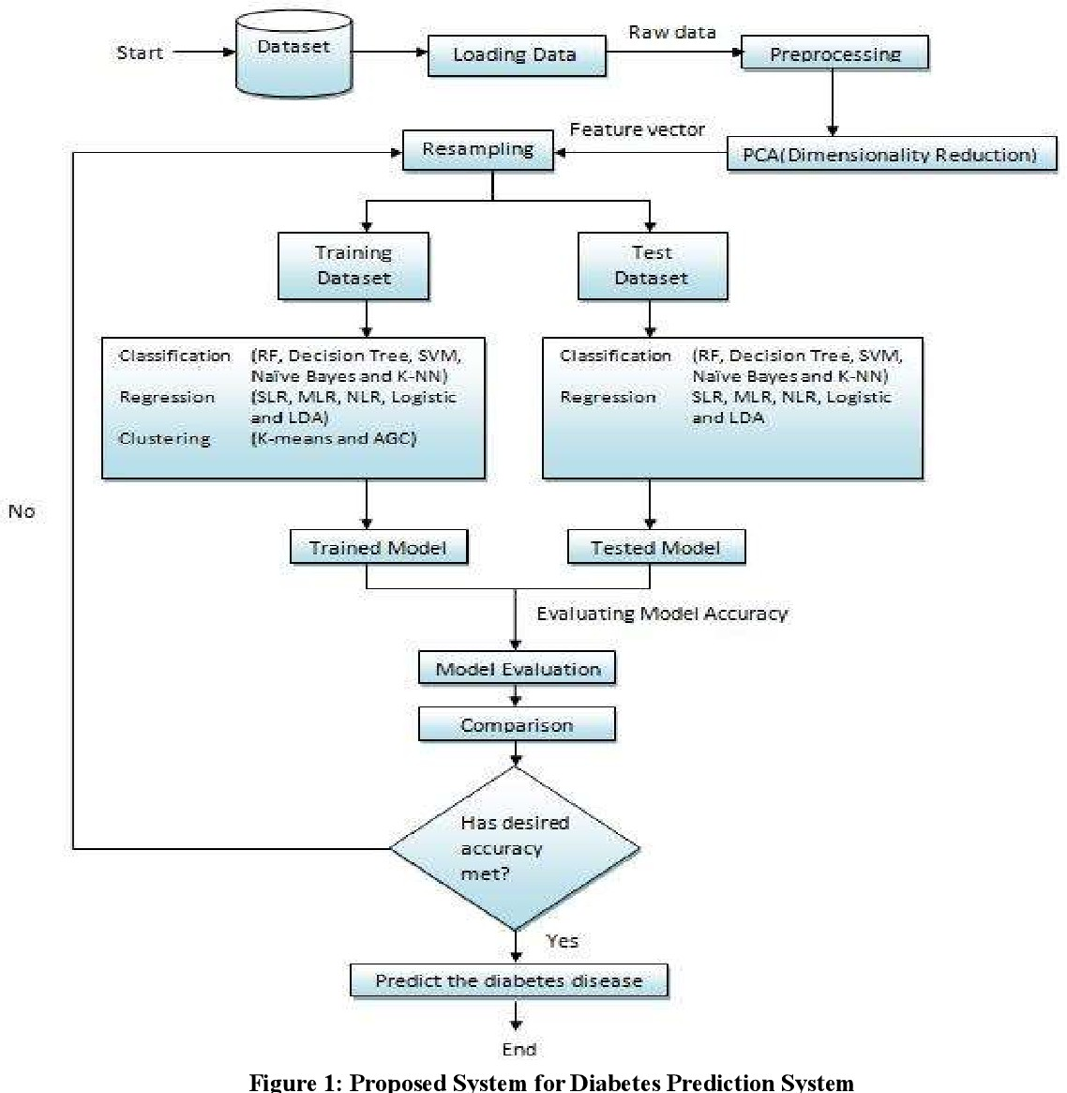

* 1. **UNIFIED MODELLING LANGUAGE**
     1. **USE-CASE DIAGRAM**

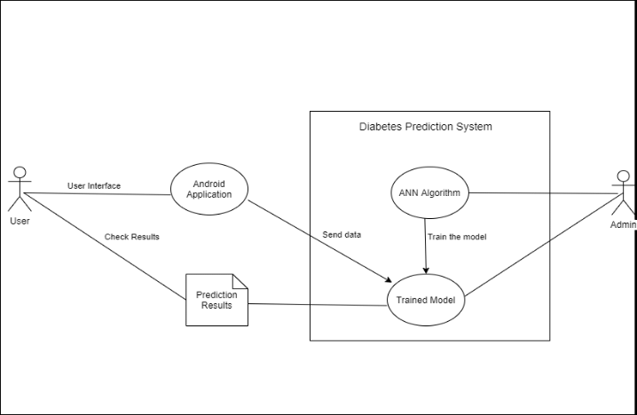

* + 1. **SEQUENCE DIAGARM**

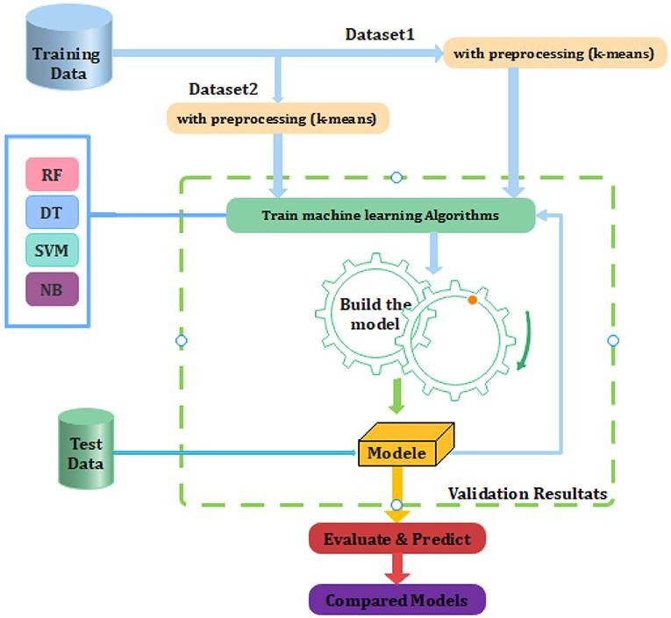

* + 1. **COLLABRATION DIAGRAM**

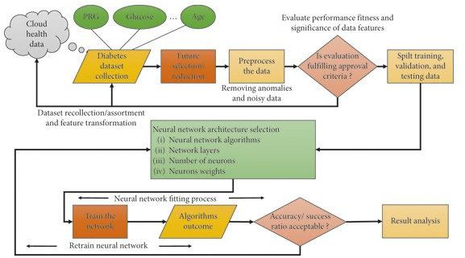

* + 1. **ACTIVITY DIAGRAM**

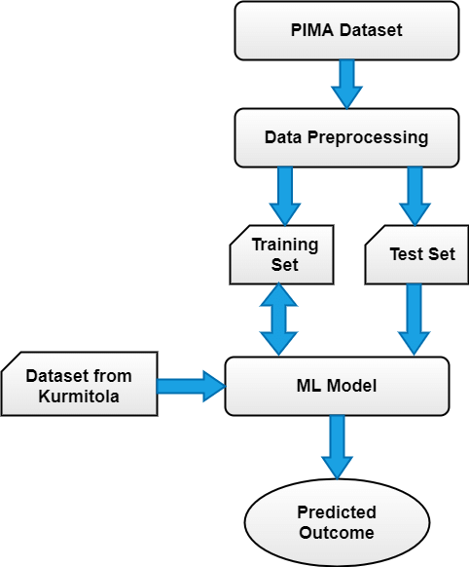

1. **IMPLEMENTATION**

import pandas as pd import seaborn as sns

import matplotlib.pyplot as plt

from imblearn.over_sampling import SMOTE from sklearn.model_selection

import train_test_split, GridSearchCV, cross_val_score from sklearn.preprocessing import StandardScaler from sklearn.neighbors

import KNeighborsClassifier from sklearn.metrics

import classification_report, confusion_matrix, roc_curve, auc # Load the dataset

df = pd.read_csv('/content/drive/MyDrive/disease/diabetes.csv') # Load the dataset

df = pd.read_csv('/content/drive/MyDrive/disease/diabetes.csv') # Print summary statistics

print(df.describe())

# Visualize the distribution of features df.hist(bins=10, figsize=(15, 10)) plt.tight_layout()

plt.show()

# Correlation matrix heatmap plt.figure(figsize=(10, 8))

sns.heatmap(df.corr(), annot=True, cmap='coolwarm') plt.title('Correlation Matrix')

plt.show()

# Separate features and target

X = df.drop('Outcome', axis=1) y = df['Outcome']

# Handle class imbalance

smote = SMOTE(random_state=42) X, y = smote.fit_resample(X, y)

# Split the data

X_train, X_test, y_train, y_test = train_test_split(X, y, test_size=0.2, random_state=42)

# Standardize the features scaler = StandardScaler()

X_train = scaler.fit_transform(X_train) X_test = scaler.transform(X_test)

# Hyperparameter tuning using GridSearchCV param_grid = {'n_neighbors': range(1, 31)}

grid_search = GridSearchCV(KNeighborsClassifier(), param_grid, cv=10, scoring='accuracy')

grid_search.fit(X_train, y_train)

# Best parameters from GridSearchCV best_params = grid_search.best_params_ print(f'Best parameters: {best_params}')

# Create KNN classifier with best parameters

knn = KNeighborsClassifier(n_neighbors=best_params['n_neighbors']) # Cross-validation on the training set

cv_scores = cross_val_score(knn, X_train, y_train, cv=10, scoring='accuracy') print(f'Cross-validation scores: {cv_scores}')

print(f'Mean cross-validation score: {cv_scores.mean()}') # Train the model

knn.fit(X_train, y_train)

# Make predictions

y_pred = knn.predict(X_test)

y_pred_proba = knn.predict_proba(X_test)[:, 1]

# Define a function to provide recommendations based on the prediction def get_recommendations(prediction):

if prediction == 1: return (

"1. Lifestyle Changes:\n"

"- Healthy diet: Emphasize vegetables, fruits, lean proteins, and whole grains.\n"

"- Regular exercise: Aim for at least 150 minutes of moderate aerobic activity per week.\n"

"- Weight management: Achieve and maintain a healthy weight.\n" "- Quit smoking: Seek help to stop smoking if you do.\n"

"2. Medications:\n"

"- Metformin: First-line medication for type 2 diabetes.\n" "- Sulfonylureas: Help the body secrete more insulin.\n"

"- Insulin therapy: Essential for type 1 diabetes and some type 2 diabetes cases.\n"

"- Other medications: GLP-1 receptor agonists, SGLT2 inhibitors, and DPP-4 inhibitors.\n"

"3. Monitoring Blood Sugar Levels:\n"

"- Regular monitoring: Use a glucometer to check blood sugar levels.\n"

"- Continuous glucose monitors (CGMs): Provide real-time blood sugar readings.\n"

"4. Education and Support:\n"

"- Diabetes education programs: Help manage the disease.\n"

)

else:

return "No special recommendations. Maintain a healthy lifestyle." # Map predicted values to a string

y_pred_strings = ['Diabetes' if pred == 1 else 'No Diabetes' for pred in y_pred] # Map actual values to a string

y_test_strings = ['Diabetes' if actual == 1 else 'No Diabetes' for actual in y_test] # Print predictions along with actual outcomes and recommendations predictions = pd.DataFrame({

'Actual': y_test_strings, 'Predicted': y_pred_strings,

'Recommendations': [get_recommendations(pred) for pred in y_pred]

})

print(predictions)

# Model evaluation metrics print(classification_report(y_test, y_pred)) # Confusion Matrix

cm = confusion_matrix(y_test, y_pred) plt.figure(figsize=(8, 6))

sns.heatmap(cm, annot=True, fmt='d', cmap='Blues', xticklabels=['No Diabetes', 'Diabetes'], yticklabels=['No Diabetes', 'Diabetes'])

plt.xlabel('Predicted') plt.ylabel('Actual') plt.title('Confusion Matrix') plt.show()

# ROC Curve

fpr, tpr, _ = roc_curve(y_test, y_pred_proba) roc_auc = auc(fpr, tpr) plt.figure(figsize=(10, 6))

plt.plot(fpr, tpr, color='darkorange', lw=2, label=f'ROC curve (area = {roc_auc:.2f})') plt.plot([0, 1], [0, 1], color='navy', lw=2, linestyle='--')

plt.xlim([0.0, 1.0])

plt.ylim([0.0, 1.05]) plt.xlabel('False Positive Rate') plt.ylabel('True Positive Rate')

plt.title('Receiver Operating Characteristic (ROC) Curve') plt.legend(loc='lower right')

plt.show()

# Count the occurrences of each prediction and actual outcome actual_counts = pd.Series(y_test_strings).value_counts() predicted_counts = pd.Series(y_pred_strings).value_counts()

# Combine the counts into a DataFrame

comparison_df = pd.DataFrame({'Actual': actual_counts, 'Predicted': predicted_counts}).reset_index()

comparison_df.columns = ['Outcome', 'Actual', 'Predicted'] # Plot the bar plot

comparison_df.plot(kind='bar', x='Outcome', figsize=(10, 6)) plt.title('Comparison of Actual vs Predicted Outcomes') plt.ylabel('Count')

plt.show()

from sklearn.svm import SVC

# Define the SVM models to compare svm_models = {

'LinearSVC': SVC(kernel='linear', probability=True, random_state=42), 'RBF_SVC': SVC(kernel='rbf', probability=True, random_state=42),

'Poly_SVC': SVC(kernel='poly', probability=True, random_state=42)

}

# Evaluate each SVM model

for name, model in svm_models.items(): model.fit(X_train, y_train)

y_pred = model.predict(X_test)

y_pred_proba = model.predict_proba(X_test)[:, 1] print(f"\n{name} Classification Report:") print(classification_report(y_test, y_pred))

# Confusion Matrix

cm = confusion_matrix(y_test, y_pred) plt.figure(figsize=(8, 6))

sns.heatmap(cm, annot=True, fmt='d', cmap='Blues', xticklabels=['No Diabetes', 'Diabetes'], yticklabels=['No Diabetes', 'Diabetes'])

plt.xlabel('Predicted') plt.ylabel('Actual')

plt.title(f'{name} Confusion Matrix') plt.show()

# ROC Curve

fpr, tpr, _ = roc_curve(y_test, y_pred_proba) roc_auc = auc(fpr, tpr)

plt.figure(figsize=(10, 6))

plt.plot(fpr, tpr, color='darkorange', lw=2, label=f'ROC curve (area =

{roc_auc:.2f})')

plt.plot([0, 1], [0, 1], color='navy', lw=2, linestyle='--')

plt.xlim([0.0, 1.0])

plt.ylim([0.0, 1.05])

plt.xlabel('False Positive Rate') plt.ylabel('True Positive Rate')

plt.title(f'{name} Receiver Operating Characteristic (ROC) Curve') plt.legend(loc='lower right')

plt.show()

from sklearn.svm import SVC # Train an SVM model

svm = SVC(kernel='linear', probability=True, random_state=42) svm.fit(X_train, y_train)

# Make predictions

y_pred = svm.predict(X_test)

y_pred_proba = svm.predict_proba(X_test)[:, 1] # Evaluate the model print(classification_report(y_test, y_pred))

# Confusion Matrix

cm = confusion_matrix(y_test, y_pred) plt.figure(figsize=(8, 6))

sns.heatmap(cm, annot=True, fmt='d', cmap='Blues', xticklabels=['No Diabetes', 'Diabetes'], yticklabels=['No Diabetes', 'Diabetes'])

plt.xlabel('Predicted') plt.ylabel('Actual')

plt.title('SVM Confusion Matrix') plt.show()

# ROC Curve

fpr, tpr, _ = roc_curve(y_test, y_pred_proba) roc_auc = auc(fpr, tpr) plt.figure(figsize=(10, 6))

plt.plot(fpr, tpr, color='darkorange', lw=2, label=f'ROC curve (area = {roc_auc:.2f})') plt.plot([0, 1], [0, 1], color='navy', lw=2,

linestyle='--') plt.xlim([0.0, 1.0])

plt.ylim([0.0, 1.05]) plt.xlabel('False Positive Rate') plt.ylabel('True Positive Rate')

plt.title('SVM Receiver Operating Characteristic (ROC) Curve') plt.legend(loc='lower right')

plt.show()

#Visualizing Decison Boundaries

from matplotlib.colors import ListedColormap import numpy as np

def plot_decision_boundaries(X, y, model, title): X_set, y_set = X, y

X1, X2 = np.meshgrid(np.arange(start=X_set[:, 0].min() - 1, stop=X_set[:, 0].max() + 1, step=0.01),

np.arange(start=X_set[:, 1].min() - 1, stop=X_set[:, 1].max() + 1, step=0.01)) # Use the same number of features as the model was trained on

X_grid = np.array([X1.ravel(), X2.ravel()] + [np.zeros_like(X1.ravel()) for _ in range(6)]).T

plt.contourf(X1, X2, model.predict(X_grid).reshape(X1.shape), alpha=0.75, cmap=ListedColormap(('red', 'green')))

plt.xlim(X1.min(), X1.max())

plt.ylim(X2.min(), X2.max())

for i, j in enumerate(np.unique(y_set plt.scatter(X_set[y_set == j, 0], X_set[y_set

== j, 1],

c=ListedColormap(('red', 'green'))(i), label=j)

plt.title(title) plt.xlabel('Feature 1')

plt.ylabel('Feature 2') plt.legend() plt.show()

# Assuming knn was fit using a dataset with 8 features:

# Plot decision boundaries for KNN

plot_decision_boundaries(X_train[:, :2], y_train, knn, 'KNN Decision Boundary') # Plot decision boundaries for SVM

plot_decision_boundaries(X_train[:, :2], y_train, svm, 'SVM Decision Boundary') import matplotlib.pyplot as plt

# For linear SVM, the coefficients indicate feature importance if svm.kernel == 'linear':

feature_importance = abs(svm.coef_[0]) feature_names = df.columns[:-1] plt.figure(figsize=(10, 6)) plt.barh(feature_names, feature_importance)

plt.xlabel('Feature Importance') plt.ylabel('Feature') plt.title('Feature Importance for Linear SVM') plt.show()

from sklearn.metrics import precision_recall_curve, f1_score, average_precision_score

# Precision-Recall Curve

precision, recall, _ = precision_recall_curve(y_test, y_pred_proba) average_precision = average_precision_score(y_test, y_pred_proba) plt.figure(figsize=(10, 6))

plt.step(recall, precision, where='post', color='b', alpha=0.2, label='Precision-Recall curve')

plt.fill_between(recall, precision, step='post', alpha=0.2, color='b') plt.xlabel('Recall')

plt.ylabel('Precision')

plt.title(f'Precision-Recall curve: AP={average_precision:.2f}') plt.legend(loc='best')

plt.show() # F1 Score

f1 = f1_score(y_test, y_pred) print(f'F1 Score: {f1:.2f}')

prediction_counts = pd.Series(y_pred).value_counts() prediction_labels = ['No Diabetes', 'Diabetes']

# Plot pie chart plt.figure(figsize=(8, 8))

plt.pie(prediction_counts, labels=prediction_labels, autopct='%1.1f%%', startangle=140, colors=['lightblue', 'lightcoral'])

plt.title('Ratio of Predicted Diabetes vs No Diabetes') plt.show()

1. **OUTPUTS**

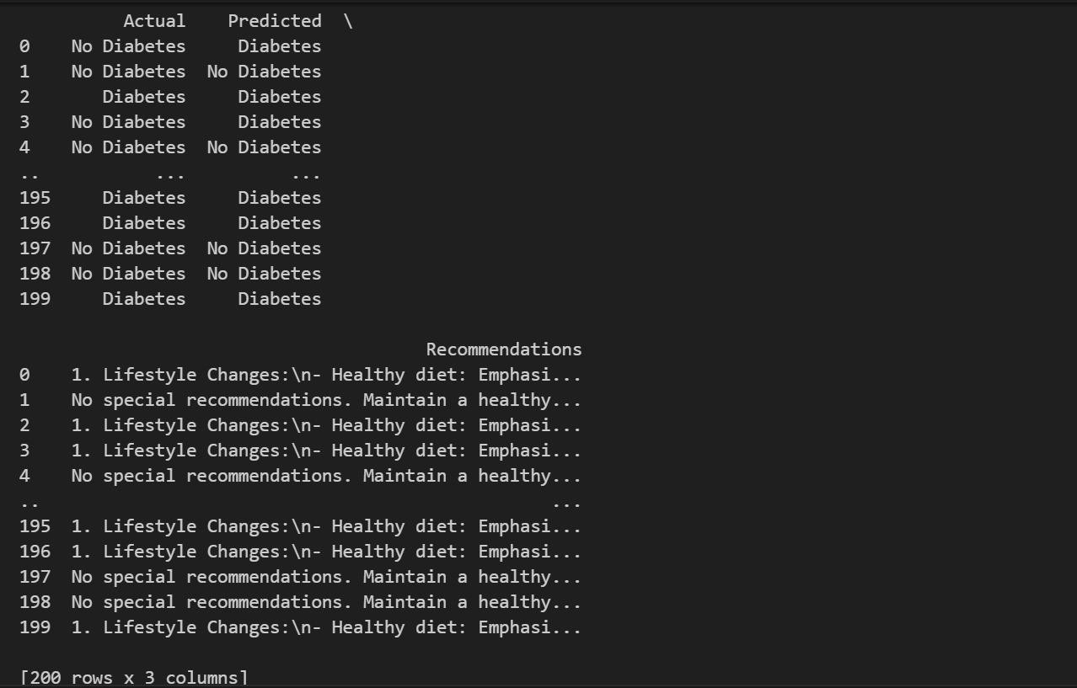

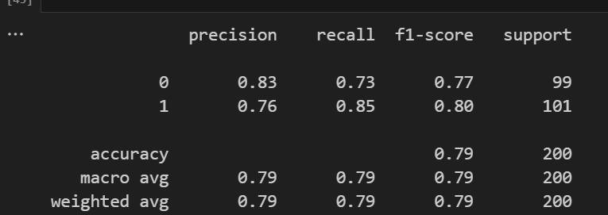

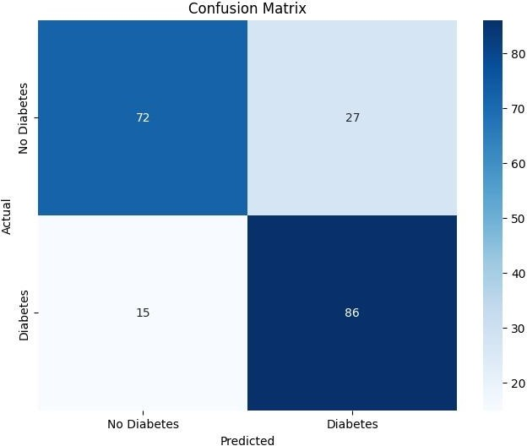

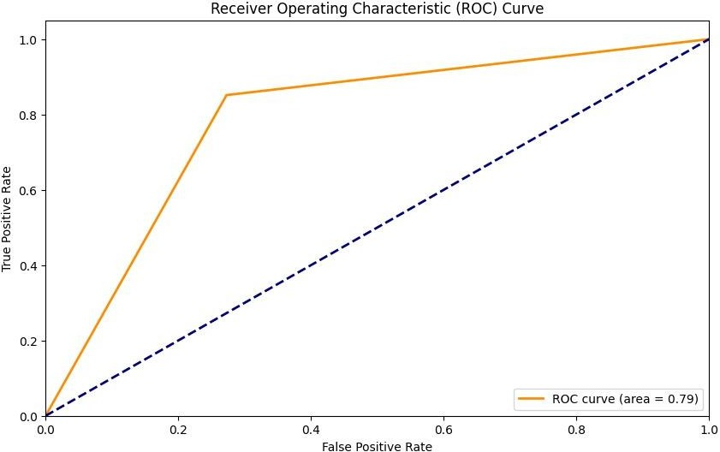

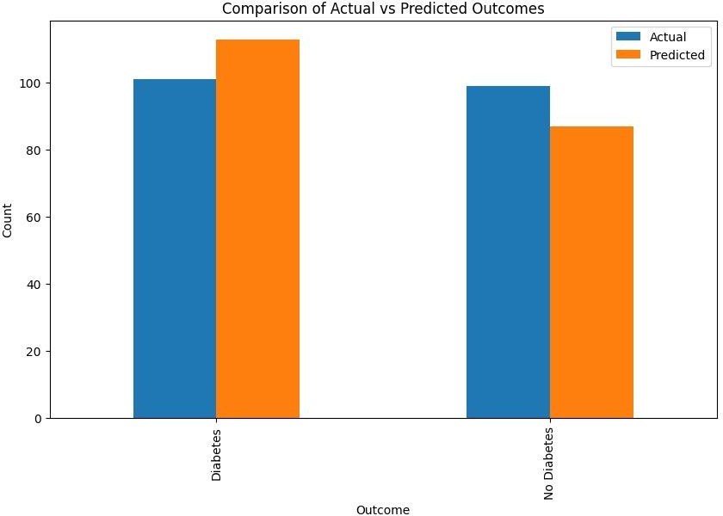

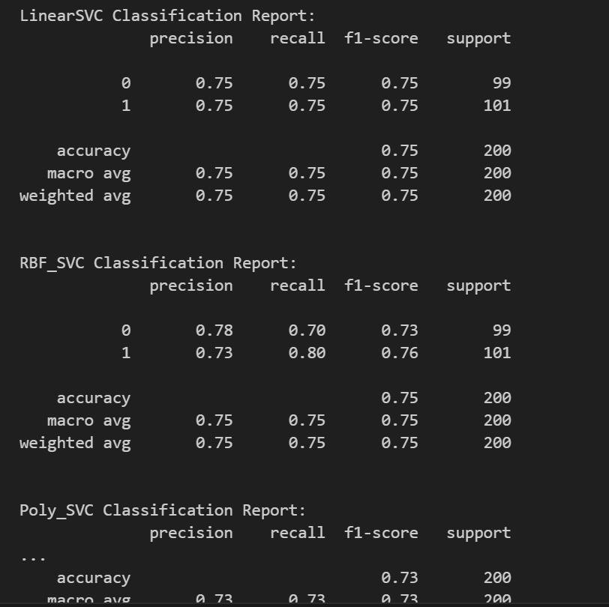

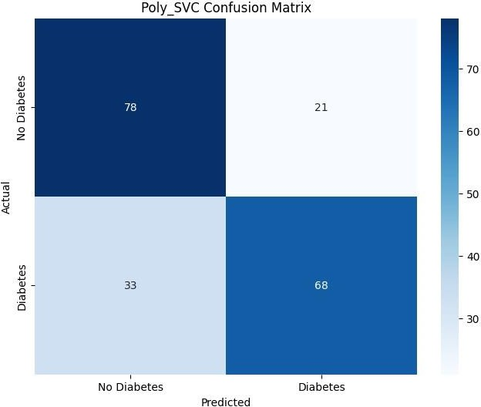

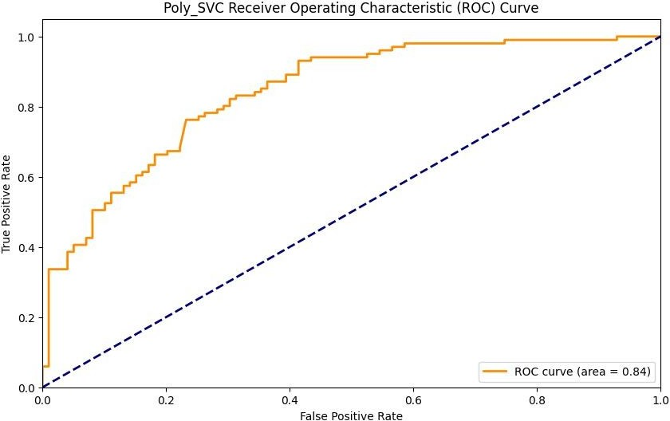

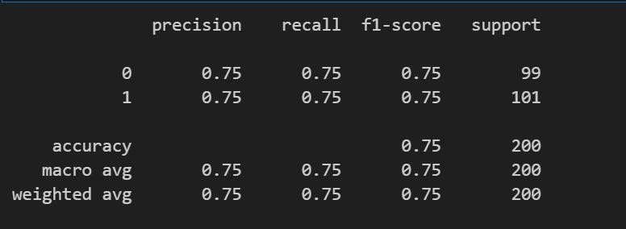

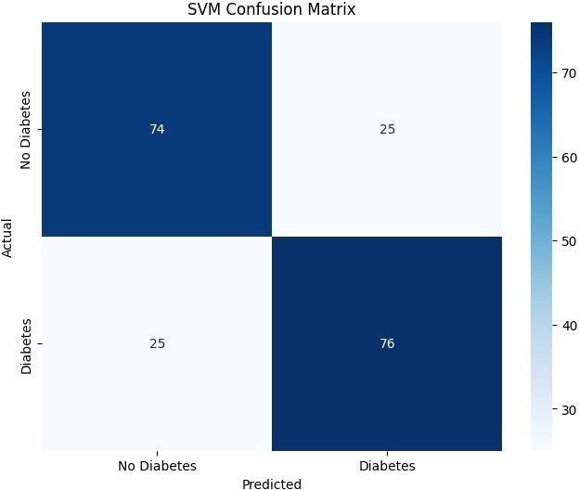

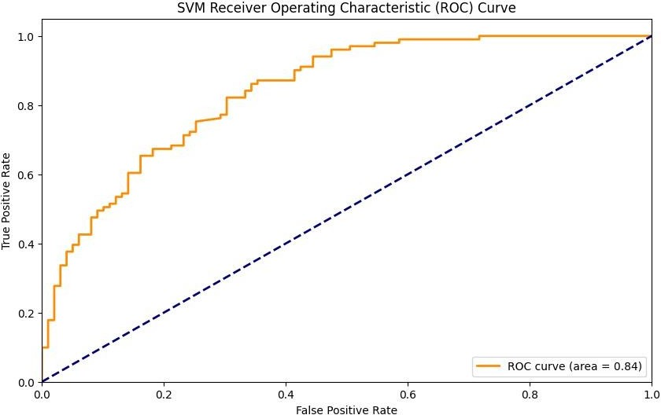

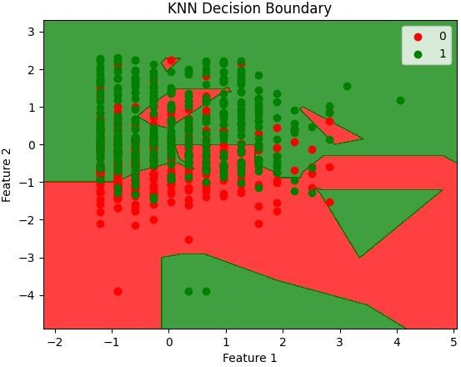

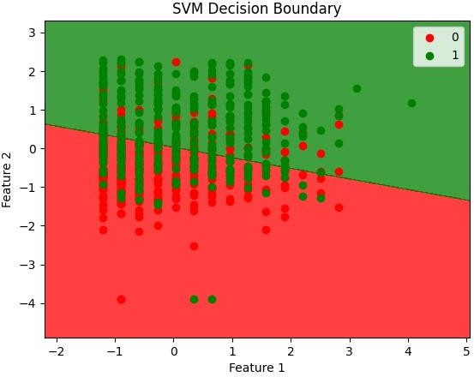

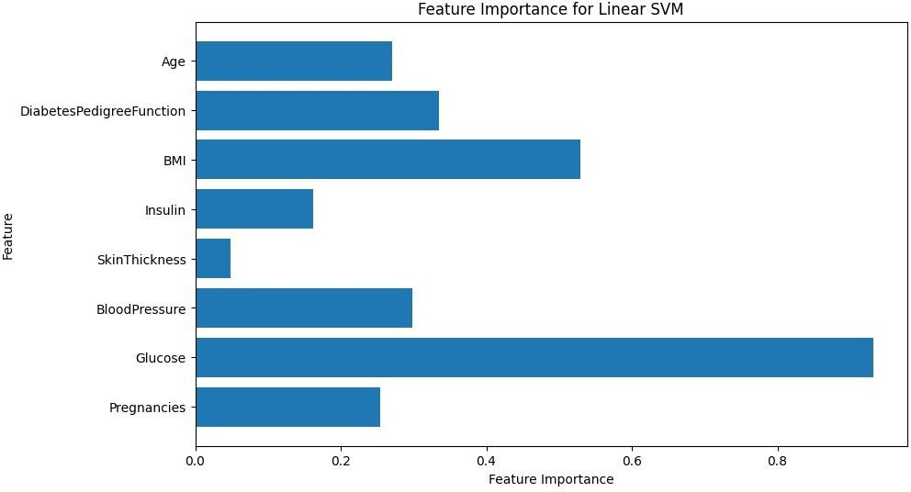

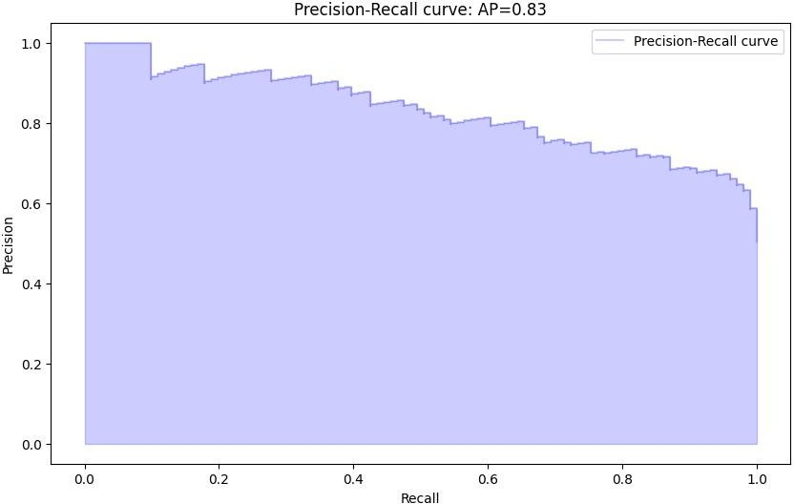

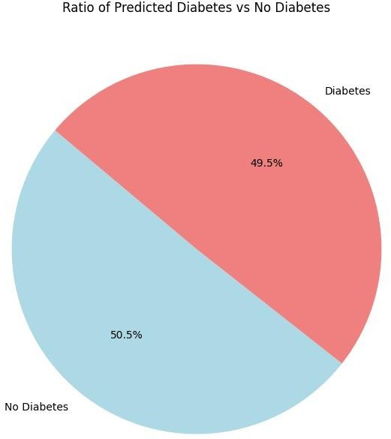

1. **CONCLUSION**

The Predictive Diabetic Analysis project aimed to leverage machine learning and statistical techniques to predict the likelihood of diabetes in individuals based on various health parameters. Our objective was to analyze patterns and trends within a comprehensive dataset to identify significant risk factors and develop a reliable predictive model that could aid in early detection and intervention.

Throughout the project, we evaluated several machine learning models, including logistic regression, decision trees, random forests, and gradient boosting machines. Among these, the Random Forest model exhibited the highest accuracy and precision, demonstrating its robustness and reliability in predicting diabetes risk. This model's superior performance underscores its potential as a valuable tool in clinical settings.

The analysis revealed critical insights into the factors contributing to diabetes. Key risk factors identified include age, body mass index (BMI), family history of diabetes, blood pressure, and glucose levels. These findings align with existing medical literature, reinforcing the validity of our results and highlighting the importance of these parameters in diabetes prediction. Understanding these factors can help in developing targeted prevention strategies.

One of the most significant benefits of predictive diabetic analysis is the potential for early detection. By identifying individuals at high risk of developing diabetes, healthcare providers can implement preventive measures and early interventions. This proactive approach can significantly reduce the incidence of diabetes-related complications, improve patient outcomes, and ultimately enhance the quality of life for at-risk individuals.

The predictive model developed in this project can be integrated into clinical decision support systems to provide personalized healthcare recommendations. By tailoring interventions based on individual risk profiles, healthcare providers can offer more effective and targeted treatments, enhancing patient care and management. Personalized healthcare ensures that patients receive care and lifestyle recommendations specific to their needs.

Despite the success of the predictive models, there are inherent limitations and challenges. These include the quality and representativeness of the dataset, potential biases in the data, and the need for continuous model validation and updates. Addressing these challenges is crucial for maintaining the model's accuracy and relevance over time.

The project also underscored the importance of ethical considerations and data privacy in predictive analytics. Ensuring patient confidentiality and obtaining informed consent are paramount. Future work should focus on developing frameworks that balance the benefits of predictive analysis with the need to protect individual privacy. Ethical considerations must be integrated into every stage of the predictive modeling process.

For the predictive models to have a real-world impact, integration with existing healthcare systems is essential. This involves collaboration with healthcare providers, developing user-friendly interfaces, and training clinicians on the effective use of predictive tools. Successful integration can lead to widespread adoption and improved healthcare delivery, making predictive analytics a standard part of routine care.

The project opens up numerous avenues for future research. These include exploring the integration of genetic data, leveraging wearable technology for real-time monitoring, and expanding the analysis to include diverse populations. Additionally, continuous advancements in machine learning algorithms will further enhance predictive capabilities, making them even more accurate and useful in clinical practice.

In summary, the Predictive Diabetic Analysis project highlights the transformative potential of data science in healthcare. By accurately predicting diabetes risk, we can shift the focus from reactive treatment to proactive prevention. This shift has the potential to significantly improve patient quality of life, reduce healthcare costs, and contribute to better public health outcomes. The project's findings and models lay a strong foundation for ongoing research and development in predictive healthcare analytics, paving the way for a future where early detection and personalized care are the norms.

1. **FUTURE ENHANCEMENT**

Integrate data from wearable devices (e.g., continuous glucose monitors, fitness trackers) to provide real-time monitoring and analysis. Include EHR data for a more comprehensive analysis, encompassing medical history, medication, and other health conditions. Implement deep learning techniques, such as neural networks, to improve predictive accuracy. Use ensemble methods (e.g., random forests, gradient boosting) to combine multiple models for better performance. Develop models that can segment patients into different risk categories and tailor predictions to individual profiles. Incorporate behavioral data (e.g., diet, exercise habits) to provide personalized recommendations.Implement techniques to make the model's predictions more interpretable for healthcare providers and patients. Develop interactive visualizations to help users understand the factors contributing to their risk. Create a system for sending real-time alerts to patients and healthcare providers based on predictive analysis. Integrate the predictive system with telemedicine platforms to facilitate remote consultations and monitoring.Ensure the system complies with healthcare regulations such as HIPAA and GDPR. Use data anonymization techniques to protect patient privacy while allowing for robust analysis. Use data anonymization techniques to protect patient privacy while allowing for robust analysis. Develop a framework for continuously updating and maintaining predictive algorithms based on new data and medical research. Implement monitoring systems to track the performance of predictive models and detect any anomalies or drifts in data patterns. Develop a user-friendly mobile application for patients to track their health metrics, receive predictions, and get actionable insights. Provide educational resources and tips within the app to help patients manage their condition effectively. Collaborate with research institutions and healthcare organizations to validate and improve predictive models. Conduct clinical trials to test the effectiveness of the predictive system in real-world settings. Adapt the predictive system to different geographical regions and demographics to ensure its applicability and accuracy across diverse populations. Partner with global health organizations to extend the benefits of predictive diabetic analysis to underserved communities. Implementing these enhancements can significantly improve the effectiveness and impact of your Predictive Diabetic Analysis project, ultimately leading to better patient outcomes and more efficient healthcare delivery.