Lesson1:
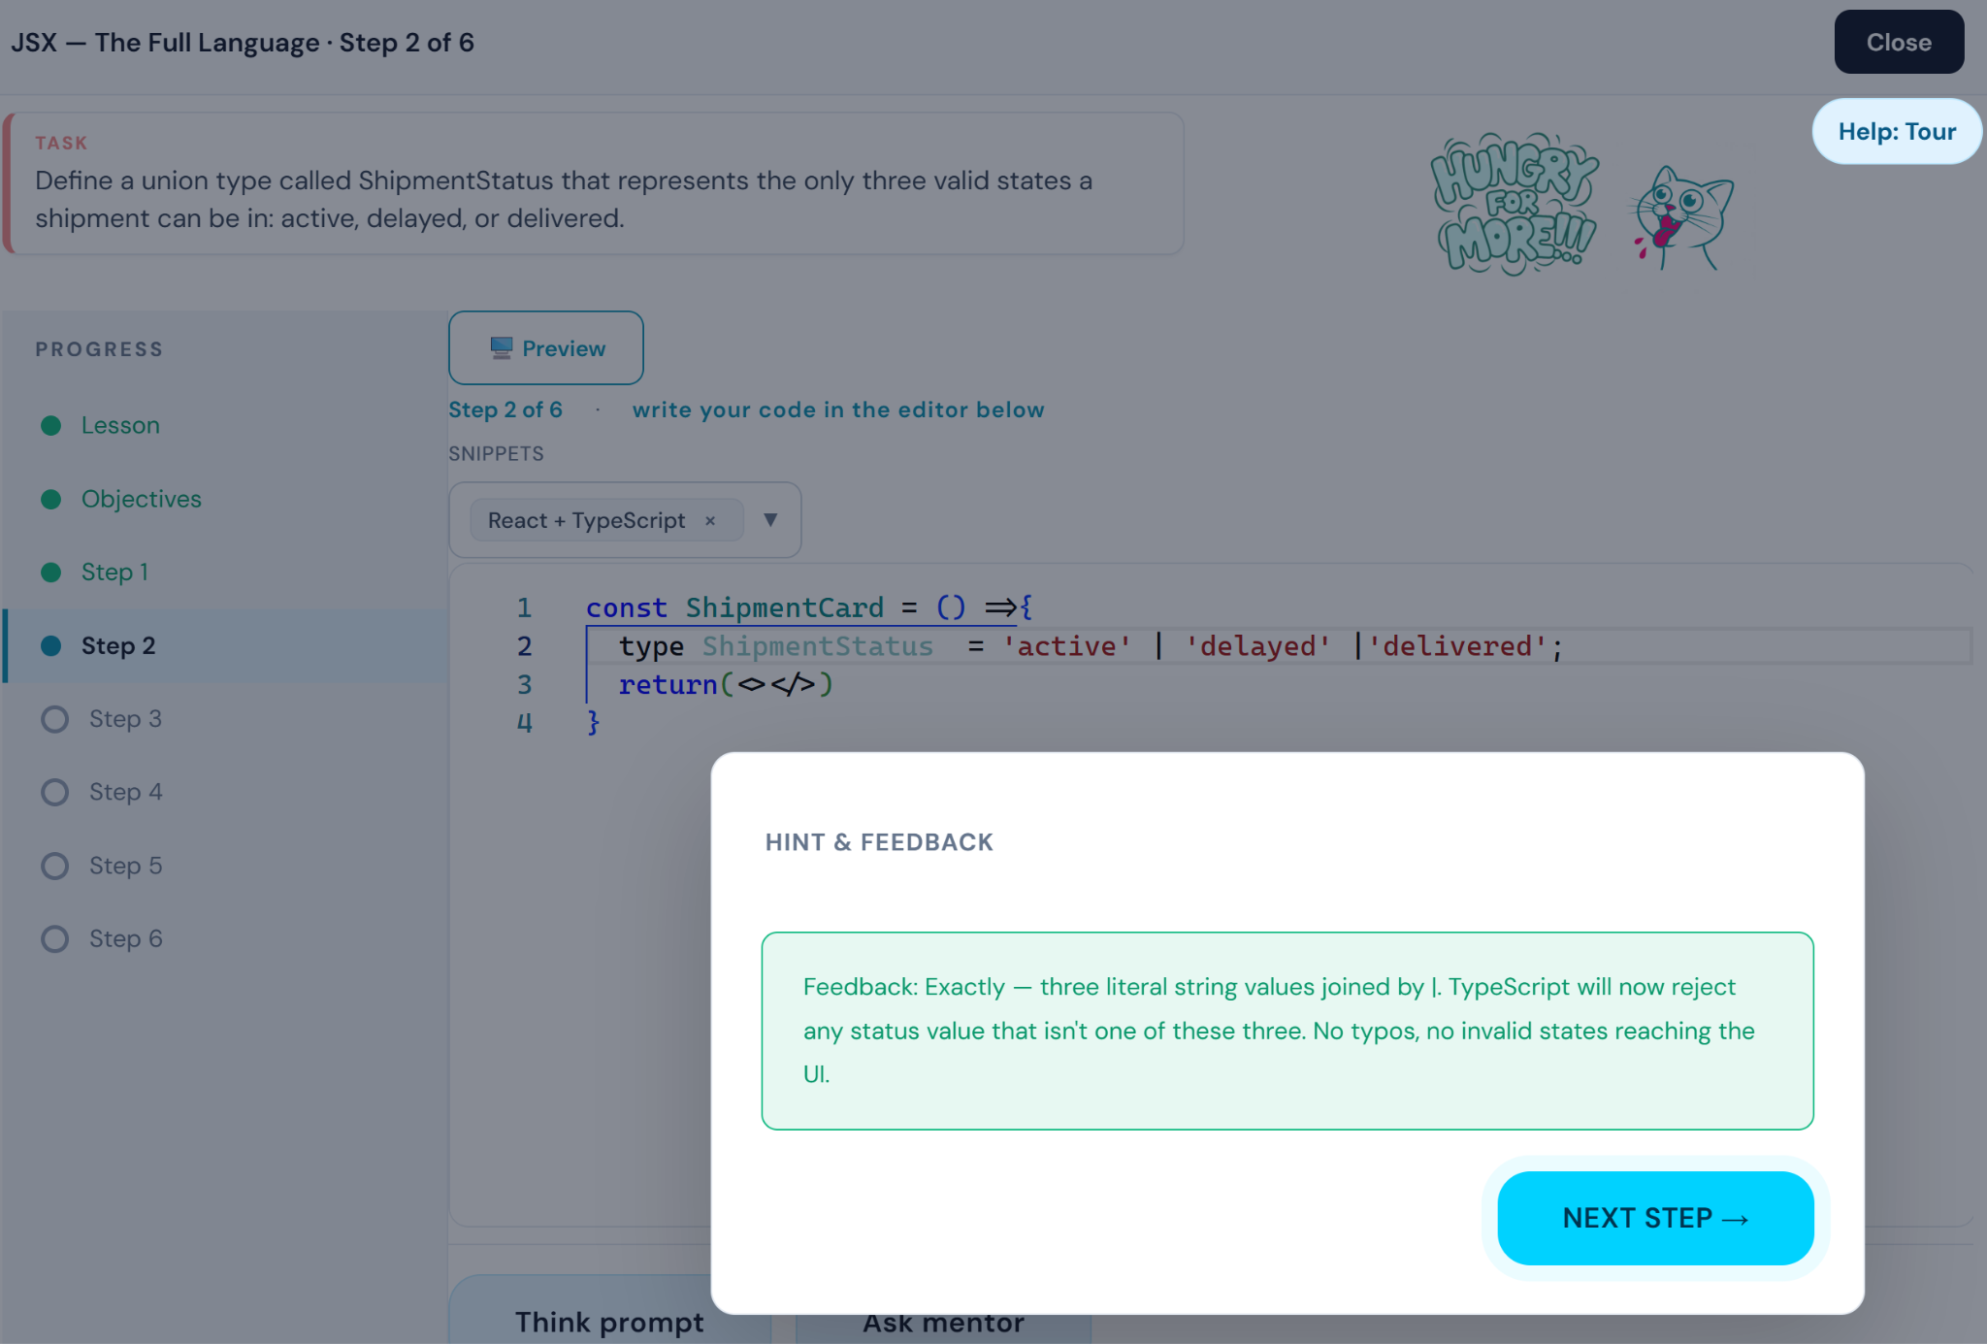
Global rule the types, interfaces and all module level definitions shud be outside of the component.
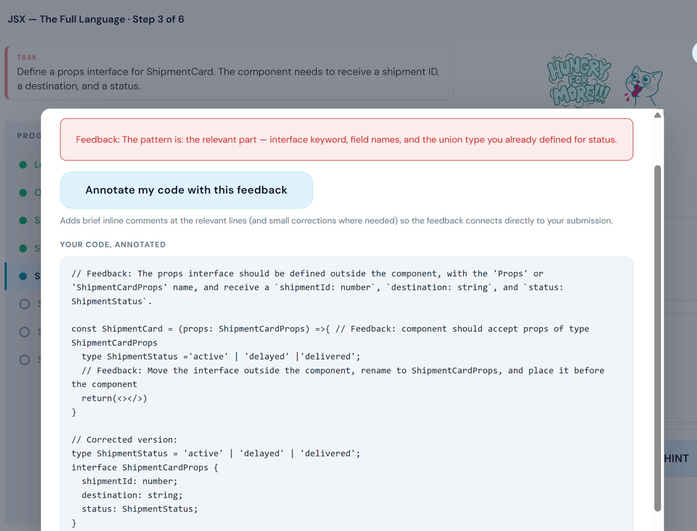
Hey the feedback demands that the “interface and type” moved outside of the component when the type inside the component was passed in previous step.. So both prev step and this step shud have clear instructions about where and how to define/declare comps, interfaces, props.. Etc.. pls match the step instructions as expected in the feedback…
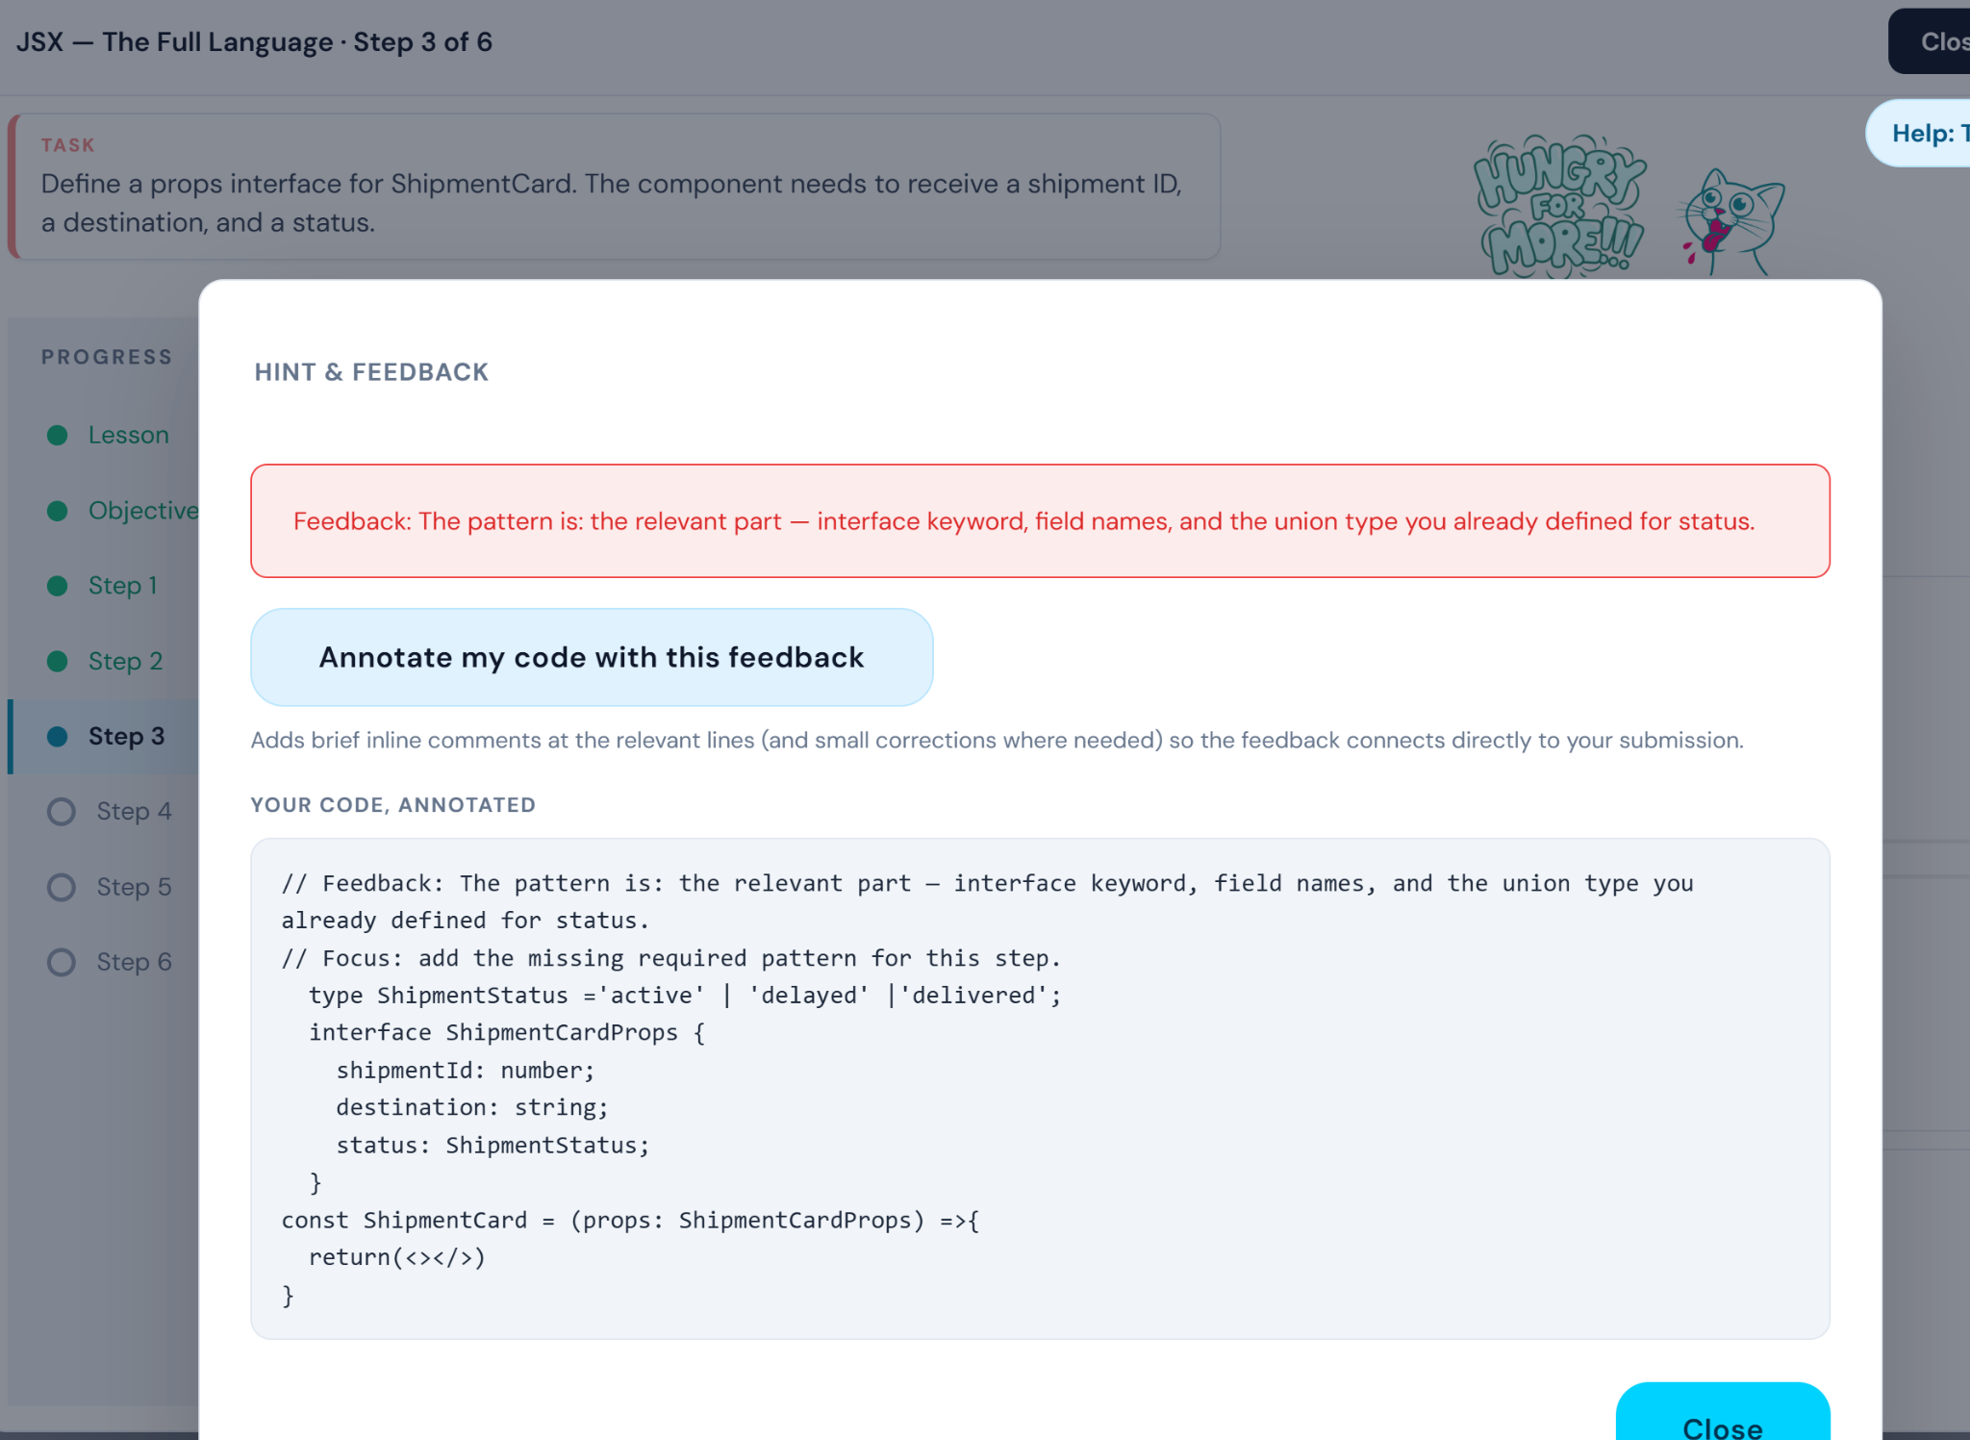
The feedback is confusing it doesnt say which pattern is missing when the code is correct

