Gangadhara Lakshmi Narayana

Deepak Kancharla

16201107

Assignment 8

Software Methods And Tools

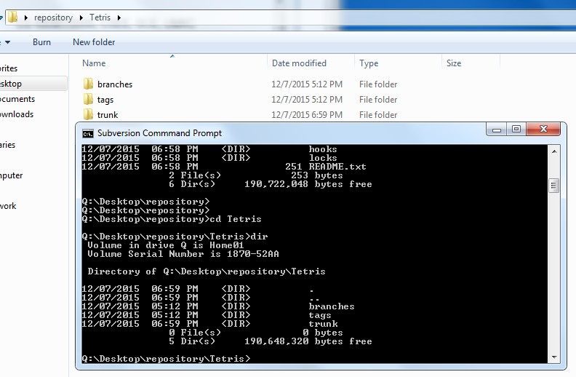

2) Screenshot that shows the content of the source code folder in the repository

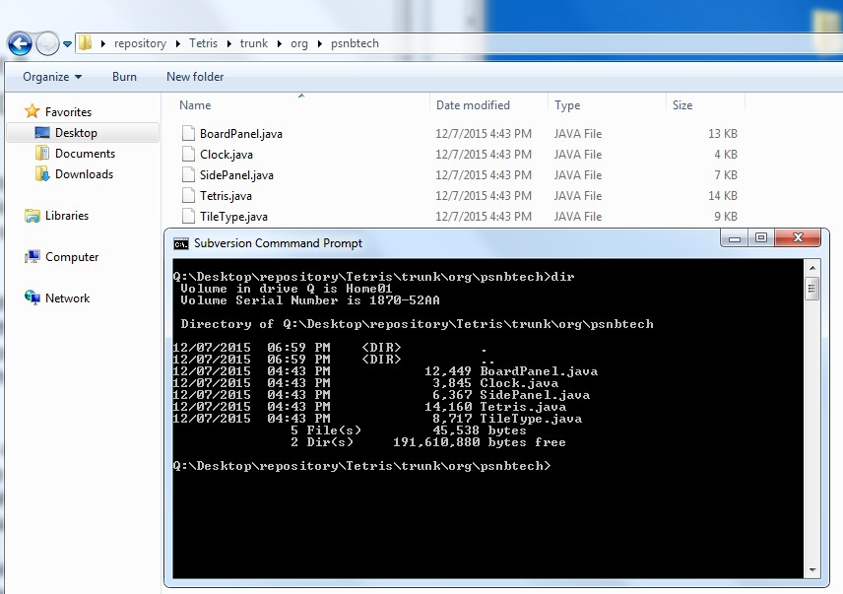

|  |  |  |  |  |
| --- | --- | --- | --- | --- |
| Event | Repository | Tom | Susan | John |
| 1 | 2 | 1 | 1 | 2 |
| Description | No conflicts occurred | | | |

Screenshot:

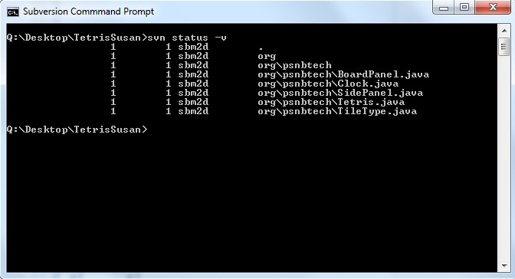

|  |  |  |  |  |
| --- | --- | --- | --- | --- |
| Event | Repository | Tom | Susan | John |
| 2 | 2 | 1 | 2 | 2 |
| Description | No Conflicts occurred | | | |

Screenshot:

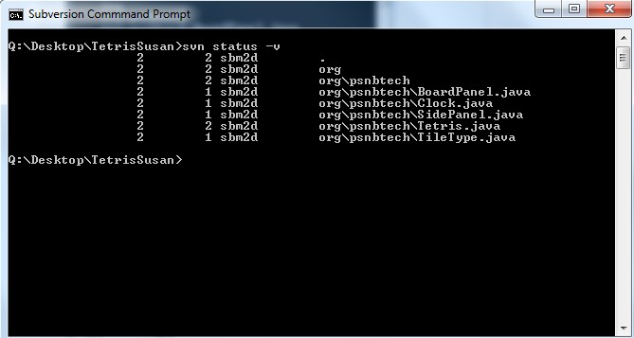

|  |  |  |  |  |
| --- | --- | --- | --- | --- |
| Event | Repository | Tom | Susan | John |
| 3 | 3 | 3 | 2 | 2 |
| Description | A conflict occurred at line 26. Tom removes already existing change by selecting option ‘e’ (edit). After the changes are done, ‘r’ command to run resolve conflict. Then changes are committed to repository. | | | |

Screenshot:

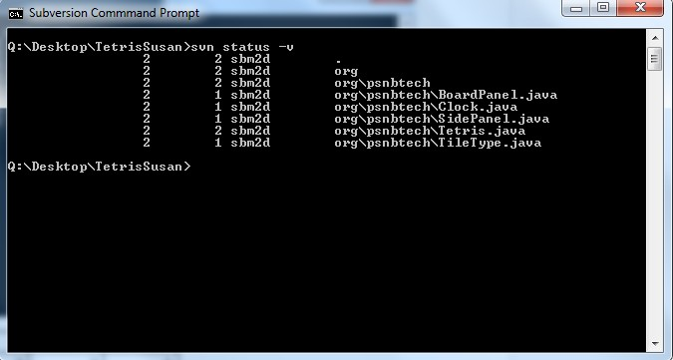

|  |  |  |  |  |
| --- | --- | --- | --- | --- |
| Event | Repository | Tom | Susan | John |
| 4 | 3 | 3 | 2 | 2 |
| Description | No conflicts | | | |

Screenshot:

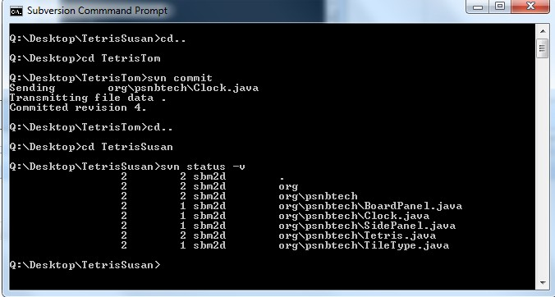

|  |  |  |  |  |
| --- | --- | --- | --- | --- |
| Event | Repository | Tom | Susan | John |
| 5 | 3 | 3 | 2 | 2 |
| Description | No conflicts occurred. | | | |

Screenshot:

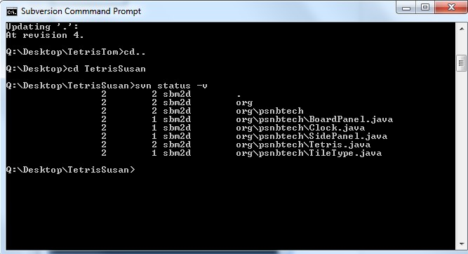

|  |  |  |  |  |
| --- | --- | --- | --- | --- |
| Event | Repository | Tom | Susan | John |
| 6 | 3 | 3 | 3 | 3 |
| Description | No conflicts occurred. | | | |

Screenshot:

