**Assignment 8**

**Phanideep Salapaka**

**Screenshot -** Shows the content the of “Tetris” folder:

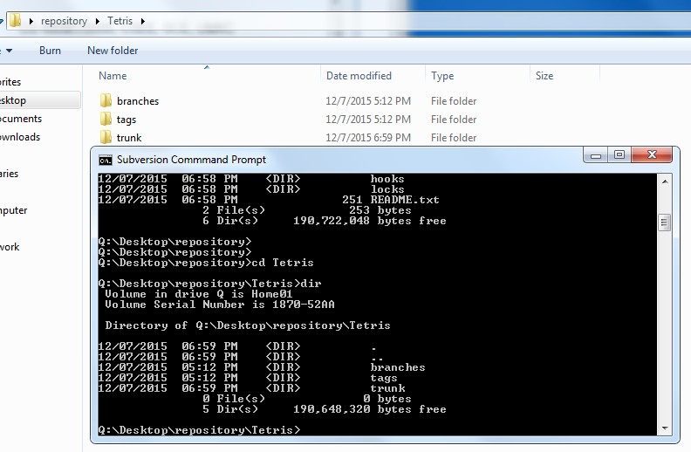

**Screenshot-** shows the content of the source code folder in the repository.

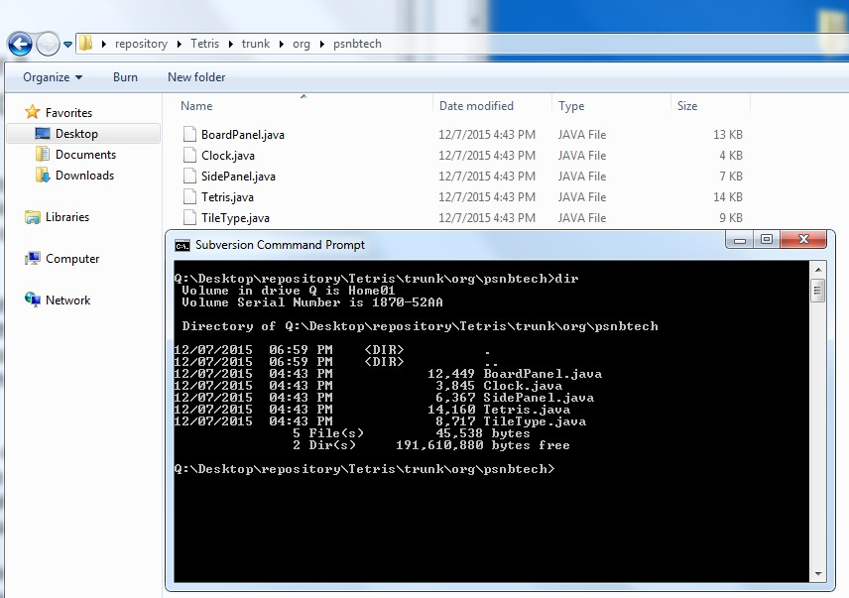

**EVENT #1:**

|  |  |  |  |  |
| --- | --- | --- | --- | --- |
| **Event** | **Repository** | **Tom** | **Susan** | **John** |
| 1 | 2 | 1 | 1 | 2 |

**Description**:

No conflicts occured

**Screenshot:**

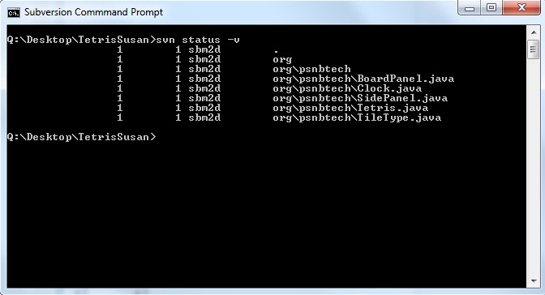

**EVENT #2**:

|  |  |  |  |  |
| --- | --- | --- | --- | --- |
| **Event** | **Repository** | **Tom** | **Susan** | **John** |
| 2 | 2 | 1 | 2 | 2 |

**Description:**

No conflicts occured

**Screenshot-**

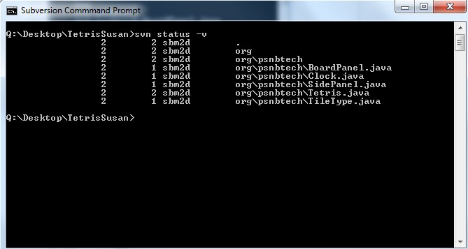

**EVENT #3**:

**Description:**

A conflict occurred at line 26. Tom removes already existing change by selecting option ‘e’ (edit). After the changes are done, ‘r’ command to run resolve conflict. Then changes are committed to repository.

|  |  |  |  |  |
| --- | --- | --- | --- | --- |
| **Event** | **Repository** | **Tom** | **Susan** | **John** |
| 3 | 3 | 3 | 2 | 2 |

**Screenshot-**

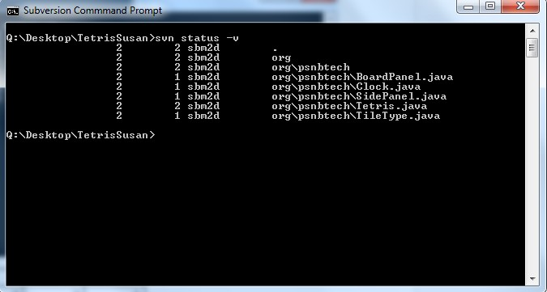

**EVENT #4**

|  |  |  |  |  |
| --- | --- | --- | --- | --- |
| **Event** | **Repository** | **Tom** | **Susan** | **John** |
| 4 | 3 | 3 | 2 | 2 |

**Description**

No conflicts.

**Screenshot-**

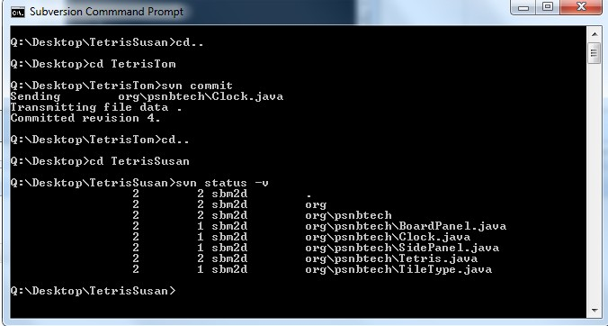

**EVENT #5**

|  |  |  |  |  |
| --- | --- | --- | --- | --- |
| **Event** | **Repository** | **Tom** | **Susan** | **John** |
| 5 | 3 | 3 | 2 | 2 |

**Description**

No conflicts occurred.

**Screenshot-**

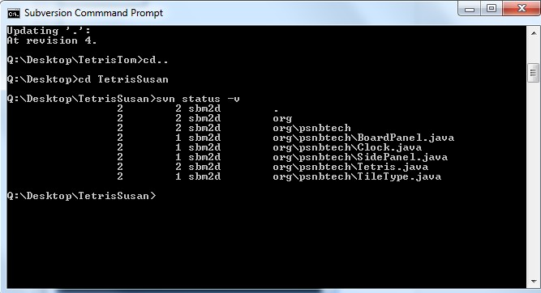

**EVENT #6**

|  |  |  |  |  |
| --- | --- | --- | --- | --- |
| **Event** | **Repository** | **Tom** | **Susan** | **John** |
| 6 | 3 | 3 | 3 | 3 |

**Description**

No conflicts occured

**Screenshot-**

