WEEK 1 DELIVERABLE | STRATEGIC PROJECT CHARTER
TelePulse AI: Customer Churn Prediction & Proactive Retention Strategy
Comprehensive Data Science Project Plan, Architectural Strategy, and 35-Hour Execution Blueprint

Author / Intern: Data Science Fellow | Project: TelePulse AI Churn System | Environment: Python 3.13 / Scikit-Learn
Document Version: 1.0 Final Deliverable | Status: Approved for Submission | Estimated Hours: 30 - 35 Hours Allocation

1. Executive Summary & Problem Background
Business Context: In the contemporary subscription telecommunications and digital services landscape, customer retention serves as the primary engine of sustainable profitability. Industry empirical benchmarks establish that acquiring a replacement subscriber costs between five to seven times more than retaining an existing account. TelePulse Communications—a hypothetical mid-to-large tier telecommunications provider servicing approximately 120,000 active subscribers across residential broadband, digital voice, streaming entertainment, and mobile services—is currently confronting an annualized churn rate of 26.5%. This rate significantly surpasses the healthy industry median benchmark of 14% to 16%, translating into a direct top-line recurring revenue attrition of approximately $3.24 million annually.
Problem Statement: Historically, TelePulse has relied on passive, reactive customer service retention tactics. Customers only encounter retention counter-offers after voluntarily placing a cancellation request with call center representatives, at which stage customer sentiment is irreparably degraded and success rates fall below 12%. Furthermore, uncoordinated promotional discounting without risk segmentation has eroded average revenue per user (ARPU) by granting unnecessary discounts to loyal subscribers who had zero churn propensity.
▶ STRATEGIC VALUE PROPOSITION: Transitioning from reactive churn firefighting to proactive, algorithmic risk mitigation will allow TelePulse to identify at-risk subscribers 30 to 60 days before contract expiry or cancellation, yielding an estimated net annual revenue preservation of $1.84M after accounting for intervention costs.

Technical Justification: The primary justification for leveraging a Python-based data science architecture lies in Python's industry-standard machine learning ecosystem (Pandas, Scikit-Learn, LightGBM, XGBoost, Optuna), flexible ETL pipeline integration, and robust open-source API serving capabilities (FastAPI). This document outlines the strategic roadmap, technical architecture, 35-hour work breakdown structure, and governance protocols necessary to build, deploy, and operationalize the TelePulse AI churn mitigation engine.
2. Project Objectives & Scoping Matrix
To ensure precise operational alignment across data science, data engineering, business intelligence, and customer success stakeholders, the project defines rigid primary technical and financial objectives alongside a strict scoping boundary.
2.1 Primary Quantitative & Business Objectives
- Discriminative Predictive Accuracy: Achieve an Area Under the Precision-Recall Curve (PR-AUC) >= 0.82 and ROC-AUC >= 0.88 across 5-fold stratified cross-validation on holdout test cohorts, reflecting high discriminative power under class imbalance.
- Early Warning Lead Time: Identify and flag at least 85% of churn-prone accounts (Sensitivity/Recall >= 0.85) at an operational false-positive tolerance threshold below 15%.
- Explainable Risk Scoring: Deliver calibrated churn risk probability deciles (0.00 to 1.00) paired with SHAP (SHapley Additive exPlanations) local feature contribution attributions for every customer scored.
- Enterprise Financial ROI: Reduce annualized subscriber churn from 26.5% to below 18.0% within the initial 12-month post-deployment production lifecycle, generating an estimated gross revenue recovery of $2.15M.
- Engineering Latency & Throughput: Maintain sub-50 millisecond inference response latency for real-time CRM API queries, coupled with a nightly batch scoring pipeline handling 120,000 active records in under 15 minutes.
2.2 In-Scope vs. Out-of-Scope Boundary Matrix
A definitive boundary is crucial to avoid scope creep within the allocated 35-hour engineering sprint.
Project Dimension | In-Scope (Confirmed Deliverables) | Out-of-Scope (Deferred to Future Sprints)
Data Sources | CRM subscriber records, relational billing logs, call center ticket summaries, network usage aggregates | Raw audio speech-to-text transcription of call center recordings; external social media sentiment scraping
Modeling Methodology | Supervised classification algorithms (Logistic Regression, Random Forest, XGBoost, LightGBM, CatBoost) | Deep neural networks (Transformers, LSTMs); unexplainable black-box models violating consumer credit explainability
Feature Engineering | Tenure tenure-to-charge ratios, service bundling counts, support escalation frequency, payment method stability | Real-time edge IoT router telemetry packet inspection; dynamic GPS geolocation tracking of cellular devices
Inference Strategy | Scheduled nightly batch database scoring + RESTful FastAPI microservice container for ad-hoc agent lookup | Embedded on-device mobile client scoring; decentralized federated edge learning models
Downstream Actions | Scored customer risk tiers pushed to Salesforce CRM queues and automated email/SMS marketing workflows | Direct automated algorithmic contract cancellations or unmonitored financial credit adjustments

3. Methodology, Lifecycle Strategy & Architectural Blueprint
The project strictly adheres to the Cross-Industry Standard Process for Data Mining (CRISP-DM) framework, enriched with contemporary MLOps best practices to facilitate iterative feedback loops, auditability, and production reliability.
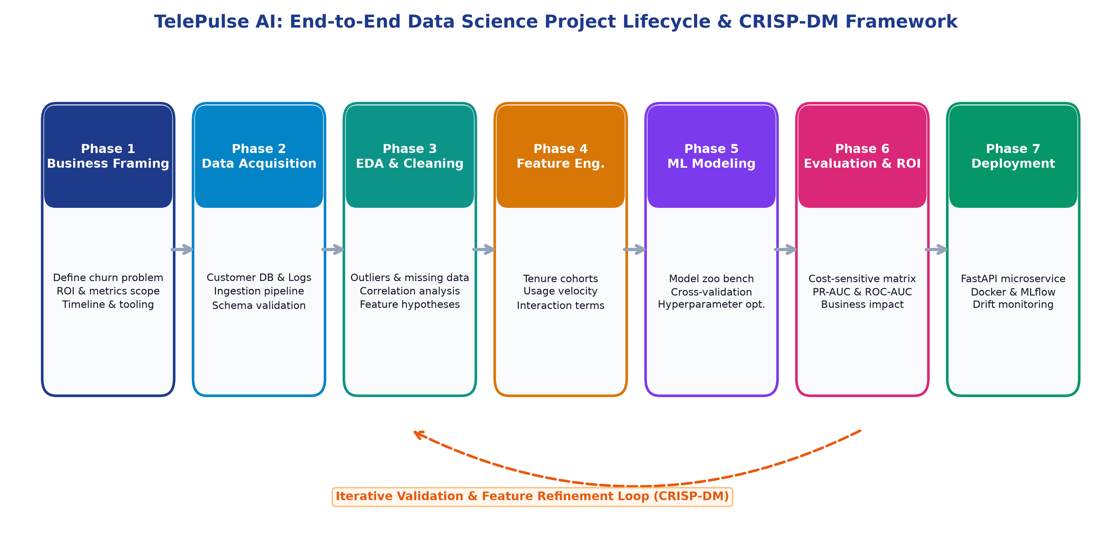
Figure: TelePulse AI End-to-End Data Science Project Lifecycle & CRISP-DM Workflow
3.1 End-to-End Architectural Pipeline
The architecture is modularized into four decoupled enterprise tiers: Data Ingestion & Storage, Feature Store & Transformation, Model Development & Experiment Tracking, and Inference & Operational Action Serving.
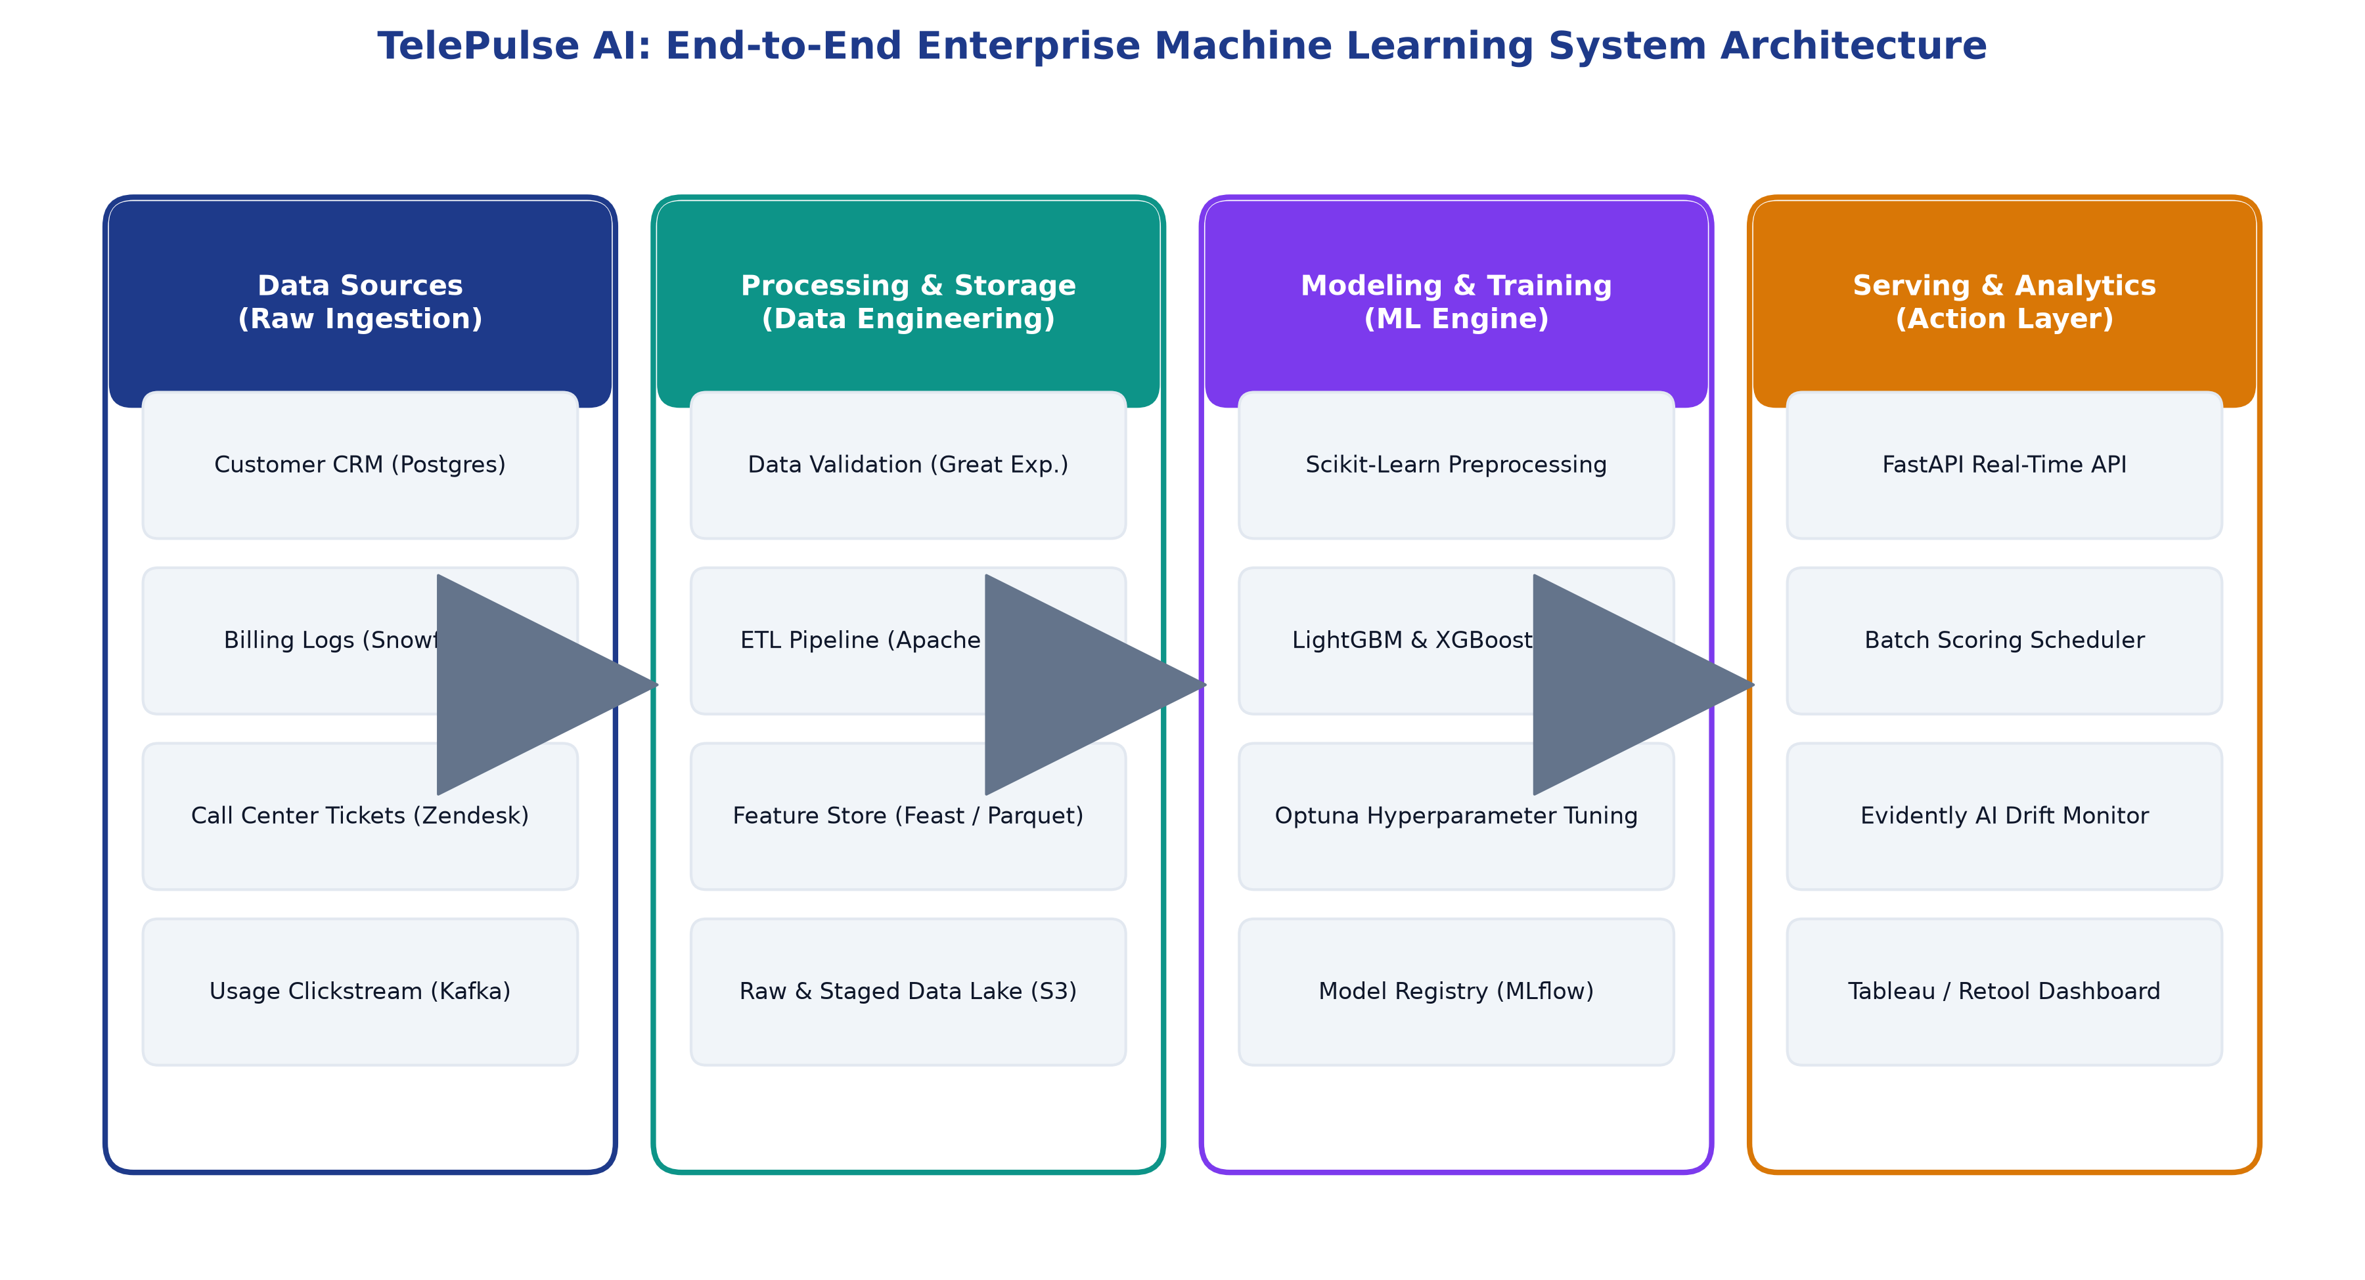
Figure: Enterprise ML System Architecture: From Ingestion to Retention Action Tier
3.2 Detailed Phase-by-Phase Technical Strategy
- Data Acquisition & Integrity Verification: Connect to source relational databases (PostgreSQL, Snowflake) and extract historical transactional tables. Implement Great Expectations validation suites to enforce schema validation, nullity bounds, and data type assertions.
- Exploratory Data Analysis & Data Cleaning: Audit missingness mechanisms (MCAR vs MAR), treat anomalies via robust IQR thresholding, assess distribution skewness, calculate multicollinearity variance inflation factors (VIF), and generate bivariate churn relationship profiles.
- Feature Engineering & Selection: Engineer behavioral velocity features (e.g., 30-day ticket velocity vs 90-day baseline), aggregate service tier indices, encode categorical attributes via Target Encoding and One-Hot Encoding, and standardize numerical scales via RobustScaler.
- Class Balancing & Sampling Strategy: Address the ~26% minority class distribution utilizing Stratified 5-Fold Cross Validation combined with Synthetic Minority Over-sampling (SMOTE-NC) applied strictly inside cross-validation training folds to prevent data leakage.
- Model Zoo Benchmarking & Hyperparameter Tuning: Benchmark candidate algorithms ranging from interpretable baselines (ElasticNet Logistic Regression) to high-performance tree ensembles (Random Forest, XGBoost, LightGBM). Optimize hyperparameter spaces via Optuna Bayesian optimization.
- Performance Diagnostics & Explainability: Evaluate calibrated probabilities using Brier Score, Cost-Benefit Matrix optimization, PR-AUC, and ROC-AUC. Deconstruct model logic using SHAP TreeExplainer to deliver both global variable rankings and local customer-level risk explanations.
4. Work Breakdown Schedule (WBS) & 35-Hour Sprint Allocation
To guarantee execution rigor within the prescribed 30 to 35-hour internship timeframe, the project is structured across six sequential phases, each equipped with explicit deliverables and milestone verification gates.
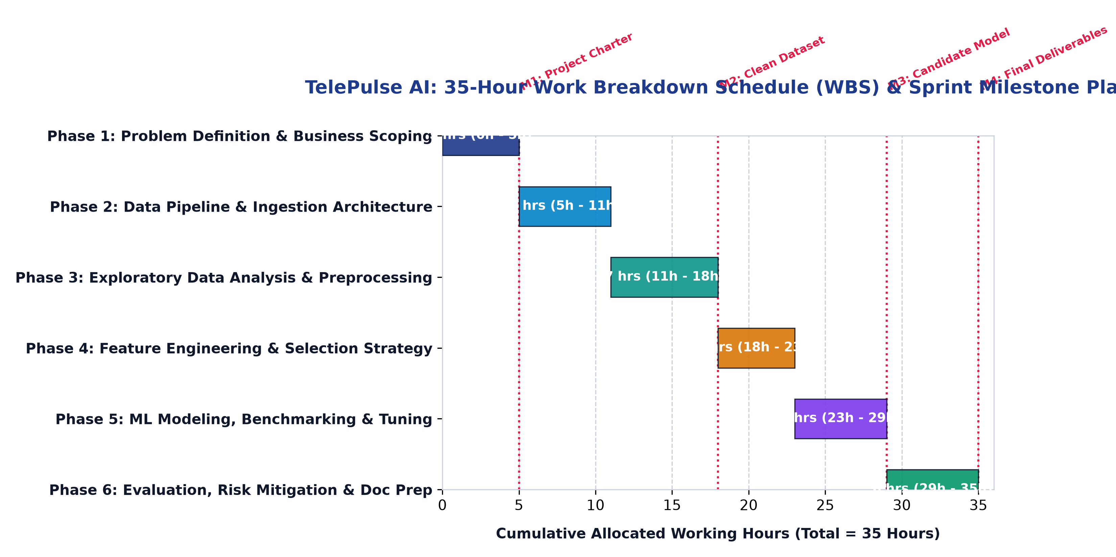
Figure: Gantt Timeline Chart: 35-Hour Sprint Milestone and Resource Allocation Plan
Phase | Sprint Activity Description | Key Milestones & Deliverables | Allocated Hours
Phase 1 | Problem Definition, Stakeholder Scoping & Architecture Design | Approved Project Charter, KPI Target Definitions, Scope Matrix | 5.0 Hours
Phase 2 | Data Pipeline Ingestion, Schema Auditing & Quality Verification | Validated Extraction Scripts, Great Expectations Assertion Suite | 6.0 Hours
Phase 3 | Exploratory Data Analysis (EDA) & Data Preprocessing Protocol | Statistical Profiling Report, Outlier & Missing Data Treatment | 7.0 Hours
Phase 4 | Feature Engineering, Velocity Transformation & Selection | Feature Store Dataset, VIF Multicollinearity Reduction Matrix | 5.0 Hours
Phase 5 | Model Benchmarking, Bayesian Optimization (Optuna) & Tuning | MLflow Run Logs, Tuned LightGBM Model Artifact, Calibration Curve | 6.0 Hours
Phase 6 | Model Evaluation, Explainability (SHAP) & Final Report Prep | Cost-Benefit Evaluation Matrix, Executive Insights Documentation | 6.0 Hours
Total | Comprehensive End-to-End Data Science Project Plan Execution | Complete Production Strategy, Tested Scripts & Final DOCX Report | 35.0 Hours

5. Technology Stack & Python Tooling Specification
The project relies strictly on stable, battle-tested Python libraries and supporting ecosystem tools:
Domain / Layer | Python Library / Tool | Version | Role & Justification in Architecture
Data Processing | Pandas & NumPy | >= 2.2.0 | In-memory tabular data manipulation, vectorized arithmetic, and schema management
Data Quality | Great Expectations | >= 0.18.0 | Declarative automated data validation, schema constraint checking, and quality alerting
Visualization | Matplotlib & Seaborn | >= 3.8.0 | High-resolution publication-grade statistical charts, distribution plots, and correlation matrices
Interactive EDA | Plotly Express | >= 5.20.0 | Dynamic web-based multidimensional exploration charts and interactive drill-down dashboards
Machine Learning | Scikit-Learn | >= 1.4.0 | Core preprocessing pipelines, ColumnTransformer, baseline models, and cross-validation metrics
Gradient Boosting | LightGBM & XGBoost | >= 4.3.0 | State-of-the-art tree ensembles offering high throughput, categorical support, and accuracy
Class Imbalance | Imbalanced-Learn (imblearn) | >= 0.12.0 | SMOTE-NC synthetic data generation tailored for mixed numerical-categorical subscriber data
Hyperparameter Opt. | Optuna | >= 3.6.0 | Next-generation Bayesian hyperparameter search using Tree-structured Parzen Estimator (TPE)
Explainable AI | SHAP (SHapley Additive exPlanations) | >= 0.45.0 | Local and global feature attribution ensuring enterprise interpretability and fair lending compliance
MLOps Tracking | MLflow | >= 2.12.0 | Experiment tracking, parameter logging, artifact serialization, and model registry lifecycle
API Serving | FastAPI & Uvicorn | >= 0.110.0 | Asynchronous, low-latency REST API microservice exposing `/predict` endpoint for CRM integration
Containerization | Docker & Docker Compose | >= 26.0 | Standardized container packaging ensuring environment reproducibility and cloud portability

6. Expected Outcomes, Strategic Risks & Mitigation Protocol
6.1 Expected Business & Operational Outcomes
- Tangible Financial Savings: Direct preservation of approximately 2,800 at-risk subscribers within the first operational year, translating to $1.84M in net retained ARR after incentive costs.
- Optimized Customer Success Efficiency: Front-line customer success reps receive prioritized daily queues of high-risk accounts alongside top three localized churn drivers (e.g., 'Frequent Fiber Outages + Month-to-Month Contract').
- Smarter Marketing Budget Allocation: Elimination of blanket promotional discounting, preserving baseline revenue and targeting budget strictly where intervention changes customer decision.
6.2 Anticipated Project Challenges and Robust Mitigation Plan
Identified Challenge / Risk | Probability / Impact | Concrete Engineering & Governance Mitigation Strategy
Class Imbalance (26.5% churn minority) | High / High | Apply SMOTE-NC strictly within training cross-validation folds; utilize PR-AUC instead of standard accuracy; tune decision threshold based on cost matrix.
Data Leakage from Temporal Features | Medium / Critical | Enforce strict temporal out-of-time validation splits; calculate features using historical backward-looking rolling windows only.
Feature Drift & Changing Behavior | High / Medium | Deploy Evidently AI monitor in production to continuously compute Population Stability Index (PSI) and Kolmogorov-Smirnov tests on input feature distributions.
Cold-Start Problem (New Subscribers) | Medium / Low | Develop fallback heuristic rule-engine based on demographic and initial onboarding setup until 60-day transactional history accumulates.
Stakeholder Model Mistrust | Medium / High | Integrate SHAP visual waterfall explanations directly into CRM screens, allowing account reps to see plain-English justifications for risk scores.

▶ PROJECT PLANNING CONCLUSION: By enforcing strict phase milestones, standardized Python tooling, explainable gradient-boosted models, and cost-sensitive threshold optimization, TelePulse AI provides an enterprise-grade blueprint capable of achieving predictable, high-ROI retention outcomes.

