UNIVERSITY DATABASE SYSTEM
Complete Entity-Relationship (ER) Architecture, Process Flowchart & Relational Data Specification
Document Type: Entity-Relationship & Flowchart Specification | Target System: University Academic & Administration DB
Source Diagram: University Database ER Diagram | Specification Version: 2.0 (3NF Relational Model)

1. Executive Summary & Architecture Overview
This document presents the complete structural decomposition, entity-relationship architecture, process flowchart, and relational schema for the University Database System. Designed to support comprehensive academic administration, the system captures entity states and operational relationships across departments, physical building structures, course catalogs, section offerings, faculty assignments, student enrollments, and academic performance tracking.
📌 DATA MODEL ARCHITECTURE: The database schema is fully normalized into Third Normal Form (3NF). It enforces referential integrity across all entities using explicit Primary Key (PK) and Foreign Key (FK) constraints, ensuring zero data redundancy and optimized query execution.

2. System Operational Process Flowchart
The workflow diagram below illustrates the sequential data operations and entity lifecycle within the University Database System, tracing data flow from initial administrative setup to student grading.

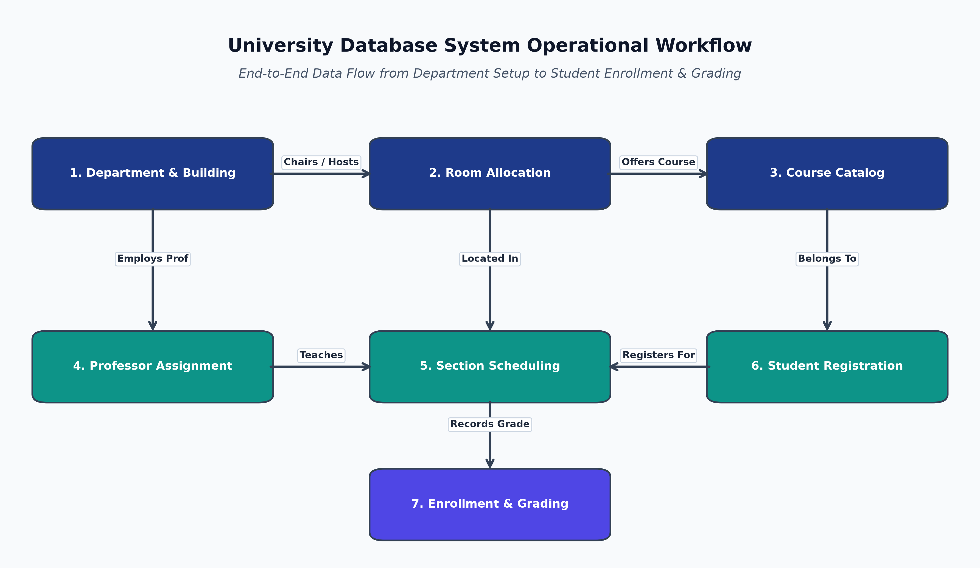
Figure 1: University Database System Operational Workflow & Entity Lifecycle

Operational Workflow Step Breakdown
Step # | Workflow Phase | Entity Operations & Business Logic
Step 1 | Infrastructure Setup | DEPARTMENT records created and associated with physical BUILDING locations via the Chairs relationship.
Step 2 | Facility Management | ROOM records defined under respective BUILDING entities with specific seat capacity and department allocation.
Step 3 | Academic Cataloging | COURSE curriculum registered under managing DEPARTMENT entities with credit hours and syllabus metadata.
Step 4 | Faculty Onboarding | PROFESSOR profiles created with academic rank, office assignment, and department affiliation (DeptID).
Step 5 | Section Scheduling | Specific course offerings instantiated as SECTION entities, assigning term/year, time block, and assigned ROOM.
Step 6 | Teaching Assignment | PROFESSOR entities assigned to instruct scheduled SECTION instances via the Teaches relationship.
Step 7 | Student Registration | STUDENT profiles registered and paired with academic advisors; students enroll in SECTION offerings generating ENROLLMENT records.
Step 8 | Grading & Records | Academic performance recorded in ENROLLMENT entities with letter grades and completion timestamps.

3. Complete ER Diagram Structural Blueprint
The diagram below provides a complete visual reconstruction of the source University Database ER Diagram, accurately capturing all 8 entities, attributes, primary/foreign keys, and cardinalities.
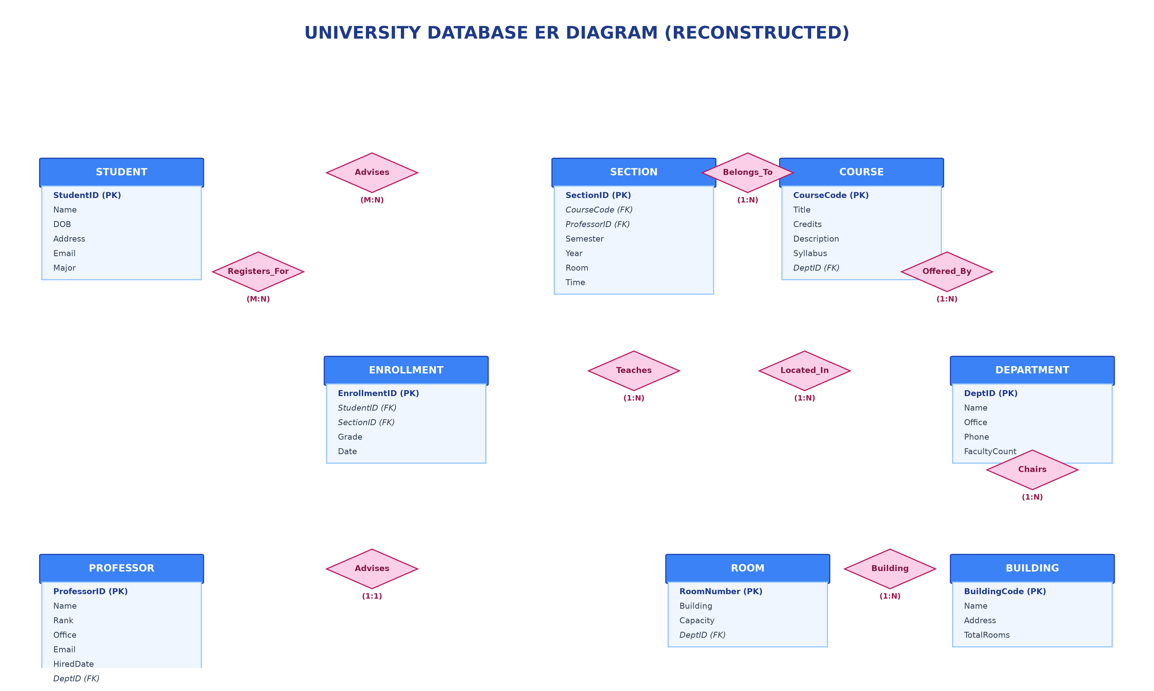
Figure 2: Complete Reconstructed University Database ER Diagram Architecture

4. Comprehensive Data Dictionary & Entity Specifications
This section provides exhaustive schema definitions for all eight entities present in the ER diagram, specifying primary keys, foreign keys, data types, and attribute descriptions.

1. STUDENT Entity
Represents students enrolled at the university.
Attribute Name | Data Type | Constraint / Type | Description
StudentID | INT / VARCHAR(20) | Primary Key | Unique identifier for each student
Name | VARCHAR(100) | Attribute | Full name of the student
DOB | DATE | Attribute | Date of birth
Address | VARCHAR(255) | Attribute | Residential street address
Email | VARCHAR(100) | Attribute / Unique | Official university email address
Major | VARCHAR(50) | Attribute | Primary academic discipline / major

2. ENROLLMENT Entity (Junction Entity)
Junction entity capturing student course registration and grading records.
Attribute Name | Data Type | Constraint / Type | Description
EnrollmentID | INT | Primary Key | Unique enrollment record identifier
StudentID | INT / VARCHAR(20) | Foreign Key | References STUDENT(StudentID)
SectionID | INT | Foreign Key | References SECTION(SectionID)
Grade | VARCHAR(5) | Attribute | Assigned letter grade (e.g., A, B+, Pass)
Date | DATE / TIMESTAMP | Attribute | Date of course registration

3. SECTION Entity
Represents a specific offering of a course in a given semester, time, and room.
Attribute Name | Data Type | Constraint / Type | Description
SectionID | INT | Primary Key | Unique section identifier
CourseCode | VARCHAR(20) | Foreign Key | References COURSE(CourseCode)
ProfessorID | INT | Foreign Key | References PROFESSOR(ProfessorID)
Semester | VARCHAR(15) | Attribute | Term of offering (e.g., Fall, Spring)
Year | INT | Attribute | Academic year (e.g., 2026)
Room | VARCHAR(20) | Attribute | Assigned classroom identifier
Time | VARCHAR(50) | Attribute | Scheduled class day/time block

4. COURSE Entity
Represents academic course subjects offered by university departments.
Attribute Name | Data Type | Constraint / Type | Description
CourseCode | VARCHAR(20) | Primary Key | Unique course catalog code (e.g., CS101)
Title | VARCHAR(150) | Attribute | Full title of the course
Credits | INT | Attribute | Academic credit hours
Description | TEXT | Attribute | Detailed course description
Syllabus | TEXT / URI | Attribute | Syllabus details or document URL
DeptID | INT / VARCHAR(20) | Foreign Key | References DEPARTMENT(DeptID)

5. PROFESSOR Entity
Represents academic faculty members who teach sections and advise students.
Attribute Name | Data Type | Constraint / Type | Description
ProfessorID | INT | Primary Key | Unique professor identifier
Name | VARCHAR(100) | Attribute | Full name of the faculty member
Rank | VARCHAR(50) | Attribute | Academic rank (e.g., Associate Professor)
Office | VARCHAR(50) | Attribute | Office room designation
Email | VARCHAR(100) | Attribute / Unique | University email address
HiredDate | DATE | Attribute | Official date of employment
DeptID | INT / VARCHAR(20) | Foreign Key | References DEPARTMENT(DeptID)

6. DEPARTMENT Entity
Represents academic departments (e.g., Computer Science, Engineering).
Attribute Name | Data Type | Constraint / Type | Description
DeptID | INT / VARCHAR(20) | Primary Key | Unique department identifier
Name | VARCHAR(100) | Attribute / Unique | Department name
Office | VARCHAR(50) | Attribute | Main departmental office location
Phone | VARCHAR(20) | Attribute | Contact telephone number
FacultyCount | INT | Attribute | Total active faculty members

7. ROOM Entity
Represents physical room locations within campus buildings.
Attribute Name | Data Type | Constraint / Type | Description
RoomNumber | VARCHAR(20) | Primary Key | Unique room designation number
Building | VARCHAR(50) | Attribute | Building name or code
Capacity | INT | Attribute | Seating capacity of the room
DeptID | INT / VARCHAR(20) | Foreign Key | References DEPARTMENT(DeptID)

8. BUILDING Entity
Represents physical structures on university campus.
Attribute Name | Data Type | Constraint / Type | Description
BuildingCode | VARCHAR(20) | Primary Key | Unique building identifier code
Name | VARCHAR(100) | Attribute | Full building name
Address | VARCHAR(255) | Attribute | Physical campus address
TotalRooms | INT | Attribute | Total count of rooms in building

5. Relationship & Cardinality Specification Matrix
The matrix below details every relationship diamond present in the ER diagram, specifying source entities, target entities, cardinality ratios, and business rules.
Relationship | Entity 1 | Entity 2 | Cardinality | Business Rule / Implementation
Registers_For | STUDENT | ENROLLMENT | M : N | Students register for course enrollments. Implemented via ENROLLMENT junction table.
Advises (Student) | STUDENT | SECTION | M : N | Advising relationship connecting students with academic sections / advisors.
Advises (Prof) | PROFESSOR | SECTION | 1 : 1 / 1 : N | Professors provide academic advisory to assigned course sections or student cohorts.
Teaches | PROFESSOR | SECTION | 1 : N | A professor teaches multiple sections; each section is taught by one professor.
Belongs_To | SECTION | COURSE | 1 : N | Multiple sections belong to one parent catalog course offering.
Offered_By | COURSE | DEPARTMENT | 1 : N | Courses are developed and offered by a specific academic department.
Located_In | COURSE | ROOM | 1 : N | Course sections are assigned to specific physical rooms for class sessions.
Building | ROOM | BUILDING | 1 : N | Rooms are located within physical campus buildings.
Chairs | DEPARTMENT | BUILDING | 1 : N | Departments chair or maintain administrative headquarters within campus buildings.

6. Relational Database SQL DDL Script
Below is the production-ready ANSI SQL DDL code to instantiate the University Database schema with primary keys, foreign key constraints, and referential integrity rules.
-- University Database Relational Schema (3NF)
CREATE TABLE BUILDING (
BuildingCode VARCHAR(20) PRIMARY KEY,
Name VARCHAR(100) NOT NULL,
Address VARCHAR(255),
TotalRooms INT DEFAULT 0
);
CREATE TABLE DEPARTMENT (
DeptID VARCHAR(20) PRIMARY KEY,
Name VARCHAR(100) UNIQUE NOT NULL,
Office VARCHAR(50),
Phone VARCHAR(20),
FacultyCount INT DEFAULT 0
);
CREATE TABLE ROOM (
RoomNumber VARCHAR(20) PRIMARY KEY,
Building VARCHAR(50) NOT NULL,
Capacity INT CHECK (Capacity > 0),
DeptID VARCHAR(20),
FOREIGN KEY (DeptID) REFERENCES DEPARTMENT(DeptID) ON DELETE SET NULL
);
CREATE TABLE PROFESSOR (
ProfessorID INT PRIMARY KEY,
Name VARCHAR(100) NOT NULL,
Rank VARCHAR(50),
Office VARCHAR(50),
Email VARCHAR(100) UNIQUE NOT NULL,
HiredDate DATE,
DeptID VARCHAR(20),
FOREIGN KEY (DeptID) REFERENCES DEPARTMENT(DeptID) ON DELETE SET NULL
);
CREATE TABLE COURSE (
CourseCode VARCHAR(20) PRIMARY KEY,
Title VARCHAR(150) NOT NULL,
Credits INT CHECK (Credits > 0),
Description TEXT,
Syllabus TEXT,
DeptID VARCHAR(20),
FOREIGN KEY (DeptID) REFERENCES DEPARTMENT(DeptID) ON DELETE CASCADE
);
CREATE TABLE SECTION (
SectionID INT PRIMARY KEY,
CourseCode VARCHAR(20) NOT NULL,
ProfessorID INT,
Semester VARCHAR(15) NOT NULL,
Year INT NOT NULL,
Room VARCHAR(20),
Time VARCHAR(50),
FOREIGN KEY (CourseCode) REFERENCES COURSE(CourseCode) ON DELETE CASCADE,
FOREIGN KEY (ProfessorID) REFERENCES PROFESSOR(ProfessorID) ON DELETE SET NULL,
FOREIGN KEY (Room) REFERENCES ROOM(RoomNumber) ON DELETE SET NULL
);
CREATE TABLE STUDENT (
StudentID VARCHAR(20) PRIMARY KEY,
Name VARCHAR(100) NOT NULL,
DOB DATE,
Address VARCHAR(255),
Email VARCHAR(100) UNIQUE NOT NULL,
Major VARCHAR(50)
);
CREATE TABLE ENROLLMENT (
EnrollmentID INT PRIMARY KEY,
StudentID VARCHAR(20) NOT NULL,
SectionID INT NOT NULL,
Grade VARCHAR(5),
Date DATE DEFAULT CURRENT_DATE,
FOREIGN KEY (StudentID) REFERENCES STUDENT(StudentID) ON DELETE CASCADE,
FOREIGN KEY (SectionID) REFERENCES SECTION(SectionID) ON DELETE CASCADE
);

