**AWS**

**1.Steps to delete the VPC(Virtual Private Cloud).**

* VPC is a regional service in AWS.
* Switch to the region in which you want to delete the VPC and search for the feature  
  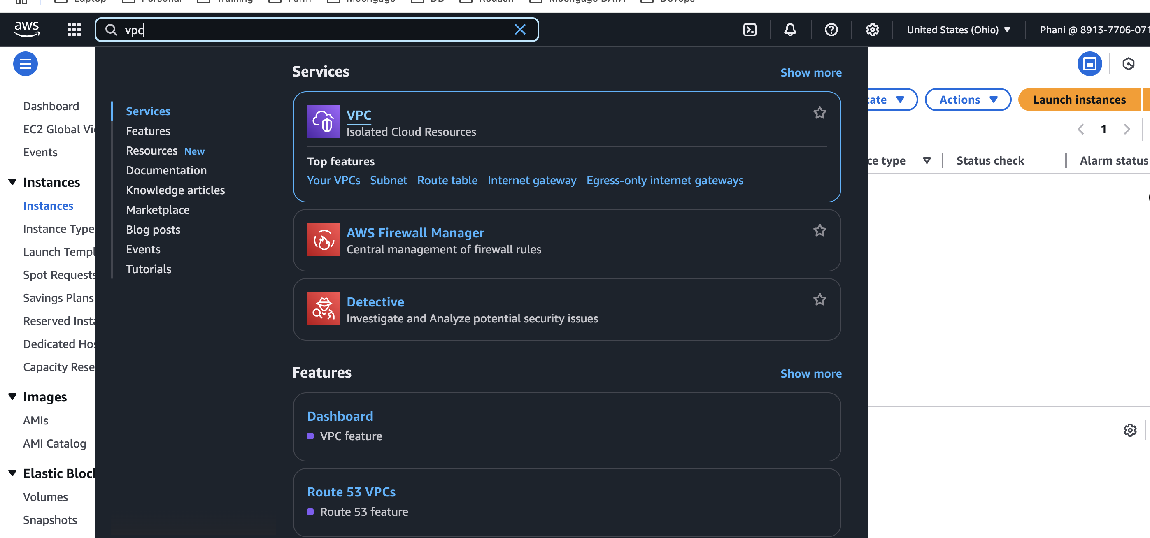
* Select the VPCs option  
  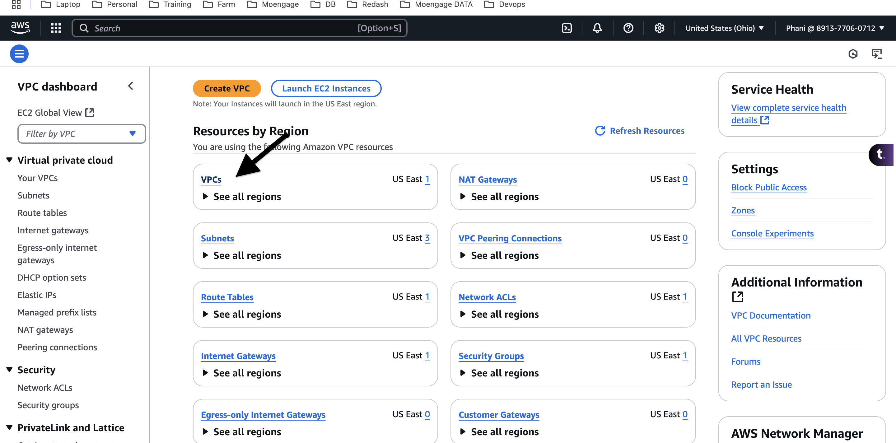
* click on the checkbox of the VPC which needs to be deleted.  
  A screenshot of a computer

  AI-generated content may be incorrect.
* Click on actions and click on delete VPC option  
  A screenshot of a computer

  AI-generated content may be incorrect.
* Click on ‘I Acknowledge’ checkbox and type the text as shown and click on delete button.  
  A screenshot of a computer

  AI-generated content may be incorrect.
* A pop-up will be shown on successful deletion.  
  A screenshot of a computer

  AI-generated content may be incorrect.

**2. What are the use cases of class A, B, C, D, E?**

Network classes are groupings of IP addresses that are divided based on the size of the network and its intended use. The most common classes are A, B, and C, but there are also classes D and E.

2^7 2^6 2^5 2^4 2^3 2^2 2^1 2^0

128 64 32 16 8 4 2 1

for value 10, the value in binary will be 00001010 (8+2)

for value 168, the binary value will be 10101000(128+32+8)

for 192, the binary value will be 11000000(128+64)

* Class A Used for large networks with many devices,
  + First octet values are 0–127, Default subnet mask is 255.0.0.0
  + Example address: 10.52.36.11. (1.0.0.0-126.255.255.255)
  + 8 bits for Network and 24 bits for hosts
* Note: 127.0.0.0 is the loop back address(localhost)
* Class B Used for medium-sized networks,
  + First octet values are 128–191, Default subnet mask is 255.255.0.0
  + Example address: 172.16.52.63. (128.0.0.0-191.255.255.255)
  + 16 bits for Network and 16 bits for hosts
* Class C Used for small networks,
  + First octet values are 192–223, Default subnet mask is 255.255.255.0
  + Example address: 192.168.123.132. (192.0.0.0-223.255.255.255)
  + 24 bits for Network and 8 bits for hosts
* Class D Used for multicast addressing, which allows multiple devices to receive a single data packet at the same time.
  + First octet values are 224–239 (224.0.0.0-239.255.255.255)
* Class E Reserved for future use and experimental purposes
  + 240-255(240.0.0.0-255.255.255.255)

**Difference Between OSI Model and TCP/IP Model**

* Data communication is a process or act in which we can send or receive data. For data communication two models are available, the OSI (Open Systems Interconnection) Model, and the TCP/IP (Transmission Control Protocol/Internet Protocol) Model.
* These models work as frameworks for organizing and understanding how data moves from one device to another across networks. While both models aim to achieve similar goals, they differ in their approach, layer organization, and practical application within computer networking.

**OSI Model**

* OSI stands for Open Systems Interconnection. It has 7 layers Physical layer, Data Link layer, Network layer, Transport layer, Session layer, Presentation layer, and Application layer. Each layer performs its task independently. It was developed in 1984 by the International Organization for Standardization (ISO).  
    
  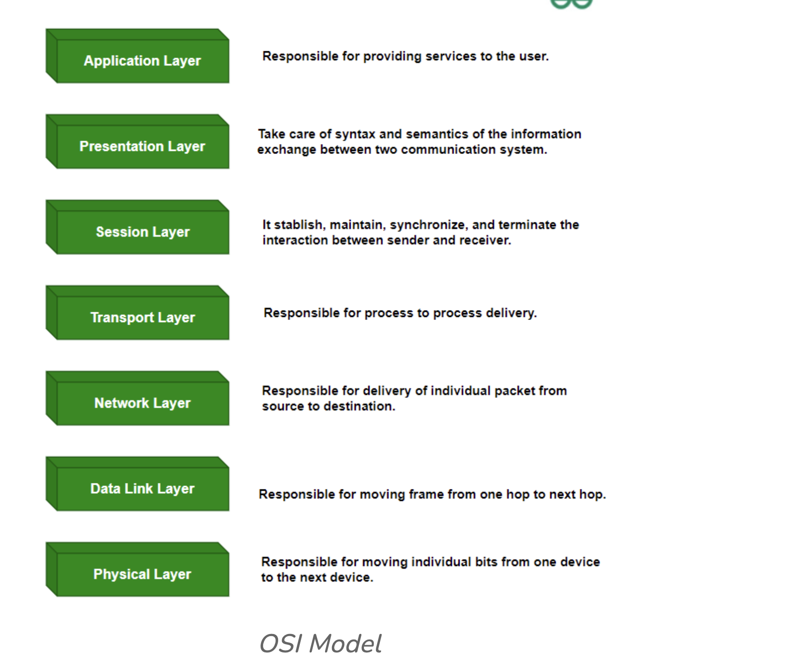
* The data flow in the OSI (Open Systems Interconnection) model describes how data is transmitted from one device to another through the seven layers of the OSI model.
* The data flow in the OSI model involves encapsulating data at each layer on the sender side, transmitting it over the network, and decapsulating it at each layer on the receiver side to ensure the data reaches its intended destination correctly and reliably.  
  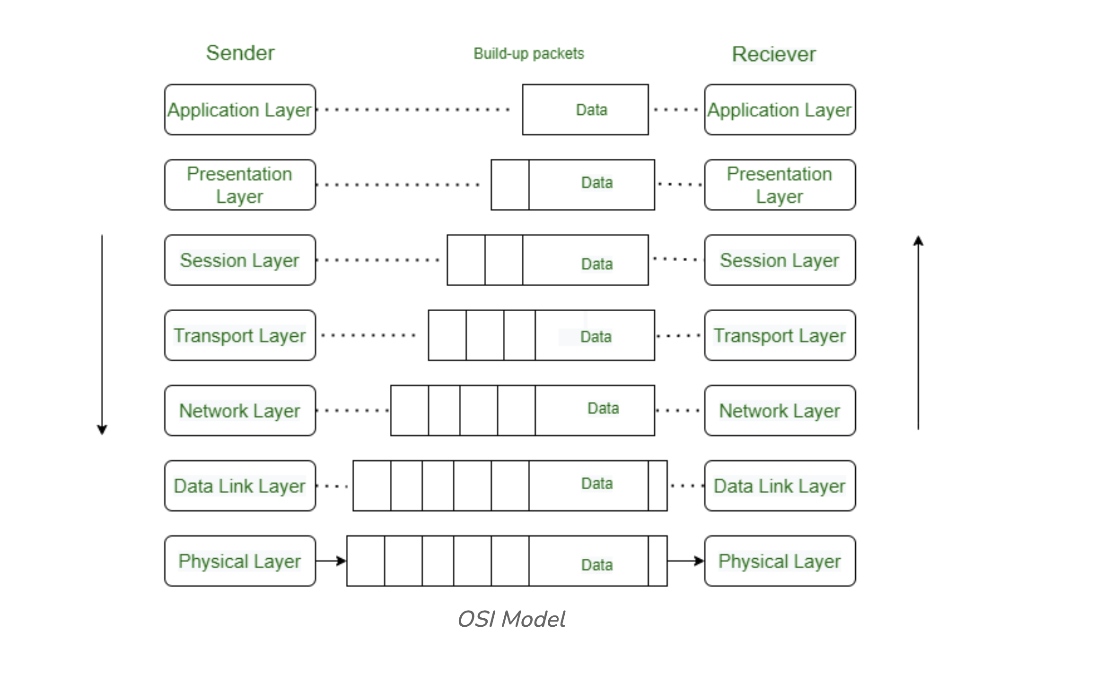

**TCP/IP:**

* TCP/IP stands for Transmission Control Protocol/Internet Protocol. It has 4 layers named as Physical layer, Network layer, Transport layer, and Application layer. It also can be used as a communications protocol in a private computer network. It was designed by Vint Cerf and Bob Kahn in the 1970s.  
  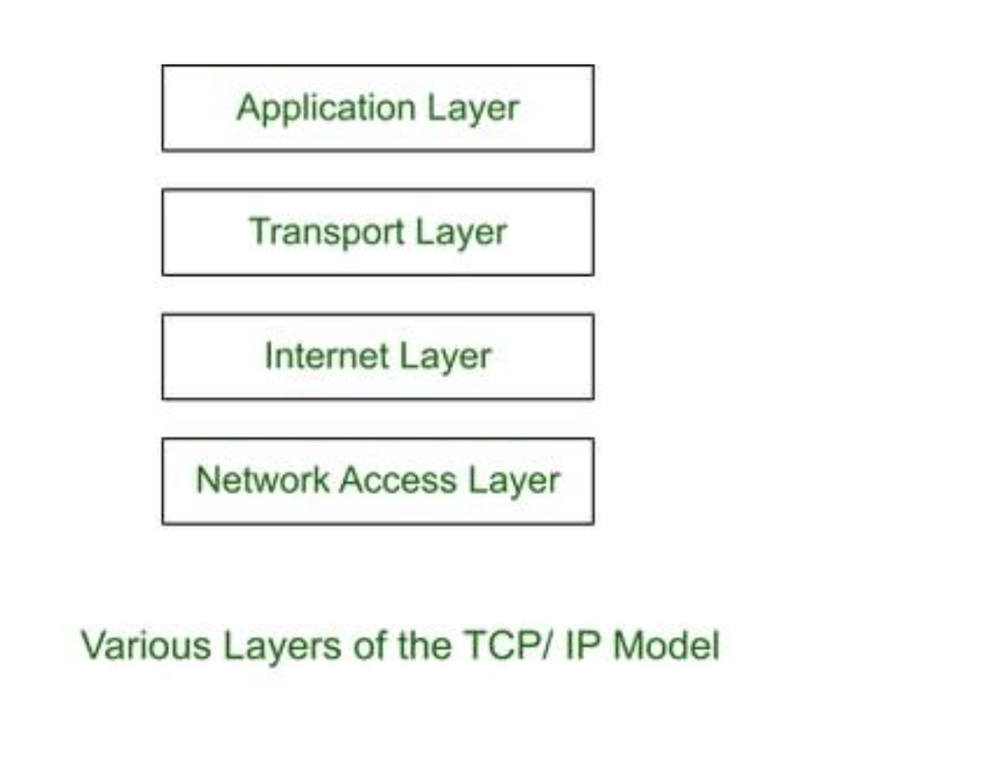

**Differences Between OSI Model and TCP/IP Model**

* The OSI (Open Systems Interconnection) Model and the TCP/IP (Transmission Control Protocol/Internet Protocol) Model are two frameworks used to understand how data moves through networks. While they both help in organizing network communication, they have distinct structures and purposes.

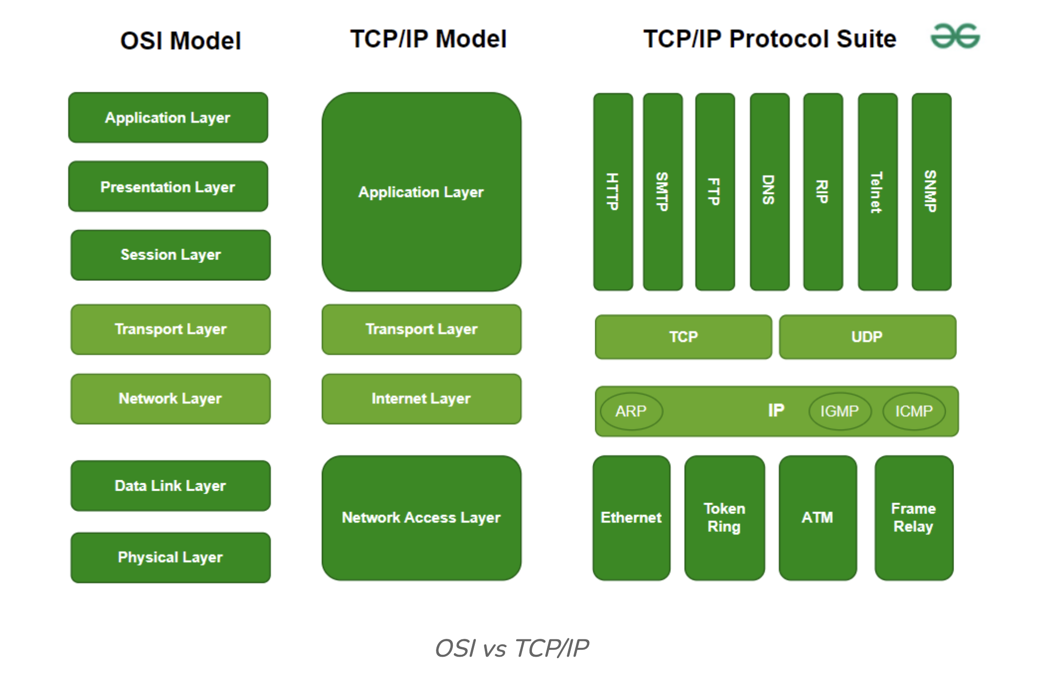

| **Parameters** | **OSI Model** | **TCP/IP Model** |
| --- | --- | --- |
| **Full Form** | OSI stands for Open Systems Interconnection | TCP/IP stands for Transmission Control Protocol/Internet Protocol |
| **Layers** | It has 7 layers | It has 4 layers |
| **Usage** | It is low in usage | It is mostly used |
| **Approach** | It is vertically approached | It is horizontally approached |
| **Delivery** | Delivery of the package is guaranteed in OSI Model | Delivery of the package is not guaranteed in TCP/IP Model |
| **Replacement** | Replacement of tools and changes can easily be done in this model | Replacing the tools is not easy as it is in OSI Model |
| **Reliability** | It is less reliable than TCP/IP Model | It is more reliable than OSI Model |
| **Protocol Example** | Not tied to specific protocols, but examples include HTTP (Application), SSL/TLS (Presentation), TCP (Transport), IP (Network), Ethernet (Data Link) | HTTP, FTP, TCP, UDP, IP, Ethernet |
| **Error Handling** | Built into Data Link and Transport layers | Built into protocols like TCP |
| **Connection Orientation** | Both connection-oriented (TCP) and connectionless (UDP) protocols are covered at the Transport layer | TCP (connection-oriented), UDP (connectionless) |