BOOTSTRAP

- What is Bootstrap?
  - Bootstrap is a popular front-end CSS framework that helps you build responsive, mobile-friendly websites quickly.
  - In simple words: Bootstrap gives you ready-made design styles and layout tools.

- What Bootstrap provide?
1️⃣ Prebuilt UI Styles
You get classes ready for:
- Buttons
- Forms
- Cards
- Alerts
- Navbars

Example
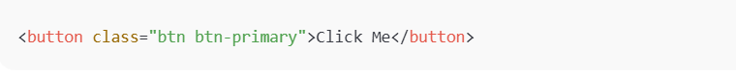

2️⃣ Responsive Grid System
Bootstrap uses a 12-column grid to make layouts adjust to screen size automatically.

Example

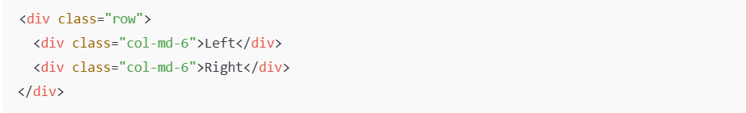

3️⃣ Ready-to-Use Components
Bootstrap includes styled components like:
- Navbar
- Modal
- Carousel
- Dropdown
- Cards
4️⃣ Utility Classes
Quick helpers for spacing and alignment:
Class | Purpose
mt-3 | margin-top
p-2 | padding
text-center | center text
d-flex | flexbox

- Why Developers Use Bootstrap
✔ Saves time
✔ No need to write CSS from scratch
✔ Responsive by default
✔ Consistent design
- Bootstrap vs Plain CSS
Plain CSS | Bootstrap
Write everything yourself | Use ready classes
Takes more time | Fast development
Manual responsiveness | Built-in grid

