Table of Contents
Execution Detection Resources
Option 1: Arize Phoenix
1. Overview
2. Prerequisites
3. Integration Steps
Step 1 — Launch Phoenix and Register the Tracer Provider
Step 2 — Wrap the Agent Run in a Custom Master Span
Step 3 — Surface Tool Failures as OpenTelemetry Errors
Step 4 — Mark the Master Span as Failed When the Goal Is Not Achieved
4. Code Example — Wiring Up Arize Phoenix
5. Viewing Traces in Phoenix
Step 1 — Navigate to the Traces Section
Step 2 — Inspect Successful and Failed Runs
6. Summary
Option 2: Traceloop
1. Overview
2. Prerequisites
Step 1 — Generate an API Key
3. Integration Steps
Step 1 — Initialise the SDK
Step 2 — Decorate the Workflow and Task Functions
Step 3 — Run the Agent
4. Code Example — Wiring Up Traceloop
5. Viewing Traces in Traceloop
Step 1 — Navigate to Traces
Step 2 — Inspect a Trace
Step 3 — Identify Failed Runs
6. Summary
Option 3: Langfuse
1. Overview
2. Prerequisites
Step 1 — Sign in to Langfuse
Step 2 — Create a New Project
Step 3 — Generate API Keys
3. Integration Steps
Step 1 — Initialise the Langfuse Callback Handler
Step 2 — Raise Exceptions for Failures
4. Code Example — Wiring Up Langfuse
5. Viewing Traces in Langfuse
Step 1 — Navigate to Traces
Step 2 — Inspect Execution Levels
6. Summary

Execution Detection Resources
This document describes how to implement Execution Detection (tracking success vs failure rates) within the AWS Unified Agent pipeline. The execution dimension can be measured using any of the following three observability platforms:
Option 1: Arize Phoenix
Option 2: Traceloop
Option 3: Langfuse

Option 1: Arize Phoenix

1. Overview
Arize Phoenix is an open-source agent observability platform that collects OpenTelemetry traces from LangChain and LangGraph workloads and presents them in an interactive local dashboard. Within the Digital Performance Index (DPI) framework, Phoenix serves as the Execution Detection layer — recording whether each agent run succeeded or failed and surfacing that status visually.
How Phoenix measures the Execution Dimension:
Every agent run generates a master Trace named AwsUnifiedAgent_Execution, which wraps all LangChain sub-spans.
On completion, a custom attribute agent.execution_status is set to "success" or "failed" on that master span.
If the agent failed to achieve its goal, the master span status is explicitly set to ERROR, turning it red in the Phoenix UI.
Execution Dimension = Successful Attempts ÷ Total Attempts.
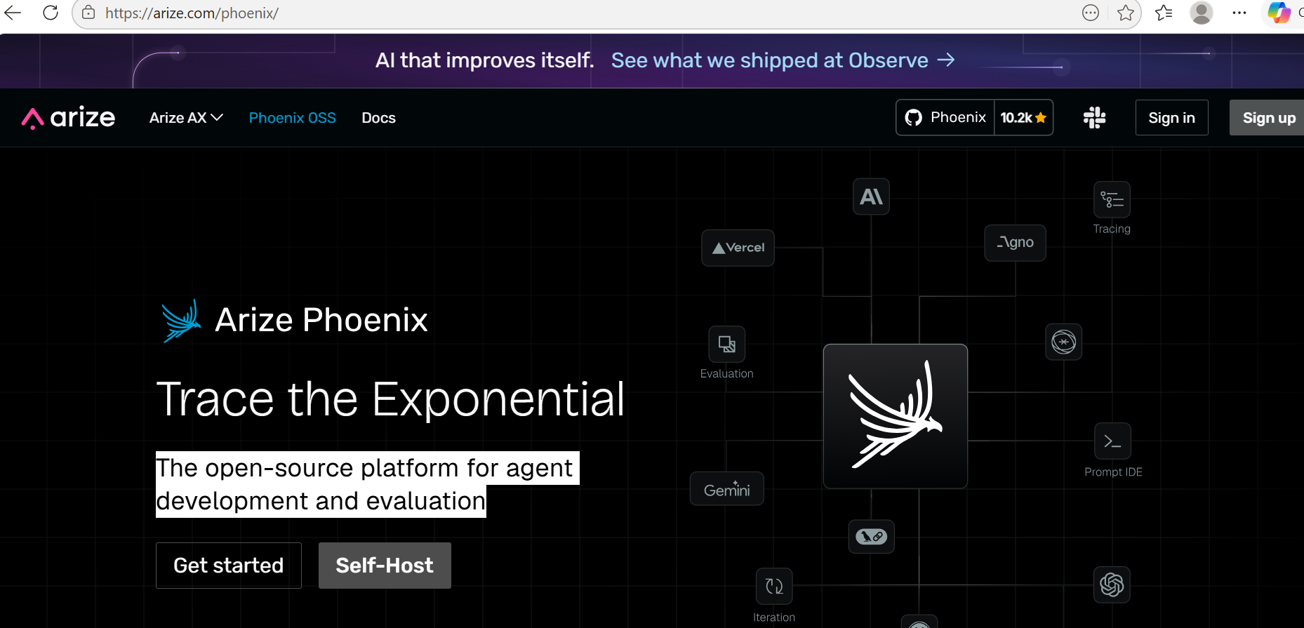

2. Prerequisites
Ensure the following packages are installed in the project environment before integrating Phoenix:
arize-phoenix — the local Phoenix server and dashboard UI.
openinference-instrumentation-langchain — automatic instrumentation for LangChain and LangGraph.
opentelemetry-api and opentelemetry-sdk — the core OpenTelemetry libraries.
Installation command: uv add arize-phoenix openinference-instrumentation-langchain opentelemetry-api opentelemetry-sdk

3. Integration Steps

Step 1 — Launch Phoenix and Register the Tracer Provider
At the script entry point, the local Phoenix dashboard is launched and registered as the global OpenTelemetry exporter. The LangChain instrumentor is then activated so that all tool calls and LLM requests are captured automatically without any manual instrumentation in the agent code.
Phoenix starts a lightweight local server at http://localhost:6006/. The register() call connects the OpenTelemetry pipeline to that server, and LangChainInstrumentor() patches all LangChain internals to emit spans transparently.

Step 2 — Wrap the Agent Run in a Custom Master Span
By default, OpenTelemetry only tracks activity inside LangChain. Because the agent runs a multi-iteration orchestrator loop, the entire pipeline execution is wrapped in a custom master span named AwsUnifiedAgent_Execution. This groups all sub-spans from every iteration into a single logical trace.
The following custom attributes are injected onto the master span after the pipeline completes and appear in the Phoenix UI under the Attributes tab:
agent.execution_status — the final outcome: "success" or "failed".
agent.iterations_used — the number of retry iterations consumed by the pipeline.

Step 3 — Surface Tool Failures as OpenTelemetry Errors
OpenTelemetry marks a span as Error (red) only when the Python function raises an unhandled Exception. Tools that return a non-zero return code without raising an exception are recorded as successful spans, making failures invisible in the dashboard.
To make tool failures visible, a custom CommandFailedError exception is raised from within each LangChain tool whenever a shell command exits with a non-zero return code. The orchestrator loop catches this exception so the script continues running, but Phoenix records that tool span as an error and highlights the exact failure point.

Step 4 — Mark the Master Span as Failed When the Goal Is Not Achieved
Even when all individual tool spans completed without errors, the overall agent run may have failed if it exhausted its retry budget without completing the task. In this case the master span status is set to StatusCode.ERROR with a descriptive message, causing the entire trace to appear red in the traces list. Failed runs are immediately identifiable without expanding sub-spans.

4. Code Example — Wiring Up Arize Phoenix
The following snippet demonstrates how to instrument an agent script with Phoenix:
python
import phoenix as px
from openinference.instrumentation.langchain import LangChainInstrumentor
from opentelemetry import trace
from opentelemetry.sdk.trace import TracerProvider
from opentelemetry.sdk.trace.export import SimpleSpanProcessor
from arize_phoenix.otel import OTLPSpanExporter

# 1. Launch the local Phoenix app
session = px.launch_app()

# 2. Set up the OpenTelemetry Tracer
tracer_provider = TracerProvider()
tracer_provider.add_span_processor(
SimpleSpanProcessor(OTLPSpanExporter(endpoint="http://127.0.0.1:6006/v1/traces"))
)
trace.set_tracer_provider(tracer_provider)

# 3. Auto-instrument LangChain
LangChainInstrumentor().instrument()

# 4. Wrap your agent execution in a master span
tracer = trace.get_tracer(__name__)
with tracer.start_as_current_span("AwsUnifiedAgent_Execution") as span:
try:
result = agent.run()
span.set_attribute("agent.execution_status", "success")
except Exception as e:
span.set_attribute("agent.execution_status", "failed")
span.set_status(trace.status.Status(trace.status.StatusCode.ERROR))

5. Viewing Traces in Phoenix
After the agent script completes, the Phoenix dashboard at http://localhost:6006/ displays all recorded traces. The dashboard provides the following views:
Traces list — all runs with duration and pass/fail status at a glance.
Trace tree — the full span hierarchy: master span at the top, LLM calls and tool invocations as children.
Attributes tab — custom attributes on any span, including agent.execution_status and agent.iterations_used.
Timeline view — a Gantt-style breakdown of time spent across each phase of the run.
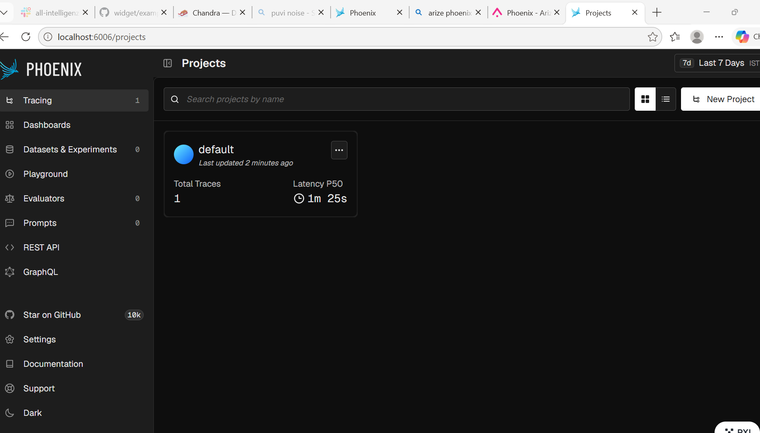

Step 1 — Navigate to the Traces Section
Open http://localhost:6006/ in a browser and select the default project from the left navigation panel. The traces list shows all recorded agent runs in chronological order.
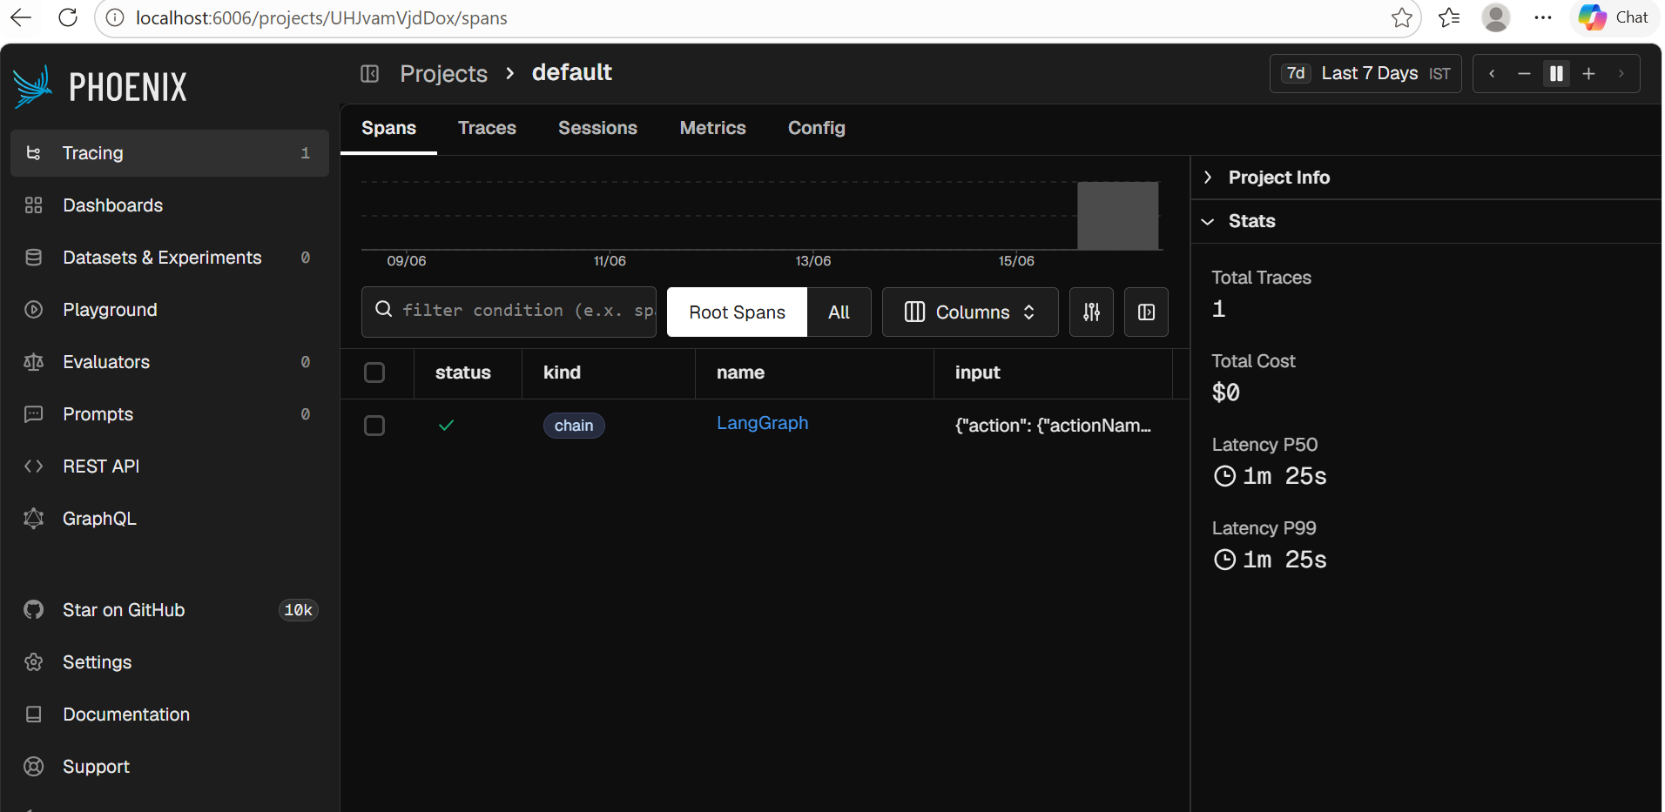
All executed traces are listed with their name, start time, duration, and status indicator.

Step 2 — Inspect Successful and Failed Runs
Successful runs are marked with a green OK indicator. Expanding the trace tree confirms every tool and LLM call completed without errors.
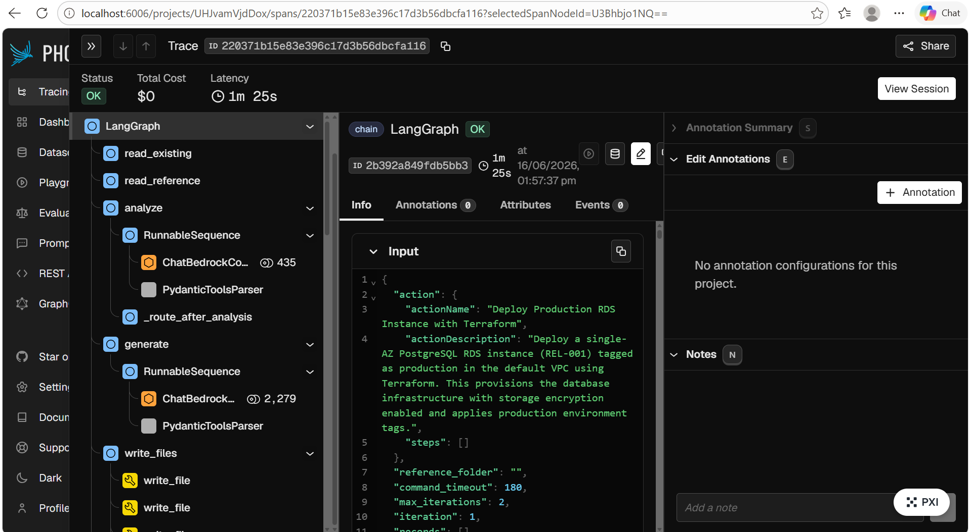
Failed runs are marked with a red Error indicator. The trace tree pinpoints exactly which tool span raised an exception and triggered the failure.
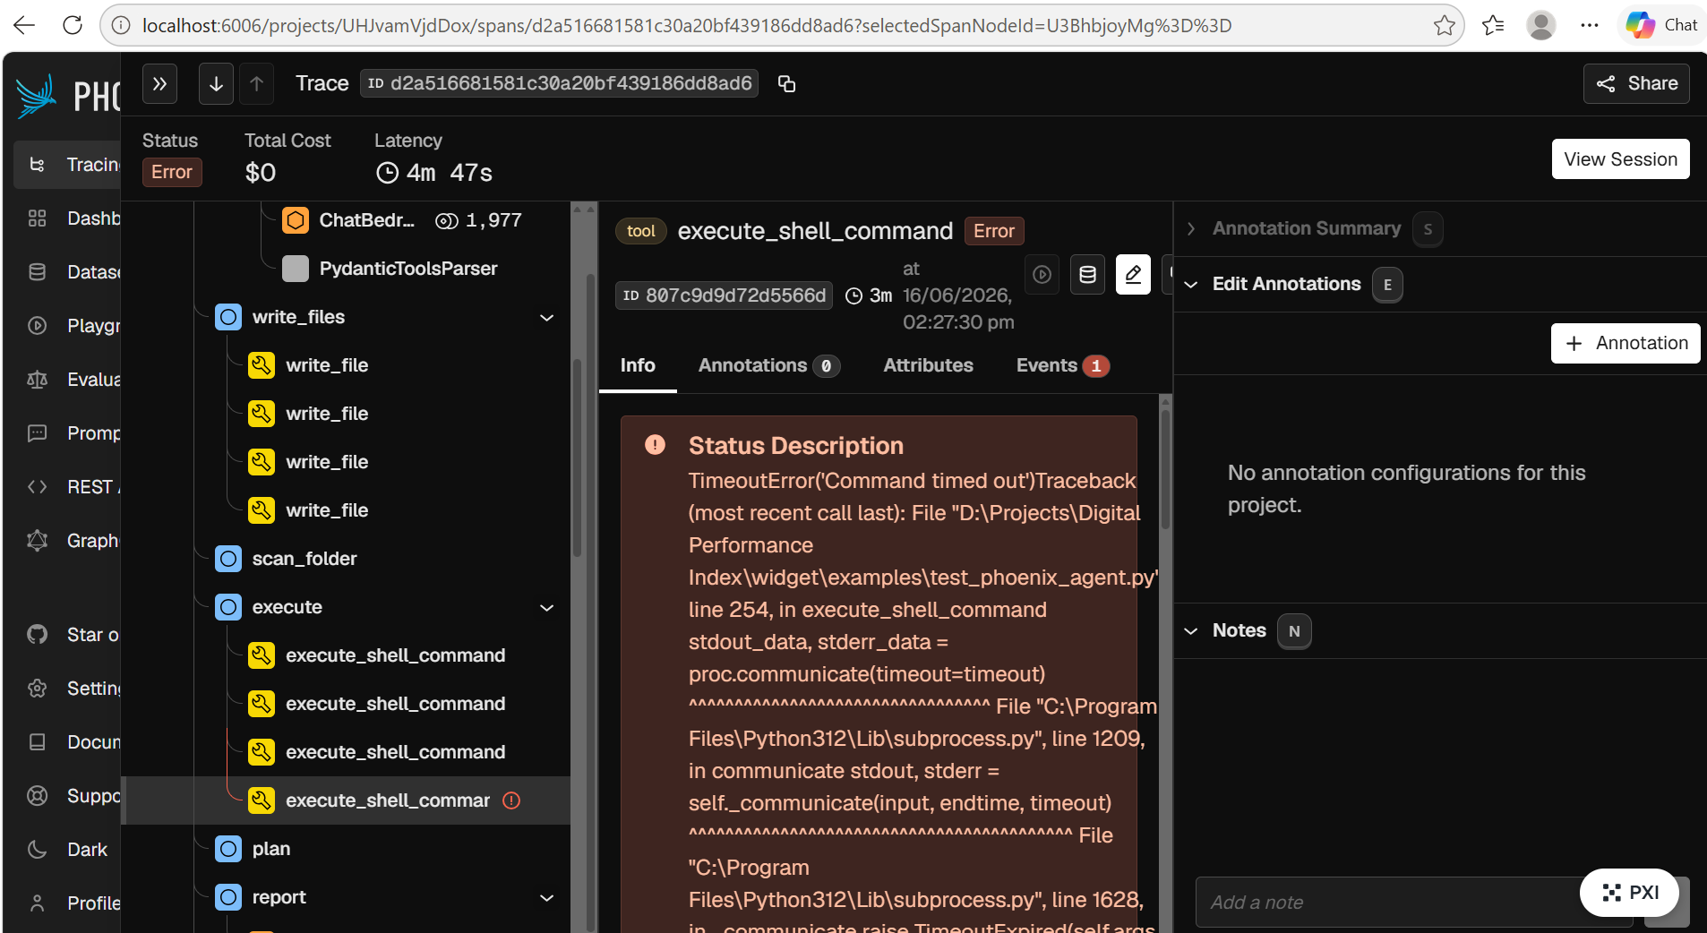
Using the success and failure counts visible in the traces list, the Execution Dimension is calculated as: Successful Attempts ÷ Total Attempts.

6. Summary
By combining automatic LangChain instrumentation with manual OpenTelemetry master spans and explicit exception raising, Arize Phoenix provides comprehensive end-to-end visibility into every agent execution. The integration enables the DPI framework to:
Track execution outcomes at the per-run level.
Pinpoint the exact tool or LLM call that caused a failure.
Calculate the Execution Dimension metric from aggregated trace data.
Monitor latency and token usage across all pipeline stages.

Option 2: Traceloop

1. Overview
Traceloop is a cloud-based observability platform for LLM applications and autonomous agents. Its underlying engine, OpenLLMetry, is built on the OpenTelemetry standard, making traces vendor-neutral — they can be forwarded to Datadog, Grafana, Honeycomb, or New Relic with no code changes.
Traceloop solves the "black box" problem of AI agents by providing:
Execution Dimension Tracking — automatically graphs success vs. failure rates across all agent runs, enabling the metric: Execution Dimension = Successful Attempts ÷ Total Attempts.
Cost Tracking — intercepts every API call to Bedrock, Anthropic, and OpenAI and calculates the precise token cost of each agent step.
Latency Debugging — a Waterfall chart shows exactly how time was distributed across each phase, identifying bottlenecks such as slow LLM responses or long-running shell commands.
Prompt Versioning and Playgrounds — the exact prompt sent to the LLM during a failed run can be copied into the Traceloop playground, edited, and replayed to verify improvements without re-running the full agent.
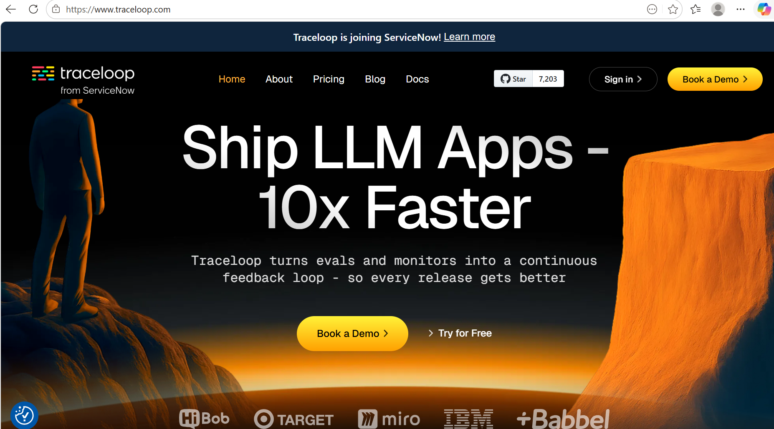

2. Prerequisites
Ensure the following are in place before integrating Traceloop:
A Traceloop account — sign up at app.traceloop.com.
An API key — generated under Settings → Projects and API Keys in the Traceloop dashboard.
The traceloop-sdk package — installed via: uv add traceloop-sdk
TRACELOOP_API_KEY environment variable — added to the project .env file.

Step 1 — Generate an API Key
Navigate to the Traceloop dashboard and go to Settings → Projects and API Keys → Generate API Key. Copy the generated key and add it to the project .env file as TRACELOOP_API_KEY.
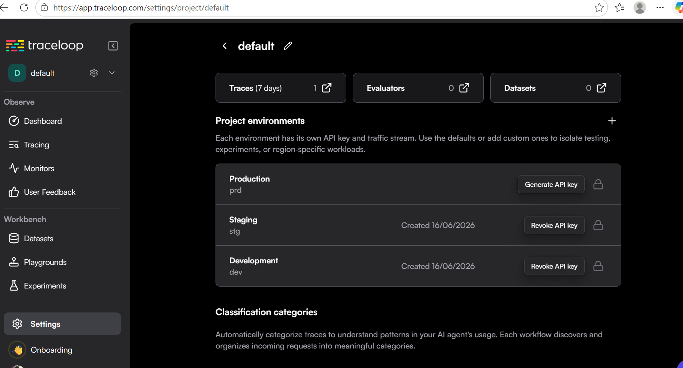

3. Integration Steps

Step 1 — Initialise the SDK
Import and initialise Traceloop at the top of the agent script, before any LangChain or LangGraph code runs. The SDK automatically reads TRACELOOP_API_KEY from the environment and begins forwarding traces to the Traceloop cloud.
The Traceloop.init() call sets up the global OpenTelemetry tracer provider and instruments all supported LLM libraries automatically. No per-call tracing code is required inside the agent itself.

Step 2 — Decorate the Workflow and Task Functions
Traceloop uses Python decorators to define the trace hierarchy. The @workflow decorator marks the top-level agent pipeline, while @task decorators mark individual node functions such as read_existing, analyze, generate, and execute.
When the agent runs, Traceloop builds a span tree that mirrors this decorator structure. Each @task span is a child of the parent @workflow span, producing a clean, readable trace in the dashboard without any manual span management.

Step 3 — Run the Agent
With the SDK initialised and the API key in place, run the agent script normally. Traceloop captures all LLM calls, tool invocations, and pipeline timings in the background and forwards them to the cloud dashboard within seconds of the run completing.

4. Code Example — Wiring Up Traceloop
The following snippet shows the minimal wiring required to integrate Traceloop into an agent script:
python
from dotenv import load_dotenv
from traceloop.sdk import Traceloop
from traceloop.sdk.decorators import workflow, task

# 1. Load TRACELOOP_API_KEY from the .env file
load_dotenv(override=True)

# 2. Initialise Traceloop
Traceloop.init()

# 3. Decorate each pipeline node with @task
class AwsUnifiedAgent:
@task(name="execute_command")
def execute_node(self, state) -> dict:
... # logic

# 4. Mark the top-level entry point with @workflow
@workflow(name="AwsUnifiedAgent")
def run(self) -> dict:
return self.execute_node({})

5. Viewing Traces in Traceloop
After a run completes, open app.traceloop.com and navigate to the relevant project. All traces appear in the traces list within a few seconds of the run finishing.

Step 1 — Navigate to Traces
Sign in to the Traceloop dashboard and open the relevant project. The traces list shows all agent runs with their status, duration, and cost.
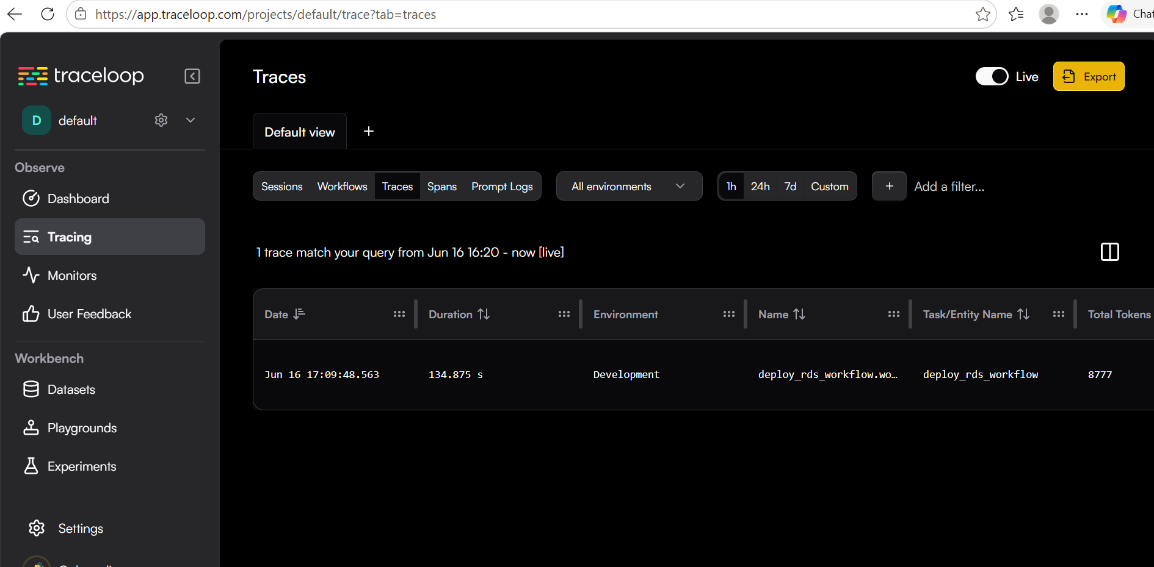

Step 2 — Inspect a Trace
Click on any trace to expand its full @workflow and @task span tree. The input and output of every LLM call and tool invocation are recorded and can be inspected directly in the dashboard.
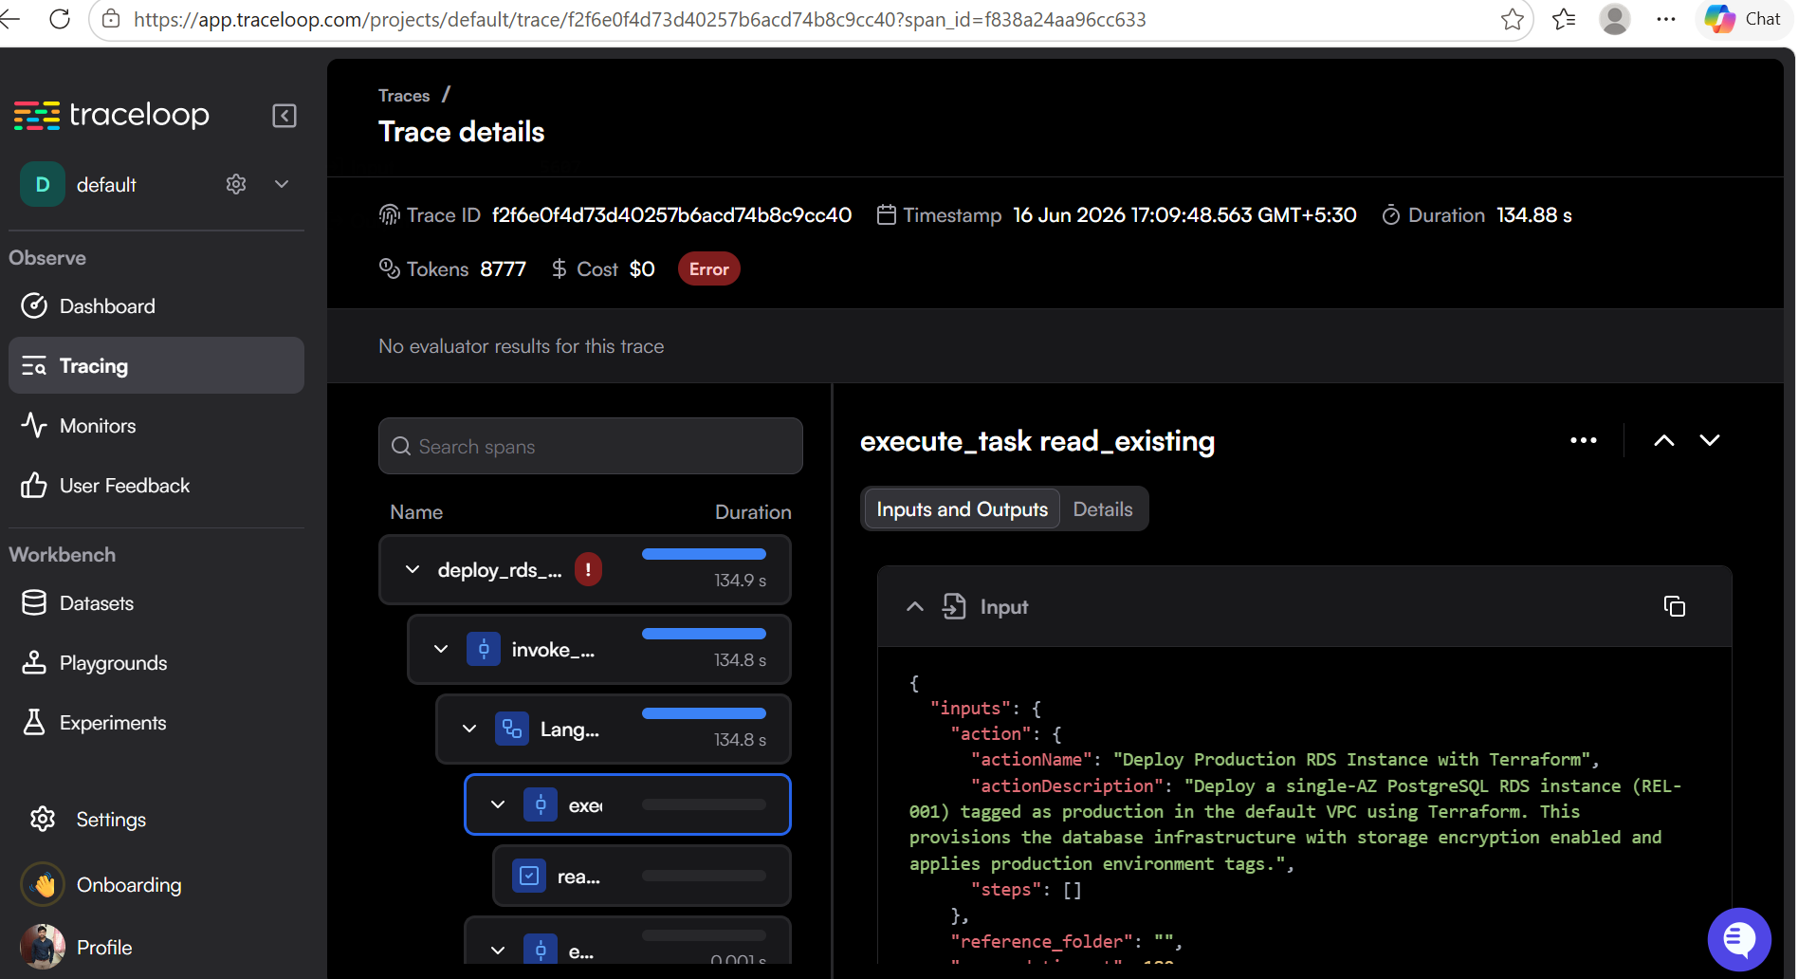

Step 3 — Identify Failed Runs
Failed agent runs are highlighted with a red error indicator. Expanding the trace tree shows which specific @task span failed and the associated error message, making root cause analysis straightforward.
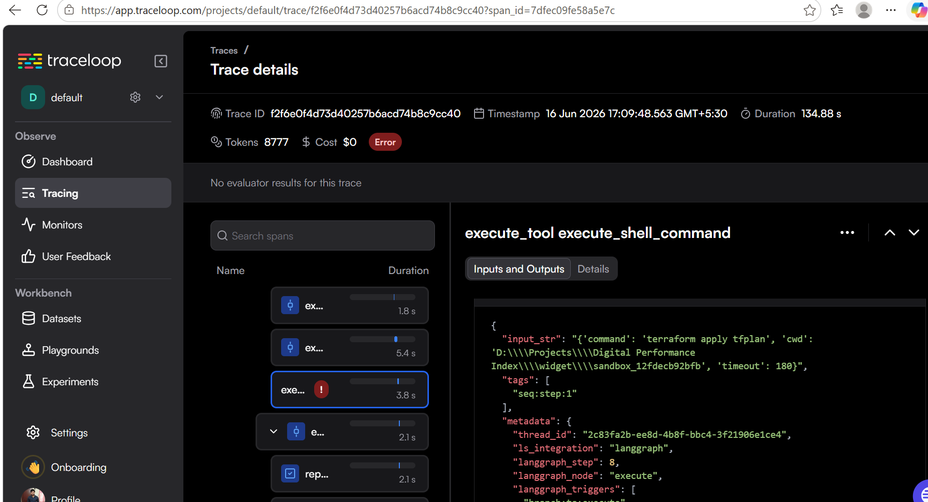
Using the pass and fail counts from the traces list, the Execution Dimension is calculated as: Successful Attempts ÷ Total Attempts.

6. Summary
Traceloop provides a cloud-native, zero-configuration observability solution for the AWS Unified Agent. By decorating workflow and task functions with the OpenLLMetry SDK, the DPI framework gains:
Automatic execution success and failure tracking across all agent runs.
Per-step cost attribution for every LLM API call.
Waterfall latency breakdown to identify pipeline bottlenecks.
Prompt replay capabilities for debugging failed runs.
A vendor-neutral telemetry standard compatible with any OpenTelemetry backend.

Option 3: Langfuse

1. Overview
Langfuse is an open-source observability and analytics platform for LLM applications. It provides detailed trace data to help debug, evaluate, and monitor agent executions.
Langfuse solves the "black box" problem by providing:
Execution Dimension Tracking — using the 'level' attribute (default vs error) to track successful vs failed tool executions.
Cost Tracking — calculating the token cost of each LLM call.
Latency Debugging — waterfall charts showing the duration of each phase of the run.

2. Prerequisites
Ensure the following are in place before integrating Langfuse:
A Langfuse account — sign up at cloud.langfuse.com or spin up locally via Docker (docker-compose up).
LANGFUSE_PUBLIC_KEY, LANGFUSE_SECRET_KEY, and LANGFUSE_HOST environment variables — added to the project .env file.
The langfuse package — installed via: uv add langfuse

Step 1 — Sign in to Langfuse
Go to the Langfuse homepage and click 'Launch App' to choose your region.
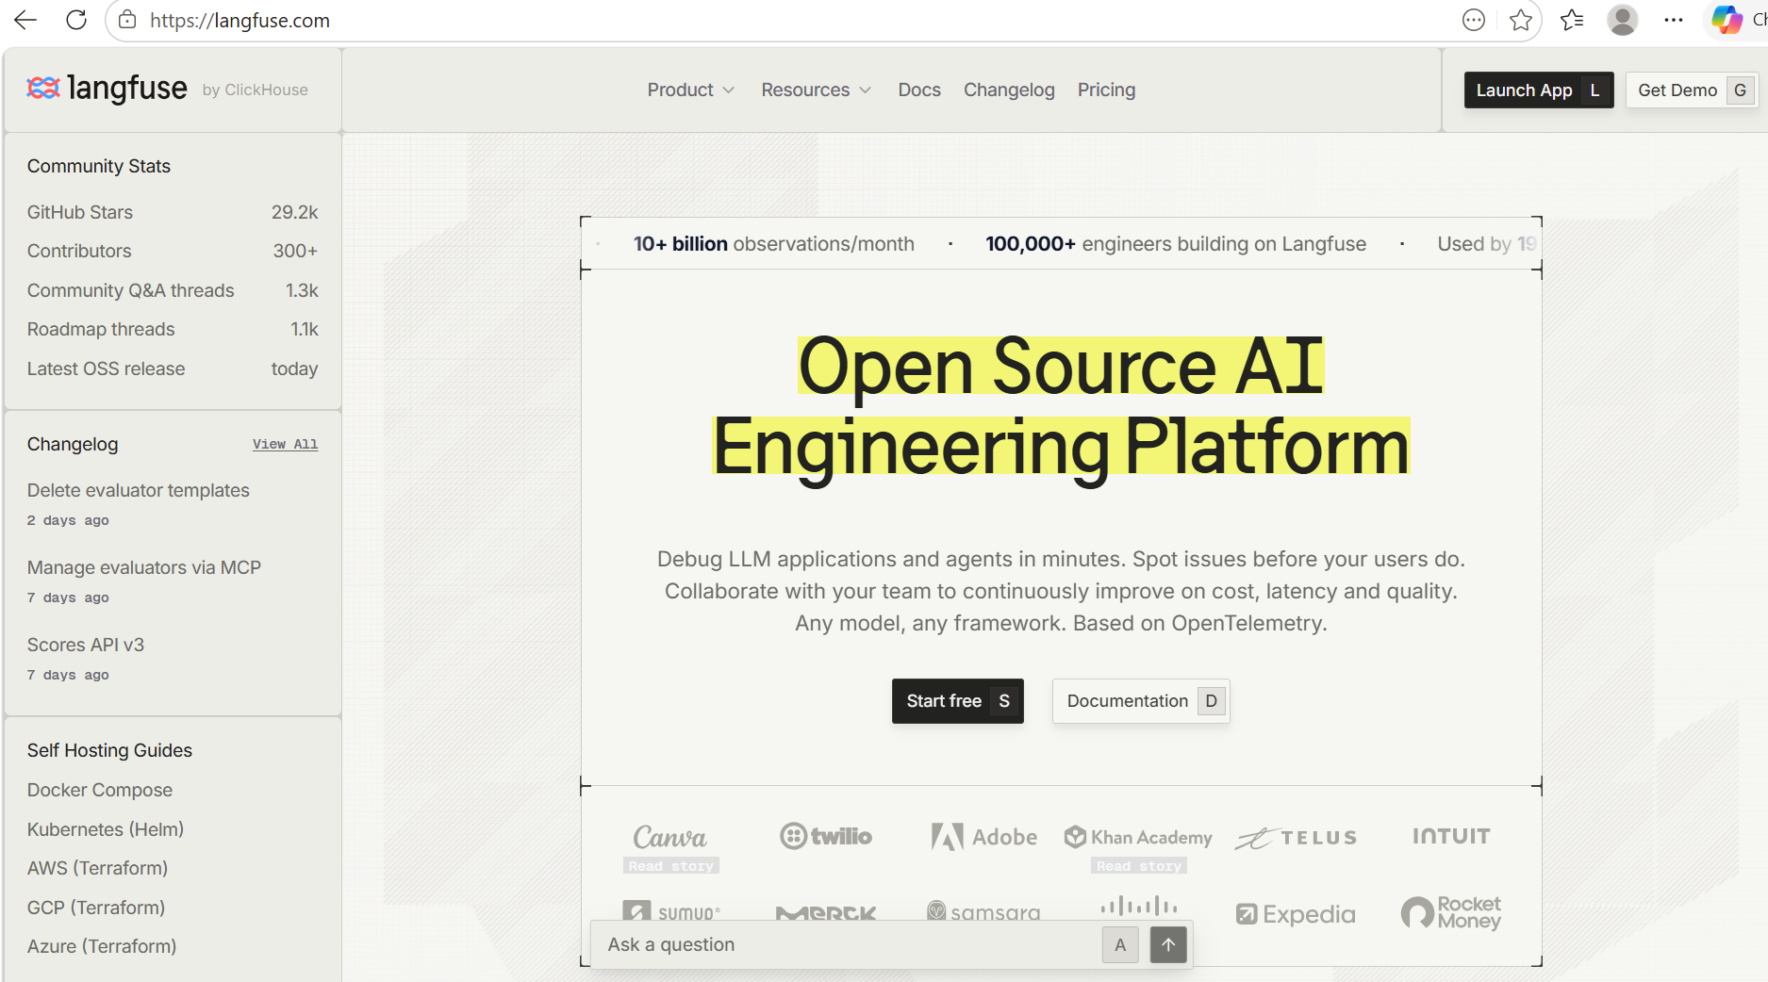

Step 2 — Create a New Project
Click 'New Project'.
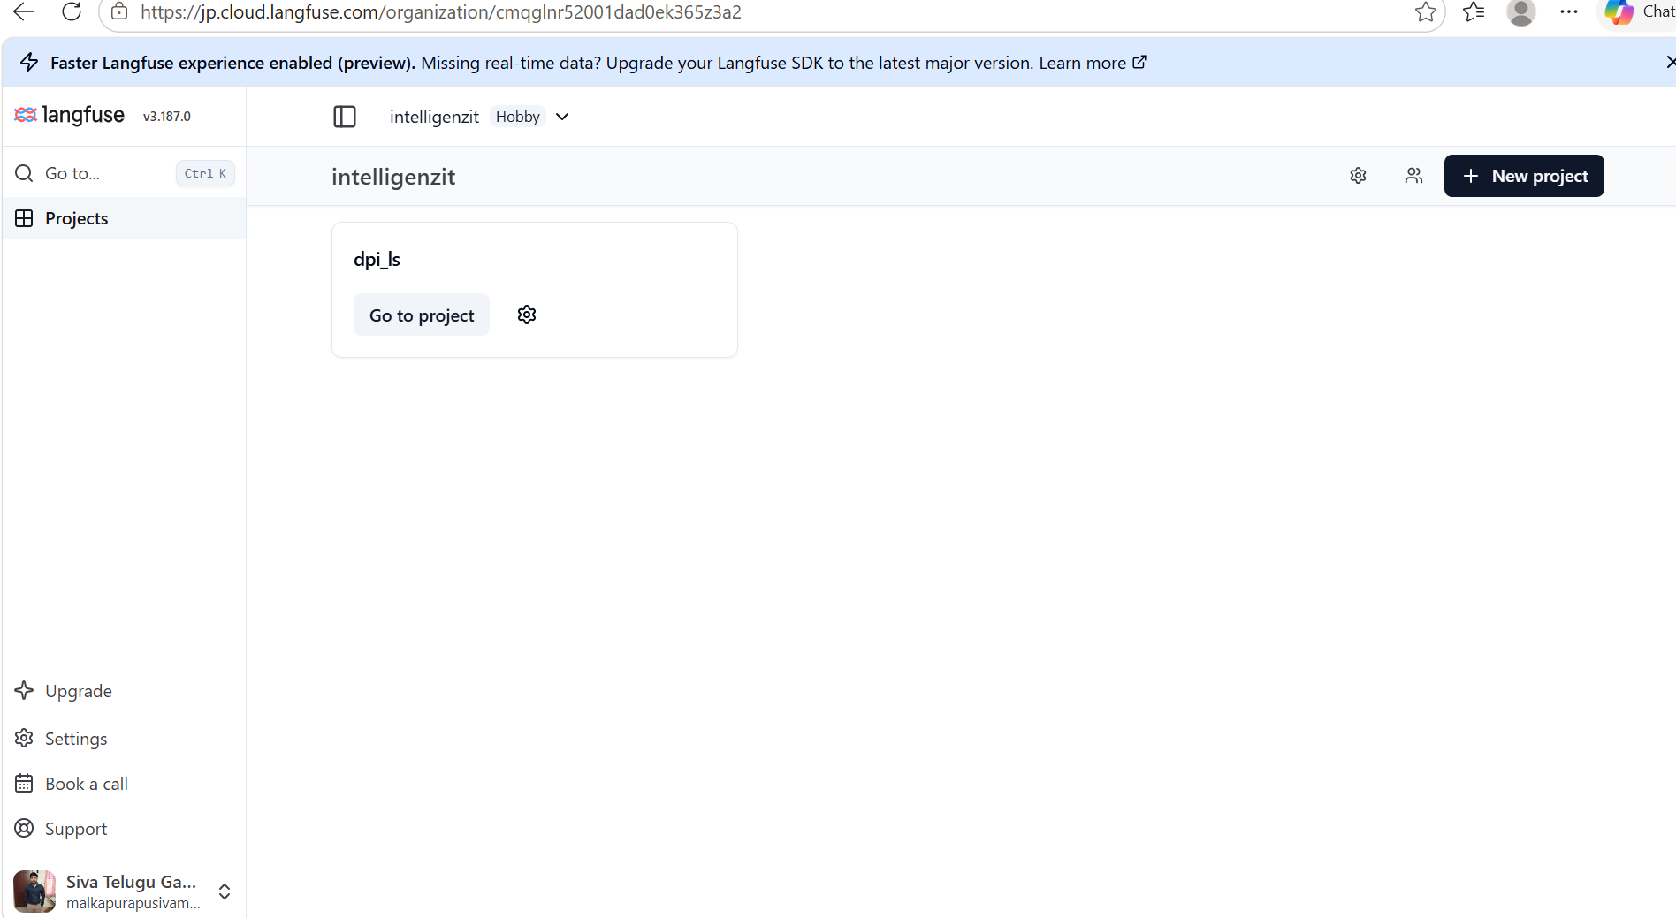
Enter your project name and click 'Create'.
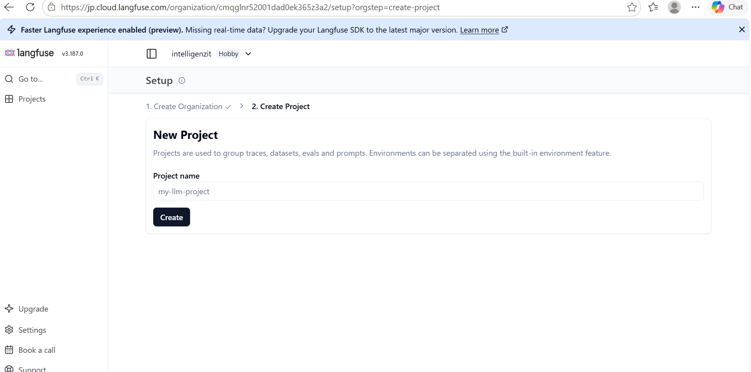
Open your new project dashboard.
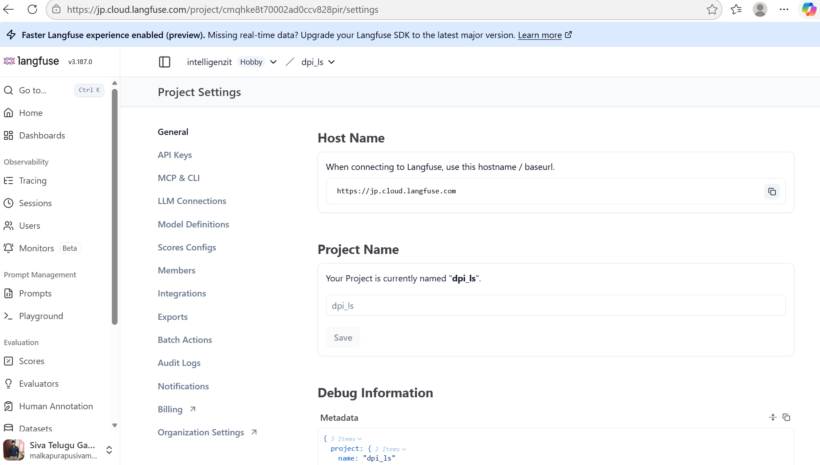

Step 3 — Generate API Keys
Navigate to the API Keys section and create a new set of API keys. Copy the Public Key, Secret Key, and Host URL into your .env file.
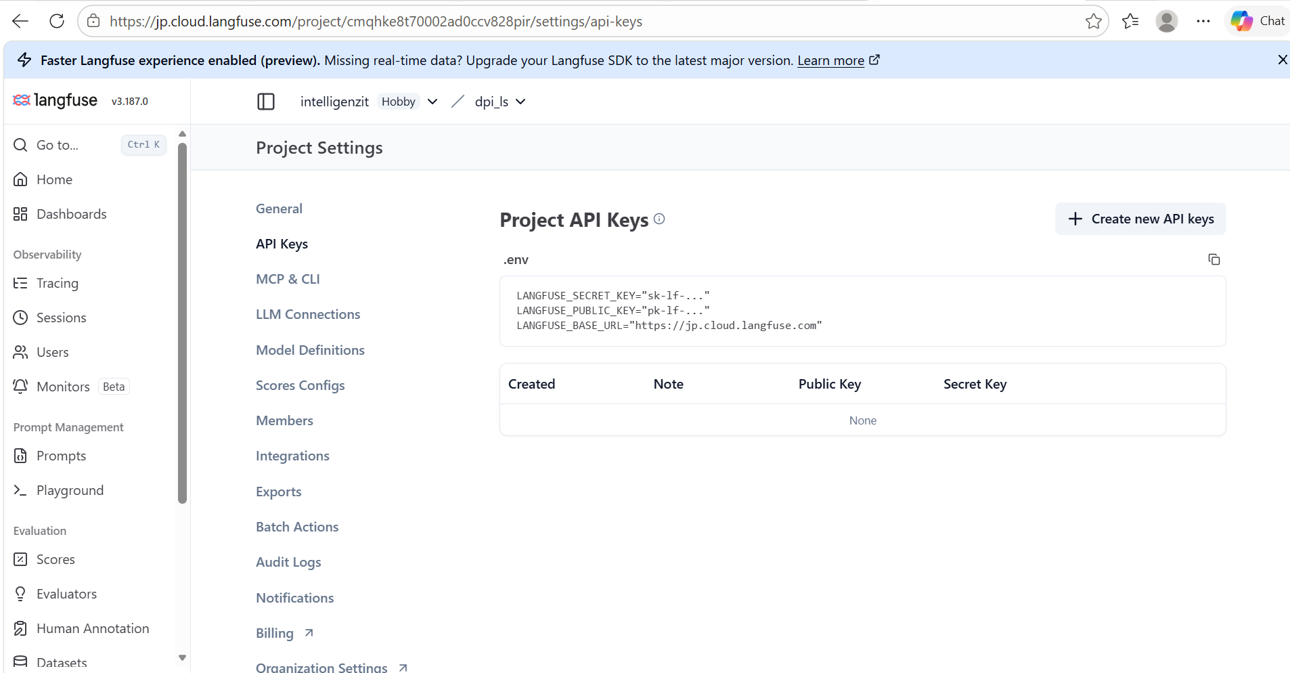

3. Integration Steps

Step 1 — Initialise the Langfuse Callback Handler
Import the CallbackHandler from the langfuse library and pass it into your LangChain or LangGraph invocation.

Step 2 — Raise Exceptions for Failures
If a tool fails, raise a standard Python exception. LangChain will catch this and pass an 'error' level status to the Langfuse tracer automatically.

4. Code Example — Wiring Up Langfuse
The following snippet shows the minimal wiring required to integrate Langfuse into an agent script:
python
import os
from dotenv import load_dotenv
from langfuse.callback import CallbackHandler
from langchain_aws import ChatBedrockConverse
from langchain_core.messages import HumanMessage

# 1. Load Langfuse credentials from the .env file
load_dotenv(override=True)

# 2. Initialize the Langfuse Callback Handler
# It automatically reads LANGFUSE_PUBLIC_KEY, LANGFUSE_SECRET_KEY, and LANGFUSE_HOST
langfuse_handler = CallbackHandler()

# 3. Initialize the LLM
llm = ChatBedrockConverse(model_id=os.getenv("BEDROCK_MODEL_ID"))

# 4. Pass the handler when invoking the LLM or agent workflow
response = llm.invoke(
[HumanMessage(content="Deploy a production RDS instance.")],
config={"callbacks": [langfuse_handler]}
)

print(response.content)
# Langfuse will automatically record this trace, including token usage and latency.

5. Viewing Traces in Langfuse
After running the script, open your Langfuse dashboard to view the generated traces.

Step 1 — Navigate to Traces
Go to the Tracing section. All executed traces are listed with their duration, token cost, and status.
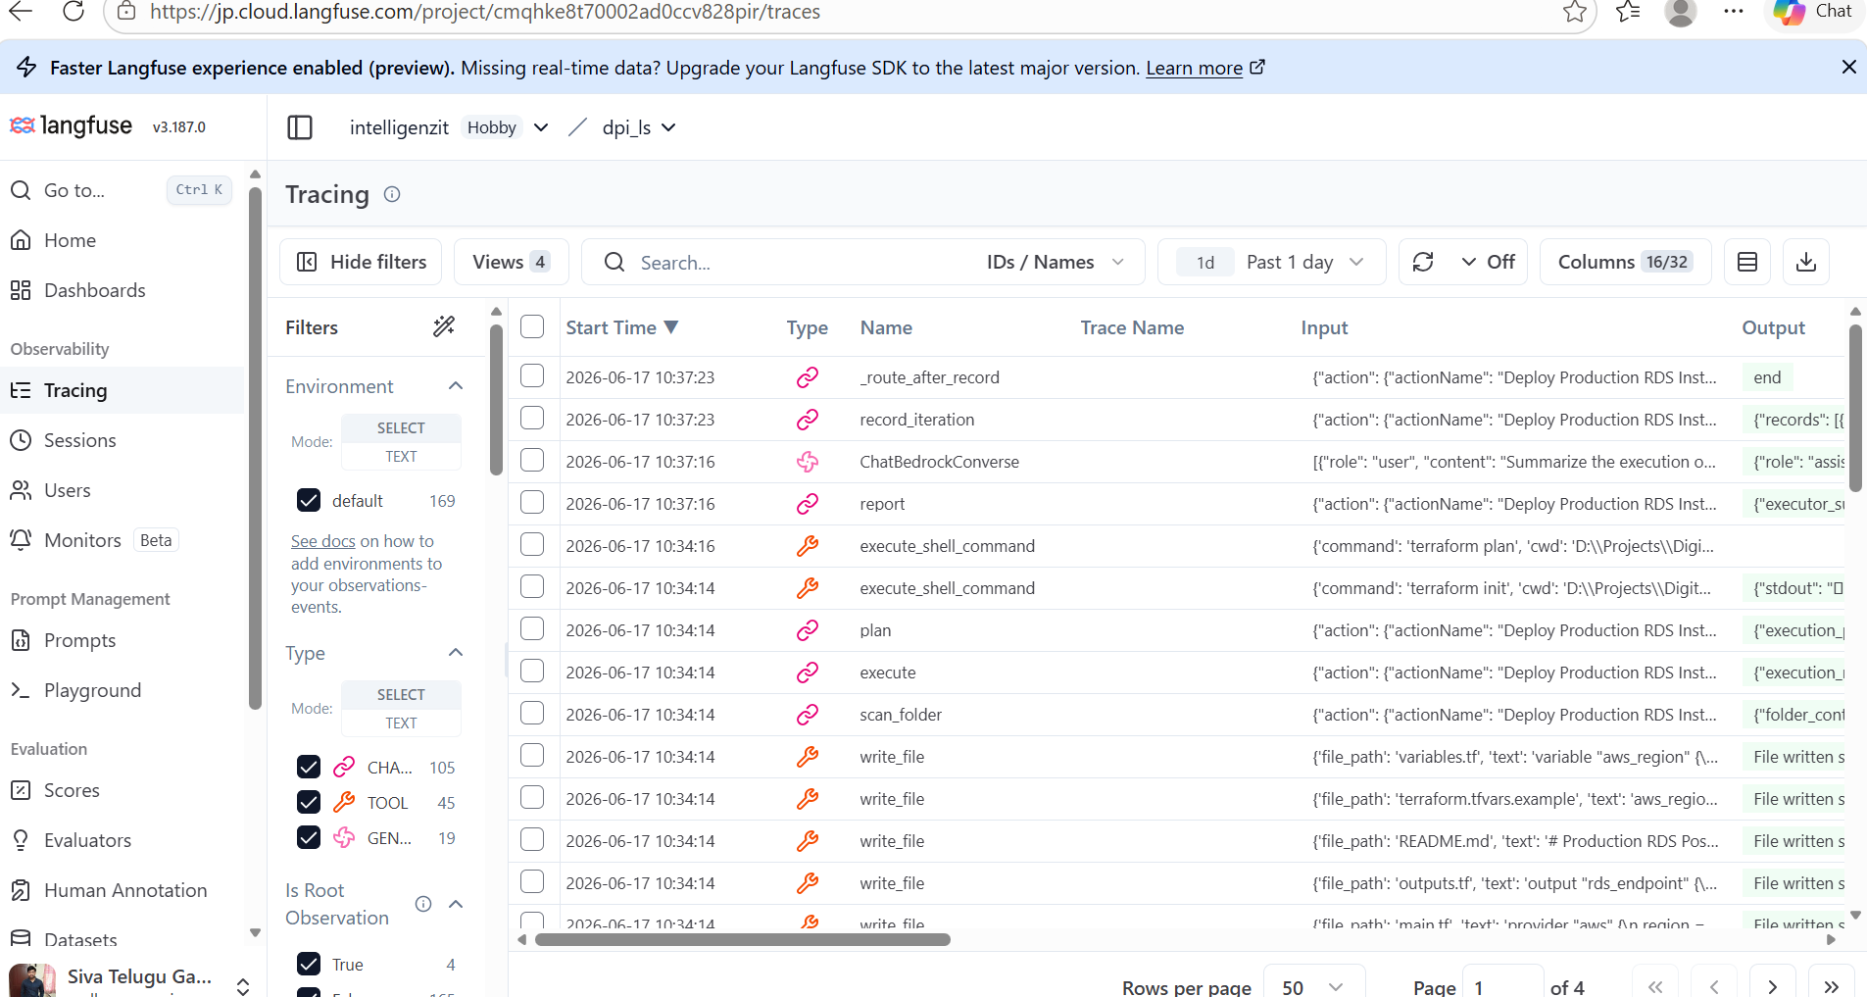

Step 2 — Inspect Execution Levels
Look at the 'level' column. Successful traces and spans will appear as 'DEFAULT', while failures will be marked as 'ERROR'.
Using the count of DEFAULT vs ERROR traces, the Execution Dimension can calculate the metric: Successful Attempts ÷ Total Attempts.
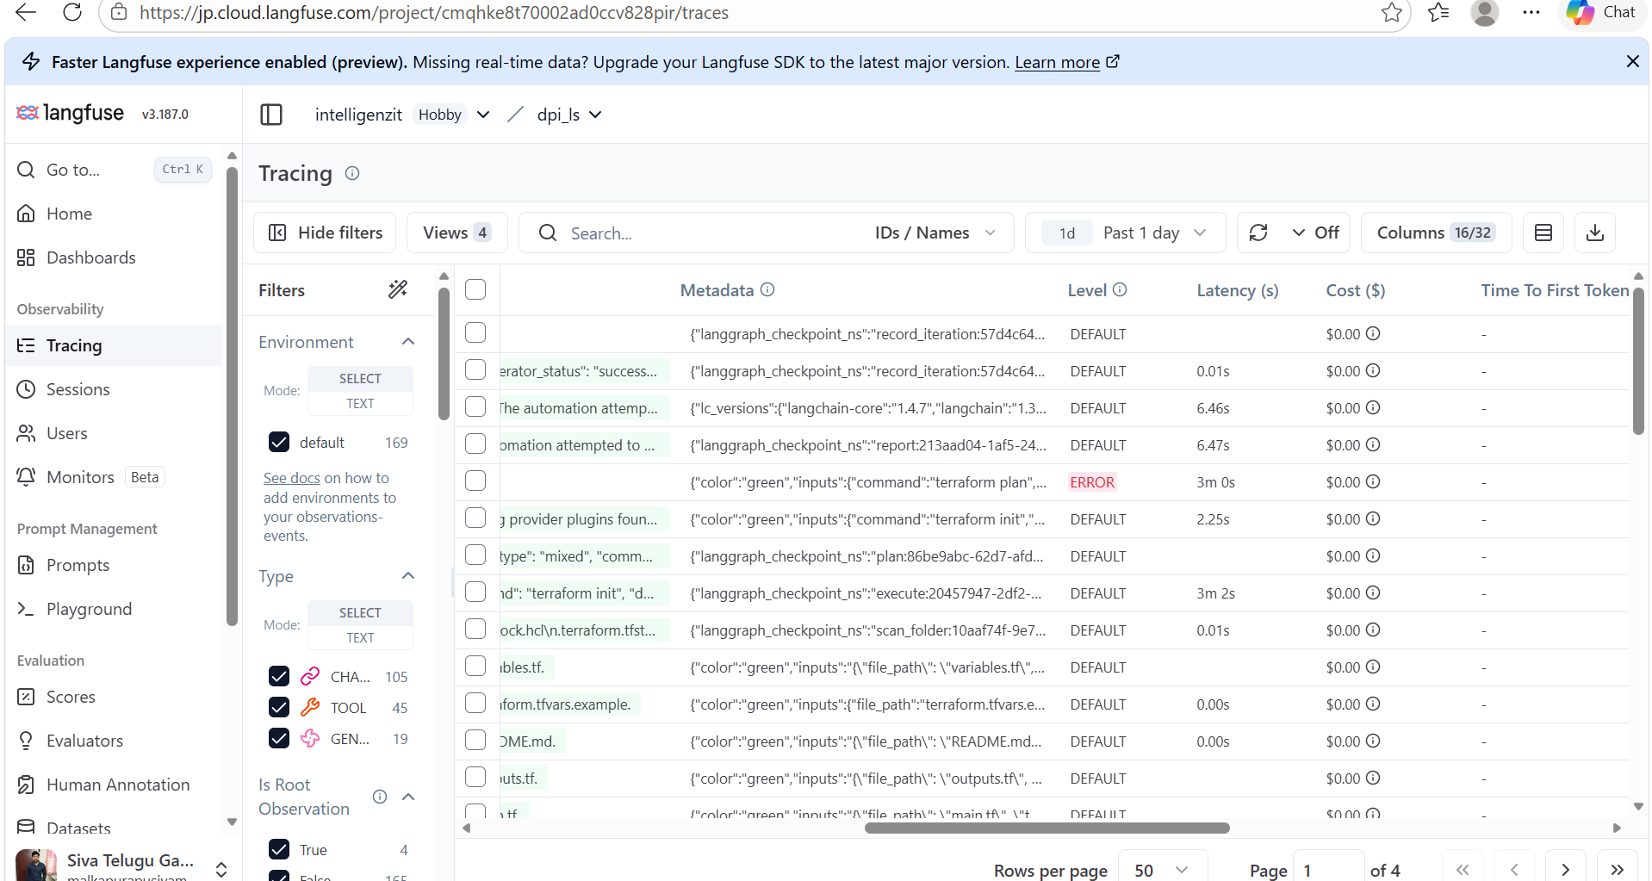

6. Summary
Langfuse provides deep observability into agent executions. By leveraging Langfuse callbacks with LangChain, you can:
Automatically track execution success and failure rates.
Monitor per-step cost and latency.
Debug specific tool errors and model outputs within complex workflows.

