DPI-LS: Digital Performance Index - Life Science

Visual Business Requirements Document (BRD)

What is DPI-LS & Why Did We Build It?
DPI-LS is an enterprise-grade AI governance and scoring platform for Large Language Model (LLM) agents. In the Life Sciences industry, highly sensitive data and strict FDA/HIPAA regulations mean a single AI hallucination can be disastrous. We built DPI-LS to act as a strict gatekeeper, aggregating telemetry from 20+ specialized observability tools to ensure AI agents are compliant, safe, and productive before and during production deployment.

Benefits, Advantages & Features
- * Mitigates Enterprise Risk: Hard stops on prompt injections, PII leaks, and rogue agents.
- * Empowers Business Owners: Non-technical SMEs can dictate what "success" means by setting custom baselines and weights.
- * Single Pane of Glass: Executives do not need to learn 20 different observability dashboards; everything is condensed into one simple score (A, B, C, F).
- * Real-Time Cost Tracking: Maps precise financial costs across GPUs and API providers to guarantee ROI.

Real Test Cases
1. Agent Registration & Scoring: Admin logs in, onboards "agent-001", configures 20% weight to Quality, and verifies the mathematically generated score on the Dashboard.
2. Offline Telemetry Fallback: If an external SaaS like AgentOps goes offline, the UI gracefully falls back to canonical dashboard links instead of crashing.
3. Security & Session Expiration: Clicking Sign Out forcefully purges the JWT token and redirects to the login screen within 1 minute of idle time.

End-to-End Visual Workflow

1. Secure Login
Administrators securely authenticate to access the DPI-LS enterprise governance platform.
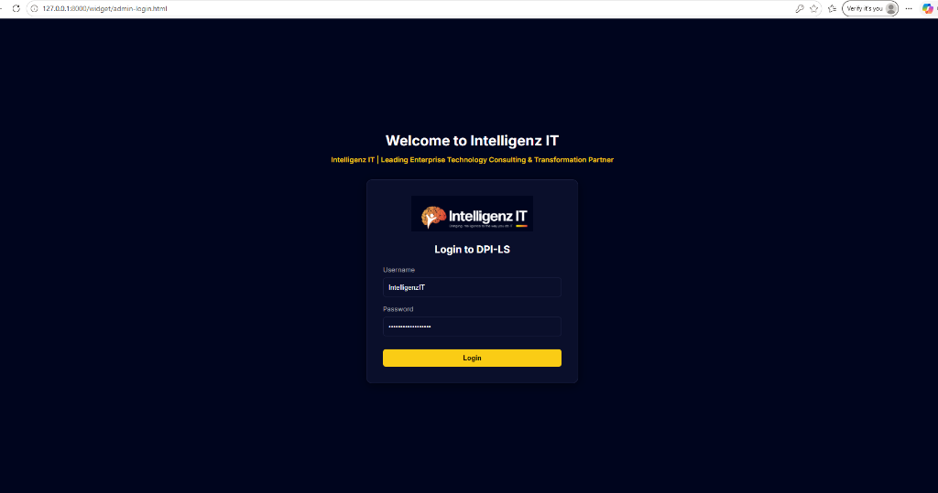

2. Global Dashboard
A unified view of all active agents and their performance scores across the 7 critical telemetry dimensions.
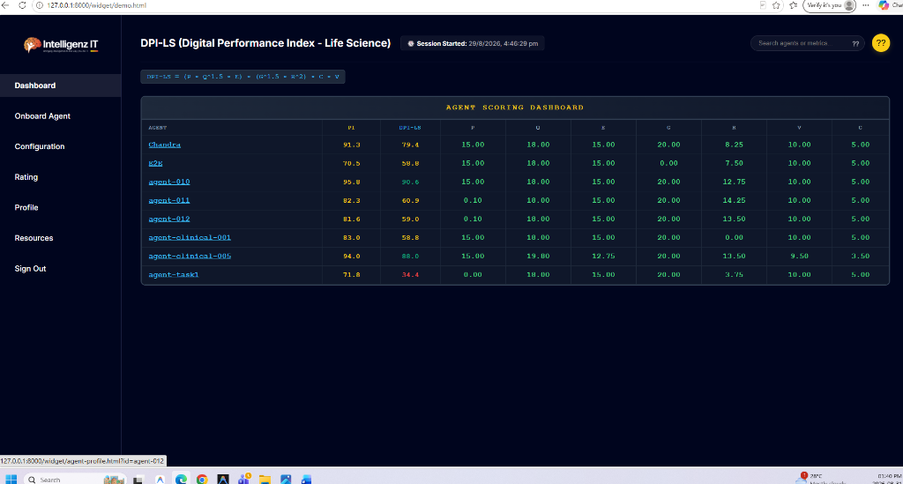

3. Agent Onboarding
Register new digital workers by defining their environment, scope, and technical/business ownership.
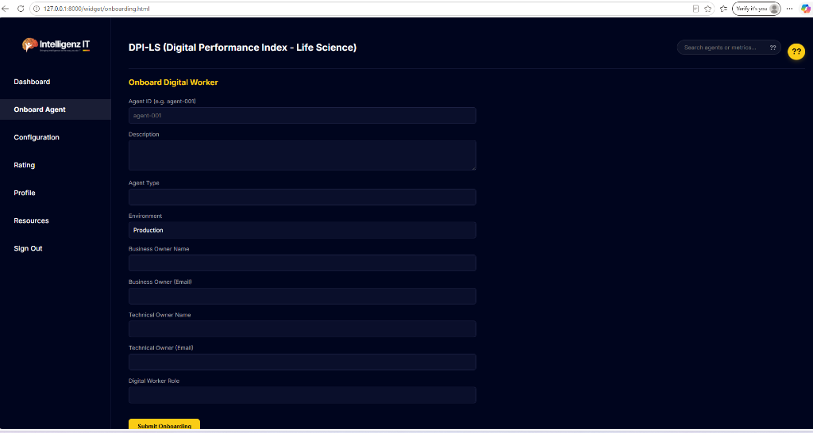

4. Business Configurations
SMEs dictate AI success by dynamically setting baseline targets and distributing 100% weight across the 7 metrics.
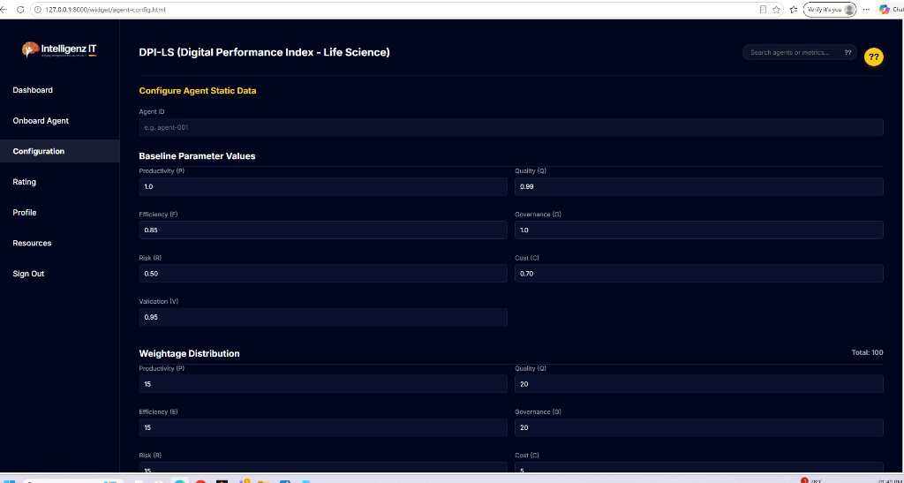

5. Manager Ratings
Business owners submit manual star-ratings to ensure empirical scores align with real-world human expectations.
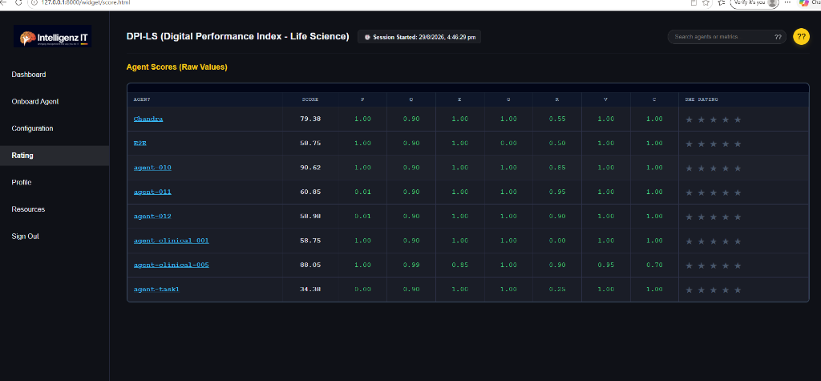

6. Agent Profile & Auditing
A deep-dive verifiable audit trail for individual agents to track parameters and reject unsafe models.
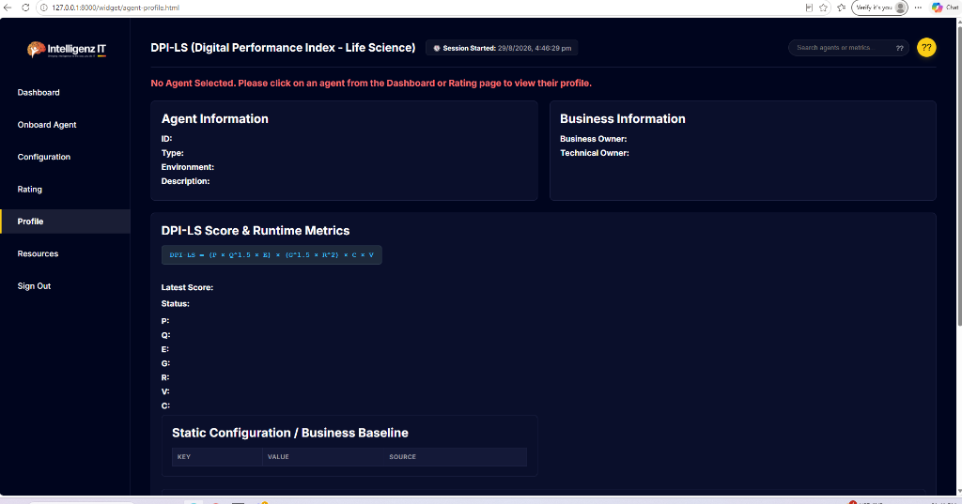

7. Telemetry Resources
Monitor the real-time operational status of 20+ integrated external observability tools like AgentOps and Langfuse.
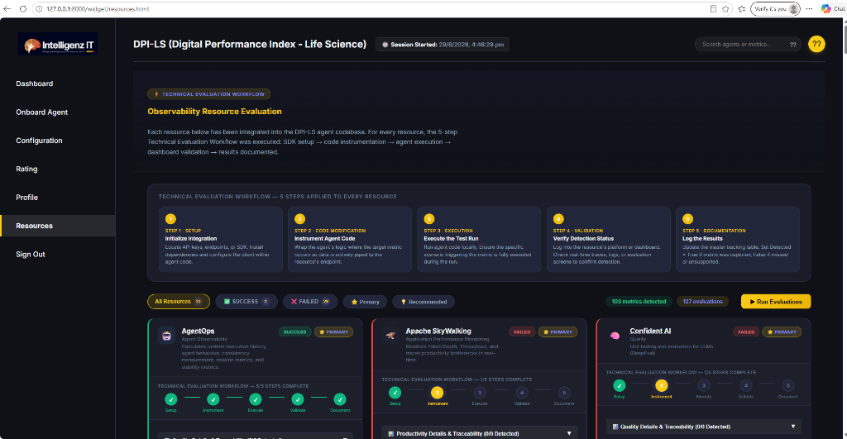

8. Secure Logout
Strict session expiration automatically terminates access and securely redirects users back to the login screen.
