**Ansible Assignment**

**Github Link:**

[**https://github.com/phanisaimunipalli/sjsu-msse/tree/main/cmpe272-esp/ansible-playbook**](https://github.com/phanisaimunipalli/sjsu-msse/tree/main/cmpe272-esp/ansible-playbook)

**Steps & Screenshots:**

1. Connect to existing Cisco Dcloud Session or create a new one
2. Check the connection – My Hub -> Connection Tests
3. Install Cisco AnyConnect and connect to the session
   1. Host: dcloud-sjc-anyconnect.cisco.com
   2. User: V27user1

Connect to any of 3 VMs from the list present in “DevNet-Express-DC-Guide-v2-1.pdf” file.

**My Instances are:**

VM1 --> 198.18.134.28 - Ubuntu 14.04.5 LTS - (main)

VM2 --> 198.18.134.49 --> CentOS7

VM3 --> 198.18.134.50 --> CentOS7

Installed Ansible on VM1

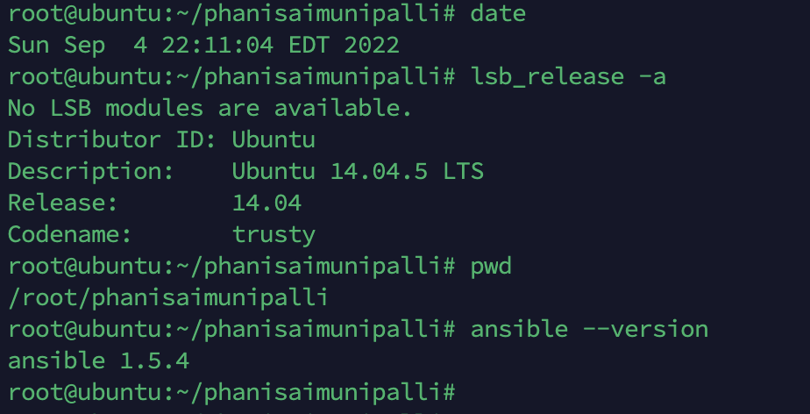

Create a separate ansible hosts per subject as a best practice and create inventory hosts' file with VM2 and VM3 instances.

To exit from nano edit --> CTRL+X then Y and ENTER

1. Create Password less connection by connecting SSH keygens between VMs
2. Run inventory by going to custom inventory path   
    ***ansible -m ping all -i inventory***

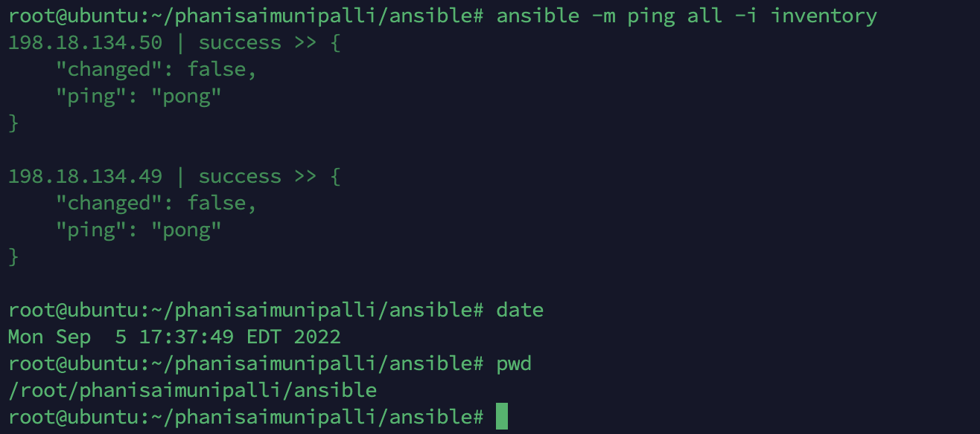

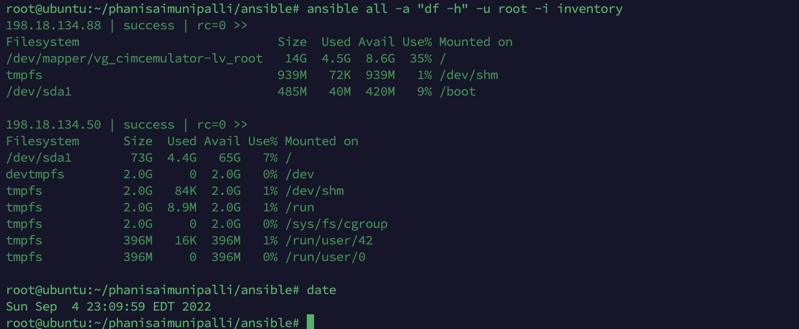

Run playbook using the command below

***ansible-playbook deploy_apache.yml -i inventory***

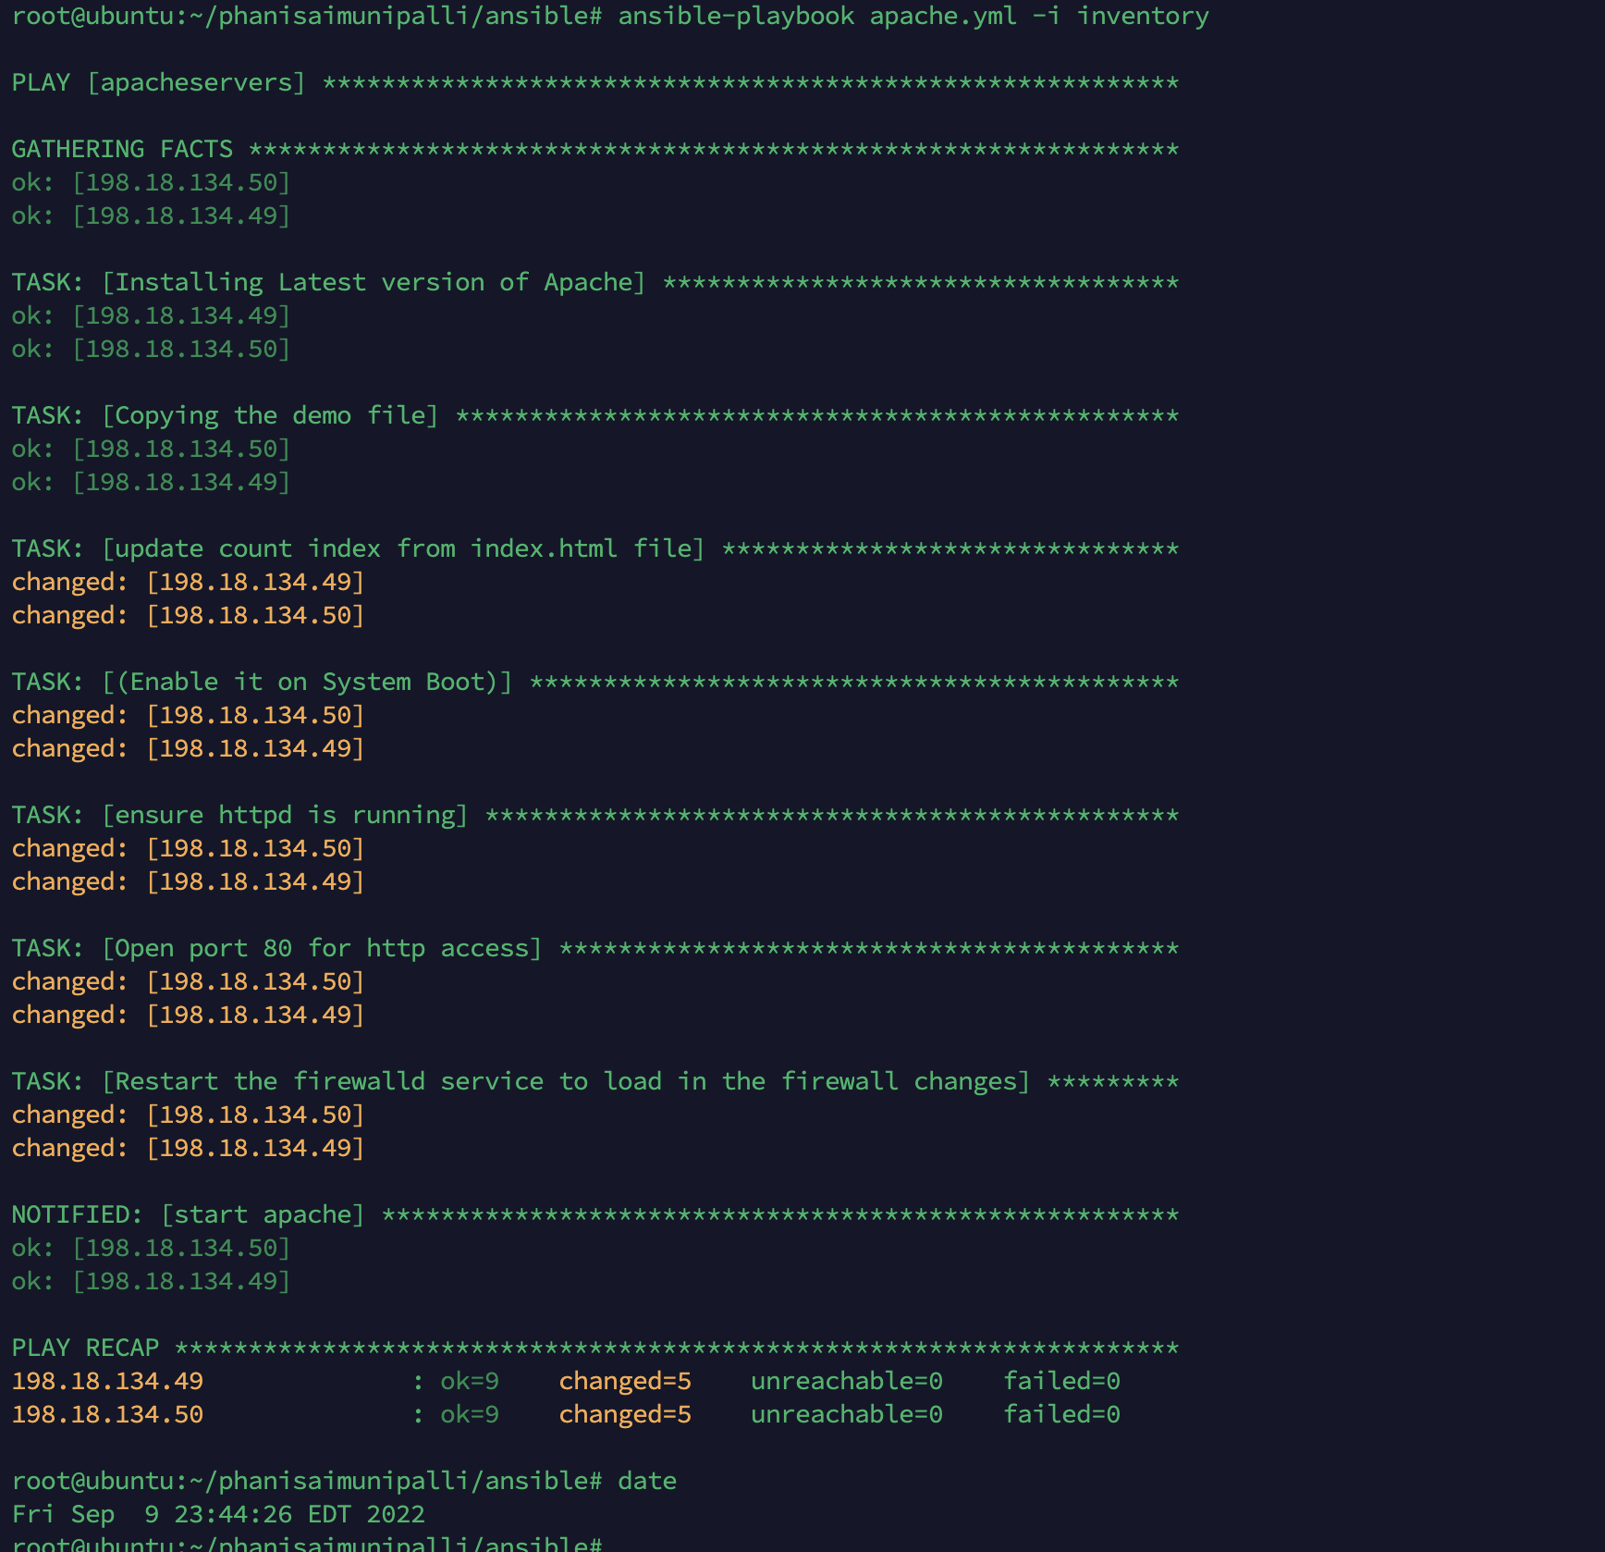

Updated playbook to open 80 port and checked status of apache

***--> sudo systemctl status httpd***

198.18.134.49 -- Successfully up and running

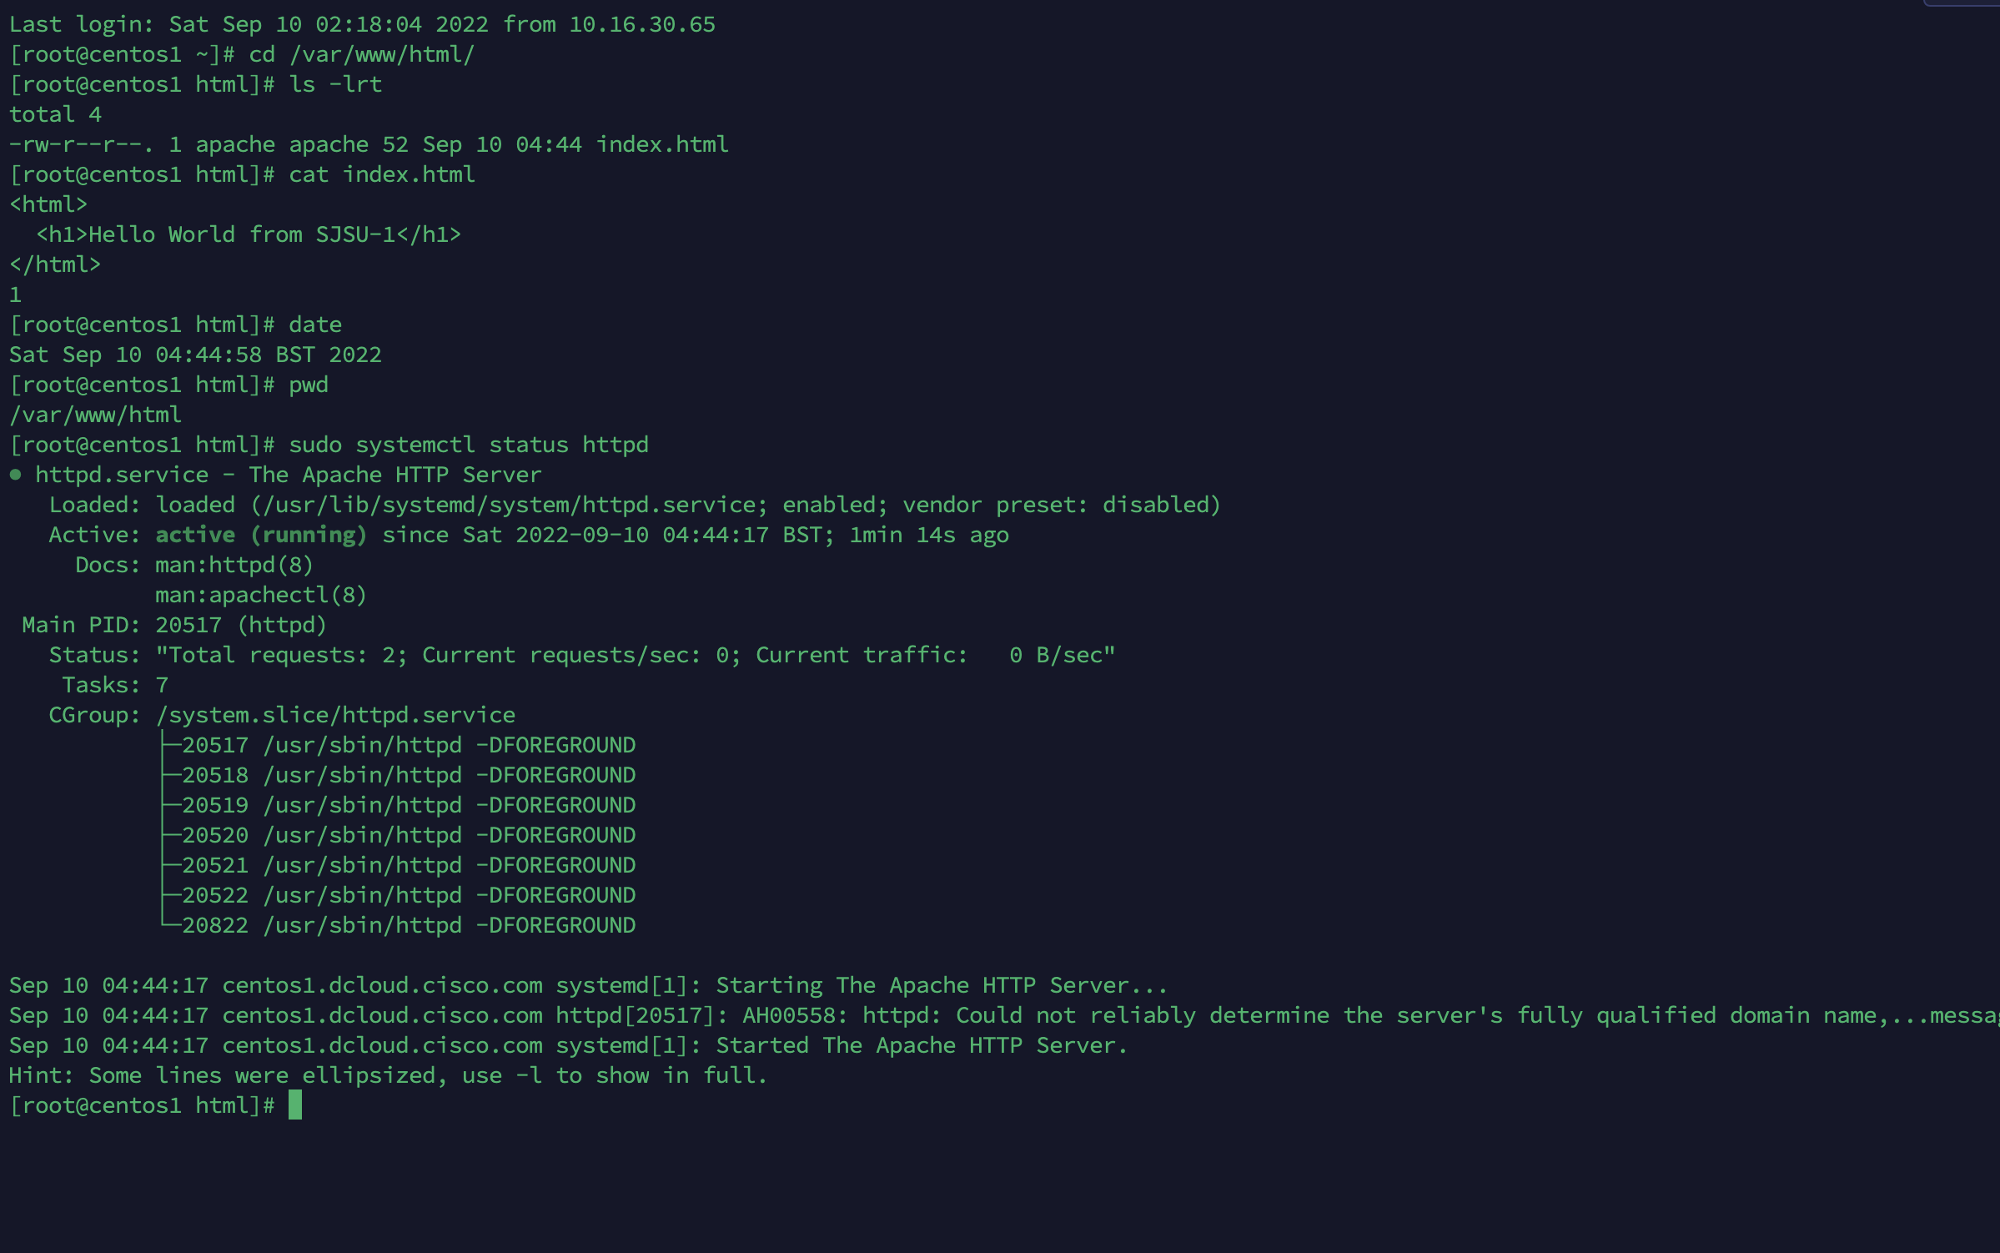

198.18.134.50 -- Successfully up and running

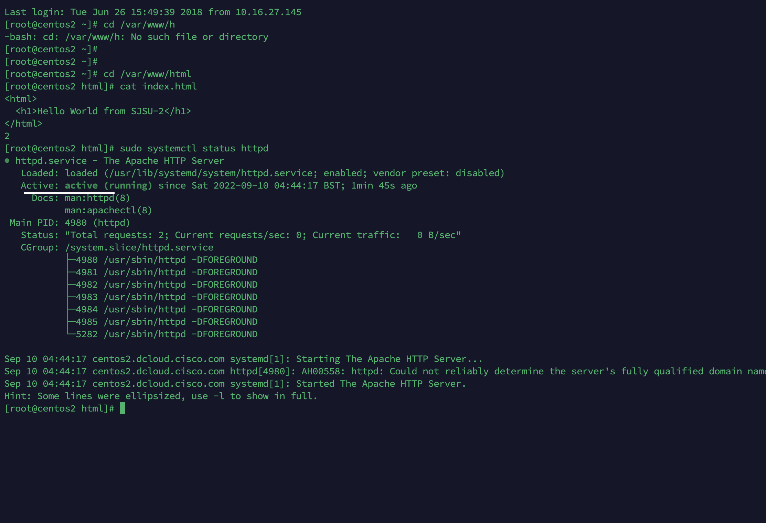

**Total files**

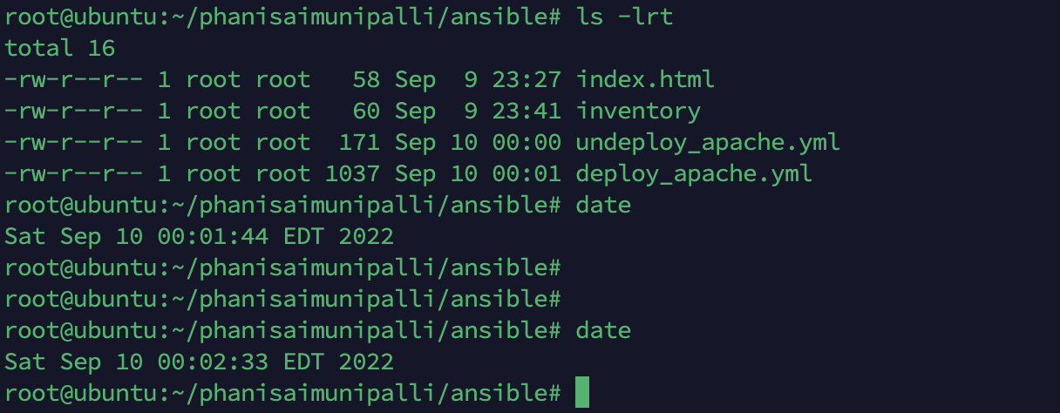

Deployed to both hosts with different messages in html page

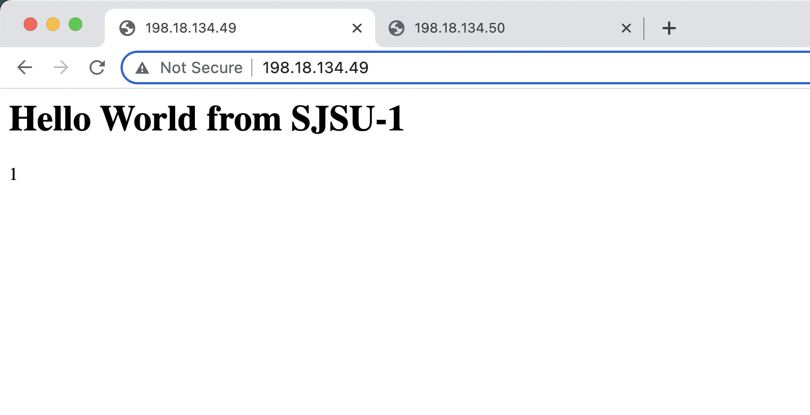

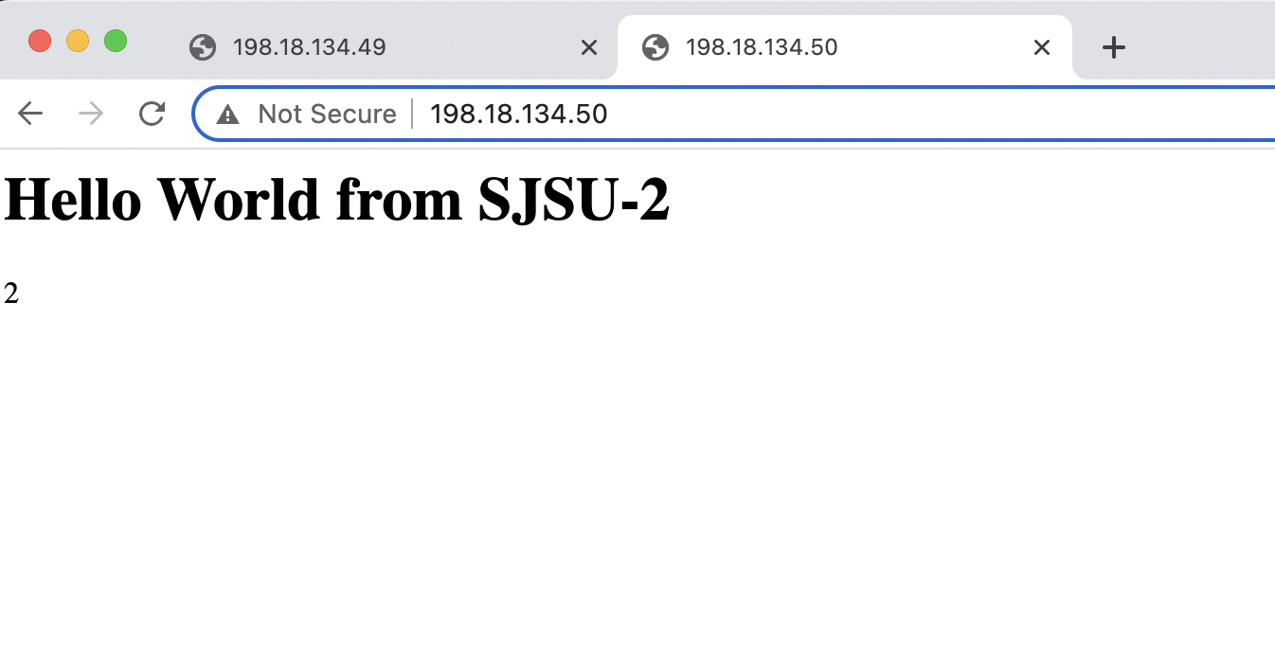

Undeploy Apache (HTTPD)

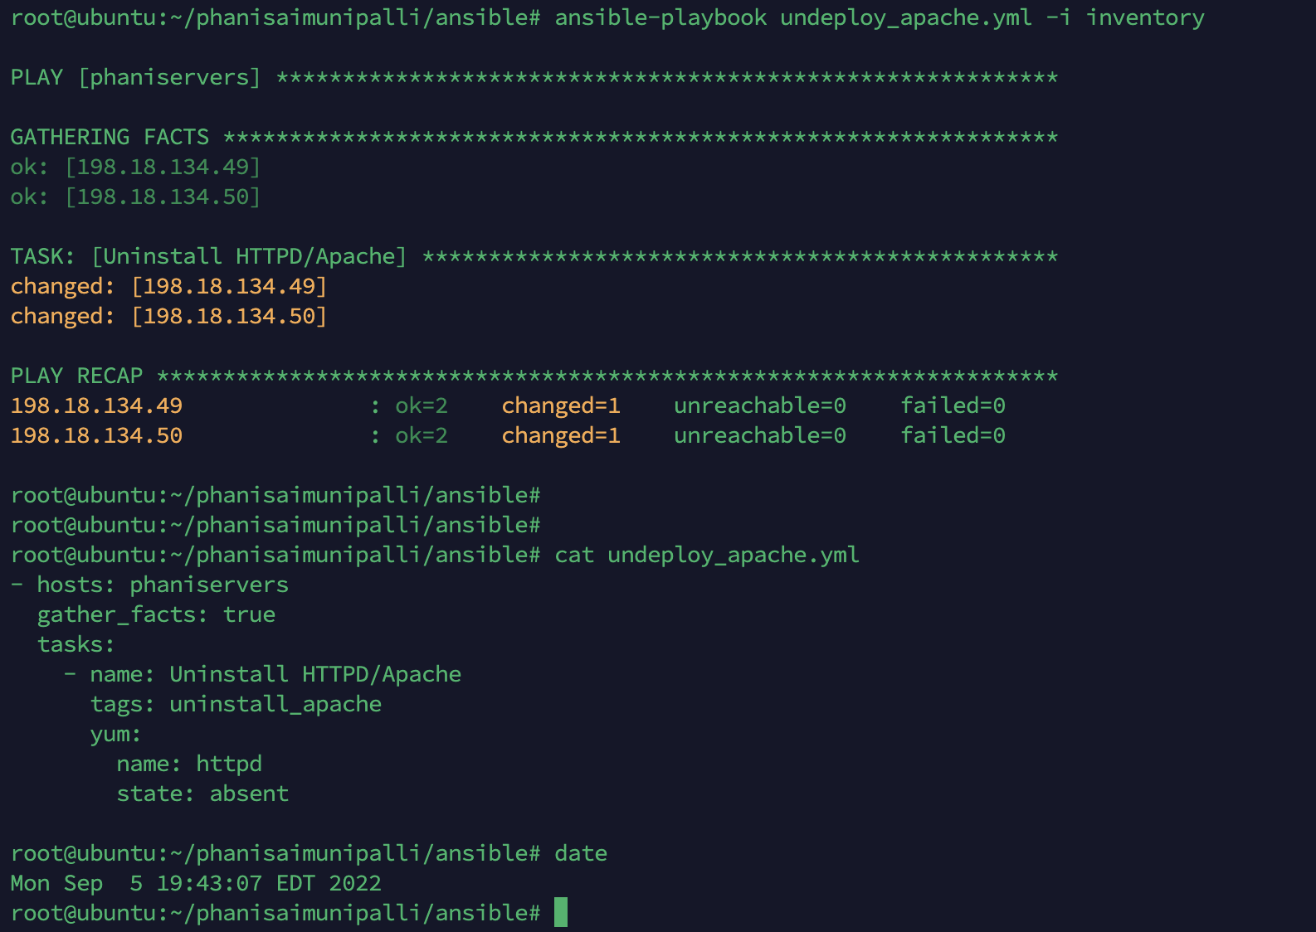

Apache service uninstalled successfully

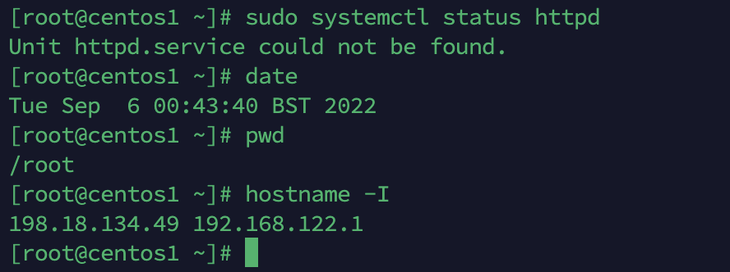

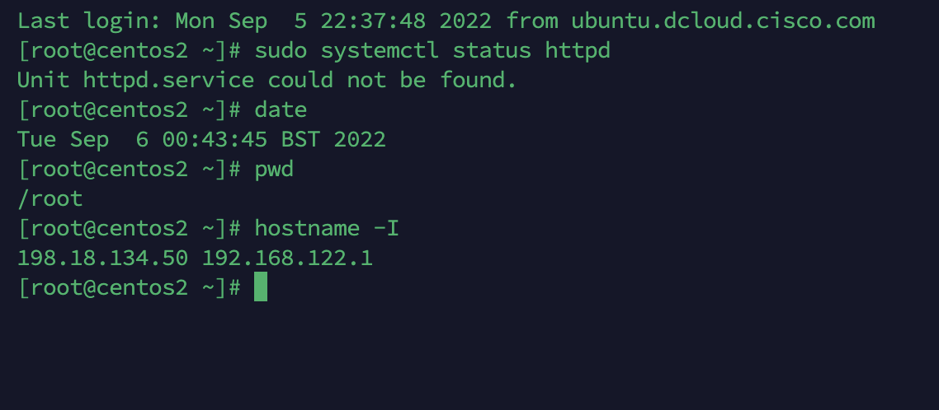

Thank you,

Phani Sai Ram Munipalli