1. Find the titles of all movies directed by Steven Spielberg

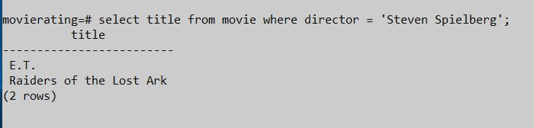

1. Find the year in which movie Star Wars released

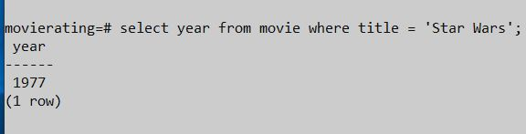

1. Find titles of all the movies that are rated at least once.

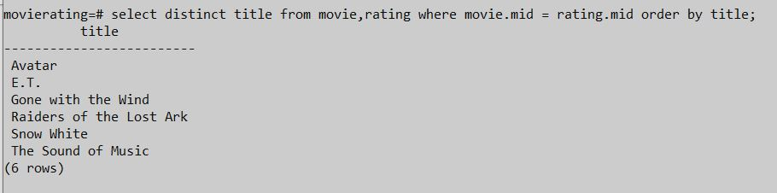

1. Find rating dates on which Brittany Harris rated his movies.

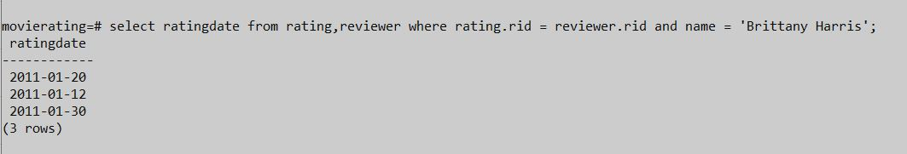

1. Find the titles of all movies not reviewed by Elizabeth Thomas.
2. Find all the movie names which are rated with 4 or 5 stars.

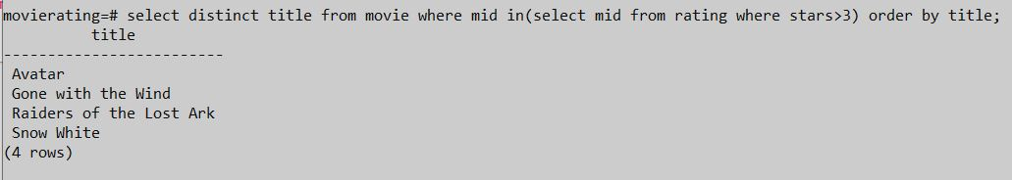

1. Find names of all reviewers who doesn’t reviewed even one film.

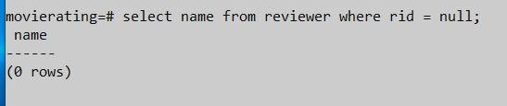

1. Find details of all the movies where Chris Jackson reviewed.

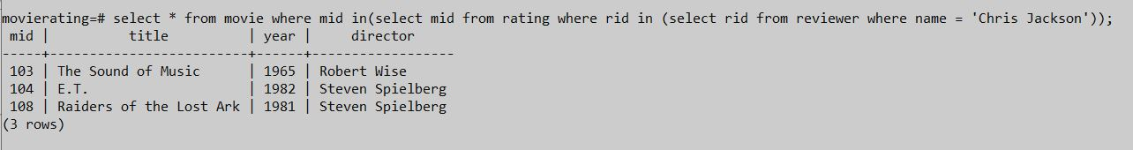

1. Find the names of all reviewers who rated for the movie Gone with the Wind.



1. Find all the directors whose movies are rated 2 by reviewer Brittany Harris.